Stabilizing Solution and Solid Phased Perovskite Towards High Performance Photovoltaic Devices with Superior Batch Stability and Consistency

Guihua Zhang,^{#[1]} Deng Wang,^{#[1][2]} Bowei Li,^{#[3]} Qing Lian,^{#[1]*} Xinyi Zou,^{[4]} Dongyang Li,^{[1]} Qiming Yin,^{[1]} Guojun Mi,^{[1]} Jie Li,^{[1]} Kui Feng,^{[1]} Abbas Amini,^{[5]} Alex K.-Y. Jen,^{[2]} Xugang Guo,^{[1]} Baomin Xu,^{[1]*} and Chun Cheng^{[1]*}

^{[1]}G. Zhang, D. Wang, Q. Lian, D. Li, Q. Yin, G. Mi, J. Li, K. Feng, X. Guo, B. Xu, C. Cheng
Department of Materials Science and Engineering, Southern University of Science and Technology, Shenzhen 518055, China
Emails: lianq@sustech.edu.cn, xubm@sustech.edu.cn, chengc@sustech.edu.cn

^{[2]}D. Wang, A. K.-Y. Jen
Department of Materials Science and Engineering, City University of Hong Kong, Tat Chee Ave, 999077 Kowloon, China

^{[3]}B. Li
Future Photovoltaic Research Center, Global Institute of Future Technology, Shanghai Jiao Tong University, Shanghai 200240, China

^{[4]}X. Zou
Department of Chemistry, Southern University of Science and Technology,
Shenzhen 518055, China.

^{[5]}A. Amini
Urban Transformations Research Centre, Western Sydney University, Penrith 2751, NSW, Australia.

#These authors contributed equally to this work.
Materials and methods
Formamidinium iodide (FAI, 99.9%), cesium iodide (CsI, 99.999%), lead iodide (PbI₂, 99.999%), and fullerene (C₆₀, 99.9%) were purchased from Ying Kou You Xuan Trade Co., Ltd. Bathocuproine (BCP, 99.99%) was obtained from Xi’an Polymer Light Technology Corp. 4-(trifluoromethyl)-phenylhydrazine hydrochloride (TFPHC, 97%) was purchased from J&K Scientific. 2PADCB was synthesized in the lab according to the previous methodology in literature. N, N-dimethylformamide (DMF, anhydrous, 99.8%), dimethyl sulfoxide (DMSO, anhydrous, 99.9%), 2-propanol (IPA, anhydrous, 99.5%), chlorobenzene (CB, anhydrous, 99.5%), dichloromethane (DCM, anhydrous, 99.9%) and methanol (MeOH, anhydrous, 99.8%) were obtained from Sigma–Aldrich. All materials were used as received.
Preparation of TFPHPbCl₃ crystals
TFPHPbCl₃ crystals were grown with the slow vapor diffusion of anti-solvent DCM into the precursor solution. The precursor solution was prepared by dissolving 425 mg of TFPH (2 mmol) and 556 mg of PbCl₂ (2 mmol) in 2 mL of the DMSO solvent. Then, the precursor solution was filtered with a 0.22 µm PTFE membrane filter to obtain a clear solution. The glass vial with clear solution was exposed to a 20 mL vial filled with 10 mL of dichloromethane and sealed with parafilm at room temperature for 30 days. Next, the solids were collected and washed with dichloromethane. Finally, white crystals were vacuum-dried for 24 hours.
Perovskite precursor solution
For the composition FA_{0.95}Cs_{0.05}PbI₃, 1.8 M perovskite precursor solution was prepared by dissolving 2.937 g FAI, 234 mg CsI, and 8.381 g PbI₂ in 10 mL mixed solvents of DMF and DMSO (v/v, 4/1) under continuous overnight stirring. Then, the precursor solution was filtered by a 0.22 µm PTFE filter before usage. For the target precursor solution, an extra TFPHPbCl₃ was added to the precursor.
Device fabrication
The planar p-i-n perovskite solar cells were fabricated with an architecture of ITO/ 2PADCB/Cs_{0.05}FA_{0.95}PbI₃/C₆₀/BCP/Cu. Patterned ITO glass was ultrasonically cleaned for 20 min with a detergent, deionized water, acetone and ethanol, sequentially. Then, the ITO-coated glass substrates were treated with ultraviolet ozone (UVO) for 20 min after being dried by an N₂ gun, then the treated ITO glass was transferred to the glove box. 2PADCB solution (0.5 mg mL⁻¹) in MeOH was spun onto the above ITO substrate at 3,000 rpm for 5 s, and then annealed at 100 ℃ for 5 min. The perovskite precursor solution was spread on the 2PADCB coated substrate at 2,000 rpm for 10 s and then at 5,000 rpm for 30 s. Then, 130 μL of CB was quickly dropped in 10 s before the end of the procedure. The wet films were immediately transferred to a heating plate and annealed at 100℃ for 30 min. A saturated PDI solution was spin-coated on the perovskite surface at 5000 rpm and annealed 100℃ for 5 min as post-treatment. Devices were completed by the thermal evaporation of 40 nm C₆₀, 8 nm BCP, and 100 nm Cu.
Device characterization
The current density–voltage (J–V) curves and steady-state output (SPO) were carried out with an active area of 0.085 cm² mask by a Keithley 2400 source measurement unit and a solar simulator with an AM1.5G spectrum. The light intensity was calibrated by Newport calibrated reference Si solar cell. EQE spectra were measured under ambient conditions by a QE-R 3011 system with 210 Hz chopped monochromatic light ranging from 300 to 900 nm. For the stability measurements, encapsulated devices were tracked at the maximum power point (MPP) on a 65 °C hotplate in 60% relative humidity under 1 Sun illumination, corresponding to the ISOS-D-2I protocol. Under dark and open-circuit conditions, unencapsulated devices were stored on a 65 °C hotplate in a N₂-filled glovebox, adopting to the ISOS-D-2I standard.
Other characteristics
UV-Vis absorption spectra were obtained using a PerkinElmer Lambda 950 UV-Vis spectrometer. For the precursor solution, toluene was used to extract iodine from the precursor solution. For the FAI-DMF solution, 1.8 M FAI with/without TFPH was dissolved in DMF and left in air at room temperature for aging. NMR spectra were acquired by using a Bruker AVANCE-Ⅲ 400 MHz spectrometer. XPS measurements were conducted on a Thermo Scientific K-Alpha XPS system with a monochromatic aluminum (Kα) X-ray source providing photons with the energy of 1486.7 eV. XRD measurements were done by using a Rigaku Smart Lab 3kW X-ray diffractometer with a Cu (Kα, 1.5406 Å) source at 10° min⁻¹ scan rate and 2θ range of 5-50°. The top-view and the cross-sectional images of the films were obtained by a field-emission SEM (Regulus 8230). Steady-state PL (excitation at 405 nm) and TRPL spectroscopy were performed using an Edinburgh FLS1000 spectrometer. SCLC measurements were performed on the hole-only device stacks using a Keithley 4200 system under dark condition. MS spectra were acquired from a Q Exactive Orbitrap Mass Spectrometer.

Figure S1. The observation by naked eyes on different perovskite solutions and their I₂ extracted solutions by toluene.
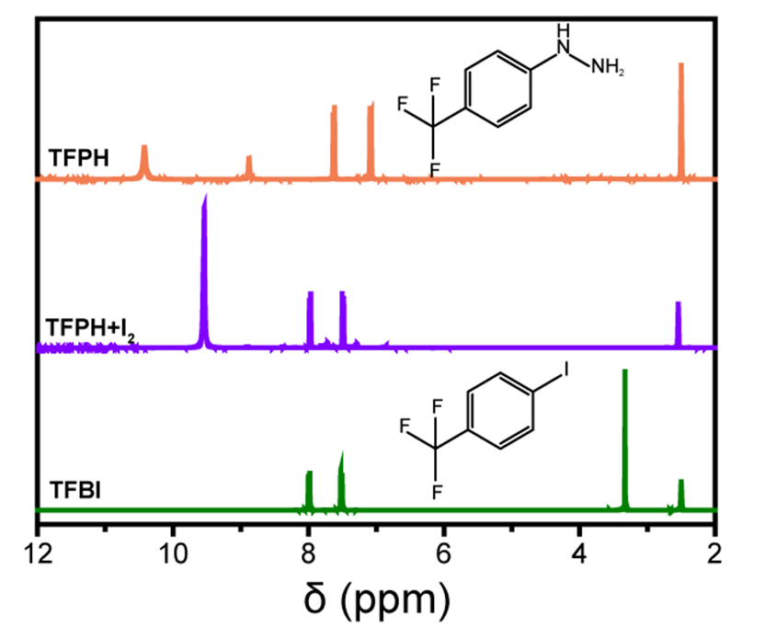
Figure S2. ¹H NMR spectra of TFPH, TFPH+I₂ and TFBI in DMSO-d₆.

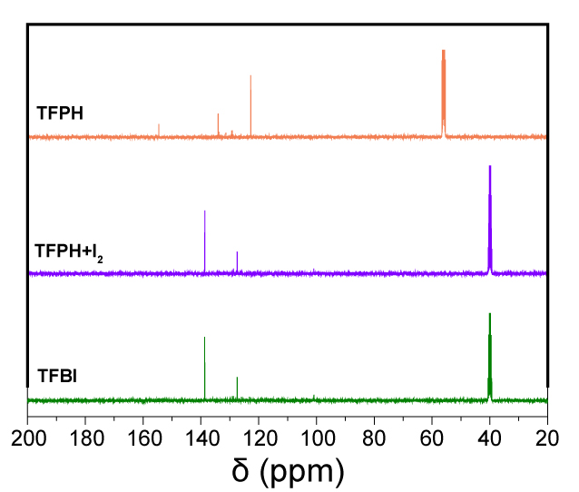
Figure S3. ¹³C NMR spectra of TFPH, TFPH+I₂ and TFBI in DMSO-d₆

Figure S4. The production of gas during mixing TFPH、I₂ and DMF.

Figure S5. Morphology of the perovskite films. a-c) Top-view SEM images of the perovskite films. d-f) Statistical distributions of the grain size.

Figure S6. GIXRD spectra of the perovskite films at different tilt angles (ψ).

Figure S7. AFM images of the perovskite films with or without TFPH.

Figure S8. XPS core-level spectra of C 1s and F 1s

Figure S9. Optical properties of the perovskite film. a) UV-Vis spectra. High-resolution XPS spectra of b) Pb 4f and c) I 3d.

Table S1. Integral intensity of peak area a function of I₂/TFPH ratios. The data were obtained from ¹H NMR.
I₂/TFPH ratio | TFPH % | TFBD % | TFBI %
0 | 100 | 0 | 0
0.1 | 96.2 | 1.9 | 1.9
0.5 | 83.4 | 8.3 | 8.3
1 | 69.0 | 13.8 | 17.2
2 | 42.4 | 20.3 | 37.3
3 | 17.2 | 25.0 | 57.8
4 | 0 | 20.0 | 80.0
5 | 0 | 13.0 | 87.0
6 | 0 | 9.1 | 90.9
8 | 0 | 7.4 | 92.6
10 | 0 | 6.5 | 93.5

Table S2. V_{TFL} and n_{trap} obtained from the dark I-V curves of the hole-only devices.
Device | V_{TFL} (V) | n_{trap} (cm⁻³)
Control (fresh) | 0.091 | 1.03×10¹⁵
Control (aged) | 0.096 | 1.09×10¹⁵
Target (aged) | 0.081 | 0.92×10¹⁵

Table S3. TRPL fitting of perovskite films with or without TFPH. Note that the films were coated on ITO/SAMs substrate.
Device | τ₁ | A₁ | τ₂ | A₂ | τ_{average}
Control (fresh) | 157.9 | 4.77 | 2485.9 | 95.23 | 2478.6
Control (aged) | 375.7 | 34.6 | 1275.3 | 65.41 | 1154.1
Target (aged) | 45.9 | 0.77 | 3821.7 | 99.23 | 3821.3

Table S4. Photovoltaic parameters of PSCs prepared from the control solution at different aging times.
Time Data |  | PCE % | FF% | V_{OC} (V) | J_{SC} (mA cm⁻²)
1 | Average | 22.99±0.40 | 81.55±0.92 | 1.114±0.006 |  | 25.38±0.42
1 | Champion | 23.71 | 82.59 | 1.121 |  | 25.45
15 | Average | 21.39±0.74 | 79.39±0.95 | 1.117±0.003 |  | 24.37±0.51
15 | Champion | 22.70 | 80.28 | 1.122 |  | 25.24
30 | Average | 19.58±1.12 | 77.67±2.24 | 1.124±0.006 |  | 23.01±0.93
30 | Champion | 21.74 | 81.77 | 1.136 |  | 23.25
60 | Average | 16.82±2.07 | 76.06±2.98 | 1.118±0.009 |  | 20.68±1.61
60 | Champion | 20.21 | 79.85 | 1.135 |  | 22.23

Table S5. Photovoltaic parameters of PSCs prepared from the target solution at different aging times.
Time Data |  | PCE % | FF% | V_{OC} (V) | J_{SC} (mA cm⁻²)
1 | Average | 25.66±0.29 | 84.77±1.01 | 1.179±0.008 |  | 25.66±0.14
1 | Champion | 25.95 | 85.70 | 1.186 |  | 25.53
15 | Average | 25.67±0.31 | 84.69±1.03 | 1.180±0.006 |  | 25.68±0.16
15 | Champion | 25.98 | 85.72 | 1.186 |  | 25.56
30 | Average | 25.67±0.33 | 84.92±0.49 | 1.179±0.007 |  | 25.65±0.15
30 | Champion | 26.00 | 85.35 | 1.185 |  | 25.71
60 | Average | 25.62±0.29 | 84.69±0.63 | 1.178±0.006 |  | 25.69±0.15
60 | Champion | 25.91 | 85.32 | 1.184 |  | 25.64

Table S6. Integrated J_{SC} from EQE spectra.
Device | Integrated J_{SC} (mA cm⁻²)
Control (fresh) | 24.94
Control (aged) | 20.67
Target (aged) | 24.93

Table S7. Summary of operational stability of high-performance inverted PSCs based on ISOS-L-3.
Device structure | Best PCE | Lifetime | Reference
ITO/Me-4PACz/Al₂O₃/  Cs_{0.05}MA_{0.1}FA_{0.85}PbI₃/PCBM/C₆₀/SnO_{x}/Ag | 26.02% | T_{96.9}=1246 h | Adv. Sci.  2024, 2407380.
ITO/NiO_{x}/Cs_{0.05}FA_{0.85}MA_{0.1}PbI₃/  PCBM/BCP/Ag | 23.91%  (certified) | T₉₂=500 h | Nat. Photon.  2022, 16, 352–358.
ITO/2PACz/Cs_{0.05}MA_{0.05}FA_{0.9}Pb(I_{0.95}Br_{0.05})₃/  C₆₀/BCP/Ag | 24.09%  (certified) | T₈₅=1560 h | Science  2023, 381,209-215.
FTO/2PACz:3-MPA/  Cs_{0.05}MA_{0.10}FA_{0.85}PbI₃/345FAn/C₆₀/BCP/Ag | 25.3% | T₉₅=1075 h | Nature  2023, 624, 289–294.
FTO/NiO_{x}/4PACz/  Cs_{0.05}MA_{0.05}FA_{0.90}PbI₃/C₆₀/BCP/Ag | 26.4% | T₉₆=2000 h | Science  2023, 382,810-815.
FTO/2PACz:Me-4PACz/  Cs_{0.05}MA_{0.1}FA_{0.85}PbI₃ /BMP/C₆₀ | 26.9% | T₉₅=1200 h | Science  2024, 384,189-193.
ITO/PTAA/Rb_{0.05}Cs_{0.05}MA_{0.05}FA_{0.85}Pb(I_{0.95}Br_{0.05})₃/C₆₀/BCP/Cu | 25.2% | T₈₅=500 h | Nature  2024, 625, 516–522.
ITO/2PADCB/FA_{0.95}Cs_{0.05}PbI₃/C₆₀/BCP/Cu | 26.0% | T₉₂=1830 h | This work

