Supplementary Materials

Table 1
The correlations between rsFC, ReHo values and clinical variables in PMS group.
 | SAS | SDS | PSQI | VMPFC-PCu_FC | IPL-MOG_FC | VMPFC_ReHo | IPL_ReHo | PCC.PCu_ReHo | MOG_ReHo
SAS | NA | 0.684 | 0.519 | 0.144 | 0.042 | 0.133 | -0.013 | 0.095 |  | -0.246
SDS | <0.001 | NA | 0.426 | 0.034 | 0.036 | 0.161 | 0.003 | 0.169 |  | -0.33
PSQI | <0.001 | <0.001 | NA | 0.377 | -0.104 | 0.206 | -0.287 | -0.039 |  | -0.047
VMPFC- PCu_FC | 0.422 | 0.891 | 0.005 | NA | -0.006 | 0.365 | 0.023 | 0.126 |  | -0.106
IPL-MOG_FC | 0.891 | 0.891 | 0.602 | 0.978 | NA | 0.059 | 0.073 | -0.013 |  | -0.057
VMPFC_ReHo | 0.47 | 0.341 | 0.173 | 0.005 | 0.865 | NA | 0.228 | 0.387 |  | -0.258
IPL_ReHo | 0.966 | 0.978 | 0.04 | 0.948 | 0.79 | 0.118 | NA | 0.301 |  | -0.25
PCu_ReHo | 0.645 | 0.319 | 0.891 | 0.491 | 0.966 | 0.005 | 0.032 | NA |  | -0.634
MOG_ReHo | 0.086 | 0.014 | 0.891 | 0.602 | 0.865 | 0.075 | 0.086 | <0.001 |  | NA

Table 2
The mediation analysis results on model 3.
 | a | b | c' | c-c'
X (PSQI)→Y (SAS) mediated by M (FC of right VMPFC – right PCu)
β | 0.024 | -1.510 | 1.482 | -0.037
p | <0.001 | 0.750 | <0.001 | 0.663
X (PSQI)→Y (SAS) mediated by M (FC of right IPL – right MOG)
β | -0.008 | 2.306 | 1.463 | -0.018
p | 0.343 | 0.555 | <0.001 | 0.309
X (PSQI)→Y (SAS) mediated by M (ReHo values of right VMPFC)
β | 0.034 | 0.962 | 1.412 | 0.033
p | 0.108 | 0.527 | <0.001 | 0.276
X (PSQI)→Y (SAS) mediated by M (ReHo values of left IPL)
β | -0.0362 | 3.128 | 1.558 | -0.113
p | 0.055 | 0.065 | <0.001 | 0.103
X (PSQI)→Y (SAS) mediated by M (ReHo values of right PCu)
β | -0.010 | 2.186 | 1.467 | -0.022
p | 0.647 | 0.128 | <0.001 | 0.491
X (PSQI)→Y (SAS) mediated by M (ReHo values of right MOG)
β | -0.018 | -2.833 | 1.395 | 0.051
p | 0.554 | 0.006 | <0.001 | 0.521

Table 3
The mediation analysis results on Model 4.
 | a | b | c' | c-c'
X (PSQI)→Y (SDS) mediated by M (FC of right VMPFC – right PCu)
β | 0.024 | -7.186 | 1.807 | -0.1746
p | <0.001 | 0.227 | <0.001 | 0.300
X (PSQI)→Y (SDS) mediated by M (FC of right IPL – right MOG)
β | -0.008 | 4.433 | 1.667 | -0.035
p | 0.343 | 0.368 | <0.001 | 0.350
X (PSQI)→Y (SDS) mediated by M (ReHo values of right VMPFC)
β | 0.034 | 1.006 | 1.598 | 0.034
p | 0.108 | 0.600 | <0.001 | 0.365
X (PSQI)→Y (SDS) mediated by M (ReHo values of left IPL)
β | -0.037 | 2.876 | 1.736 | -0.104
p | 0.055 | 0.181 | <0.001 | 0.200
X (PSQI)→Y (SDS) mediated by M (ReHo values of right PCu)
β | -0.010 | 3.412 | 1.667 | -0.035
p | 0.647 | 0.058 | <0.001 | 0.490
X (PSQI)→Y (SDS) mediated by M (ReHo values of right MOG)
β | -0.018 | -4.802 | 1.547 | 0.086
p | 0.554 | <0.001 | <0.001 | 0.616

Figure 1 Matrix Heatmap of correlations between rsFC, ReHo values and clinical variables in PMS group. Abbreviations: IPL, inferior parietal lobule; PCu, posterior cingulate/precuneus; MOG, middle occipital gyrus ; VMPFC, ventromedial prefrontal cortex; PSQI, Pittsburgh Sleep Quality Index; SAS, Self-Rating Anxiety Scale; SDS, Self-Rating Depression Scale; ReHo, Regional Homogeneity. * denotes p < 0.05, ** denotes p < 0.01, and ***denotes p < 0.001.
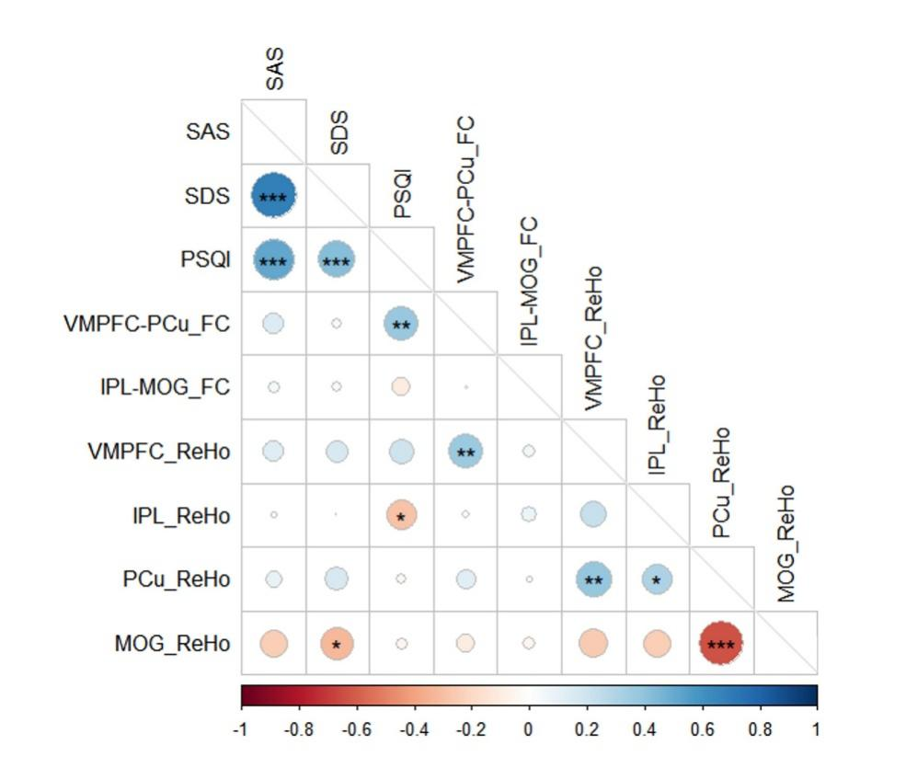

Figure 2 Conceptual diagram of mediation analysis in PMS group based on Model 3 and Model 4. A) and B) showing the results based on the rsFC and ReHo values, respectively. Abbreviations: IPL, inferior parietal lobule; PCu, posterior cingulate/Precuneus; MOG, middle occipital gyrus; VMPFC, ventromedial prefrontal cortex; * denotes p < 0.05, ** denotes p < 0.01, and *** denotes p < 0.001.
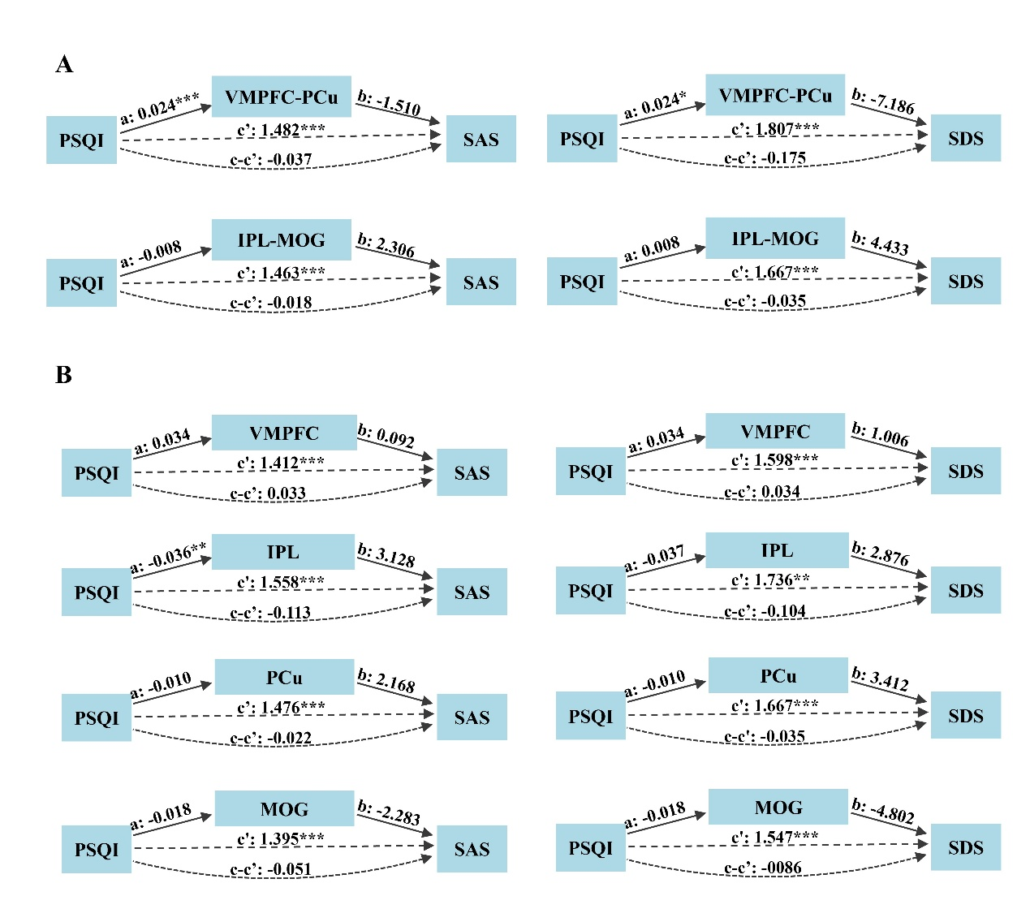

1. Inclusion and exclusion criteria
1.1 Inclusion criteria:
1) Age between 18 and 45 years.
2) Right-handed.
3) Regular menstrual cycles between 21 and 35 days.
4) No physical or mental chronic disorders.
5) Of the first 21 items on the DRSP scale, at least 3 items must meet the following criteria: (1) a variation ratio of ≥ 30 %, (2) mean DRSP scores > 3 during the late luteal phase of the menstrual cycle (days −5 to −1), and (3) mean DRSP scores < 3 during the mid-follicular phase of the menstrual cycle (days +6 to +10),
$$variation ratio=\frac{L−M}{M}×100 \%$$
where $L$ is the mean DRSP scores of late luteal phase and $M$ is the mean DRSP scores of mid-follicular phase.
6) At least one item from the last three terms of the DRSP involves impairment in daily functioning and interpersonal relationships.
1.2 Exclusion criteria:
1) Pregnant or nursing at present, or with a past medical history of thyroid conditions, dysmenorrhea, gynecological infections, menopausal disorders, uterine removal, bilateral ovarian excision, breast-related illnesses, malignancies, or other structural abnormalities.
2) Having a prior history of treatment with steroids (such as hormonal intrauterine devices or oral contraceptives), benzodiazepines, or other psychiatric medications influencing PMS.
3) Any contraindication to MRI.
4) Smokers or those who suffer from alcohol dependence.
2. MRI data acquisition
3D_T1: MPRAGE sequence: TR = 2000 ms, TE = 2.04 ms, FOV = 256 mm × 256 mm, slice thickness = 1 mm, resolution = 256 × 256, flip angle = 7°.
Rs-fMRI: EPI sequence: TR = 2000 ms, TE = 30 ms, FOV = 220 mm × 220 mm, slice thickness = 2.5 mm, resolution = 64 × 64, flip angle = 90°, 240 volumes, and acquisition time = 480 s.

