SNP‒SNP interactions with acute coronary arteries
Impact of SNP‒SNP interactions on acute coronary risk analyzed via MDR establishment. The best model was identified as the rs1799983(TTvsGG+TG), rs1799983(TGvsTT+GG), and rs1800780(GGvsAG+AA) combination model, with balanced training accuracy (Bal.Acc. CV training) CV = 0.5313, test parallel accuracy (Bal.Acc. CV Testing) CV = 0.5262, and cross-validation consistency (CV Consistency) CV = 9/10 (Supplementary Table 1). rs1799983 TTvsGG+TG and rs1800780 GGvsAG+AA had similar effects on ACS, both affecting the same branch (Supplementary Figure 1). The main effects of each attribute were rs1799983 TTvsGG+TG (0.19%), rs1800780 GGvsAG+AA (0.07%), rs1800780 AGvsAA+GG (0.05%), rs1799983 GGvsTT+TG (0.03%), rs1799983 TGvsTT+GG (0.02%), and rs1800780 AAvsGG+AG (0.00%) (Supplementary Figure 2).
Supplementary table 1 Analysis of SNP‒SNP interactions for MDR in ACS risk
Model | Bal.Acc.CV Training | Bal.Acc.CV Testing | CV Consistency
rs1800780(GGvsAG+AA) | 0.5156 | 0.5051 | 7/10
rs1799983(GGvsTT+TG), rs1800780(GGvsAG+AA) | 0.5274 | 0.5117 | 4/10
rs1799983(TTvsGG+TG), rs1799983(TGvsTT+GG), rs1800780(GGvsAG+AA) | 0.5313 | 0.5262 | 9/10
Bal.Acc. CV training: training accuracy, where the value range is 0--1; the larger the value is, the higher the prediction accuracy of the model; Bal.Acc. CV testing: When the value range is 0--1, the larger the value is, the higher the prediction accuracy of the model. CV consistency is cross-validation consistency, which indicates that the factor combinations are repeatedly recognized as the best model in multiple cross-validations; the higher the value is, the better the model is. CV Consistency: Cross-validation consistency rate, indicating the number of times a combination of factors is repeatedly recognized as the best model in multiple cross-validations; the higher the value is, the better the model performs.
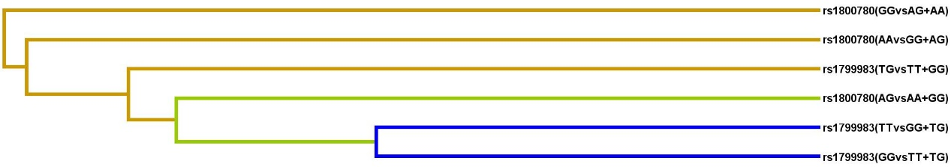
Supplementary Figure 1 Clustering dendrogram of the rs1799983 and rs1800780 interactions
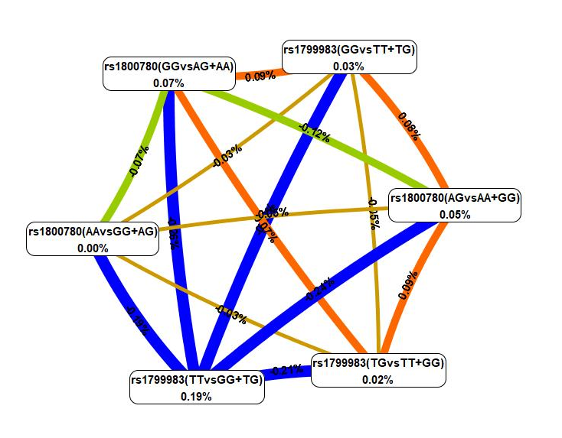
Supplementary Figure 2 MDR ring network diagram of the rs1799983 and rs1800780 gene interactions

To further explore the relationship between SNP polymorphisms in the eNOS rs1799983 and rs1800780 genes and acute coronary syndrome and the impact of these independent factors when they cooperate with the disease. In this model, the effects of SNP gene polymorphisms (rs1799983, rs1800780) on ACS were explored. We constructed an SNP‒SNP interaction model via the MDR method. In this model, the effects of SNP gene polymorphisms (rs1799983, rs1800780) on acute coronary syndrome were explored. The analysis results show that the rs1799983(TTvsGG+TG), rs1799983(TGvsTT+GG), and rs1800780(GGvsAG+AA) models are the best models, with a training balance accuracy of 0.5313, a test‒parallel accuracy of 0.5262, and a cross-validated agreement rate of 9/10. These data indicate that the MDR analytical model has good predictive performance and stability. The effects of rs1799983TTvsGG+TG and rs1800780 GGvsAG+AA on ACS were similar. The effects of each attribute were as follows: rs1799983TTvsGG+TG (0.19%), rs1800780GGvsAG+AA (0.07%), rs1800780AGvsAA+GG (0.05%), rs1799983GGvsTT+TG (0.03%), rs1799983TGvsTT+GG (0.02%), and rs1800780AAvsGG+AG (0.00%). This finding indicates that the polymorphisms rs1799983 and rs1800780, when interacting with ACS, may aid in diagnosing the disease alongside other factors.

