Supplementary Tables and Figures

Table A1: The estimated type I error rate of the five multiple phenotype association tests divided by the nominal significance level for 40, 60, and 80 phenotypes with half binary and half quantitative phenotype under model 2. The type I error rates were calculated using the 100 MC runs equivalent to 10⁶ replicates.

Method | Category | K
Method | Category | 40 |  | 60 |  | 80
Method | Category | α=0.001 | α=0.0001 | α=0.001 | α=0.0001 | α=0.001 | α=0.0001
 | NO | 0.849 | 0.780 | 0.797 | 0.780 | 0.737 | 0.680
ACAT | Cor | 0.849 | 0.780 | 0.797 | 0.780 | 0.737 | 0.680
 | sGGM | 0.856 | 0.760 | 0.760 | 0.840 | 0.723 | 0.690
 | NO | 0.941 | 0.930 | 0.818 | 0.590 | 0.830 | 0.860
Wald | Cor | 1.035 | 1.120 | 0.934 | 0.890 | 0.928 | 0.890
 | sGGM | 1.013 | 1.040 | 0.981 | 1.090 | 0.965 | 1.090
 | No | 0.938 | 1.020 | 0.821 | 0.620 | 0.817 | 0.850
PCFisher | Cor | 1.035 | 1.090 | 0.952 | 0.870 | 0.916 | 0.890
 | sGGM | 1.013 | 0.940 | 0.996 | 1.150 | 0.978 | 1.040
 | NO | 0.986 | 1.030 | 0.893 | 0.860 | 0.861 | 0.900
HCLC | Cor | 0.977 | 0.970 | 0.990 | 1.000 | 0.993 | 1.030
 | sGGM | 1.022 | 1.030 | 1.030 | 1.060 | 0.967 | 1.050
 | NO | 1.028 | 1.000 | 1.073 | 1.040 | 1.157 | 1.340
O’Brien | Cor | 0.974 | 1.110 | 1.006 | 1.130 | 1.025 | 1.070
 | sGGM | 0.945 | 0.840 | 1.007 | 0.850 | 0.935 | 0.960

Note: The bold-faced values indicate that the values are beyond the upper bound of the 95 % confidence interval. The 95 % confidence interval for type I error rates divided by the nominal significance level 0.001 and 0.0001 are (0.938, 1.062) and (0.804, 1.196) respectively. “NO” represents the type I error rate calculated without considering the network modules, “Cor” represents the type I error rate calculated using the network structure based on the covariance matrix, and “sGGM” represents the type I error rate calculated using the network structure partial correlation matrix.

Table A2: The estimated type I error rate of the five multiple phenotype association tests divided by the nominal significance level for 40, 60, and 80 phenotypes with half binary and half quantitative phenotype under model 3. The type I error rates were calculated using 100 MC runs equivalent to 10⁶ replicates.

Method | Category | K
Method | Category | 40 |  | 60 |  | 80
Method | Category | α=0.001 | α=0.0001 | α=0.001 | α=0.0001 | α=0.001 | α=0.0001
 | NO | 0.838 | 0.900 | 0.752 | 0.740 | 0.730 | 0.640
ACAT | Cor | 0.838 | 0.900 | 0.752 | 0.740 | 0.730 | 0.640
 | sGGM | 0.869 | 0.920 | 0.754 | 0.700 | 0.699 | 0.600
 | NO | 0.938 | 0.860 | 0.808 | 0.760 | 0.874 | 0.860
Wald | Cor | 0.932 | 0.940 | 0.937 | 0.850 | 0.877 | 0.850
 | sGGM | 0.998 | 0.960 | 0.939 | 1.040 | 0.987 | 0.940
 | NO | 0.950 | 0.940 | 0.820 | 0.770 | 0.832 | 0.940
PCFisher | Cor | 0.934 | 0.880 | 0.945 | 0.800 | 0.888 | 0.830
 | sGGM | 0.992 | 0.990 | 0.927 | 1.130 | 1.001 | 0.910
 | NO | 0.998 | 1.090 | 0.927 | 0.970 | 0.872 | 0.870
HCLC | Cor | 0.957 | 1.060 | 0.941 | 0.890 | 1.032 | 0.960
 | sGGM | 1.003 | 1.070 | 0.973 | 1.030 | 0.985 | 1.070
 | NO | 1.024 | 1.040 | 1.123 | 1.180 | 1.213 | 1.270
O’Brien | Cor | 0.980 | 1.070 | 1.055 | 1.240 | 1.049 | 1.140
 | sGGM | 0.988 | 1.130 | 0.988 | 1.040 | 0.916 | 1.030

Note: The bold-faced values indicate that the values are beyond the upper bound of the 95 % confidence interval. The 95 % confidence interval for type I error rates divided by the nominal significance level 0.001 and 0.0001 are (0.938, 1.062) and (0.804, 1.196) respectively. “NO” represents the type I error rate calculated without considering the network modules, “Cor” represents the type I error rate calculated using the network structure based on the covariance matrix, and “sGGM” represents the type I error rate calculated using the network structure from the partial correlation matrix.

Table A3: The estimated type I error rate of the five multiple phenotype association tests divided by the nominal significance level for 40, 60, and 80 phenotypes with half binary and half quantitative phenotype under model 4. The type I error rates were calculated using 100 MC runs equivalent to 10⁶ replicates.
Method | Category | K
Method | Category | 40 |  | 60 |  | 80
Method | Category | α=0.001 | α=0.0001 | α=0.001 | α=0.0001 | α=0.001 | α=0.0001
 | NO | 0.844 | 0.800 | 0.736 | 0.720 | 0.739 | 0.710
ACAT | Cor | 0.844 | 0.800 | 0.736 | 0.720 | 0.739 | 0.710
 | sGGM | 0.829 | 0.770 | 0.739 | 0.690 | 0.727 | 0.720
 | NO | 0.881 | 0.940 | 0.809 | 0.450 | 0.808 | 0.850
Wald | Cor | 0.942 | 0.860 | 0.989 | 0.850 | 0.914 | 0.920
 | sGGM | 0.989 | 1.010 | 0.965 | 0.800 | 0.954 | 0.840
 | NO | 0.908 | 1.030 | 0.809 | 0.480 | 0.791 | 0.820
PCFisher | Cor | 0.939 | 0.920 | 0.983 | 1.040 | 0.916 | 0.980
 | sGGM | 0.982 | 1.030 | 0.934 | 0.770 | 0.966 | 0.932
 | NO | 0.944 | 0.920 | 0.875 | 1.050 | 0.884 | 0.884
HCLC | Cor | 0.926 | 1.020 | 0.985 | 0.940 | 0.984 | 0.984
 | sGGM | 0.998 | 0.970 | 1.084 | 0.940 | 0.932 | 0.932
 | NO | 1.079 | 0.970 | 1.111 | 0.990 | 1.206 | 1.220
O’Brien | Cor | 1.011 | 1.090 | 1.046 | 1.370 | 0.997 | 0.997
 | sGGM | 0.959 | 1.120 | 1.062 | 1.230 | 0.944 | 0.944

Note: The bold-faced values indicate that the values are beyond the upper bound of the 95 % confidence interval. The 95 % confidence interval for type I error rates divided by the nominal significance level 0.001 and 0.0001 are (0.938, 1.062) and (0.804, 1.196) respectively. “NO” represents the type I error rate calculated without considering the network modules, “Cor” represents the type I error rate calculated using the network structure based on the covariance matrix, and “sGGM” represents the type I error rate calculated using the network structure from partial correlation matrix.

Table A4: ICD-10 codes of the diseases of the circulatory system.

Code | Description
I00-I02 | Acute rheumatic fever
I05-I09 | Chronic rheumatic heart diseases
I10-I1A | Hypertensive diseases
I20-I25 | Ischemic heart diseases
I26-I28 | Pulmonary heart disease and diseases of pulmonary circulation
I30-I5A | Other forms of heart disease
I60-I69 | Cerebrovascular diseases
I70-I79 | Diseases of arteries, arterioles and capillaries
I80-I89 | Diseases of veins, lymphatic vessels and lymph nodes, not elsewhere  classified
I95-I99 | Other and unspecified disorders of the circulatory system

Table A5: Community detection results from the correlation matrix for the phenotypes in Chapter IX (Disease of the circulatory system) in the UK Biobank. The number beside the Roman numerals represents the number of phenotypes in each community.

Community | ICD10 code of phenotypes
I (6) | I07.1, I27.0, I27.2, I34.0, I34.1, I33.8
II (9) | I08.0, I08.3, I35.0, I35.1, I35.2, I44.0, I44.1, I44.2, I45.1
III (12) | I08.1, I42.0, I42.9, I44.7, I47.2, I48.0, I50.0, I50.1, I50.9, I51.7, I51.8, I51.9
IV (17) | I10, I20.0, I20.8, I20.9, I21.0, I21.1, I21.4, I21.9, I22.9, I24.8, I24.9, I25.1, I25.2, I25.8, I25.9, I46.0, I49.0
V (10) | I12.0, I70.0, I70.2, I71.4, I73.0, I73.9, I74.3, I77.1, I95.1, I95.9
VI (4) | I26.9, I80.1, I80.2, I80.3
VII (2) | I31.3, I31.9
VIII (2) | I46.9, I49.8
IX (3) | I47.1, I49.3, I49.9
X (2) | I49.5, I49.8
XI (11) | I60.9, I61.9, I63.5, I63.9, I64, I65.2, I67.1, I67.8, I67.9, I69.3, I69.4
XII (3) | I78.1, I85.9, I98.2
XIII (3) | I83.1, I83.9, I89.0
XIV (7) | I84.1, I84.2, I84.4, I84.5, I84.6, I84.8, I84.9
XV (1) | I86.1

Table A6: Community detection results from the sGGM for the phenotypes in Chapter IX (Disease of the circulatory system) in the UK Biobank. The number beside the Roman numerals represents the number of phenotypes in each community.

Community | ICD-10 code of phenotypes
I (5) | I07.1, I08.1, I27.0, I27.2, I51.7
II (5) | I08.0, I08.3, I35.0, I35.1, I35.2
III (3) | I10, I12.0, I89.0
IV (5) | I20.0, I20.8, I20.9, I25.1, I25.9
V (1) | I21.0
VI (3) | I21.1, I25.2, I25.8
VII (1) | I21.4
VIII (2) | I21.9, I24.9
IX (2) | I22.9, I24.8
X (4) | I26.9, I80.1, I80.2, I80.3
XI (2) | I31.3, I31.9
XII (3) | I34.0, I34.1, I38
XIII (8) | I42.0, I42.9, I44.7, I50.0, I50.1, I50.9, I51.8, I51.9
XIV (3) | I44.0, I44.2, I45.1
XV (5) | I44.1, I47.1, I48, I49.5, I49.8
XVI (3) | I46.0, I47.2, I49.0
XVII (5) | I46.9, I62.0, I73.0, I95.1, I95.9
XVIII (2) | I49.3, I49.9
XIX (3) | I60.9, I61.9, I67.1,
XX (8) | I63.5, I63.9, I64, I65.2, I67.8, I67.9, I69.3, I69.4
XXI (6) | I70.0, I70.2, I71.4, I73.9, I74.3, I77.1
XXII (3) | I78.1, I85.9, I98.2
XXIII (3) | I83.1, I83.9, I86.1
XXIV (7) | I84.1, I84.2, I84.4, I84.5, I84.6, I84.8, I84.9

Table A7: The genes mapped with independent SNPs. “NA” indicates that the gene mapped to that SNP is unavailable.

CHR | BP | SNP | Mapped Gene |  | CHR |  | BP | SNP | Mapped Gene
1 | 10729640 | rs284279 | CASZ1 |  | 5 |  | 32690093 | rs7715779 | NPR3
1 | 10781964 | rs11121617 | CASZ1 |  | 5 |  | 128011321 | rs34145453 | SLC12A2-DT
1 | 10786483 | rs776910 | CASZ1 |  | 5 |  | 138084300 | rs2040862 | WNT8A
1 | 11802721 | rs17367504 | MTHFR |  | 5 |  | 158319625 | rs7730050 | NA
1 | 56497149 | rs17114036 | PLPP3 |  | 5 |  | 158829110 | rs11954193 | EBF1
1 | 109274570 | rs7528419 | CELSR2 |  | 6 |  | 12888772 | rs1332844 | PHACTR1
1 | 112500200 | rs12037987 | WNT2B |  |  | 6 | 16414322 | rs59430691 | ATXN1
1 | 154841792 | rs6666258 | KCNN3 |  | 6 |  | 18278346 | rs9396839 | NA
1 | 154867811 | rs10908444 | KCNN3 |  | 6 |  | 26305179 | rs994379 | NA
1 | 169101212 | rs12061601 | NA |  | 6 |  | 126787775 | rs2021708 | NA
1 | 169129899 | rs75112989 | ATP1B1 |  | 6 |  | 149077964 | rs117984853 | NA
1 | 169494280 | rs4656682 | NA |  | 6 |  | 150677375 | rs57139556 | PLEKHG1
1 | 169520274 | rs2213866 | F5 |  | 6 |  | 160298709 | rs932925 | NA
1 | 170663243 | rs56250774 | PRRX1 |  | 6 |  | 26500335 | rs13194984 | BTN1A1/LOC107986583
2 | 26673079 | rs1838209 | NA |  | 7 |  | 27181212 | rs6461992 | HOXA10/HOXA11/HOXA10-HOXA9
2 | 68157965 | rs2044693 | PNO1/DNAAF10 |  | 7 |  | 27298248 | rs17428471 | NA
2 | 85542588 | rs1078004 | MAT2A |  | 7 |  | 116470441 | rs5886821 | NA
2 | 178531627 | rs3829748 | TTN/TTN-AS1 |  | 8 |  | 9286011 | rs11249913 | NA
2 | 202881162 | rs6725887 | WDR12 |  | 8 |  | 123539735 | rs62521286 | FBXO32
3 | 27306603 | rs683503 | NEK10 |  | 9 |  | 21974219 | rs3731239 | CDKN2A
3 | 38725824 | rs6801957 | SCN10A |  | 9 |  | 22003224 | rs3217992 | CDKN2B/CDKN2B-AS1
4 | 80243569 | rs1458038 | LOC124900725 |  | 9 |  | 94951177 | rs10821415 | AOPEP
4 | 110589415 | rs1470618 | NA |  | 9 |  | 133205932 | rs11244035 | OBP2B
4 | 110645721 | rs2197815 | LOC124900857 |  | 9 |  | 133255960 | rs8176745 | ABO
4 | 110687329 | rs2723298 | NA |  | 7 |  | 116470441 | rs5886821 | NA
4 | 110804745 | rs13125644 | NA |  | 8 |  | 9286011 | rs11249913 | NA
4 | 110824443 | rs4124163 | NA |  | 8 |  | 123539735 | rs62521286 | FBXO32
4 | 110837427 | rs7670455 | NA |  | 9 |  | 21974219 | rs3731239 | CDKN2A
4 | 110867519 | rs521511 | NA |  | 9 |  | 22003224 | rs3217992 | CDKN2B/CDKN2B-AS1
4 | 110978126 | rs55947985 | NA |  | 9 |  | 94951177 | rs10821415 | AOPEP
4 | 147453615 | rs61075980 | NA |  | 9 |  | 133205932 | rs11244035 | OBP2B
4 | 154530607 | rs12511469 | NA |  | 9 |  | 133255960 | rs8176745 | ABO
4 | 155716921 | rs3796587 | GUCY1A1 |  | 10 |  | 18422266 | rs11014171 | CACNB2
4 | 186264231 | rs3756008 | F11 |  | 10 |  | 61707795 | rs4590817 | CABCOCO1
4 | 186274397 | rs1593 | F11 |  | 10 |  | 103579664 | rs1018014 | NEURL1/LOC124902496
2 | 26673079 | rs1838209 | NA |  | 10 |  | 103707050 | rs12772784 | SH3PXD2A
2 | 68157965 | rs2044693 | PNO1/DNAAF10 |  | 11 |  | 1852842 | rs907611 | LSP1
2 | 85542588 | rs1078004 | MAT2A |  | 11 |  | 1863112 | rs2137320 | LSP1
2 | 178531627 | rs3829748 | TTN/TTN-AS1 |  | 11 |  | 100662290 | rs10895001 | NA
2 | 202881162 | rs6725887 | WDR12 |  | 11 |  | 65782099 | rs11227299 | AP5B1
3 | 27306603 | rs683503 | NEK10 |  | 11 |  | 128921646 | rs2604193 | KCNJ5
3 | 38725824 | rs6801957 | SCN10A |  | 12 |  | 24617944 | rs17287293 | LOC105369698
4 | 80243569 | rs1458038 | LOC124900725 |  | 12 |  | 32835973 | rs35292063 | PKP2
4 | 110589415 | rs1470618 | NA |  | 12 |  | 114353723 | rs1895596 | TBX5
4 | 110645721 | rs2197815 | LOC124900857 |  | 12 |  | 115114632 | rs35444 | NA
14 | 23392602 | rs365990 | MYH6 |  | 12 |  | 89615182 | rs2681472 | ATP2B1
15 | 73359833 | rs7164883 | HCN4 |  | 16 |  | 20353266 | rs4293393 | UMOD
15 | 78673624 | rs11072783 | NA |  | 16 |  | 73017721 | rs2106261 | ZFHX3
15 | 90861475 | rs4932370 | NA |  | 16 |  | 88653572 | rs8046018 | MVD
19 | 7253173 | rs34328549 | INSR |  | 16 |  | 88717041 | rs8057031 | PIEZO1/MIR4722
19 | 11077477 | rs55791371 | NA |  | 16 |  | 88781115 | rs57374020 | PIEZO1
19 | 44892362 | rs2075650 | TOMM40 |  | 16 |  | 65013432 | rs1520243 | CDH11
20 | 8626686 | rs1535067 | PLCB1 |  | 17 |  | 49254625 | rs663576 | FLJ40194
20 | 10988382 | rs1327235 | NA |  | 22 |  | 43928847 | rs738409 | PNPLA3
20 | 51538585 | rs6021275 | NFATC2
20 | 59122965 | rs1465537 | ZNF831

Table A8: Pathway enrichment analysis of the genes mapped with independent SNPs.

Pathway  ID | Pathway | n | Genes | FDR
hsa04022 | cGMP-PKG signaling pathway | 7 | PLCB1, GUCY1A1, INSR, MYH6, NFATC2, ATP1B1, ATP2B1 | 2.323912e-05
hsa04261 | Adrenergic signaling in cardiomyocytes | 5 | PLCB1, MYH6, ATP1B1, ATP2B1, CACNB2 | 1.401341e-03
hsa04921 | Oxytocin signaling pathway | 5 | PLCB1, GUCY1A1, KCNJ5, NFATC2, CACNB2 | 1.401341e-03
hsa04934 | Cushing syndrome | 5 | CDKN2A, CDKN2B, PLCB1, WNT8A, WNT2B | 1.401341e-03
hsa04970 | Salivary secretion | 4 | PLCB1, GUCY1A1, ATP1B1, ATP2B1 | 2.128771e-03
hsa04925 | Aldosterone synthesis and secretion | 4 | PLCB1, KCNJ5, ATP1B1, ATP2B1 | 2.367398e-03
hsa04961 | Endocrine and other  factor-regulated calcium reabsorption | 3 | PLCB1, ATP1B1, ATP2B1 | 6.178156e-03
hsa04929 | GnRH secretion | 3 | PLCB1, KCNJ5, KCNN3 | 9.433222e-03
hsa04310 | Wnt signaling pathway | 4 | PLCB1, NFATC2, WNT8A, WNT2B | 1.288096e-02
hsa04260 | Cardiac muscle contraction | 3 | MYH6, ATP1B1, CACNB2 | 1.677319e-02
hsa04911 | Insulin secretion | 3 | PLCB1, KCNN3, ATP1B1 | 1.677319e-02
hsa05410 | Hypertrophic cardiomyopathy | 3 | MYH6, TTN, CACNB2 | 1.695338e-02
hsa04713 | Circadian entrainment | 3 | PLCB1, GUCY1A1, KCNJ5 | 1.801831e-02
hsa05414 | Dilated cardiomyopathy | 3 | MYH6, TTN, CACNB2 | 1.801831e-02
hsa04916 | Melanogenesis | 3 | PLCB1, WNT8A, WNT2B | 1.820252e-02
hsa04972 | Pancreatic secretion | 3 | PLCB1, ATP1B1, ATP2B1 | 1.820252e-02
hsa04919 | Thyroid hormone signaling pathway | 3 | PLCB1, MYH6, ATP1B1 | 2.780841e-02
hsa04960 | Aldosterone-regulated sodium reabsorption | 2 | INSR, ATP1B1 | 2.987585e-02
hsa04068 | FoxO signaling pathway | 3 | CDKN2B, FBXO32, INSR | 3.109486e-02
hsa04072 | Phospholipase D signaling pathway | 3 | PLCB1, INSR, PLPP3 | 3.684093e-02
hsa04550 | Signaling pathways regulating pluripotency of  stem cells | 3 | ZFHX3, WNT8A, WNT2B | 3.684093e-02
hsa04973 | Carbohydrate digestion and absorption | 2 | PLCB1, ATP1B1 | 3.684093e-02
hsa05022 | Pathways of neurodegeneration- multiple diseases | 5 | TOMM40, PLCB1, ATXN1, WNT8A, WNT2B | 3.684093e-02

Pathway  ID | Pathway | n | Genes | FDR
hsa05226 | Gastric cancer | 3 | CDKN2B, WNT8A, WNT2B | 3.684093e-02
hsa04150 | mTOR signaling pathway | 3 | INSR, WNT8A, WNT2B | 3.689664e-02
hsa04218 | Cellular senescence | 3 | CDKN2A, CDKN2B, NFATC2 | 3.689664e-02
hsa05225 | Hepatocellular carcinoma | 3 | CDKN2A, WNT8A, WNT2B | 4.282855e-02
hsa04730 | Long-term depression | 2 | PLCB1, GUCY1A1 | 4.595802e-02
hsa04978 | Mineral absorption | 2 | ATP1B1, ATP2B1 | 4.595802e-02
hsa05200 | Pathways in cancer | 5 | CDKN2A, CDKN2B, PLCB1, WNT8A, WNT2B | 4.595802e-02
hsa00561 | Glycerolipid metabolism | 2 | PNPLA3, PLPP3 | 4.731840e-02
hsa05217 | Basal cell carcinoma | 2 | WNT8A, WNT2B | 4.731840e-02
hsa04924 | Renin secretion | 2 | PLCB1, GUCY1A1 | 5.460496e-02
hsa04918 | Thyroid hormone synthesis | 2 | PLCB1, ATP1B1 | 5.999071e-02
hsa04971 | Gastric acid secretion | 2 | PLCB1, ATP1B1 | 5.999071e-02
hsa05010 | Alzheimer disease | 4 | PLCB1, INSR, WNT8A, WNT2B | 5.999071e-02
hsa05412 | Arrhythmogenic right ventricular cardiomyopathy | 2 | PKP2, CACNB2 | 5.999071e-02
hsa04024 | cAMP signaling pathway | 3 | HCN4, ATP1B1, ATP2B1 | 6.357812e-02
hsa05163 | Human cytomegalovirus infection | 3 | CDKN2A, PLCB1, NFATC2 | 6.357812e-02
hsa05166 | Human T-cell leukemia virus 1 infection | 3 | CDKN2A, CDKN2B, NFATC2 | 6.357812e-02
hsa04610 | Complement and coagulation cascades | 2 | F5, F11 | 6.523741e-02
hsa04540 | Gap junction | 2 | PLCB1, GUCY1A1 | 6.796921e-02
hsa04726 | Serotonergic synapse | 2 | PLCB1, KCNJ5 | 1.038696e-01
hsa04611 | Platelet activation | 2 | PLCB1, GUCY1A1 | 1.222487e-01
hsa04110 | Cell cycle | 2 | CDKN2A, CDKN2B | 1.230548e-01
hsa04728 | Dopaminergic synapse | 2 | PLCB1, KCNJ5 | 1.309492e-01
hsa04270 | Vascular smooth muscle contraction | 2 | PLCB1, GUCY1A1 | 1.316851e-01
hsa04915 | Estrogen signaling pathway | 2 | PLCB1, KCNJ5 | 1.359450e-01
hsa00670 | One carbon pool by folate | 1 | MTHFR | 1.387556e-01
hsa05017 | Spinocerebellar ataxia | 2 | PLCB1, ATXN1 | 1.387556e-01
hsa04723 | Retrograde endo cannabinoid signaling | 2 | PLCB1, KCNJ5 | 1.422019e-01
hsa05224 | Breast cancer | 2 | WNT8A, WNT2B | 1.422019e-01
hsa04390 | Hippo signaling pathway | 2 | WNT8A, WNT2B | 1.492774e-01
Note: n represents the number of genes in that pathway.
Table A9: Functional enrichment analysis of the genes mapped with independent SNPs.

Biological function | n | Genes | FDR
Blood circulation | 12 | PKP2, HCN4, NPR3, GUCY1A3, CACNB2, F5, ATP1B1, C9orf3, MYH6, ATP2B1, KCNJ5, TTN | 2.05e-05
Cell communication involved in cardiac conduction | 6 | PKP2, HCN4, CACNB2, ATP1B1, SCN10A, KCNJ5 | 2.83e-05
Cardiac muscle cell action potential | 6 | PKP2, HCN4, CACNB2, ATP1B1, SCN10A, KCNJ5 | 4.27e-05
Cell-cell signaling involved in cardiac conduction | 5 | PKP2, HCN4, CACNB2, SCN10A, KCNJ5 | 8.42e-05
Regulation of multicellular organismal process | 27 | HOXA11, PKP2, PRRX1, BTN1A1, HCN4, NPR3, ZFHX3, CELSR2, GUCY1A3, INSR, TBX5, CACNB2,  PHACTR1, PLCB1, ATP1B1, WNT2B, NEURL1, PPAP2B, CASZ1, NFATC2, F11, MYH6, SCN10A, ATP2B1, CDKN2A, FBXO32, KCNJ5 | 1.30e-04
Cardiac muscle contraction | 6 | PKP2, CACNB2, ATP1B1, MYH6, KCNJ5, TTN | 3.10e-04
Regulation of heart rate | 6 | PKP2, HCN4, CACNB2, MYH6, SCN10A, KCNJ5 | 6.90e-04
Regulation of heart contraction | 8 | PKP2, HCN4, CACNB2, ATP1B1, MYH6, SCN10A, ATP2B1, KCNJ5 | 7.00e-04
Muscle system process | 8 | PKP2, HCN4, GUCY1A3, CACNB2, ATP1B1, MYH6, KCNJ5, TTN | 2.10e-03
Regulation of muscle system process | 7 | PKP2, HCN4, GUCY1A3, ATP1B1, SCN10A, ATP2B1, FBXO32 | 4.00e-03
System process | 18 | PKP2, ATXN1, HCN4, NPR3, GUCY1A3, INSR, CACNB2, PLCB1, F5, ATP1B1, C9orf3, UMOD, MYH6,  SCN10A, ATP2B1, KCNJ5, TTN, OBP2B | 4.20e-03
Regulation of heart rate by cardiac conduction | 4 | PKP2, HCN4, CACNB2, KCNJ5 | 4.20e-03
Muscle contraction | 7 | PKP2, HCN4, CACNB2, ATP1B1, MYH6, KCNJ5, TTN | 4.90e-03
Regulation of muscle contraction | 6 | PKP2, HCN4, GUCY1A3, ATP1B1, SCN10A, ATP2B1 | 4.90e-03
Regulation of system process | 10 | PKP2, HCN4, GUCY1A3, CACNB2, ATP1B1, MYH6, SCN10A, ATP2B1, FBXO32, KCNJ5 | 4.90e-03
Actin-mediated cell contraction | 5 | PKP2, CACNB2, MYH6, KCNJ5, TTN | 4.90e-03

Biological function | n | Genes | FDR
Multicellular organismal process | 36 | HOXA11, PKP2, PRRX1, ATXN1,  HCN4, NPR3, ZFHX3, CDH11, CELSR2, CDKN2B, HOXA10, GUCY1A3, INSR, TBX5, CACNB2, EBF1, PHACTR, PLCB1, SH3PXD2A, F5, ATP1B1, WNT2B, NEURL1, C9orf3, MTHFR, CASZ1, NFATC2, UMOD, F11, MYH6, SCN10A, ATP2B1, WNT8A, KCNJ5,  TTN, OBP2B | 1.00e-02
Membrane depolarization | 4 | HCN4, CACNB2, SCN10A, CDKN2A, ATP1B1, SCN10A, CDKN2A, KCNJ5 | 1.11e-02
Regulation of membrane potential | 8 | PKP2, HCN4, PIEZO1, CACNB2, | 1.97e-02
Muscle structure development | 8 | PKP2, ZFHX3, TBX5, NEURL1, NFATC2, MYH6, WNT8A, TTN | 3.42e-02
Regulation of cardiac muscle con traction | 4 | PKP2, HCN4, ATP1B1, SCN10A | 4.05e-02
Cell-cell signaling | 12 | PKP2, HCN4, CELSR2, GUCY1A3, TBX5, CACNB2, PLCB1, WNT2B, PPAP2B, SCN10A, WNT8A, KCNJ5 | 4.13e-02
Cardiac muscle tissue development | 5 | PKP2, TBX5, MYH6, WNT8A, TTN | 4.67e-02
Membrane depolarization during action potential | 3 | HCN4, CACNB2, SCN10A | 4.67e-02
Cardiac muscle cell differentiation | 4 | TBX5, MYH6, WNT8A, TTN | 4.70e-02
Note: n represents the number of genes in that pathway

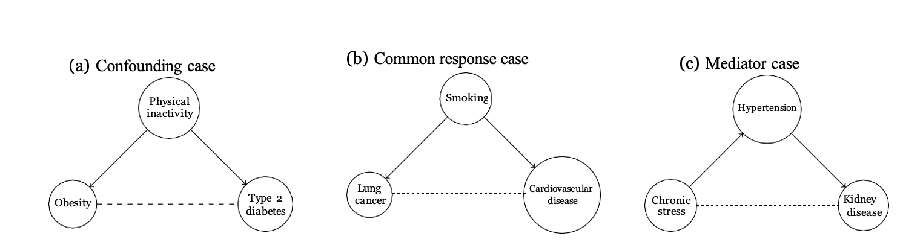
Figure A1: Diagrammatic representation of how the pair of variables can be correlated. The dashed line represents the observed correlation between variables. (a) The correlation between obesity and Type 2 diabetes is due to the confounding variable, physical inactivity. (b) The correlation between lung cancer and cardiovascular disease is due to the common response, smoking. (c) The correlation between chronic stress and kidney disease is through the mediator, hypertension.

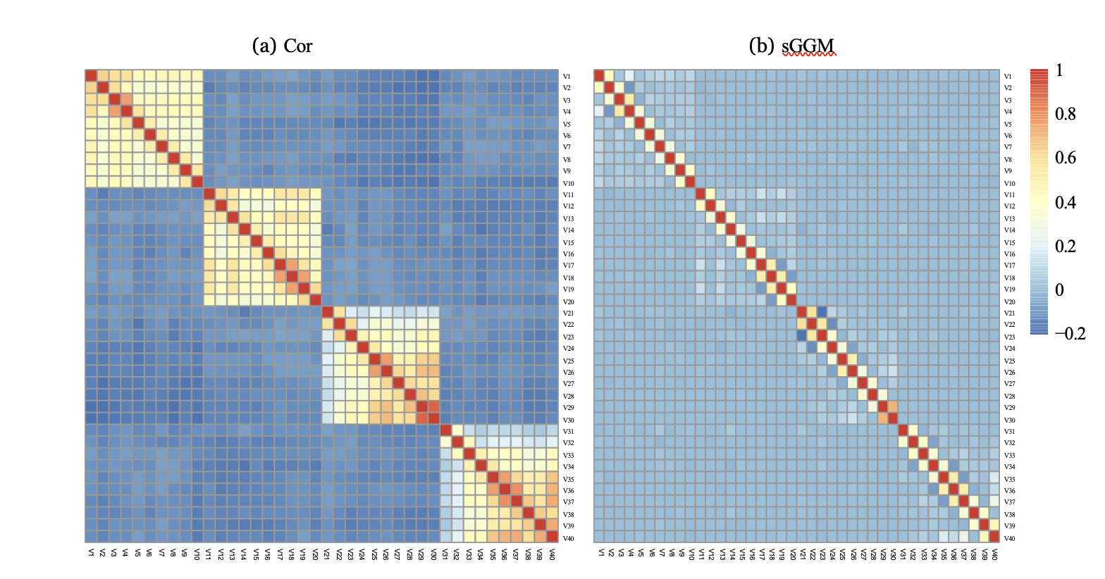
Figure A2: (a)The cluster structure identified from the correlation matrix (b) The cluster structure obtained from the sGGM.

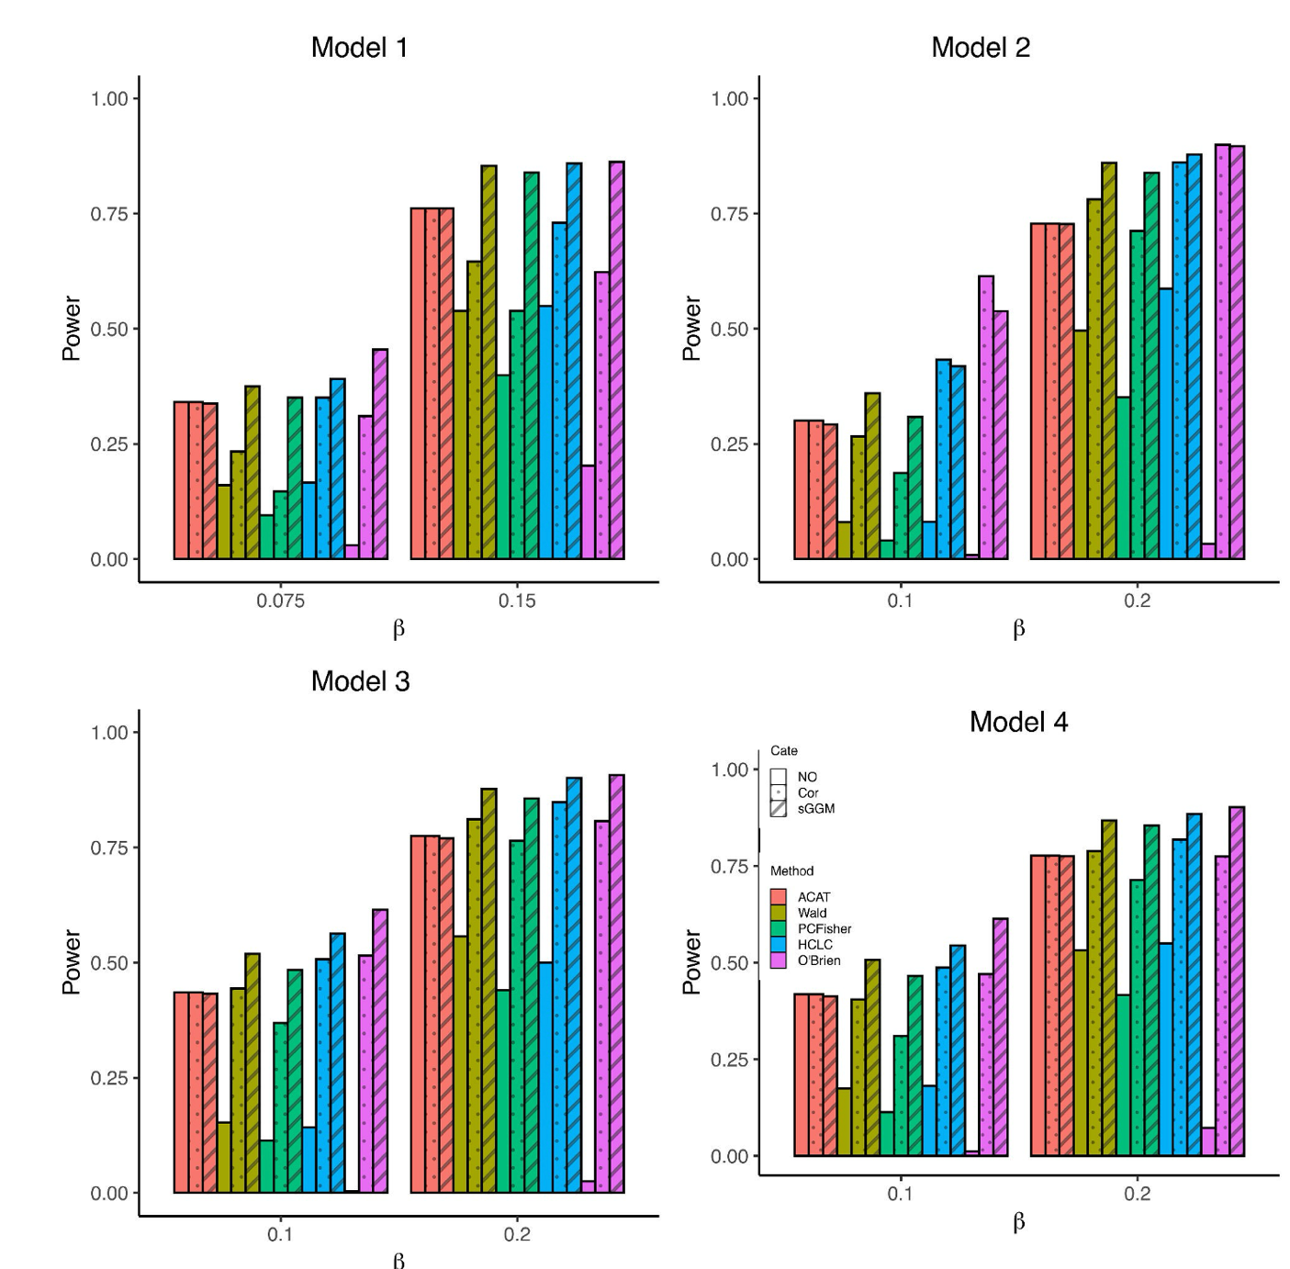
Figure A3: Power comparisons of the five multiple phenotype association tests as a function of effect size β under four models. The dataset consists of 60 mixture phenotypes (half continuous and half binary phenotypes with balanced case-control ratios) and a sample size of 4000. The power of each test is computed using 10 MC runs.

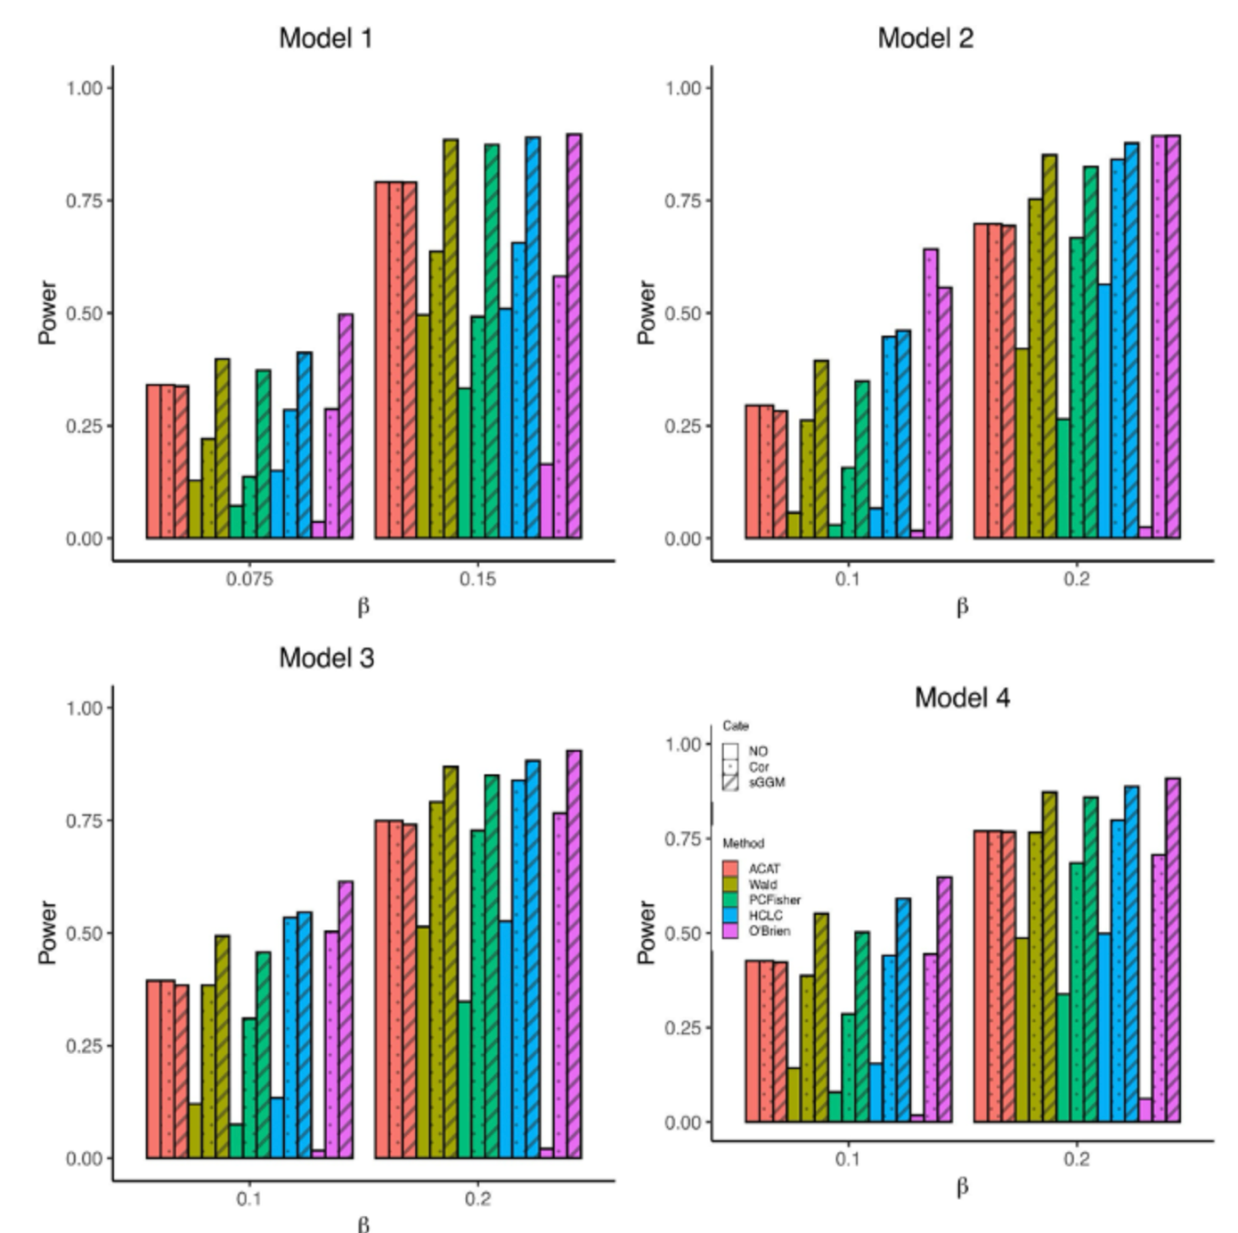
Figure A4: Power comparisons of the five multiple phenotype association tests as a function of effect size β under four models. The dataset consists of 80 mixture phenotypes (half continuous and half binary phenotypes with balanced case-control ratios) and a sample size of 4000. The power of each test is computed using 10 MC runs.

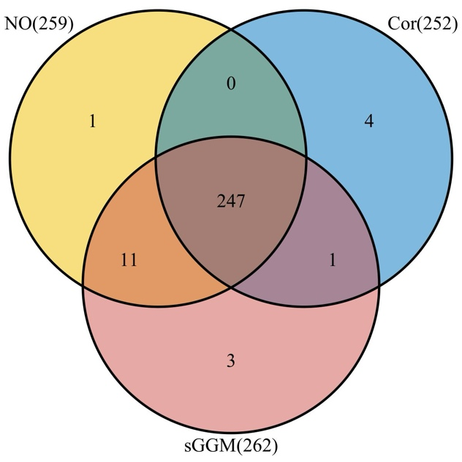

Figure A5: Comparison of the number of significant SNPs identified by ACAT without network modules, with network modules from correlation matrix, and network module obtained from sGGM. The number beside each category indicates the number of significant SNPs identified under the corresponding category.

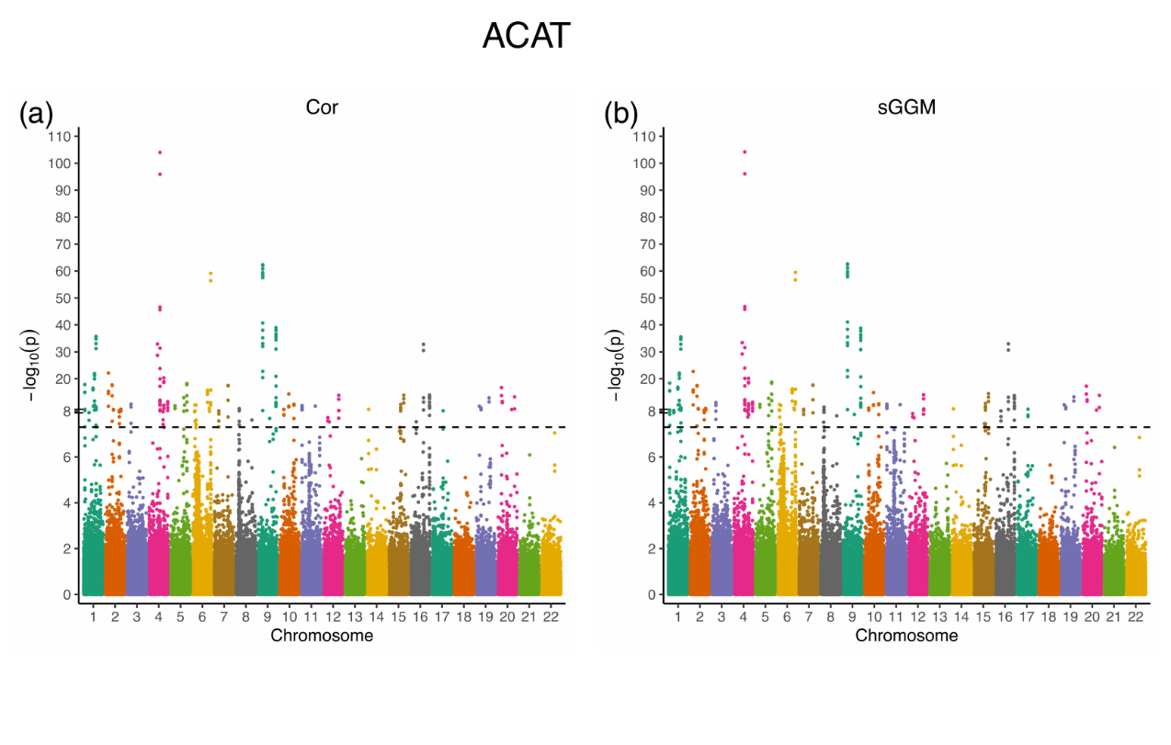
Figure A6: Comparison of the Manhattan plots of the p-values obtained from ACAT. The genomic position of the SNP is represented in the x-axis, and the transformed p-value, −log₁₀(p), is represented in the y-axis. (a) The Manhattan plot of ACAT using the network module from the correlation matrix. (b) The Manhattan plot of the ACAT using the network module from the sGGM.

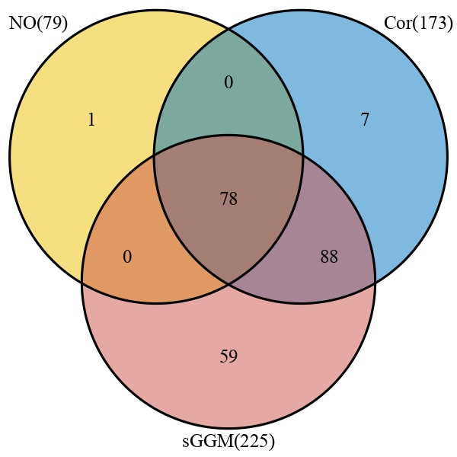
Figure A7: Comparison of the number of significant SNPs identified by Wald without network modules, with network modules from correlation matrix, and network module obtained from sGGM. The number beside each category indicates the number of significant SNPs identified under the corresponding category.

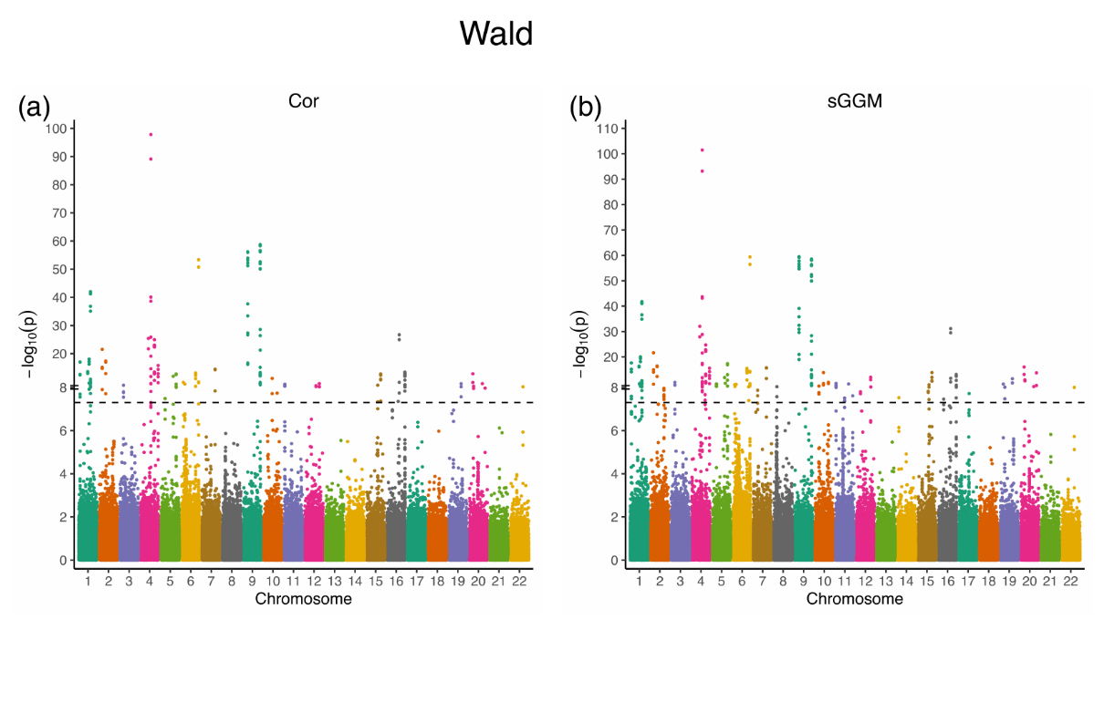
Figure A8: Comparison of the Manhattan plots of the p-values obtained from Wald. The genomic position of the SNP is represented in the x-axis, and the transformed p-value, −log₁₀(p), is represented in the y-axis. (a) The Manhattan plot of the Wald using the network module from the correlation matrix. (b) The Manhattan plot of Wald using the network module from the sGGM.

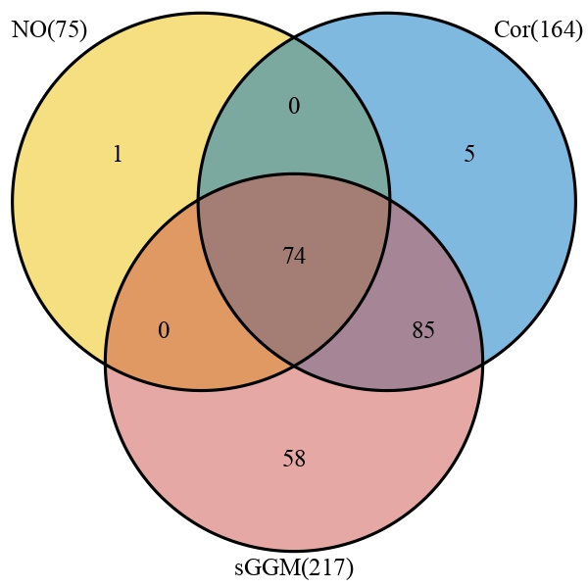
Figure A9: Comparison of the number of significant SNPs identified by PCFisher without network modules, with network modules from correlation matrix, and network module obtained from sGGM. The number beside each category indicates the number of significant SNPs identified under the corresponding category.

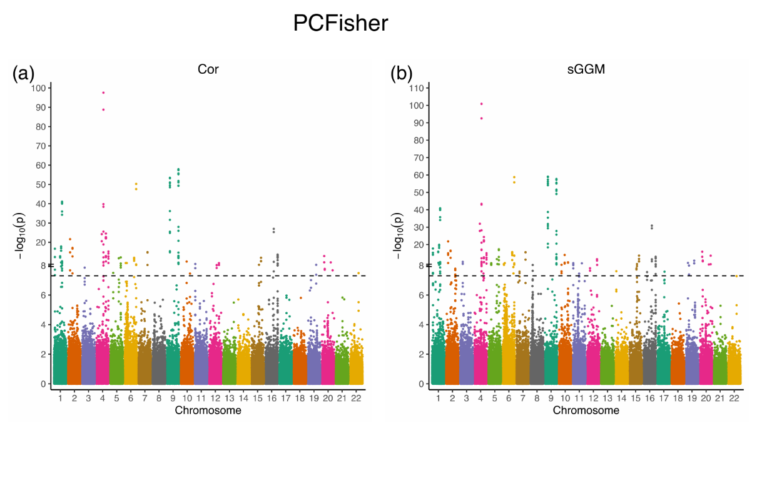
Figure A10: Comparison of the Manhattan plots of the p-values obtained from PCFisher. The genomic position of the SNP is represented in the x-axis, and the transformed p-value, −log₁₀(p), is represented in the y- axis. (a) The Manhattan plot of the PCFisher using the network module from the correlation matrix. (b) The Manhattan plot of the PCFisher using the network module from the sGGM.
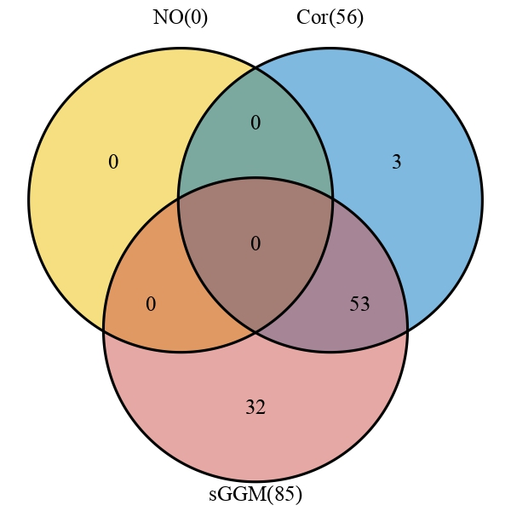
Figure A11: Comparison of the number of significant SNPs identified by O’Brien without network modules, with network modules from correlation matrix, and network module obtained from sGGM. The number beside each category indicates the number of significant SNPs identified under the corresponding category.

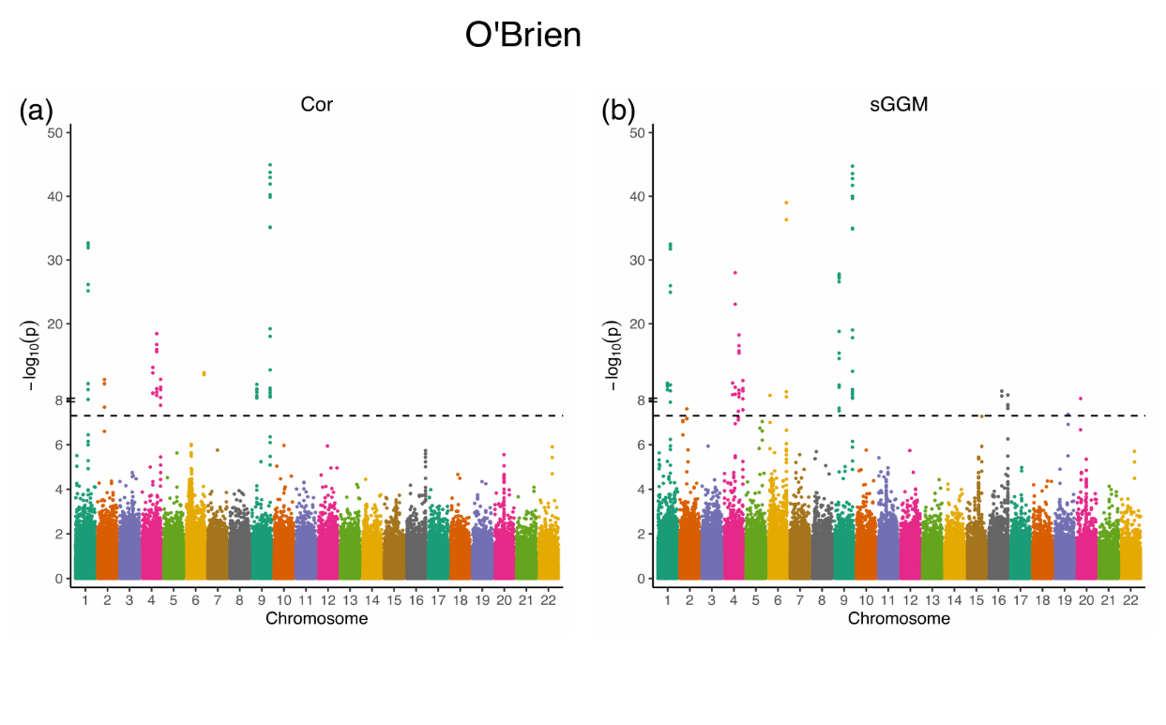
Figure A12: Comparison of the Manhattan plots of the p-values obtained from the O’Brien. The genomic position of the SNP is represented in the x-axis, and the transformed p-value, −log₁₀(p), is represented in the y-axis. (a) The Manhattan plot of the O’Brien using the network module from the correlation matrix. (b) The Manhattan plot of the O’Brien using the network module from the sGGM.

