Supplementary Material

Figure A1
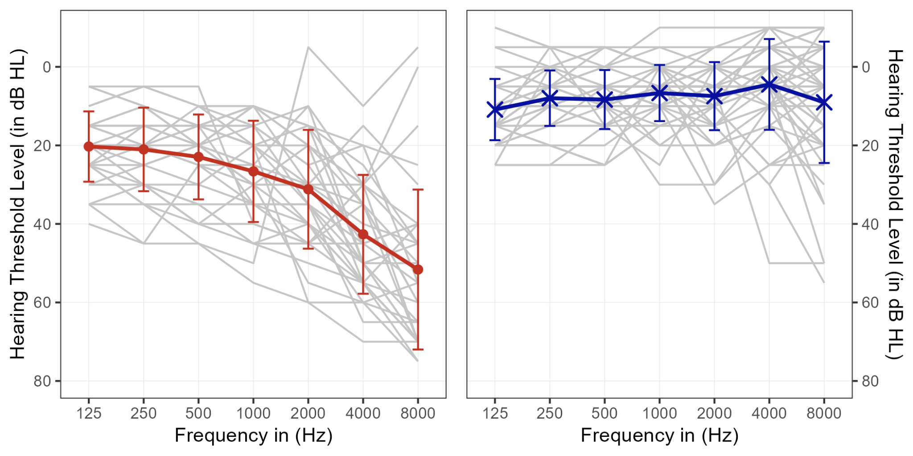Figure A1. Pure-tone audiometric thresholds (PTA) for all participants' better listening ear. Thresholds for individuals with hearing impairment are plotted on the left (red) and for those with normal hearing on the right (blue). A standard clinical ascending-descending procedure in 5 dB HL steps was used. Participants were classified as hearing-impaired if their better ear PTA exceeded 20 dB HL across all frequency bins. The grey lines represent individual participants' thresholds. The bold lines (along SD as error bars) represent the average PTA for each listening group.

Table A1
Hearing aid use and listening conditions
 |  |  |  |  | Hearing aids
ID | Age | Gender |  | Usage² | Hours³ | Years⁴ | Ear noise⁵ | dB adjustment⁶
V2 | 80 | Female |  | Yes | 10 bis 12 | 4 | Yes
V4 | 58 | Female |  | Yes | 18 | 11 | No | -7
V9 | 81 | Female |  | No | -¹ | - | No | -7
V10 | 70 | Male |  | Yes | - | 6 | No | +5
V13 | 59 | Male |  | Yes | 10-13 | 4 | Yes
V15 | 73 | Male |  | Yes | 6 | < 1 | No | +4
V16 | 65 | Male |  | Yes | 14 | 6 | Yes
V17 | 82 | Male |  | Yes | always | 4 | No
V22 | 67 | Male |  | Yes | 12 | 6 | Yes
V30 | 23 | Female |  | No | - | - | No | -5
V33 | 32 | Male |  | No | - | - | No | -6
V41 | 68 | Female |  | Yes | 8 | 6 | Yes
V73 | 75 | Female |  | Yes | 3 | 4 | No | -7
V76 | 67 | Male |  | Yes | 5 bis 10 | 3 | Yes
V77 | 66 | Male |  | Yes | 10 | 8 | No
V80 | 65 | Male |  | Yes | 20 | 9 | Yes
V82 | 66 | Male |  | Yes | 16 | 12 | Yes
V83 | 53 | Female |  | Yes | always | 1,5 | No
V85 | 64 | Male |  | Yes | 14 | 1 | Don’t know
V86 | 67 | Male |  | Yes | 16 | 4 | No
V89 | 52 | Male |  | Yes | 17 | 3 | No
V90 | 69 | Female |  | Yes | 13 | 3 | No
Note. ¹no response were provided; ²Do you normally wear hearing aids?; ³How many hours a day do you wear your hearing aid(s); ⁴How many years have you been wearing a hearing aid?; ⁵Do you suffer from ringing in the ears / tinnitus / ringing in the ears?; ⁶relative to the standard to 75 dB SPL (A) presentation level. The remaining participants (not listed here) provided no additional comments.

