Supplemental Figure 1. Comparison of SNP x DEPR effects at novel and known loci identified in dDEPR analyses between dDEPR and qDEPR models
dDEPR | qDEPR
1q31.3 (rs1664073690)
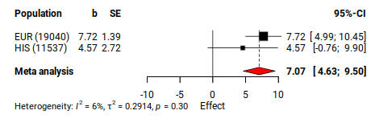 | 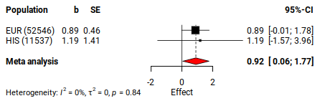
2q13.3 (rs10178576)
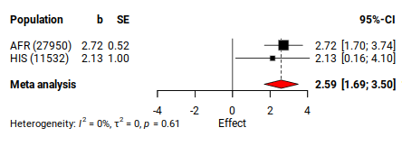 | 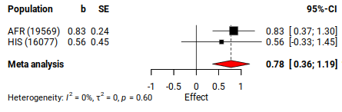
3p22.1 (rs115760284)
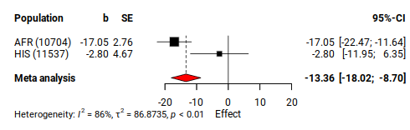 | 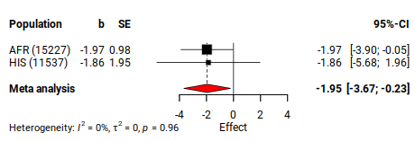
4q35.1 (rs113521945)
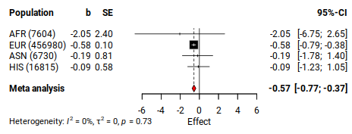 | 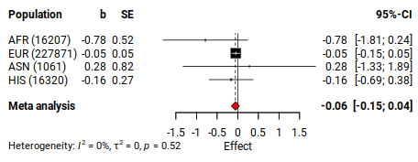
7q21.11 (rs147967138)
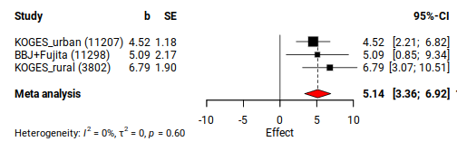 | 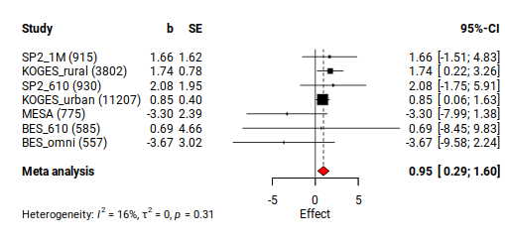
7q31.1 (rs757194)
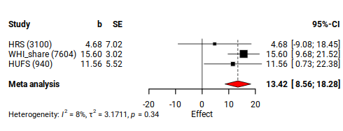 | 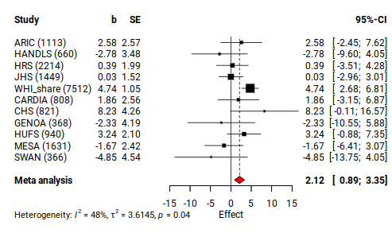
12p12.1 (rs7979305)
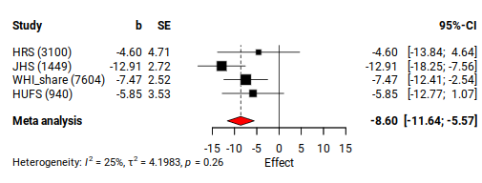 | 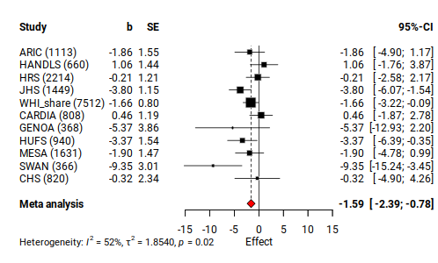
13q32.1 (rs75095906)
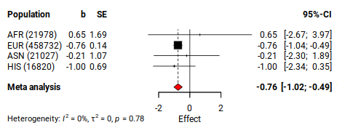 | 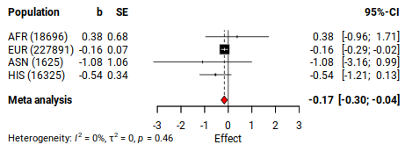
16q23.2 (rs9931605)
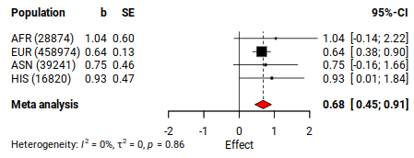 | 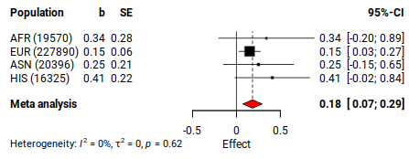

Supplemental Figure 2. Comparison of SNP x DEPR effects at novel and known loci identified in qDEPR analyses between dDEPR and qDEPR models
dDEPR | qDEPR
2q14.2 (rs77572777)
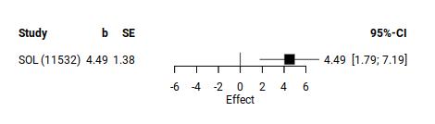 | 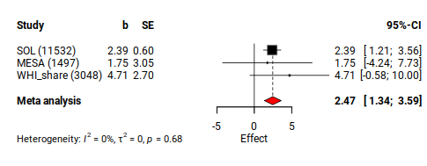
3p26.3 (rs148780833)
Not available | 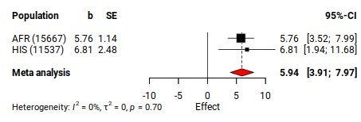
3p25.3 (rs59284269)
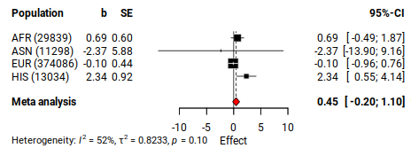 | 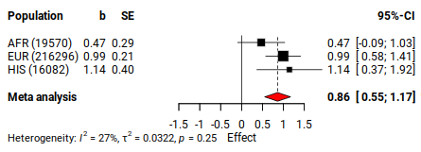
3q13.11 (rs748650739)
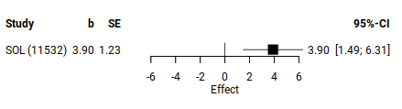 | 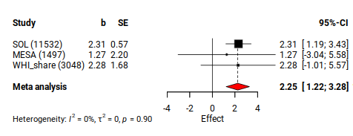
4p14 (rs145132348)
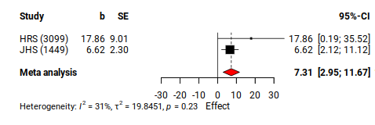 | 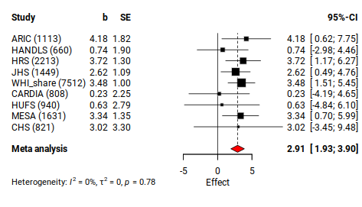
12q13.13 (rs114544309)
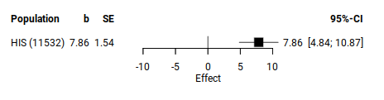 | 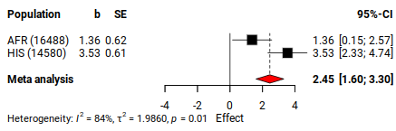
17p13.3 (rs140618249)
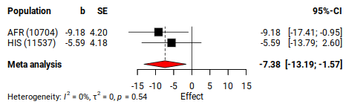 | 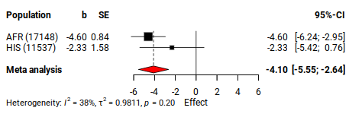

Supplemental Figure 3. Number of SNPs in dDEPR (D) and qDEPR (Q) analyses across three BP traits in population-specific and cross-population meta-analyses (CPMA)
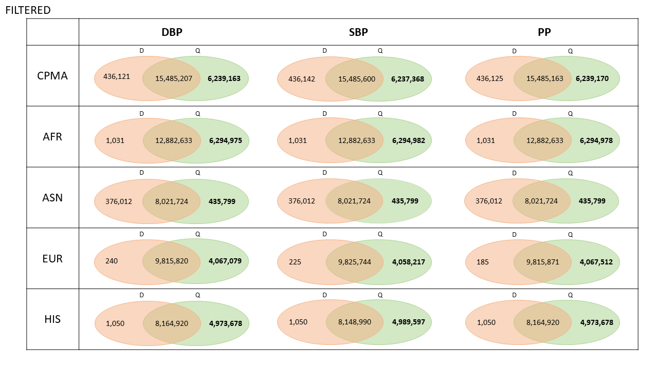
Supplemental Figure 4. Enrichment of the prioritized genes mapped to novel and known BP loci in differentially expressed genes (DEG) sets from GTEx v8 54 tissue types
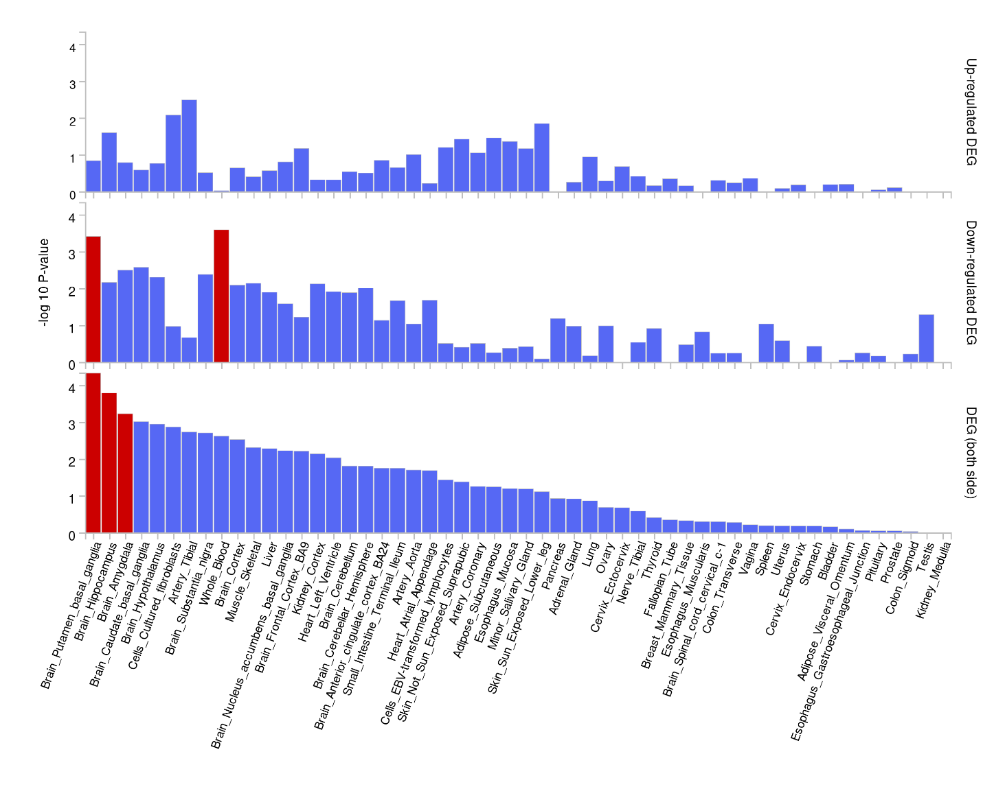

Supplemental Figure 5. Manhattan and QQ plots for the 2df joint and 1df interaction P-values in cross-population dDEPR analyses. (Green: known, Blue: novel)
2df joint P-value
DBP | 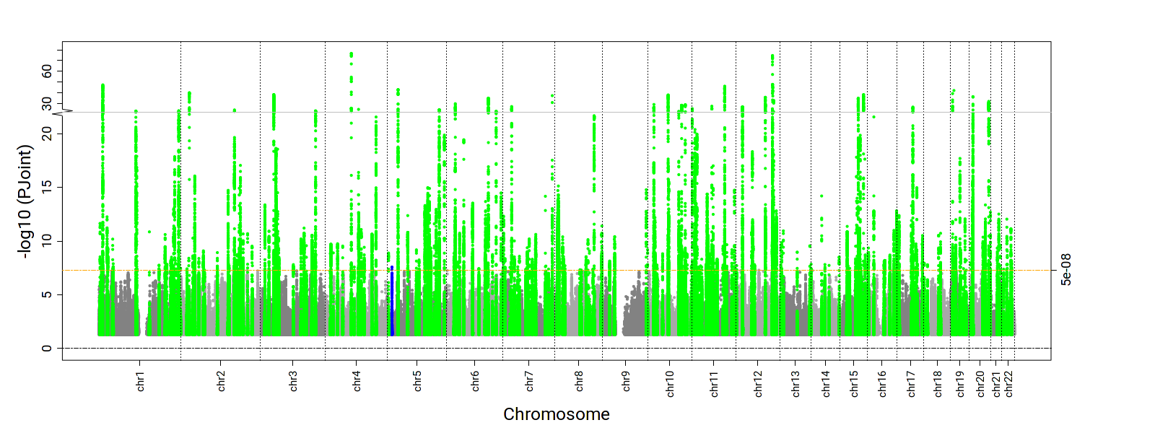 | 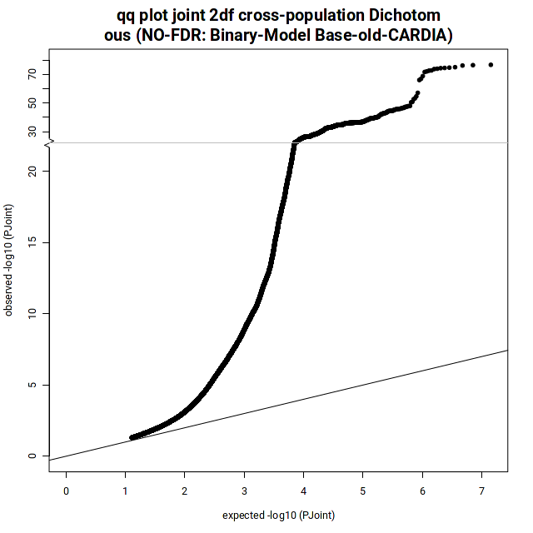  λ = 1.12  Ffdfdsfdsλsffdsfdfkl;jjkfldsfds
SBP | 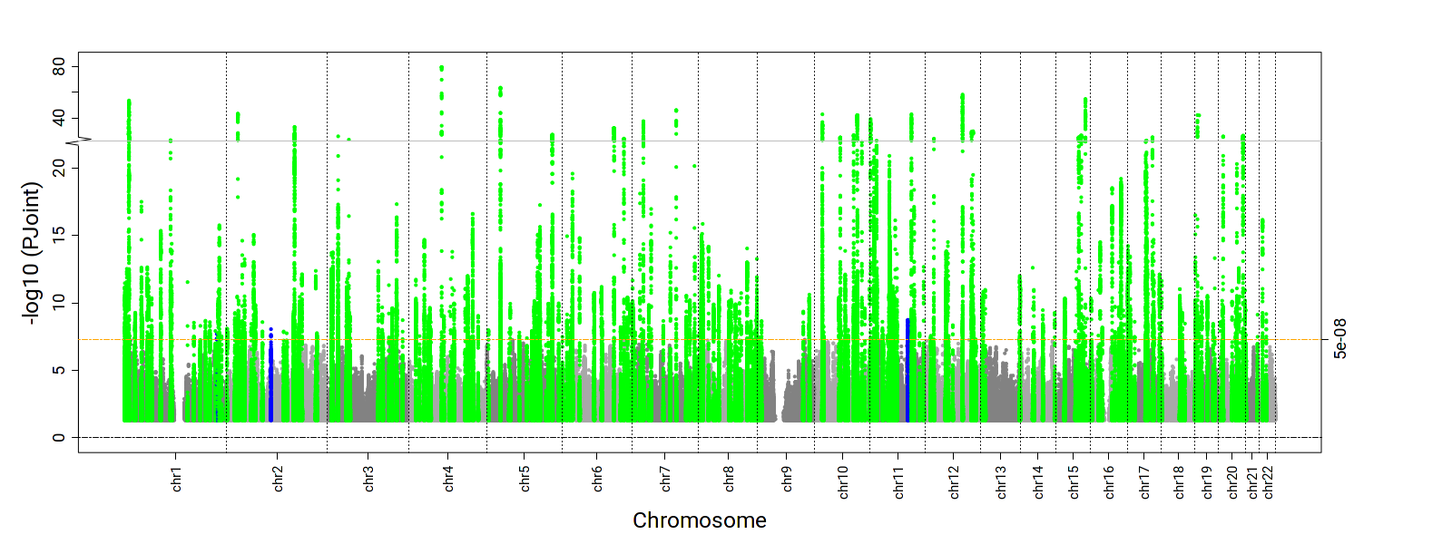 | 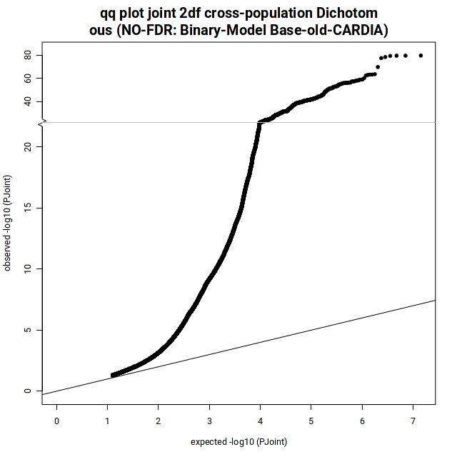  λ = 1.13
PP | 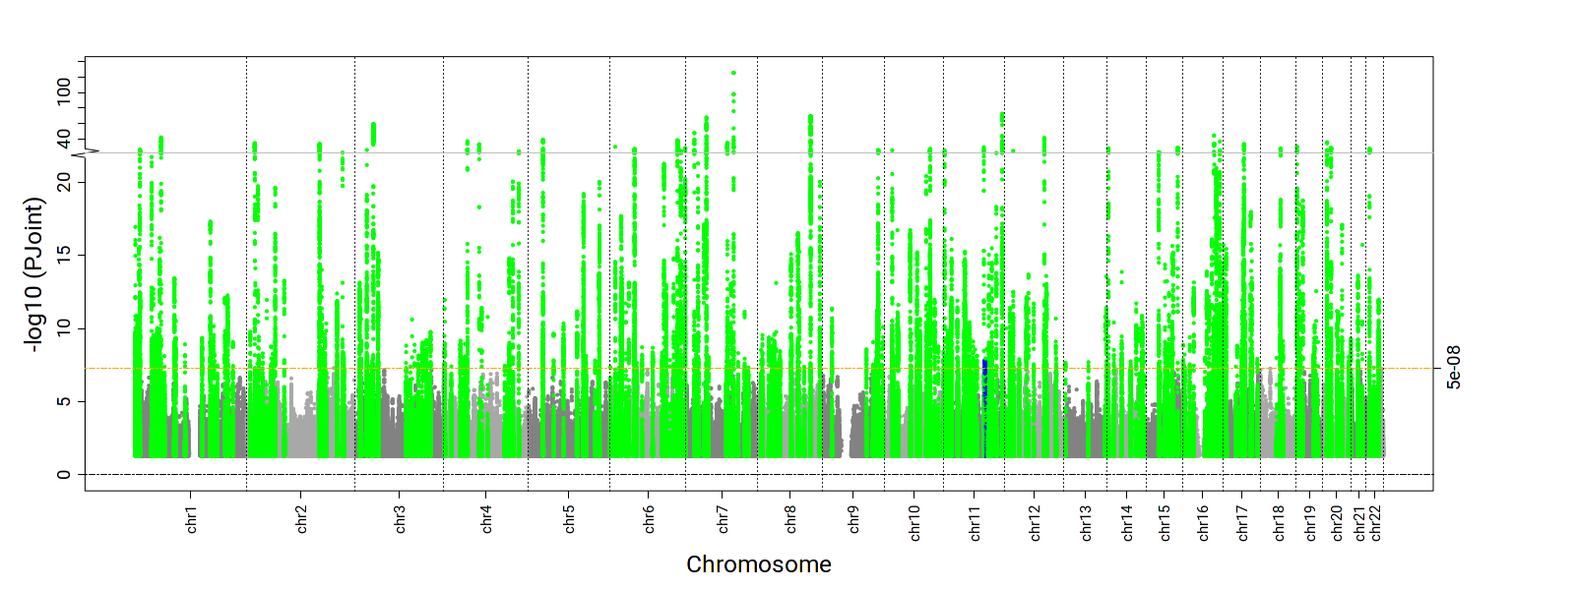 | 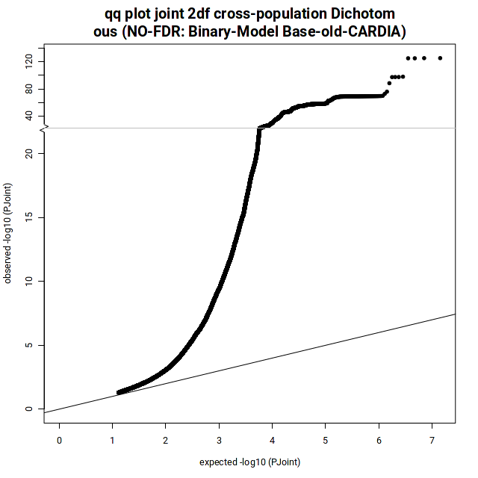  λ = 1.12
1df Interaction P-value
DBP | 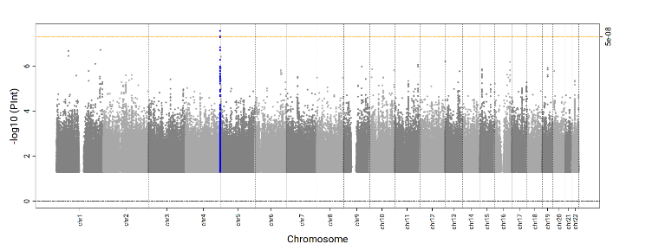 | 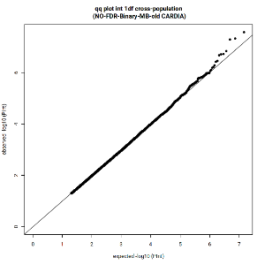  λ = 0.99
SBP | 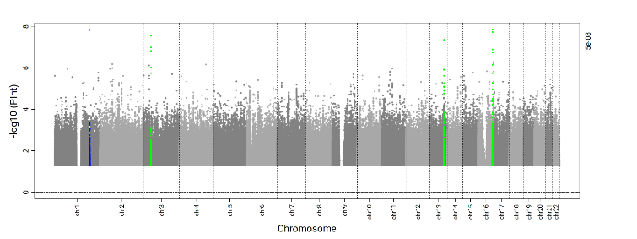 | 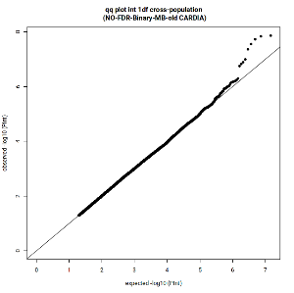  λ = 1.00
PP | 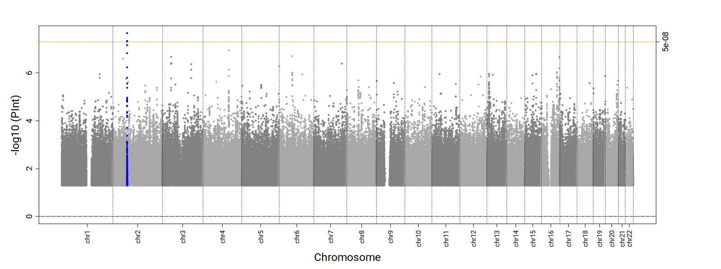 | 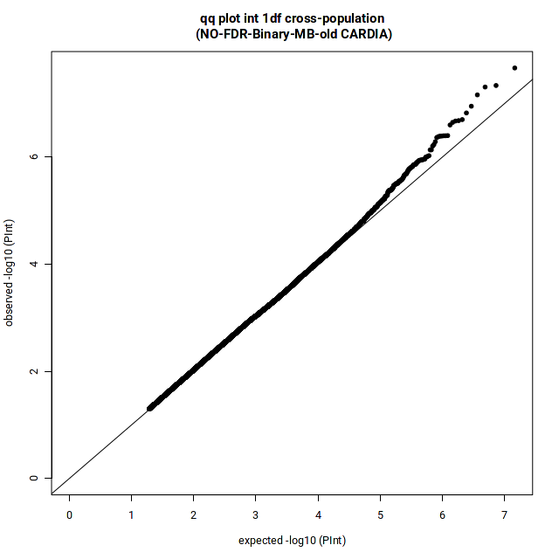  λ = 1.01
Supplemental Figure 6. Manhattan and QQ plots for the 2df joint and 1df interaction P-values in EUR-specific dDEPR analyses. (Green: known, Blue: novel)
2df joint P-value
DBP | 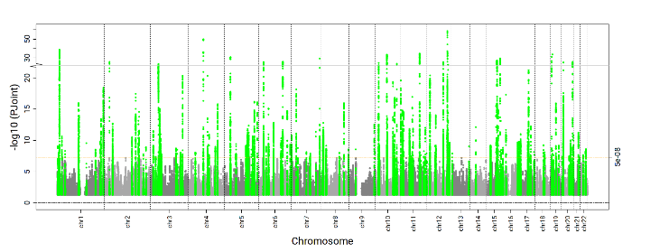 | 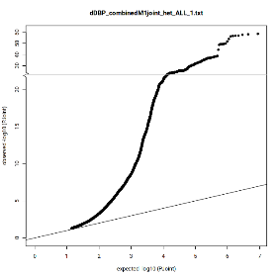  λ = 1.28  Ffdfdsfdsλsffdsfdfkl;jjkfldsfds
SBP | 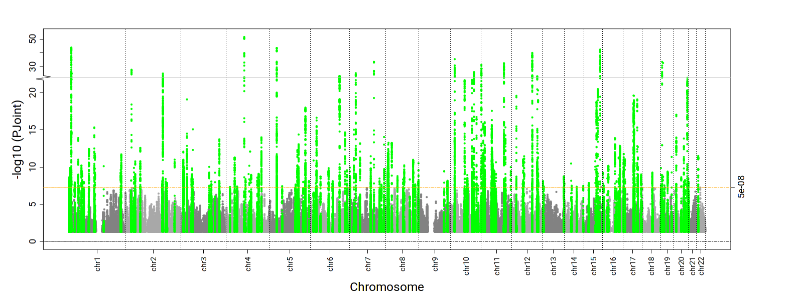 | 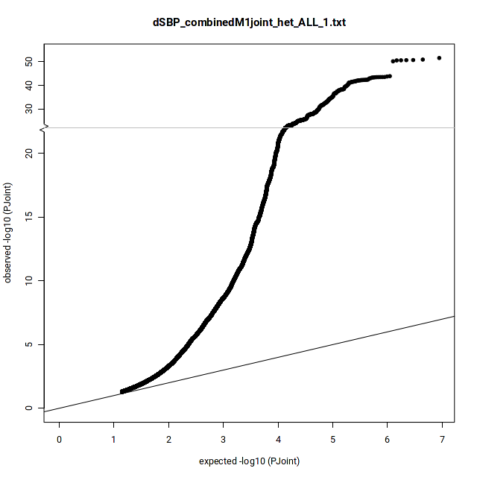  λ = 1.28
PP | 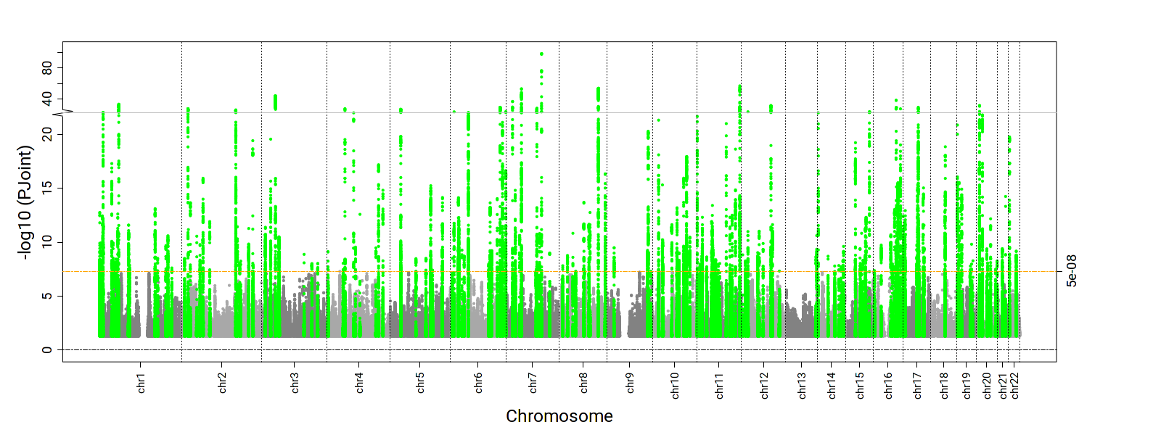 | 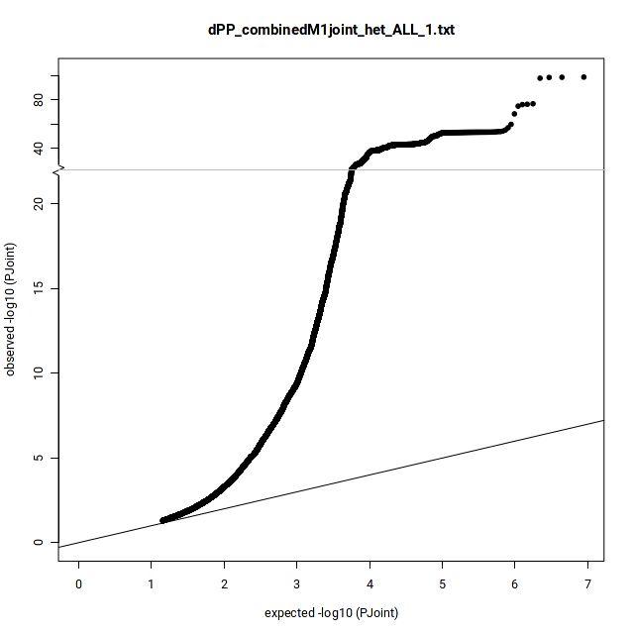  λ = 1.27
1df Interaction P-value
DBP | 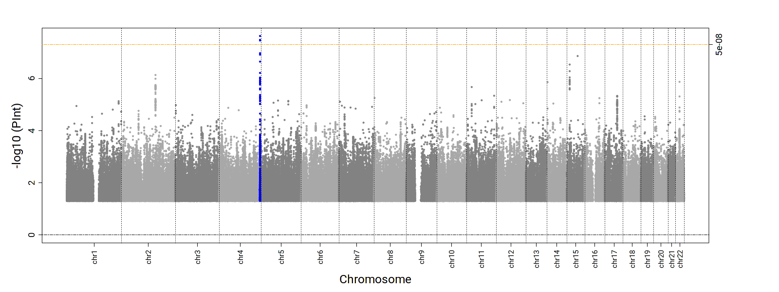 | 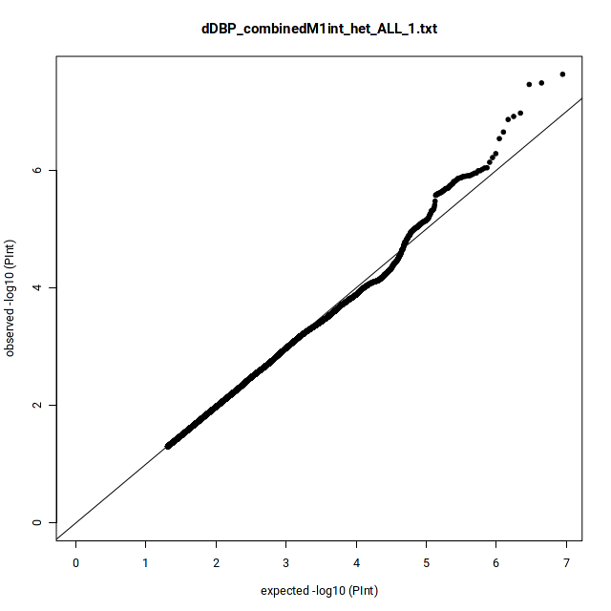  λ = 1.00
SBP | 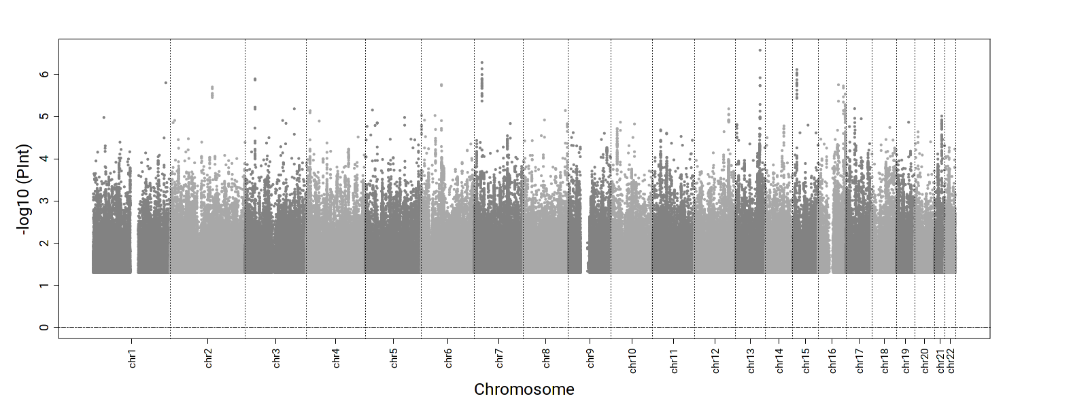 | 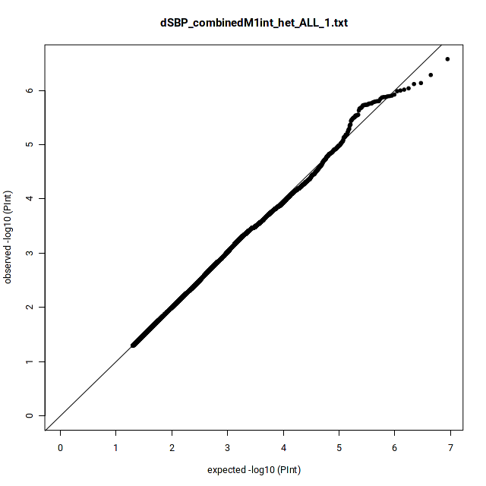  λ = 1.00
PP | 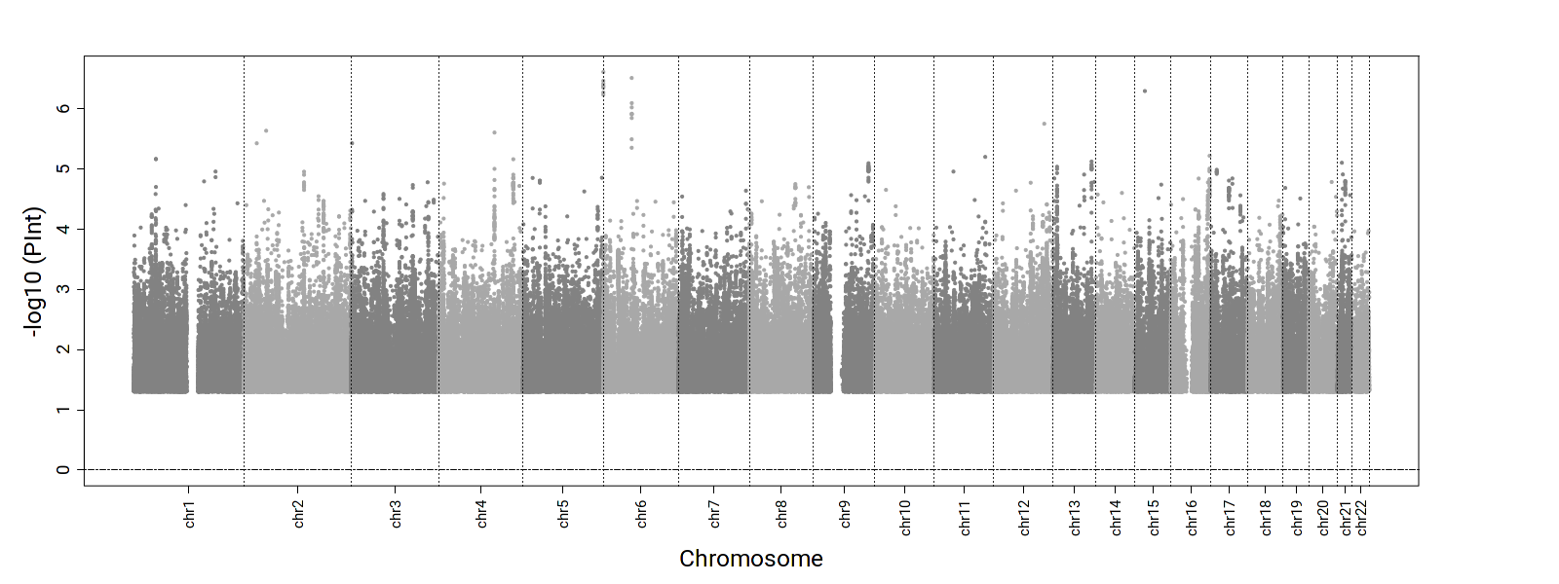 | 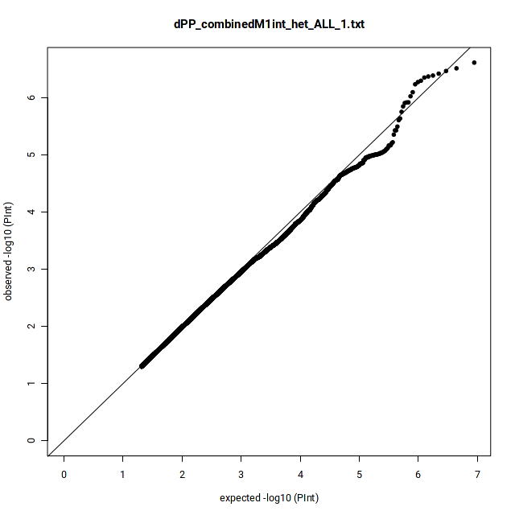  λ = 0.98
Supplemental Figure 7. Manhattan and QQ plots for the 2df joint and 1df interaction P-values in AFR-specific dDEPR analyses. (Green: known, Blue: novel)
2df joint P-value
DBP | 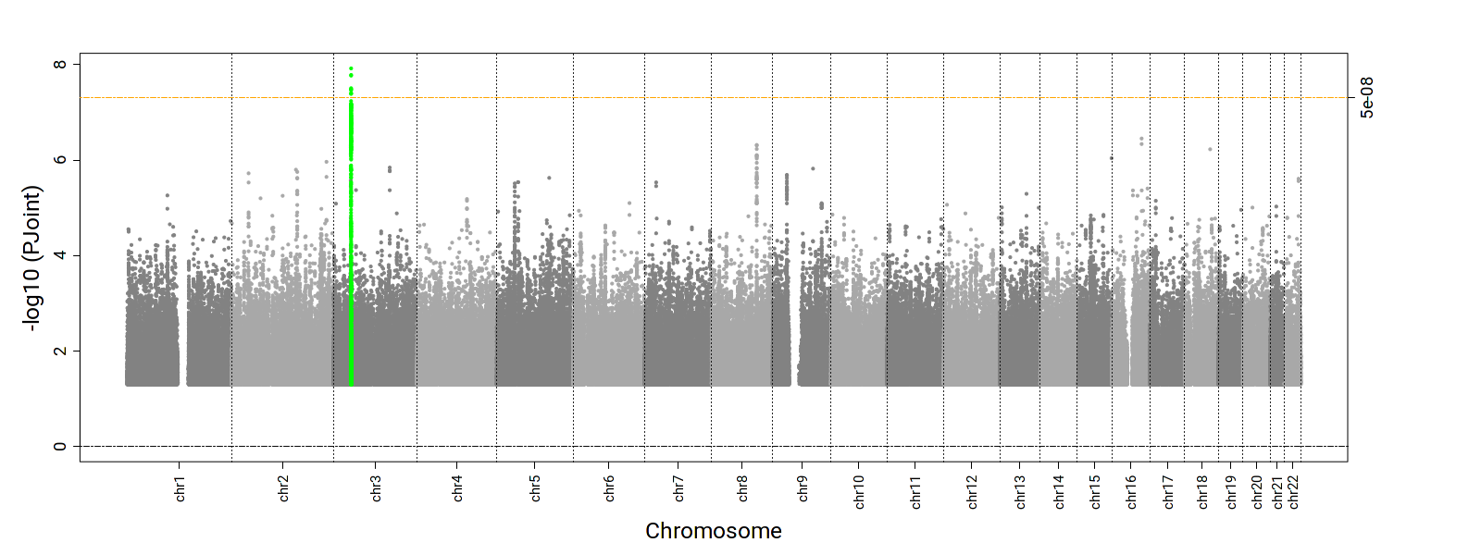 | 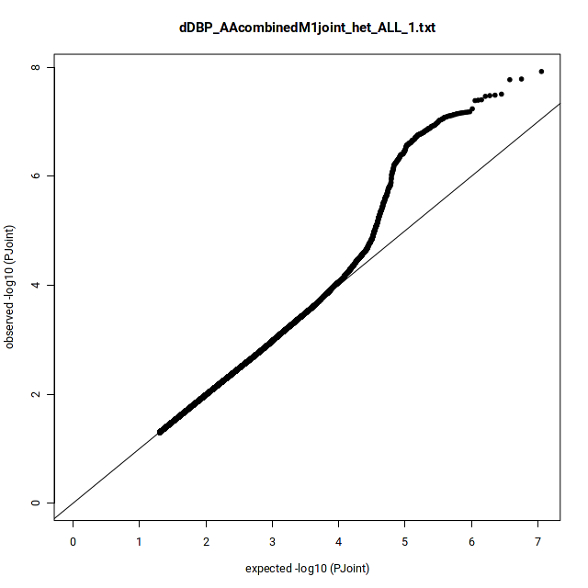  λ = 1.03  Ffdfdsfdsλsffdsfdfkl;jjkfldsfds
SBP | 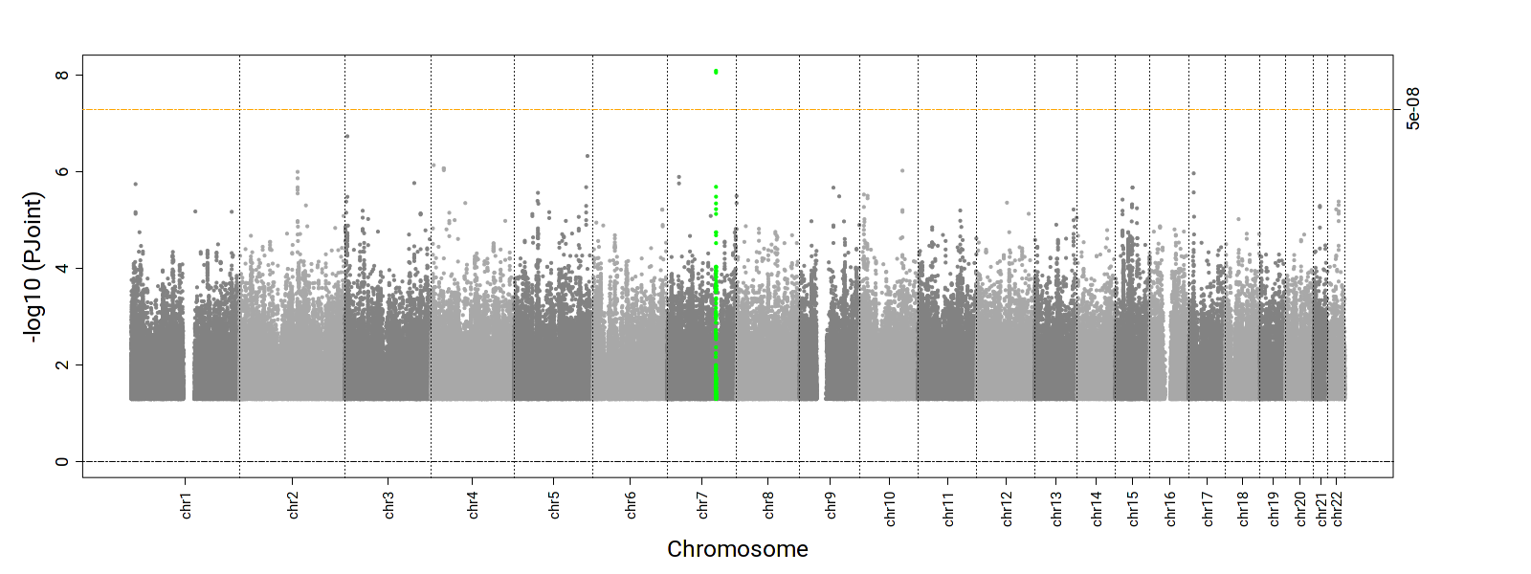 | 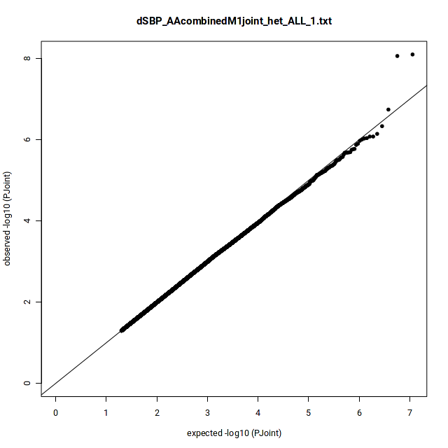  λ = 1.01
PP | 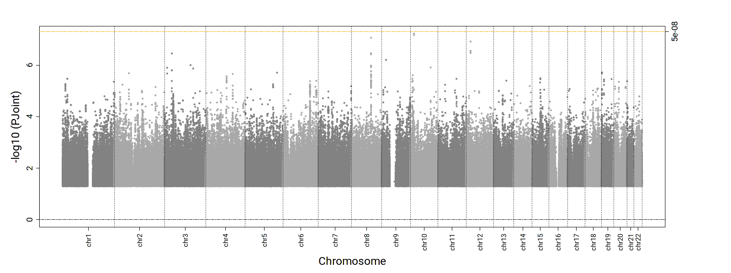 | 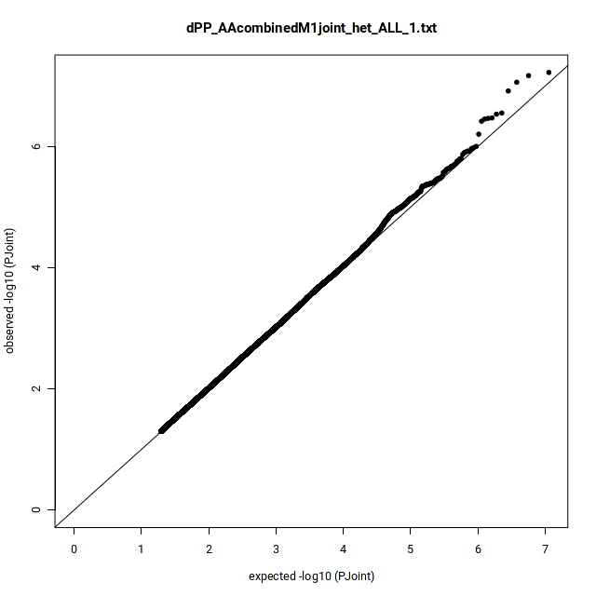  λ = 1.03
1df Interaction P-value
DBP | 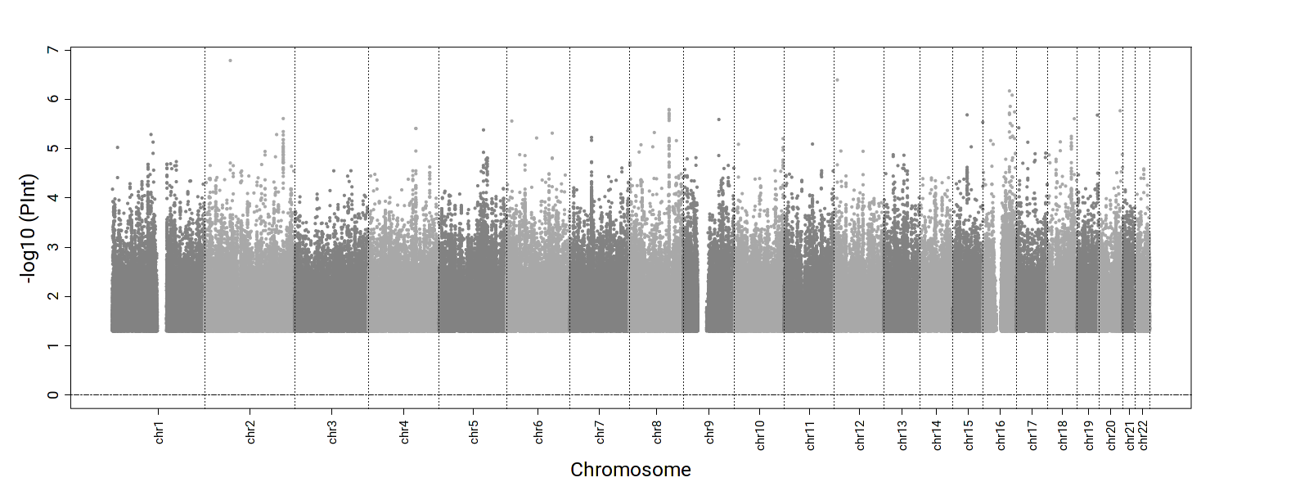 | 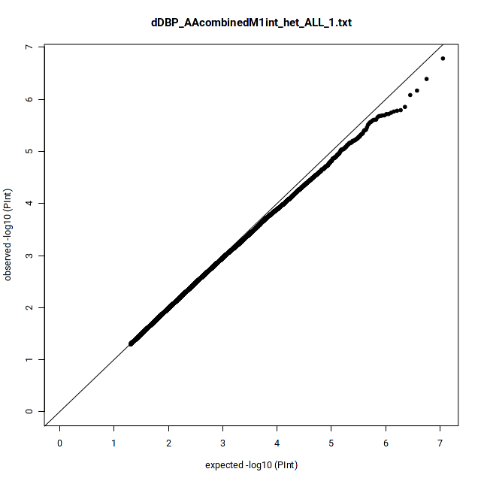  λ = 0.99
SBP | 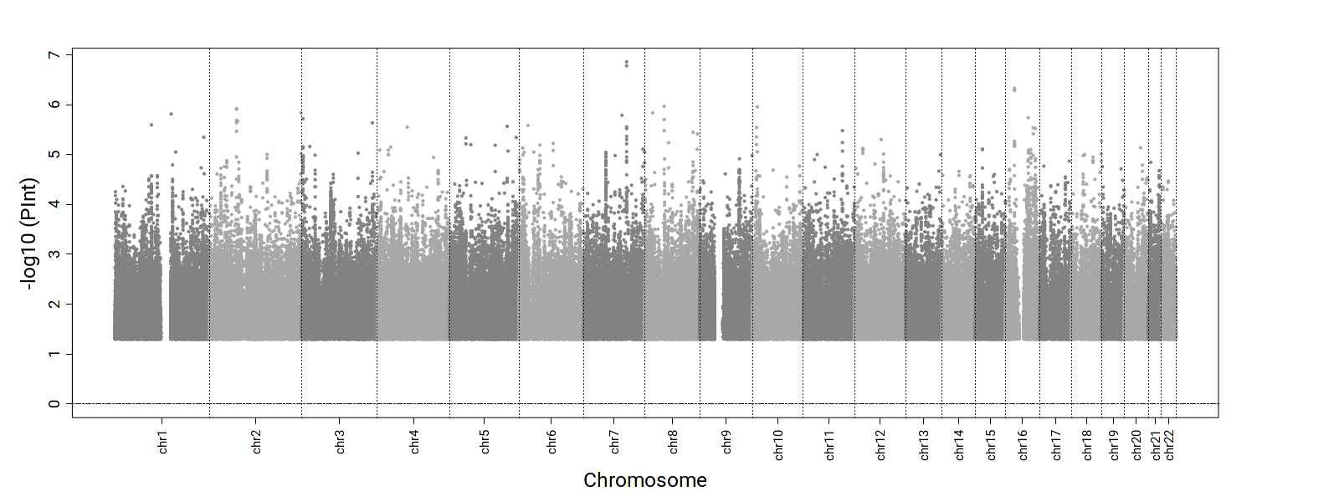 | 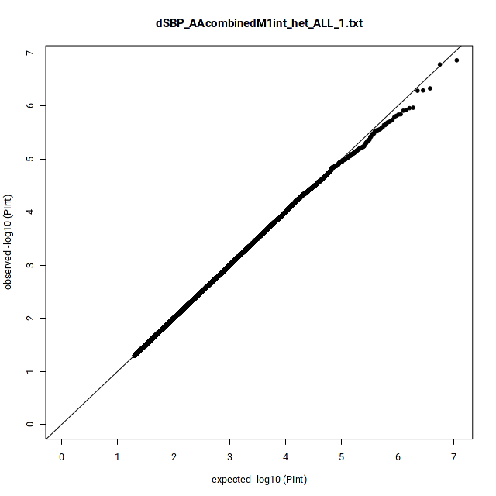  λ = 1.00
PP | 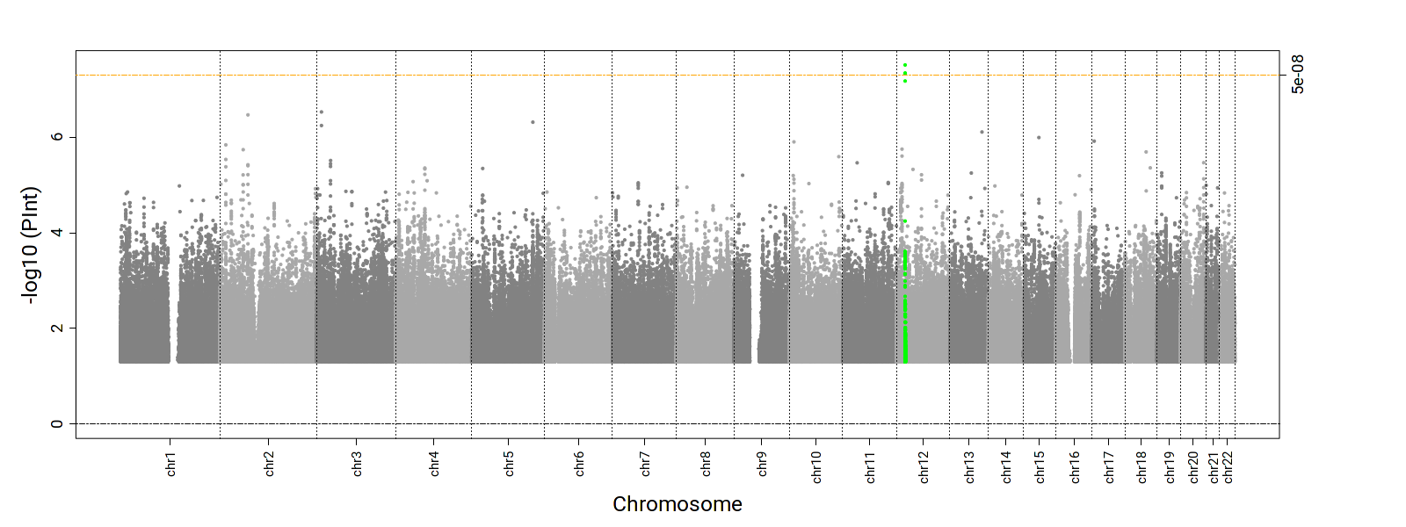 | 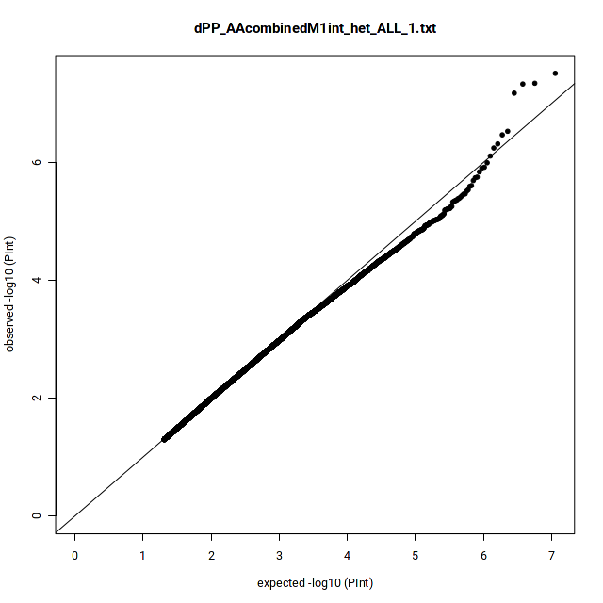  λ = 0.98
Supplemental Figure 8. Manhattan and QQ plots for the 2df joint and 1df interaction P-values in ASN-specific dDEPR analyses. (Green: known, Blue: novel)
2df joint P-value
DBP | 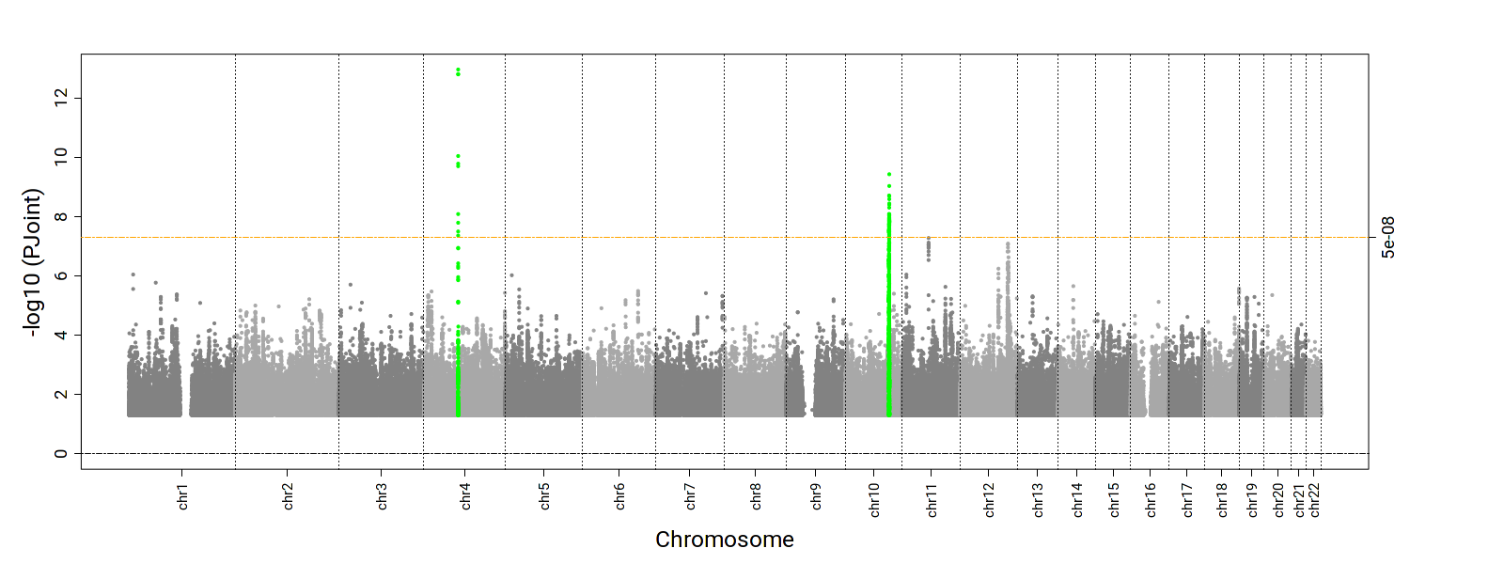 | 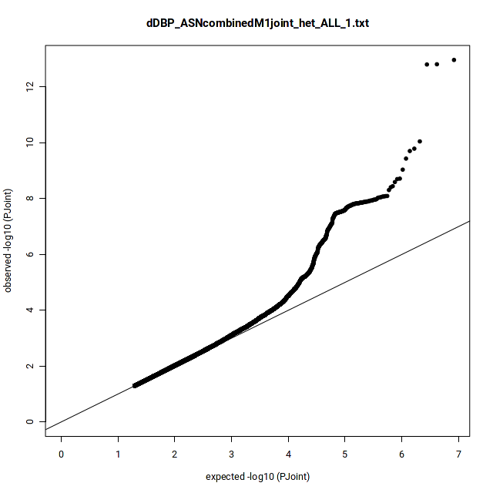  λ = 1.03  Ffdfdsfdsλsffdsfdfkl;jjkfldsfds
SBP | 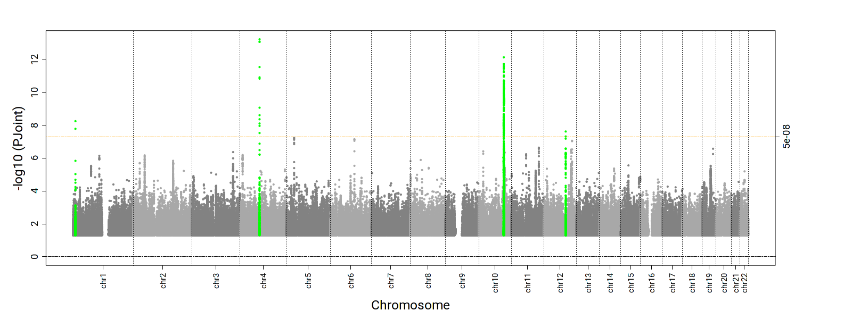 | 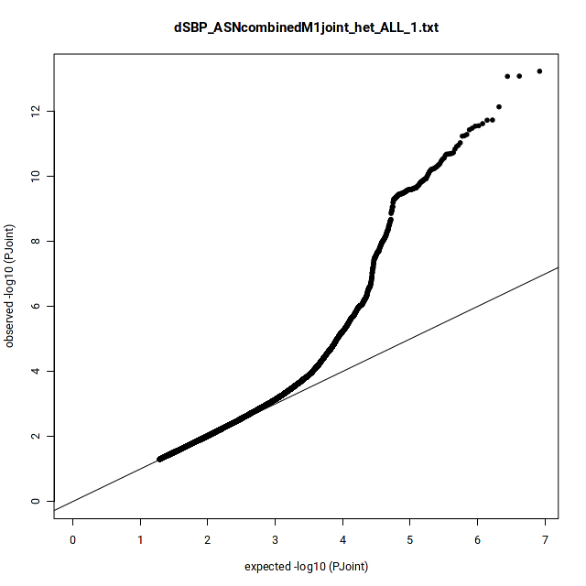  λ = 1.01
PP | 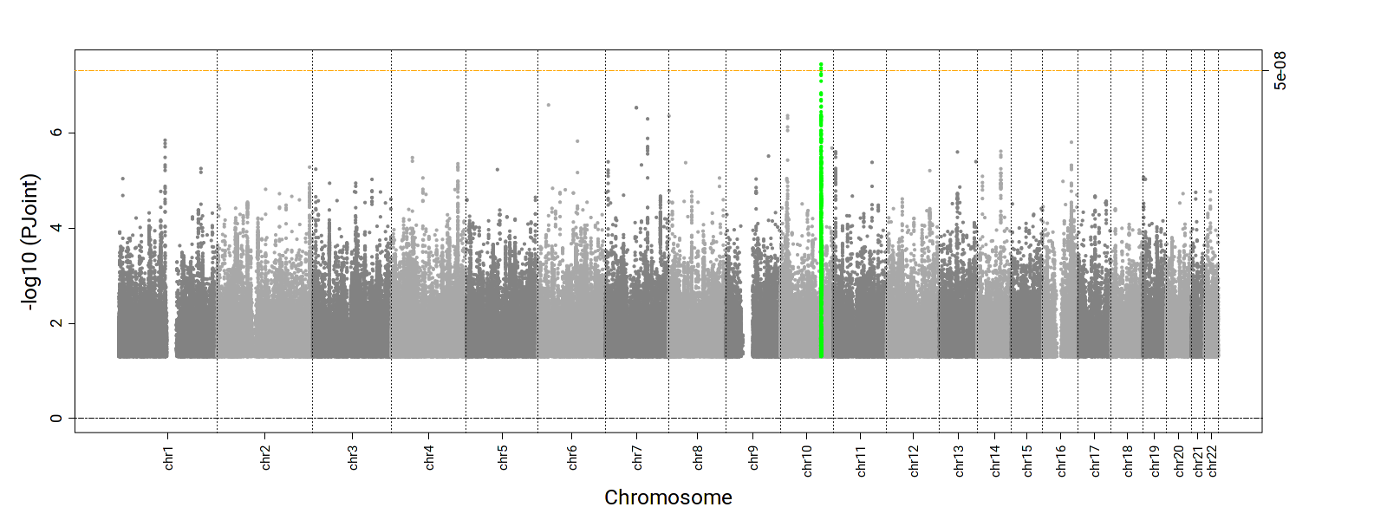 | 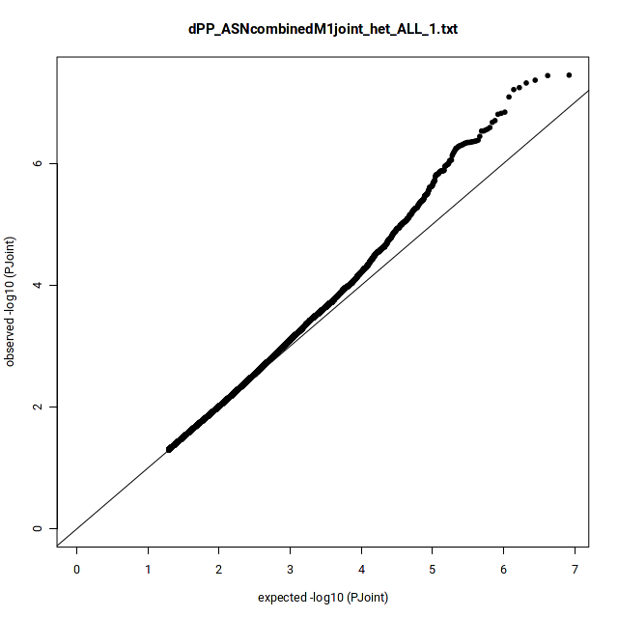  λ = 1.03
1df Interaction P-value
DBP | 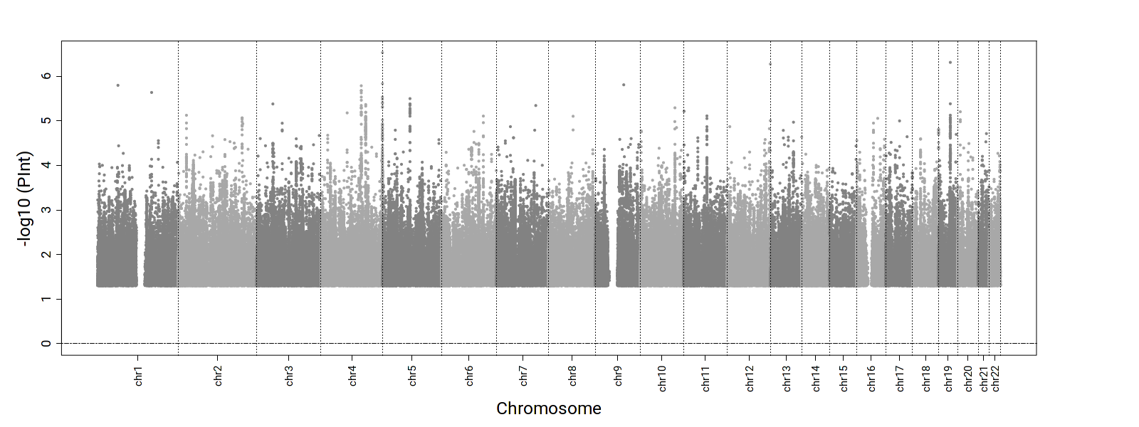 | 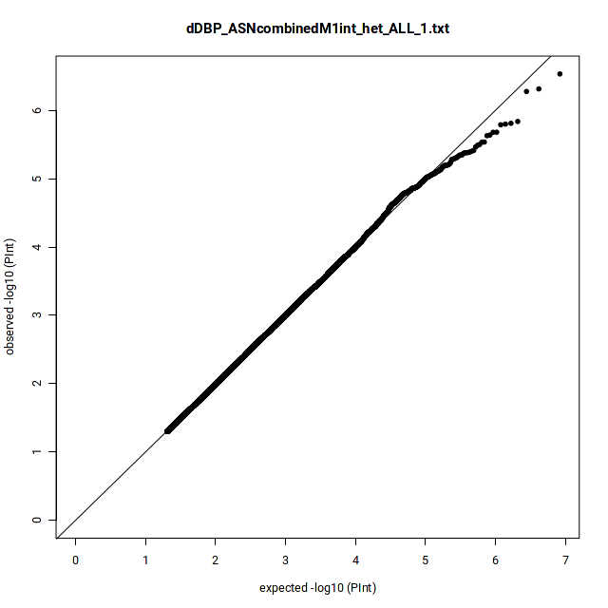  λ = 1.03
SBP | 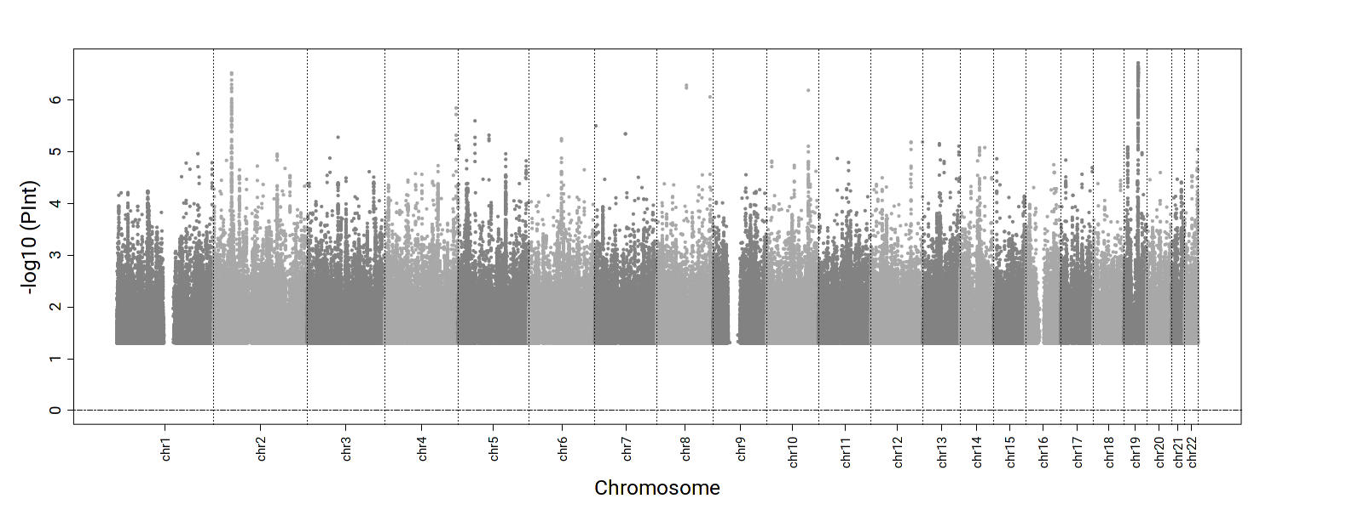 | 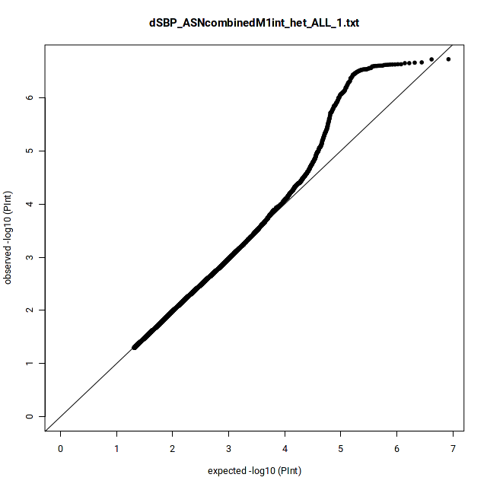  λ = 1.02
PP | 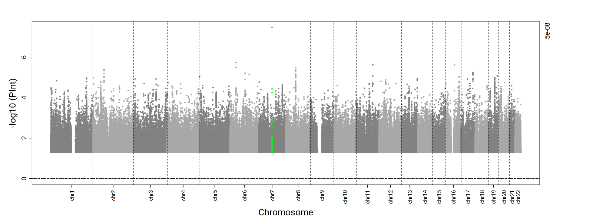 | 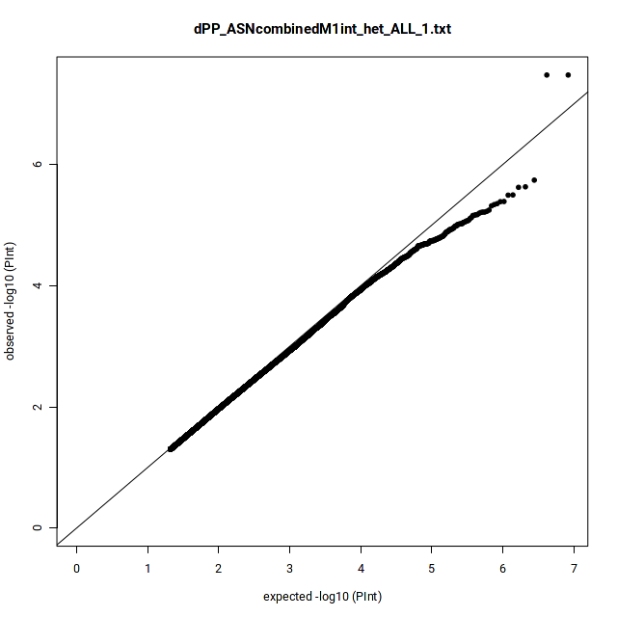  λ = 1.01
Supplemental Figure 9. Manhattan and QQ plots for the 2df joint and 1df interaction P-values in HIS-specific dDEPR analyses. (Green: known, Blue: novel)
2df joint P-value
DBP | 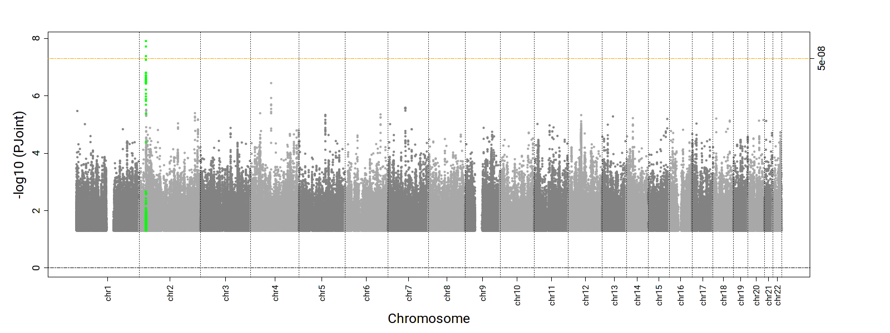 | 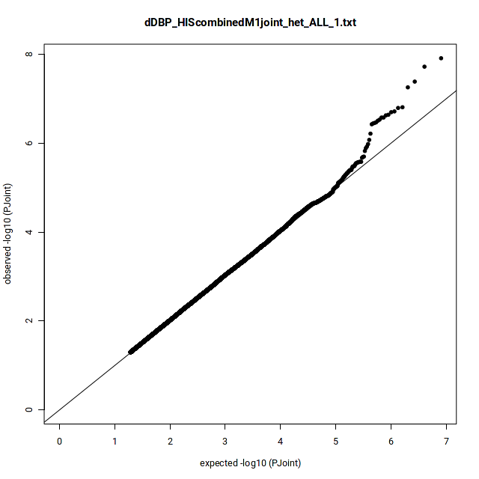  λ = 1.01  Ffdfdsfdsλsffdsfdfkl;jjkfldsfds
SBP | 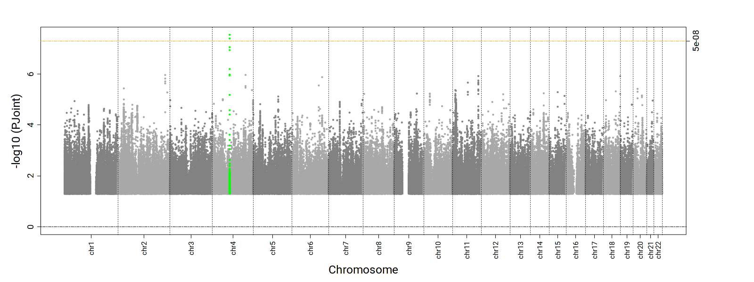 | 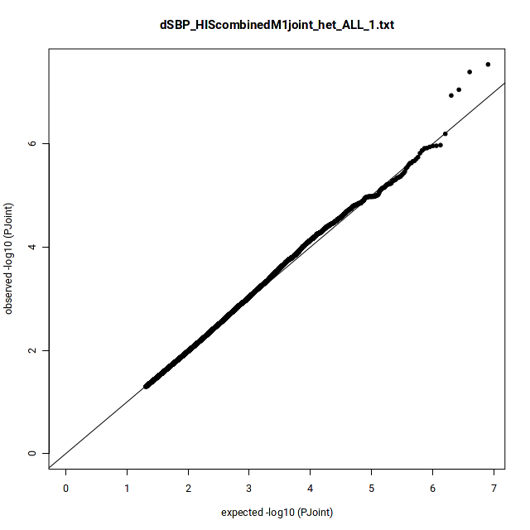  λ = 0.97
PP | 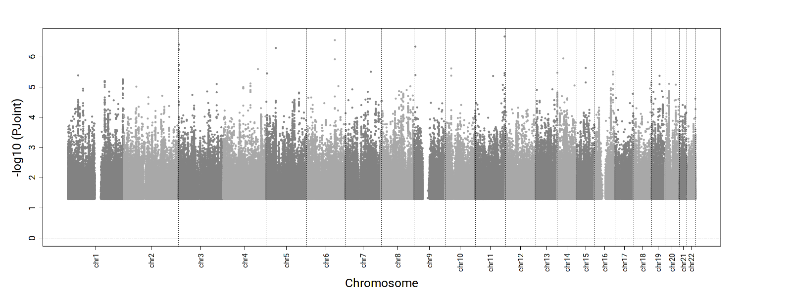 | 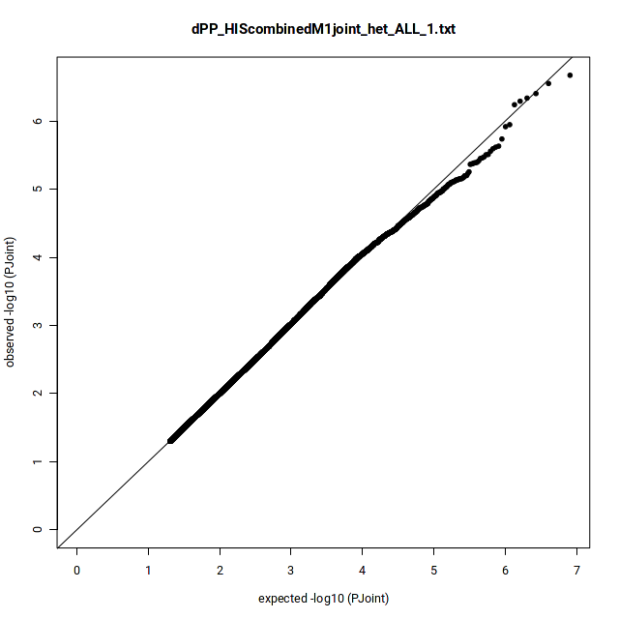  λ = 0.96
1df Interaction P-value
DBP | 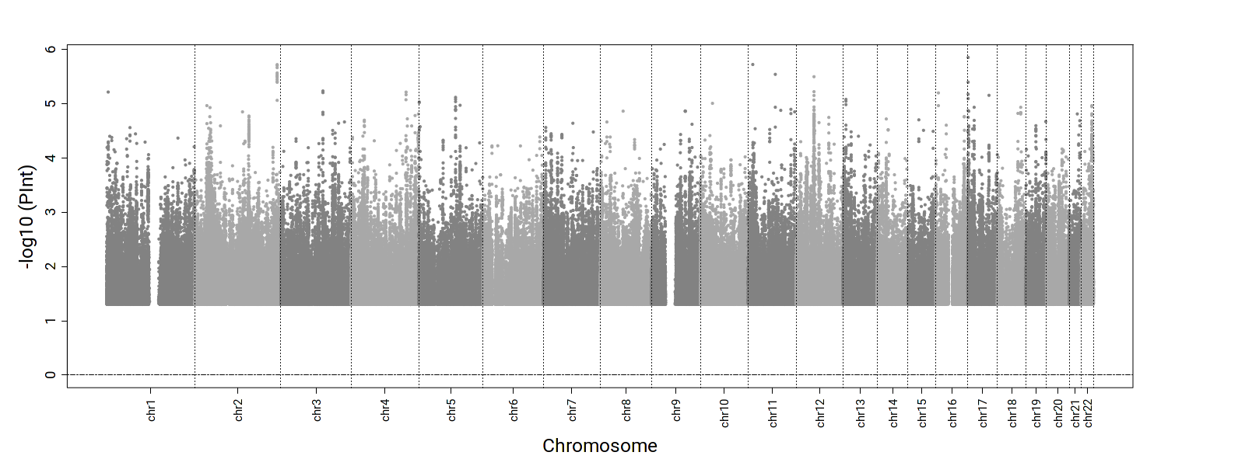 | 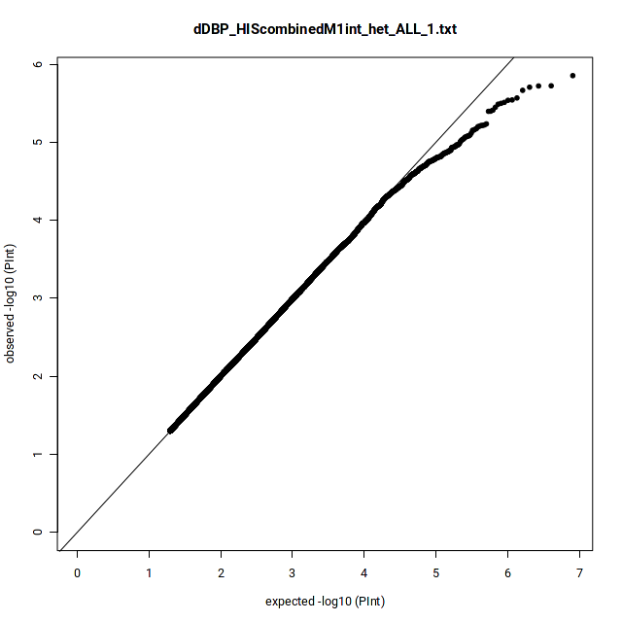  λ = 1.00
SBP | 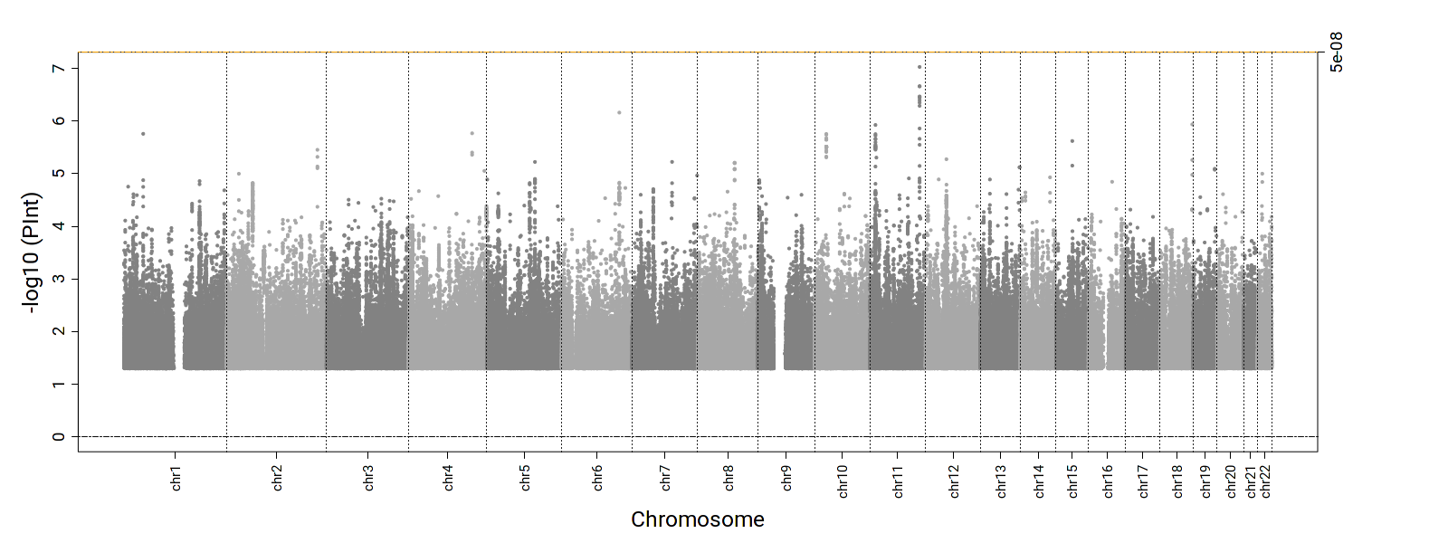 | 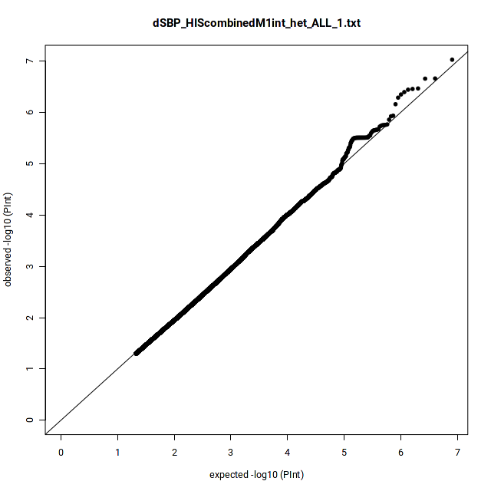  λ = 0.96
PP | 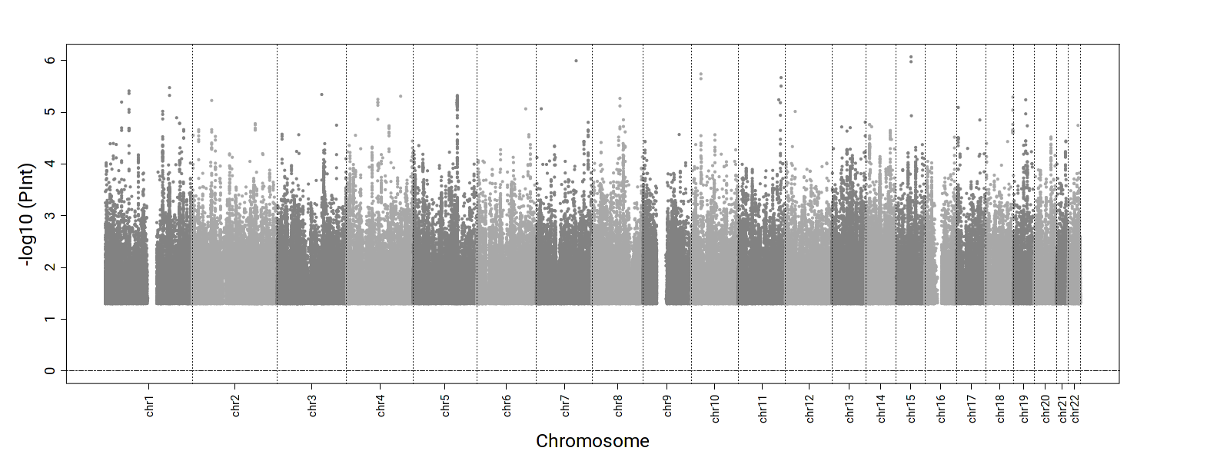 | 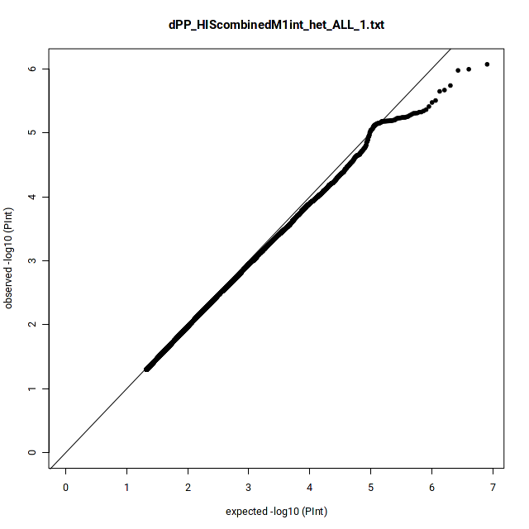  λ = 0.97
Supplemental Figure 10. Manhattan and QQ plots for the 2df joint and 1df interaction P-values in cross-population qDEPR analyses. (Green: known, Blue: novel)
2df joint P-value
DBP | 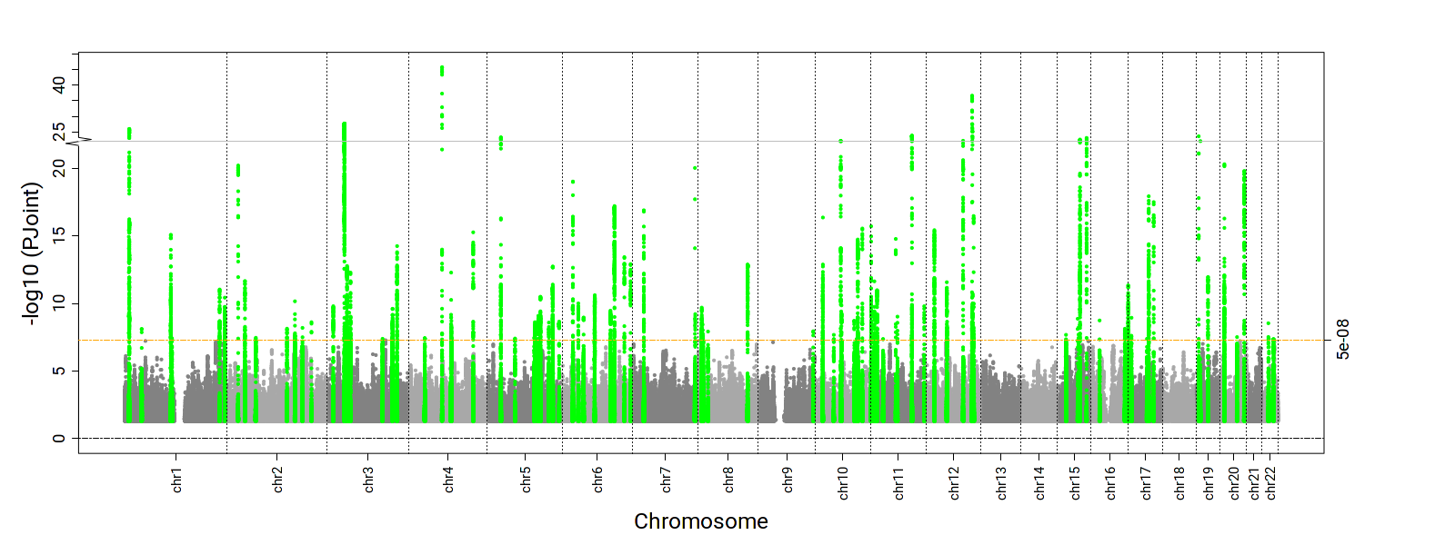 | 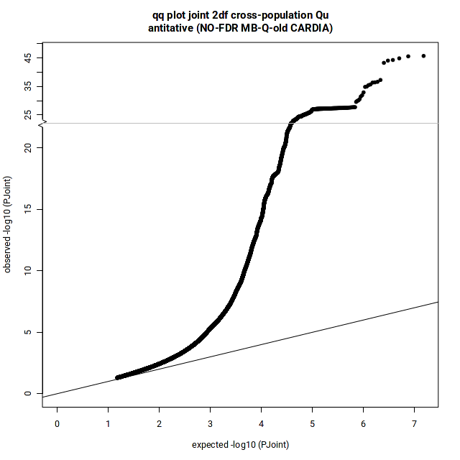  λ = 1.08  Ffdfdsfdsλsffdsfdfkl;jjkfldsfds
SBP | 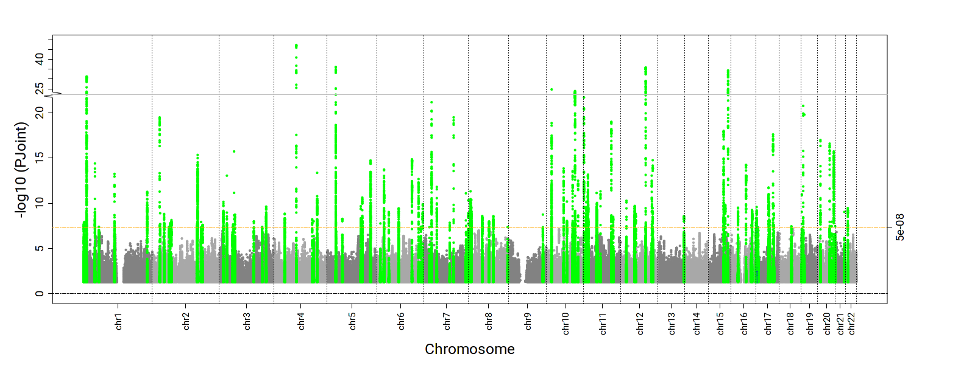 | 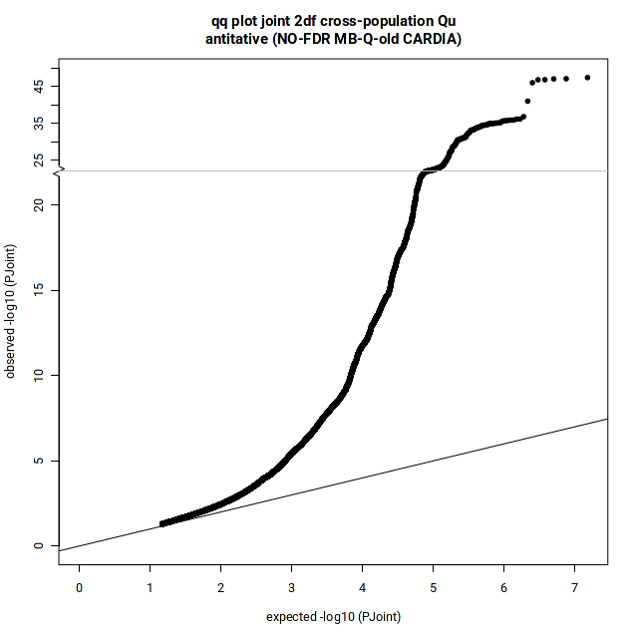  λ = 1.09
PP | 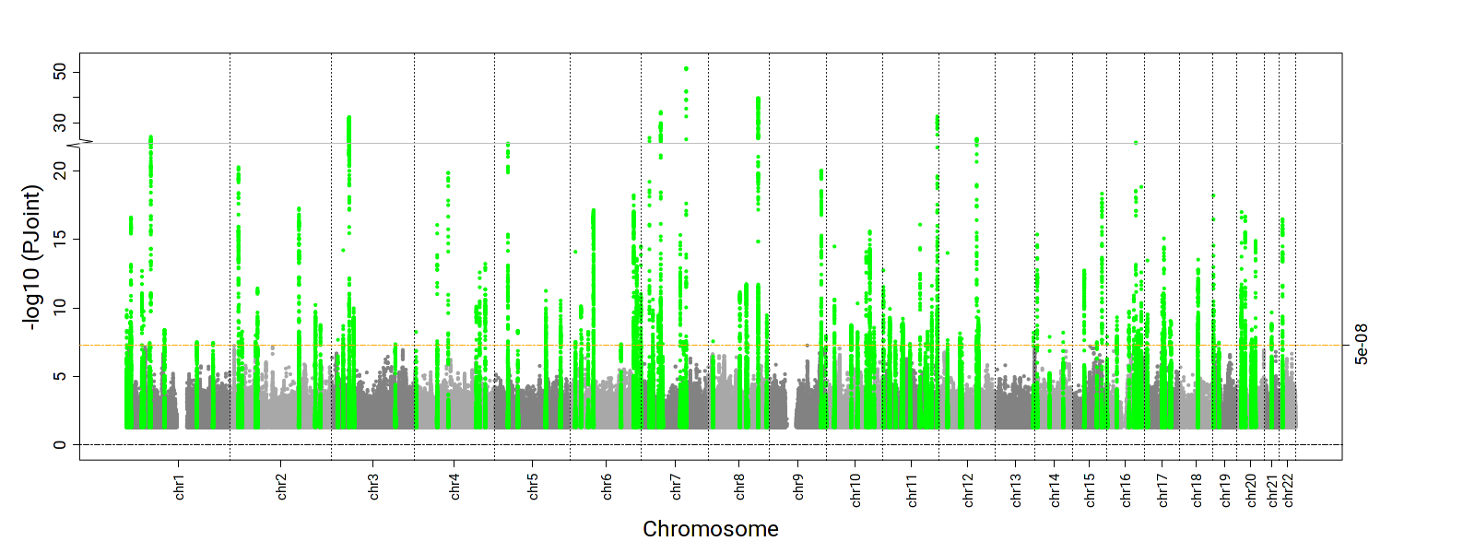 | 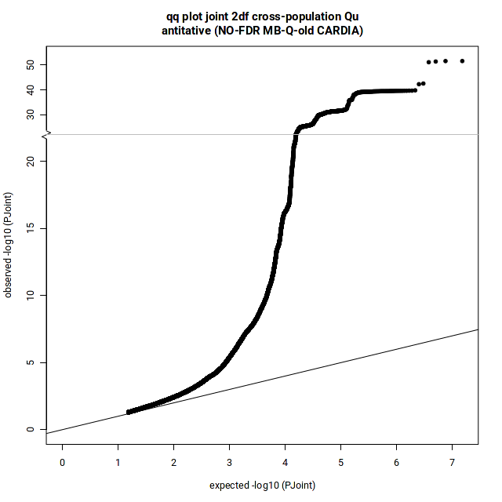  λ = 1.09
1df Interaction P-value
DBP | 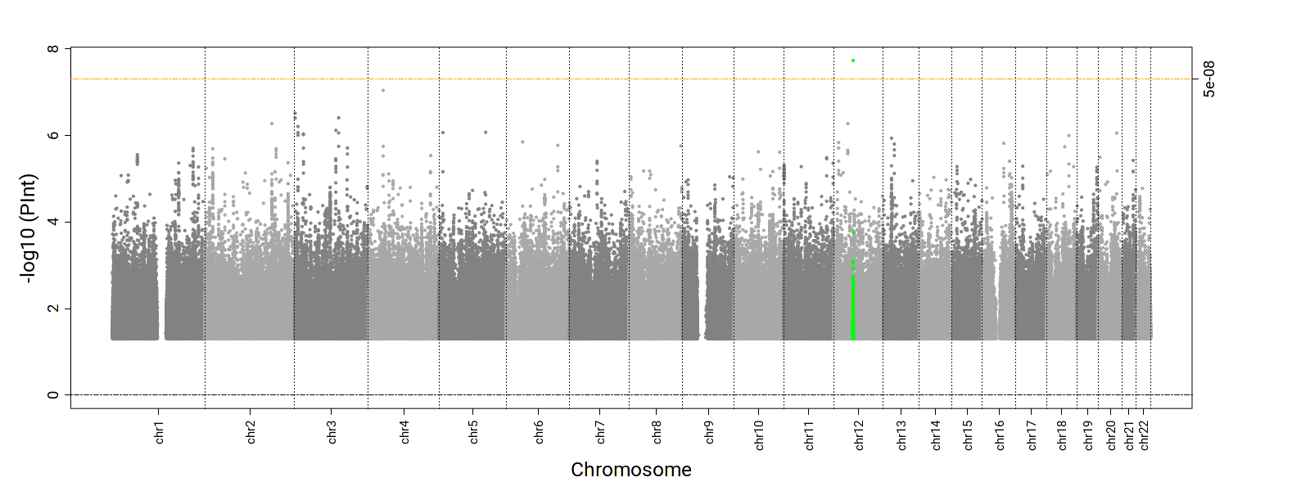 | 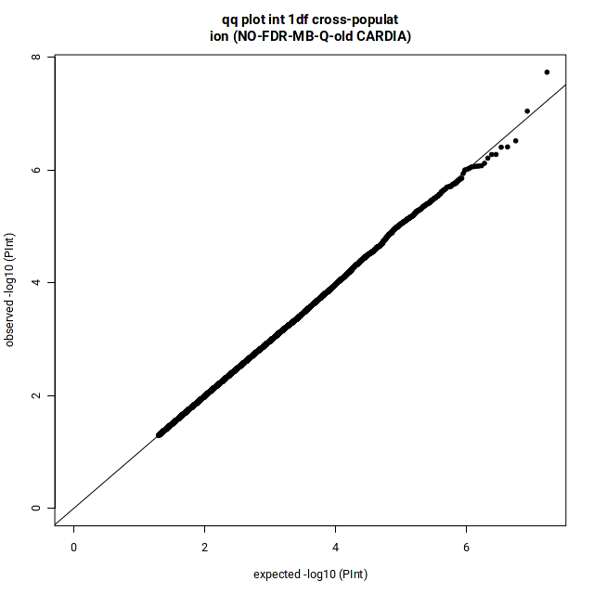  λ = 0.98
SBP | 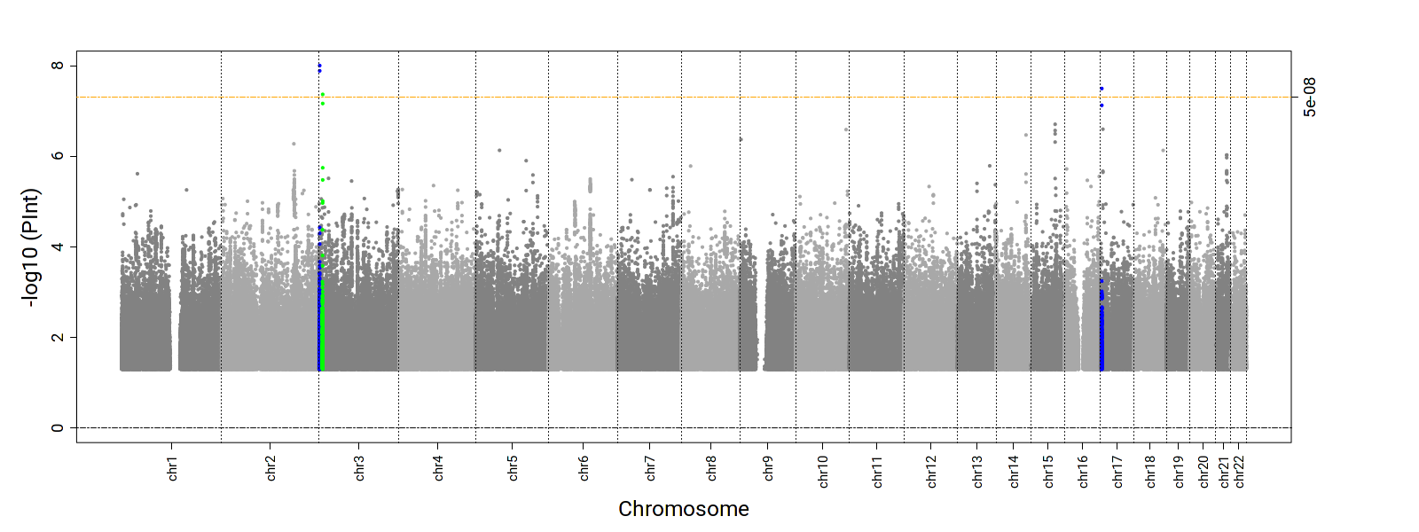 | 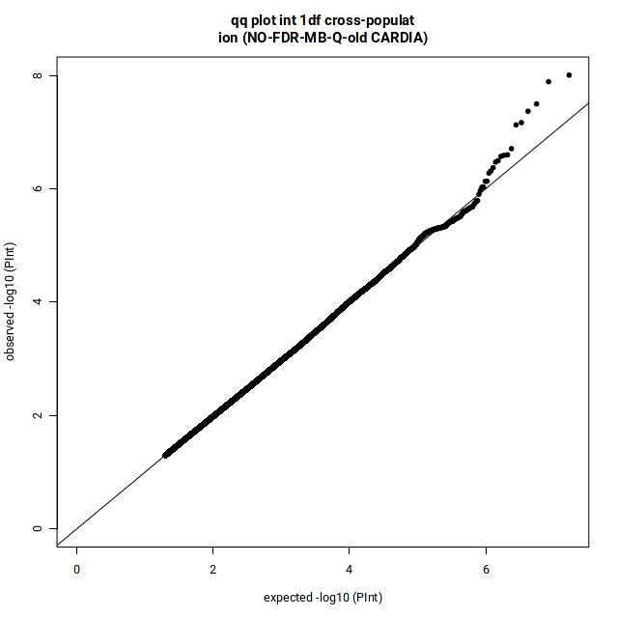  λ = 1.00
PP | 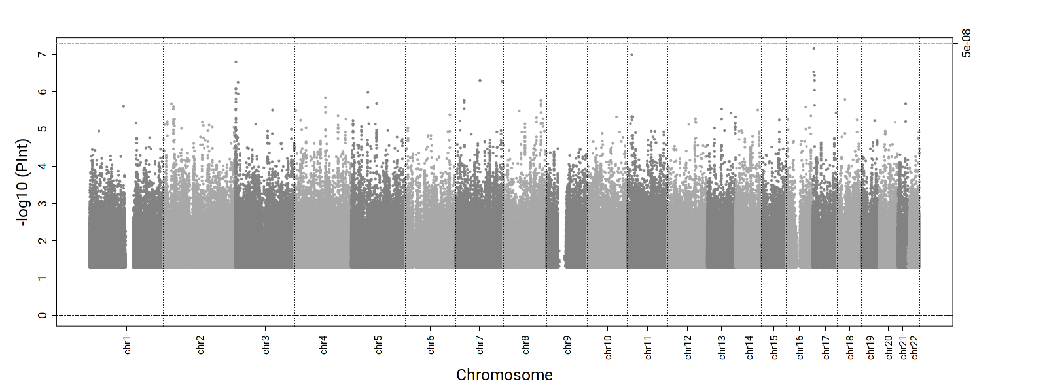 | 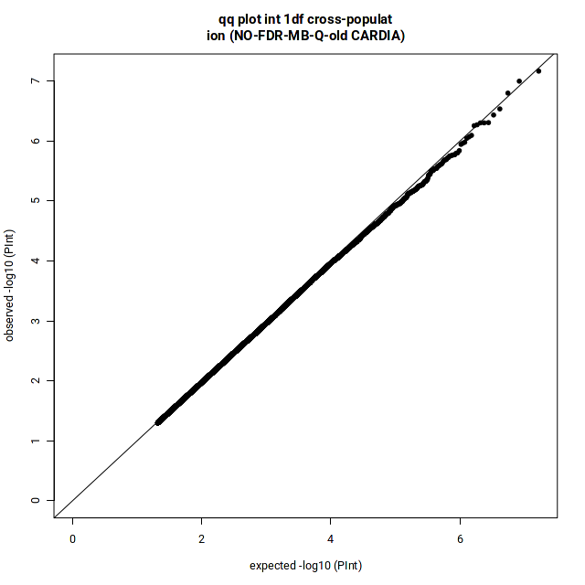  λ = 1.00
Supplemental Figure 11. Manhattan and QQ plots for the 2df joint and 1df interaction P-values in EUR-specific qDEPR analyses. (Green: known, Blue: novel)
2df joint P-value
DBP | 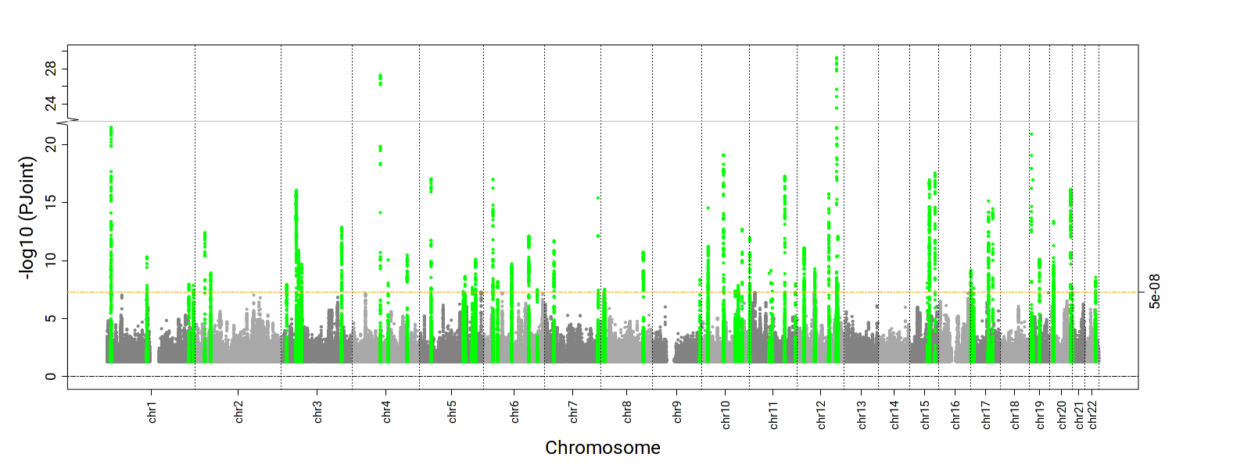 | 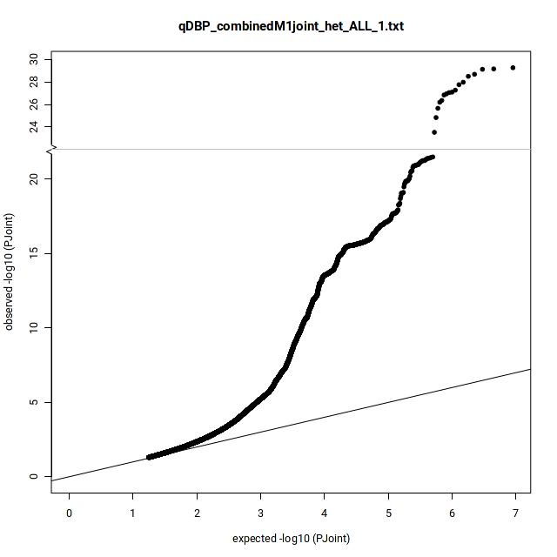  λ = 1.28  Ffdfdsfdsλsffdsfdfkl;jjkfldsfds
SBP | 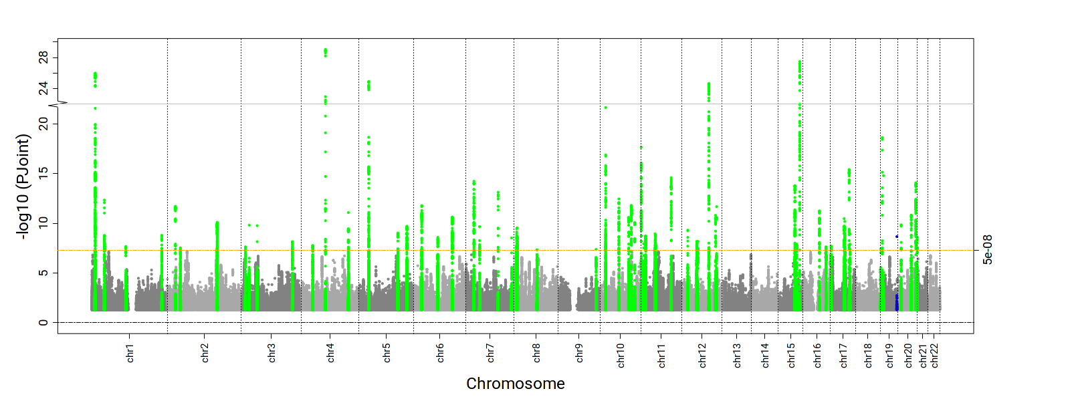 | 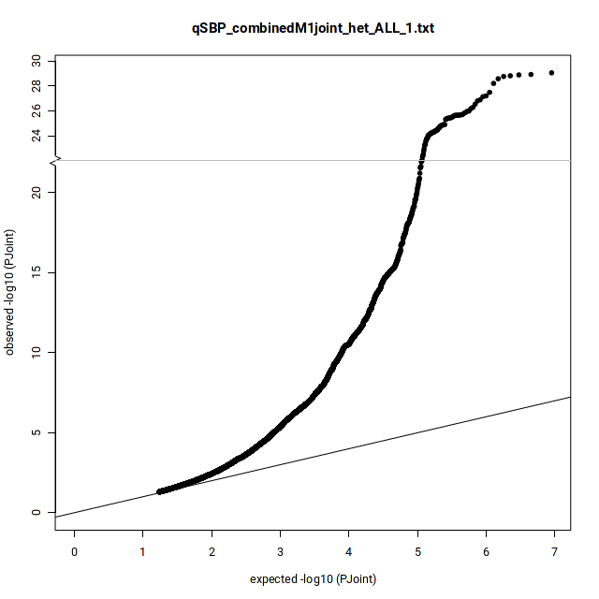  λ = 1.27
PP | 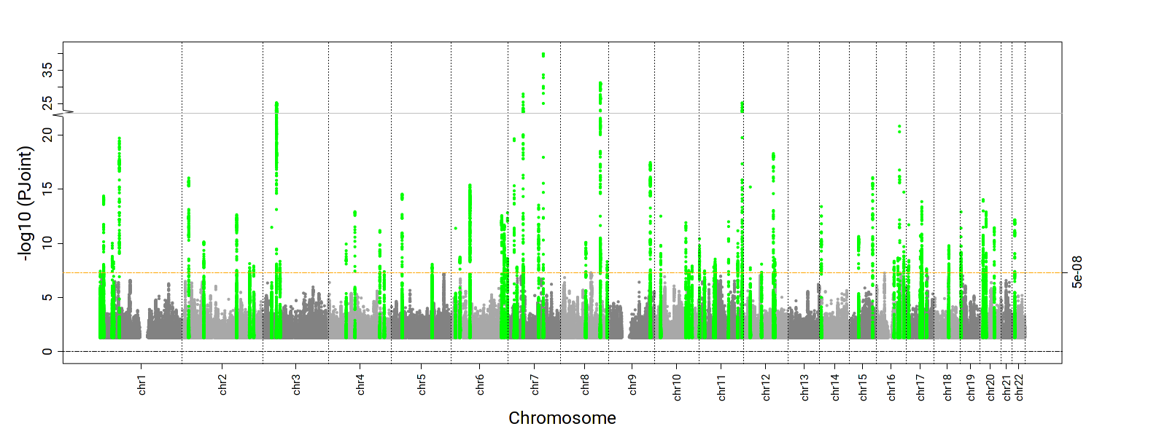 | 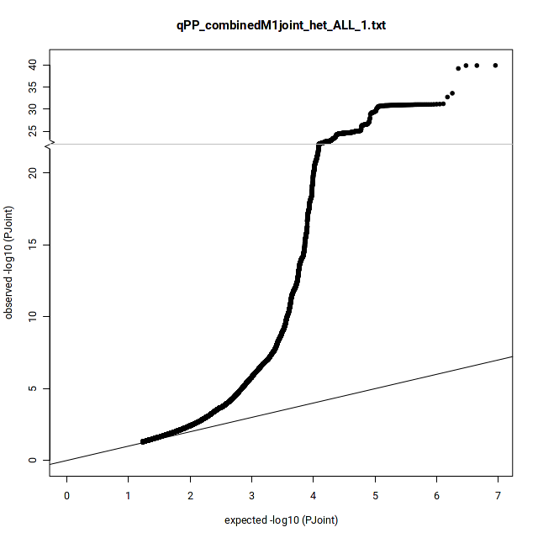  λ = 1.30
1df Interaction P-value
DBP | 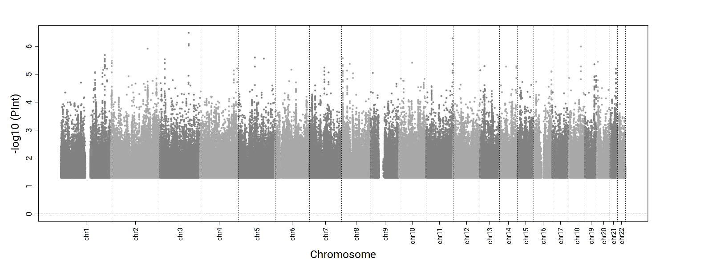 | 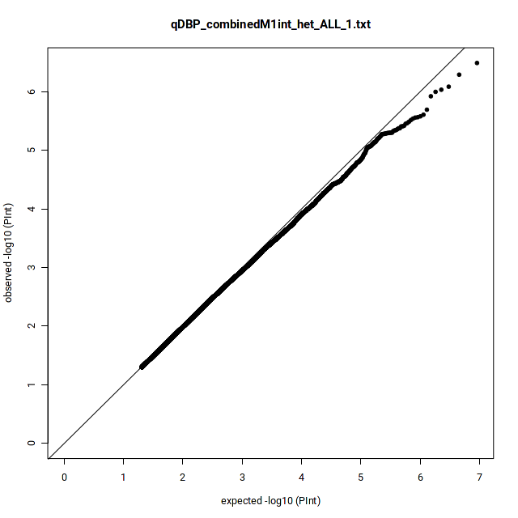  λ = 1.00
SBP | 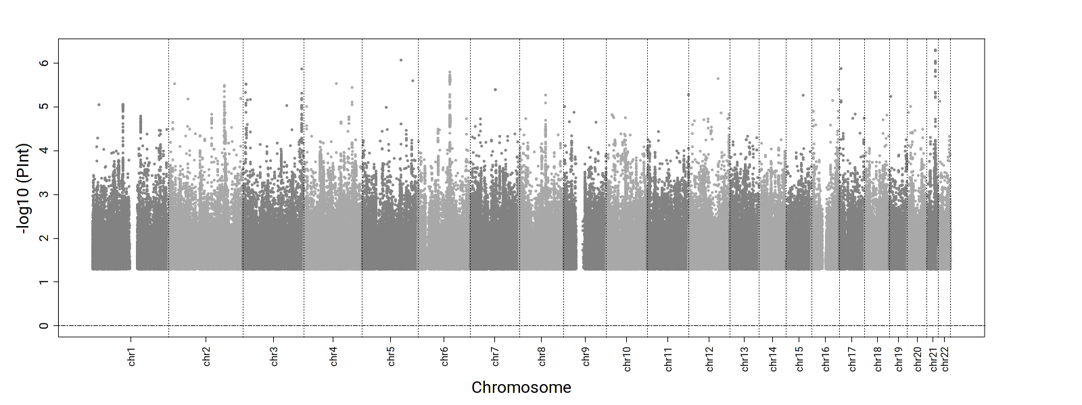 | 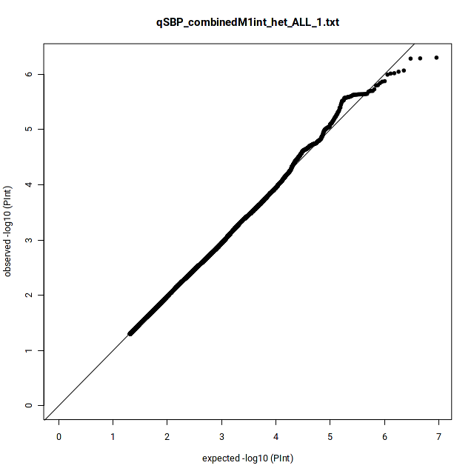  λ = 1.00
PP | 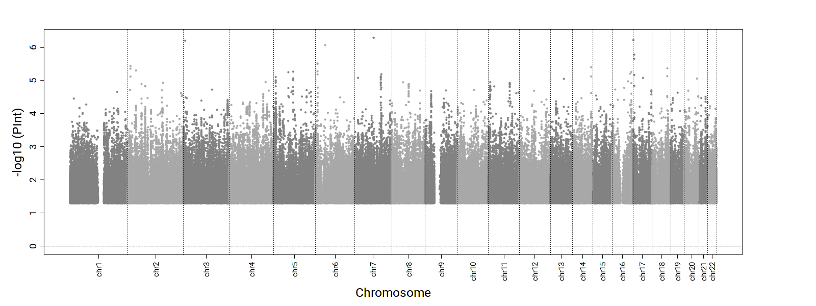 | 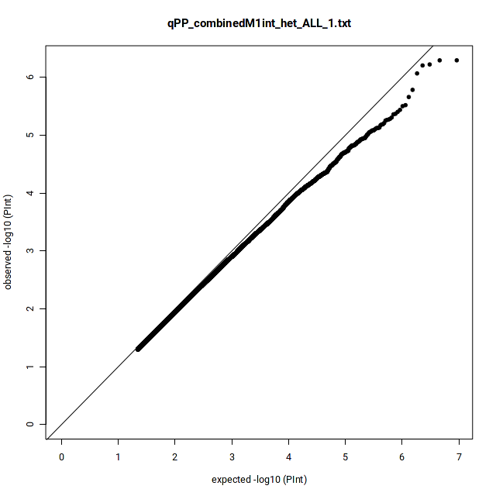  λ = 0.98
Supplemental Figure 12. Manhattan and QQ plots for the 2df joint and 1df interaction P-values in AFR –specific qDEPR analyses. (Green: known, Blue: novel)
2df joint P-value
DBP | 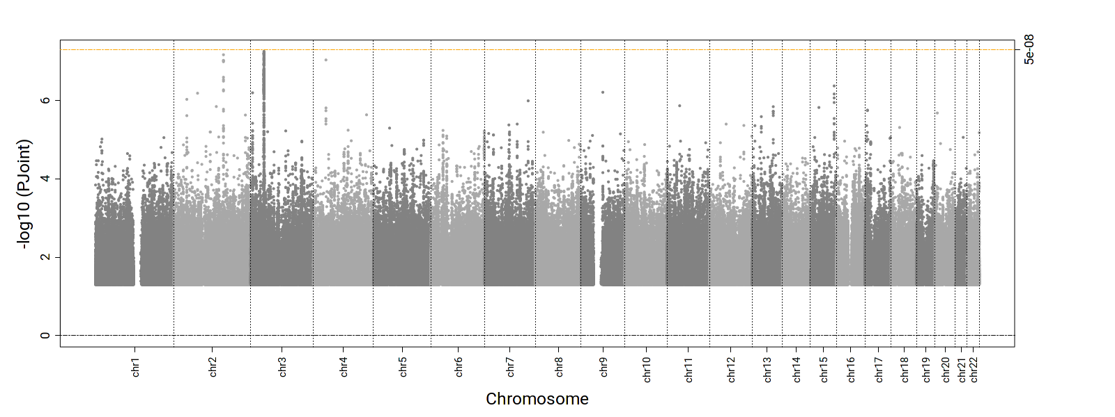 | 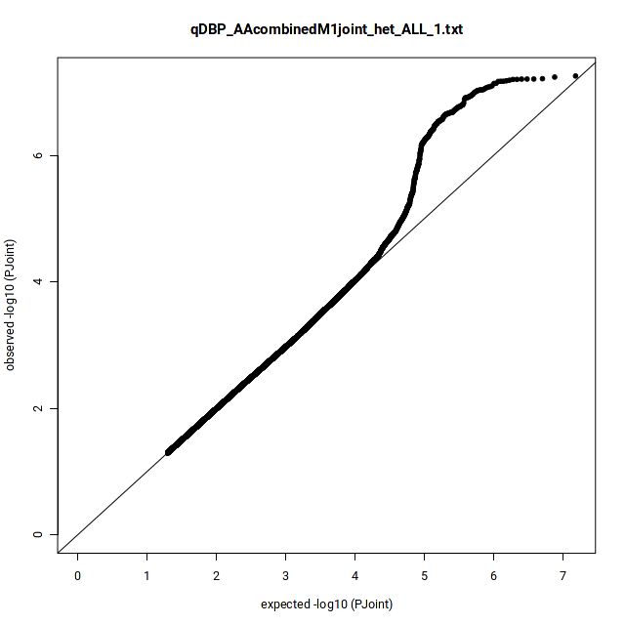  λ = 1.02  Ffdfdsfdsλsffdsfdfkl;jjkfldsfds
SBP | 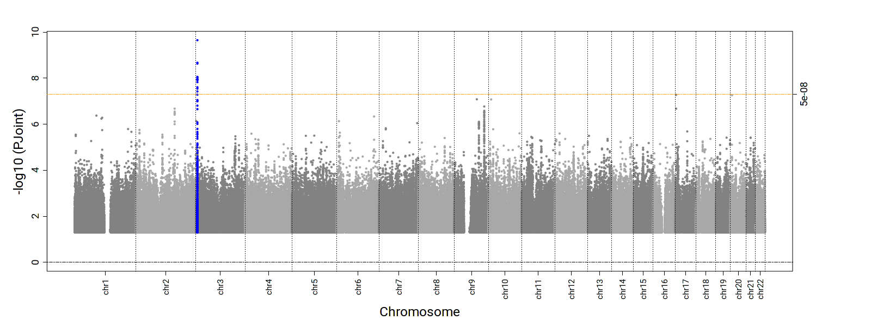 | 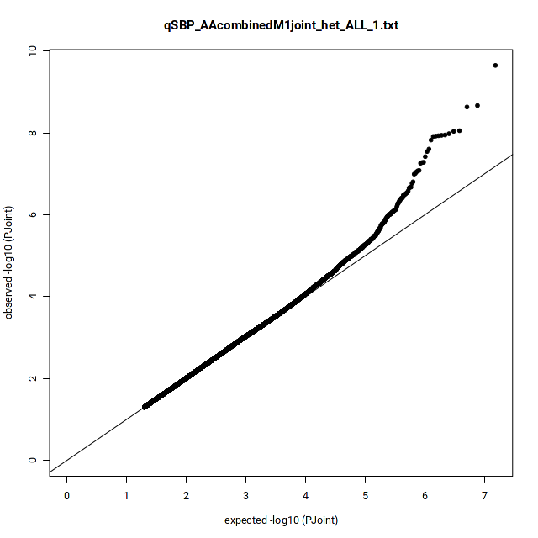  λ = 1.01
PP | 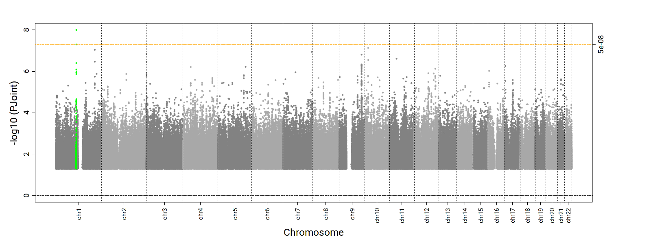 | 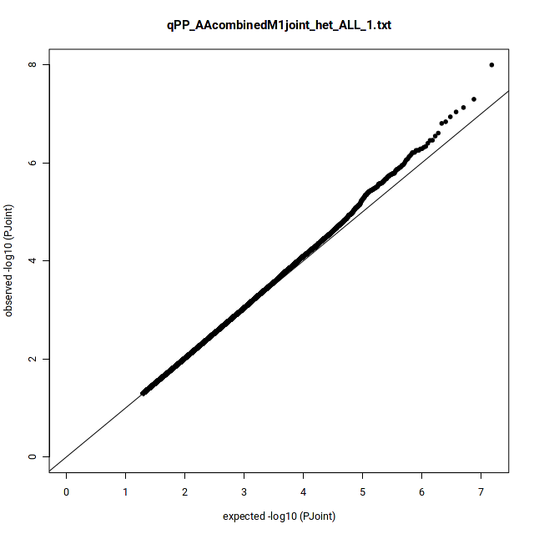  λ = 1.00
1df Interaction P-value
DBP | 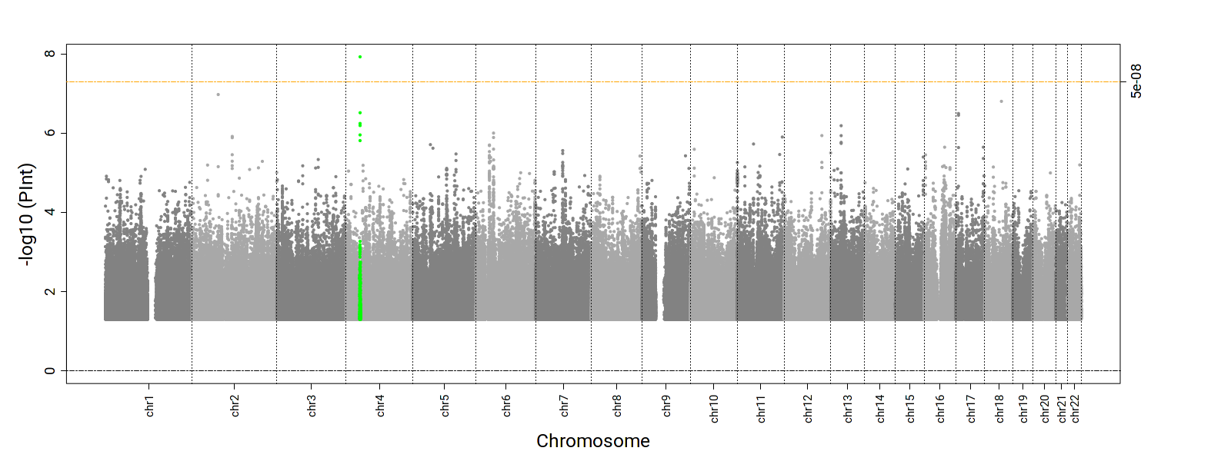 | 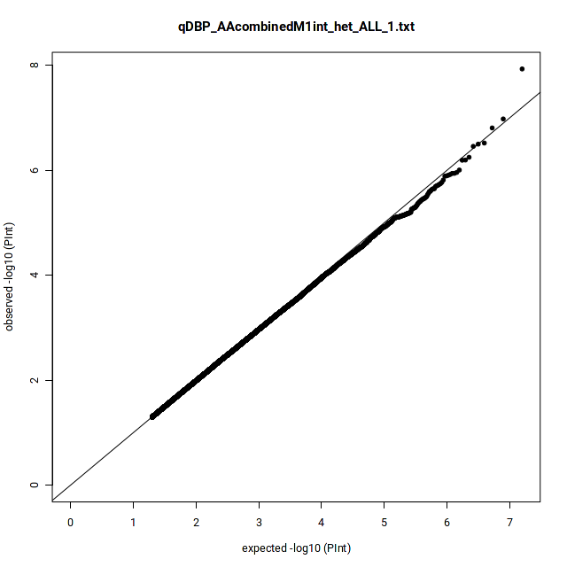  λ = 1.03
SBP | 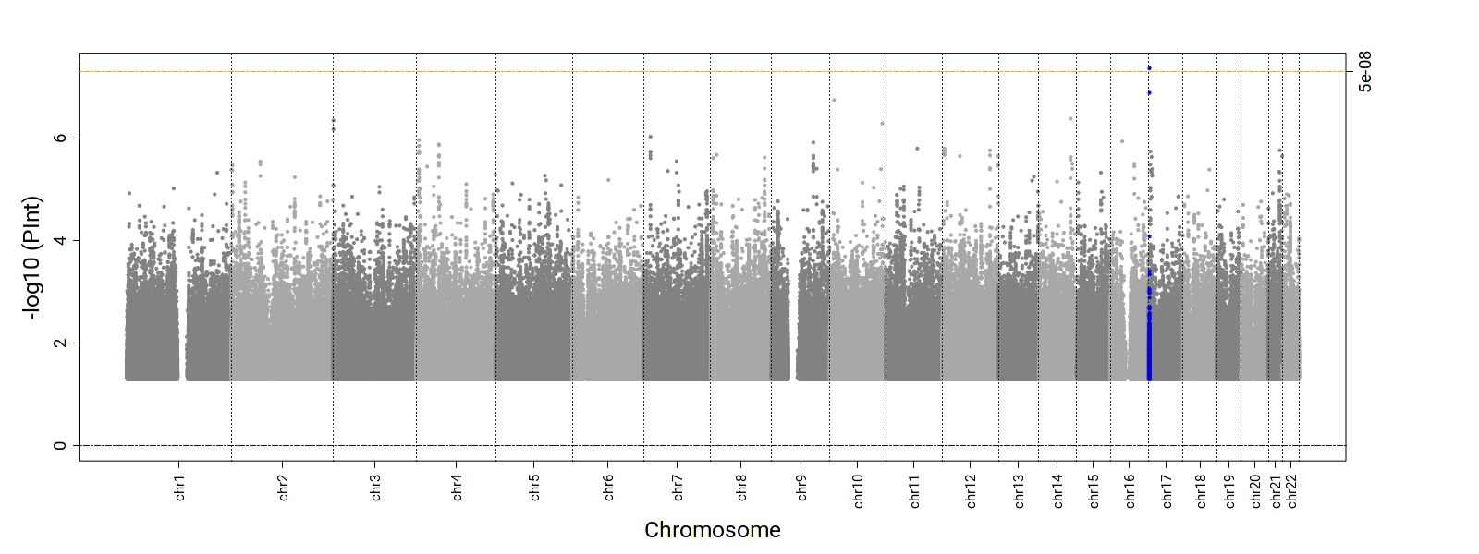 | 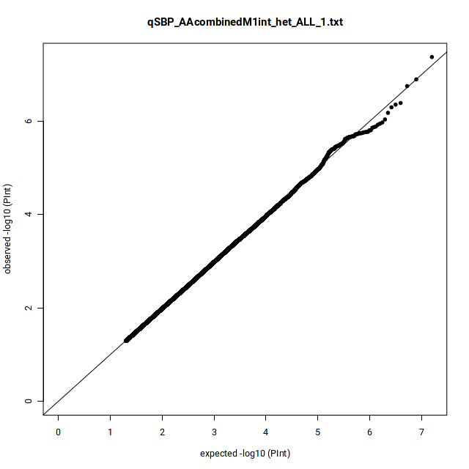  λ = 1.01
PP | 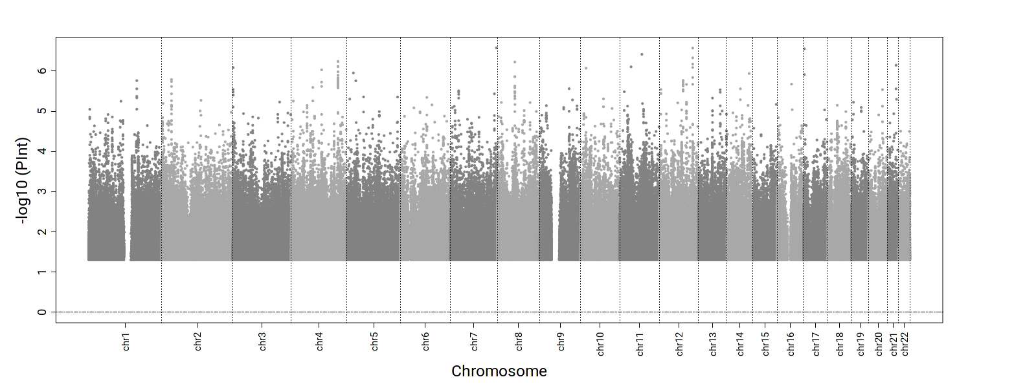 | 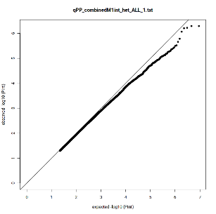  λ = 1.01
Supplemental Figure 13. Manhattan and QQ plots for the 2df joint and 1df interaction P-values in ASN-specific qDEPR analyses. (Green: known, Blue: novel)
2df joint P-value
DBP | 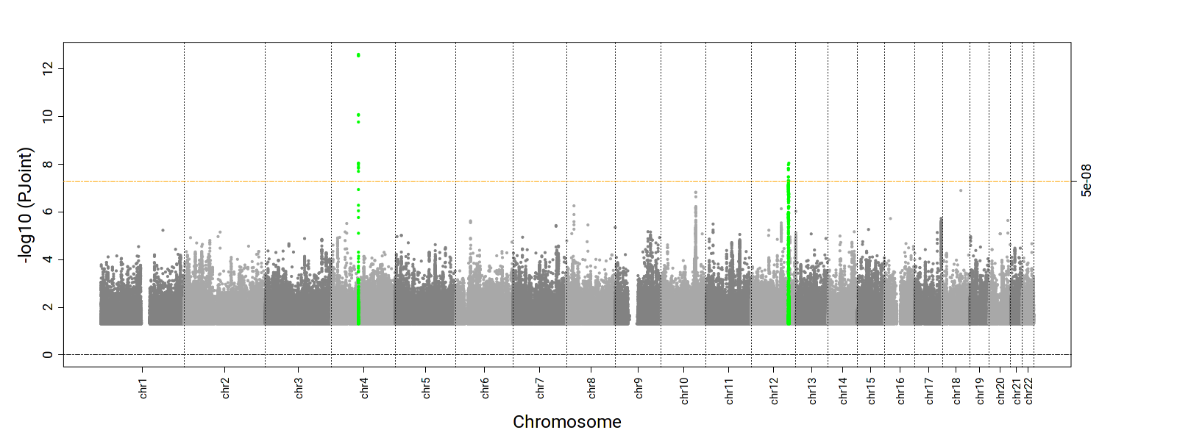 | 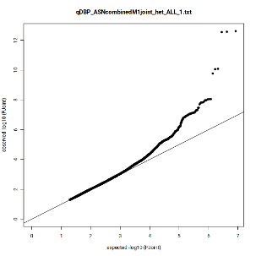  λ = 1.01  Ffdfdsfdsλsffdsfdfkl;jjkfldsfds
SBP | 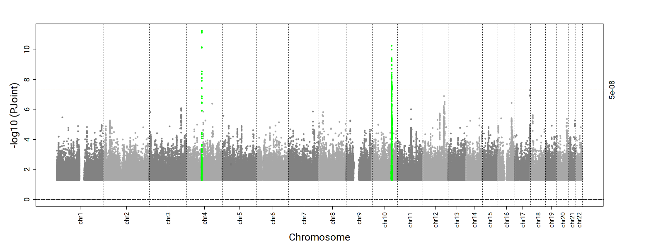 | 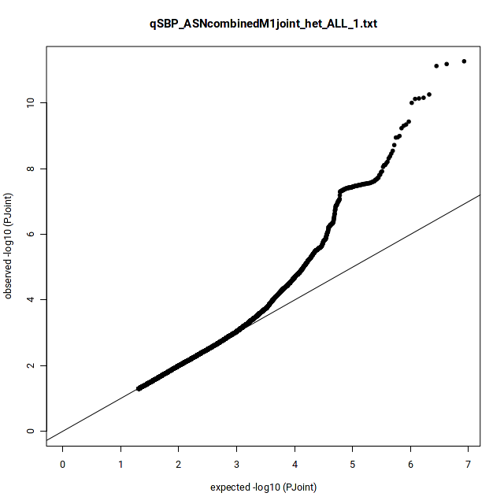  λ = 1.02
PP | 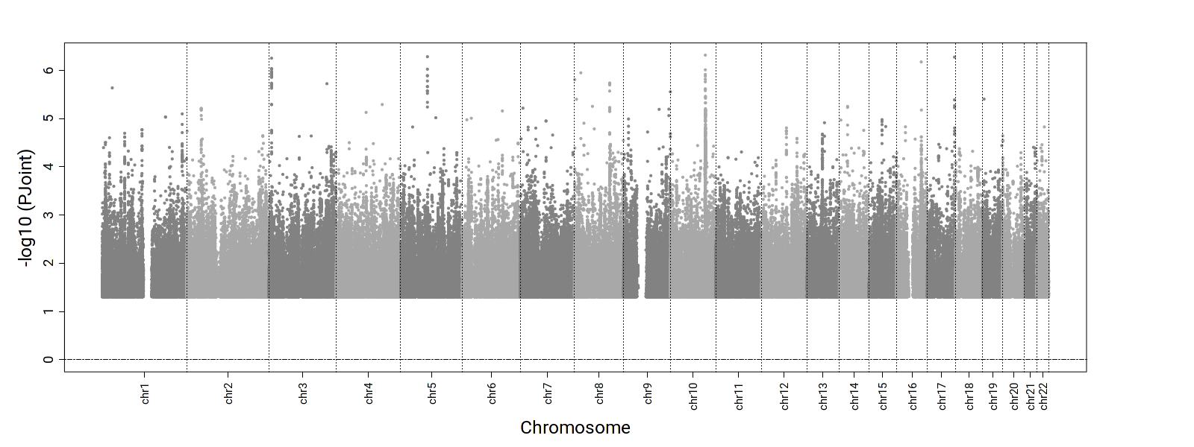 | 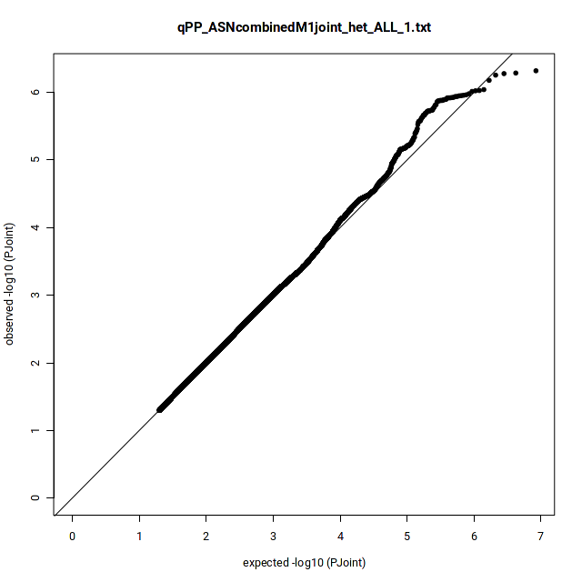  λ = 1.01
1df Interaction P-value
DBP | 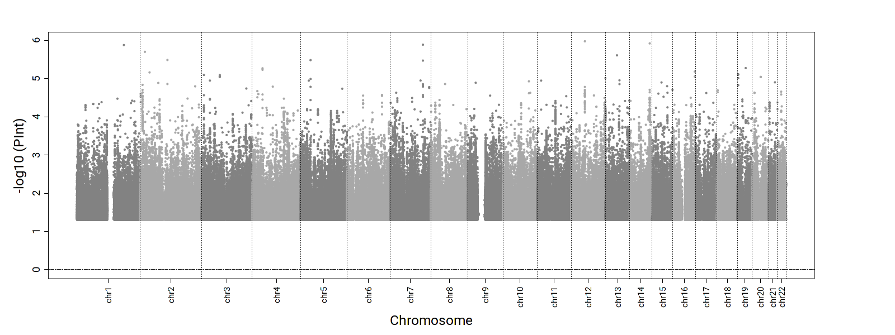 | 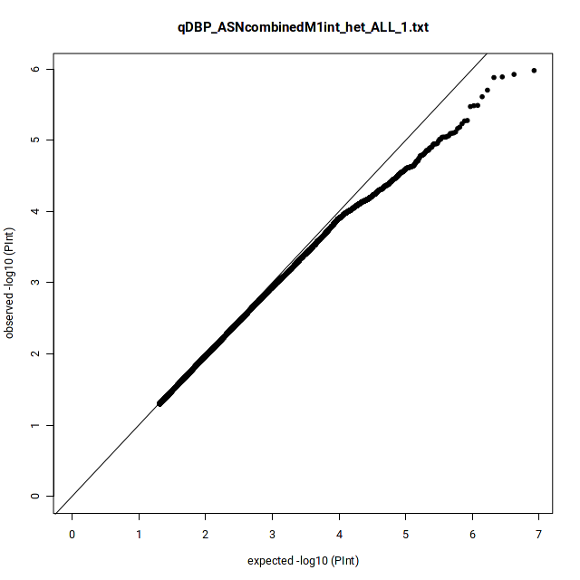  λ = 1.03
SBP | 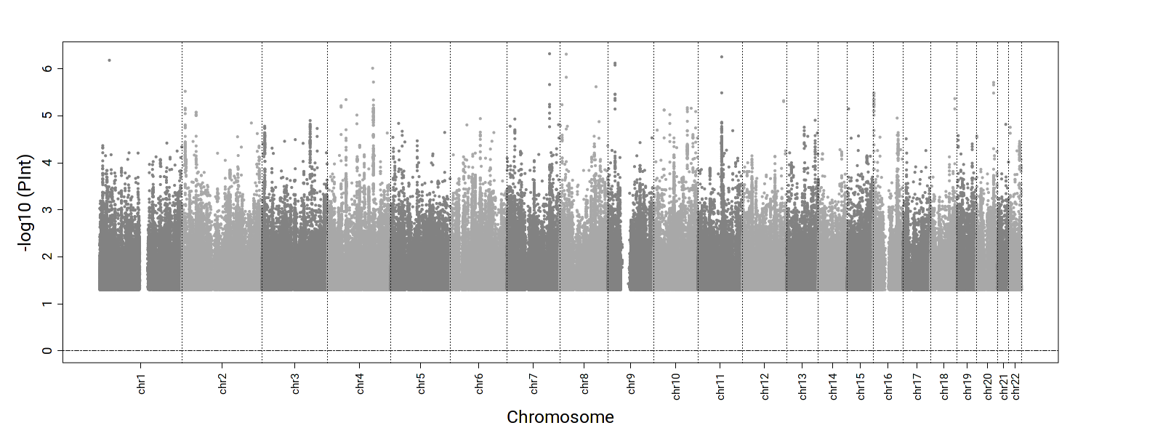 | 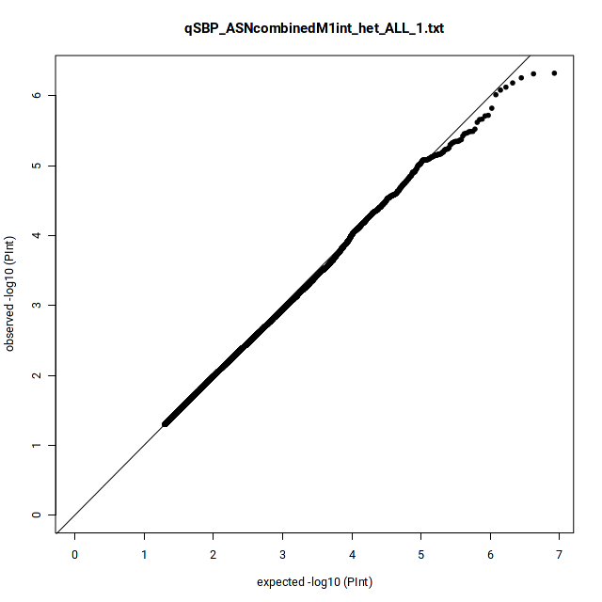  λ = 1.02
PP | 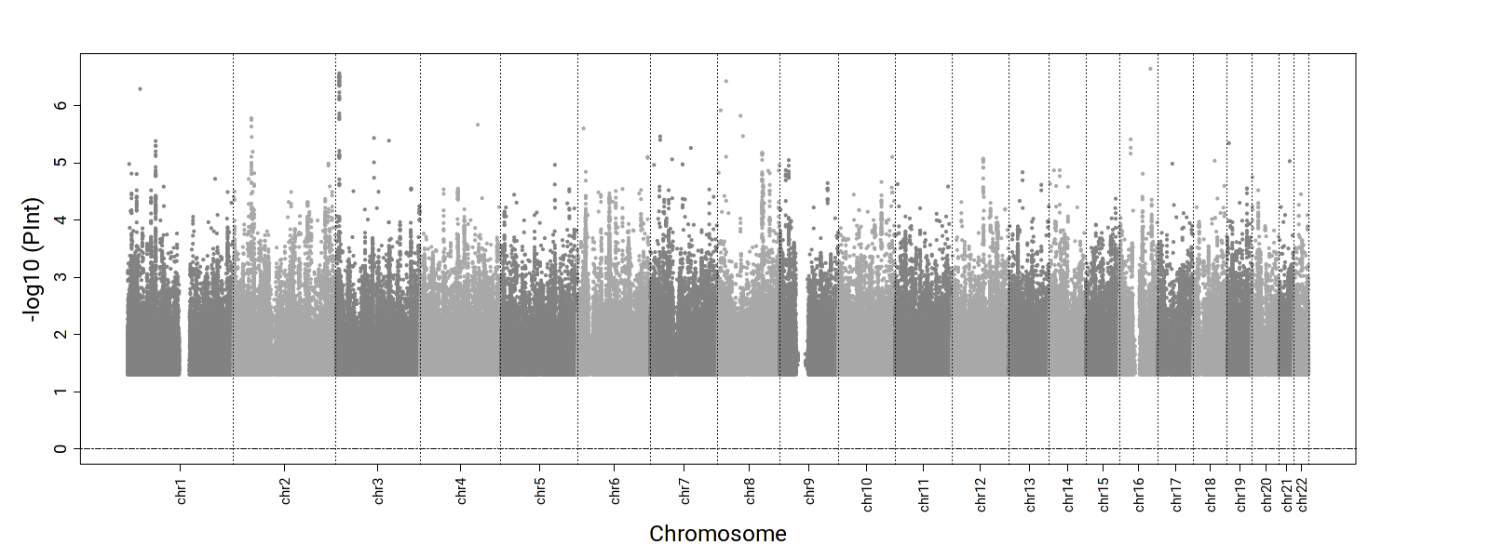 | 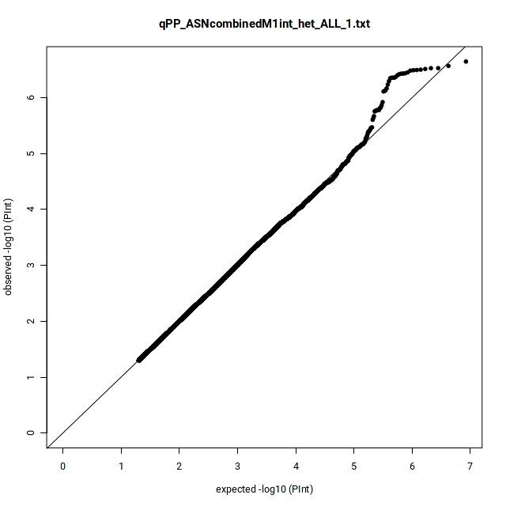  λ = 1.01

Supplemental Figure 14. Manhattan and QQ plots for the 2df joint and 1df interaction P-values in HIS-specific qDEPR analyses. (Green: known, Blue: novel)
2df joint P-value
DBP | 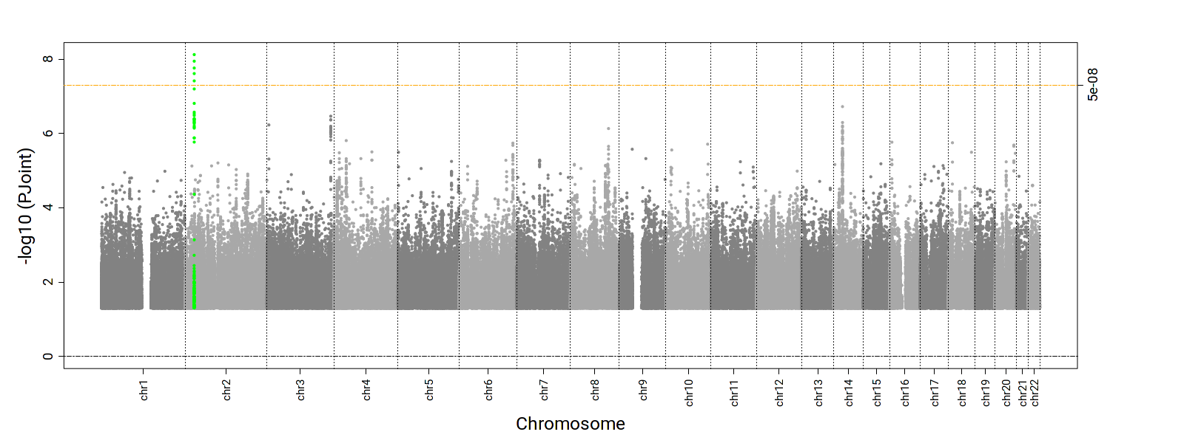 | 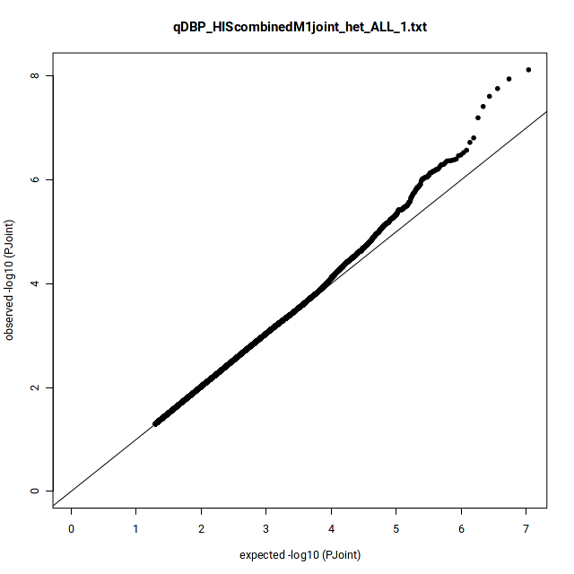  λ = 1.00  Ffdfdsfdsλsffdsfdfkl;jjkfldsfds
SBP | 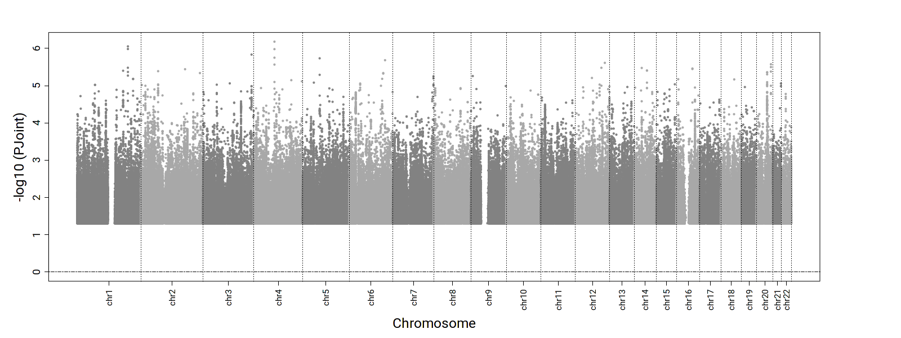 | 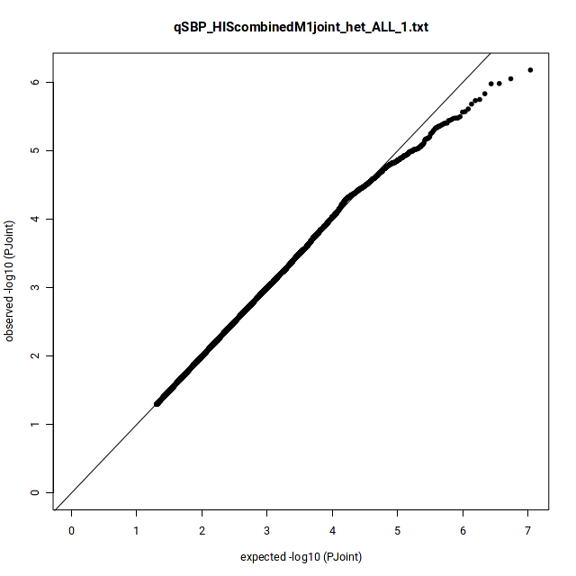  λ = 0.97
PP | 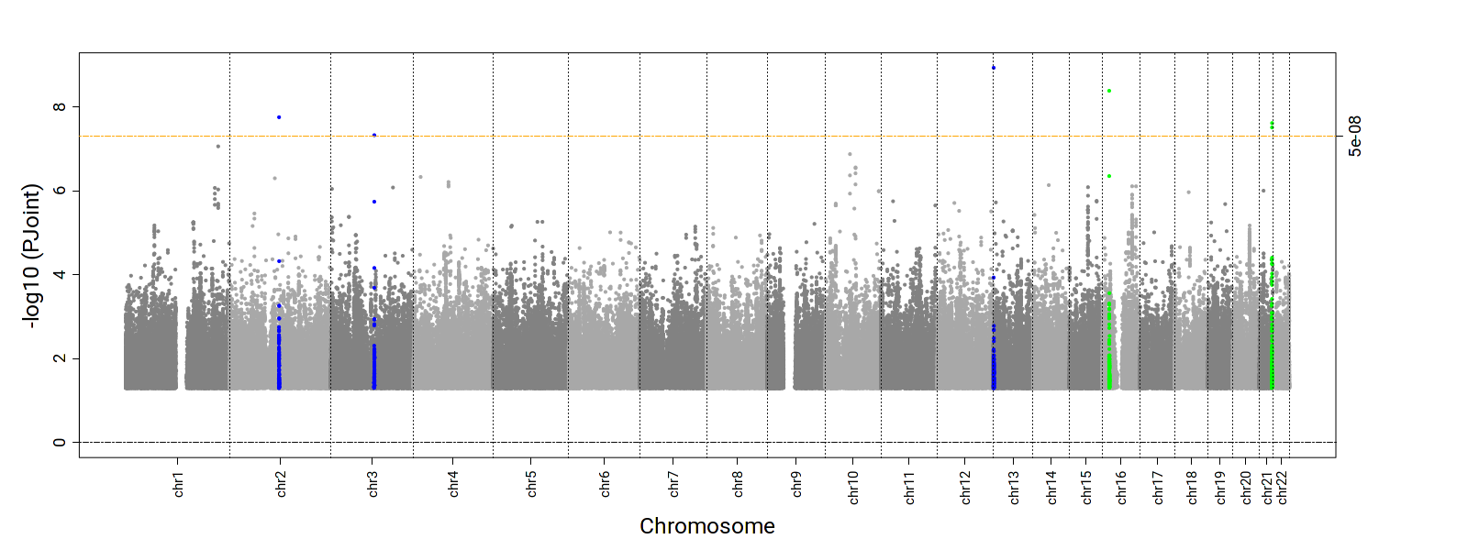 | 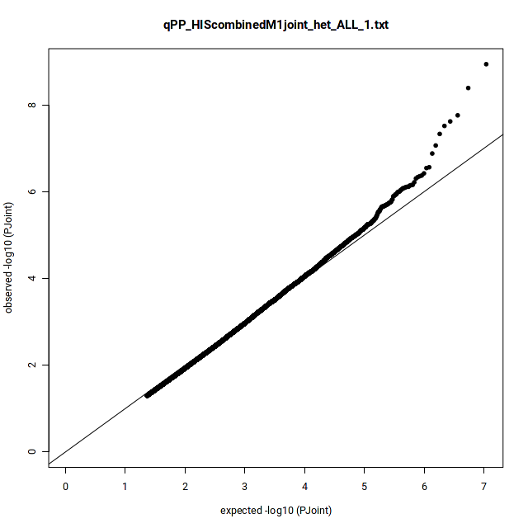  λ = 0.99
1df Interaction P-value
DBP | 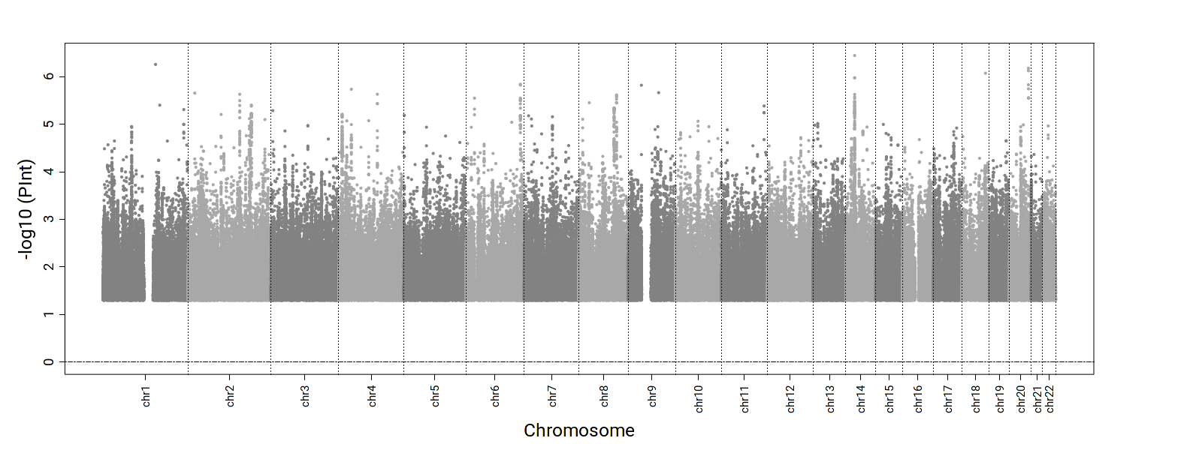 | 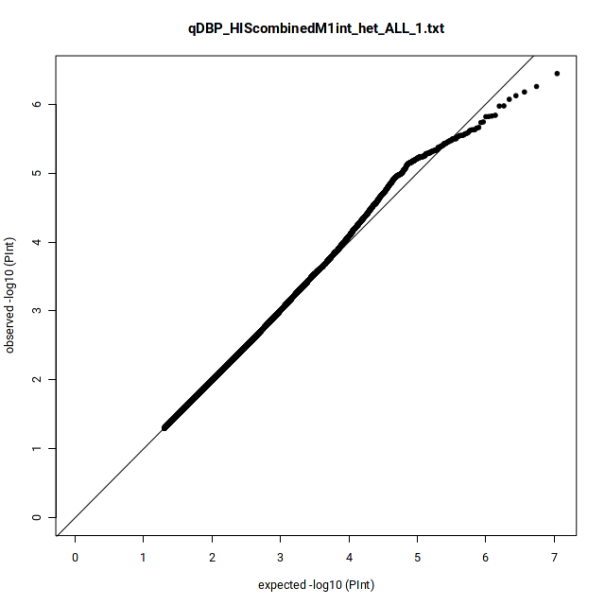  λ = 0.99
SBP | 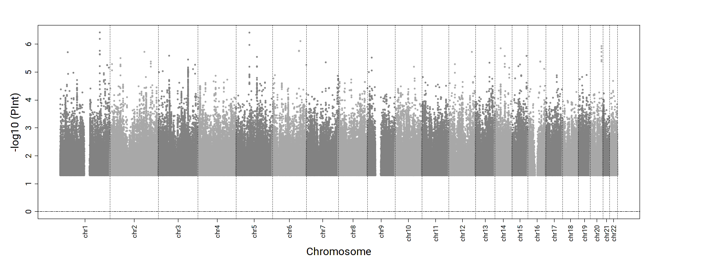 | 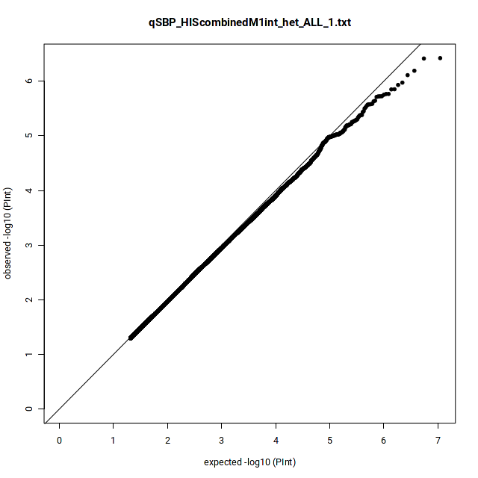  λ = 0.99
PP | 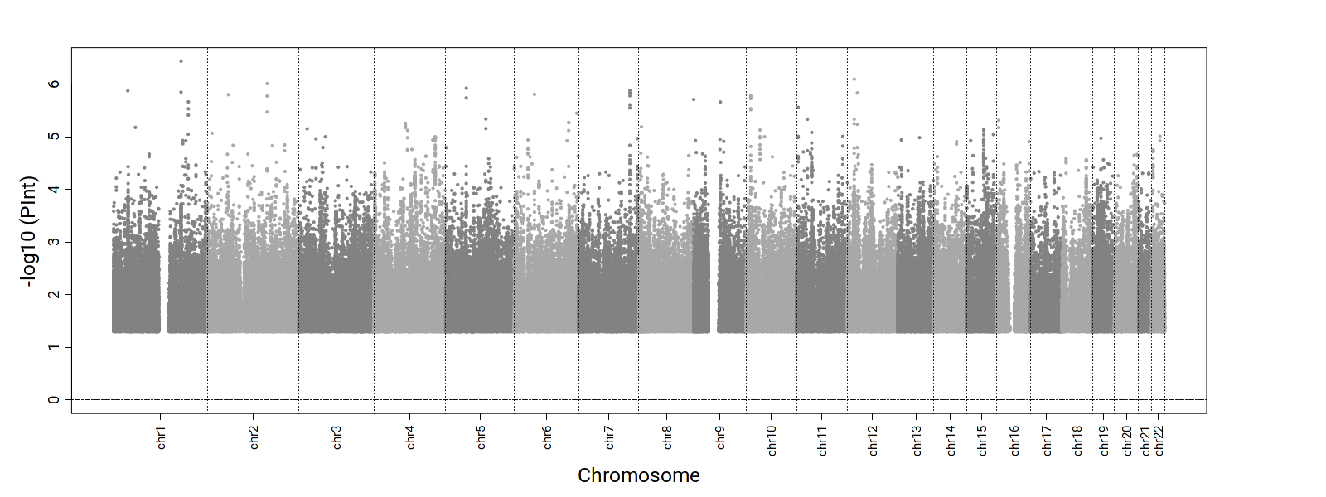 | 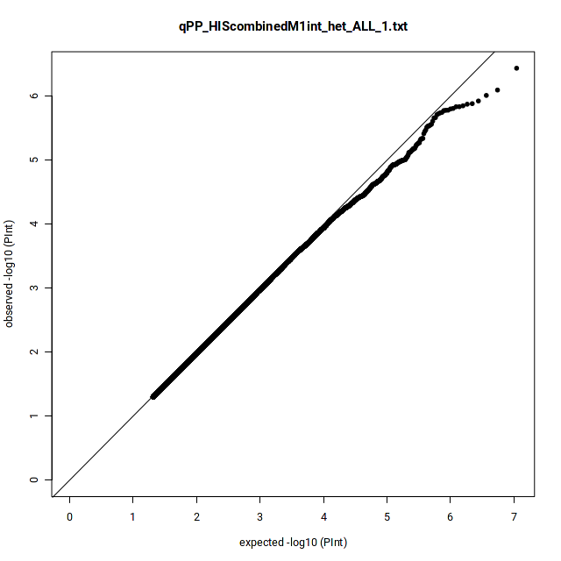  λ = 0.99

