Supplemental Information: Financial losses associated with US floods occur with surprisingly frequent, low return period precipitation
Adam Nayak^{1,2,3}, Pierre Gentine^{1,2,3}, Upmanu Lall^{1,2,4,5}
¹ Department of Earth and Environmental Engineering, Columbia University, New York, NY 10027, USA.
² Columbia Water Center, Columbia Climate School, Columbia University, New York, NY 10027, USA.
³ Learning the Earth with Artificial Intelligence and Physics (LEAP) National Science Foundation Center, Columbia University, New York, NY 10027, USA.
⁴ School of Complex Adaptive Systems, Arizona State University, Tempe, AZ, 85281, USA.
⁵ The Water Institute, Arizona State University, Tempe, AZ, 85281, USA.

1) Summary of Datasets 3
Table S3: Comprehensive Summary of Datasets Analyzed 3
2) Disaster Declaration Event Types 4
Table S2: FEMA Flood-Related Disaster Declaration Classifications 4
3) Urban-Rural Classification 6
Table S3: CDC NCHS Urban-Rural Classification Scheme 6
4) ERA5: Max Daily Intercomparison 7
Figure E1: ERA5 Return Period Sensitivity to Event Duration 8
Figure E2: ERA5 Spatial Distribution of Return Periods by Financing Type 9
Figure E3: ERA5 Types of Flood-Related Presidential Declarations 10
Figure E4: ERA5 Spatiotemporal Storm Clustering 11
Figure E5: ERA5 Return Period Sensitivity to Spatiotemporal Clustering 12
Figure E7: ERA5 Summary of Costs and Return Periods by Financing Type 13
5) MSWEP: Sensitivity to Event Duration 14
A) Three-Day 15
Figure D2: Max 3-Day Spatial Distribution of Return Periods by Financing Type 15
Figure D3: Max 3-Day Types of Flood-Related Presidential Declarations 16
Figure D4: Max 3-Day Spatiotemporal Storm Clustering 17
Figure D5: Max 3-Day Return Period Sensitivity to Spatiotemporal Clustering 18
Figure D7: Max 3-Day Summary of Costs and Return Periods by Financing Type 19
B) Weekly 20
Figure W2: Weekly Spatial Distribution of Return Periods by Financing Type 20
Figure W3: Weekly Types of Flood-Related Presidential Declarations 21
Figure W4: Weekly Spatiotemporal Storm Clustering 22
Figure W5: Weekly Return Period Sensitivity to Spatiotemporal Clustering 23
Figure W7: Weekly Summary of Costs and Return Periods by Financing Type 24
C) Monthly 25
Figure M2: Monthly Spatial Distribution of Return Periods by Financing Type 25
Figure M3: Monthly Types of Flood-Related Presidential Declarations 26
Figure M4: Monthly Spatiotemporal Storm Clustering 27
Figure M5: Monthly Return Period Sensitivity to Spatiotemporal Clustering 28
Figure M7: Monthly Summary of Costs and Return Periods by Financing Type 29
6) PRISM: Monthly Percentile and Return Period Intercomparison 30
Figure S4: Intercomparison of Percentiles/Return Periods Across Datasets 30
7) ST-DBSCAN Parameterization Sensitivity Analysis 31
A) Damage and Return Period 32
Figure S5: Correlation Between Damage and Return Period 32
B) Sensitivity Analysis: Cluster Attributes 32
8) Nonstationary GEV Duration Sensitivity 32
A) Mann-Kendall Test for Nonstationary Clusters 32
B) Nonstationary Analysis for Three-Day Event Duration 32
Figure D6: Three-Day Nonstationarity Sensitivity in Intensity Distributions 33
C) Extended Nonstationary GEV 34
Figure E6: Extended Nonstationarity Sensitivity in Intensity Distributions 34
9) Raw Precipitation: Monthly Dataset Intercomparison 35
Figure S1: Distribution Comparison of Gridded Raw Precipitation for Claims 36
Figure S2: Spatial Comparison of Gridded Raw Precipitation for Claims 37
10) Additional References 37

1) Summary of Datasets
We provide a comprehensive overview of all datasets used in attaining our results in Table S3. All sources provided below are publicly available. Processed datasets can be accessed from our GitHub.

Table S3: Comprehensive Summary of Datasets Analyzed
Name | Source | Short Description | Time Horizon
MSWEP | GloH2O | Daily gridded precipitation, 0.1° resolution | 1979 to 2020
ERA5 | Copernicus Data Store | Daily gridded precipitation, 0.25° resolution | 1940 to 2023
PRISM | PRISM Climate Group | Monthly gridded precipitation, 4km resolution | 1923 to 2023
FIMA NFIP Redacted Claims | FEMA | Flood Insurance Claims | 1978 to 2024
FIMA NFIP Redacted Policies | FEMA | Flood Insurance Premiums | 1978 to 2024
Risk Rating 2.0 2024 Policies | FEMA | Flood Insurance Premiums (Risk-Based) | 2024
Hazard Mitigation Assistance Mitigated Properties | FEMA | Property buyouts and mitigation grants | 1988 to 2024
Disaster Declaration Summaries | FEMA | Presidential disaster numbers and classifications | 1974 to 2024
Housing Assistance Program Data - Owners | FEMA | Disaster aid for individual assistance for homeowners | 1979 to 2024
Housing Assistance Program Data - Renters | FEMA | Disaster aid for individual assistance for renters | 1979 to 2024
CPI-U | BLS | Consumer Price Index for all urban consumers | 1947 to 2024
NCHS Rural-Urban Classification Scheme | CDC - NCHS | Urban rural classification scheme used by the CDC | Updated 2013
County Boundaries | US Census | Shapefile for US counties | Updated 2019
State Boundaries | US Census | Shapefile for US states | Updated 2018
Caption: Comprehensive list of data sources used for analysis.

2) Disaster Declaration Event Types
Here we provide the definitions provided by federally for different types of presidential disaster declarations and specify types that are flood related used in our analysis. This provides context for our groupings found in Figure 3 in the main text.

Table S2: FEMA Flood-Related Disaster Declaration Classifications
Hazard | Flooding-Related? | Description (for Flooding-Related) | Grouping
Hurricane | Yes | Tropical cyclone with sustained winds of 64 kt (74 mph) or higher, winds may be accompanied by storm surge, and coastal and/or river flooding | Hurricane/Tropical Cyclone
Tropical Storm | Yes | Tropical cyclone with sustained winds of 34 to 63 kt (39 to 73 mph) or higher, winds may be accompanied by storm surge, and coastal and/or river flooding | Hurricane/Tropical Cyclone
Severe Storm | Yes | Hydrologic events produced by thunderstorms with  1) Winds of 58 mph or higher (damaging winds)  AND/OR  2) Hail 1 inch in diameter or larger  With characteristics of flash flooding, dama | Storm
Coastal Storm | Yes | Ocean/lake water being forced inland from the nearby body such as storm surge (caused by either nor'easters, tropical cyclones or thunderstorms) | Storm
Dam/Levee Break | Yes | Break of dam or levee. | Dam/Levee Break
Flood | Yes | General flooding of streets, low-lying areas, urban storm drains, creeks, and small streams. Associated with excessive rainfall, or when flooding is imminent/occurring. Includes riverine flooding, flash floods. | Flood
Tsunami | Yes, but typically seismologically induced, not considered | Potential to generate strong currents or waves dangerous to those in or very near the water is imminent, expected, or occurring | N/A
Mud/Landslide | Potentially, but not considered due to confounding factors such as erosion | Mass sliding of the earth or ground. | N/A
Severe Ice Storm | Not directly | Accumulations range from 1⁄4 to 1⁄2 inch (6.4 to 12.7 mm) or more of freezing rain on elevated horizontal flat surfaces. | N/A
Winter Storm | Not directly | Significant and hazardous winter weather defined as a combination of:  1) 5 inches or more of snow/sleet within a 12-hour period or 7 inches or more of snow/sleet within a 24-hour period  AND/OR  2) Enough ice accumulation to cause damage to trees or powerlines.  AND/OR  3) a life threatening or damaging combination of snow and/or ice accumulation with wind. | N/A
Freezing | No | - | N/A
Fishing Losses | No | - | N/A
Drought | No | - | N/A
Earthquake | No | - | N/A
Straight-Line Winds | No | - | N/A
Fire | No | - | N/A
Chemical | No | - | N/A
Biological | No | - | N/A
Terrorist | No | - | N/A
Tornado | No | - | N/A
Toxic Substances | No | - | N/A
Volcanic Eruption | No | - | N/A
Caption: Flood related Presidential disaster declaration categories and descriptions provided by NOAA NWS (National Weather Service 2024; Moss, Schellhamer, and Berman 2009).

3) Urban-Rural Classification
Here we provide the definitions provided by CDC NCHS for their urban-rural classification scheme. This provides context for our groupings found in Figure 2 in the main text.

Table S3: CDC NCHS Urban-Rural Classification Scheme
Classification | Description | Simplified
Large Central Metro | County that is within a metropolitan statistical area (MSA) of 1 million or more population that either 1) contains at least 250,000 residents of any principal city of the MSA, 2) is completely contained in the largest principal city of the MSA, or 3) contains the entire population of the largest principal city of the MSA | Urban
Large Fringe Metro | “Suburban” county in MSA of 1 million or more population that does not qualify as large central | Suburban
Medium Metro | County within MSA of 250,000 to 999,999 population | Suburban
Small Metro | County within MSA of less than 250,000 population | Suburban
Micropolitan | Micropolitan statistical areas are associated with at least one urban cluster of at least 10,000 but less than 50,000 population | Rural
Non-Core | “Rural” county not in micropolitan statistical areas | Rural
Caption: Urban-rural classification scheme provided by the CDC NCHS (CDC 2024). Sourced from CDC.

4) ERA5: Max Daily Intercomparison
In the following section, we provide identical plots to main text Figures 1-5 and Figure 7 using ERA5 data for the maximum daily event within 30 days preceding a given loss (Figures E1-E5, E7). We note that ERA5 estimates consistently show lower return periods across most assessments other than disaster aid. All median estimates are also under 20-year return periods across financial loss types (Figure E1). With ERA5, return periods associated with disaster aid are the highest in comparison with insurance claims and buyouts, which are both much lower than the MSWEP estimates. We note that rural-urban divide characteristics vary with ERA5 estimates in relation to MSWEP (Figure E2). Disaster type return period estimates are also largely lower, particularly for all event types other than hurricanes/tropical storms, which are slightly heightened (Figure E3).

Figure E1: ERA5 Return Period Sensitivity to Event Duration
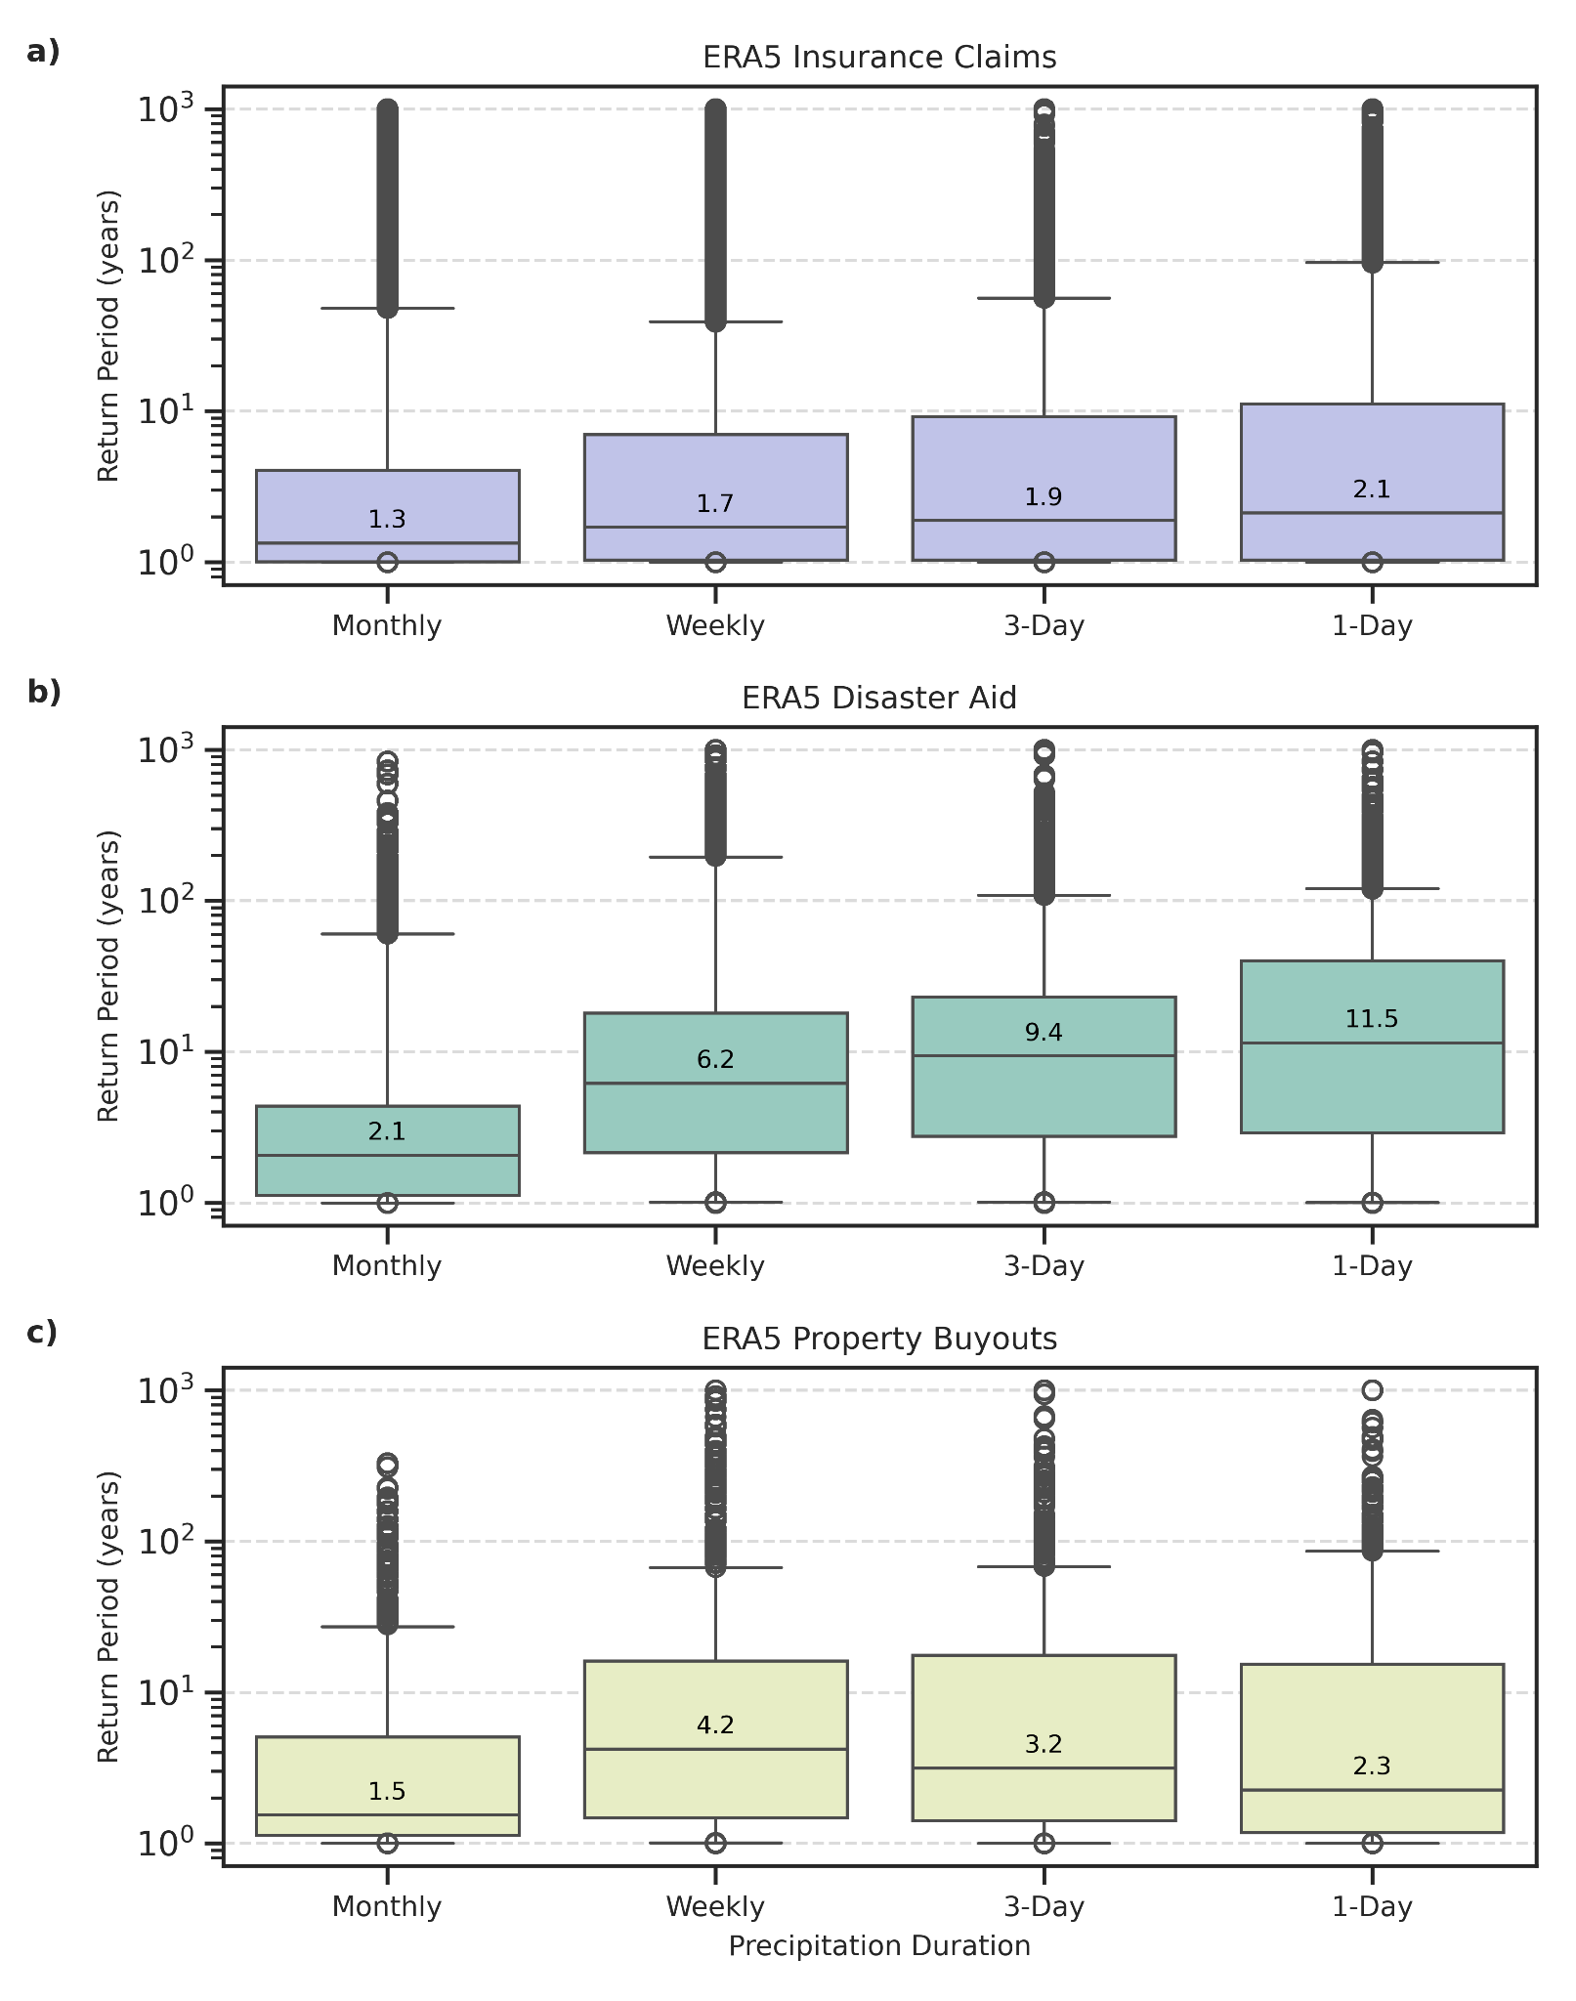
Caption: Sensitivity of return period distribution calculations for financial loss data under varying precipitation event durations (maximum daily, three-day, weekly, and 30-day precipitation event within 30 days of declaration for the county) across the ERA5 dataset.

Figure E2: ERA5 Spatial Distribution of Return Periods by Financing Type
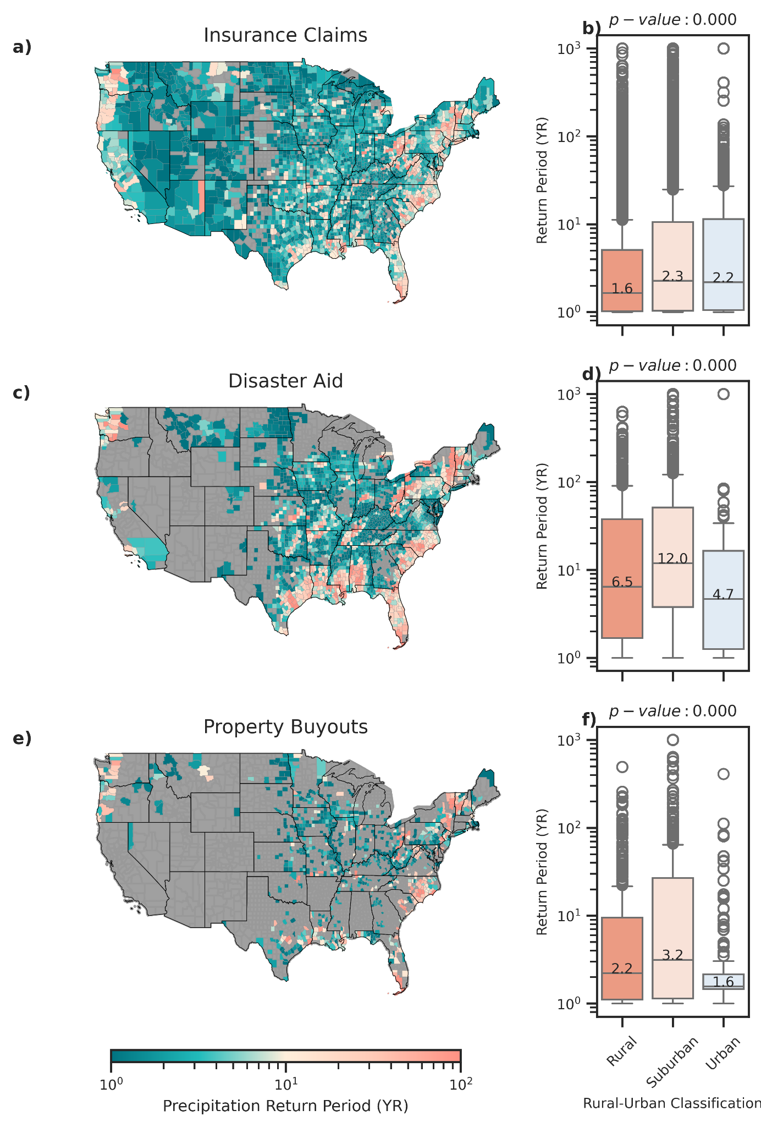
Caption: Spatial distribution and rural-urban classification of mean county-level precipitation return periods associated with varying modes of federal flood loss financing: insurance claims (panel a, b), disaster aid (panel c, d), property buyouts (panel e, f). Rural-urban classifications are derived from the US CDC National Center for Health Statistics’ Urban-Rural Classification Scheme. Return periods (in years) reflect the maximum daily precipitation event within 30 days preceding declaration or date of loss modeled by county-fitted stationary GEV distribution using ERA5 daily precipitation data. One-way ANOVA tests across all three forms of financial support statistically significant differences between rural, suburban, and urban return periods (p<0.001).

Figure E3: ERA5 Types of Flood-Related Presidential Declarations
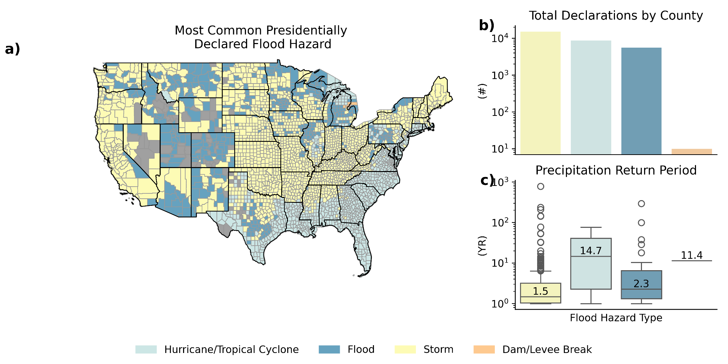
Caption: Overview of flood-related presidentially declared disasters by type. Panel a) reflects the mode of most commonly-declared event by CONUS county. Panel b) reflects the raw counts by event type per county of declaration. Panel c) shows the distribution of the return period of the maximum daily precipitation event within 30 days of declaration for the county with the maximum return for each given disaster declaration in years modeled by county-fitted stationary GEV distribution using ERA5 daily precipitation data.

Figure E4: ERA5 Spatiotemporal Storm Clustering
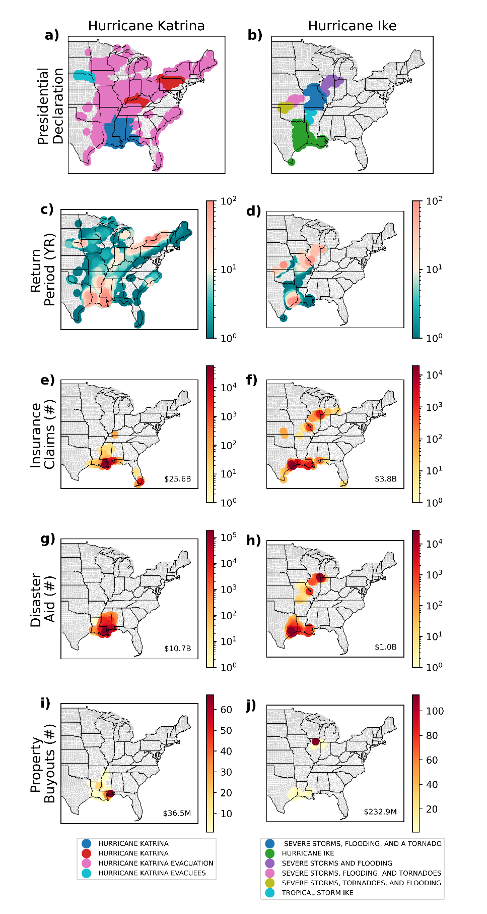
Caption: Visualization of spatiotemporal clustering for Hurricane Katrina and Hurricane Ike. Figure progresses from disaster declaration event types (panels a, b), their associated county-level precipitation return periods (panels c, d) to associated total counts of insurance claims (panels e, f), disaster aid (panels g, h), and property buyouts (panels i, j) with total damage costs in the lower right of each panel (CPI-adjusted). Clustering is conducted using ST-DBSCAN with a 3 degree latitude/longitude space threshold, a time threshold of 5 days, and number threshold of 7 datapoints. Return periods reflect ERA5 daily maximum preceding precipitation within 30 days of the reported loss.

Figure E5: ERA5 Return Period Sensitivity to Spatiotemporal Clustering
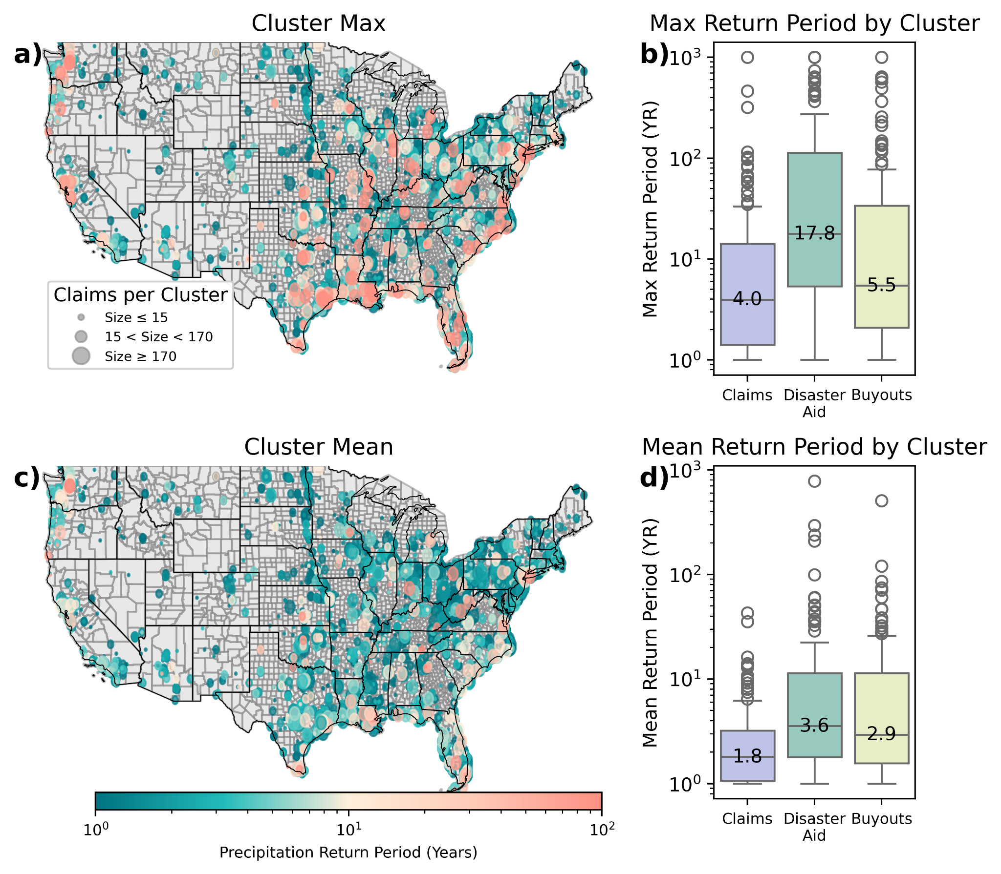
Caption: Spatiotemporally clustered financial losses across insurance claims (panels a, b, c, d), as well as disaster aid and buyouts (panels b and d). Clusters in panels a) and c) vary in size on the basis of the median cluster size (15) and 90th percentile cluster size (170). Clusters are extracted using ST-DBSCAN with threshold parameters a space threshold of 3 degrees latitude/longitude, time threshold of 5 days, and a minimum cluster size of 7 as optimized under validation and sensitivity, as detailed in Section 9 of the SI. Return periods are in years and reflect the maximum daily precipitation event within 30 days preceding declaration for each given loss modeled by county-fitted stationary GEV distribution using ERA5 daily precipitation data.

Figure E7: ERA5 Summary of Costs and Return Periods by Financing Type
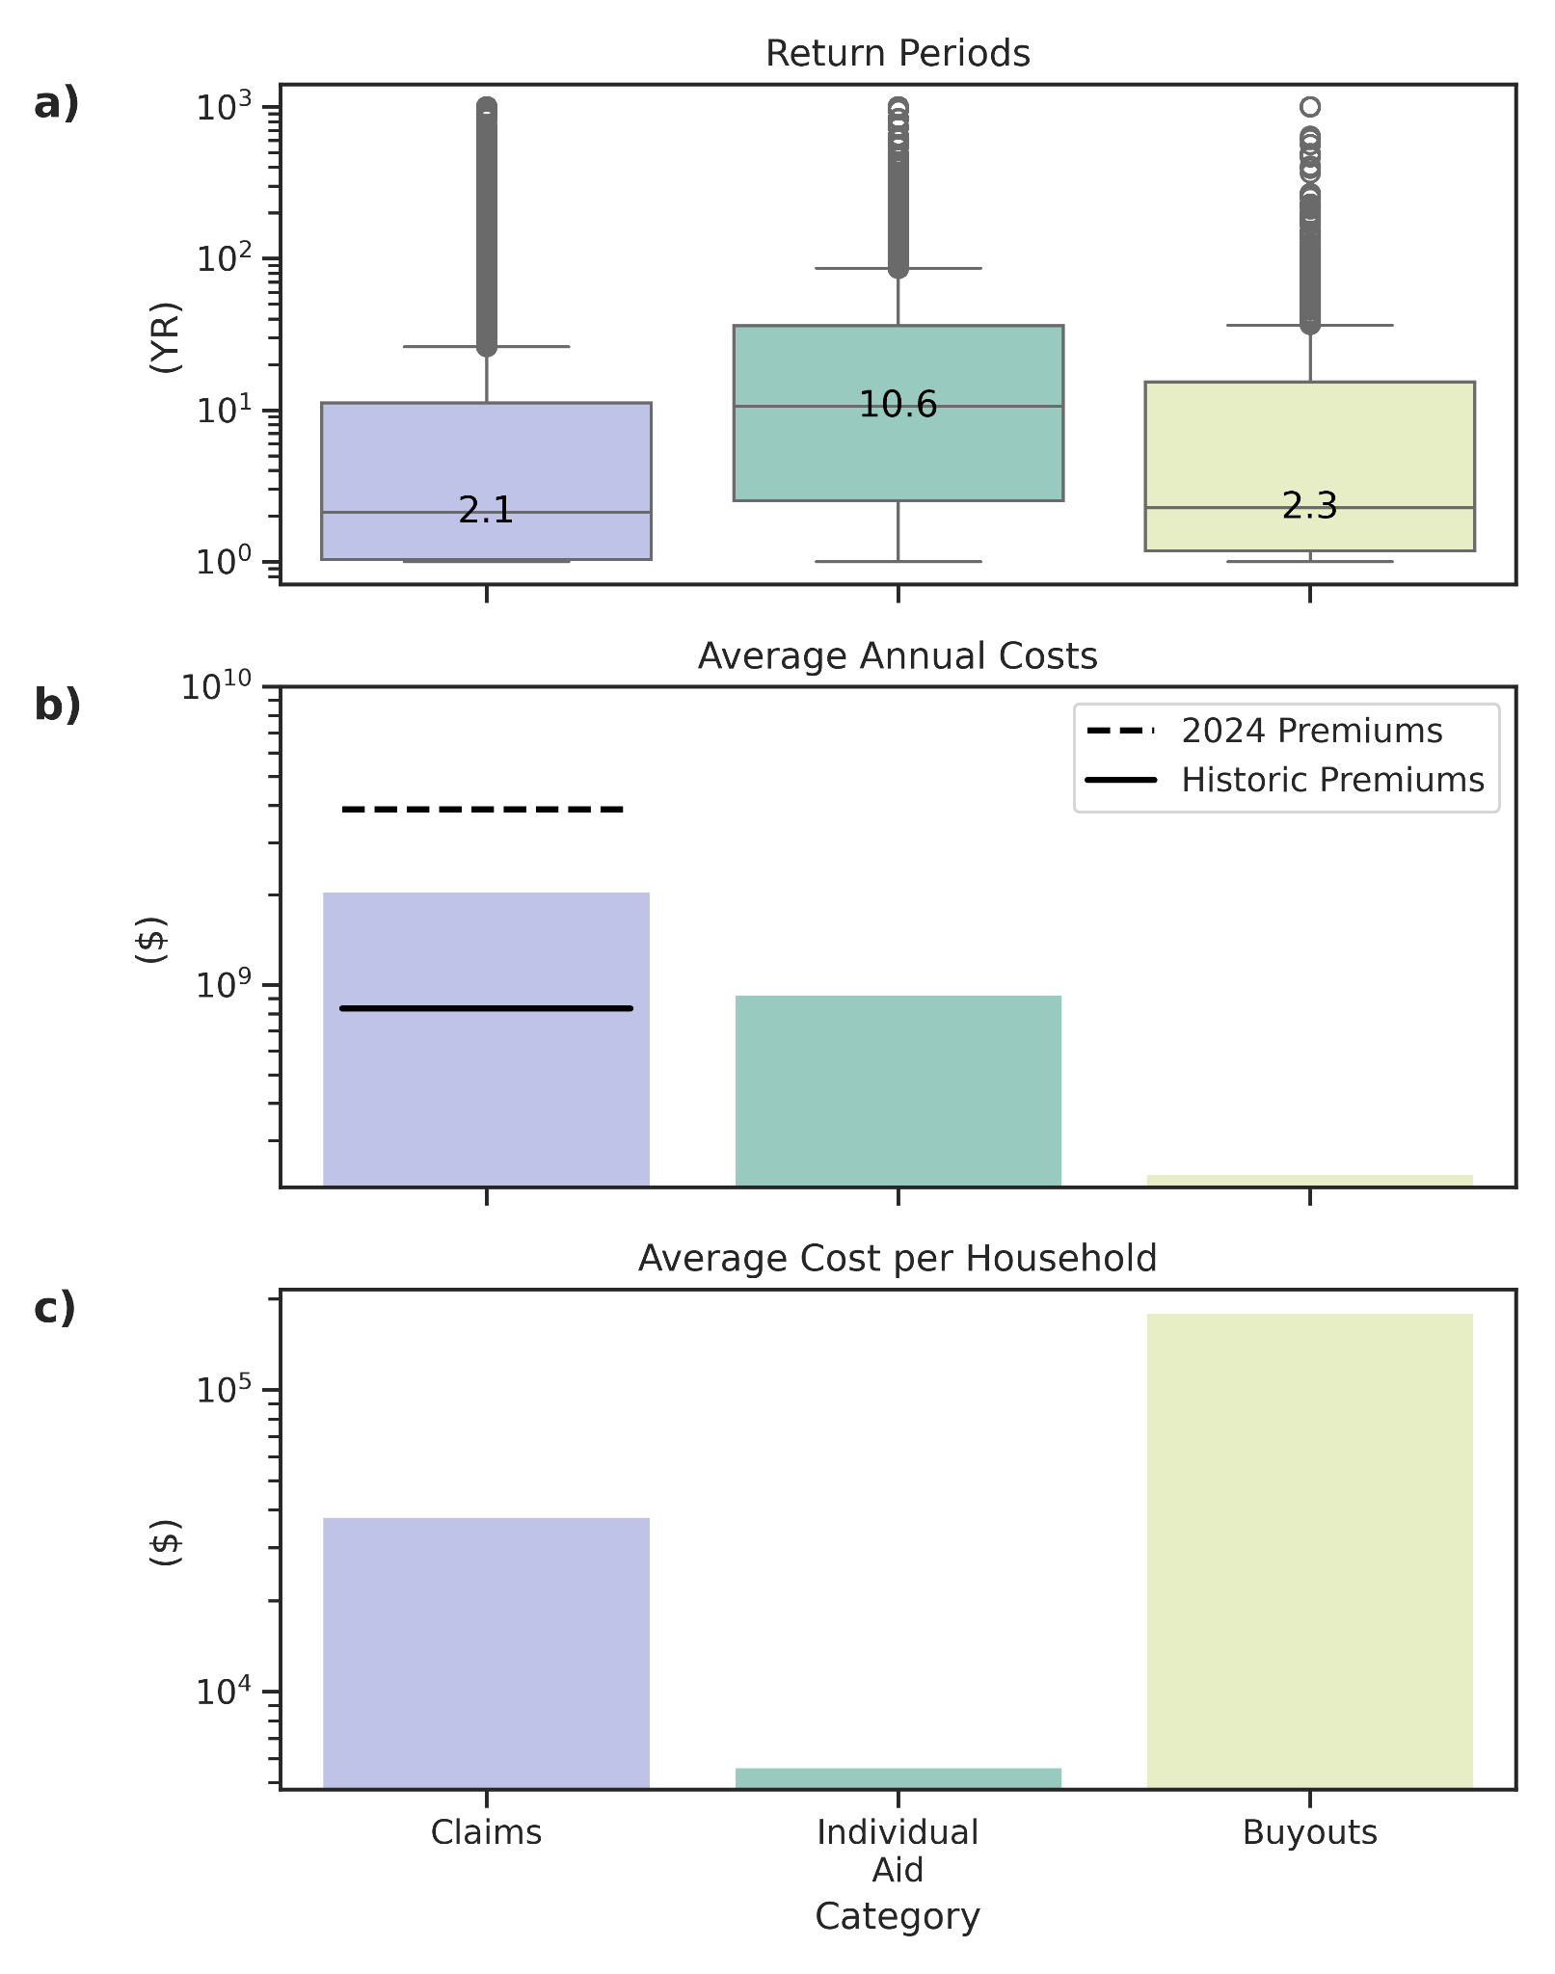
Caption: Summary of return periods, aggregate national annualized costs, and costs per household across various forms of federal financial flood support: insurance claims, disaster aid, and property buyouts. Panel a) shows the distribution of the return period in years of the maximum daily precipitation event within 30 days preceding declaration for each given loss modeled by county-fitted stationary GEV distribution using ERA5 daily precipitation data. Costs in panels b) and c) are inflation-adjusted using CPI-U values the US Bureau of Labor Statistics based upon the reported event date. All records are obtained from OpenFEMA.

5) MSWEP: Sensitivity to Event Duration
In the following section, we provide identical plots to main text Figures 1-5 and Figure 7 using different precipitation event duration metrics including maximum 3-day (Figures D2-D5, D7), 7-day (Figures W2-W5, W7), and 30-day running sums (Figures M2-M5, M7) within 30 days prior to the event. Sensitivity reveals consistently low return period estimates. Return periods are largely lower on average across estimates than those reported across the main text.

A) Three-Day

Figure D2: Max 3-Day Spatial Distribution of Return Periods by Financing Type
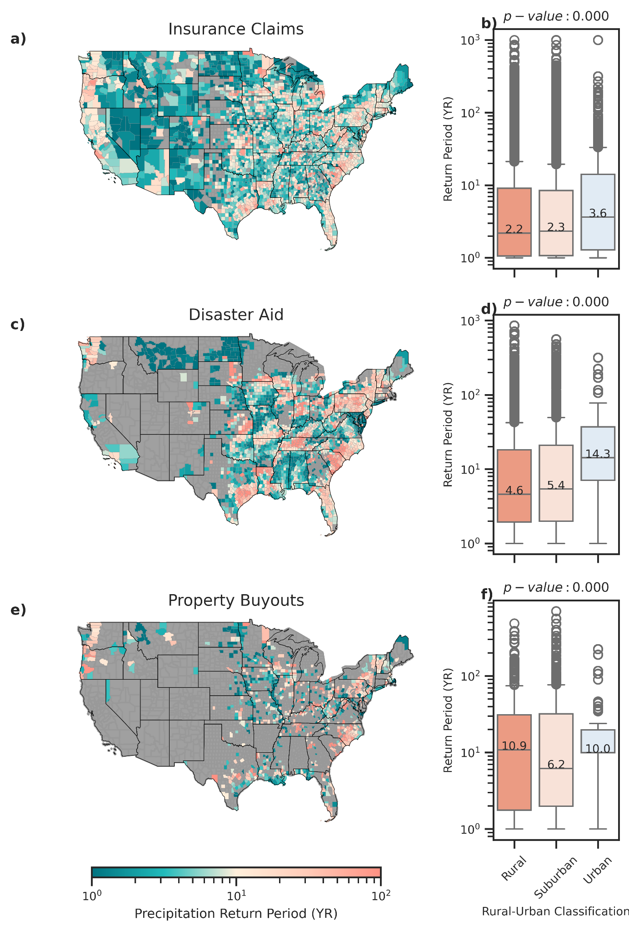
Caption: Spatial distribution and rural-urban classification of mean county-level precipitation return periods associated with varying modes of federal flood loss financing: insurance claims (panel a, b), disaster aid (panel c, d), property buyouts (panel e, f). Rural-urban classifications are derived from the US CDC National Center for Health Statistics’ Urban-Rural Classification Scheme. Return periods (in years) reflect the maximum daily precipitation event within 30 days preceding declaration or date of loss modeled by county-fitted stationary GEV distribution using MSWEP 3-day precipitation data. One-way ANOVA tests across all three forms of financial support statistically significant differences between rural, suburban, and urban return periods (p<0.001).

Figure D3: Max 3-Day Types of Flood-Related Presidential Declarations
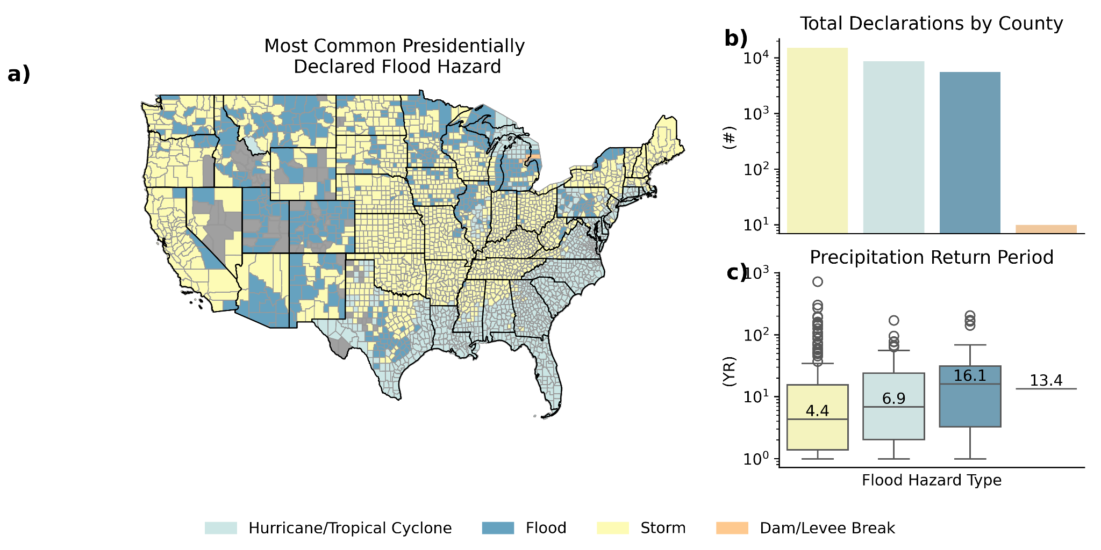
Caption: Overview of flood-related presidentially declared disasters by type. Panel a) reflects the mode of most commonly-declared event by CONUS county. Panel b) reflects the raw counts by event type per county of declaration. Panel c) shows the distribution of the return period of the max daily precipitation event within 30 days preceding declaration for the county with the maximum return for each given disaster declaration in years modeled by county-fitted stationary GEV distribution using MSWEP daily precipitation data.

Figure D4: Max 3-Day Spatiotemporal Storm Clustering
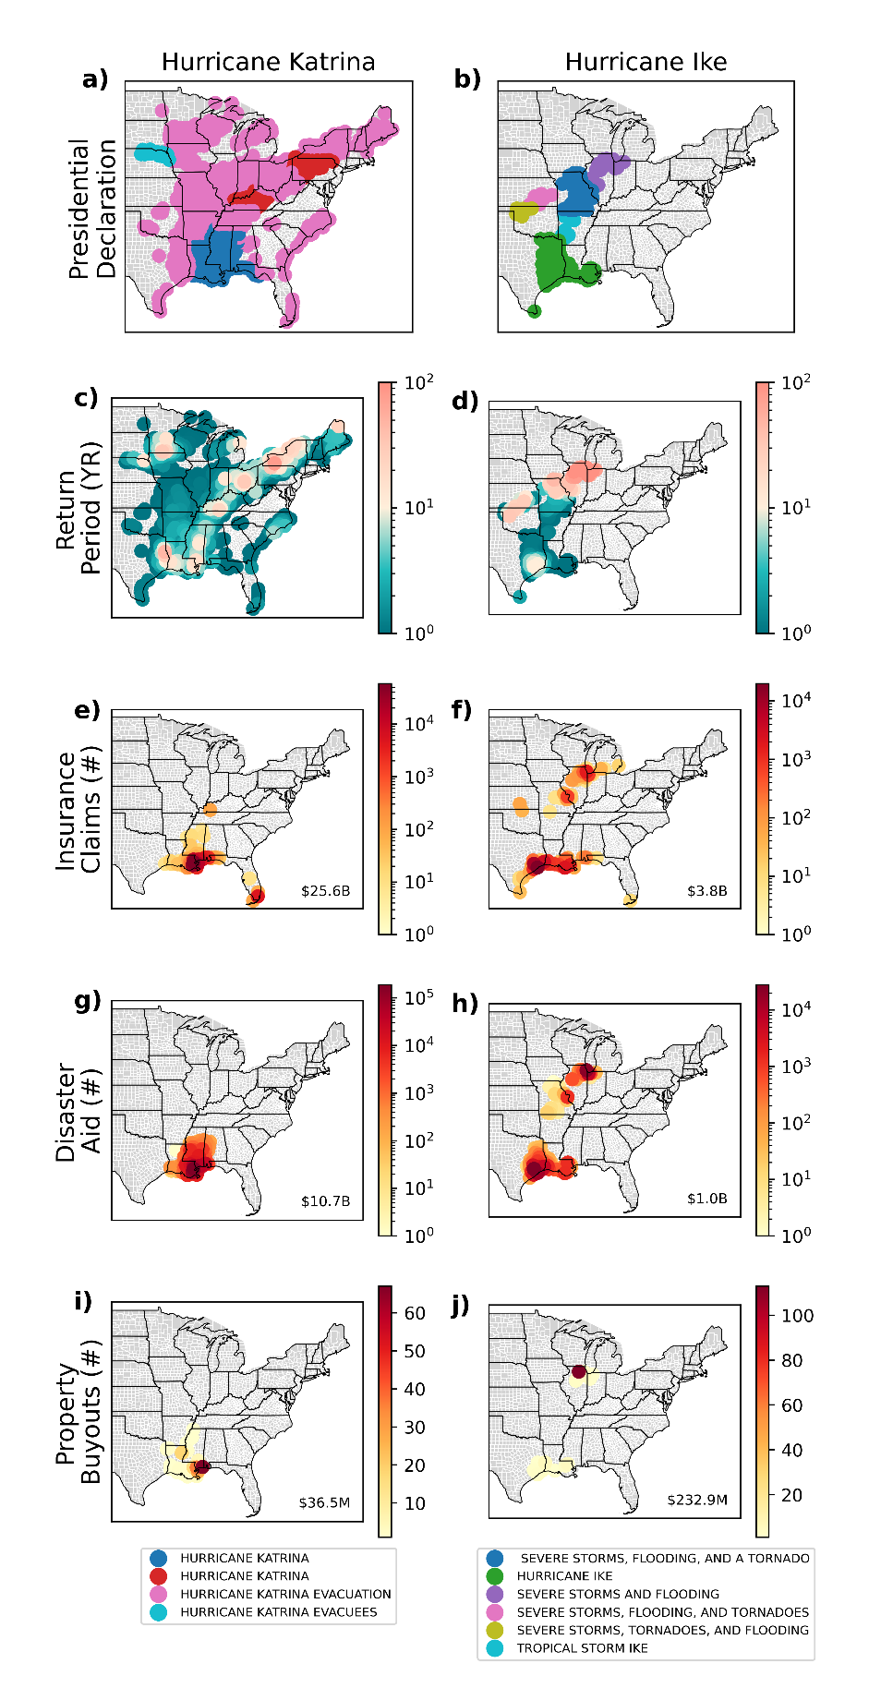
Caption: Visualization of spatio-temporal clustering for Hurricane Katrina and Hurricane Ike. Figure progresses from disaster declaration event types (panels a, b), their associated county-level precipitation return periods (panels c, d) to associated total counts of insurance claims (panels e, f), disaster aid (panels g, h), and property buyouts (panels i, j) with total damage costs in the lower right of each panel (CPI-adjusted). Clustering is conducted using ST-DBSCAN with a 3 degree latitude/longitude space threshold, a time threshold of 5 days, and number threshold of 7 datapoints. Return periods reflect MSWEP 3-day maximum preceding precipitation within 30 days of the reported loss.

Figure D5: Max 3-Day Return Period Sensitivity to Spatiotemporal Clustering
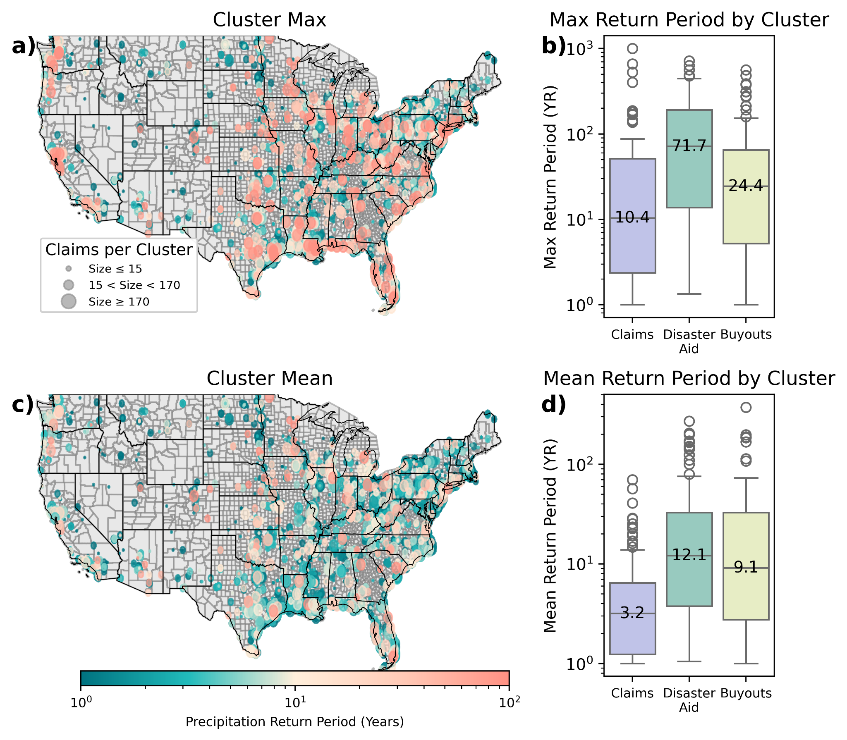
Caption: Spatiotemporally clustered financial losses across insurance claims (panels a, b, c, d), as well as disaster aid and buyouts (panels b and d). Clusters in panels a) and c) vary in size on the basis of the median cluster size (15) and 90th percentile cluster size (170). Clusters are extracted using ST-DBSCAN with threshold parameters a space threshold of 3 degrees latitude/longitude, time threshold of 5 days, and a minimum cluster size of 7 as optimized under validation and sensitivity, as detailed in Section 9 of the SI. Return periods are in years and reflect the maximum 3-day precipitation event within 30 days preceding declaration for each given loss modeled by county-fitted stationary GEV distribution using MSWEP daily precipitation data.

Figure D7: Max 3-Day Summary of Costs and Return Periods by Financing Type
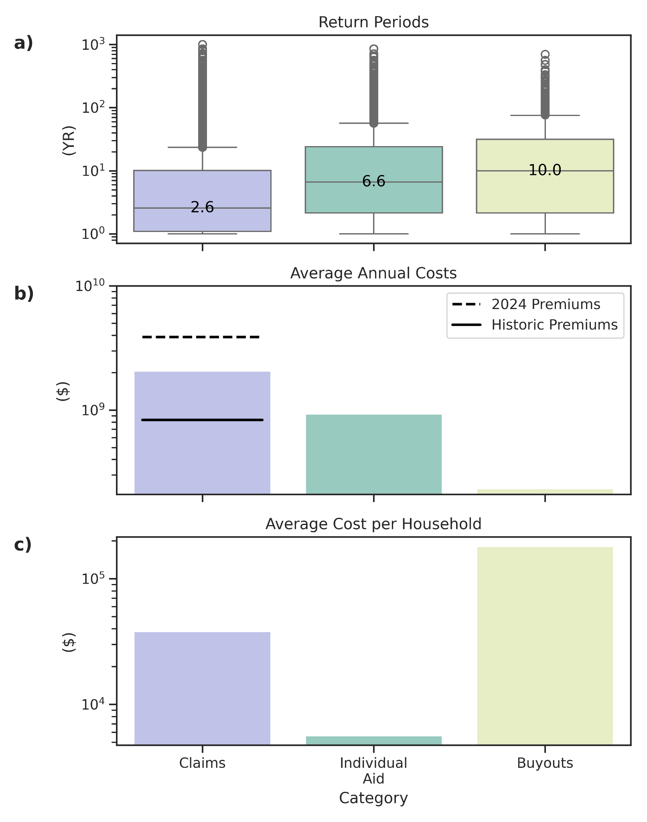
Caption: Summary of return periods, aggregate national annualized costs, and costs per household across various forms of federal financial flood support: insurance claims, disaster aid, and property buyouts. Panel a) shows the distribution of the return period in years of the maximum 1-day precipitation event within 30 days preceding declaration for each given loss modeled by county-fitted stationary GEV distribution using MSWEP daily precipitation data. Costs in panels b) and c) are inflation-adjusted using CPI-U values the US Bureau of Labor Statistics based upon the reported event date. All records are obtained from OpenFEMA.

B) Weekly

Figure W2: Weekly Spatial Distribution of Return Periods by Financing Type
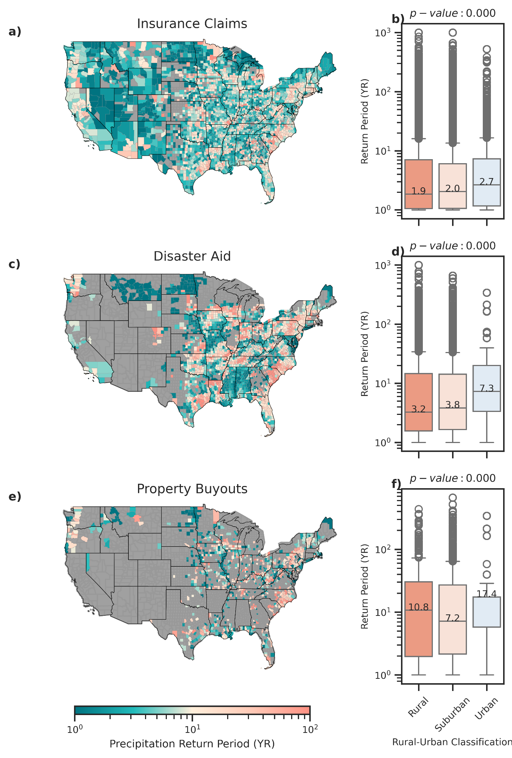
Caption: Spatial distribution and rural-urban classification of mean county-level precipitation return periods associated with varying modes of federal flood loss financing: insurance claims (panel a, b), disaster aid (panel c, d), property buyouts (panel e, f). Rural-urban classifications are derived from the US CDC National Center for Health Statistics’ Urban-Rural Classification Scheme. Return periods (in years) reflect the maximum daily precipitation event within 30 days preceding declaration or date of loss modeled by county-fitted stationary GEV distribution using MSWEP weekly precipitation data. One-way ANOVA tests across all three forms of financial support statistically significant differences between rural, suburban, and urban return periods (p<0.001).

Figure W3: Weekly Types of Flood-Related Presidential Declarations
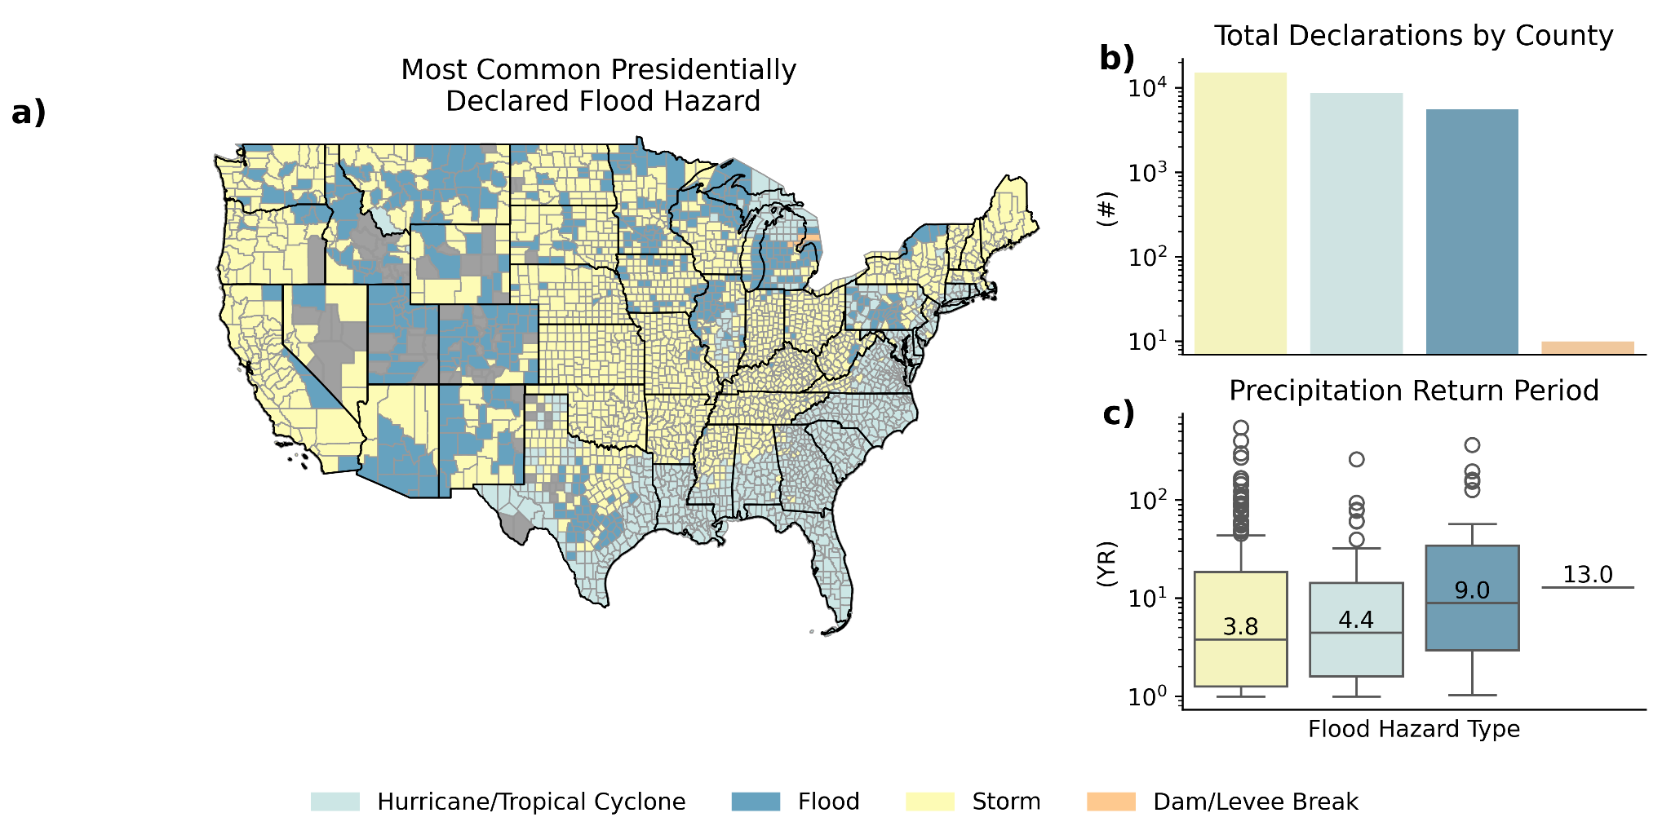
Caption: Overview of flood-related presidentially declared disasters by type. Panel a) reflects the mode of most commonly-declared event by CONUS county. Panel b) reflects the raw counts by event type per county of declaration. Panel c) shows the distribution of the return period of the 7-day precipitation event preceding declaration for the county with the maximum return for each given disaster declaration in years modeled by county-fitted stationary GEV distribution using MSWEP daily precipitation data.

Figure W4: Weekly Spatiotemporal Storm Clustering
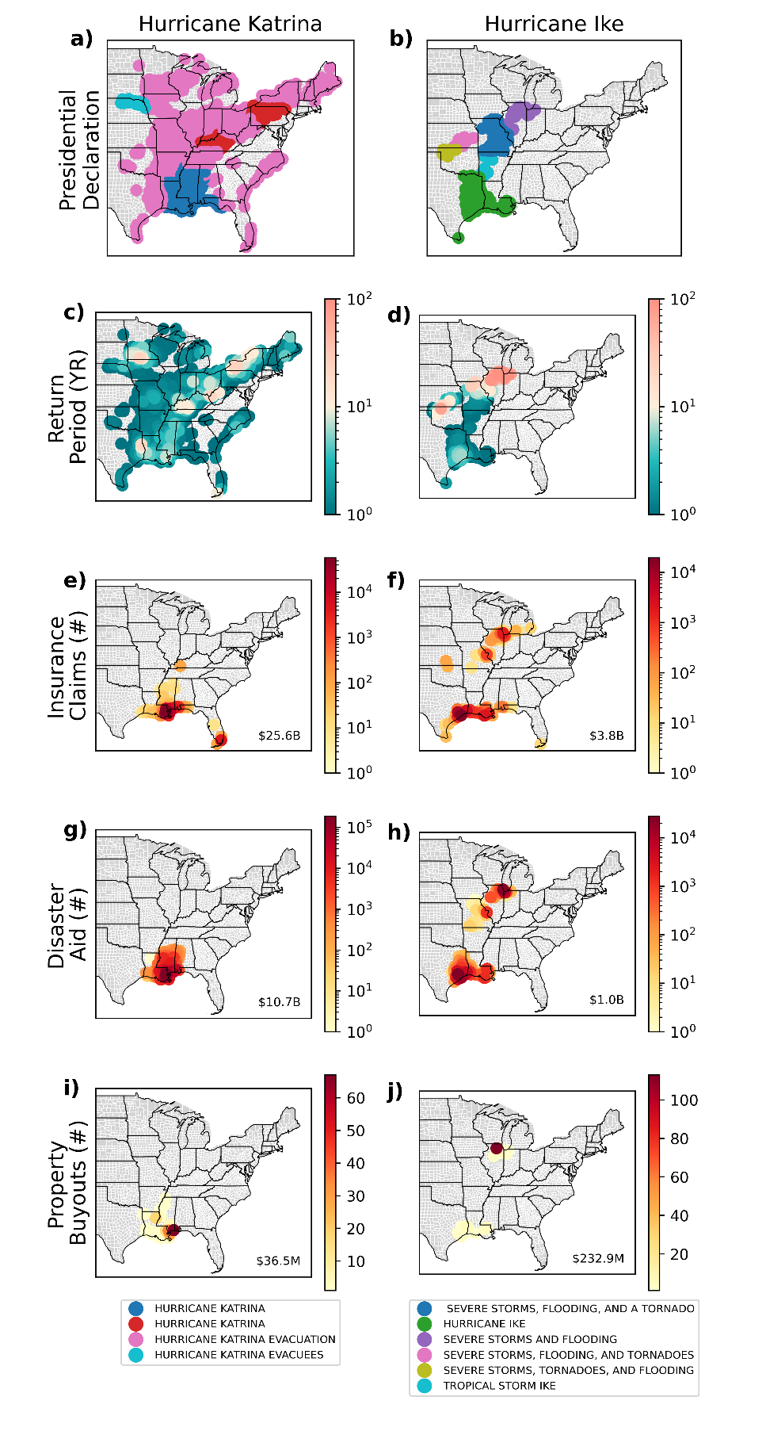
Caption: Visualization of spatio-temporal clustering for Hurricane Katrina and Hurricane Ike. Figure progresses from disaster declaration event types (panels a, b), their associated county-level precipitation return periods (panels c, d) to associated total counts of insurance claims (panels e, f), disaster aid (panels g, h), and property buyouts (panels i, j) with total damage costs in the lower right of each panel (CPI-adjusted). Clustering is conducted using ST-DBSCAN with a 3 degree latitude/longitude space threshold, a time threshold of 5 days, and number threshold of 7 datapoints. Return periods reflect MSWEP weekly maximum preceding precipitation within 30 days of the reported loss.

Figure W5: Weekly Return Period Sensitivity to Spatiotemporal Clustering
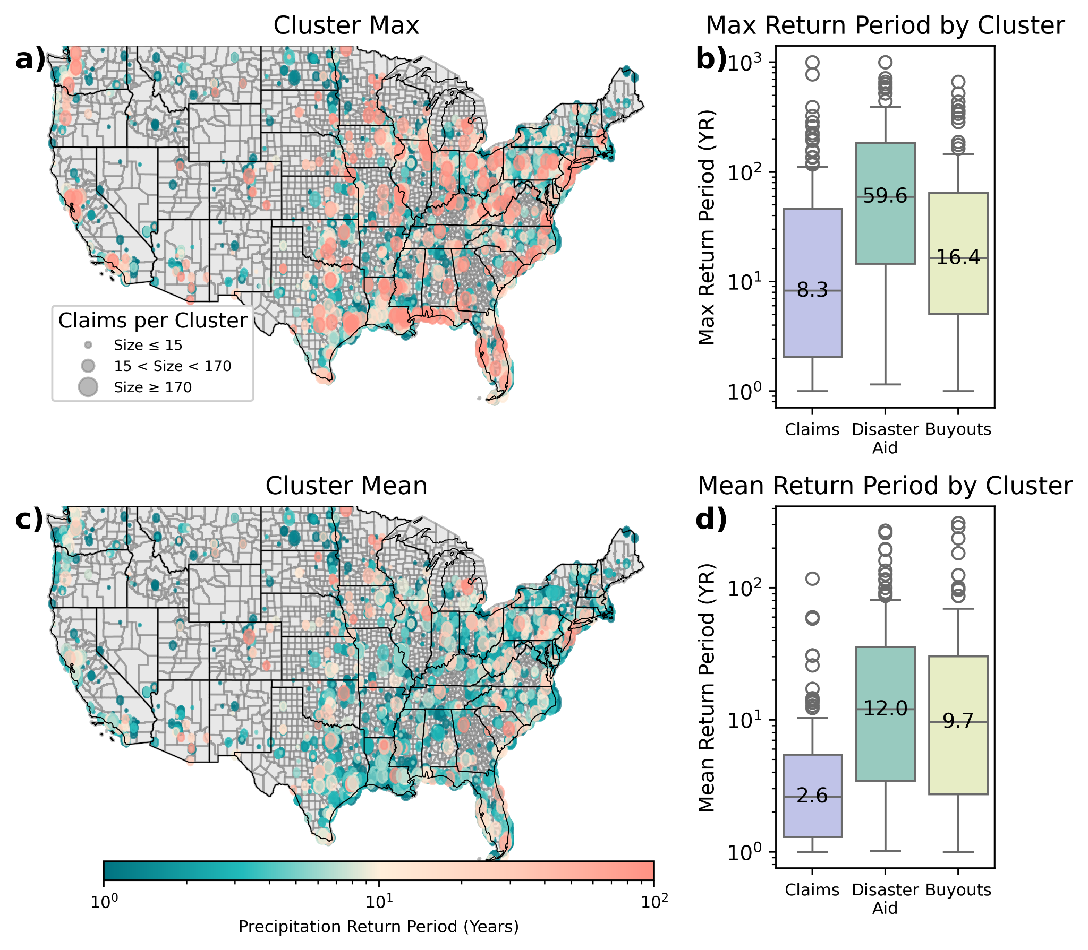
Caption: Spatiotemporally clustered financial losses across insurance claims (panels a, b, c, d), as well as disaster aid and buyouts (panels b and d). Clusters in panels a) and c) vary in size on the basis of the median cluster size (15) and 90th percentile cluster size (170). Clusters are extracted using ST-DBSCAN with threshold parameters a space threshold of 3 degrees latitude/longitude, time threshold of 5 days, and a minimum cluster size of 7 as optimized under validation and sensitivity, as detailed in Section 9 of the SI. Return periods are in years and reflect the maximum weekly precipitation event within 30 days preceding declaration for each given loss modeled by county-fitted stationary GEV distribution using MSWEP daily precipitation data.

Figure W7: Weekly Summary of Costs and Return Periods by Financing Type
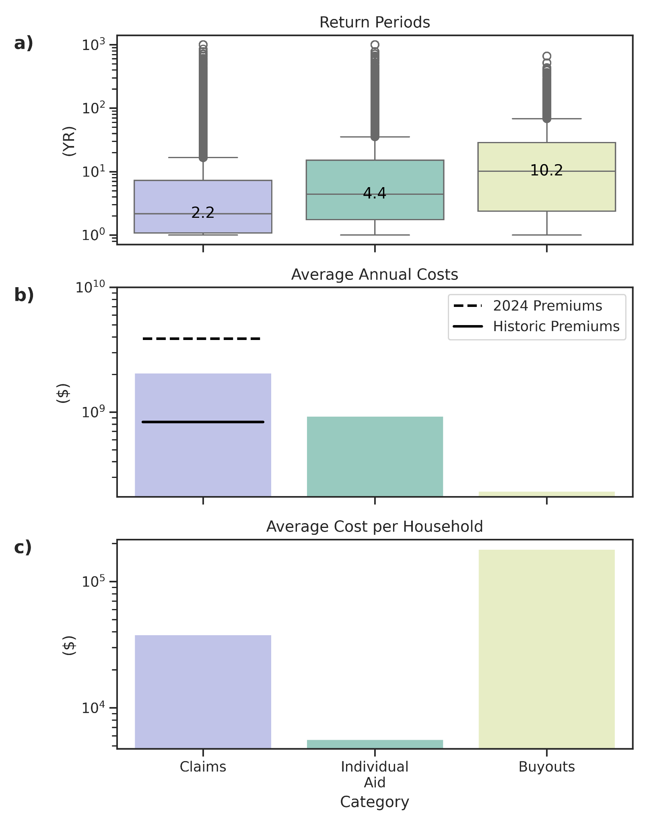
Caption: Summary of return periods, aggregate national annualized costs, and costs per household across various forms of federal financial flood support: insurance claims, disaster aid, and property buyouts. Panel a) shows the distribution of the return period in years of the 7-day precipitation event preceding declaration for each given loss modeled by county-fitted stationary GEV distribution using MSWEP daily precipitation data. Costs in panels b) and c) are inflation-adjusted using CPI-U values the US Bureau of Labor Statistics based upon the reported event date. All records are obtained from OpenFEMA.

C) Monthly

Figure M2: Monthly Spatial Distribution of Return Periods by Financing Type
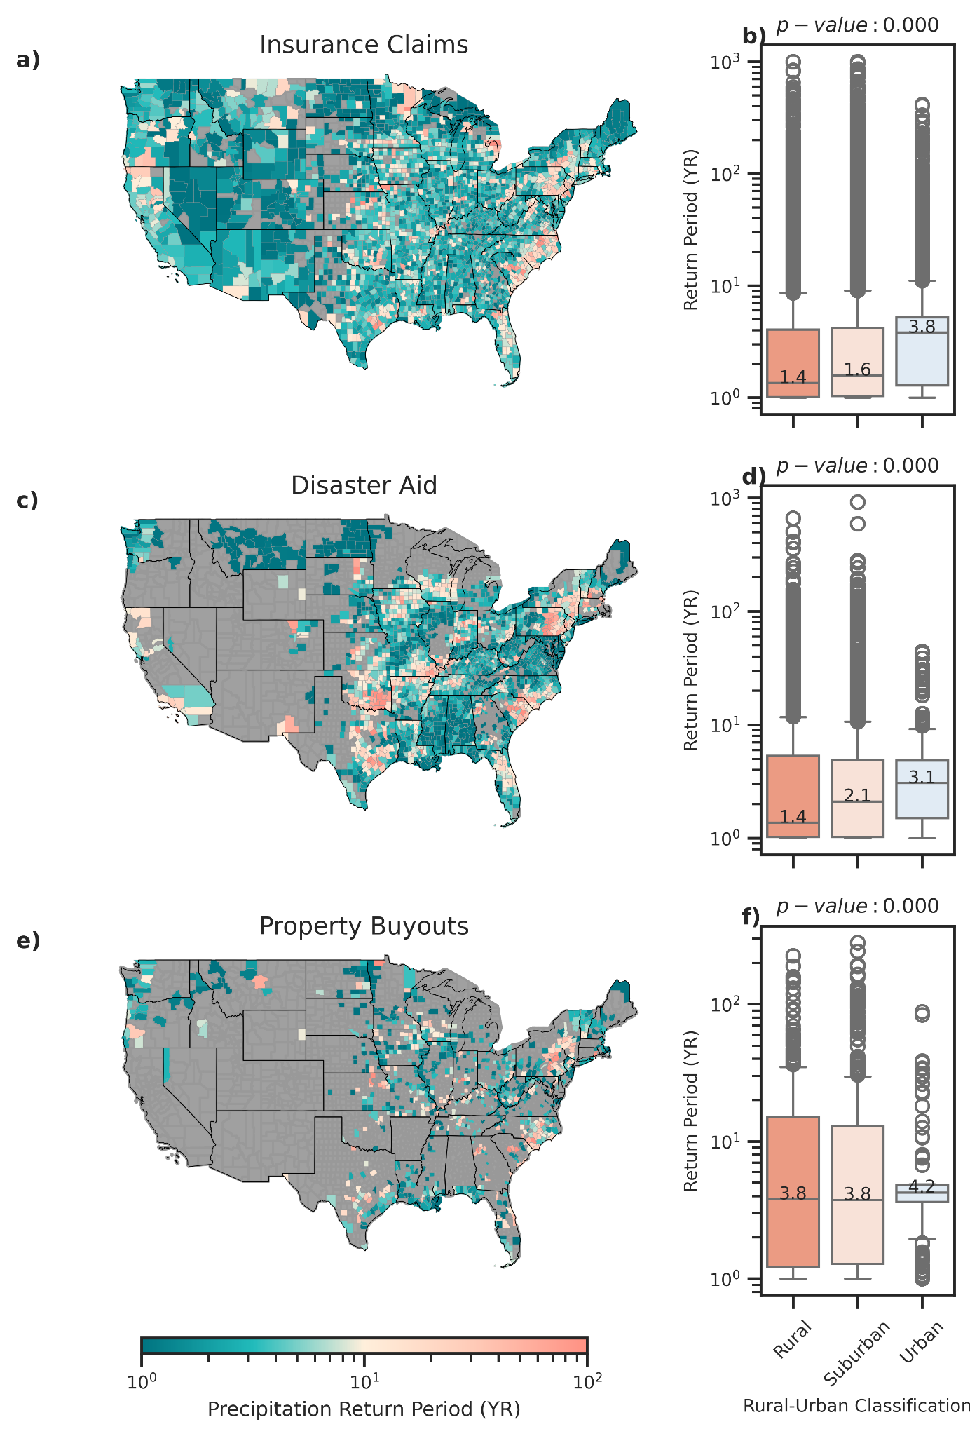
Caption: Spatial distribution and rural-urban classification of mean county-level precipitation return periods associated with varying modes of federal flood loss financing: insurance claims (panel a, b), disaster aid (panel c, d), property buyouts (panel e, f). Rural-urban classifications are derived from the US CDC National Center for Health Statistics’ Urban-Rural Classification Scheme. Return periods (in years) reflect the maximum daily precipitation event within 30 days preceding declaration or date of loss modeled by county-fitted stationary GEV distribution using MSWEP monthly precipitation data. One-way ANOVA tests across all three forms of financial support statistically significant differences between rural, suburban, and urban return periods (p<0.001).

Figure M3: Monthly Types of Flood-Related Presidential Declarations
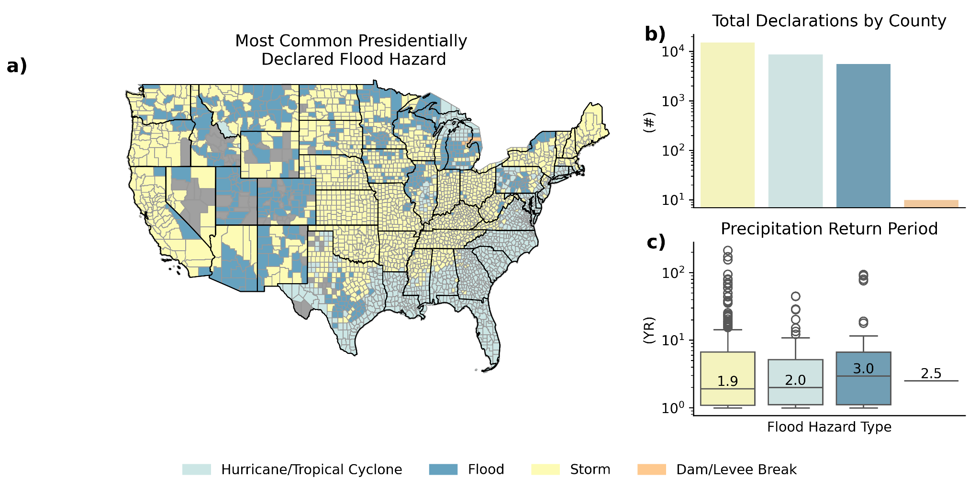
Caption: Overview of flood-related presidentially declared disasters by type. Panel a) reflects the mode of most commonly-declared event by CONUS county. Panel b) reflects the raw counts by event type per county of declaration. Panel c) shows the distribution of the return period of the 30-day precipitation event preceding declaration for the county with the maximum return for each given disaster declaration in years modeled by county-fitted stationary GEV distribution using MSWEP daily precipitation data.

Figure M4: Monthly Spatiotemporal Storm Clustering
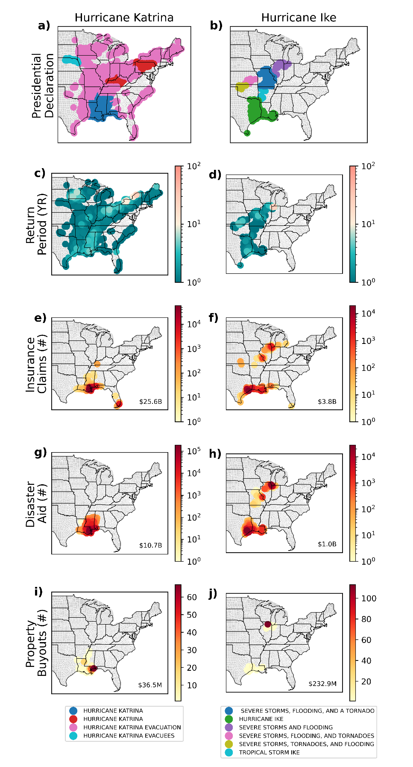
Caption: Visualization of spatio-temporal clustering for Hurricane Katrina and Hurricane Ike. Figure progresses from disaster declaration event types (panels a, b), their associated county-level precipitation return periods (panels c, d) to associated total counts of insurance claims (panels e, f), disaster aid (panels g, h), and property buyouts (panels i, j) with total damage costs in the lower right of each panel (CPI-adjusted). Clustering is conducted using ST-DBSCAN with a 3 degree latitude/longitude space threshold, a time threshold of 5 days, and number threshold of 7 datapoints. Return periods reflect MSWEP monthly maximum preceding precipitation within 30 days of the reported loss.

Figure M5: Monthly Return Period Sensitivity to Spatiotemporal Clustering
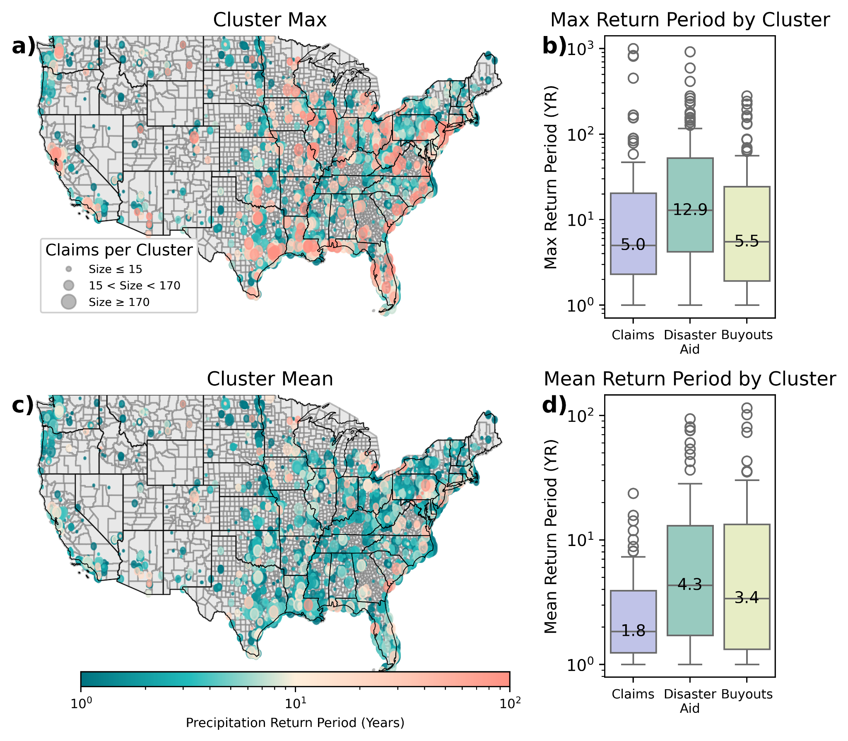
Caption: Spatiotemporally clustered financial losses across insurance claims (panels a, b, c, d), as well as disaster aid and buyouts (panels b and d). Clusters in panels a) and c) vary in size on the basis of the median cluster size (15) and 90th percentile cluster size (170). Clusters are extracted using ST-DBSCAN with threshold parameters a space threshold of 3 degrees latitude/longitude, time threshold of 5 days, and a minimum cluster size of 7 as optimized under validation and sensitivity, as detailed in Section 9 of the SI. Return periods are in years and reflect the maximum monthly precipitation event within 30 days preceding declaration for each given loss modeled by county-fitted stationary GEV distribution using MSWEP daily precipitation data.

Figure M7: Monthly Summary of Costs and Return Periods by Financing Type
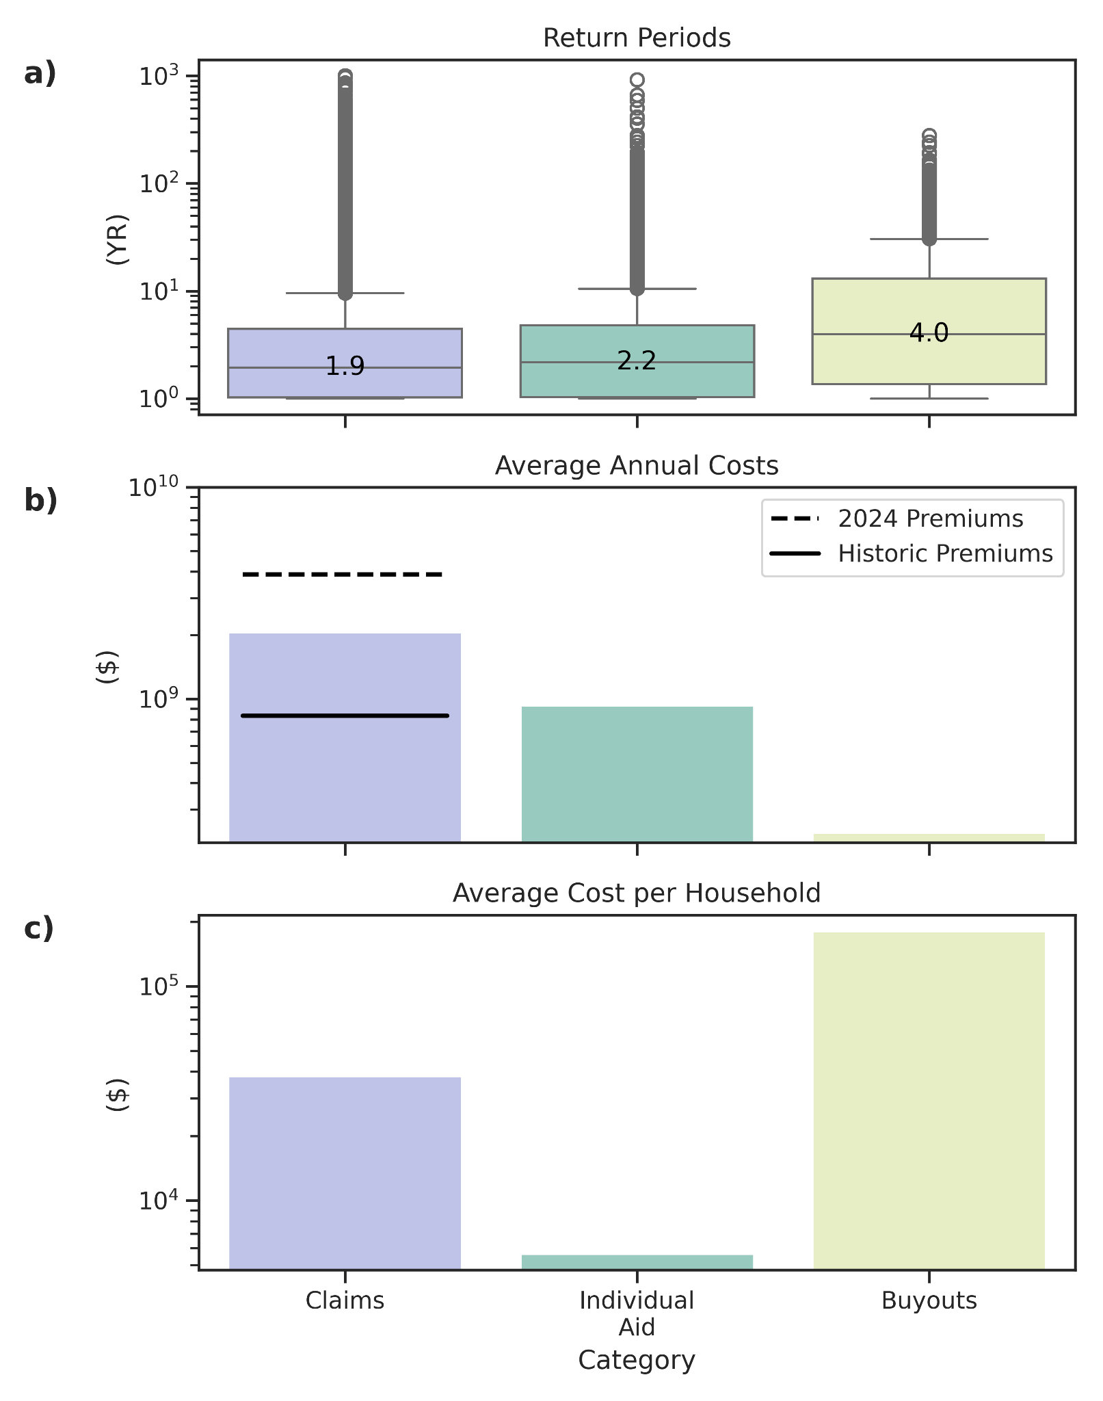
Caption: Summary of return periods, aggregate national annualized costs, and costs per household across various forms of federal financial flood support: insurance claims, disaster aid, and property buyouts. Panel a) shows the distribution of the return period in years of the 30-day precipitation event preceding declaration for each given loss modeled by county-fitted stationary GEV distribution using MSWEP daily precipitation data. Costs in panels b) and c) are inflation-adjusted using CPI-U values the US Bureau of Labor Statistics based upon the reported event date. All records are obtained from OpenFEMA.

6) PRISM: Monthly Percentile and Return Period Intercomparison
We also provide below a detailing of the percentiles, associated return periods and the spatial distributions of such percentiles and return periods across all three datasets for monthly precipitation associated with insurance claims. We see that PRISM again provides the highest estimate, and ERA5 the lowest. We underscore that since PRISM data is only monthly and cannot capture the exact preceding 30 days to the event this estimate is likely an overestimate and inaccurate. Despite this, we are seeing consistently low return periods under 10 years for monthly precipitation across all three datasets. Here we filter all 0th percentile data for each dataset, to compare across non-zero values.

Figure P1: Intercomparison of Percentiles/Return Periods Across Datasets
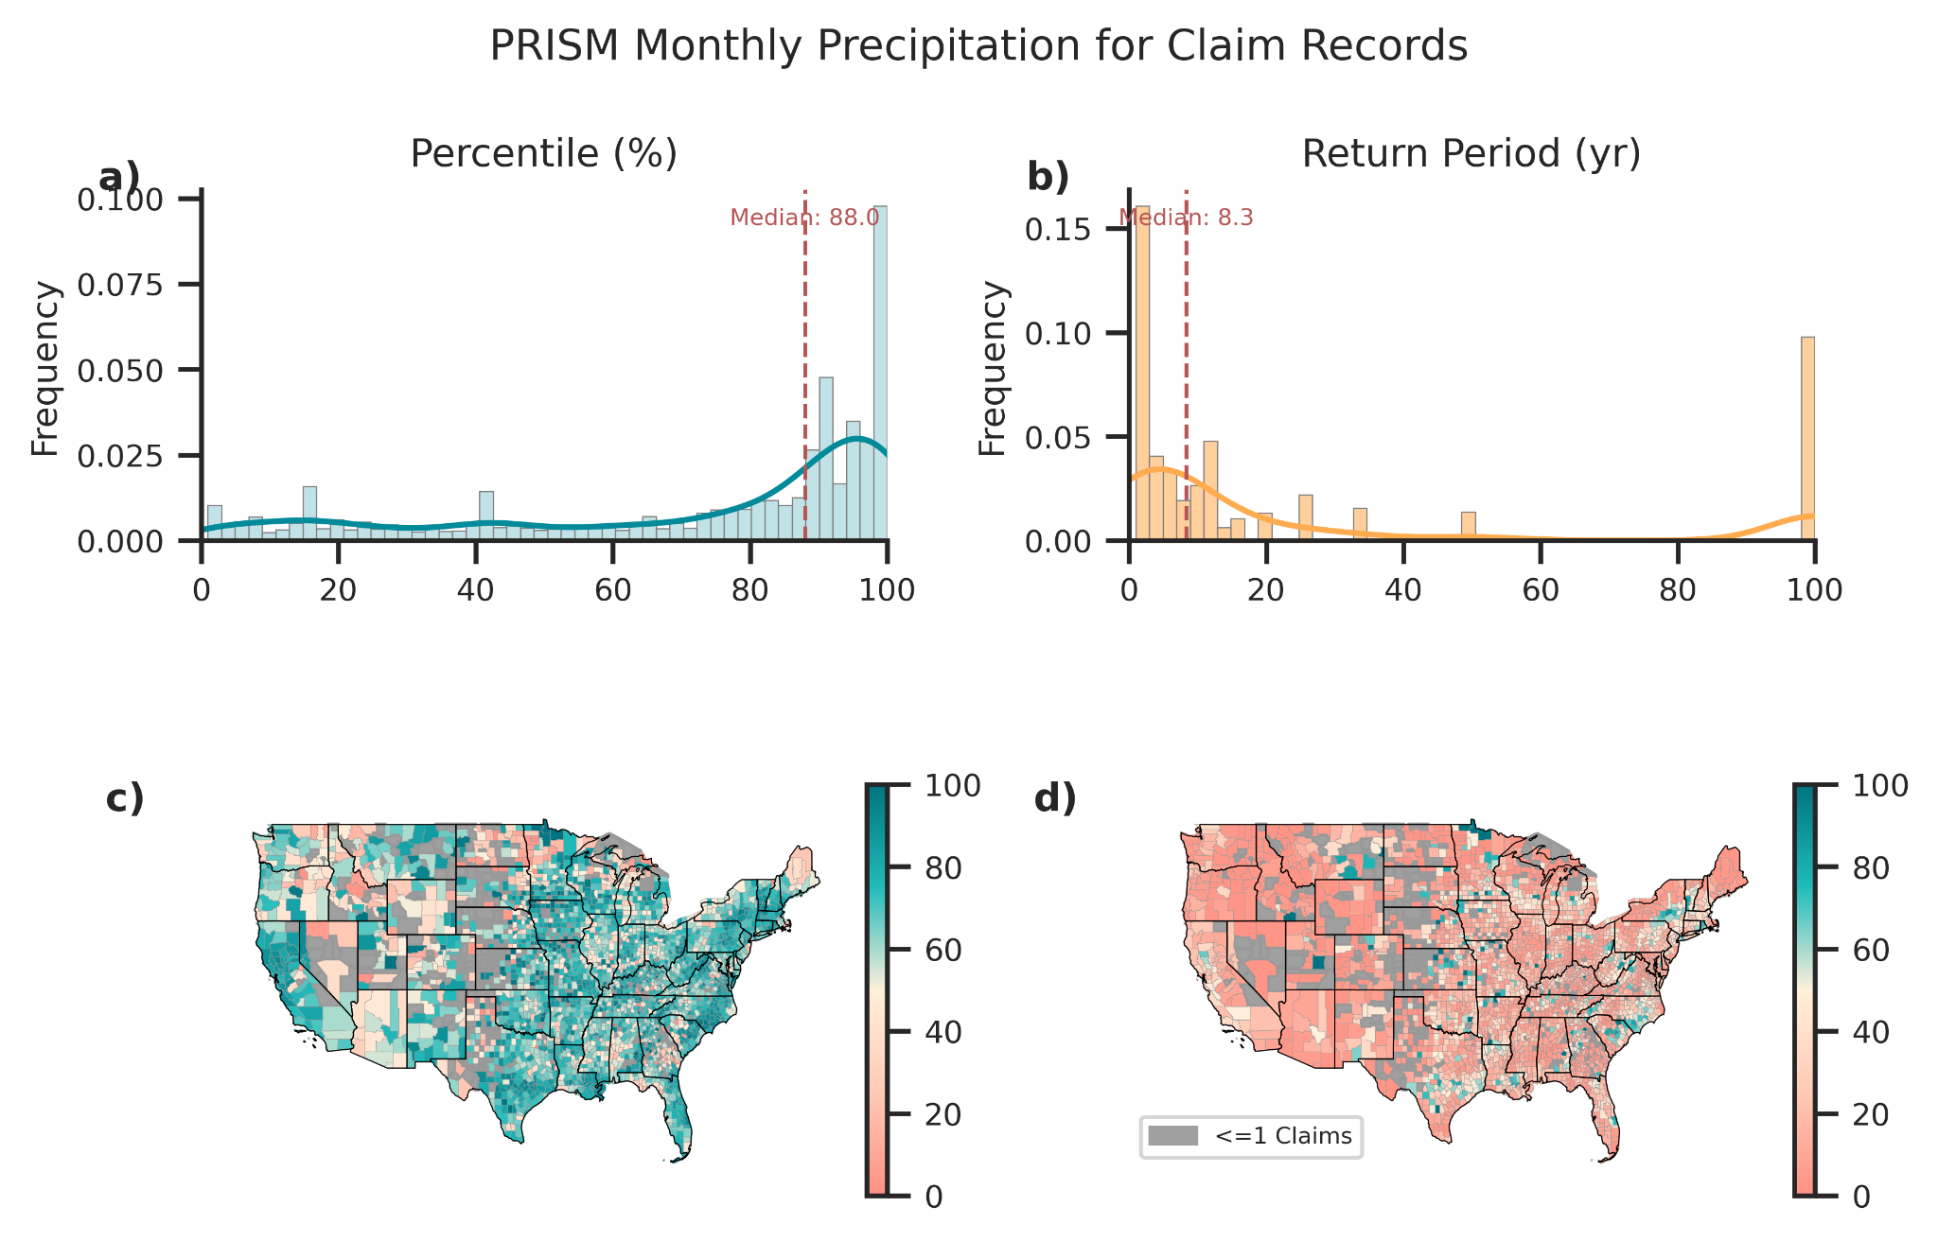
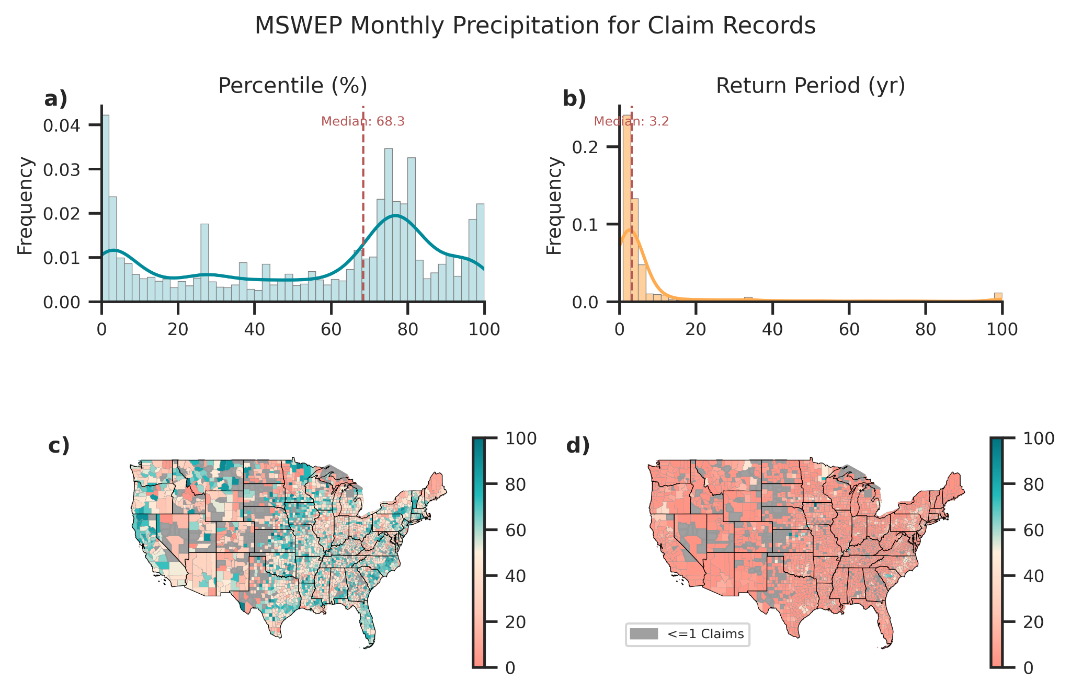
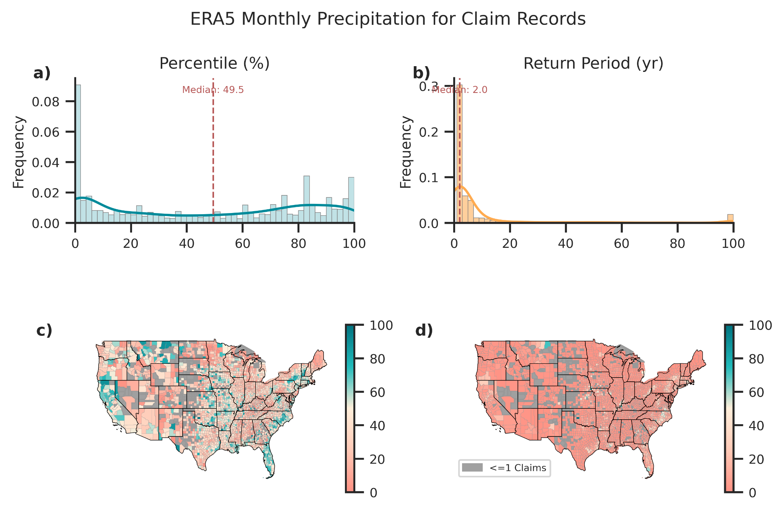
Caption: Associated monthly percentiles and return periods for precipitation associated with flood insurance claims across PRISM, ERA5, and MSWEP datasets. ERA5 and MSWEP datasets include the 30 days prior to the event, while PRISM denotes the monthly precipitation value of the month of the event.

7) ST-DBSCAN Parameterization Sensitivity Analysis

A) Cluster Claim Value and Return Period
Interestingly, we do find a significant correlation between damage and precipitation return period across clusters of claims for both the mean and maximum return periods within clusters for insurance claims. We also find no correlation between insurance claim damage and return period across unclustered claims. We report the result below in Figure S5.

Figure S1: Correlation Between Damage and Return Period
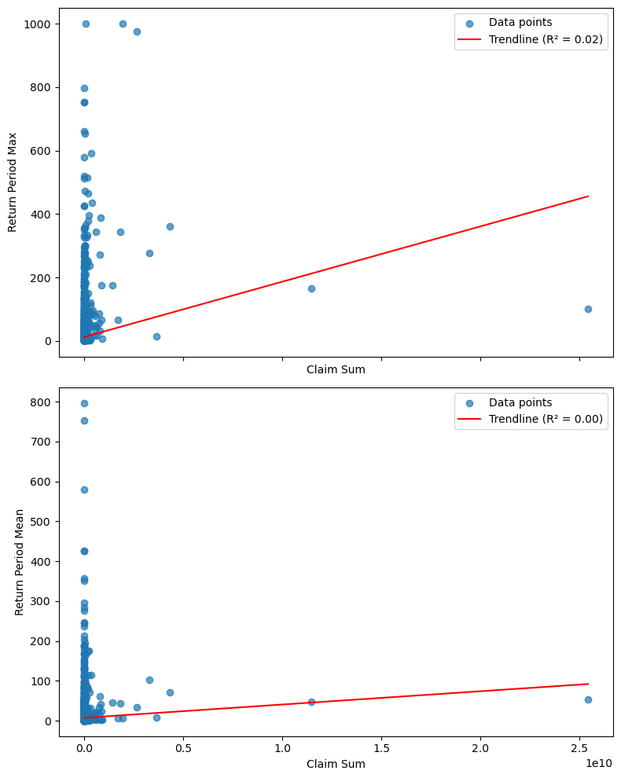
Caption: Correlation between sum of claims and the return period for associated precipitation events across clusters for both mean and max within clusters. We find no significant correlation using MSWEP daily maximum precipitation and CPI-adjusted claim sums.

B) Sensitivity Analysis: Cluster Attributes
Here we provide a thorough sensitivity analysis of the space, time, and number thresholds selected in the implementation of ST-DBSCAN. We provide pairplots across varying thresholds for all three parameters on the duration, latitude span, and longitudinal span focusing on averages, variance, and maximums across clusters. We also examine the number of clusters produced and the percent of data that is clustered. We chose cluster parameters using our validation metric of “disasterNumber” across the Presidential disaster dataset which allowed us to choose the minimum space, time, and number threshold parameters that also minimized the number of presidential disaster declaration numbers split between multiple clusters. This is shown in the top two pair plots in Figure S2. A time threshold of 5 days, a space threshold of 3 degrees (lat/long) and a number threshold of 7 data points allowed us to have no disasters split across clusters. The full table of combinations for cluster sensitivity can be found in our GitHub.

Figure S3: Sensitivity Analysis for Cluster Parameterization

Number of Split Cases between DisasterNumber
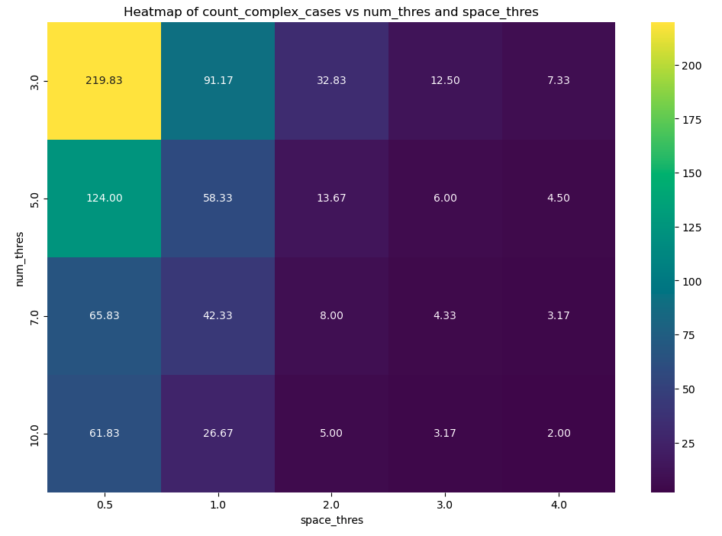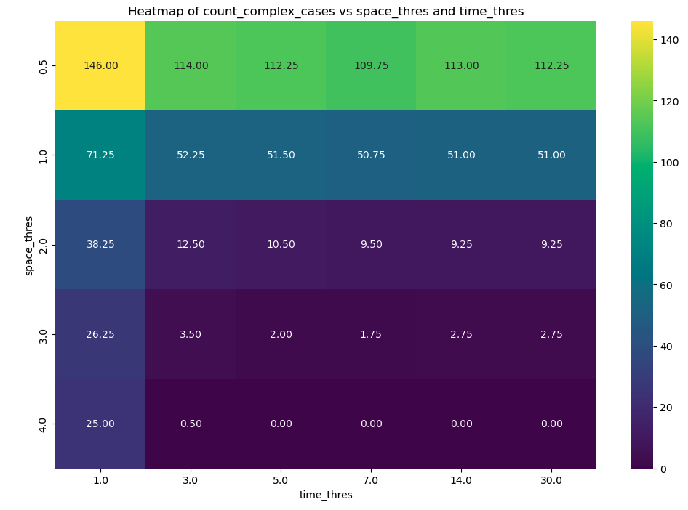

Percent Clustered
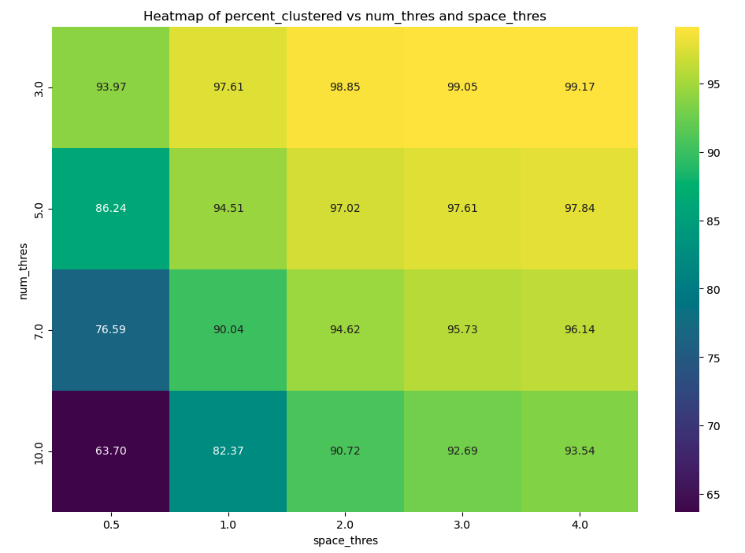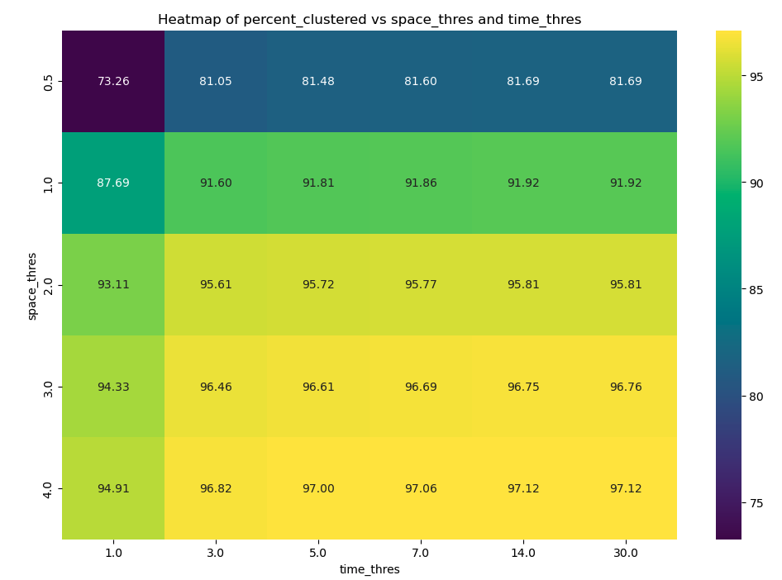

Average Cluster Duration

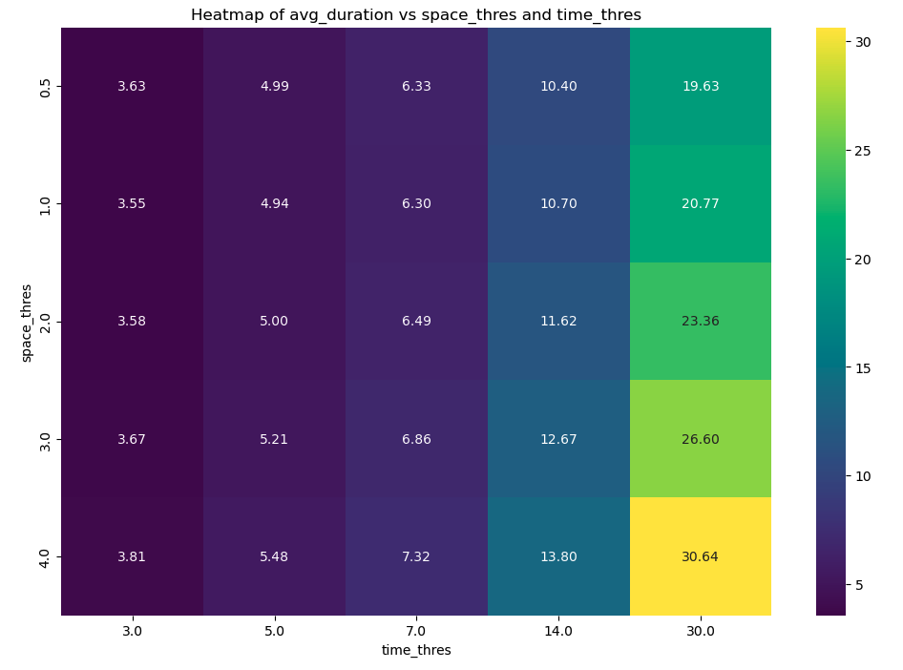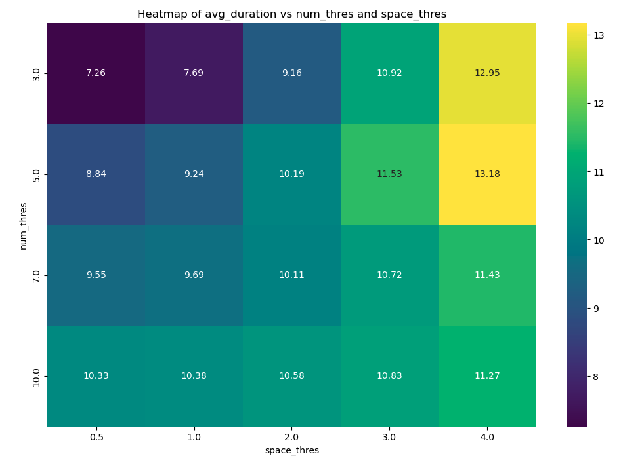

Average Longitudinal Span

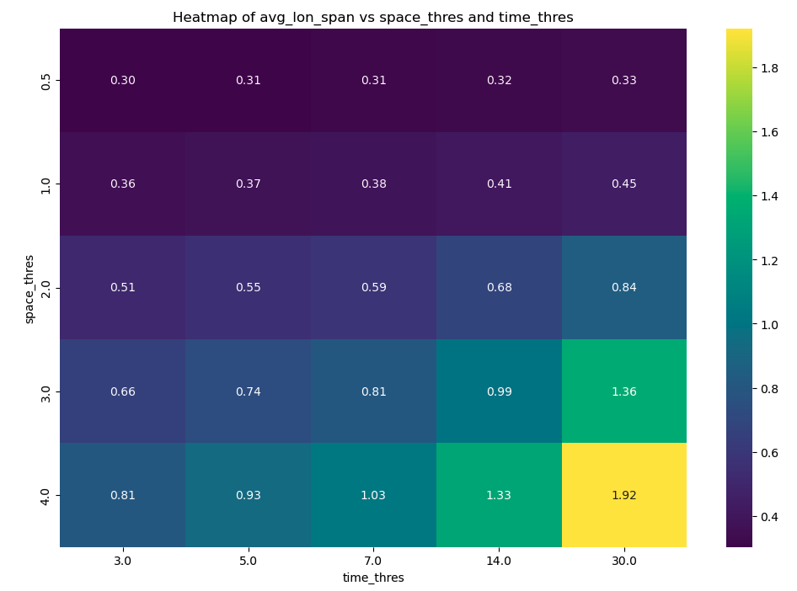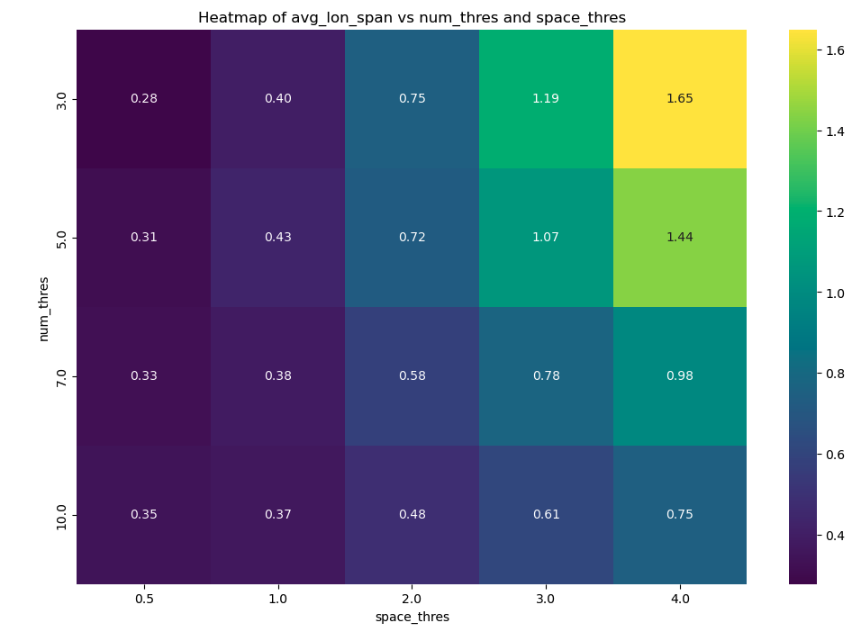

Average Latitudinal Span

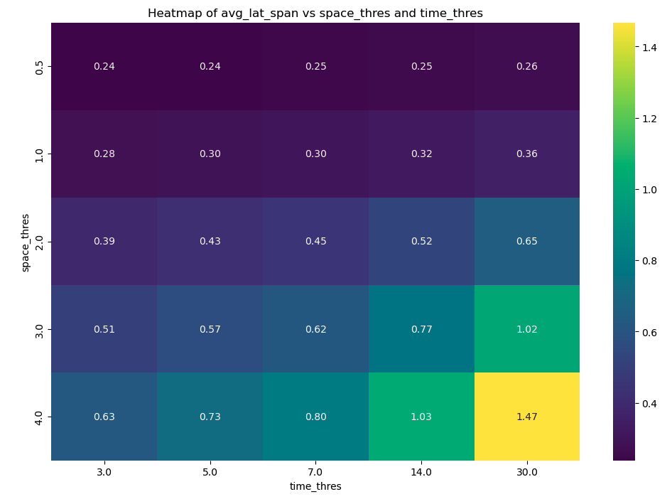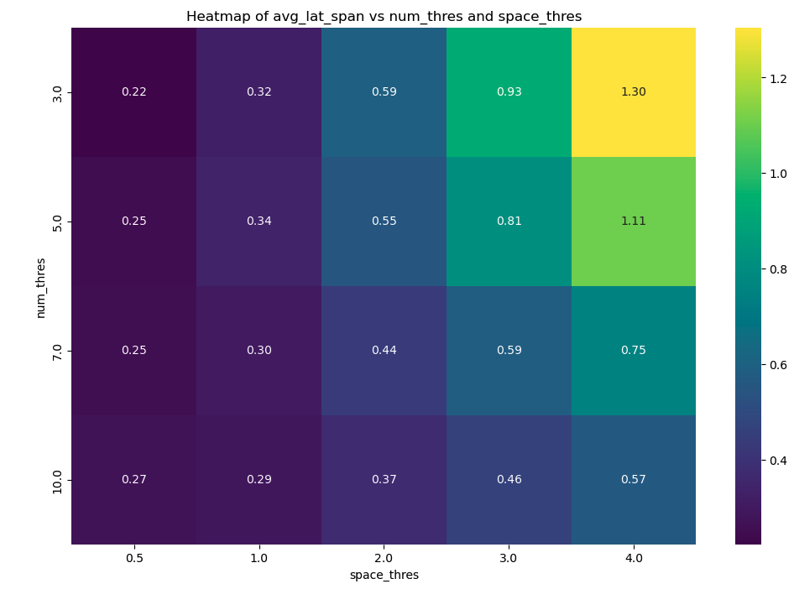

Maximum Cluster Duration
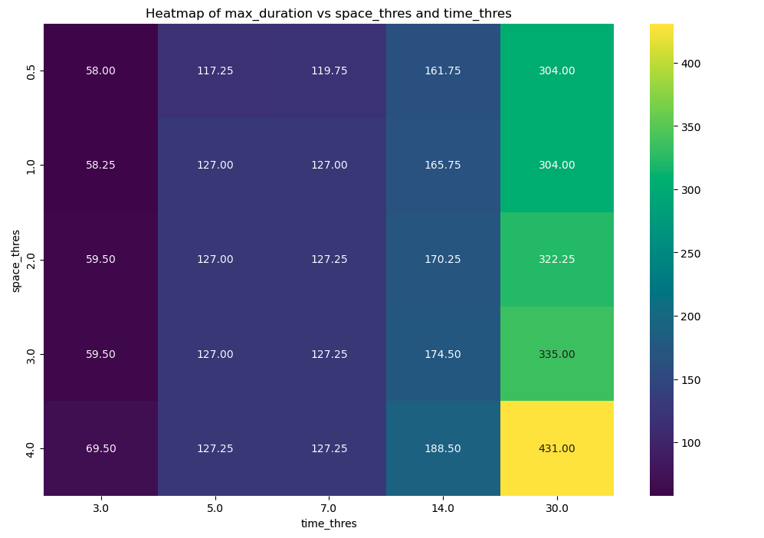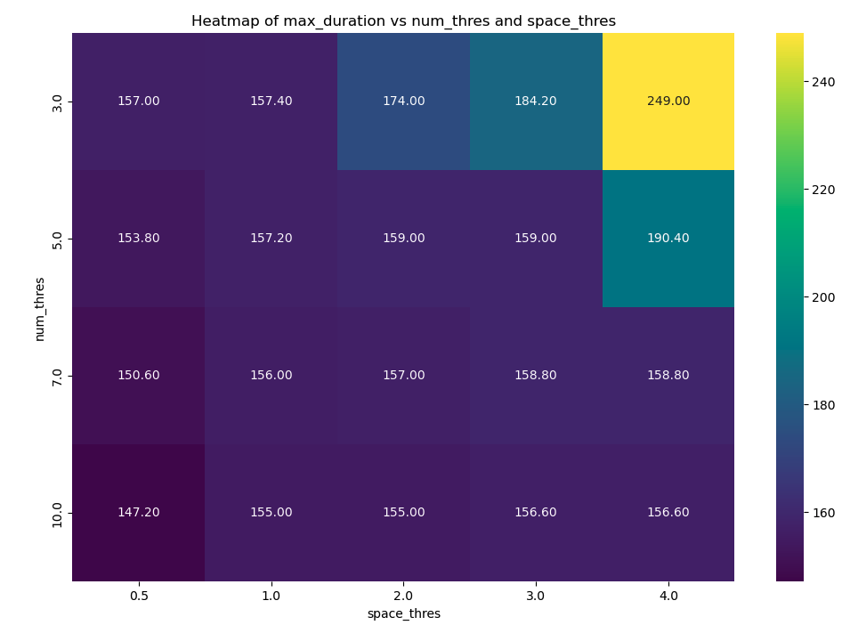

Maximum Longitudinal Span
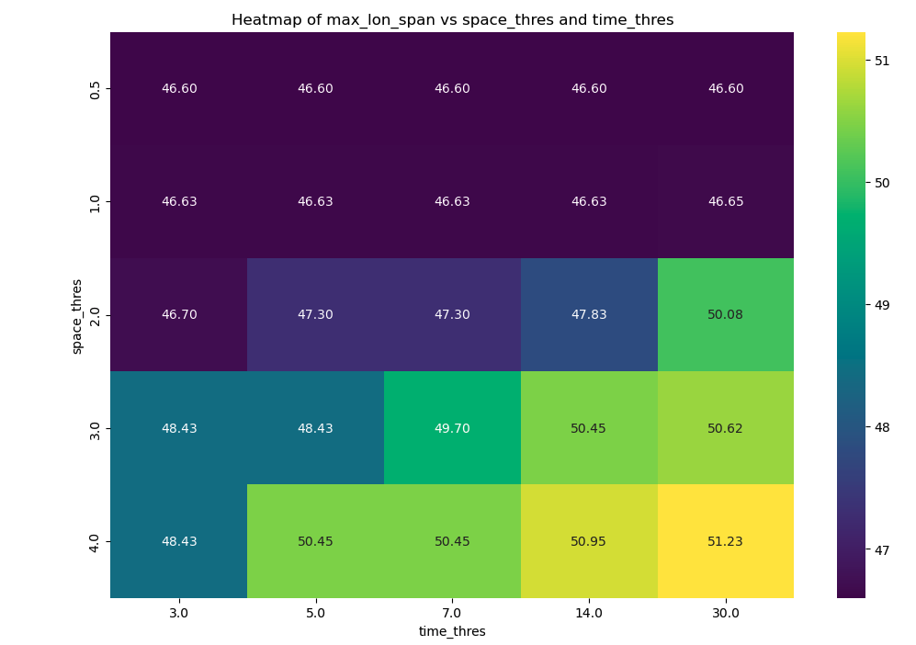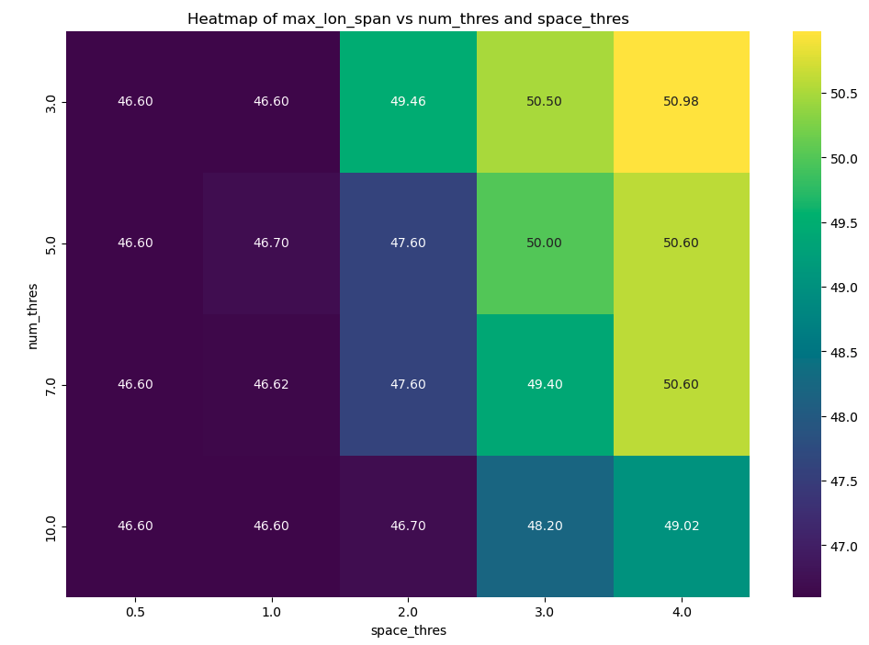

Maximum Latitudinal Span
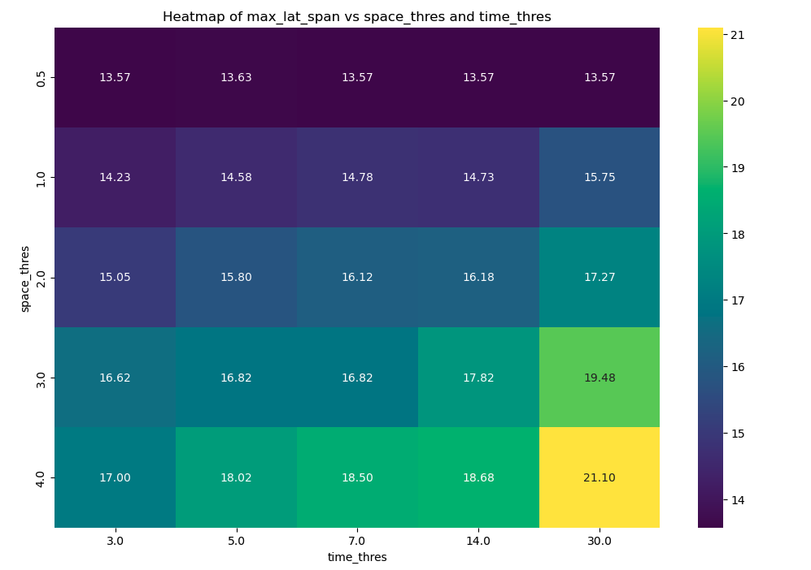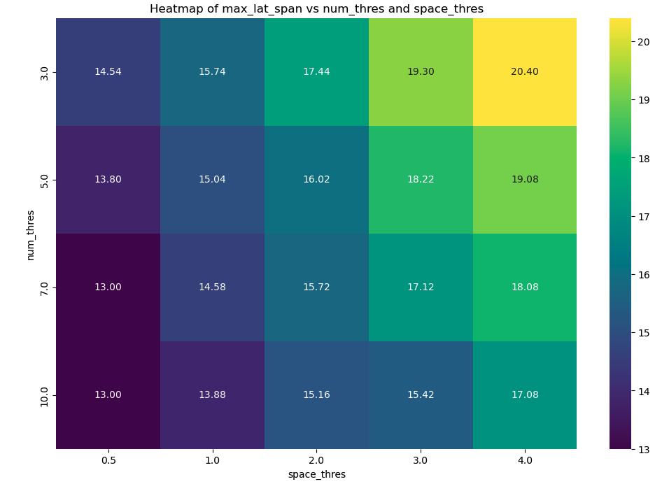

Variance Cluster Duration
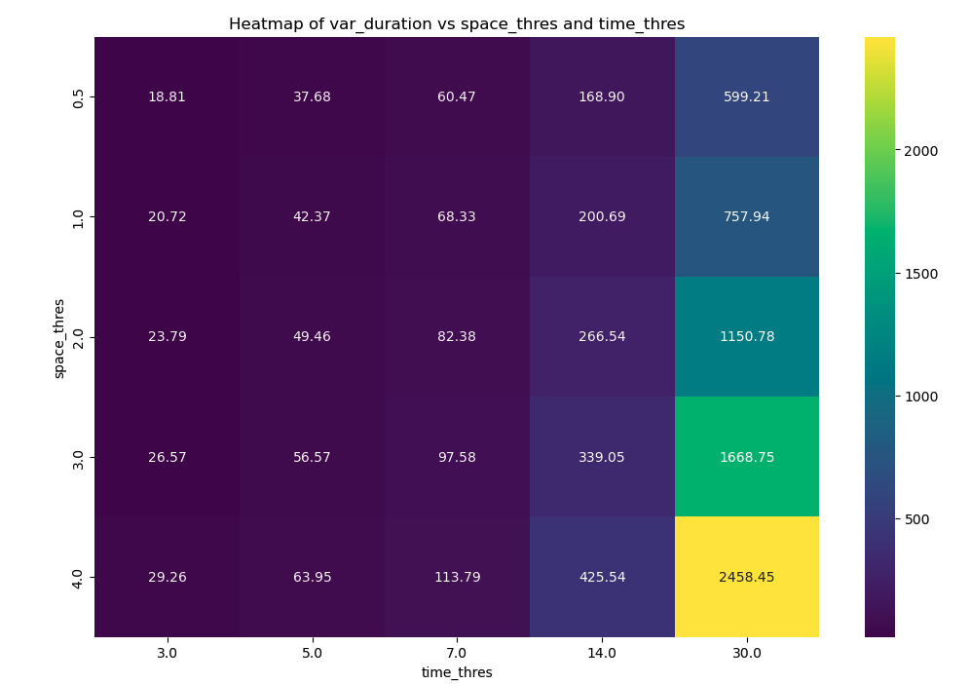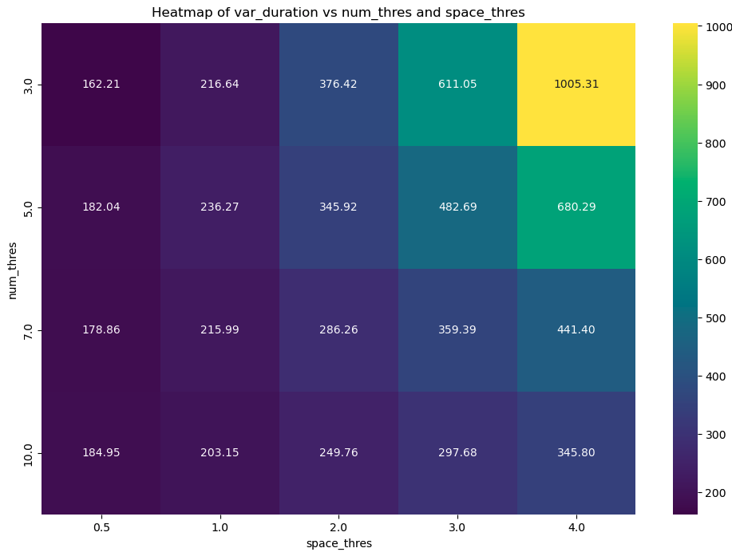

Variance Longitudinal Span
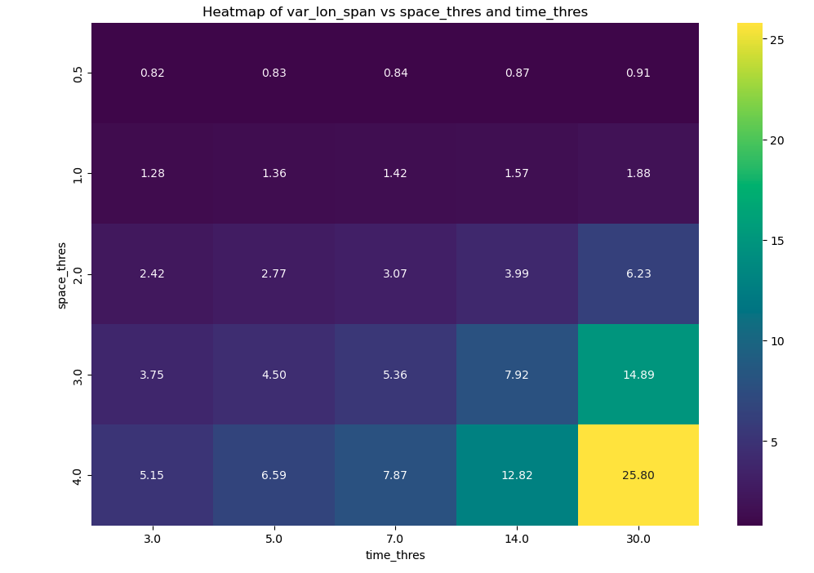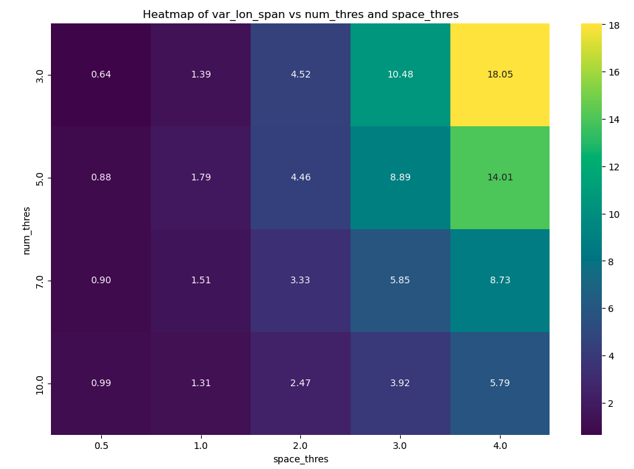

Variance Latitudinal Span
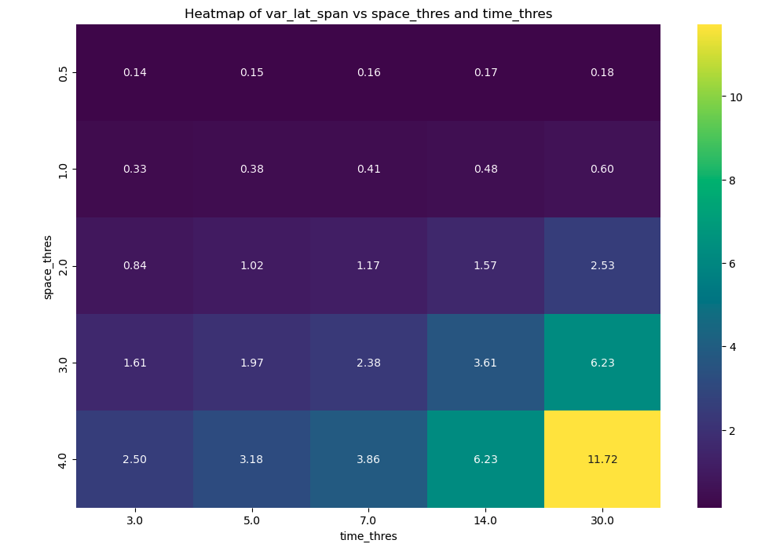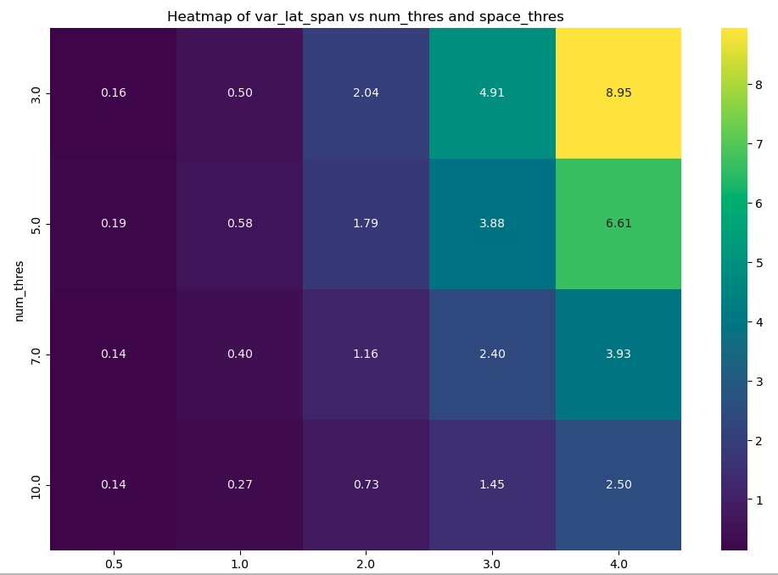

Caption: Here we provide detailed pair plots comparing duration, latitude span, and longitudinal span focusing on averages, variance, and maximums across clusters.

8) Nonstationary GEV Duration Sensitivity

A) Mann-Kendall Test for Nonstationary Clusters
We report below the p-value and Sen’s slope for the Mann Kendall test for return periods across clusters. We find a statistically significant trend with a very low slope value for trends across clusters as reported below:
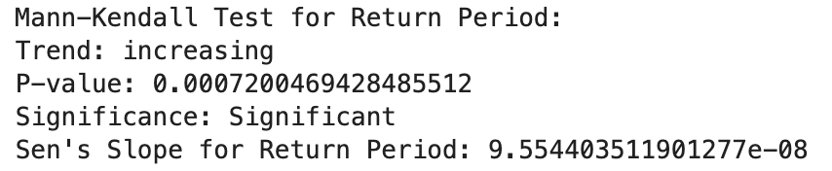

B) Nonstationary Analysis for Three-Day Event Duration
Here we provide the identical figure to Figure 6 in the main text under 3-day maximum precipitation in lieu of maximum daily precipitation. Trends are largely similar across the two analyses, however there are some discrepancies between some counties. Particularly, we see more decreasing trends found in the nonstationary GEV return periods across both MSWEP and ERA5 datasets (Figure D6, panels a and b).

Figure D6: Three-Day Nonstationary Sensitivity in Intensity Distributions
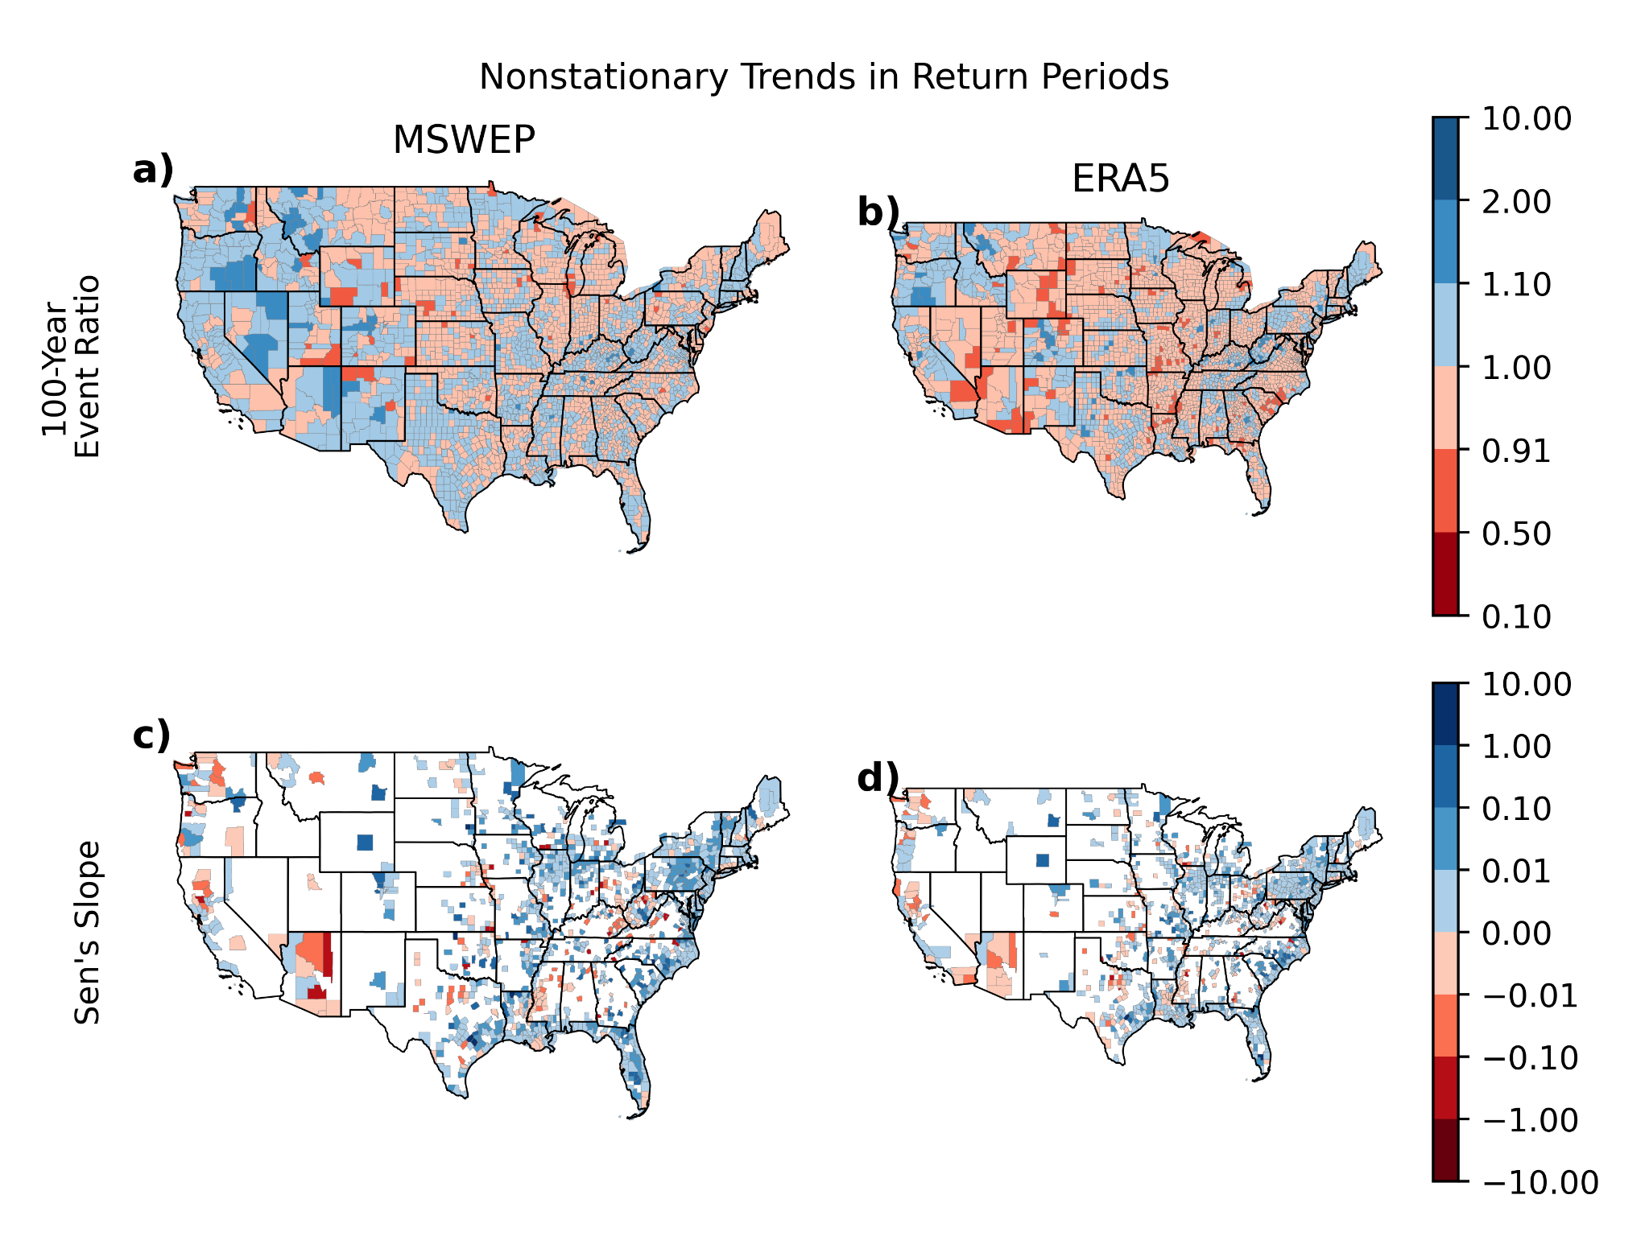
Caption: Ratios of 100-year precipitation events under county-level heterogeneous nonstationary GEV distributions for the maximum 3-day precipitation event, and Sen’s Slope values for statistically significant trends in 3-day maximum precipitation return periods of claims using a Mann Kendall trend analysis by county (p < 0.05) for both MSWEP and ERA5 datasets. Ratios are compared between years 1979 and 2020 (the temporal record of MSWEP for standard comparison between datasets).

C) Extended Nonstationary GEV
Here we provide an extended version of Figure 6 from the main text to also show the nonstationary trends in 3-day maxima distributions in comparison to the daily sum distributions (Figure E6). Overall, Figure E6 shows very similar results across duration metrics, but large differences between datasets, speaking to the uncertainty within trend analyses with limited data histories.

Figure E6: Extended Nonstationarity Sensitivity in Intensity Distributions
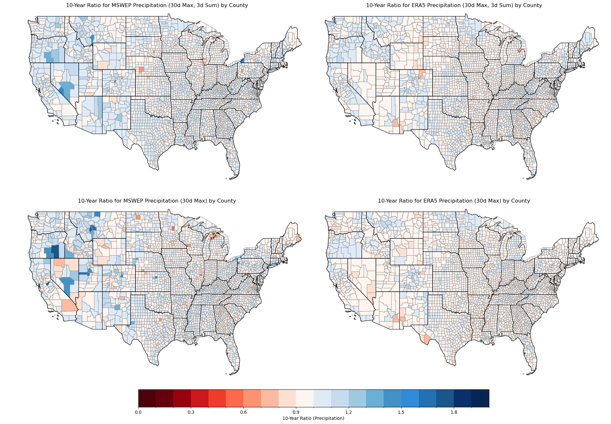
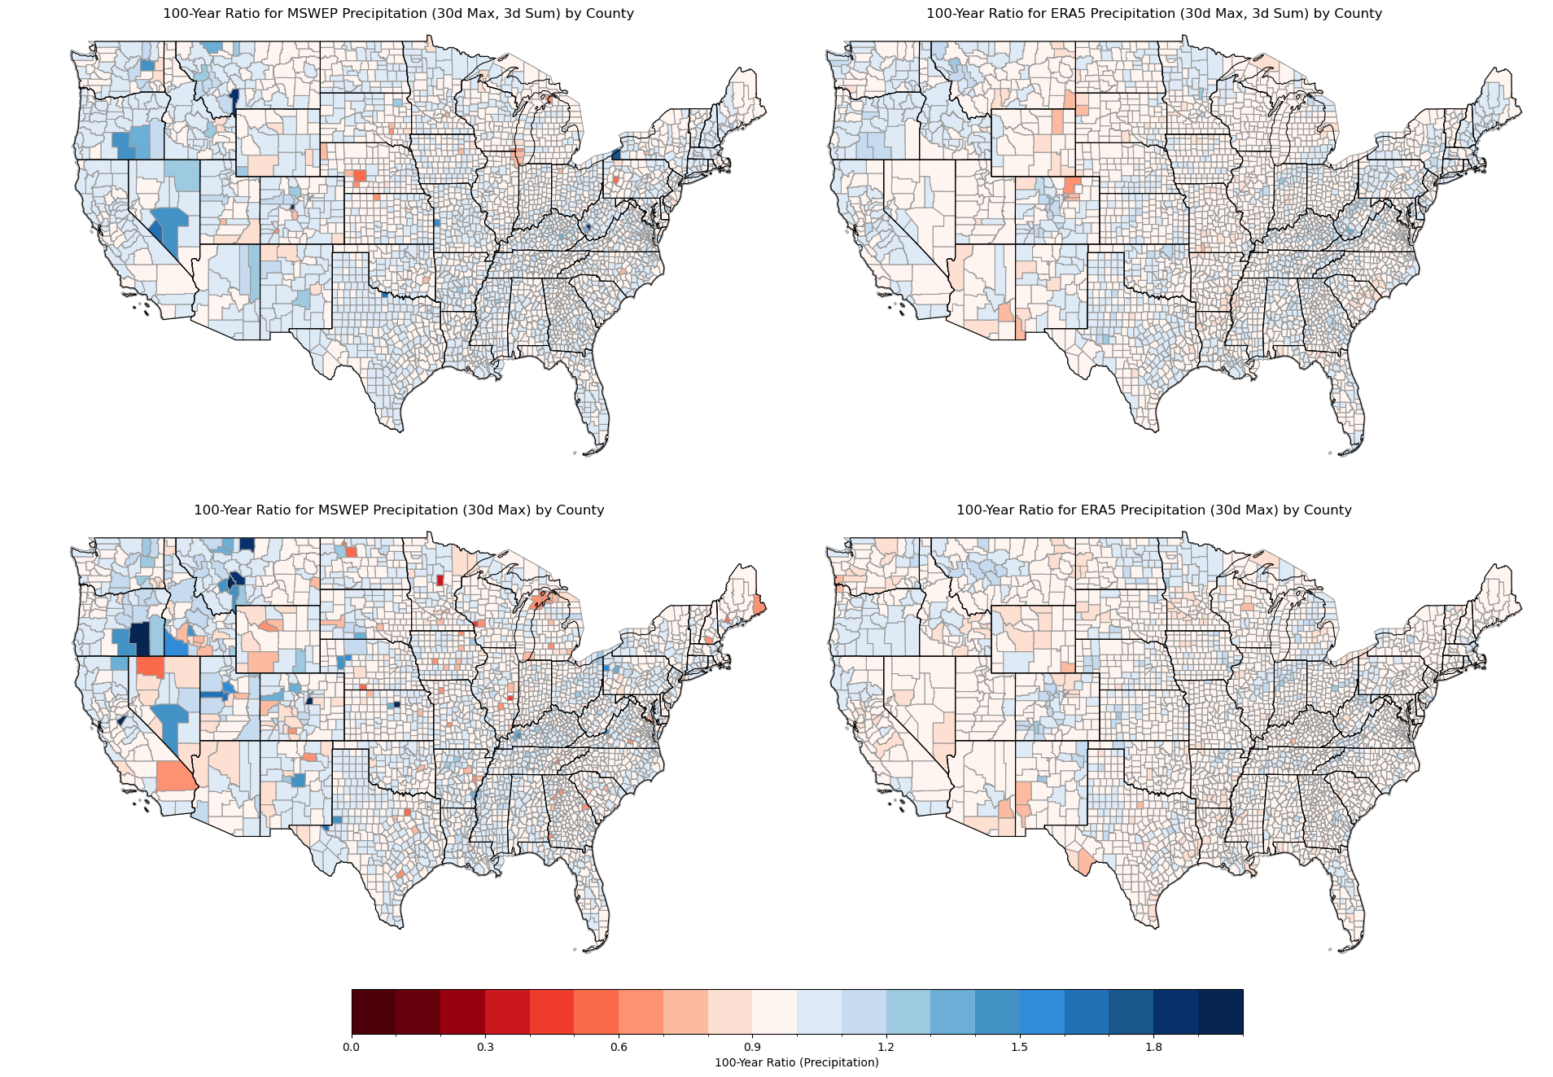
Caption: Ratios of 10 year and 100 year precipitation events under county-level heterogeneous nonstationary GEV distributions for both MSWEP and ERA5 datasets for the maximum 3-day precipitation event and 1-day precipitation event. Ratios are compared between years 1979 and 2020 (the temporal record of MSWEP for standard comparison between datasets).

9) Raw Precipitation: Monthly Dataset Intercomparison
In comparing the three different datasets across the same periods of time in their monthly precipitation values associated with insurance claims, we see that PRISM seems to have the highest raw estimates of precipitation, then MSWEP, and ERA5 has the lowest raw estimates across the distribution (Figure S1). The percentiles follow the same pattern, with the highest coming from PRISM. We note here that PRISM percentiles should be biased upward as the distribution of monthly values is not a rolling horizon over all days but only represents twelve values per year. Thus, this is likely an overestimate of percentiles, as we cannot consider the 30-day period preceding any given event, rather only the month in which it occurs. This is another reason for why PRISM data is only used here as a validation technique and not as an estimate of return periods, as the monthly timescale is not resolute enough to capture storm-level effects.

In consideration of the spatial distribution patterns, we see similar patterns across all three datasets (Figure S2). Raw values could indicate that ERA5 has a slight bias downward, and MSWEP strikes a good balance between ERA5 and PRISM estimates. Thus, more rationale for our decision to include these values in the main text.

Figure S3: Distribution Comparison of Gridded Raw Precipitation for Claims
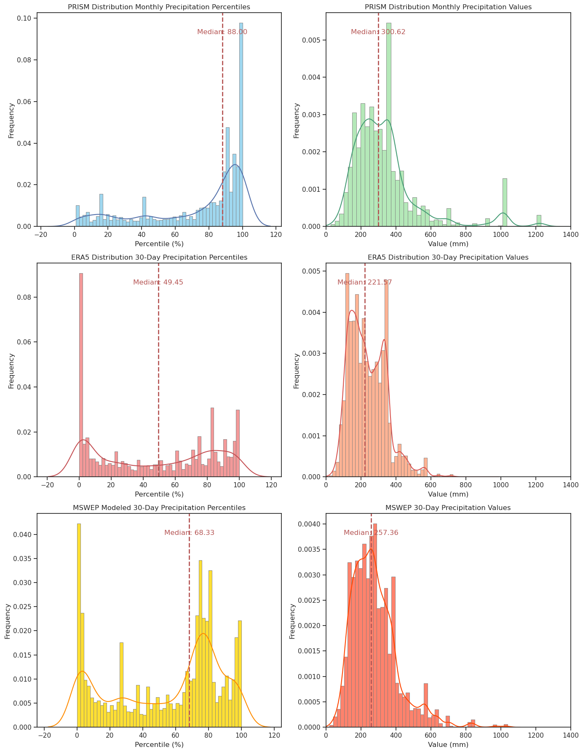
Caption: Percentiles and monthly precipitation values across PRISM, ERA5, and MSWEP gridded datasets associated with insurance claims. ERA5 and MSWEP datasets include the 30 days prior to the event, while PRISM denotes the monthly precipitation value of the month of the event.

Figure S4: Spatial Comparison of Gridded Raw Precipitation for Claims
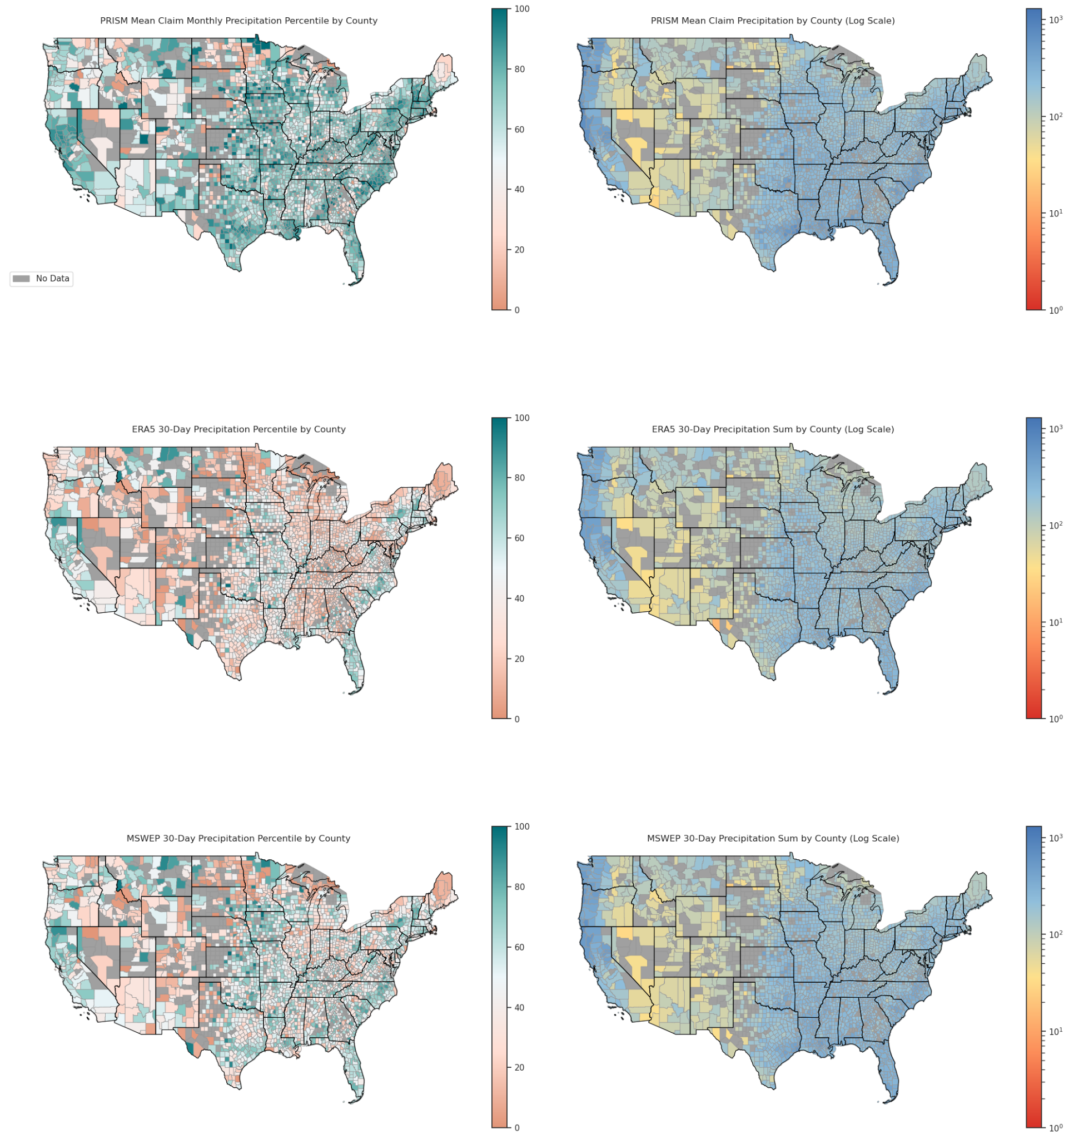
Caption: Spatial distribution of percentiles and monthly precipitation values across PRISM, ERA5, and MSWEP gridded datasets associated with insurance claims. ERA5 and MSWEP datasets include the 30 days prior to the event, while PRISM denotes the monthly precipitation value of the month of the event.

10) Additional References
CDC. 2024. “NCHS Urban-Rural Classification Scheme for Counties.” National Center for Health Statistics. October 17, 2024. https://www.cdc.gov/nchs/data-analysis-tools/urban-rural.html.
Moss, Mitchell, Charles Schellhamer, and David A. Berman. 2009. “The Stafford Act and Priorities for Reform.” Journal of Homeland Security and Emergency Management 6 (1). https://doi.org/10.2202/1547-7355.1538.
National Weather Service. 2024. “Watch/Warning/Advisory Definitions,” November. https://www.weather.gov/lwx/warningsdefined.

