Supplementary Figures and Tables
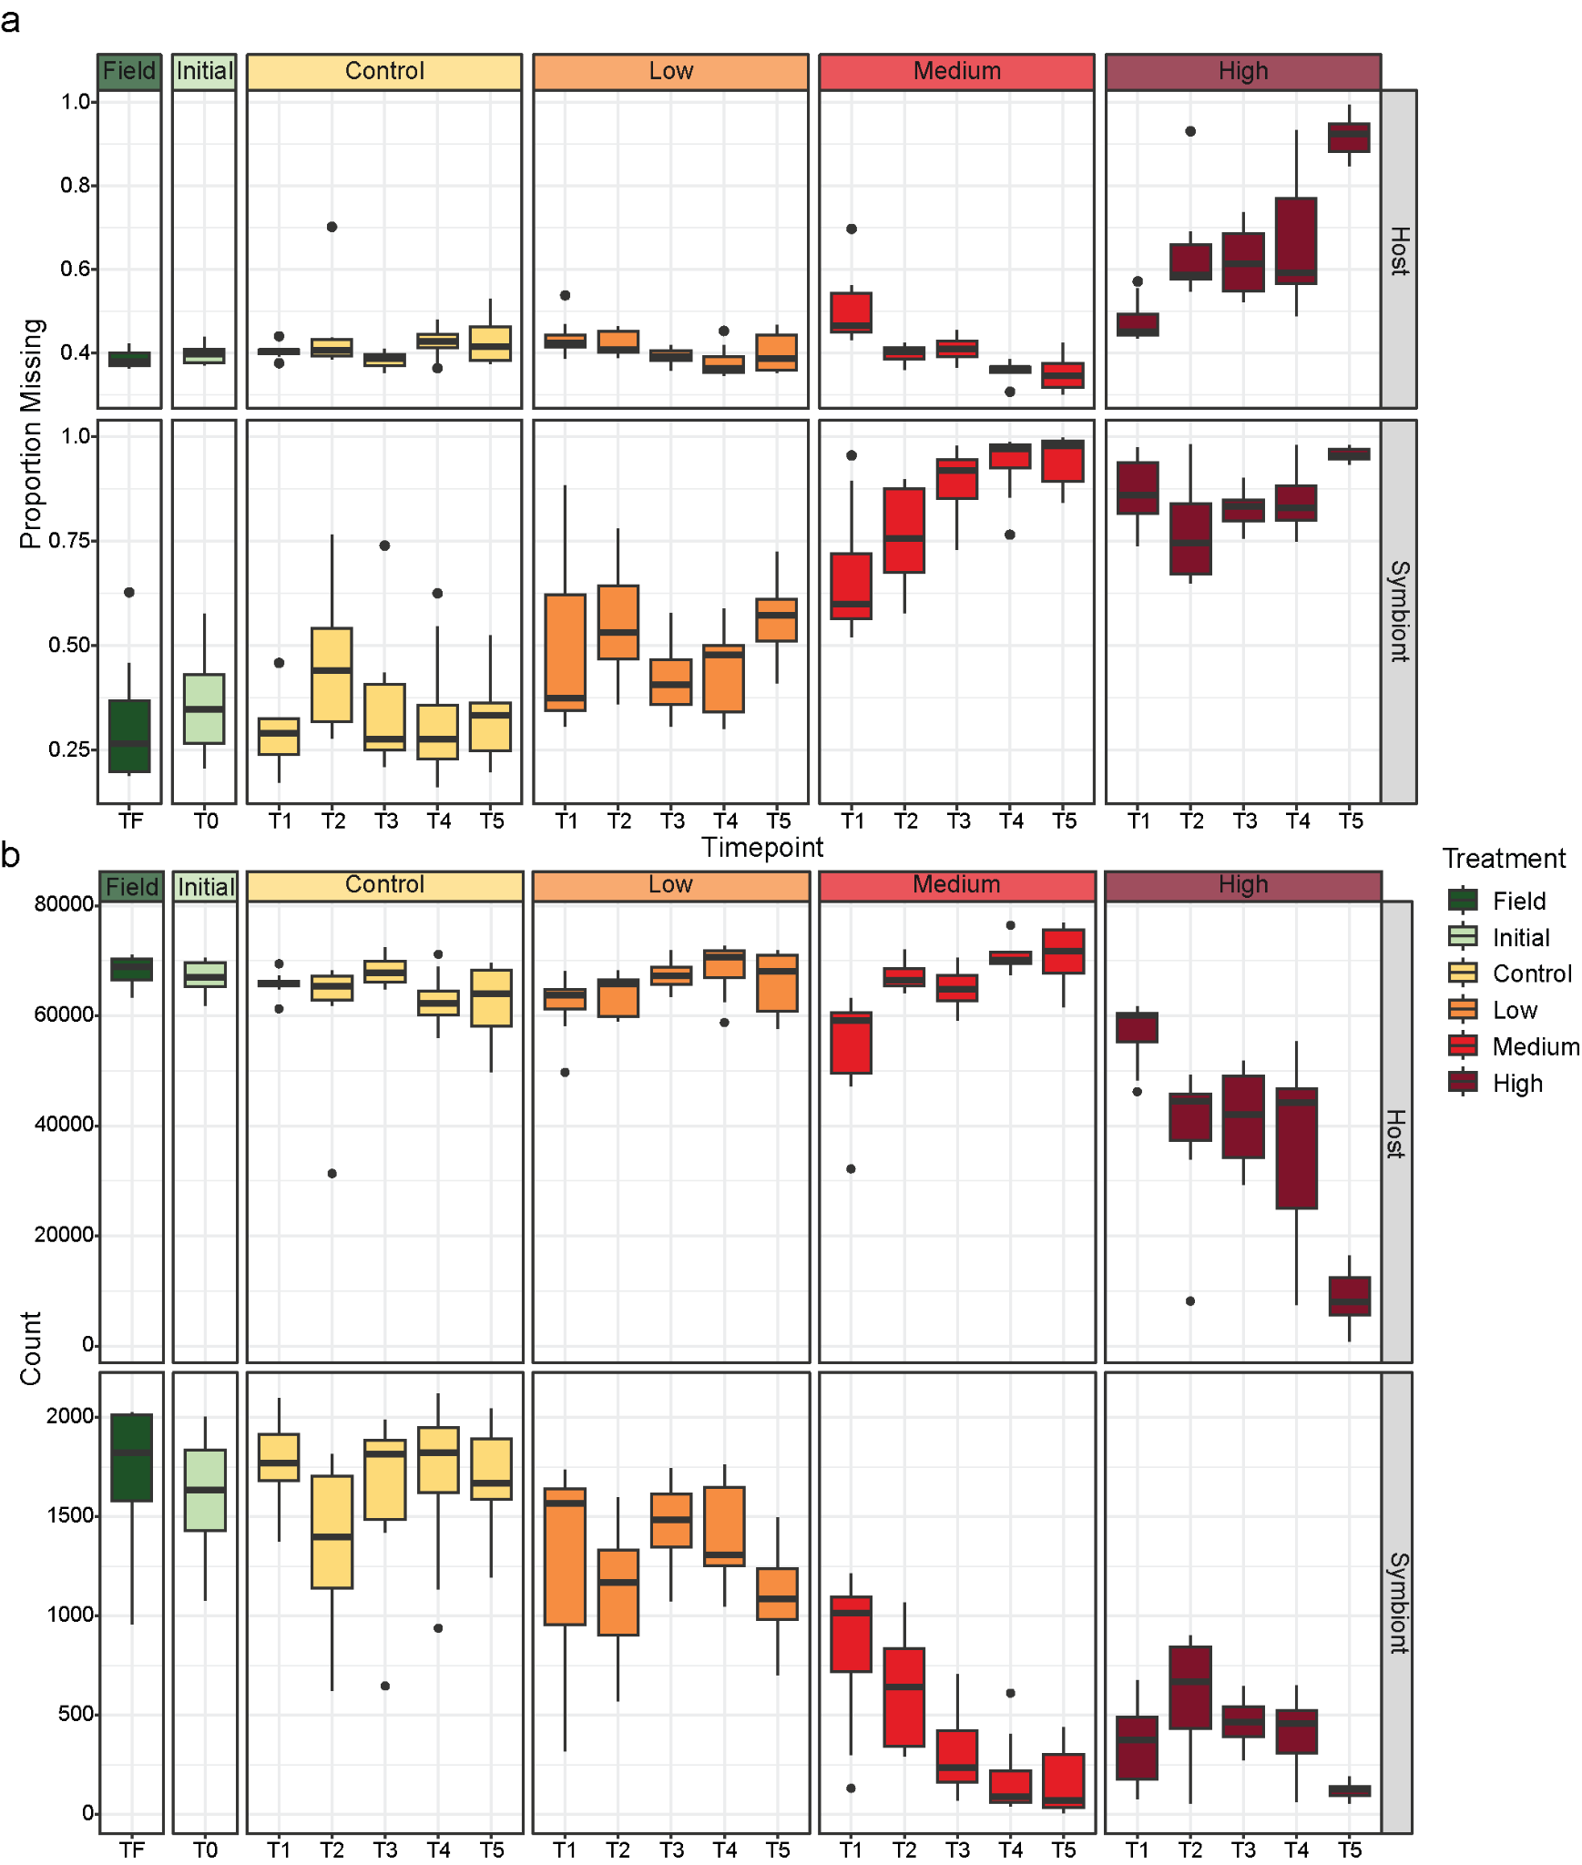
Supplementary Fig. 1: RNA-Seq and AS filtering quality control by species. Boxplots of a) the proportion of AS events with missing PSI estimates and, b) the total number of AS events are shown for each sample type (Field = dark green, Initial = light green, Control = yellow, Low = orange, Medium = red, High = dark red) at each timepoint (x-axis) for both the coral host and the algal endosymbiont. Note the different y-axis scales.

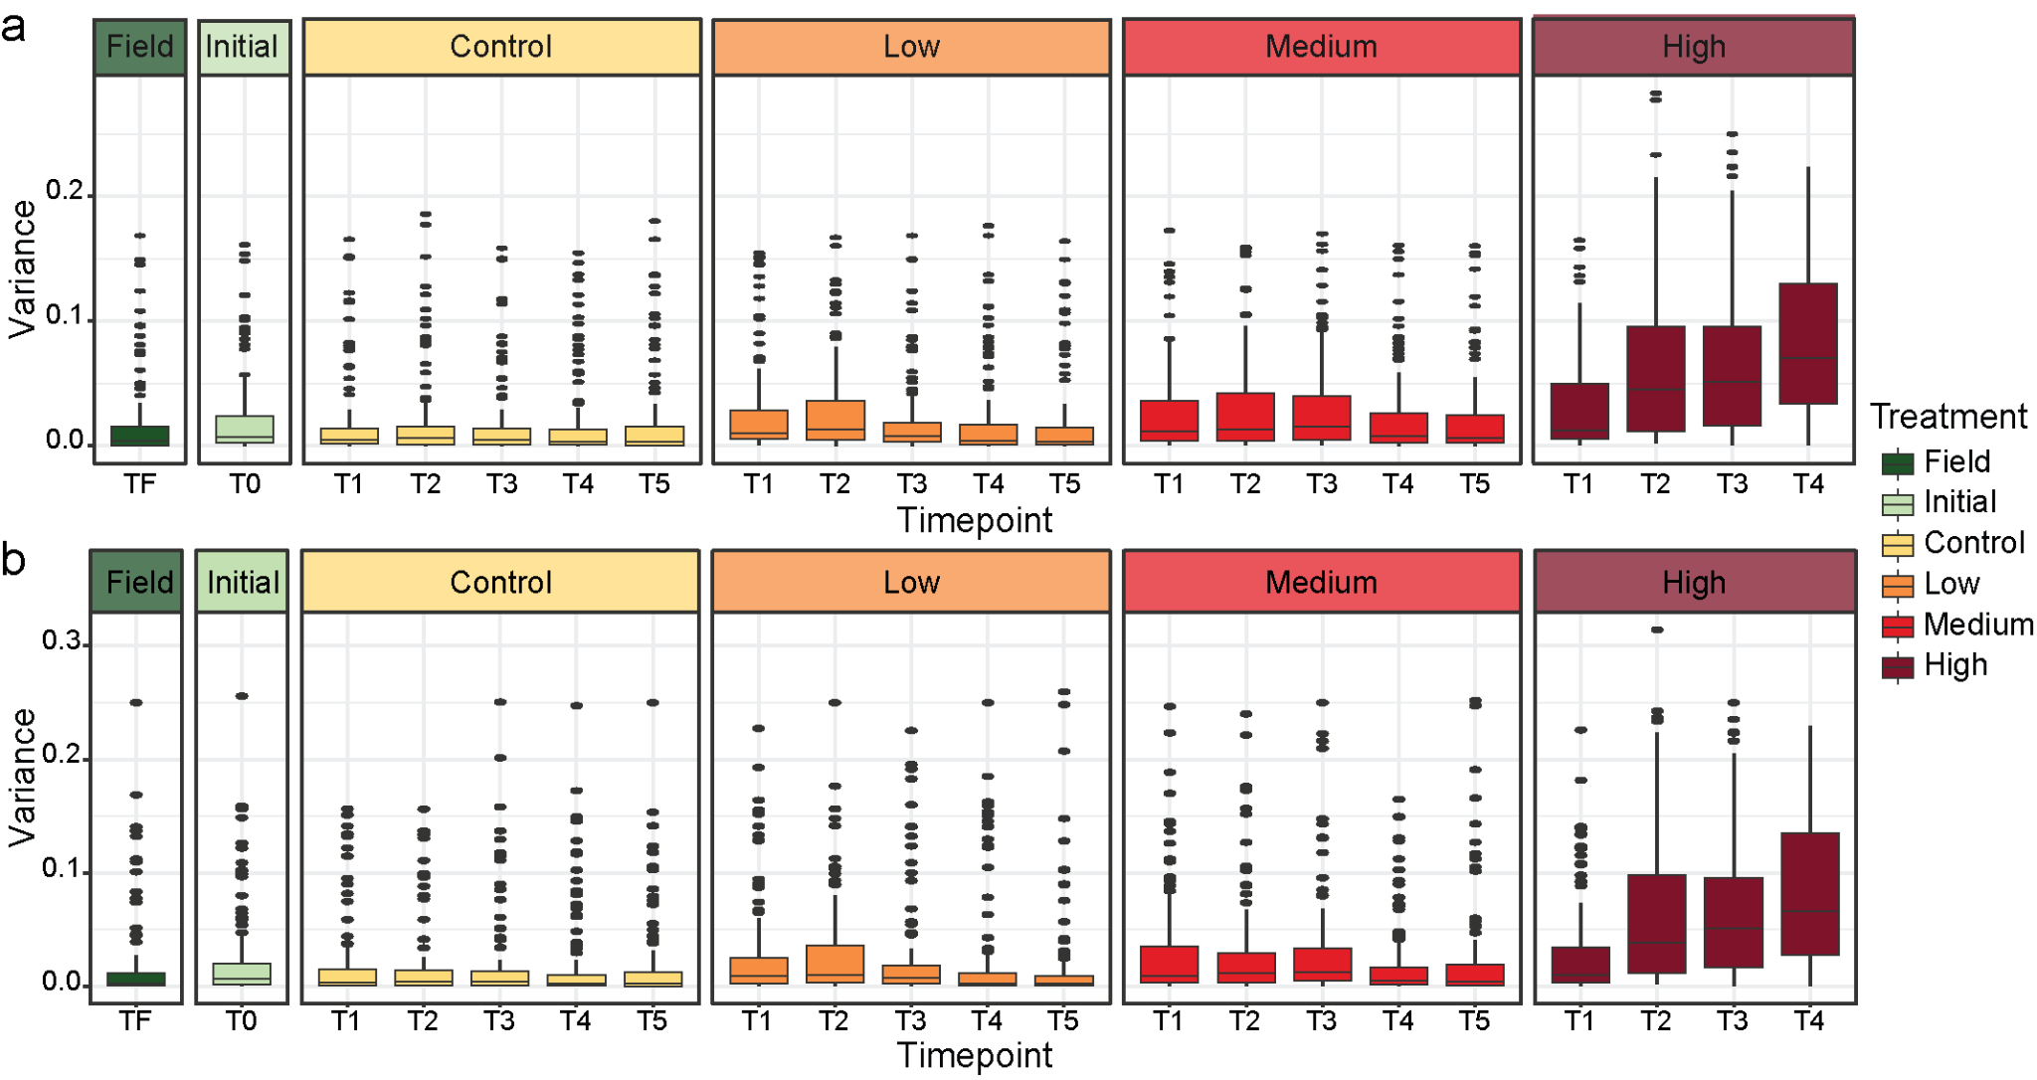
Supplementary Fig. 2: Within group variance by sample type in the coral host. Boxplots of the distribution of variances in PSI estimates per AS event by treatment type (Field = dark green, Initial = light green, Control = yellow, Low = orange, Medium = red, High = dark red) and timepoint (x-axis). Events with identical PSI for all samples or missing values were filtered prior to variance calculation. Plots are shown for a) all samples in the global analysis (n = 156) and b) four randomly selected replicate genets for each combination of treatment and timepoint representing an equal number of samples for each category (n = 84).

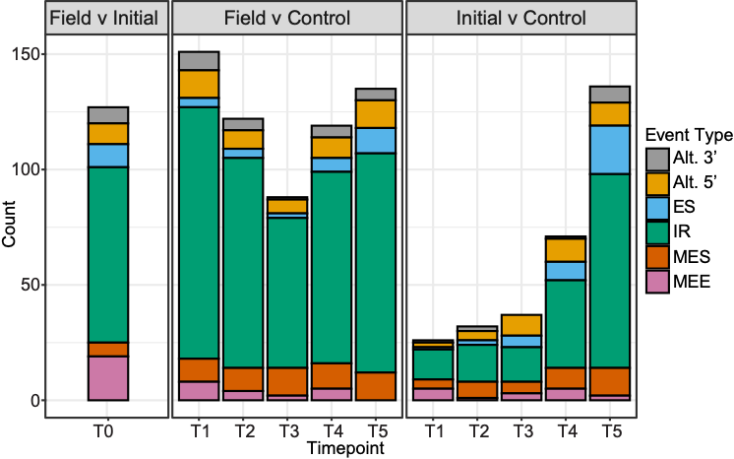
Supplementary Fig. 3: Significant differential AS in Field, Initial, and Control contrasts in the coral host. The number of significantly differentially AS events (adj. p-value < 0.05; delta PSI > 0.3) for pairwise contrasts comparing Field, Initial, and Control samples is shown at each timepoint and colored according to the splice event type (gray = alternative 3’ splice site, yellow = alternative 5’ splice site, blue = exon skip, green = intron retention, red = multiple exon skips, pink = mutually exclusive exons).

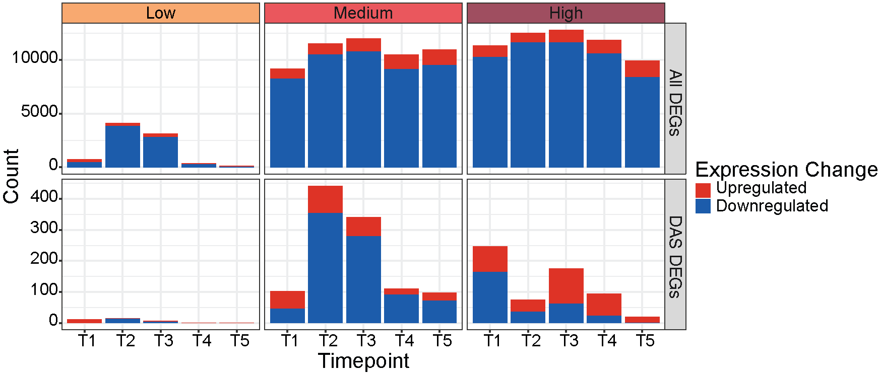
Supplementary Fig. 4: Summary counts of genes with differential expression by contrast. The number of significantly differentially expressed genes (DEGs) are shown for each temperature treatment (Low, Medium, and High) at each timepoint (T1-T5). Counts are shown for positive log₂ fold change (upregulated; red) and negative log₂ fold change (downregulated; blue). The top panels show counts for all DEGs while the bottom panels show counts only for DEGs that were also differentially alternatively spliced (DAS).

Supplementary Table 1: CBASS temperature profile log file
Supplementary Table 2: Count of uniquely mapped reads per sample per species (coral host and symbiont)
Supplementary Table 3: PSI estimates of called events for all samples in the coral host and symbiont
Supplementary Table 4: Significant differential AS events in the coral host
Supplementary Table 5: Enriched GO terms for significant differentially AS genes for each tested contrast
Supplementary Table 6: Enriched GO terms for significant differentially expressed genes for each tested contrast

