Supplementary materials
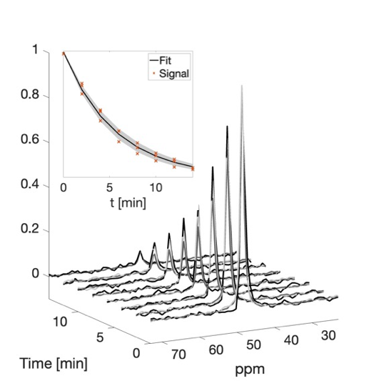
Figure S1: Normalized MRS spectra obtained from hyperpolarized ¹⁵N,d₉-Betaine in vivo at 3T, from the abdomen region of 3 rats. ¹⁵N,d₉-Betaine signals were present at all investigated time-points, until 14 minutes post-injection. The spectra and integrals from all animals are displayed, together with the decay of signal integrals, where the solid line represents the average of the T₁ fits while the shaded area represents the standard deviation. The individual integral values are indicated by red crosses.

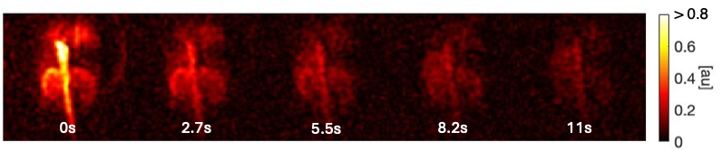
Figure S2: Higher resolution imaging of ¹⁵N,d₉-Betaine in the rodent kidneys in coronal view. Images are normalized to maximum intensity and colormaps of images are windowed to 80% of maximum signal.

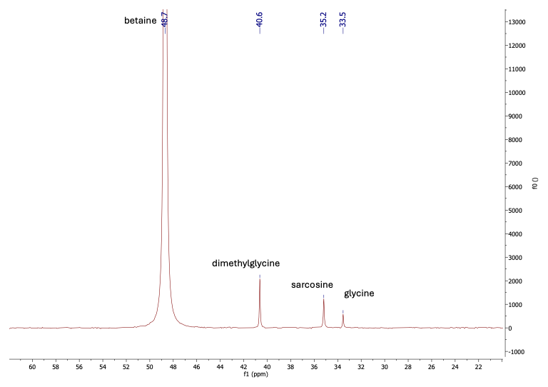

Figure S3: ¹⁵N NMR spectrum of hyperpolarized ¹⁵N,d₉-Betaine (48.7 ppm) in buffer solution, with its primary metabolite, dimethylglyine (40.6 ppm), and downstream metabolites sarcosine (35.2 ppm) and glycine (33.5 ppm).

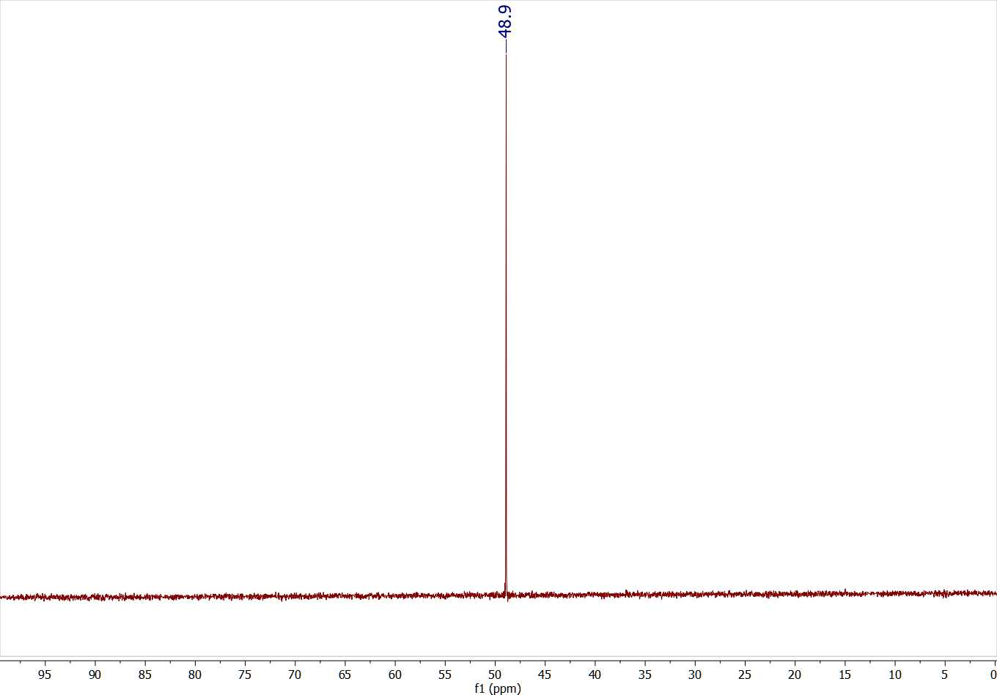
Figure S4: ¹⁵N NMR spectrum of ¹⁵N,d₉-Betaine, referenced to ¹⁵N-glycine at 33.5 ppm.
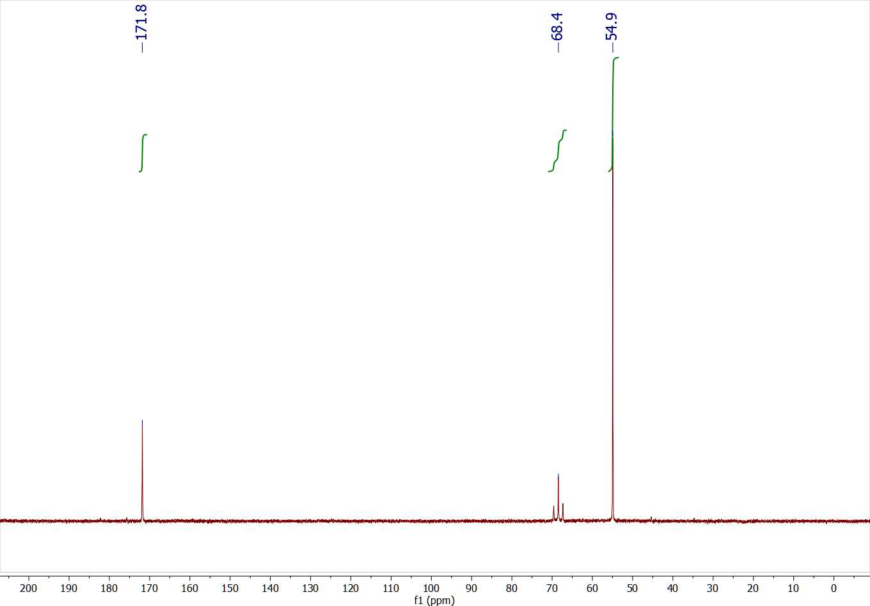
Figure S5: ¹³C{²H} NMR spectrum of ¹⁵N,d₉-Betaine.
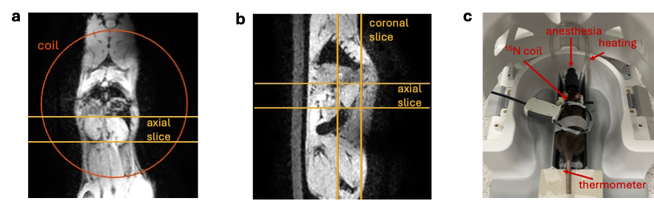
Figure S6: Set-up of in vivo ¹⁵N-HypMRI experiments. a: Placement of ¹⁵N Tx/Rx loop coil and slice used for axial ¹⁵N-imaging experiments (15-mm slice thickness) with reference to a ¹H image in coronal view. b: Slice locations for axial and coronal ¹⁵N-imaging experiments shown with reference to a ¹H image (a ¹H slice centered at the right kidney was chosen for display) in the sagittal view. Both axial and coronal slices were 15 mm thick. c: Image of experimental set-up for in vivo imaging. The rat cradle is placed within a 21-channel ¹H head-and-neck coil.

