Supplementary Fig. 1

Supplementary Fig. 1 Alpha diversity breed wise analysis using Chao1 index Similar significant variation in rumen microbial richness can be noticed for Osmanabadi, Malabari and Salem black heat stress and control goats. While Chao1 index indicated decreased ruminal microbial diversity in Salem Black goats subjected to heat stress, the microbial richness increased in Osmanabadi and Malabari heat stress goats

Supplementary Fig. 2

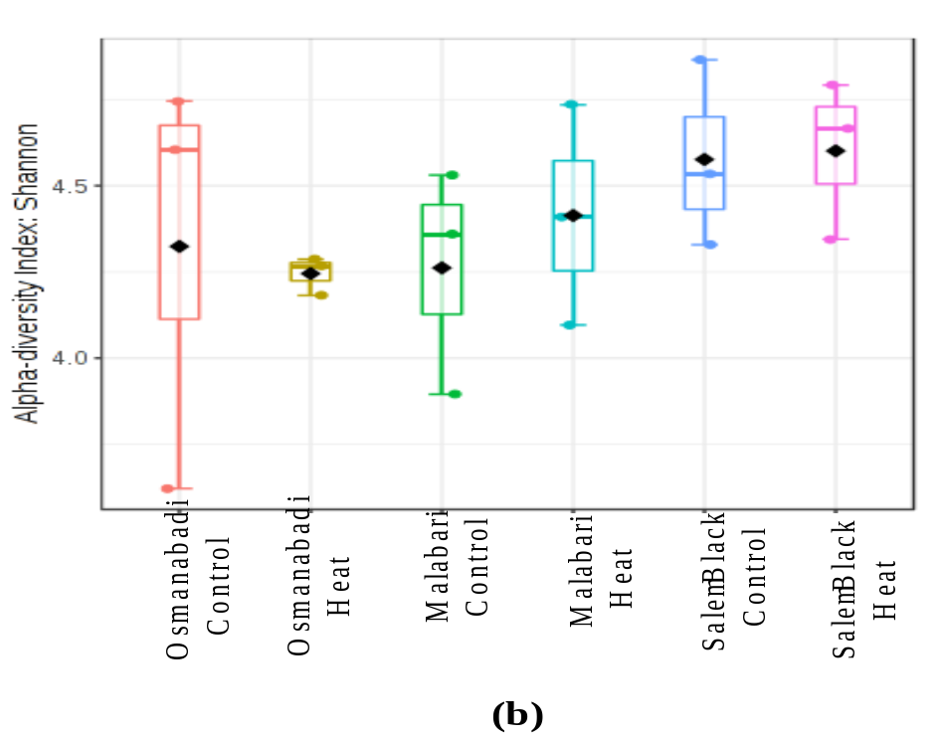
Supplementary Fig. 2 Alpha diversity breed wise analysis using Shannon index. At the breed level while the microbial diversity increased in Malabari and Salem Black goats subjected to heat stress, than their respective control, that of Osmanabadi goats reduced during heat stress.

Supplementary Fig. 3

Supplementary Fig. 3 Principal coordinate analysis (PCoA) based on Bray Curtis index for Osmanabadi control (Group I), Osmanabadi heat stress (Group II), Malabari control (Group III), Malabari heat stress (Group IV), Salem Black control (Group V) and Salem Black heat stress (Group VI) groups. The percentage of variation explained by PC1, PC2 and PC3 are indicated in the axis. The rumen microbes of individual samples were clustered together as per their respective treatment.

Supplementary Fig. 4
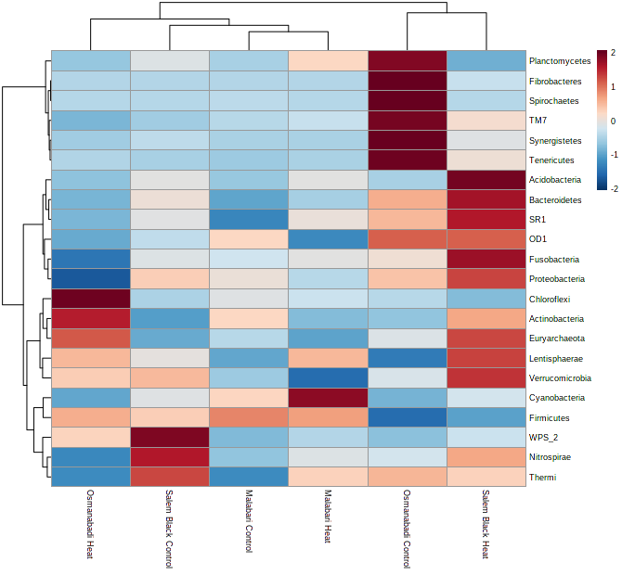
Supplementary Fig. 4 Taxonomic distribution of the 22 bacterial phyla of the caprine ruminal microbiota. The heat map shows the relative abundance of each rumen microbial phyla (variables clustered along the y axis) within each experimental group (depicted and clustered on the x-axis). The heatmap color represents the relative abundance of the phylum in their representative experimental group. The stronger the color intensity, the greater the relative abundance of the phyla while blue indicates absence of representative bacteria

Supplementary Fig. 5
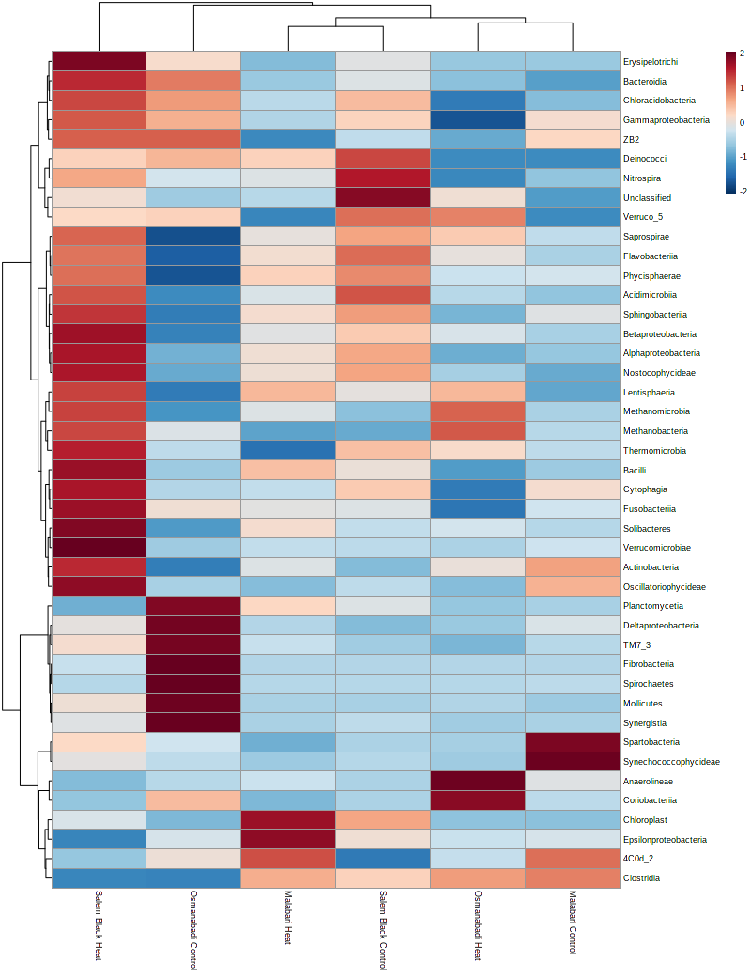
Supplementary Fig. 5 Taxonomic distribution of the rumen microbial classes. The heat map depicts the abundance at the class level in the caprine rumen. The hierarchical clustering represents experimental groups along the X-axis and the class across the Y-axis. Color represents relative abundance of each microbial class across the groups, the intensity of which highlights its abundance. Stronger the color intensity of the microbial class, greater is its relative abundance. Additionally, blue color indicates absence of representative bacteria.
Supplementary Fig. 6
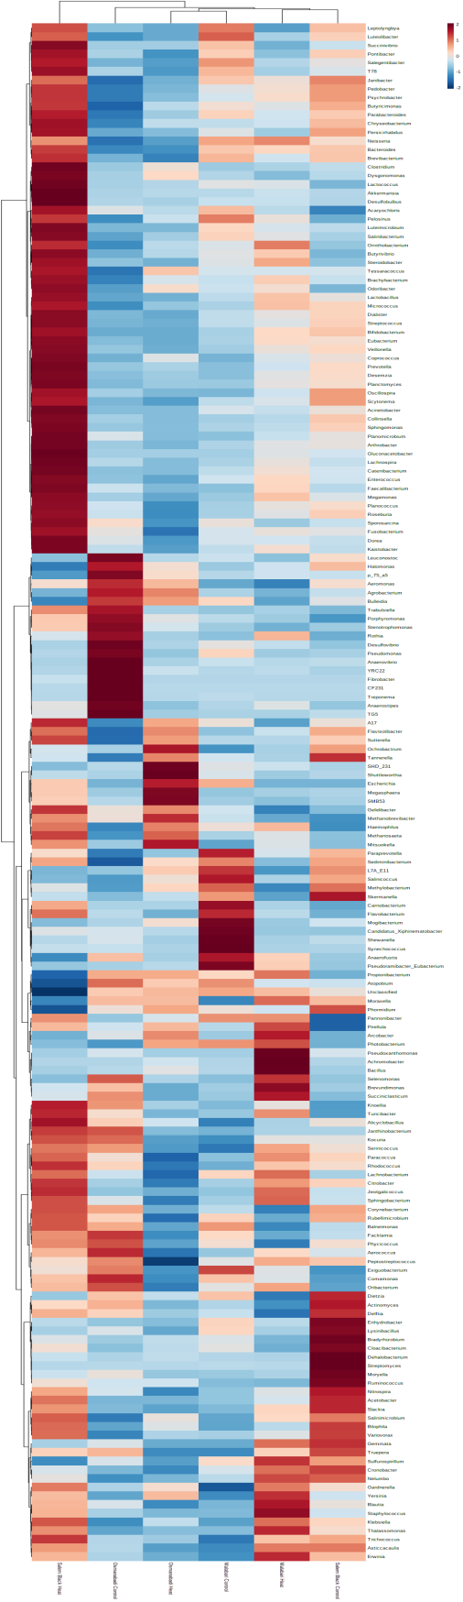
Supplementary Fig. 6 Taxonomic composition of the rumen microbial genera. The heat map depicts the abundance at the class level in the caprine rumen. The hierarchical clustering represents experimental groups along the X-axis and the genus across the Y-axis. Color represents relative abundance of each microbial genus across the groups, the intensity of which highlights its abundance. Stronger the color intensity of the microbial genera, greater is its relative abundance. Additionally, blue color indicates absence of representative bacteria
Supplementary Fig. 7
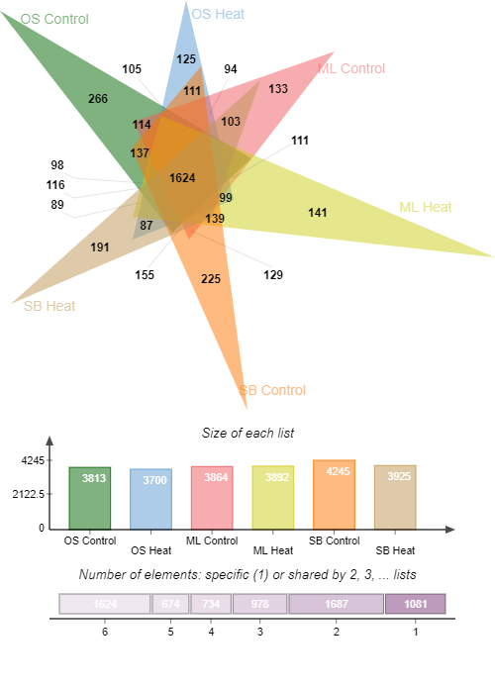
Supplementary Fig. 7 Venn diagram depicting the phylum-wise ruminal microbiome unique and common between the 6 treatment groups. OS Control-Osmanabadi Control, OS Heat-Osmanabadi Heat, ML Control-Malabari Control, ML Heat-Malabari Heat, SB Control-Salem Black Control and SB Heat-Salem Black Heat. The Venn diagram was created using the Jvenn software. The number of unique phyla in each group has been depicted while those in the overlapping areas are the number of common phyla between the groups. A total of 1624 phyla were found to be common among all the treatment groups while the phyla unique to Osmanabadi Control, Osmanabadi Heat, Malabari Control, Malabari Heat, Salem Black Control and Salem Black Heat groups were 266, 125, 133, 141, 225 and 191 respectively.
Supplementary Fig. 8
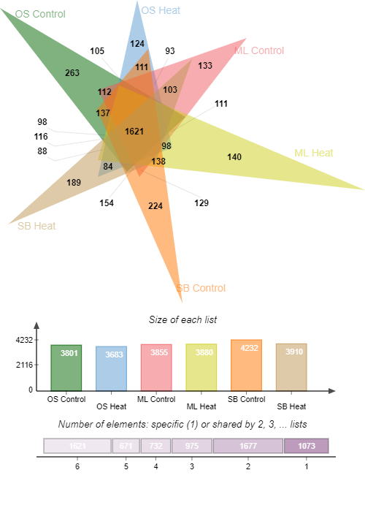
Supplementary Fig. 8 Venn diagram depicting the class-wise ruminal microbiome unique and common between the 6 treatment groups. OS Control-Osmanabadi Control, OS Heat-Osmanabadi Heat, ML Control-Malabari Control, ML Heat-Malabari Heat, SB Control-Salem Black Control and SB Heat-Salem Black Heat. The Venn diagram was created using the Jvenn software. The number of unique class in each group has been depicted while those in the overlapping areas are the number of common class between the groups. A total of 1621 classes were found to be common among all the treatment groups while the genera unique to Osmanabadi Control, Osmanabadi Heat, Malabari Control, Malabari Heat, Salem Black Control and Salem Black Heat groups were 263, 124, 133, 140, 224 and 189 respectively.

Supplementary Fig. 9

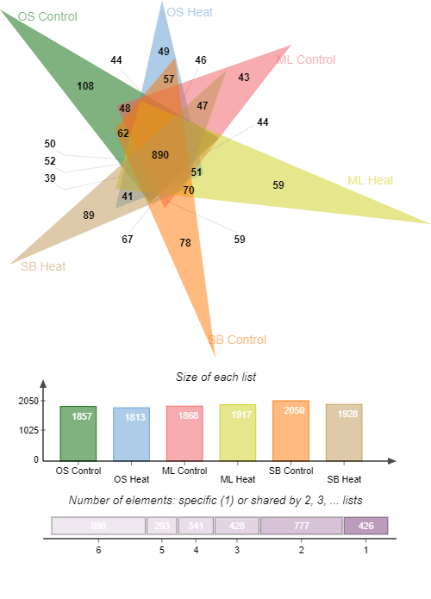
Supplementary Fig. 9 Venn diagram depicting the bacterial genus common and unique in the rumen of all the three treatment groups. OS Control-Osmanabadi Control, OS Heat-Osmanabadi Heat, ML Control-Malabari Control, ML Heat-Malabari Heat, SB Control-Salem Black Control and SB Heat-Salem Black Heat. The Venn diagram was created using the Jvenn software. The number of unique genera in each group has been depicted while those in the overlapping areas are the number of common genera between the groups. A total of 890 genera were found to be common among all the treatment groups while the genera unique to Osmanabadi Control, Osmanabadi Heat, Malabari Control, Malabari Heat, Salem Black Control and Salem Black Heat groups were 108, 49, 43, 59, 78 and 89 respectively.
Table 1 Description and scoring of panting behavior in goats (Source: Darcan et al. 2007)
Score | Description
0 | Normal respiration 60 or less breaths/min
1 | Slightly elevated respiration 60-90 breaths/min
2 | Moderate panting and / or the presence of drool or small amount of saliva, 90-120 breaths/min
3 | Heavy open-mouthed panting, saliva usually present 120-150 breaths/min
4 | Severe open-mouthed panting accompanied by protruding tongue and excessive salivation

Table 2 Average weather variables and temperature-humidity-index of the study period

Weather  Variables | Time of Recording | Day 0 | Inside the shed |  |  | Outside the Shed
Weather  Variables | Time of Recording | Day 0 | Day 15 | Day 30 | Day 45 | Day 15 | Day 30 | Day 45
DBT (ᵒC) | 08.00 h | 23.50±00ª | 22.71±0.34ª | 23.29±0.07ª | 23.50±0.18 ª | 25.64±0.60^{b} | 26.58±0.90^{b} | 29.08±0.78^{b}
DBT (ᵒC) | 14.00 h | 26.00±00ª | 25.00±0.31ª | 26.42±0.91ª | 26.33±0.21ª | 34.21±0.34^{b} | 34.50±0.69^{b} | 35.17±0.60^{b}
WBT (ᵒC) | 08.00 h | 17.50±00ª | 16.93±0.30ª | 17.58±0.26ª | 18.08±0.27ª | 24.36±0.64^{b} | 24.17±0.49^{b} | 24.33±0.33^{b}
WBT (ᵒC) | 14.00 h | 20.00±00ª | 22.14±0.24ª | 21.54±0.26ª | 21.25±0.25ª | 29.57±0.75^{b} | 28.96±0.56^{b} | 29.00±1.21^{b}
Max T (ᵒC) | 08.00 h | 40.20±00ª | 44.48±3.18ª | 40.16±2.20ª | 43.63±0.94ª | 44.53±3.06^{b} | 42.78±1.86^{b} | 45.73±1.55^{b}
Max T (ᵒC) | 14.00 h | 42.80±00ª | 47.08±2.28ª | 44.22±1.08ª | 43.07±1.43ª | 48.91±0.64^{b} | 43.67±1.10^{b} | 42.53±1.29^{b}
Min T (ᵒC) | 08.00 h | 24.80±00ª | 26.20±0.64ª | 20.61±1.58ª | 20.50±1.76ª | 26.56±0.60^{b} | 21.22±1.49^{b} | 22.40±1.69^{b}
Min T (ᵒC) | 14.00 h | 22.50±00ª | 26.04±0.53ª | 21.77±1.73ª | 27.25±2.26ª | 27.76±2.82^{b} | 21.74±1.72^{b} | 25.87±1.49^{b}
RH (%) | 08.00 h | 65.00±00ª | 51.57±3.52ª | 56.67±1.88ª | 64.17±3.30 ª | 47.71±4.47^{b} | 60.92±3.08^{b} | 66.83±3.99^{b}
RH (%) | 14.00 h | 47.00±00ª | 28.28±1.43ª | 37.42±1.35ª | 49.17±1.11ª | 21.64±0.62^{b} | 28.83±2.41^{b} | 38.17±2.36^{b}
AT (ᵒC) | 08.00 h | 26.80±00ª | 26.78±0.46ª | 27.04±0.44ª | 25.58±0.83ª | 31.26±1.01^{b} | 28.36±0.84^{b} | 26.82±0.71^{b}
AT (ᵒC) | 14.00 h | 33.40±00ª | 34.74±0.51ª | 34.29±0.29ª | 33.35±0.49ª | 42.11±0.87^{b} | 39.12±1.01^{b} | 38.95±0.95^{b}
PST (ᵒC) | 08.00 h | 27.00±00ª | 25.57±0.37ª | 25.99±0.25ª | 24.70±0.49ª | 29.00±0.87^{b} | 29.97±1.15^{b} | 29.27±0.59^{b}
PST (ᵒC) | 14.00 h | 29.50±00ª | 30.28±0.28ª | 31.40±0.91ª | 28.67±0.32ª | 47.14±1.08^{b} | 47.57±1.40^{b} | 47.20±1.16^{b}
THI | 08.00 h | 70.12±00ª | 69.14±0.34ª | 70.03±0.19ª | 70.54±0.22ª | 76.60±0.89^{b} | 77.14±0.95^{b} | 79.06±0.75^{b}
THI | 14.00 h | 73.72±00ª | 74.56±0.22ª | 75.13±0.25ª | 74.86±0.27ª | 86.52±0.69^{b} | 86.29±0.60^{b} | 86.80±0.84^{b}

DBT- Dry Bulb Temperature; WBT- Wet Bulb Temperature; MaxT- Maximum Temperature; MinT- Minimum Temperature;
RH- Relative Humidity; AT- Ambient Temperature; PST- Pen Surface Temperature; THI-Temperature–Humidity Index
Means bearing different superscript with the column differ significantly at P<0.01.

