In-Silico Identification and Evaluation of Diosgenin as a Promising Phytomedicine Targeting MHC-I for Cancer Therapy
Shailja Jasrotia¹, Awadhesh Kumar Verma^{1*} Tanya Singh¹, Sumit Sheoran¹, Swati Arora¹, Reena Singh¹, Chirag Chopra¹, Anupam Kumar^{3*},

¹School of Bioengineering and Biosciences, Lovely Professional University, Jalandhar, Punjab, India, 144411
² Thyme Phyto BioMed Pvt. Ltd., Hisar, Haryana, India, 125001
³Department of Biotechnology, Asian International University, Imphal West, Manipur, India
Corresponding Authors: anupam.kumar167@gmail.com (Anupam Kumar), dradverma@gmail.com (Awadhesh Kumar Verma)
Supplementary figures
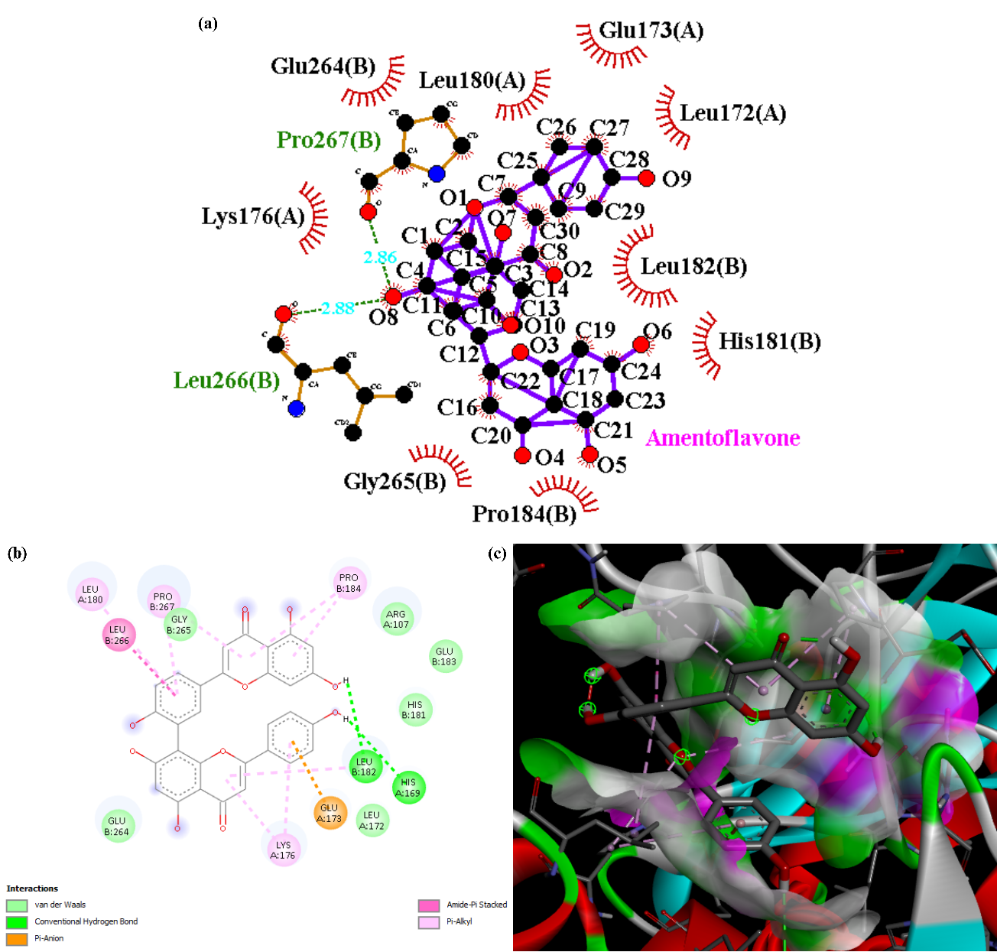
Figure S1: Integrated diagram showing the 2D interaction of MHC1 and Amentoflavone through (a) Ligplot software, (b) Discovery Studio, and (c) 3D representation of MHC1- Amentoflavone through Discovery Studio.

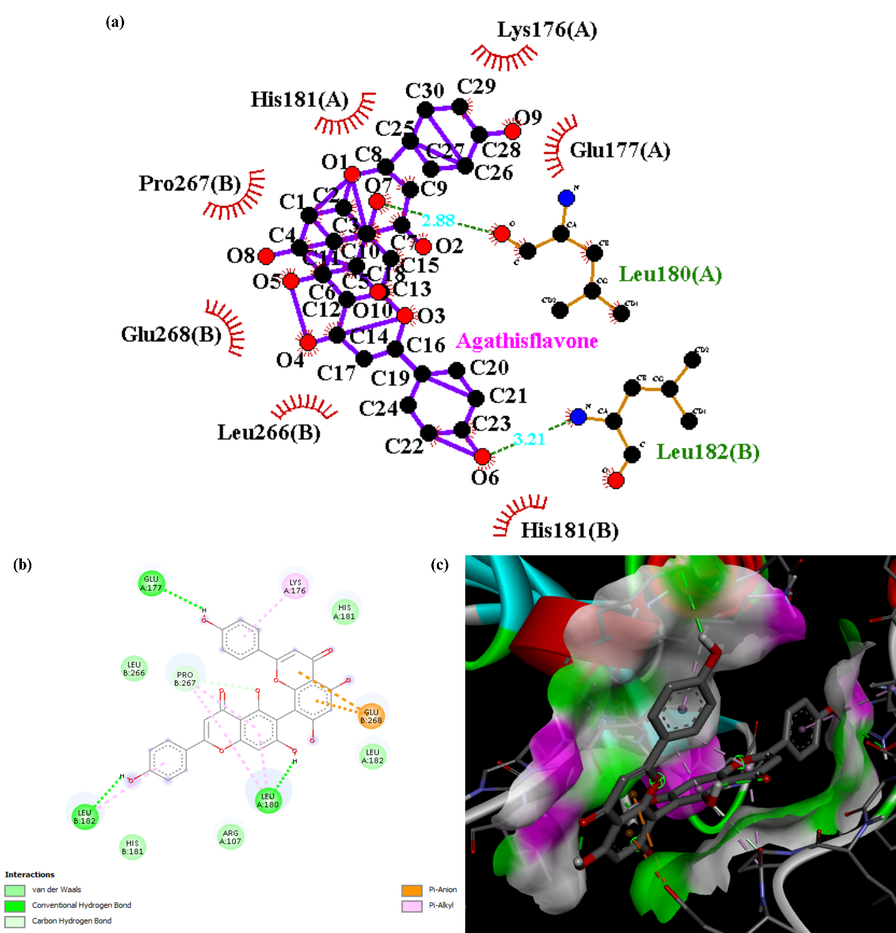
Figure S2: Integrated diagram showing the 2D interaction of MHC1 and Agathisflavone through (a) Ligplot software, (b) Discovery Studio, and (c) 3D representation of MHC1- Agathisflavone through Discovery Studio.
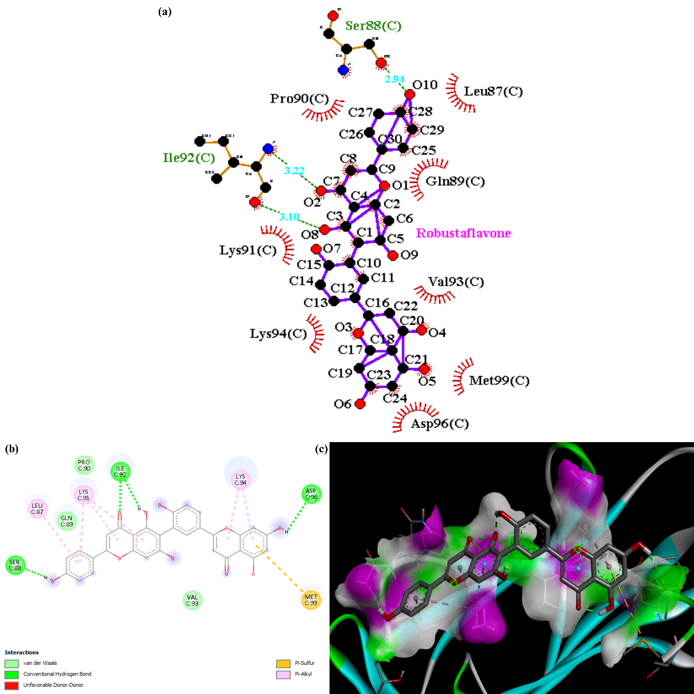
Figure S3: Integrated diagram showing the 2D interaction of MHC1 and Robustaflavone through (a) Ligplot software, (b) Discovery Studio, and (c) 3D representation of MHC1- Robustaflavone through Discovery Studio.

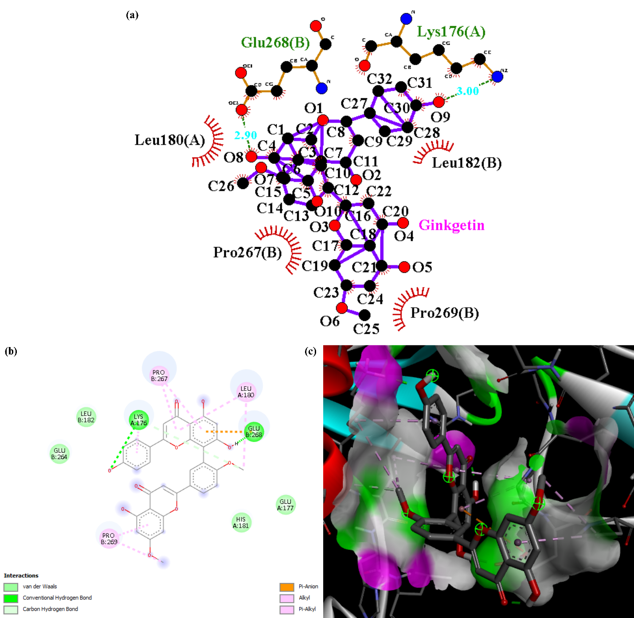
Figure S4: Integrated diagram showing the 2D interaction of MHC1 and Ginkgetin through (a) Ligplot software, (b) Discovery Studio, and (c) 3D representation of MHC1- Ginkgetin through Discovery Studio.

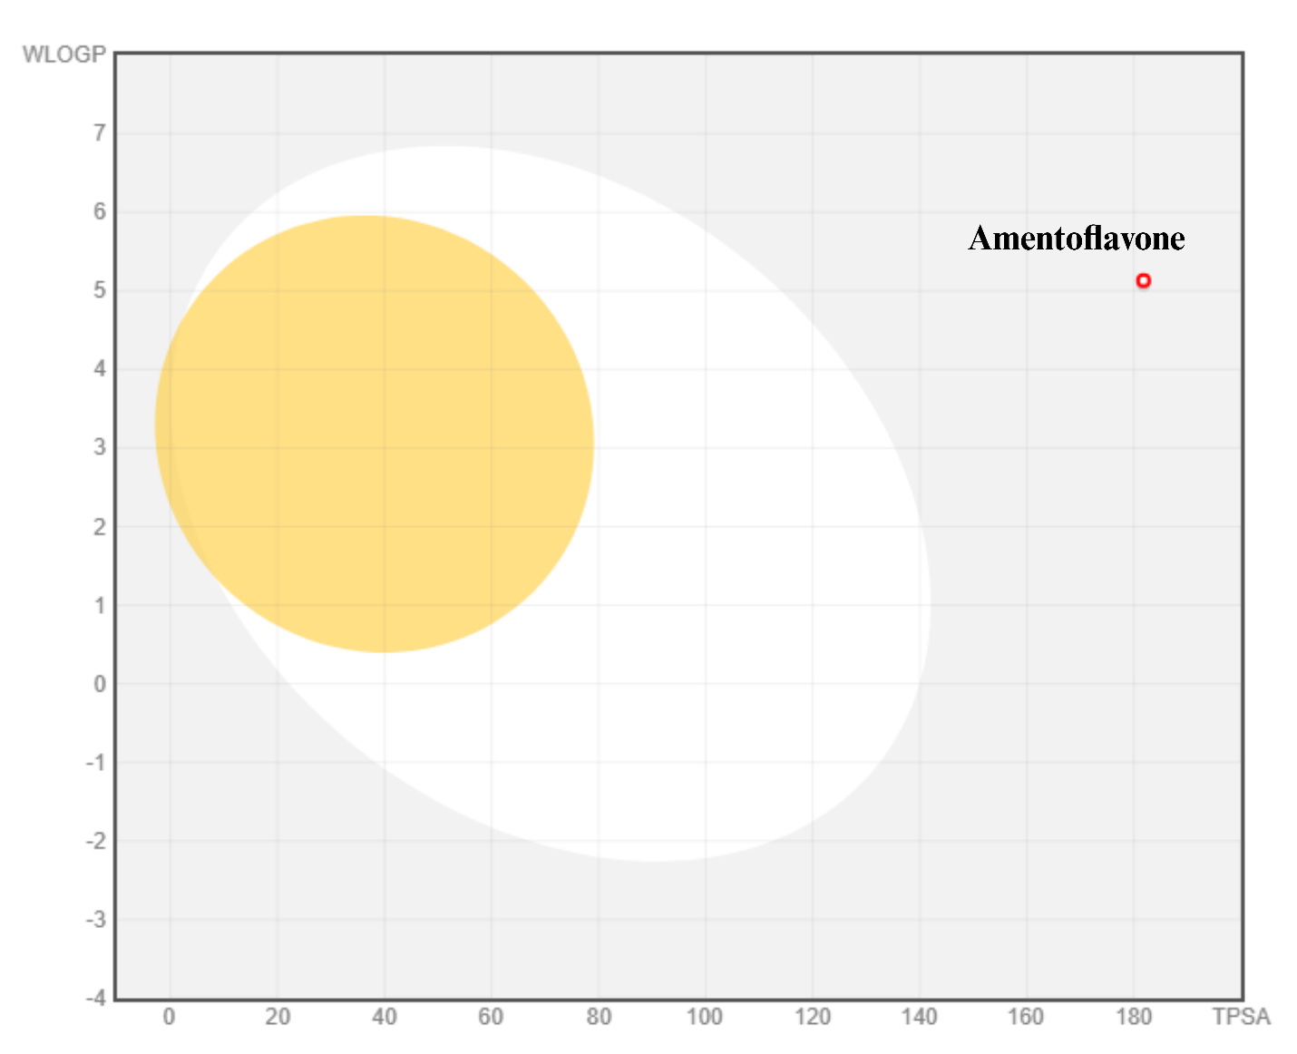
Figure S5: Boiled egg plot analysis for Amentoflavone by employing SwissADME showing the location of the drug for GI absorption and BBB permeability.

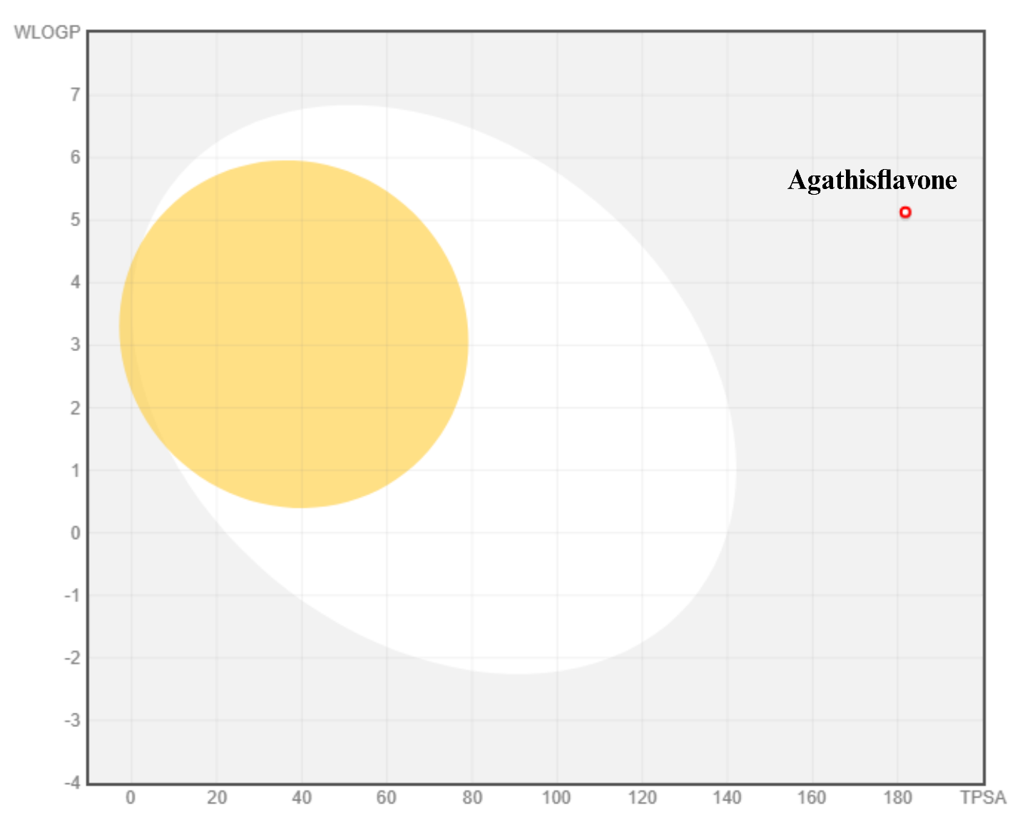
Figure S6: Boiled egg plot analysis for Agathisflavone by employing SwissADME showing the location of the drug for GI absorption and BBB permeability.
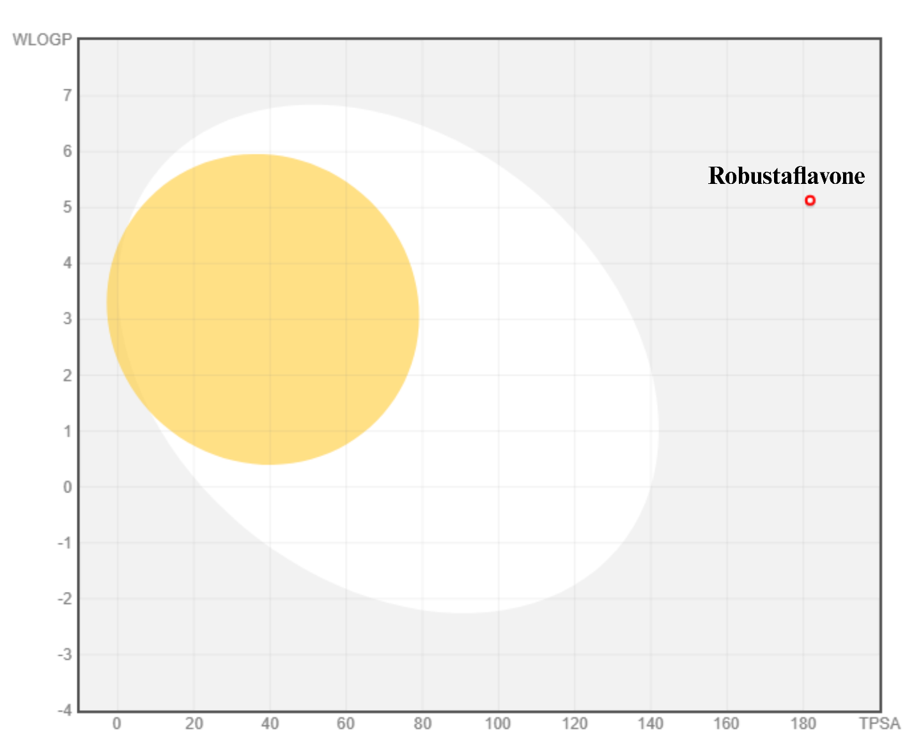
Figure S7: Boiled egg plot analysis for Robustaflavone by employing SwissADME showing the location of the drug for GI absorption and BBB permeability.
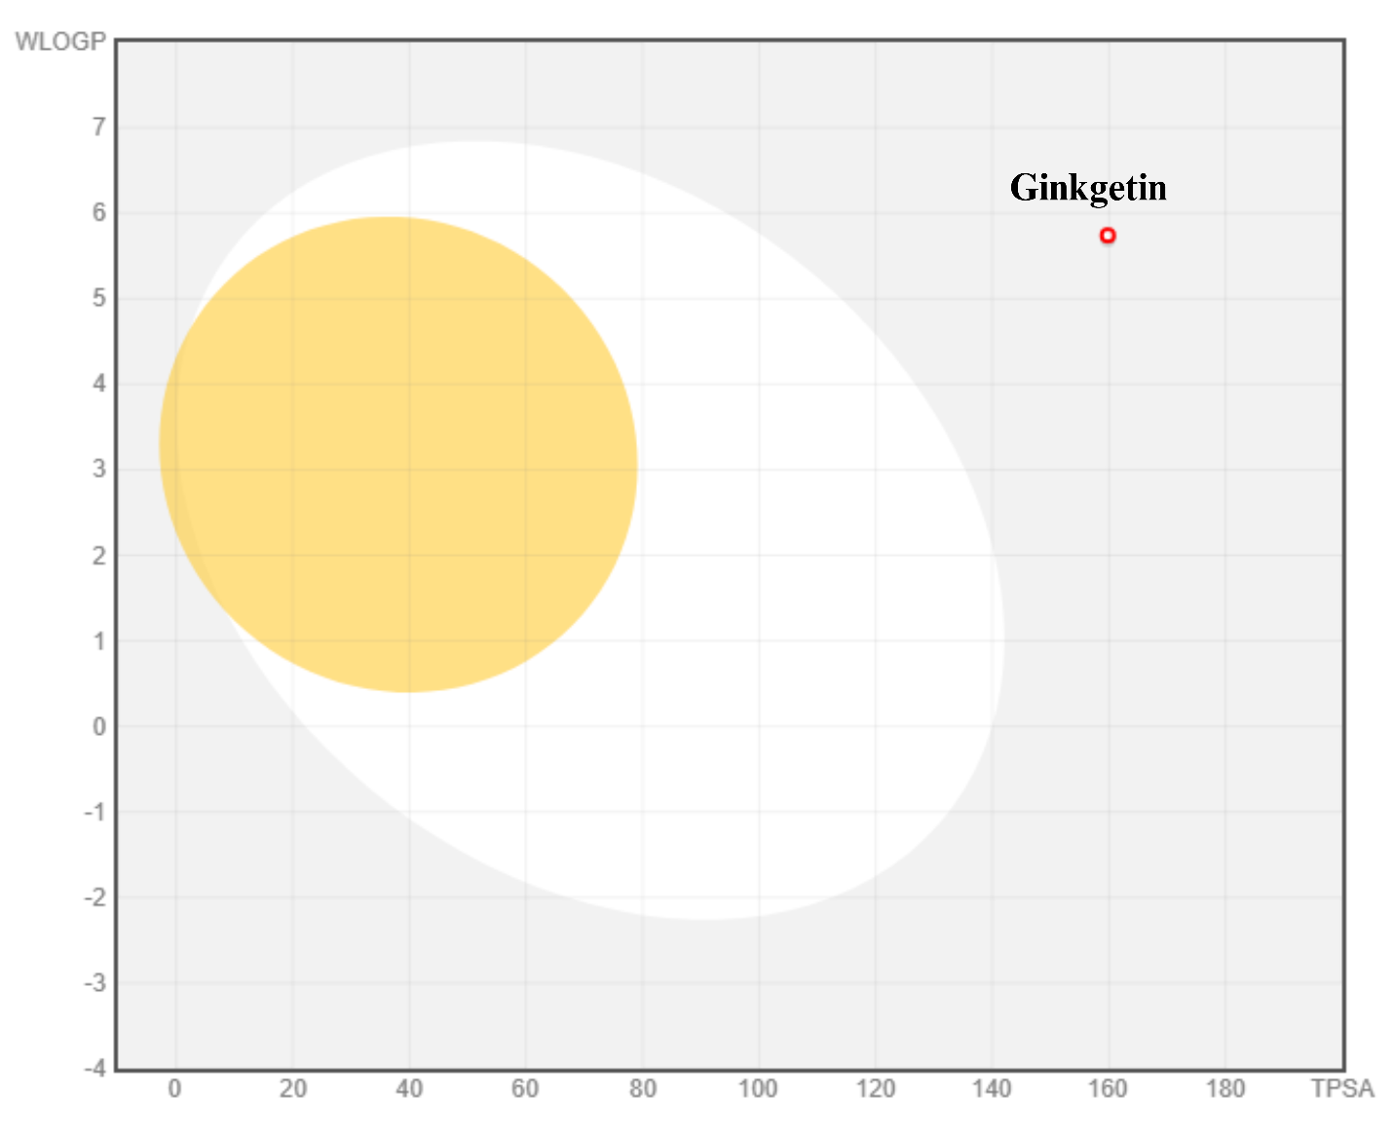
Figure S8: Boiled egg plot analysis for Ginkgetin by employing SwissADME showing the location of the drug for GI absorption and BBB permeability.

