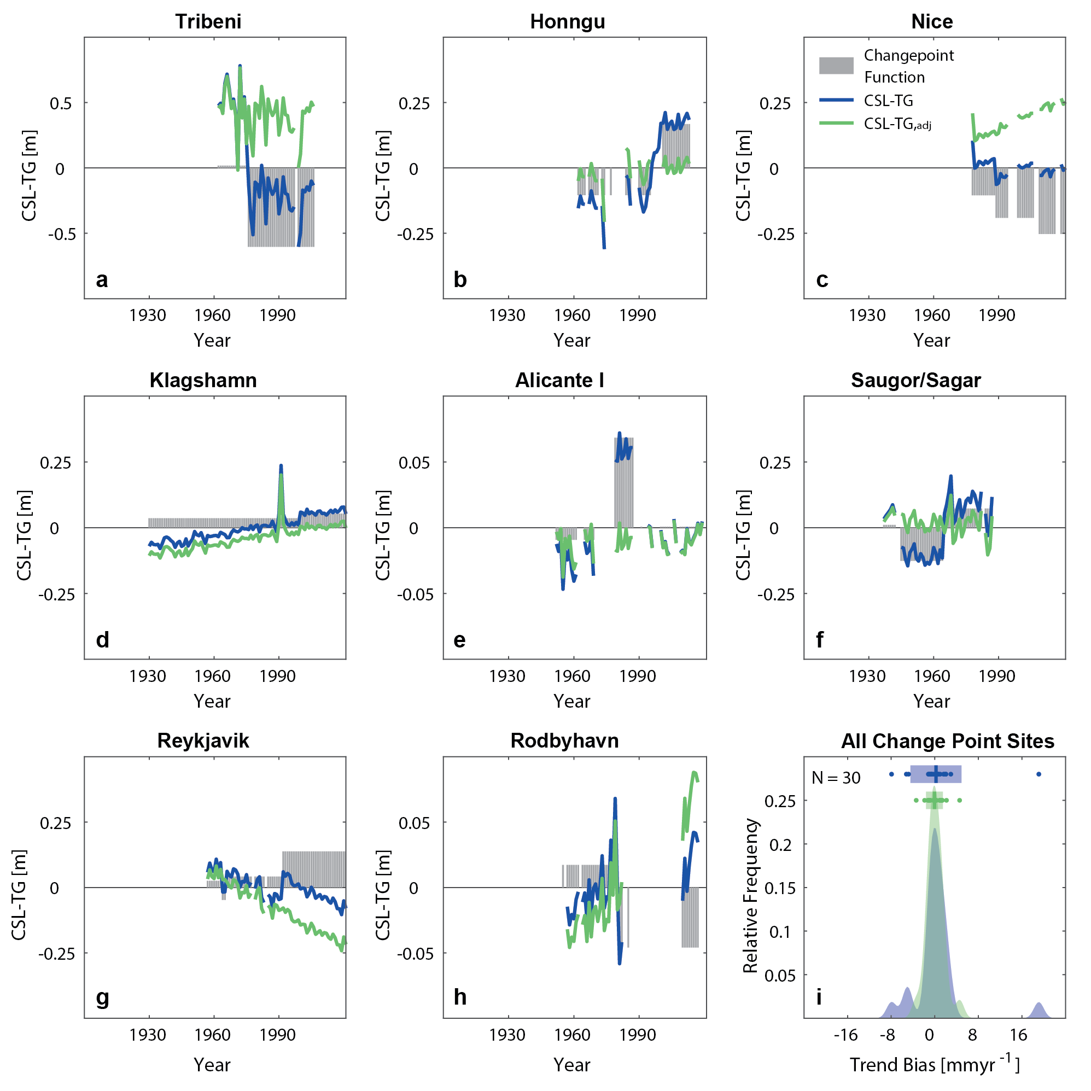
Extended Data Fig. 1 | Changepoint detection in CSL-TG and its impact on the estimation of VLM. Shown are 8 out of 24 examples of CSL-TG time series with datum shifts that have not been addressed in the PSMSL database for: a, Tribeni, India, b Honngu, Vietnam, c Nice, France, d Klagsham, Sweden, e Alicante 1, Spain, f Saugor/Sagar, India, g Reykjavik, Island, and h Rodbyhavn, Denmark. Also shown are the empirical distributions of trend differences between CSL-TG and GNSS VLM from ref. 24 in (i). The shaded rectangle with the thick vertical line represents the 95% confidence interval and the associated median. Before adjusting for changepoints, the trend bias is 0.06 ± 4.13 mmyr⁻¹, while after adjustment the bias reduces to 0.09 ± 1.4 mmyr⁻¹. This indicates that the changepoint corrections are reasonable and that the remaining residuals reflect VLM.
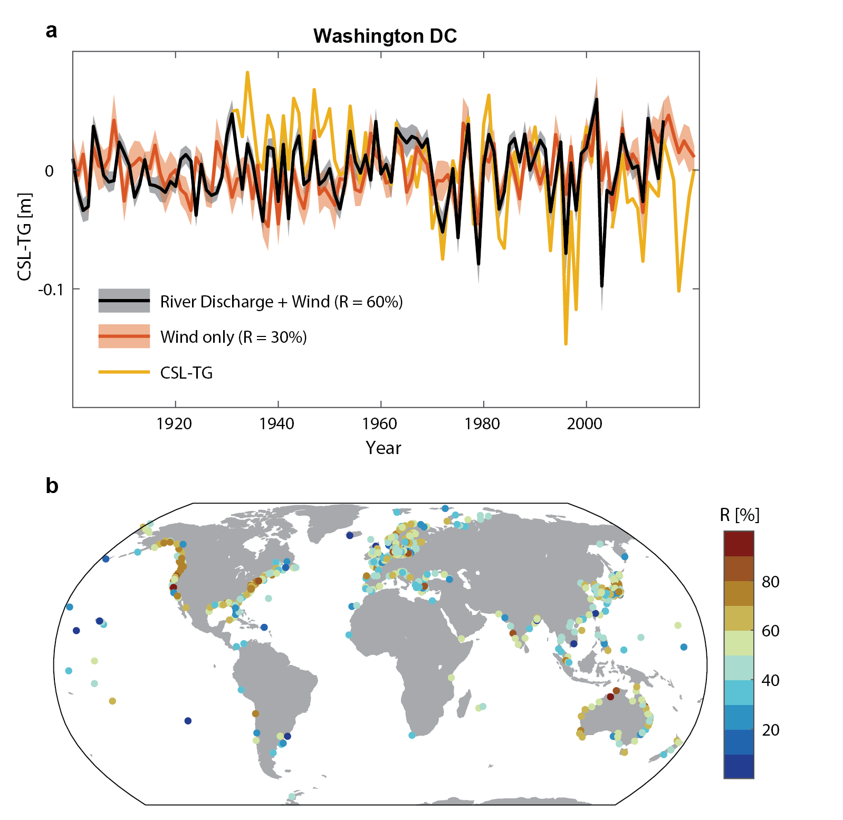
Extended Data Fig. 2 | Estimation of near-coastal processes through multiple stepwise regression. a Shown are CSL-TG in comparison to the results of a full stepwise regression model forced with river discharge and wind versus a model solely forced with winds at the location of Washington DC. RThe explained variability in % as given by the coefficients of determination (R) is listed in parenthesis. b Map of explained varibility by the full stepwise regression model forced with river discharge and winds.
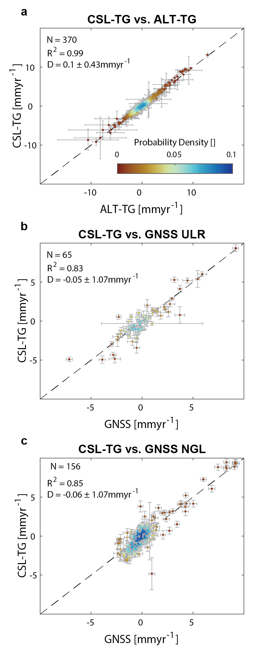
Extended Data Fig. 3 | Validation of linear VLM from CSL-TG against state-of-the-art approaches. a Comparison of linear trends from 1993 to 2021 from CSL-TG and ALT-TG at sites that provide at least 75% of data coverage. N provides the number of sites considered, R² is the coefficient of determination, and D the difference between the products provided as median and standard deviation over all sites in mm yr⁻¹. b Same as b, but for GNSS data from ULR at sites that have a GNSS observation within 5 km. c Same as a, but for GNSS records from NGL that meet the ‘good’ criterium (Methods).
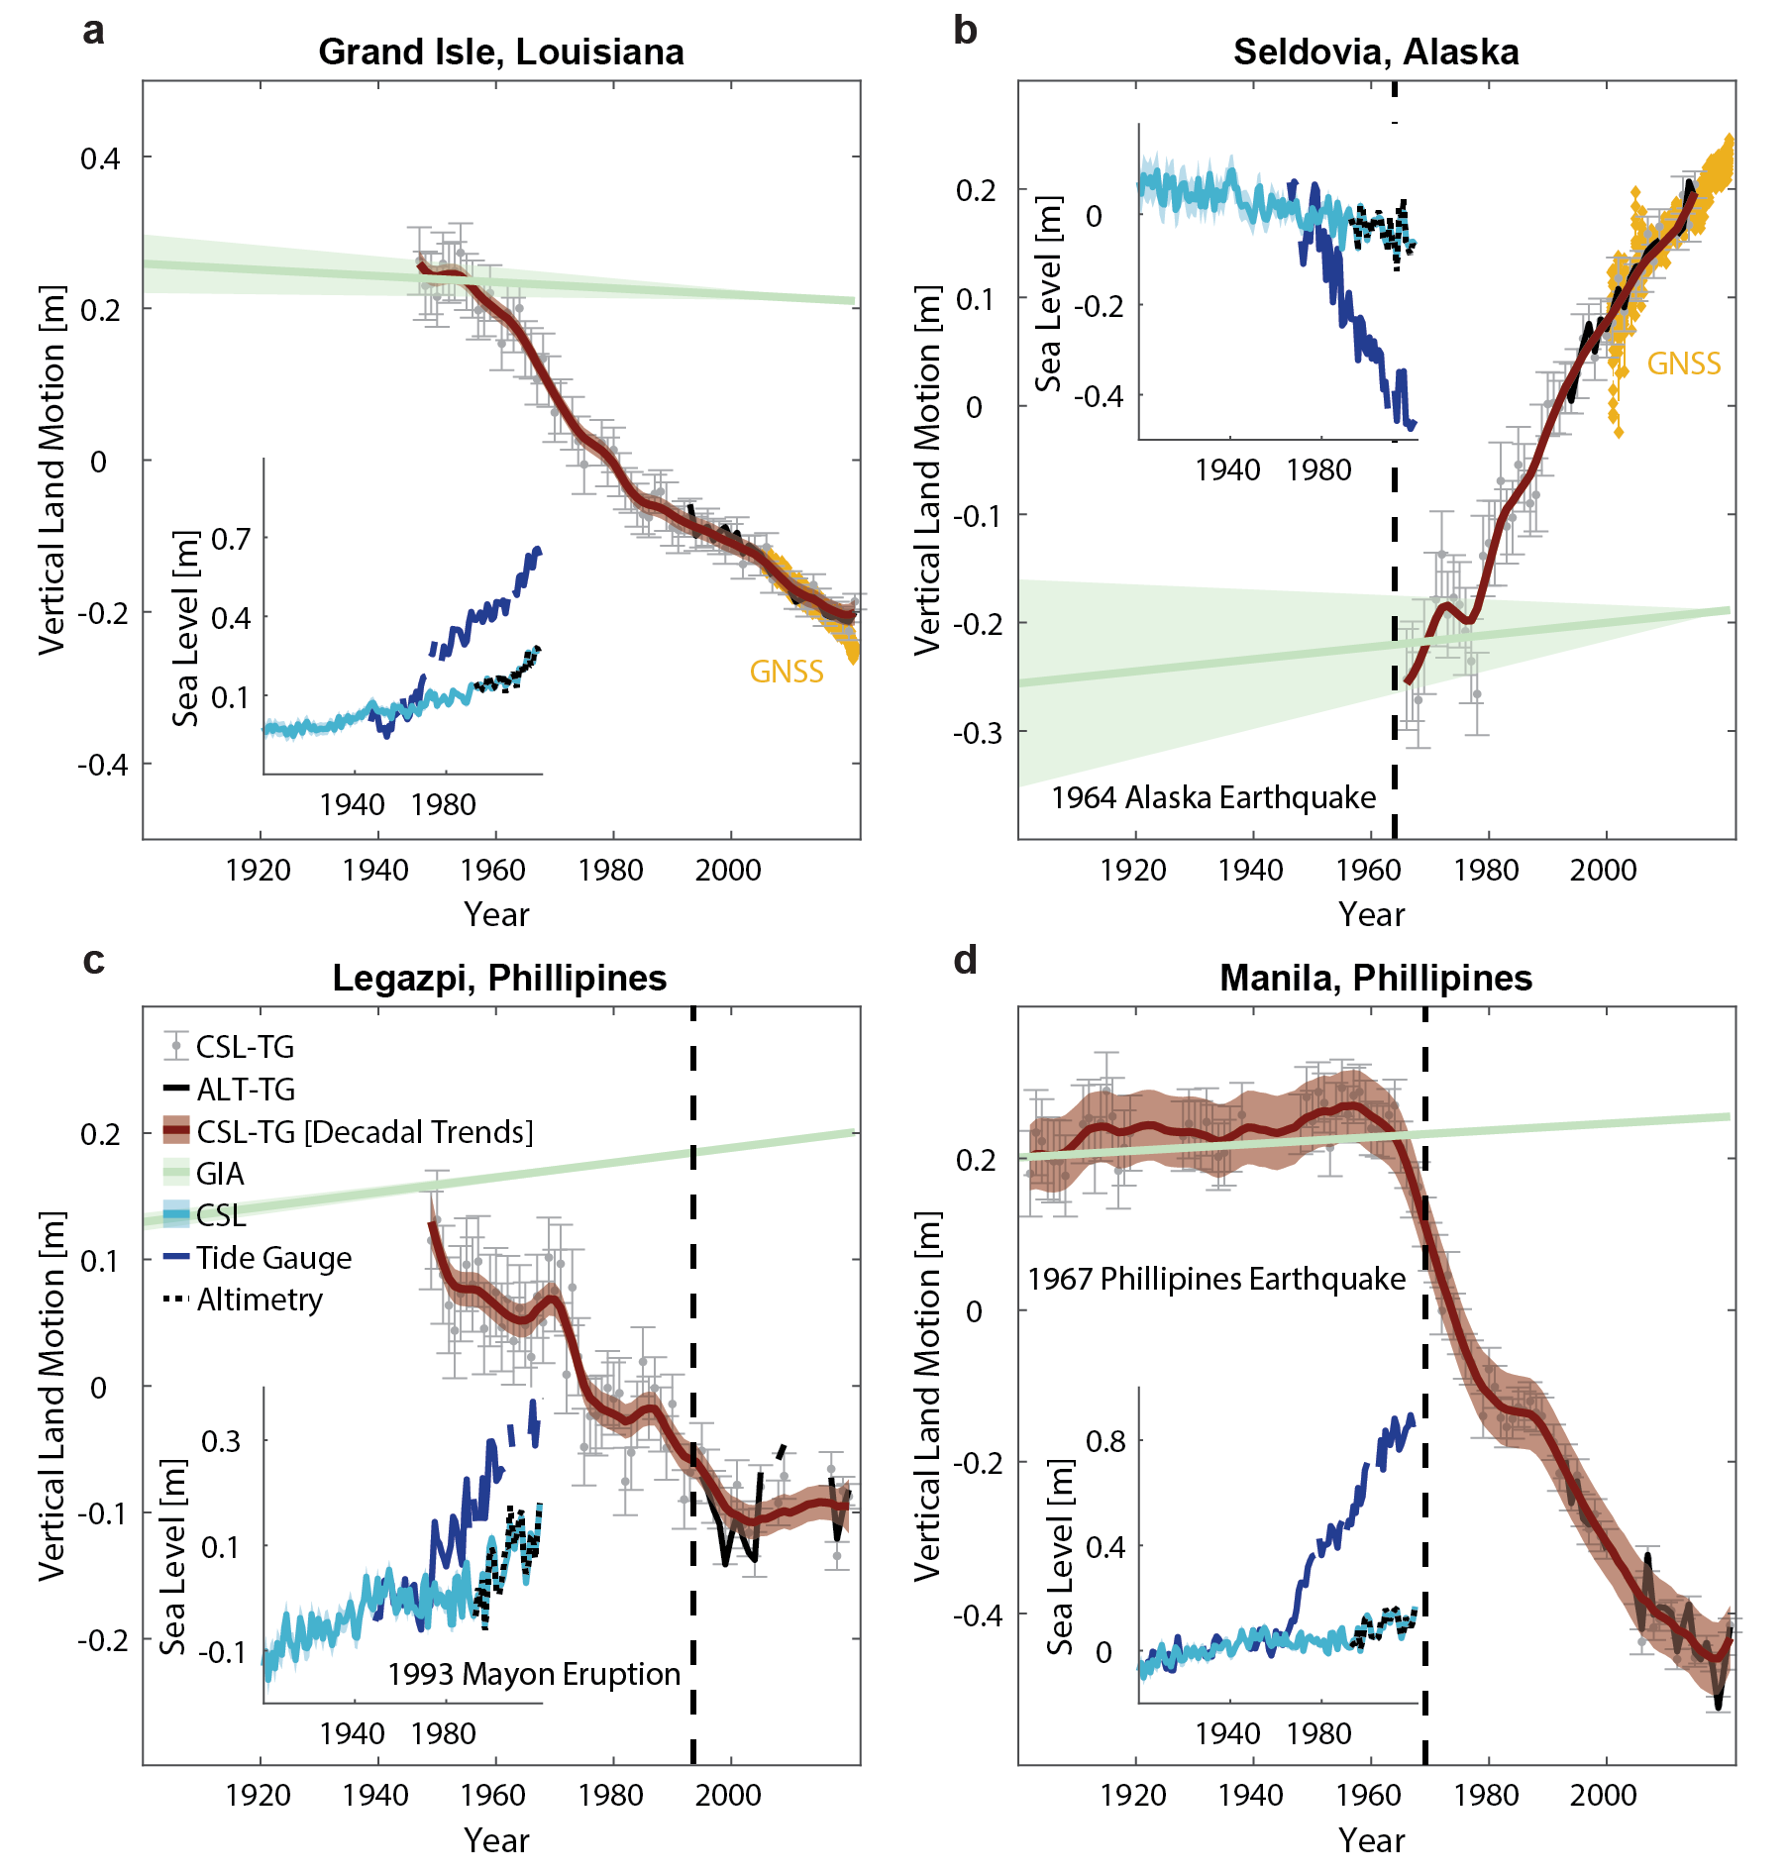
Extended Data Fig. 4 | Examples of nonlinear Vertical Land Motion (VLM) from the climatic sea-level reconstruction minus tide gauges (CSL-TG) at selected sites. Nonlinear VLM at Grand Isle, Louisiana (a), Seldovia, Alaska (b), Legaspi, Phillipines (c), and Manila, Phillipines (d). All subplots show tide gauge and satellite altimetry observations in comparison to CSL in the insets. CSL-TG differences are shown with their uncertainties as error bars and a smoothed version based on a Singular Spectrum Analysis (SSA) with decadal smoothing. In (a) and (b) GNSS records from the vicinity of the tide gauge are shown for validation. Vertical dashed lines mark major earthquakes or volcanic eruptions. For instance at Legazpi, the changing motions in the VLM rates may correspond to magmatic events, including the eruptions in 1993 and associated re-inflation⁸⁴. At Manila, the nonlinear VLM before may show precursory uplift (shortening) prior to the 1968 magnitude 7.3 earthquake in addition to the groundwater widthdrawals¹¹.
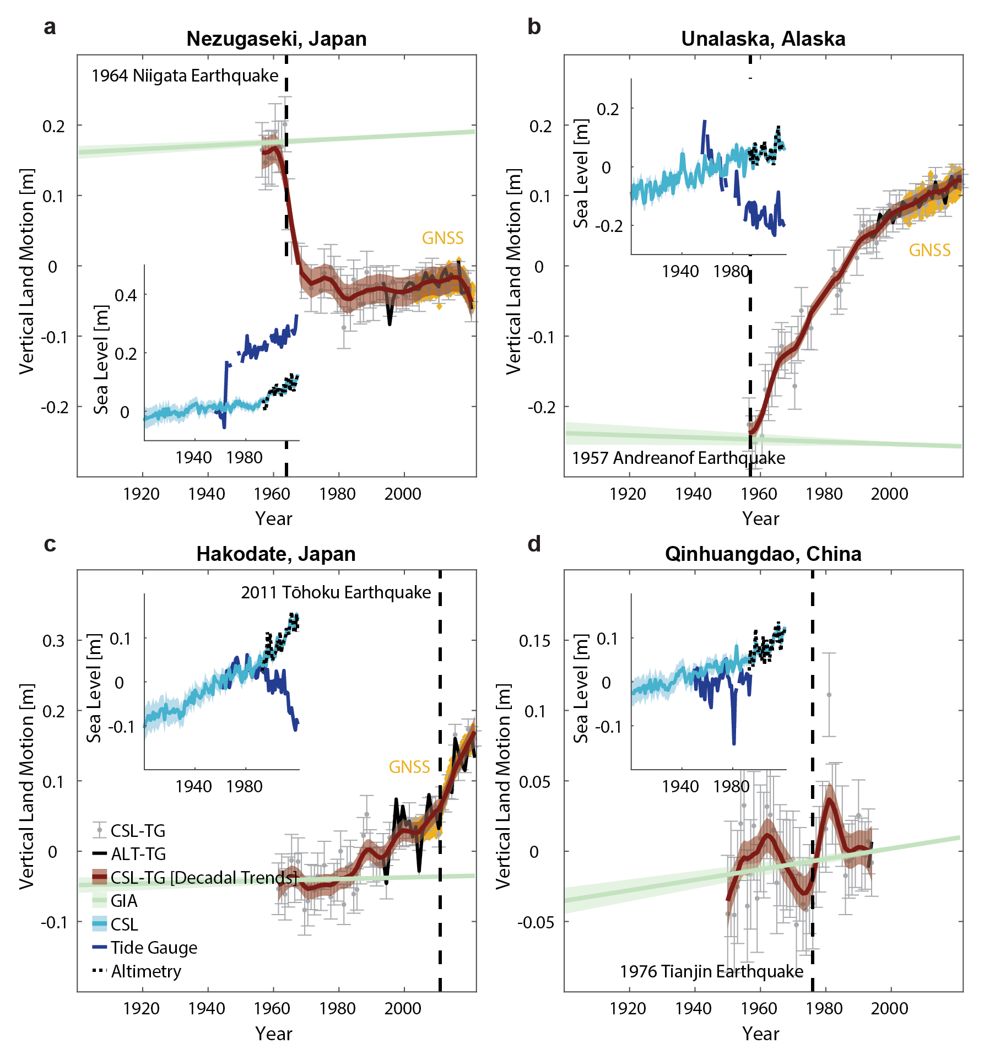
Extended Data Fig. 5 | Examples of nonlinear Vertical Land Motion (VLM) from the climatic sea-level reconstruction minus tide gauges (CSL-TG) at selected sites. Nonlinear VLM at Nezugaseki, Japan (a), Unalaska, Alaska (b), Hakodate, Japan (c), and Quinhuandao, China (d). All subplots show tide gauge and satellite altimetry observations in comparison to CSL in the insets. CSL-TG differences are shown with their uncertainties as error bars and a smoothed version based on a Singular Spectrum Analysis (SSA) with decadal smoothing. In (a), (b) and (c) GNSS records from the vicinity of the tide gauge are shown for validation. At Unalaska (b) uplift rates coincide with eruptions of the Makushin volcano in 1980, 1987, 1993, and 1995 (Global Volcanisms Program, 2025, https://volcano.si.edu/). At Hakodate, the nearby E-San volcano experienced a period of unrest in 2012 (Global Volcanisms Program, 2025, https://volcano.si.edu/).
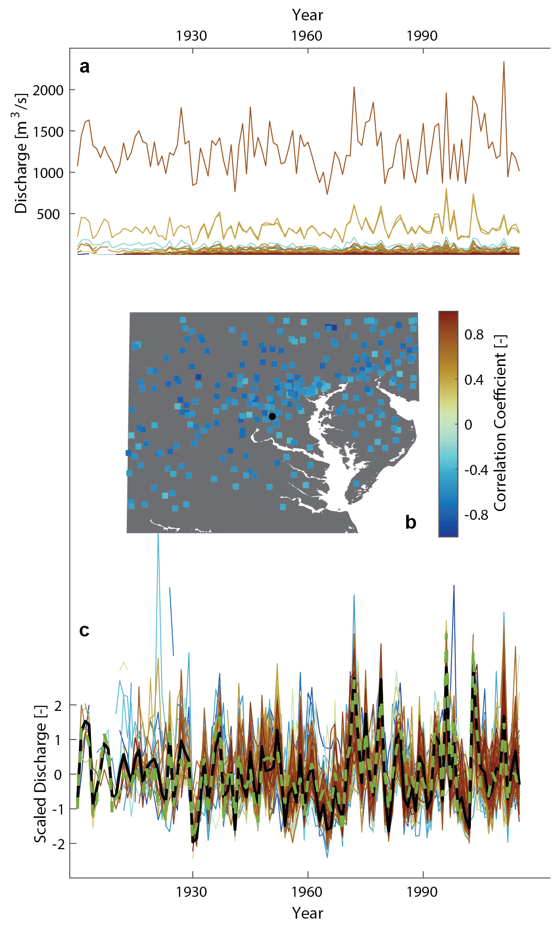
Extended Data Fig. 6 | Example of the calculation of river discharge indices. a River discharge at different river gauges within ± 4 degrees proximity to the tide gauge at Washington DC. b Correlation between CSL-TG and each river discharge time series in a. c All river discharge time series from a, but now standard-normalized. The black thick line shows the first principal component determined from a probabilistic principal component analysis. For comparison, the Potomac River, which is hyrdodynamically connected to the Washington, DC tide gauge, is shown as a thick green dotted line.

