Supplementary Materials for
Bioinspired passive radiative cooler with superior transparency and durability for energy-efficient building
Hanliang Ding¹, Bo Li^{1,2,}*, Yicong Zhang¹, Yufan Zhang¹, Shichao Niu^{1,2,3,}*, Zhiwu Han^{1,2,3,}*, Luquan Ren^{1,2,3}
¹ Key Laboratory of Bionic Engineering (Ministry of Education), Jilin University, Changchun 130022, People’s Republic of China
² The National Key Laboratory of Automotive Chassis Integration and Bionics (ACIB), College of Biological and Agricultural Engineering, Jilin University, Changchun 130022, China
³ Institute of Structured and Architected Materials, Liaoning Academy of Materials, Shenyang 110167, China

*Correspondence to: boli@jlu.edu.cn; niushichao@jlu.edu.cn; zwhan@jlu.edu.cn
This PDF file includes:
Supplementary Figs. 1 to 24
Supplementary Table 1
Other Supplementary Materials for this manuscript include the following:
Supplementary Movies 1 and 2

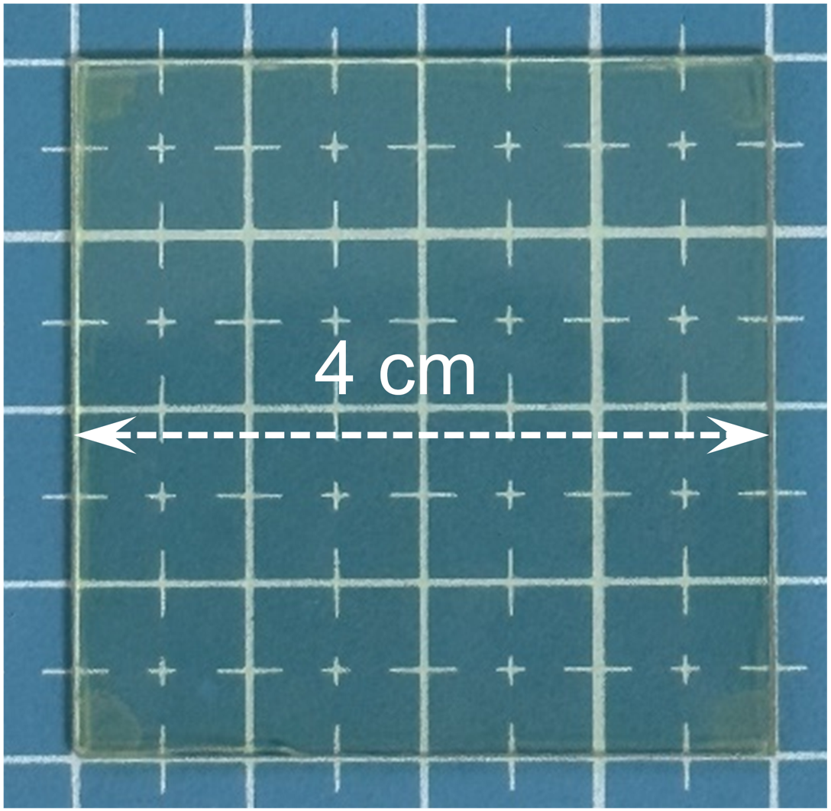
Supplementary Fig. 1. Bio-PRC device fabricated under laboratory condition.

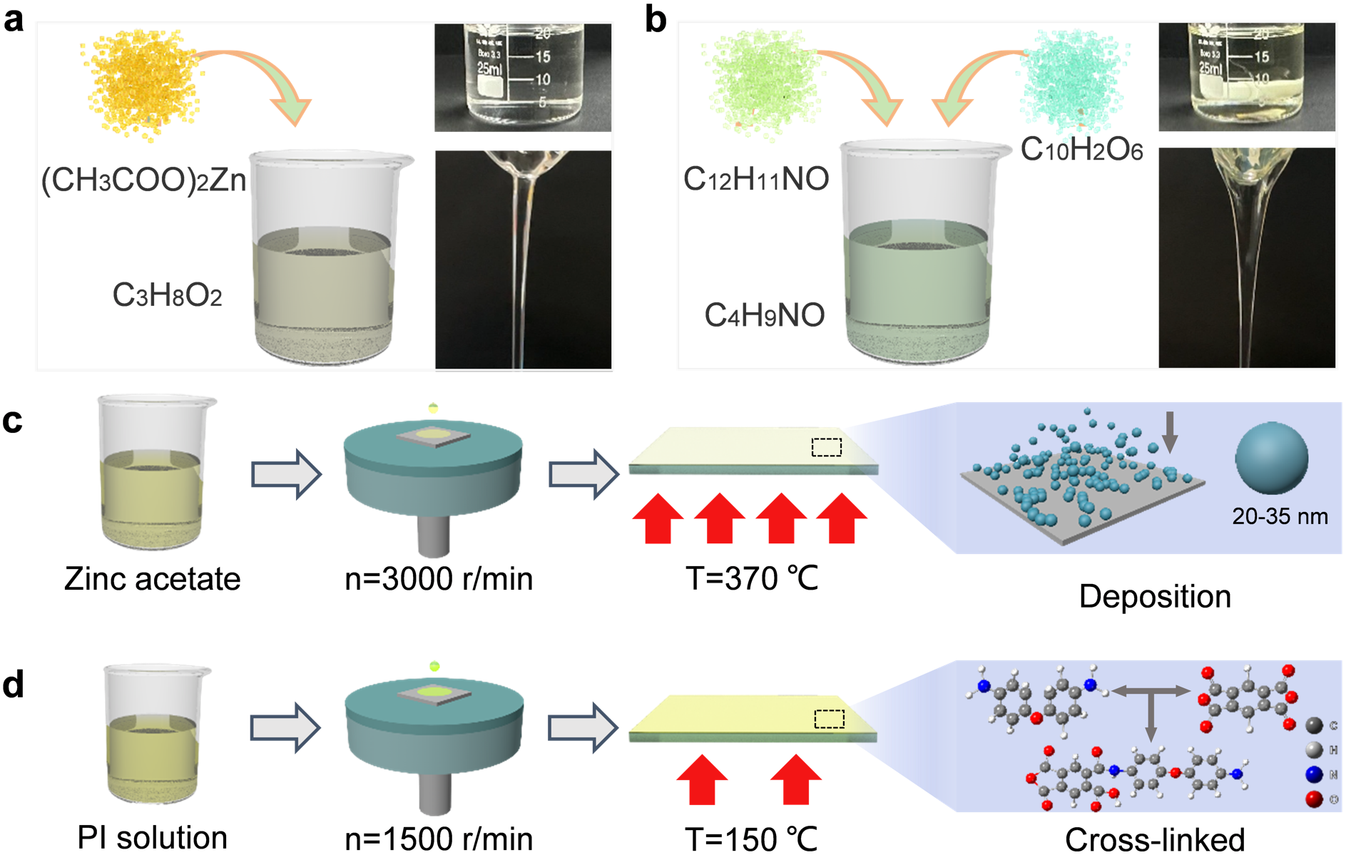
Supplementary Fig. 2. Fabrication process and parameters of PRC device. a, Preparation of zinc acetate solution and its flowability after stabilization. b, Preparation of PI precursor solution and its flowability after stabilization. c, Process and conditions for preparing ZnO layer. d, Process and conditions for preparing PI layer.

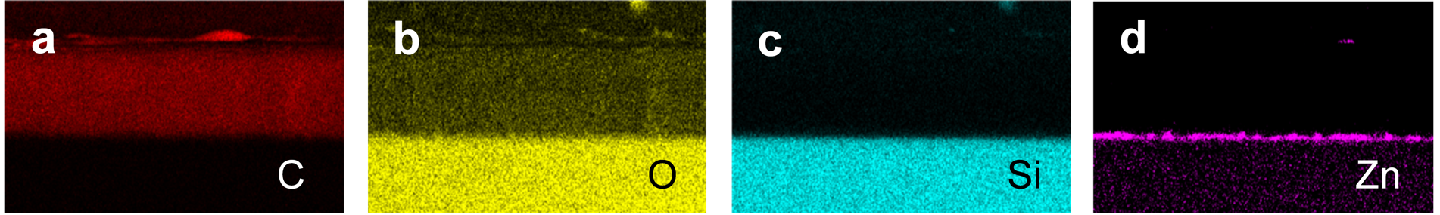
Supplementary Fig. 3. Distribution of various elements on PRC device.

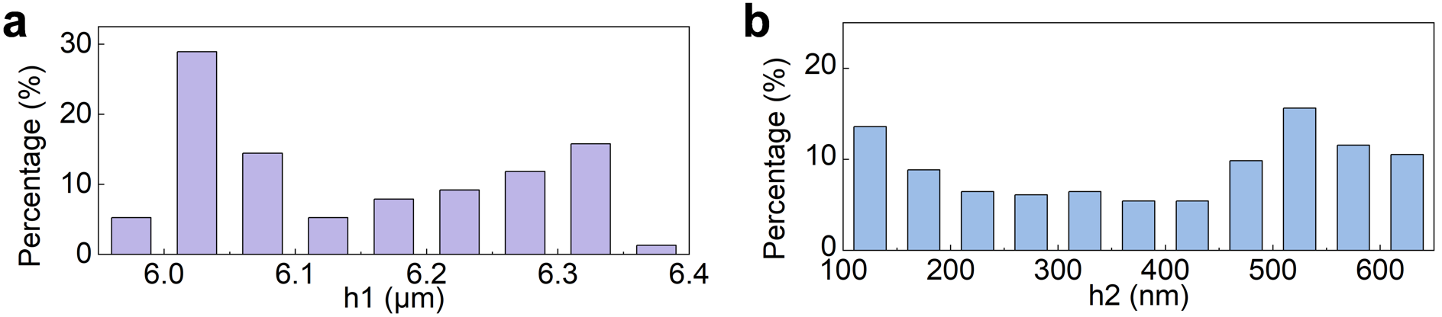
Supplementary Fig. 4. Statistical analysis of the structural dimensions of each layer of PRC device. a, Thickness statistics of PI layer. b, Thickness statistics of ZnO layer.

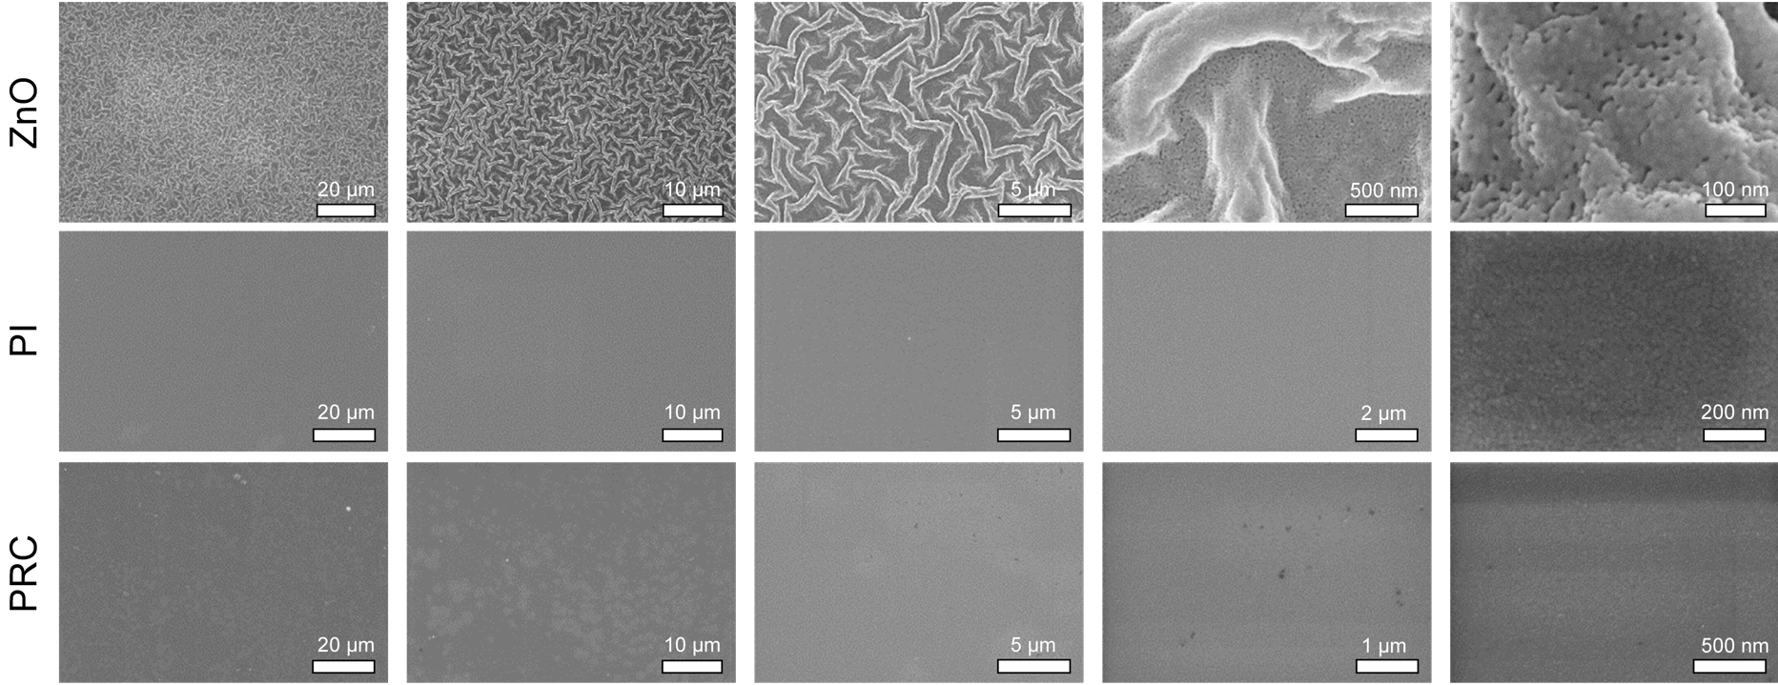
Supplementary Fig. 5. SEM characterization of various surface structures. The ZnO represents that decomposition of Zinc acetate to form a wrinkled surface by the accumulation of ZnO nano-spheres. The PI represents that pi layer is directly fabricated on bare glass, while the PRC including pi layer and ZnO layer.

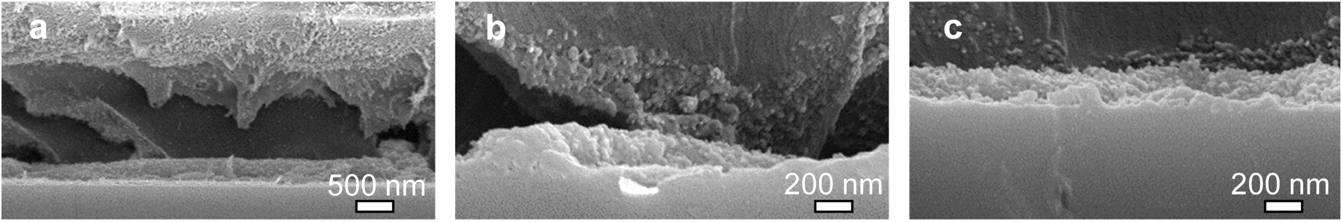
Supplementary Fig. 6. SEM characterization of the structural joint surface between the PI layer and ZnO layer. a, PI surface is uniformly distributed with nano-ZnO particles, indicating that pi solution has good wettability in nano-ZnO layer during the fabrication process. b, After the separation of the PI layer and the nano-ZnO layer, a large number of nano-ZnO particles will adhere locally, and this bonding mechanism is the reason for the enhanced adhesion. c, The remained nano-ZnO layer.

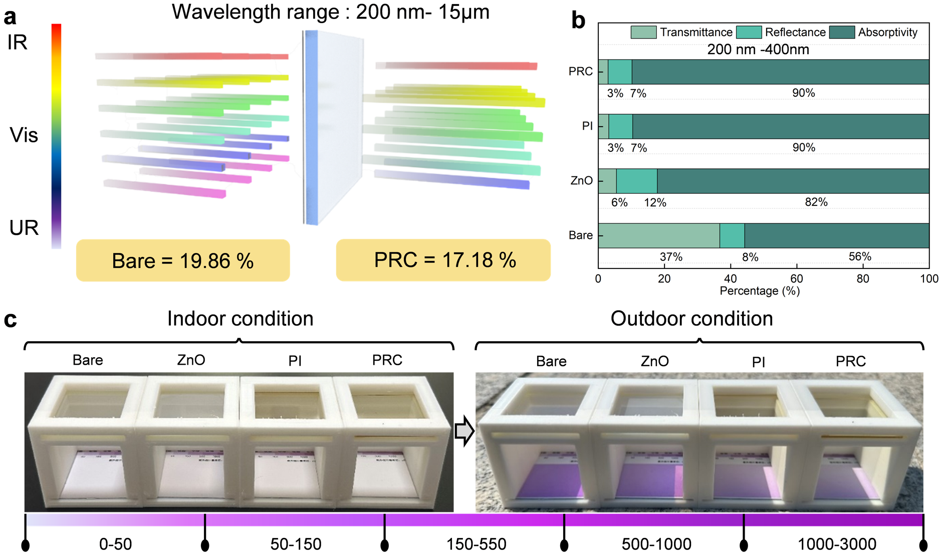
Supplementary Fig. 7. The UV resistance of PRC device. a, Within the entire testing wavelength, the transmittance of bare glass is 19.86%, while the transmittance of PRC film is 17.18%. b, The transmittance, reflectance, and absorbance of four samples in the ultraviolet region. c, UV resistance of four samples under indoor and outdoor conditions. After passing through PRC and PI device, the ultraviolet component of sunlight is significantly reduced.

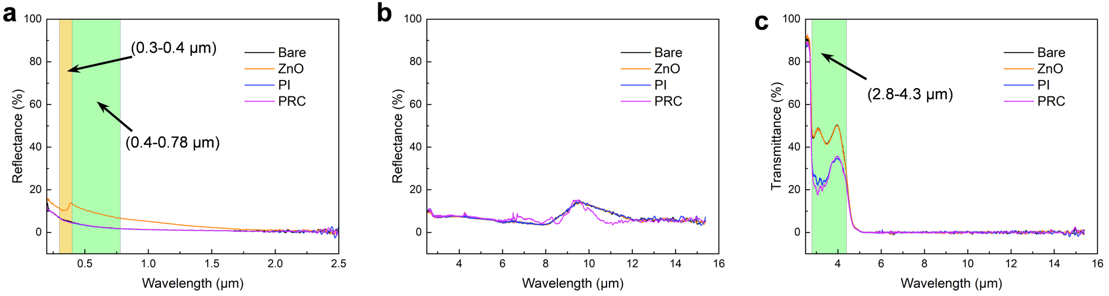
Supplementary Fig. 8. The optical property of PRC devcie. a, Reflectance of four samples in UV (0.2-0.4 μm), VIS (0.4-0.78 μm) and NIR (0.78-2.5 μm). b, Reflectance of four samples in MIR (2.5-15 μm). c, Transmittance of four samples in MIR (2.5-15 μm).

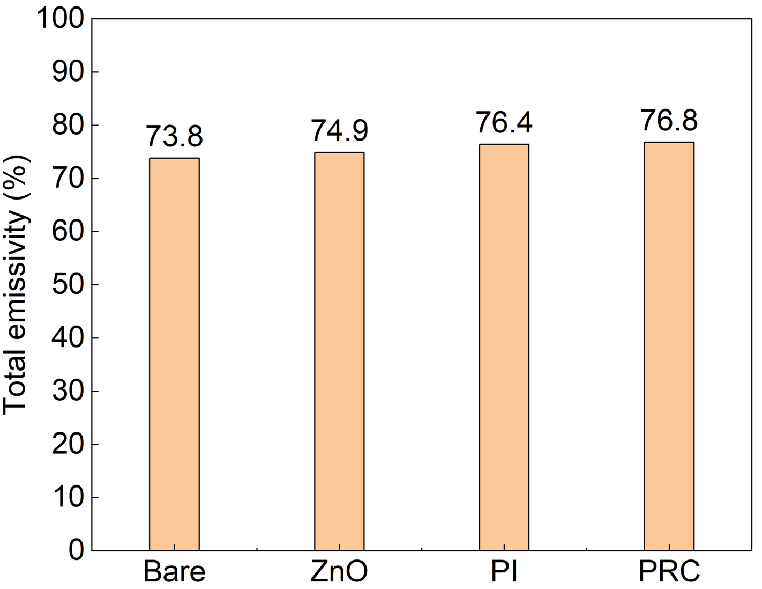
Supplementary Fig. 9. Statistical of emissivity of four samples in the entire testing range.

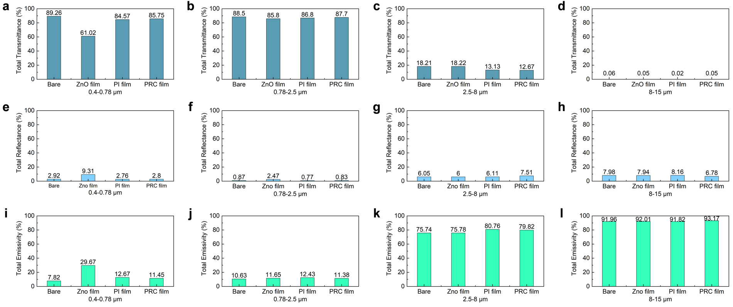
Supplementary Fig. 10. Statistical analysis of optical properties of four samples in different testing range. a-d, Transmittance statistical analysis of four samples in different testing range. e-h, Reflectance statistical analysis of four samples in different testing range. i-l, Emissivity statistical analysis of four samples in different testing range.

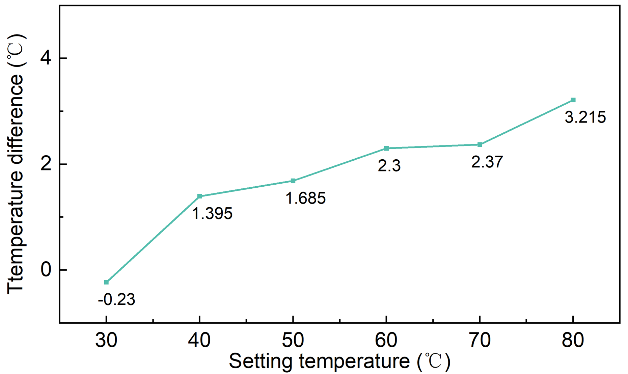
Supplementary Fig. 11. Temperature difference between heating table surface and bare glass surface.

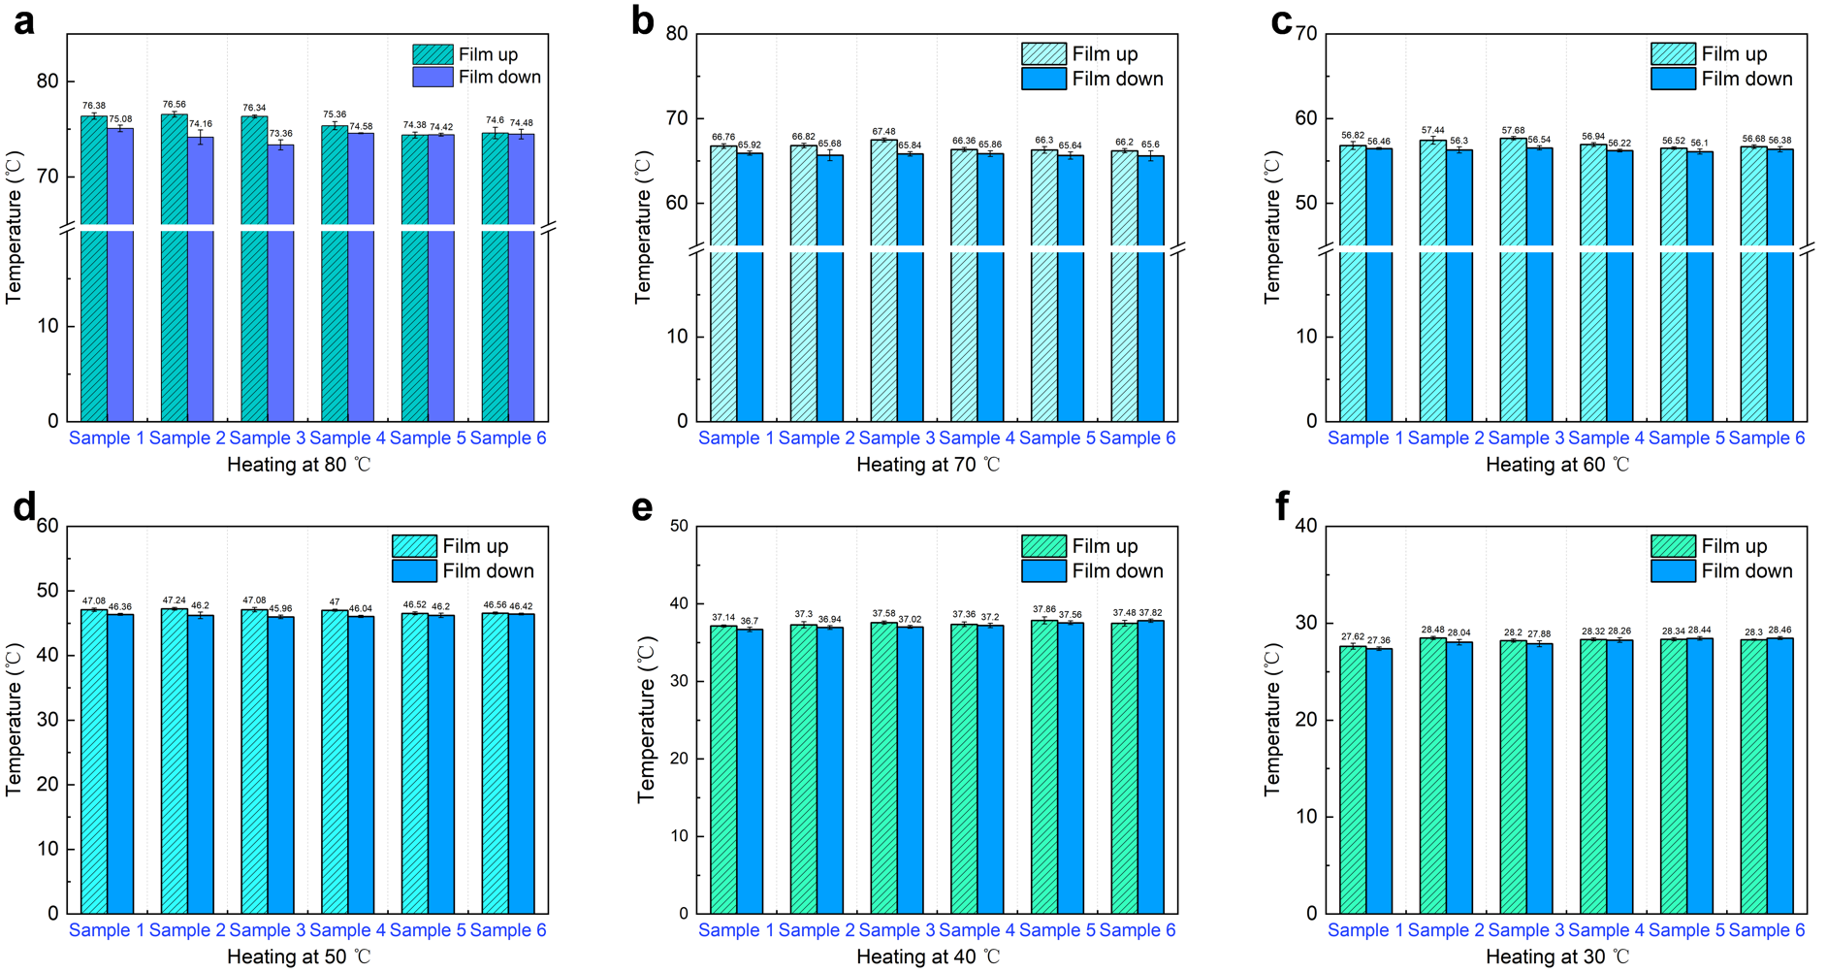
Supplementary Fig. 12. Surface temperature of different PRC devices at different states.

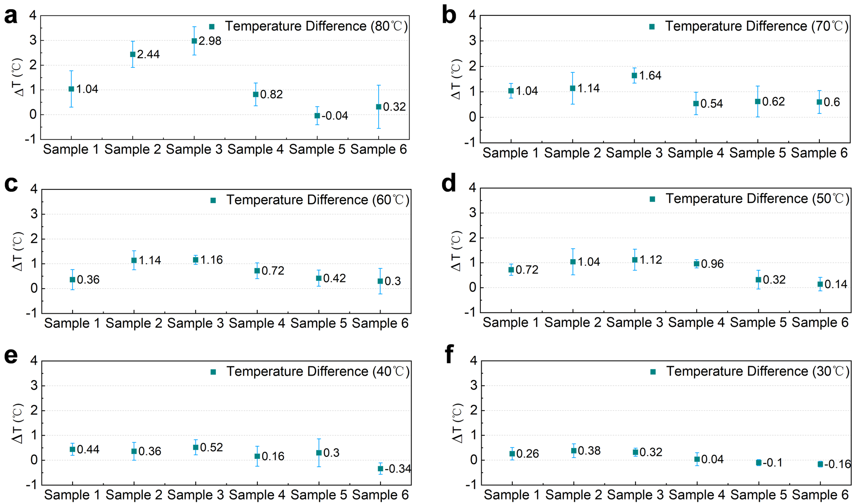
Supplementary Fig. 13. The temperature difference between the two conditions in SF 12.

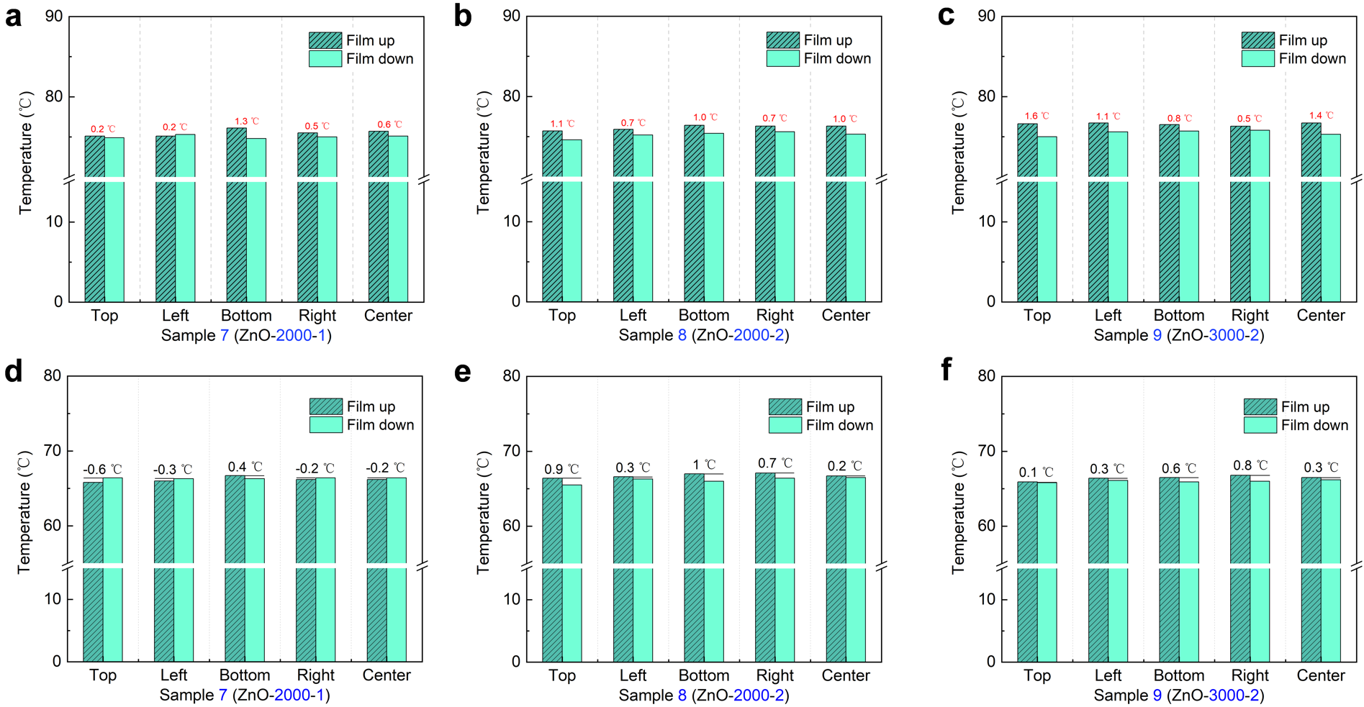
Supplementary Fig. 14. Heat transfer capability of ZnO device. Sample 7 is spin coated once at the maximum speed of 2000 r/min to prepare a ZnO layer. Sample 8 is spin coated twice at the maximum speed of 2000 r/min to prepare a ZnO layer. Sample 9 is spin coated twice at the maximum speed of 3000 r/min to prepare a ZnO layer. a-c, Surface temperature of 3 samples when ZnO layer placed up and down at 80 ℃. d-f, Surface temperature of 3 samples when ZnO layer placed up and down at 70 ℃.

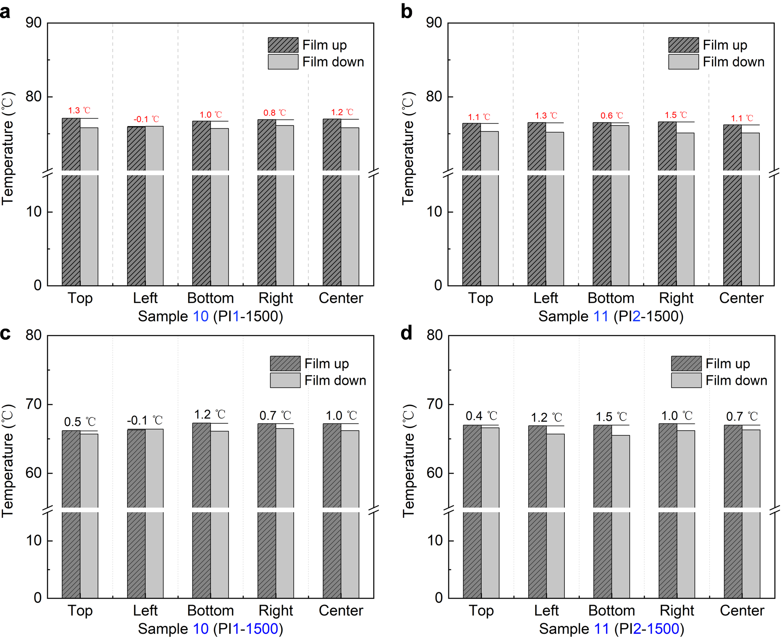
Supplementary Fig. 15. Heat transfer capability of PI device. PI1 represents adding ODA firstly when preparing PI precursor solution, while PI2 represents the adding PMDA firstly. Sample 10 is spin coated once at the maximum speed of 1500 r/min with PI1 to prepare PI layer. Sample 11 is fabricated under same condition with PI2. a, b, Surface temperature of 2 samples when setting temperature is at 80 ℃. d-f, Surface temperature of 2 samples when setting temperature is at 70 ℃.

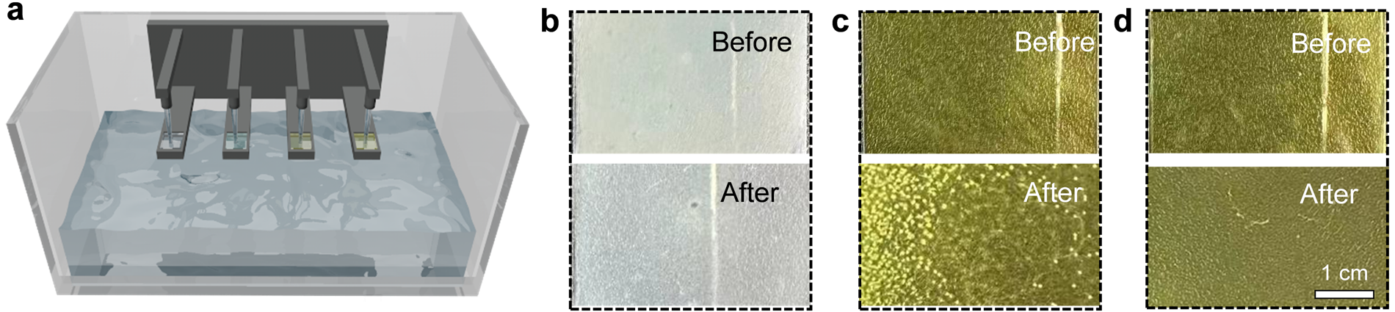
Supplementary Fig. 16. Water flushing test. a, Schematic diagram of flushing device. b, Surface morphology characterization of ZnO device before and after flushing. c, Surface morphology characterization of PI device before and after flushing. d, Surface morphology characterization of PRC device before and after flushing.

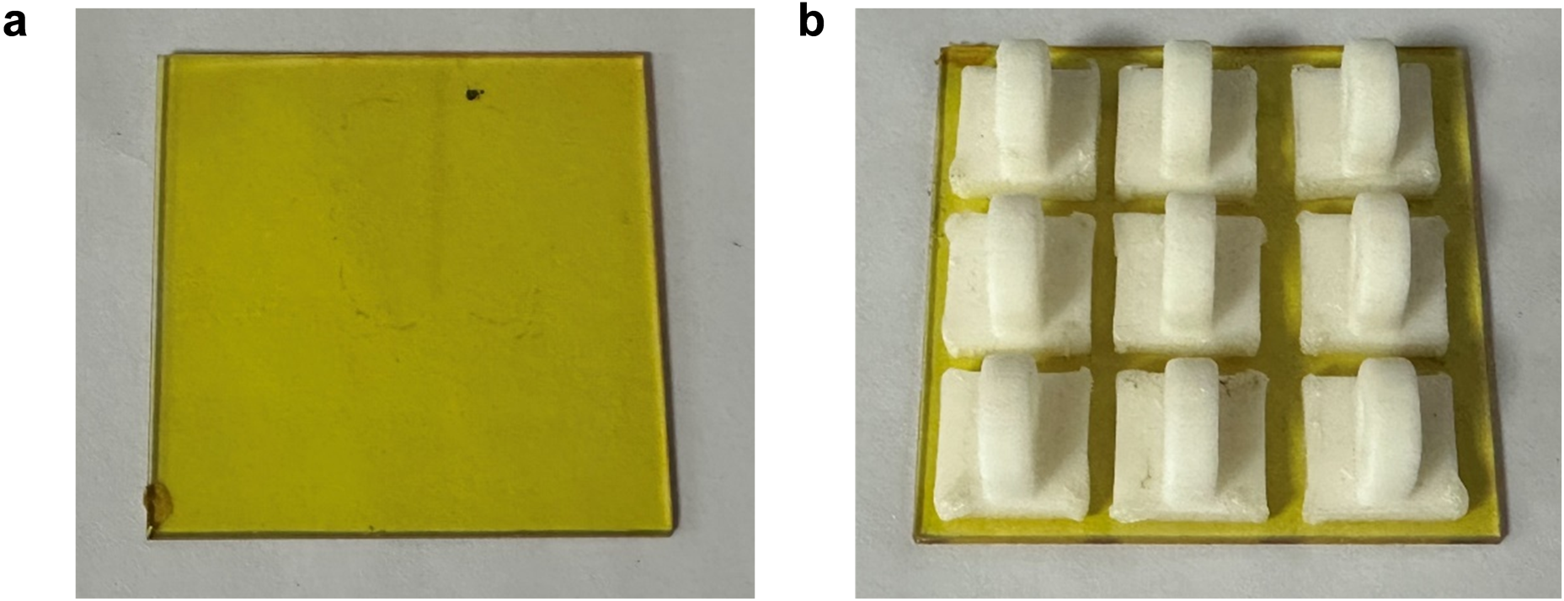
Supplementary Fig. 17. a, PRC device after flushing. b, Pre-treatment for adhesion testing, divide the adhesive hooks into three areas and stick them to the testing surface.

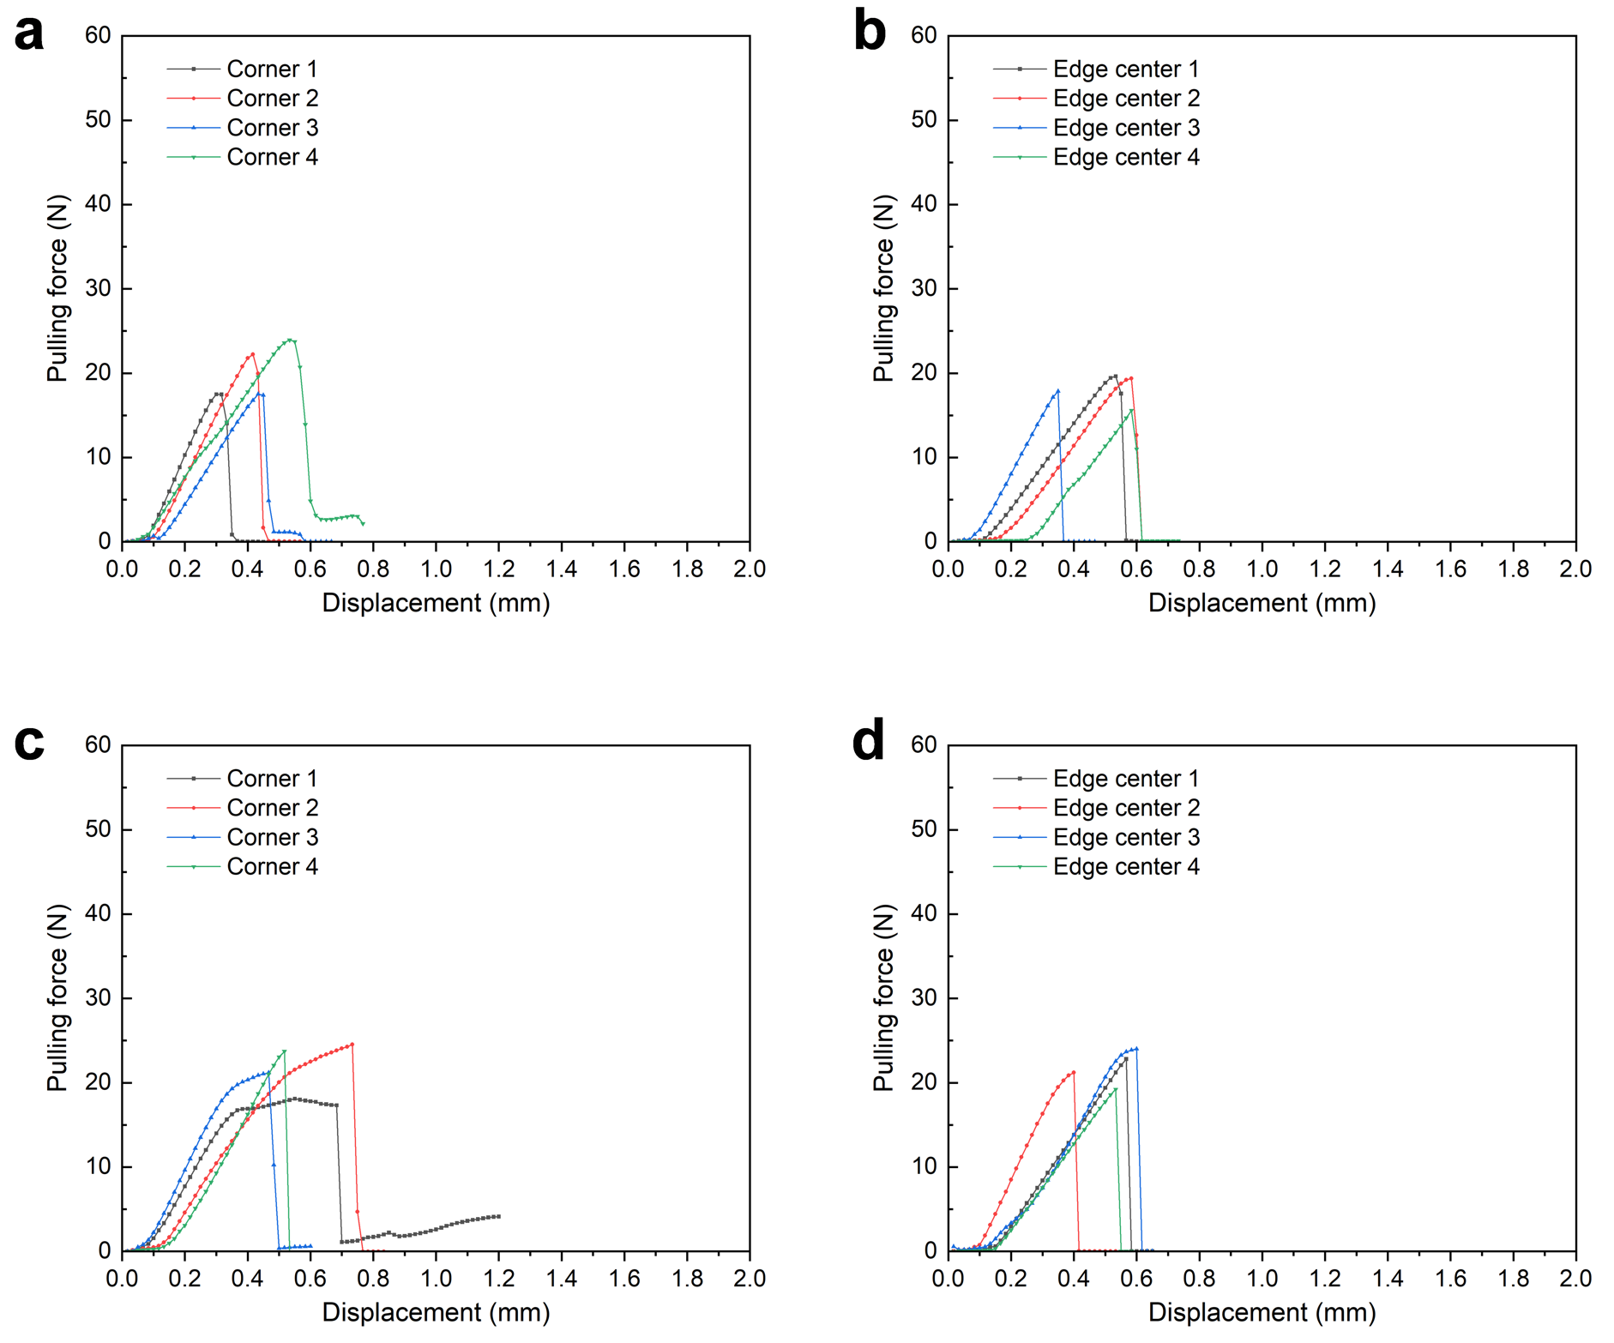
Supplementary Fig. 18. Adhesion test results of PI film before and after flushing process. a, Results of PI device in the corner areas before flushing. b, Results of PI film in the edge center areas before flushing. c, Results of PI film in the corner areas after flushing. d, Results of PI film in the edge center areas after flushing.

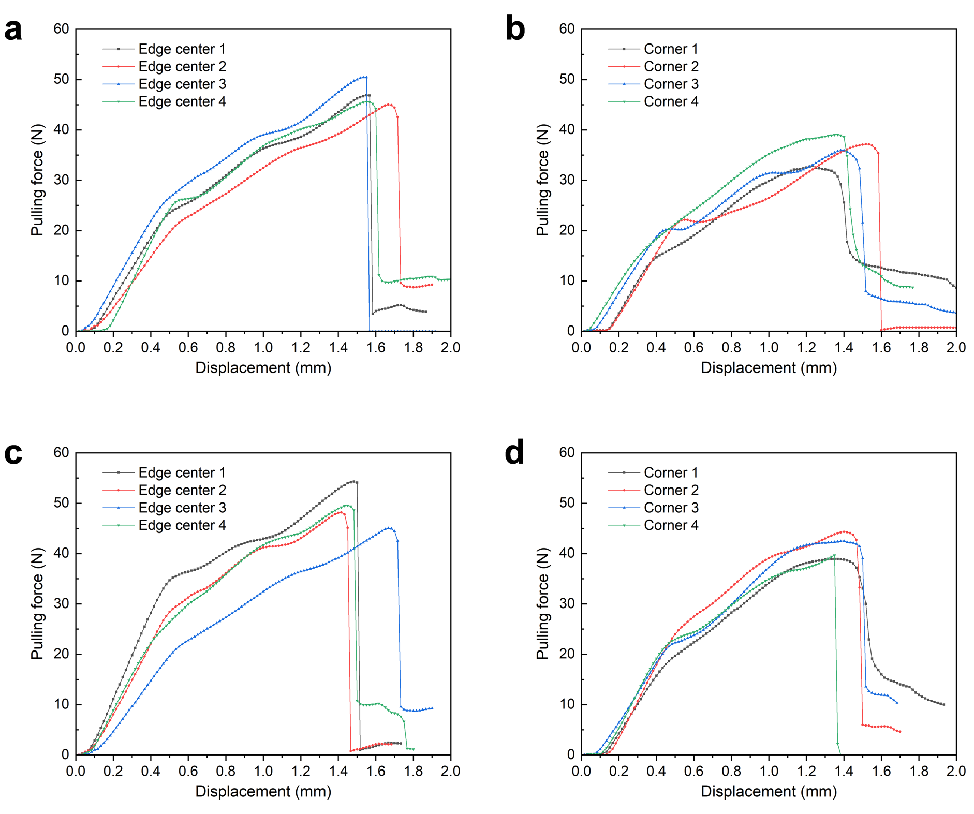
Supplementary Fig. 19. Adhesion test results of PRC device before and after flushing process. a, Results of PRC device in the corner areas before flushing. b, Results of PRC device in the edge center areas before flushing. c, Results of PRC device in the corner areas after flushing. d, Results of PRC device in the edge center areas after flushing.

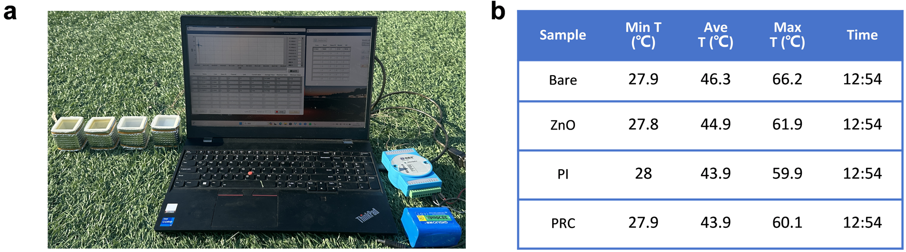
Supplementary Fig. 20. a, Outdoor temperature testing device. b, Statistics of outdoor temperature test results.

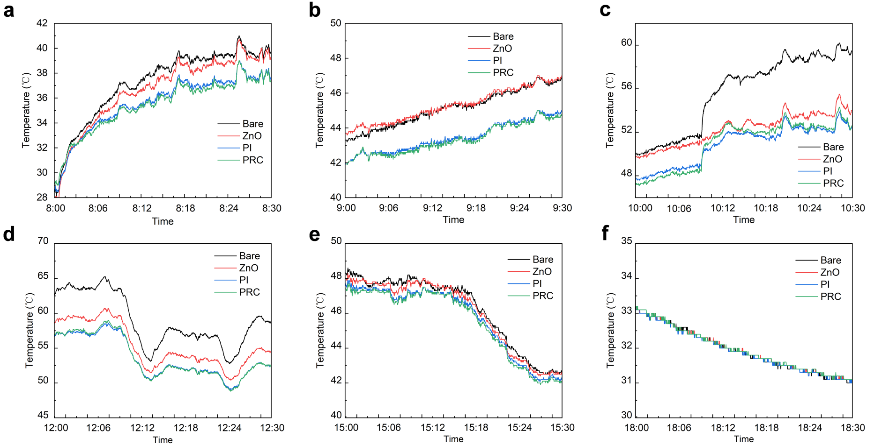
Supplementary Fig. 21. Detailed information of temperature curves in the whole day.

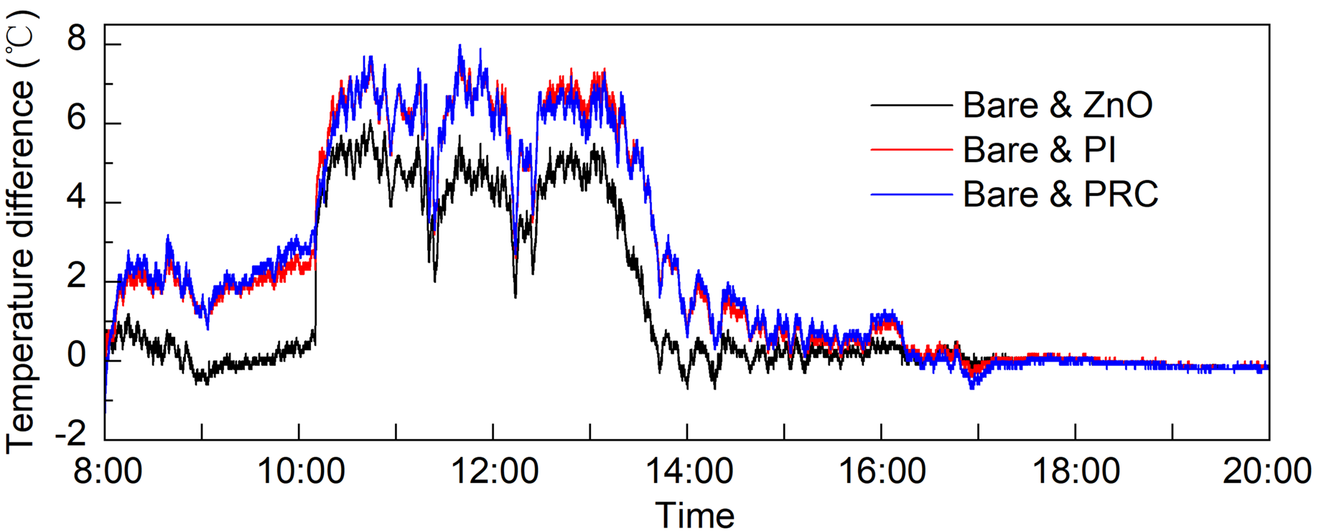
Supplementary Fig. 22. The temperature difference between the testing device covered with different films.

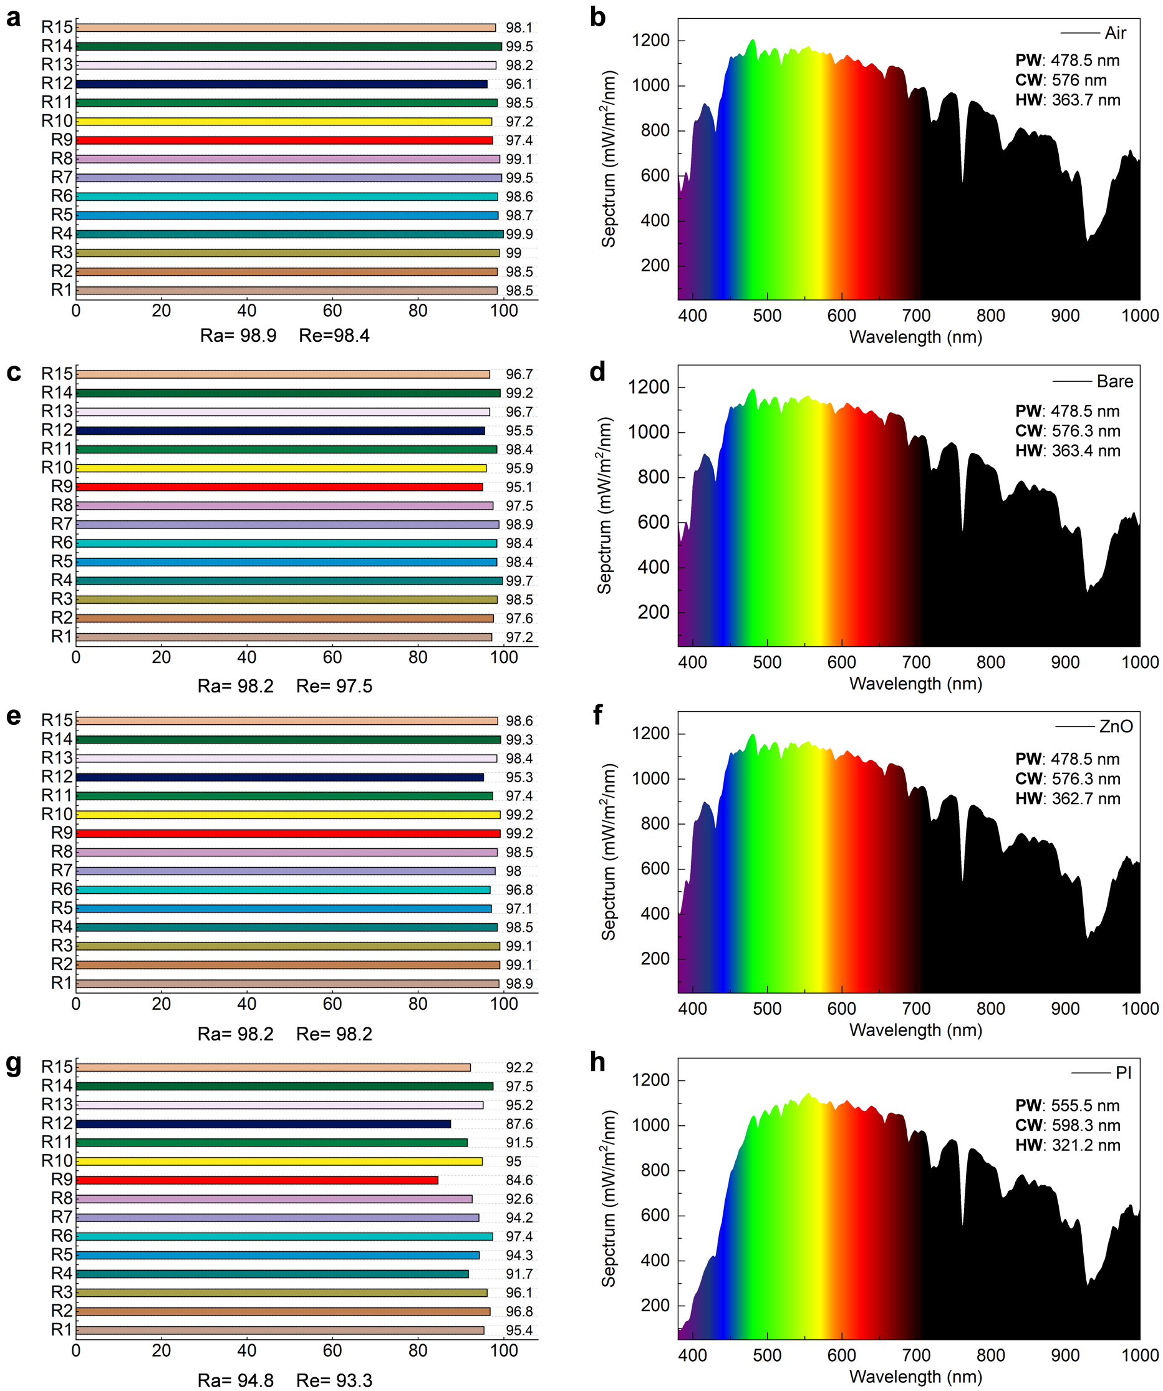
Supplementary Fig. 23. The composition of sunlight after passing through different samples. a, b, General color rendering index and each light composition of sunlight. c, d, General color rendering index and each light composition of sunlight after passing through bare glass. e, f, General color rendering index and each light composition of sunlight after passing through ZnO device. g, h, General color rendering index and each light composition of sunlight after passing through PI device.

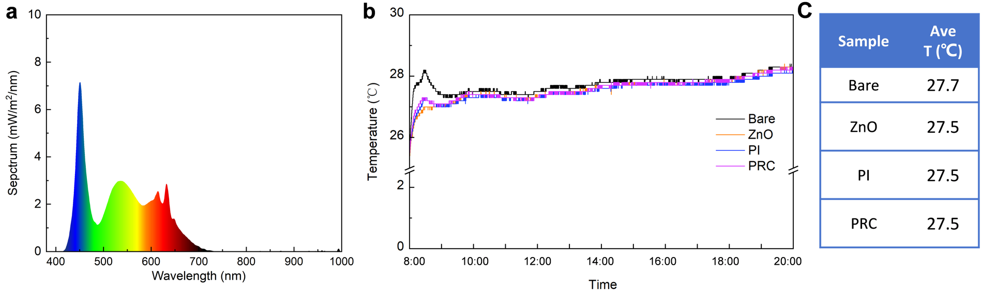
Supplementary Fig. 24. a, The composition of indoor light. b, Indoor temperature and average temperature statistics of 4 samples.

Supplementary Table 1. Fabrication parameters of samples mentioned in Fig. 3
Sample number | ZnO layer |  | PI layer
Sample number | Spin coating speed (r/min) | Spin coating frequency | PI precursor | Spin coating speed (r/min) | Spin coating frequency
Sample 1 | 2000 | 1 | PI1 | 1500 | 1
Sample 2 | 2000 | 2 | PI1 | 1500 | 1
Sample 3 | 3000 | 2 | PI1 | 1500 | 1
Sample 4 | 2000 | 1 | PI2 | 1500 | 1
Sample 5 | 2000 | 2 | PI2 | 1500 | 1
Sample 6 | 3000 | 2 | PI2 | 1500 | 1
Sample 7 | 2000 | 1
Sample 8 | 2000 | 2
Sample 9 | 3000 | 2
Sample 10 |  |  | PI1 | 1500 | 1
Sample 11 |  |  | PI2 | 1500 | 1

