Exploratory Factor Analysis of modified Perceived Social Support Scale
Factor Loadings
 | Factor
 | 1 | 2 | 3 | 4 | Uniqueness
Q54_Row14 | 0.990 |  |  |  | 0.0419
Q54_Row15 | 0.971 |  |  |  | 0.0755
Q54_Row13 | 0.931 |  |  |  | 0.1008
Q54_Row16 | 0.898 |  |  |  | 0.1494
Q54_Row11 |  | 0.995 |  |  | 0.0750
Q54_Row12 |  | 0.965 |  |  | 0.0888
Q54_Row10 |  | 0.901 |  |  | 0.1305
Q54_Row9 |  | 0.854 |  |  | 0.1764
Q54_Row6 |  |  | 0.962 |  | 0.1039
Q54_Row7 |  |  | 0.941 |  | 0.0997
Q54_Row8 |  |  | 0.909 |  | 0.1543
Q54_Row5 |  |  | 0.906 |  | 0.1434
Q54_Row2 |  |  |  | 0.958 | 0.1410
Q54_Row3 |  |  |  | 0.911 | 0.1494
Q54_Row4 |  |  |  | 0.889 | 0.1664
Q54_Row1 |  |  |  | 0.827 | 0.2502
Note. 'Maximum likelihood' extraction method was used in combination with a 'oblimin' rotation

Factor Statistics
Summary
Factor | SS Loadings | % of Variance | Cumulative %
1 | 3.64 | 22.7 | 22.7
2 | 3.52 | 22.0 | 44.7
3 | 3.51 | 21.9 | 66.7
4 | 3.29 | 20.6 | 87.2

Model Fit
Model Fit Measures
 | RMSEA 90% CI |  |  |  | Model Test
RMSEA | Lower | Upper | TLI | BIC | χ² | df | p
0.0681 | 0.0616 | 0.0747 | 0.975 | -51.6 | 384 | 62 | <.001

Assumption Checks
Bartlett's Test of Sphericity
χ² | df | p
24735 | 120 | <.001

KMO Measure of Sampling Adequacy
 | MSA
Overall | 0.937
Q54_Row1 | 0.961
Q54_Row2 | 0.932
Q54_Row3 | 0.934
Q54_Row4 | 0.942
Q54_Row5 | 0.946
Q54_Row6 | 0.926
Q54_Row7 | 0.926
Q54_Row8 | 0.945
Q54_Row9 | 0.964
Q54_Row10 | 0.952
Q54_Row11 | 0.932
Q54_Row12 | 0.937
Q54_Row13 | 0.931
Q54_Row14 | 0.894
Q54_Row15 | 0.919
Q54_Row16 | 0.944

Eigenvalues
Scree Plot
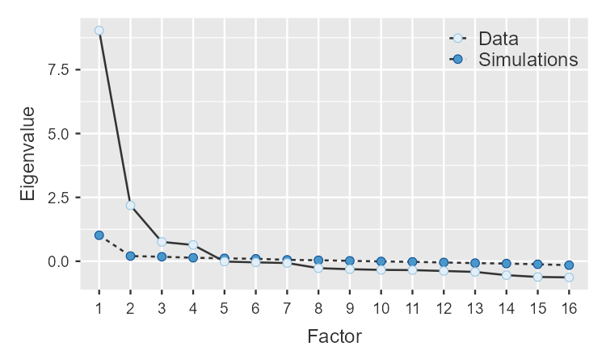
Results
Exploratory Factor Analysis
Factor Loadings
 | Factor
 | 1 | 2 | 3 | 4 | Uniqueness
Q54_Row14 | 0.990 |  |  |  | 0.0419
Q54_Row15 | 0.971 |  |  |  | 0.0755
Q54_Row13 | 0.931 |  |  |  | 0.1008
Q54_Row16 | 0.898 |  |  |  | 0.1494
Q54_Row11 |  | 0.995 |  |  | 0.0750
Q54_Row12 |  | 0.965 |  |  | 0.0888
Q54_Row10 |  | 0.901 |  |  | 0.1305
Q54_Row9 |  | 0.854 |  |  | 0.1764
Q54_Row6 |  |  | 0.962 |  | 0.1039
Q54_Row7 |  |  | 0.941 |  | 0.0997
Q54_Row8 |  |  | 0.909 |  | 0.1543
Q54_Row5 |  |  | 0.906 |  | 0.1434
Q54_Row2 |  |  |  | 0.958 | 0.1410
Q54_Row3 |  |  |  | 0.911 | 0.1494
Q54_Row4 |  |  |  | 0.889 | 0.1664
Q54_Row1 |  |  |  | 0.827 | 0.2502
Note. 'Maximum likelihood' extraction method was used in combination with a 'oblimin' rotation

Factor Statistics
Summary
Factor | SS Loadings | % of Variance | Cumulative %
1 | 3.64 | 22.7 | 22.7
2 | 3.52 | 22.0 | 44.7
3 | 3.51 | 21.9 | 66.7
4 | 3.29 | 20.6 | 87.2

Model Fit
Model Fit Measures
 | RMSEA 90% CI |  |  |  | Model Test
RMSEA | Lower | Upper | TLI | BIC | χ² | df | p
0.0681 | 0.0616 | 0.0747 | 0.975 | -51.6 | 384 | 62 | <.001

Assumption Checks
Bartlett's Test of Sphericity
χ² | df | p
24735 | 120 | <.001

KMO Measure of Sampling Adequacy
 | MSA
Overall | 0.937
Q54_Row1 | 0.961
Q54_Row2 | 0.932
Q54_Row3 | 0.934
Q54_Row4 | 0.942
Q54_Row5 | 0.946
Q54_Row6 | 0.926
Q54_Row7 | 0.926
Q54_Row8 | 0.945
Q54_Row9 | 0.964
Q54_Row10 | 0.952
Q54_Row11 | 0.932
Q54_Row12 | 0.937
Q54_Row13 | 0.931
Q54_Row14 | 0.894
Q54_Row15 | 0.919
Q54_Row16 | 0.944

Eigenvalues
Scree Plot

Confirmatory Factor Analysis of modified Perceived Social Support Scale
Factor Loadings
Factor | Indicator | Estimate | SE | Z | p
Factor 1 | Q54_Row1 | 1.33 | 0.0367 | 36.2 | <.001
Factor 1 | Q54_Row2 | 1.35 | 0.0336 | 40.1 | <.001
Factor 1 | Q54_Row3 | 1.37 | 0.0339 | 40.3 | <.001
Factor 1 | Q54_Row4 | 1.37 | 0.0345 | 39.7 | <.001
Factor 2 | Q54_Row5 | 1.47 | 0.0363 | 40.6 | <.001
Factor 2 | Q54_Row6 | 1.55 | 0.0369 | 42.1 | <.001
Factor 2 | Q54_Row7 | 1.53 | 0.0360 | 42.7 | <.001
Factor 2 | Q54_Row8 | 1.49 | 0.0369 | 40.3 | <.001
Factor 3 | Q54_Row9 | 1.44 | 0.0364 | 39.4 | <.001
Factor 3 | Q54_Row10 | 1.48 | 0.0359 | 41.4 | <.001
Factor 3 | Q54_Row11 | 1.50 | 0.0345 | 43.5 | <.001
Factor 3 | Q54_Row12 | 1.49 | 0.0346 | 43.1 | <.001
Factor 4 | Q54_Row13 | 1.32 | 0.0310 | 42.6 | <.001
Factor 4 | Q54_Row14 | 1.34 | 0.0297 | 45.2 | <.001
Factor 4 | Q54_Row15 | 1.29 | 0.0296 | 43.7 | <.001
Factor 4 | Q54_Row16 | 1.24 | 0.0308 | 40.3 | <.001

Factor Estimates
Factor Covariances
 |  | Estimate | SE | Z | p
Factor 1 | Factor 1 | 1.000ᵃ
Factor 1 | Factor 2 | 0.497 | 0.0238 | 20.9 | <.001
Factor 1 | Factor 3 | 0.650 | 0.0185 | 35.2 | <.001
Factor 1 | Factor 4 | 0.607 | 0.0200 | 30.4 | <.001
Factor 2 | Factor 2 | 1.000ᵃ
Factor 2 | Factor 3 | 0.732 | 0.0149 | 49.3 | <.001
Factor 2 | Factor 4 | 0.341 | 0.0272 | 12.5 | <.001
Factor 3 | Factor 3 | 1.000ᵃ
Factor 3 | Factor 4 | 0.497 | 0.0233 | 21.4 | <.001
Factor 4 | Factor 4 | 1.000ᵃ
ᵃ fixed parameter

Factor Intercepts
 | Estimate | SE | Z | p
Factor 1 | 1.00ᵃ
Factor 2 | 1.00ᵃ
Factor 3 | 1.00ᵃ
Factor 4 | 1.00ᵃ
ᵃ fixed parameter

Residual Estimates
Residual Covariances
 |  | Estimate | SE | Z | p
Q54_Row1 | Q54_Row1 | 0.5885 | 0.02942 | 20.0 | <.001
Q54_Row2 | Q54_Row2 | 0.3270 | 0.01938 | 16.9 | <.001
Q54_Row3 | Q54_Row3 | 0.3244 | 0.01941 | 16.7 | <.001
Q54_Row4 | Q54_Row4 | 0.3626 | 0.02087 | 17.4 | <.001
Q54_Row5 | Q54_Row5 | 0.3718 | 0.02013 | 18.5 | <.001
Q54_Row6 | Q54_Row6 | 0.2967 | 0.01798 | 16.5 | <.001
Q54_Row7 | Q54_Row7 | 0.2542 | 0.01636 | 15.5 | <.001
Q54_Row8 | Q54_Row8 | 0.3991 | 0.02113 | 18.9 | <.001
Q54_Row9 | Q54_Row9 | 0.4359 | 0.02163 | 20.1 | <.001
Q54_Row10 | Q54_Row10 | 0.3264 | 0.01754 | 18.6 | <.001
Q54_Row11 | Q54_Row11 | 0.1973 | 0.01269 | 15.5 | <.001
Q54_Row12 | Q54_Row12 | 0.2200 | 0.01338 | 16.4 | <.001
Q54_Row13 | Q54_Row13 | 0.1977 | 0.01034 | 19.1 | <.001
Q54_Row14 | Q54_Row14 | 0.0821 | 0.00683 | 12.0 | <.001
Q54_Row15 | Q54_Row15 | 0.1368 | 0.00835 | 16.4 | <.001
Q54_Row16 | Q54_Row16 | 0.2820 | 0.01381 | 20.4 | <.001

Residual Intercepts
 | Estimate | SE | Z | p
Q54_Row1 | 5.27 | 0.0458 | 115.0 | <.001
Q54_Row2 | 5.37 | 0.0437 | 122.8 | <.001
Q54_Row3 | 5.25 | 0.0443 | 118.5 | <.001
Q54_Row4 | 5.33 | 0.0447 | 119.2 | <.001
Q54_Row5 | 4.42 | 0.0476 | 92.7 | <.001
Q54_Row6 | 4.20 | 0.0492 | 85.5 | <.001
Q54_Row7 | 4.37 | 0.0483 | 90.6 | <.001
Q54_Row8 | 4.33 | 0.0482 | 89.8 | <.001
Q54_Row9 | 4.84 | 0.0472 | 102.5 | <.001
Q54_Row10 | 4.72 | 0.0475 | 99.3 | <.001
Q54_Row11 | 4.76 | 0.0468 | 101.8 | <.001
Q54_Row12 | 4.76 | 0.0467 | 102.0 | <.001
Q54_Row13 | 5.66 | 0.0417 | 135.7 | <.001
Q54_Row14 | 5.74 | 0.0410 | 140.0 | <.001
Q54_Row15 | 5.79 | 0.0402 | 144.1 | <.001
Q54_Row16 | 5.89 | 0.0404 | 145.8 | <.001

Model Fit
Test for Exact Fit
χ² | df | p
543 | 98 | <.001

Fit Measures
 |  |  |  | RMSEA 90% CI
CFI | TLI | SRMR | RMSEA | Lower | Upper | AIC | BIC
0.982 | 0.978 | 0.0203 | 0.0636 | 0.0585 | 0.0689 | 41376 | 41647

Path Diagram
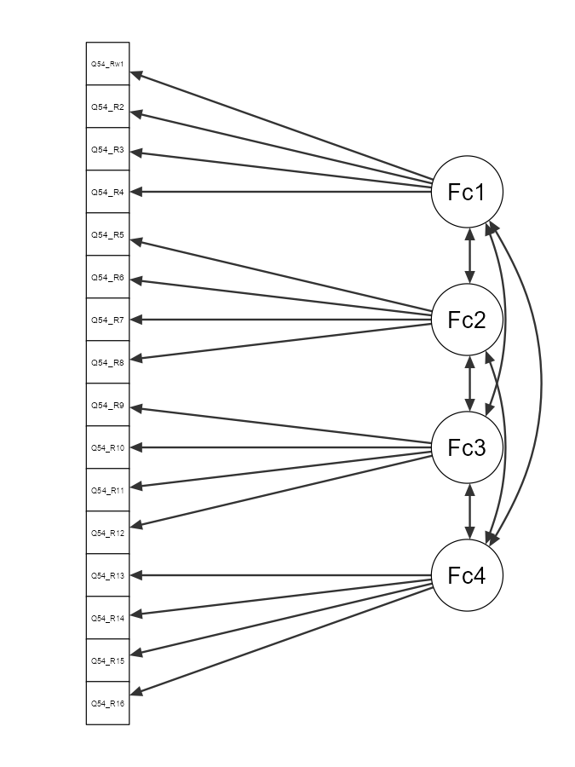

Exploratory Factor Analysis of Patient Activation Measure 13
Factor Loadings
 | Factor
 | 1 | 2 | 3 | Uniqueness
Q56_Row1 |  |  | 0.715 | 0.348
Q56_Row2 |  |  | 0.938 | 0.180
Q56_Row3 |  |  | 0.788 | 0.249
Q56_Row4 |  |  | 0.592 | 0.332
Q56_Row5 |  | 0.775 |  | 0.201
Q56_Row6 |  | 0.827 |  | 0.189
Q56_Row7 |  | 0.749 |  | 0.275
Q56_Row8 |  | 0.702 |  | 0.306
Q56_Row9 | 0.448 |  |  | 0.410
Q56_Row10 | 0.777 |  |  | 0.270
Q56_Row11 | 0.828 |  |  | 0.171
Q56_Row12 | 0.858 |  |  | 0.220
Q56_Row13 | 0.867 |  |  | 0.218
Note. 'Maximum likelihood' extraction method was used in combination with a 'promax' rotation

Factor Statistics
Summary
Factor | SS Loadings | % of Variance | Cumulative %
1 | 3.57 | 27.4 | 27.4
2 | 3.24 | 24.9 | 52.4
3 | 2.82 | 21.7 | 74.1

Inter-Factor Correlations
 | 1 | 2 | 3
1 | — | 0.787 | 0.700
2 |  | — | 0.771
3 |  |  | —

Model Fit
Model Fit Measures
 | RMSEA 90% CI |  |  |  | Model Test
RMSEA | Lower | Upper | TLI | BIC | χ² | df | p
0.0853 | 0.0776 | 0.0932 | 0.953 | 89.0 | 384 | 42 | <.001

Assumption Checks
Bartlett's Test of Sphericity
χ² | df | p
13678 | 78 | <.001

KMO Measure of Sampling Adequacy
 | MSA
Overall | 0.952
Q56_Row1 | 0.961
Q56_Row2 | 0.930
Q56_Row3 | 0.945
Q56_Row4 | 0.965
Q56_Row5 | 0.951
Q56_Row6 | 0.949
Q56_Row7 | 0.959
Q56_Row8 | 0.961
Q56_Row9 | 0.977
Q56_Row10 | 0.954
Q56_Row11 | 0.949
Q56_Row12 | 0.936
Q56_Row13 | 0.943

Eigenvalues
Initial Eigenvalues
Factor | Eigenvalue
1 | 8.3882
2 | 0.6081
3 | 0.3243
4 | 0.0873
5 | -0.0264
6 | -0.0507
7 | -0.0791
8 | -0.0830
9 | -0.1011
10 | -0.1217
11 | -0.1614
12 | -0.1816
13 | -0.2215

Scree Plot
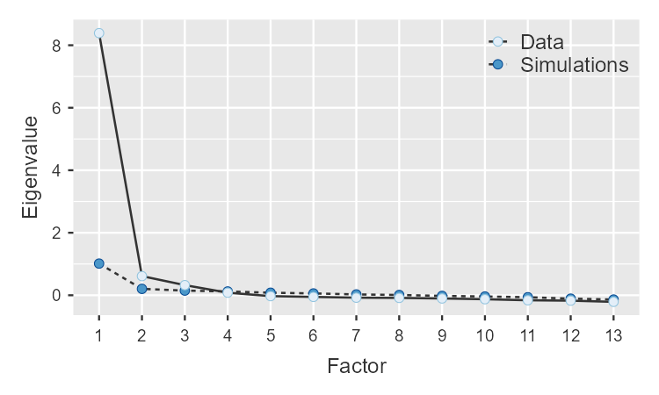

Confirmatory Factor Analysis of Patient Activation Measure 13
Factor Loadings
Factor | Indicator | Estimate | SE | Z | p
Factor 1 | Q56_Row1 | 0.654 | 0.0204 | 32.1 | <.001
Factor 1 | Q56_Row2 | 0.676 | 0.0184 | 36.7 | <.001
Factor 1 | Q56_Row3 | 0.694 | 0.0191 | 36.2 | <.001
Factor 1 | Q56_Row4 | 0.626 | 0.0192 | 32.5 | <.001
Factor 2 | Q56_Row5 | 0.672 | 0.0176 | 38.2 | <.001
Factor 2 | Q56_Row6 | 0.692 | 0.0180 | 38.4 | <.001
Factor 2 | Q56_Row7 | 0.636 | 0.0182 | 34.9 | <.001
Factor 2 | Q56_Row8 | 0.650 | 0.0195 | 33.4 | <.001
Factor 3 | Q56_Row9 | 0.554 | 0.0187 | 29.6 | <.001
Factor 3 | Q56_Row10 | 0.652 | 0.0184 | 35.5 | <.001
Factor 3 | Q56_Row11 | 0.669 | 0.0170 | 39.3 | <.001
Factor 3 | Q56_Row12 | 0.672 | 0.0183 | 36.8 | <.001
Factor 3 | Q56_Row13 | 0.664 | 0.0181 | 36.7 | <.001

Factor Estimates
Factor Covariances
 |  | Estimate | SE | Z | p
Factor 1 | Factor 1 | 1.000ᵃ
Factor 1 | Factor 2 | 0.841 | 0.0117 | 72.0 | <.001
Factor 1 | Factor 3 | 0.769 | 0.0148 | 51.8 | <.001
Factor 2 | Factor 2 | 1.000ᵃ
Factor 2 | Factor 3 | 0.856 | 0.0104 | 82.5 | <.001
Factor 3 | Factor 3 | 1.000ᵃ
ᵃ fixed parameter

Model Fit
Test for Exact Fit
χ² | df | p
557 | 62 | <.001

Fit Measures
 |  |  |  | RMSEA 90% CI
CFI | TLI | SRMR | RMSEA | Lower | Upper | AIC | BIC
0.964 | 0.954 | 0.0292 | 0.0845 | 0.0781 | 0.0910 | 20385 | 20596

