Plots
symptomburden
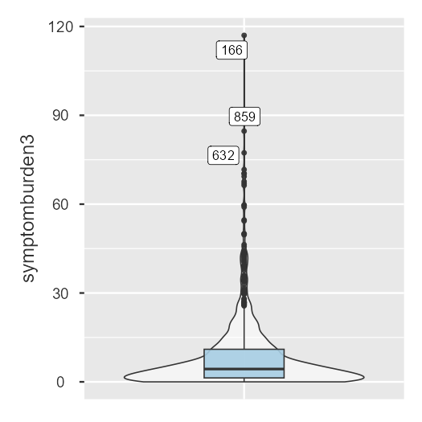
Violin plot
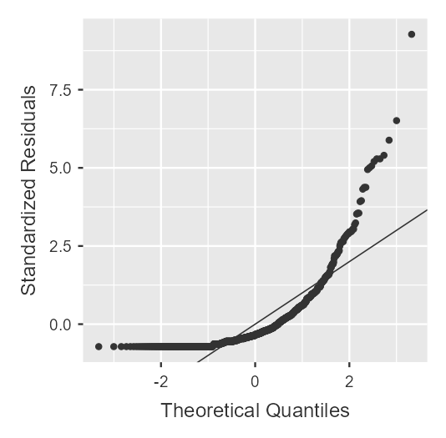
Q-Q plot

Iteration history
Iterations | Fluctuations in Clustering Centers
Iterations | 1 | 2
1 | 134.077 | 22.993
2 | 50.805 | 2.159
3 | 21.581 | 1.633
4 | 9.383 | .729
5 | 9.295 | .760
6 | 7.485 | .704
7 | 1.576 | .152
8 | 2.515 | .246
9 | 2.321 | .243
10 | .447 | .048
11 | .000 | .000
