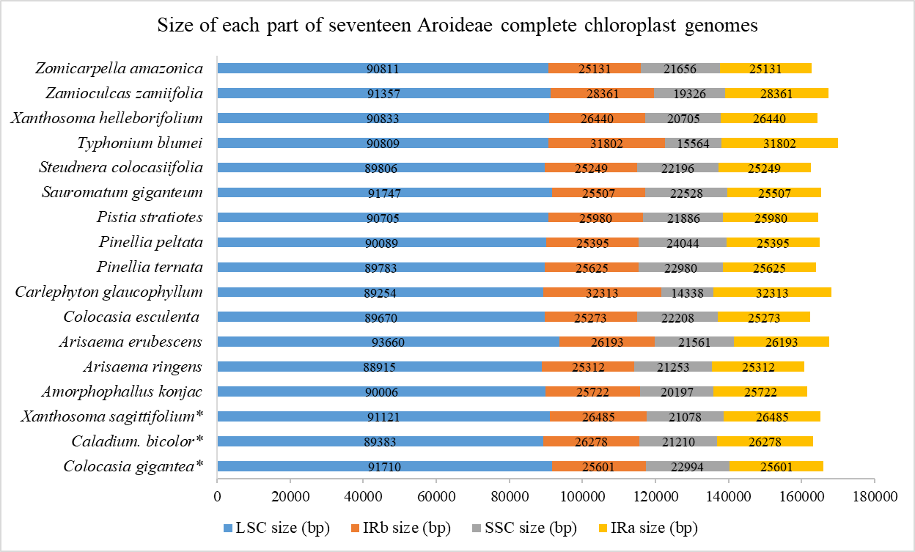
Additional file 1: Figure S1. The sizes of each part of complete chloroplast genomes of seventeen Aroideae species.

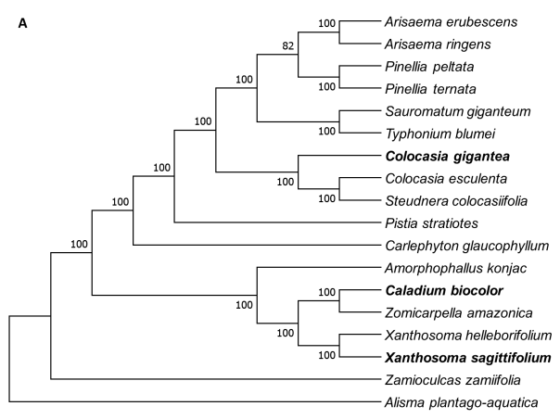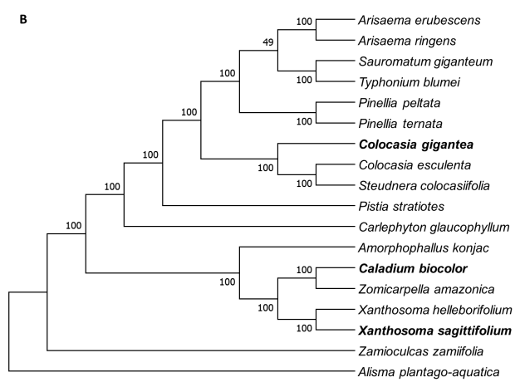
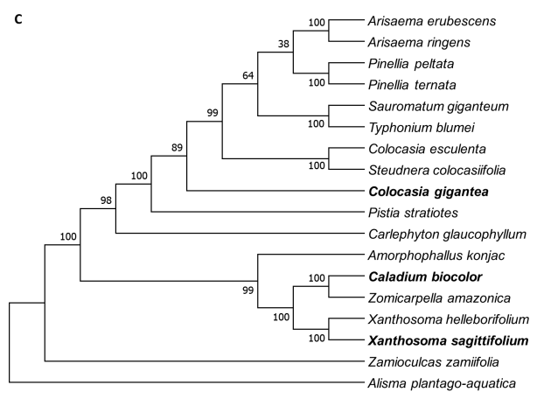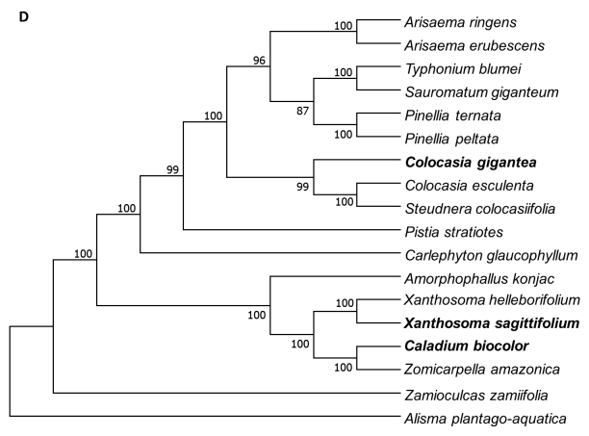
Additional file 2: Figure S2. Phylogenetic trees of the 17 Aroideae species based on the chloroplast genome by ML. A. Phylogenetic tree constructed using the CPG; B. Phylogenetic tree constructed using LSC region; C. Phylogenetic tree constructed using IR region; D. Phylogenetic tree constructed using SSC region. Alisma plantago-aquatica were used as the outgroups. Colocasia gigantea, Caladium bicolor and Xanthosoma sagittifolium were marked in bold characters.

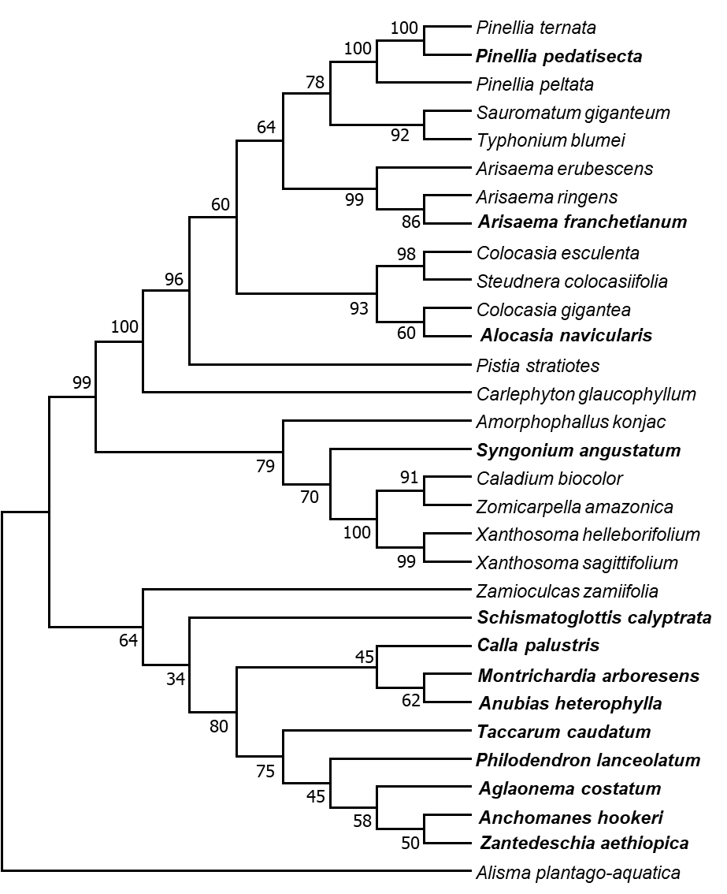
Additional file 3: Figure S3. Phylogenetic trees of the 30 Aroideae species based on the chloroplast genome by ML. Phylogenetic tree constructed using the atpH-atpI + psaC-ndhE + trnS-trnG, Alisma plantago-aquatica were used as the outgroups. 13 Aroideae species were marked in bold characters (Henriquez et al. 2020a).

