Additional file 1

We provide additional results for the performance of the models including confusion matrices, ROC curves and the results of statistical tests. In addition, we provide examples of computation of expected costs for the decision tree.

A.1 Confusion Matrices

Table A1: Confusion matrix for the manual BN model (with default threshold).
 | Predicted malaria absent | Predicted malaria present
Actual malaria absent | 583 | 141
Actual malaria present | 282 | 133

Table A2: Confusion matrix for the manual BN model (with optimal threshold).
 | Predicted malaria absent | Predicted malaria present
Actual malaria absent | 301 | 423
Actual malaria present | 109 | 306

Table A3: Confusion matrix for the TAN model (with default threshold)
 | Predicted malaria absent | Predicted malaria present
Actual malaria absent | 607 | 117
Actual malaria present | 322 | 93

Table A4: Confusion matrix for the TAN model (with optimal threshold)
 | Predicted malaria absent | Predicted malaria present
Actual malaria absent | 492 | 232
Actual malaria present | 226 | 189

Table A5: Confusion matrix for the logistic regression model (with default threshold)
 | Predicted malaria absent | Predicted malaria present
Actual malaria absent | 674 | 50
Actual malaria present | 387 | 28

Table A6: Confusion matrix for the logistic regression model (with optimal threshold)
 | Predicted malaria absent | Predicted malaria present
Actual malaria absent | 397 | 327
Actual malaria present | 171 | 244

Table A7: Confusion matrix for the random forest model (with default threshold)
 | Predicted malaria absent | Predicted malaria present
Actual malaria absent | 703 | 21
Actual malaria present | 402 | 13

Table A8: Confusion matrix for the random forest model (with optimal threshold)
 | Predicted malaria absent | Predicted malaria present
Actual malaria absent | 447 | 277
Actual malaria present | 200 | 215

A.2 ROC Curves

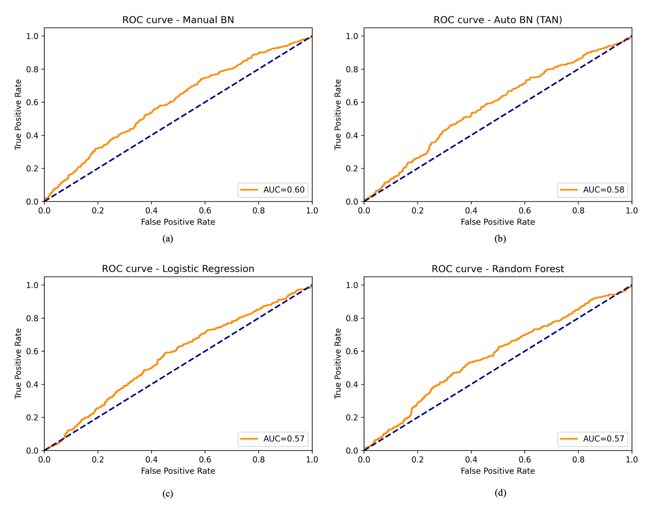
Figure A1: ROC curves for the manual BN, TAN, logistic regression, and random forest models.

A.3 Results of Statistical Tests

Table A9: p-values from pairwise comparisons of AUCs of the models using the DeLong test.
AUC | Experimental model
Baseline model | Random Forest | Manual BN | TAN
Logistic Regression | 0.492 | 0.004 | 0.289
Random Forest | - | 0.003 | 0.471
Manual BN | - | - | 0.042

Table A10: p-values from pairwise comparisons of BACs of the models using the paired two-sample Wilcoxon test (with default threshold).
BAC (with default threshold) | Experimental model
Baseline model | Random Forest | Manual BN | TAN
Logistic Regression | 1.000 | 0.006 | 0.037
Random Forest | - | 0.049 | 0.126
Manual BN | - | - | 0.027

Table A11: p-values from pairwise comparisons of BACs of the models using the paired two-sample Wilcoxon test (with optimal threshold).
BAC (with optimal threshold) | Experimental model
Baseline model | Random Forest | Manual BN | TAN
Logistic Regression | 0.922 | 0.846 | 1.000
Random Forest | - | 0.375 | 0.922
Manual BN | - | - | 0.769

Table A12: p-values of pairwise comparisons of the sensitivity values of the models using the McNemar's Chi-Square test (with default threshold).
Sensitivity (with default threshold) | Experimental model
Baseline model | Random Forest | Manual BN | TAN
Logistic Regression | 0.003 | <0.001 | <0.001
Random Forest | - | <0.001 | <0.001
Manual BN | - | - | <0.001

Table A13: p-values of pairwise comparisons of the sensitivity values of the models using the McNemar's Chi-Square test (with optimal threshold).
Sensitivity (with optimal threshold) | Experimental model
Baseline model | Random Forest | Manual BN | TAN
Logistic Regression | <0.001 | <0.001 | <0.001
Random Forest | - | <0.001 | <0.001
Manual BN | - | - | <0.001

Table A14: p-values of pairwise comparisons of the specificity values of the models using the McNemar's Chi-Square test (with default threshold).
Specificity (with default threshold) | Experimental model
Baseline model | Random Forest | Manual BN | TAN
Logistic Regression | <0.001 | <0.001 | <0.001
Random Forest | - | <0.001 | <0.001
Manual BN | - | - | 0.011

Table A15: p-values of pairwise comparisons of the specificity values of the models using the McNemar's Chi-Square test (with optimal threshold).
Specificity (with optimal threshold) | Experimental model
Baseline model | Random Forest | Manual BN | TAN
Logistic Regression | <0.001 | <0.001 | <0.001
Random Forest | - | <0.001 | <0.001
Manual BN | - | - | <0.001

Table A16: Net reclassification improvement (NRI) with the default threshold.
NRI (with default threshold) | Experimental model
Baseline model | Random Forest | Manual BN | TAN
Logistic Regression | 0.004 | 0.127 | 0.064
Random Forest | - | 0.123 | 0.060
Manual BN | - | - | -0.063

Table A17: Net reclassification improvement (NRI) with the optimal threshold.
NRI (with optimal threshold) | Experimental model
Baseline model | Random Forest | Manual BN | TAN
Logistic Regression | -0.001 | 0.017 | -0.001
Random Forest | - | 0.018 | -0.001
Manual BN | - | - | -0.018

A.4 Examples of Computation of Expected Costs for the Decision Tree

As illustrative examples, we computed the expected costs for three encounters in the dataset for the decision tree shown in Figure 1. For each of the encounters, we obtained the probability of having malaria from the manual BN model. Table A18 shows the values for the predictor variables and the value of the target variable from the manual BN model.

Table A18: Predictor variable values and probability of malaria for three encounters.
Predictor variable | Encounter 1 | Encounter 2 | Encounter 3
Age (in months) | Other | 2-12 | 24-60
Duration of Illness (in days) | 15-30 | 3-15 | 3-15
Conscious | Yes | Yes | Yes
Anemia | Absent | Absent | Present
Convulsions | Absent | Absent | Absent
Cough or Difficulty Breathing (CDB) | Present | Present | Absent
Diarrhea | Absent | Present | Present
History of Fever | Absent | Present | Present
Fever (temperature>37.5 C) | Absent | Absent | Present
Lethargy | Absent | Absent | Absent
Malnutrition | Absent | Absent | Absent
Unable to Feed | Absent | Absent | Present
Vomiting | Absent | Absent | Present
Target variable
P(malaria+|F) | 0.018 | 0.202 | 0.745

Given the probability of malaria for an encounter, we computed the expected costs of performing and not performing the mRDT that are represented by the [mRDT?=no] and [mRDT?=yes] branches of the decision tree in Figure 1. We use the equations described in Section 2.6 on Decision Tree Development to compute the costs. Table A19 displays the expected costs of the [mRDT?=yes] and [mRDT?=no] branches in the decision tree for each encounter. For encounters 1 and 3, the expected cost of the [mRDT?=no] branch is lower than the [mRDT?=yes] branch and the preferred decision is to forego the mRDT. These encounters serve as examples where P(malaria+|F) lies between 0 and 0.04, and 0.40 and 1.00 respectively (see Figure 4). However, for encounter 2, the expected cost of obtaining the mRDT is lower than the expected cost of not obtaining the mRDT and thus, the preferred decision is to perform the test. This encounter serves as an example where P(malaria+|F) lies between 0.04 and 0.40 (see Figure 4).

Table A19: Probability of malaria and expected costs of performing and not performing the mRDT for three encounters.
 | P(malaria+|F) | Expected cost of [mRDT?=no] | Expected cost of [mRDT?=yes]
Encounter 1 | 0.018 | 0.288 | 0.618
Encounter 2 | 0.202 | 1.000 | 0.802
Encounter 3 | 0.745 | 1.000 | 1.345

