ToC
Melanin-like nanofibers with highly ordered structures achieve unprecedented specific electromagnetic interference shielding efficiency.
Peng Chen¹, Shibo He¹, Tianyou Wang¹,Chencan Wang¹, Junru Tao¹, Yiwen Li^{1,}*

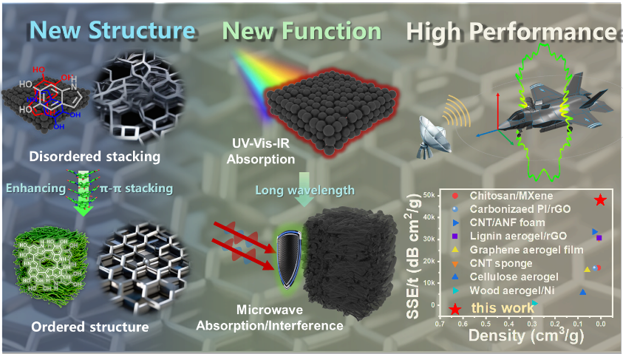
In this work, we have engineered those bioinspired nanostructured polymers with highly ordered microstructures as a new class of promising high-performance and lightweight electromagnetic shielding materials for the first time, which reached the highest absolute electromagnetic shielding effectiveness value in organic carbon materials reported to date.

