Supporting Information

Bio-inspired core-shell microcapsules enhance storage stability and soil survival of non-spore bacteria for improving plant salinity tolerance
Kai Yang^{a#}, Yian Gu^{a#}, Chao Tangª, Chen Wangª, Zhong Yangª, Wei Bai ^{b,*}, Peng Lei ^{a,} Liang Sunª, Zongqi Xu^{c}, Xiaohai Feng^{c}, Bao Tang^{d}, Rui Wang^{a*}, Hong Xu^{a*}

Author information
ª State Key Laboratory of Materials-oriented Chemical Engineering, College of Food Science and Light Industry, Nanjing Tech University, Nanjing 211816, China
^{b} Tillage and Cultivation Research Institute, Liaoning Academy of Agricultural Sciences, Shenyang 110161, China
^{c} Nanjing Shineking Biotech Co., Ltd.，Nanjing 210000，China
^{d} Institute of Plant Protection, Jiangsu Academy of Agricultural Sciences, Nanjing 210014, China
#These authors contributed to the work equally and should be regarded as co-first authors

Experimental Section
One-factor-at-a-time (OFAT) experiments
In order to investigate the reliable range of preparation parameters for microcapsules and the influence of individual factors on the encapsulation efficiency and viable cells of microbial agents, OFAT experiments were carried out on concentration of CaCO₃, ratio of SA/γ-PGA, concentration of chitosan, ratio of polymers/bacterium, oil-to-water phase ration, concentration of actetic acid, emulsification time, stirring time and concentration of Span 80. The optimization range for each factor was CaCO₃ concentration of 0.5-2.5wt%, SA/γ-PGA ratio of 1:1-8:1 w/w, chitosan concentration of 0.1-0.5wt%, polymers/bacterium ratio of 1:1-8:1 v/v, oil-water ratio of 1:1-5:1 v/v, actetic acid concentration of 500-2500 µL/L, emulsification time of 5-25 min, stirring speed of 250-1250 rpm, and Span 80 concentration of 1-5wt%. Other factors remain unchanged when a single factor is changed during the experiment (concentration of CaCO₃, 2.0 wt%; ratio of SA/γ-PGA, 4:1; concentration of chitosan, 0.3 wt%; ratio of polymers/bacterium, 4:1; oil-to-water phase ration, 3:1; concentration of actetic acid, 1500 µL/L; emulsification time, 15 min; stirring speed, 750 rpm; concentration of Span 80, 3.0%). In addition, the effect of chitosan on viability and membrane function of bacteria entrapped in microcapsules were evaluated using a live/dead backlight bacterial viability kit.

Taguchi orthogonal array design
To determine the optimum condition for preparation of microcapsules, a L₁₆ (4⁵) orthogonal array was employed based on OFAT experiments. Four main factors (concentration of CaCO₃, ratio of SA/γ-PGA, concentration of chitosan, ratio of polymers/bacterium) with four different levels were then thoroughly evaluated by means of orthogonal array design to determine the best level of each factor. The encapsulation efficiency and viable cells of microcapsules was selected as the response. The factors and levels were shown in Table 1, and the extra blank column was used as experimental error to manifest the reliability of the total experiments. The statistical analysis contained a range analysis and an analysis of variance (ANOVA). Range analysis was used to identify the optimal level of each factor, and ANOVA was performed to evaluate the significance of each factor. A p-value < 0.05 was considered as statistically significant.
ROS assay
Evaluation of ROS generation during storage was conducted at every four weeksaccording to the methods of Aranda et al. 1 g microcapsules were added into 9 mL PBS solution after washing with deionized water repeatedly. For CK treatment, 1 mL cell suspension was centrifuged to collect the bacteria, and the cell pellet was resuspended in a 9 mL PBS solution. Samples were were incubated with the carboxy-2’,7’-dichloro-dihydro-fluorescein diacetate (DCFHDA, final concentration of 10 μmol/L) at 37 ℃ for 30 min. Then, the samples were observed for each time period at an excitation wavelength of 485 nm and an emission wavelength of 527 nm using confocal fluorescence microscopy (LSM 710, Zeiss, Germany).

Figure. S1. One-factor-at-a-time optimization of preparation of microcapsules. (a) Ratio of SA/γ-PGA. (b) concentration of CaCO_{3.} (c) Ratio of polymers/bacterium. (d) Concentration of chitosan. (e) Oil-to-water phase ration. (f) Concentration of actetic acid. (g) Emulsification time. (h) Stirring speed. (i) Concentration of Span 80.

Figure. S2. Fluorescent micrographs of bacteria encapsulated in microcapsules to determine the effect of chitosan concentration on viability of bacteria: (a) 0.3% chitosan; (b) 0.5% chitosan; (c) 0.7% chitosan.

Table S1 Experimental results of the optimization of microcapsules preparation based on a Taguchi L₁₆ (4⁵) orthogonal array.

Trials | Factors |  |  |  |  | Encapsulation efficiency(%) | Viable Cells  (10⁷ cells/g)
Trials | A  (ratio of  SA/γ-PGA) | B  (concentration of CaCO₃ ) | C  (ratio of polymers /bacterium ) | D  (concentration of chitosan) | E  (blank) | Encapsulation efficiency(%) | Viable Cells  (10⁷ cells/g)
1 | 1(2:1) | 1(0.5%) | 1(2:1) | 1(0.1%) | 1 | 31.16±2.16 | 173.5
2 | 1(2:1) | 2(1.0%) | 2(4:1) | 2(0.3%) | 2 | 71.68±4.11 | 218
3 | 1(2:1) | 3(1.5%) | 3(6:1) | 3(0.5%) | 3 | 78.15±3.21 | 146
4 | 1(2:1) | 4(2.0%) | 4(8:1) | 4(0.7%) | 4 | 42.26±1.80 | 57.55
5 | 2(4:1) | 1(0.5%) | 2(4:1) | 3(0.5%) | 4 | 49.55±4.20 | 112
6 | 2(4:1) | 2(1.0%) | 1(2:1) | 4(0.7%) | 3 | 32.37±1.66 | 195
7 | 2(4:1) | 3(1.5%) | 4(8:1) | 1(0.1%) | 2 | 86.73±4.30 | 121
8 | 2(4:1) | 4(2.0%) | 3(6:1) | 2(0.3%) | 1 | 88.29±4.59 | 163.57
9 | 3(6:1) | 1(0.5%) | 3(6:1) | 4(0.7%) | 2 | 36.39±1.92 | 76
10 | 3(6:1) | 2(1.0%) | 4(8:1) | 3(0.5%) | 1 | 72.92±1.35 | 108
11 | 3(6:1) | 3(1.5%) | 1(2:1) | 2(0.3%) | 4 | 50.10±1.56 | 264.25
12 | 3(6:1) | 4(2.0%) | 2(4:1) | 1(0.1%) | 3 | 67.38±2.75 | 183.5
13 | 4(8:1) | 1(0.5%) | 4(8:1) | 2(0.3%) | 3 | 47.37±5.51 | 64.5
14 | 4(8:1) | 2(1.0%) | 3(6:1) | 1(0.1%) | 4 | 68.04±5.94 | 126
15 | 4(8:1) | 3(1.5%) | 2(4:1) | 4(0.7%) | 1 | 40.39±3.30 | 110
16 | 4(8:1) | 4(2.0%) | 1(2:1) | 3(0.5%) | 2 | 42.69±0.28 | 232.5

Table S2 Range analysis of process factors in Taguchi L₁₆ (4⁵) orthogonal array (effect on encapsulation efficieny).
 | A | B | C | D | E
 | ratio of SA/γ-PGA | concentration of CaCO₃ | ratio of polymers /bacterium | concentration of chitosan | blank
K₁ | 223.26 | 164.47 | 156.32 | 253.31 | 223.26
K₂ | 256.98 | 245.01 | 229 | 257.48 | 256.98
K₃ | 226.8 | 255.38 | 270.91 | 243.31 | 226.8
K₄ | 198.49 | 240.66 | 249.29 | 151.42 | 198.49
k₁ | 55.81 | 41.12 | 39.08 | 63.33 | 55.81
k₂ | 64.24 | 61.25 | 57.25 | 64.37 | 64.24
k₃ | 56.7 | 63.84 | 67.73 | 60.83 | 56.7
k₄ | 49.62 | 60.17 | 62.32 | 37.85 | 49.62
R | 14.62 | 22.73 | 28.65 | 26.51 | 14.62
C₃>D₂>B₃>A₂

Table S3 ANOVA of process factors in Taguchi L₁₆ (4⁵) orthogonal array (effect on encapsulation efficieny).
Factors | Sum of squares | Degrees of  freedom | Variance | F | P
A | 1250.353 | 3 | 416.784 | 0.923 | 0.526
B | 8743.309 | 3 | 2914.436 | 6.452 | 0.080
C | 35028.640 | 3 | 11676.213 | 25.848 | 0.012*
D | 9415.910 | 3 | 3138.636 | 6.948 | 0.073

Table S4 Physiochemical characteristics of the soil used in this experiment.
Soil type | pH | SOM (g/kg) | AN  (mg/kg) | AP (mg/kg) | AK  (mg/kg) | TN  (g/kg) | TP  (g/kg) | TK  (g/kg)
Farmland soil | 8.08 | 14.77 | 98.36 | 59.82 | 228.88 | 0.96 | 1.34 | 5.12

Figure. S3. ROS quantification for bacteria entrapped with microcapsules

Figure. S4. Viability of free Lysobacter enzymogenes OH11 and encapsulated Lysobacter enzymogenes OH11 during storage.

Figure. S5. Viability of free Pseudomonas nitroreducens L16 and encapsulated Pseudomonas nitroreducens L16 during storage.

Figure. S6. Enrichment bubble chart of the KEGG pathways of down-regulated DEPs between CK-12W and CK-0W.

Figure. S7. Enrichment bubble chart of the KEGG pathways of up-regulated DEPs between APC-12W and CK-0W.
Figure. S8. Interaction networks of enriched DEPs with the highest confidence score of >0.400. Proteins are represented by nodes, while the interaction is represented by edges. Proteins (different sports) are clustered with a specified “MCL inflation parameter” of 3. Sports in one cluster are shown with the same color, and edges between them were performed as solid lines. Otherwise, the interactive edges are performed as dashed lines.
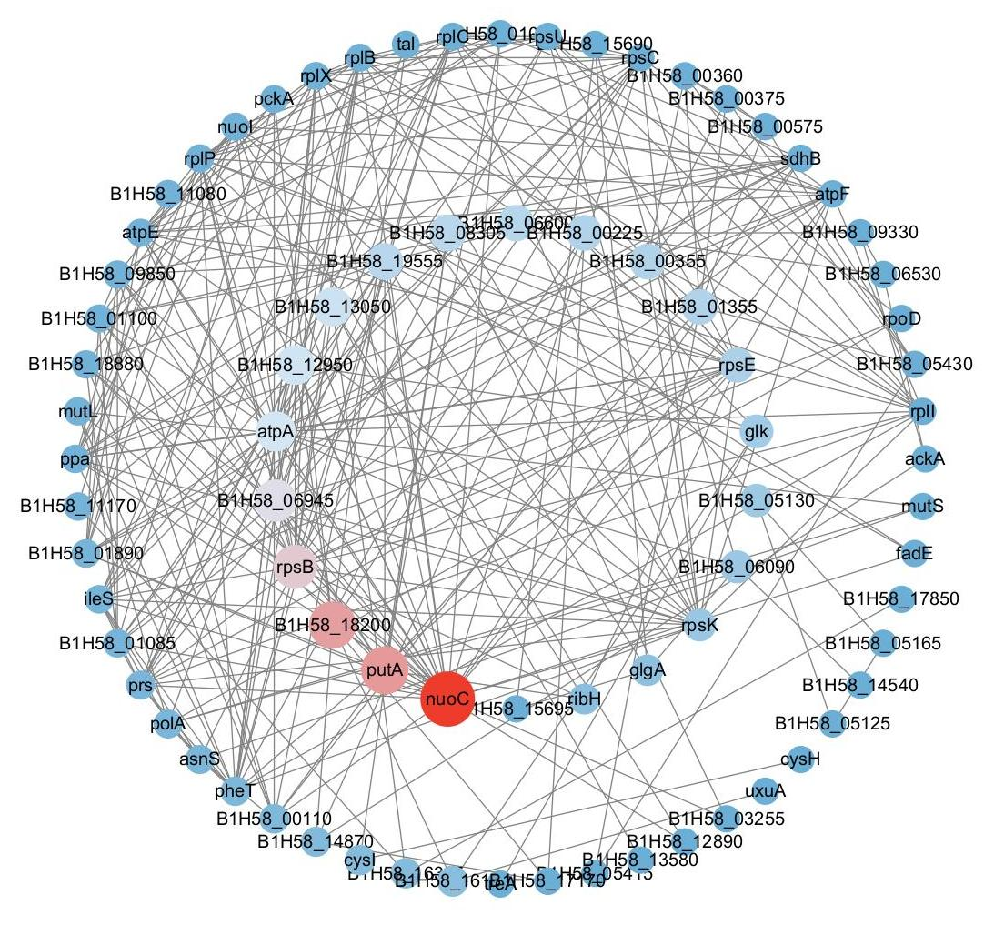
Figure. S9. Interaction networks of enriched DEPs constructed by Cytoscape software and ranked by cytoHubba. Red represents a higher value of betweenness, while blue indicates a lower value of betweenness.

