Supplementary Materials

Untangling the Molecular Mechanism of SpCas9 Catalytic Activation: A Gear-and-Wedge Fitting Model

Xinyi Li^{a,b,#}, Jiacheng Wei^{a,#}, Feiying Chenª, Mingyu Liª, Ning Liu^{c}, Jian Zhang^{a,*}, Shaoyong Lu^{a,c,*}

ª Medicinal Chemistry and Bioinformatics Center, Shanghai Jiao Tong University School of Medicine, Shanghai 200025, China
^{b} Department of Medical Genetics, Cambridge Institute for Medical Research, the Keith Peters Building, Cambridge Biomedical Campus, Hills Road, Cambridge CB2 0XY, UK
^{c} Key Laboratory of Protection, Development and Utilization of Medicinal Resources in Liupanshan Area, Ministry of Education, Peptide & Protein Drug Research Center, School of Pharmacy, Ningxia Medical University, Yinchuan 750004, China

#These authors contributed equally to this work.
*To whom correspondence should be addressed:
Dr. Shaoyong Lu; E-mail: lushaoyong@sjtu.edu.cn
Dr. Jian Zhang; E-mail: jian.zhang@sjtu.edu.cn

Supplementary Fig. 1 | Structural alignments of inactive (PDB ID: 6O0Z) and active (PDB ID: 6O0Y) SpCas9 ribonucleoprotein (RNP) and the 30 intermediate structures generated with NEB. Protein is shown in line for clarity, with REC lobe and NUC lobe colored yellow and gray separately. HNH nuclease domain is highlighted with surface representation, and the Cα atom of H840 is shown as spheres in each structure. The different location of HNH domain and the catalytic H840 residue obtained through NEB method allowed identification of the potential conformational transition pathway during SpCas9 RNP activation. HNH domain exhibited stepwise relocation pattern during activation.

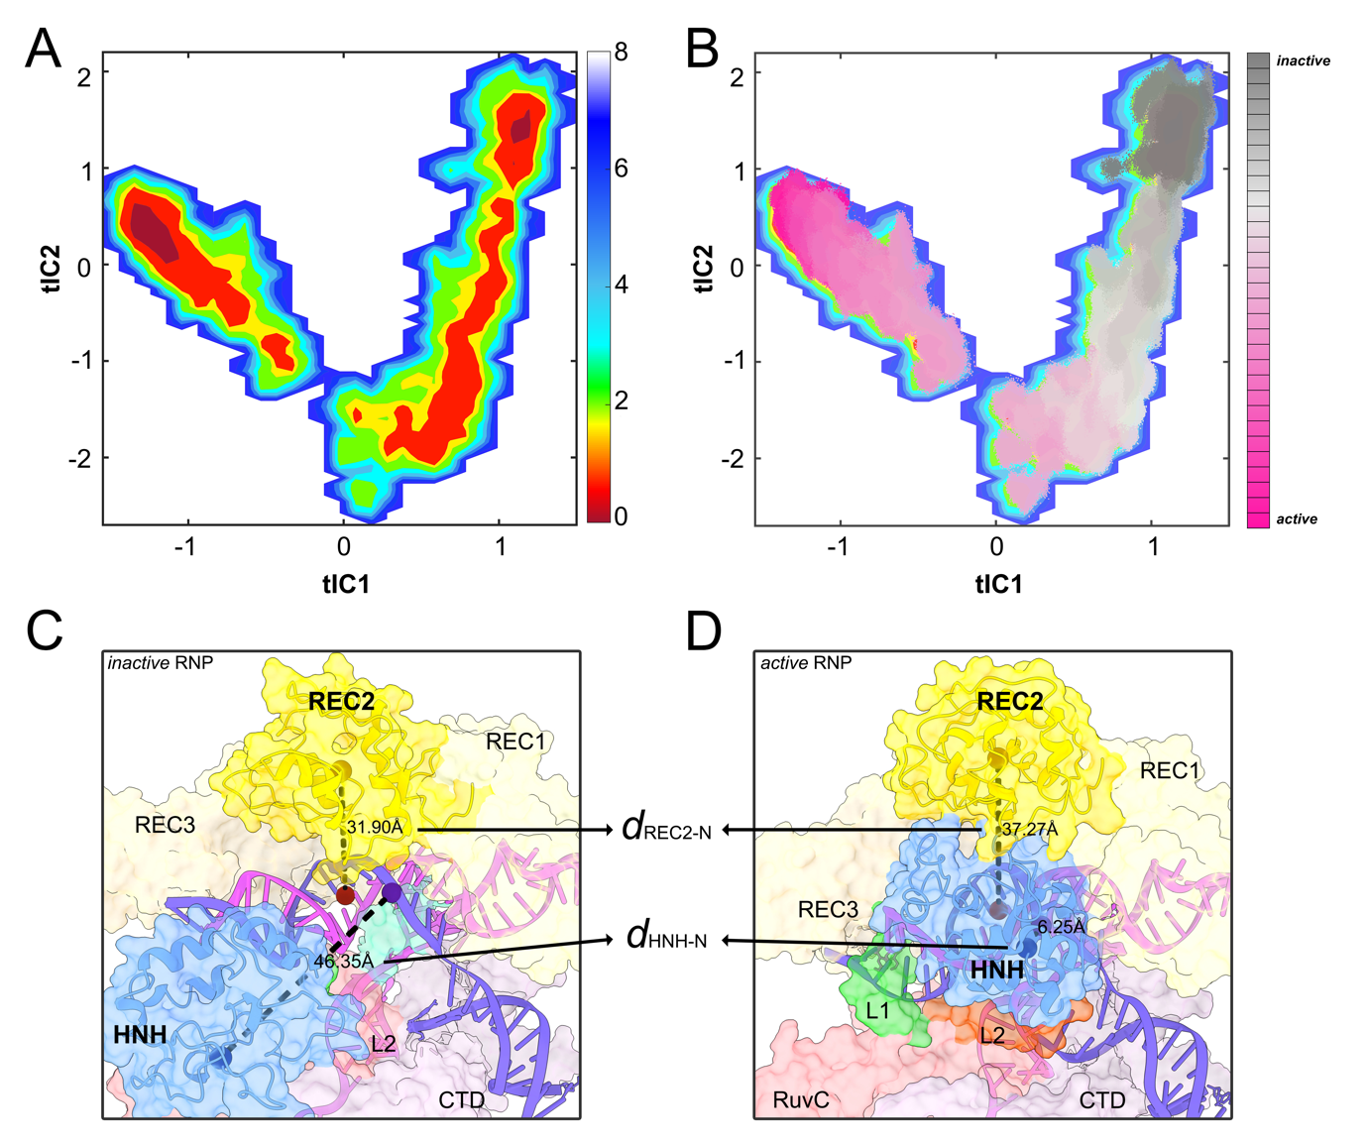
Supplementary Fig. 2 | A Free energy landscape (FEL) of the first two components resolved using TICA. Colormap is shown on the right. B Scatter plot of all simulation trajectories. Each scatter is color-coded based on its activation status, as indicated by the colormap on the right. The distribution pattern reveals continuous transition from inactive towards active state. C and D Schematic illustration of the two distance parameters used for constructing Markov state model (MSM). REC2 and HNH domain are highlighted with cartoon representation. d_{REC2-N} measures the distance between REC2 domain and the sgRNA:dsDNA heteroduplex. Geometric center of REC2 domain and the sgRNA:dsDNA heteroduplex (consider only the five base pairs near cleavage site) is shown as brown and dark red spheres, respectively. d_{HNH-N} is the distance between catalytic H840 residue and the tDNA cleavage site. H840 and the target phosphodiester bond on tDNA is shown as dark blue and purple spheres, respectively. The parameters are measured in precatalytic (C) and catalytic (D) states and displayed here for illustration purpose.

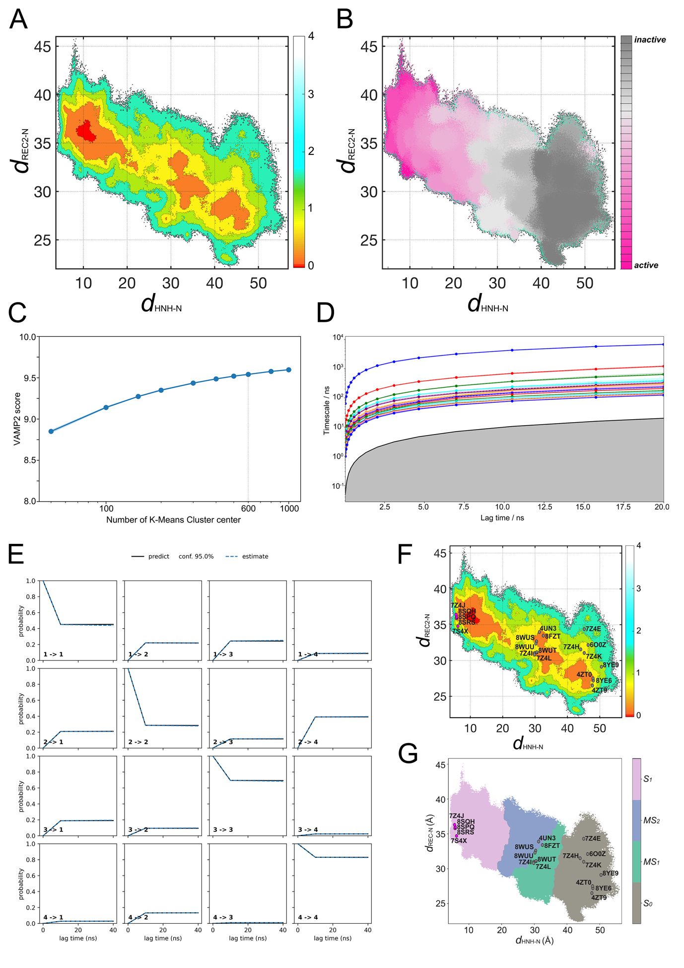
Supplementary Fig. 3 | (A) Free-energy landscape (FEL) of the two distance parameters d_{HNH-N} and d_{REC2-N}. (B) Scatter plot of d_{HNH-N} and d_{REC2-N} from all simulation trajectories. Each scatter is color-coded based on its activation status, as indicated by the colormap on the right, the same as Fig. S2B. The distribution pattern reveals stepwise change of the two distance parameters during activation. (C) Variational approach for Markov processes score of different cluster number. MSM was constructed with 600 K-Means cluster centers. (D) Implied time scale test. Distinct resolved timescales are shown as lines as a function of lag time. The 95% confidence intervals for the eigenvalues are depicted as shaded areas. A black solid curve marks the boundary of a shaded region, indicating where the implied timescales fall short of the lag time. (E) 4-metastable state Chapman-Kolmogorov test to confirm markovianity of our established model. The probabilities of transiting between the macrostates (dash lines) observed in the simulations are consistent with the estimated probabilities from the constructed MSM (solid line). (F) Projection of solved SpCas9 RNP crystal or cryo-EM structures onto the FEL of d_{HNH-N} and d_{REC2-N}. (G) Projection of solved SpCas9 RNP crystal or cryo-EM structures onto the metastable state distribution map. Projection of crystal structures are color-coded according to their documented activation status, with catalytic inactive and active structures colored grey and magenta, respectively.

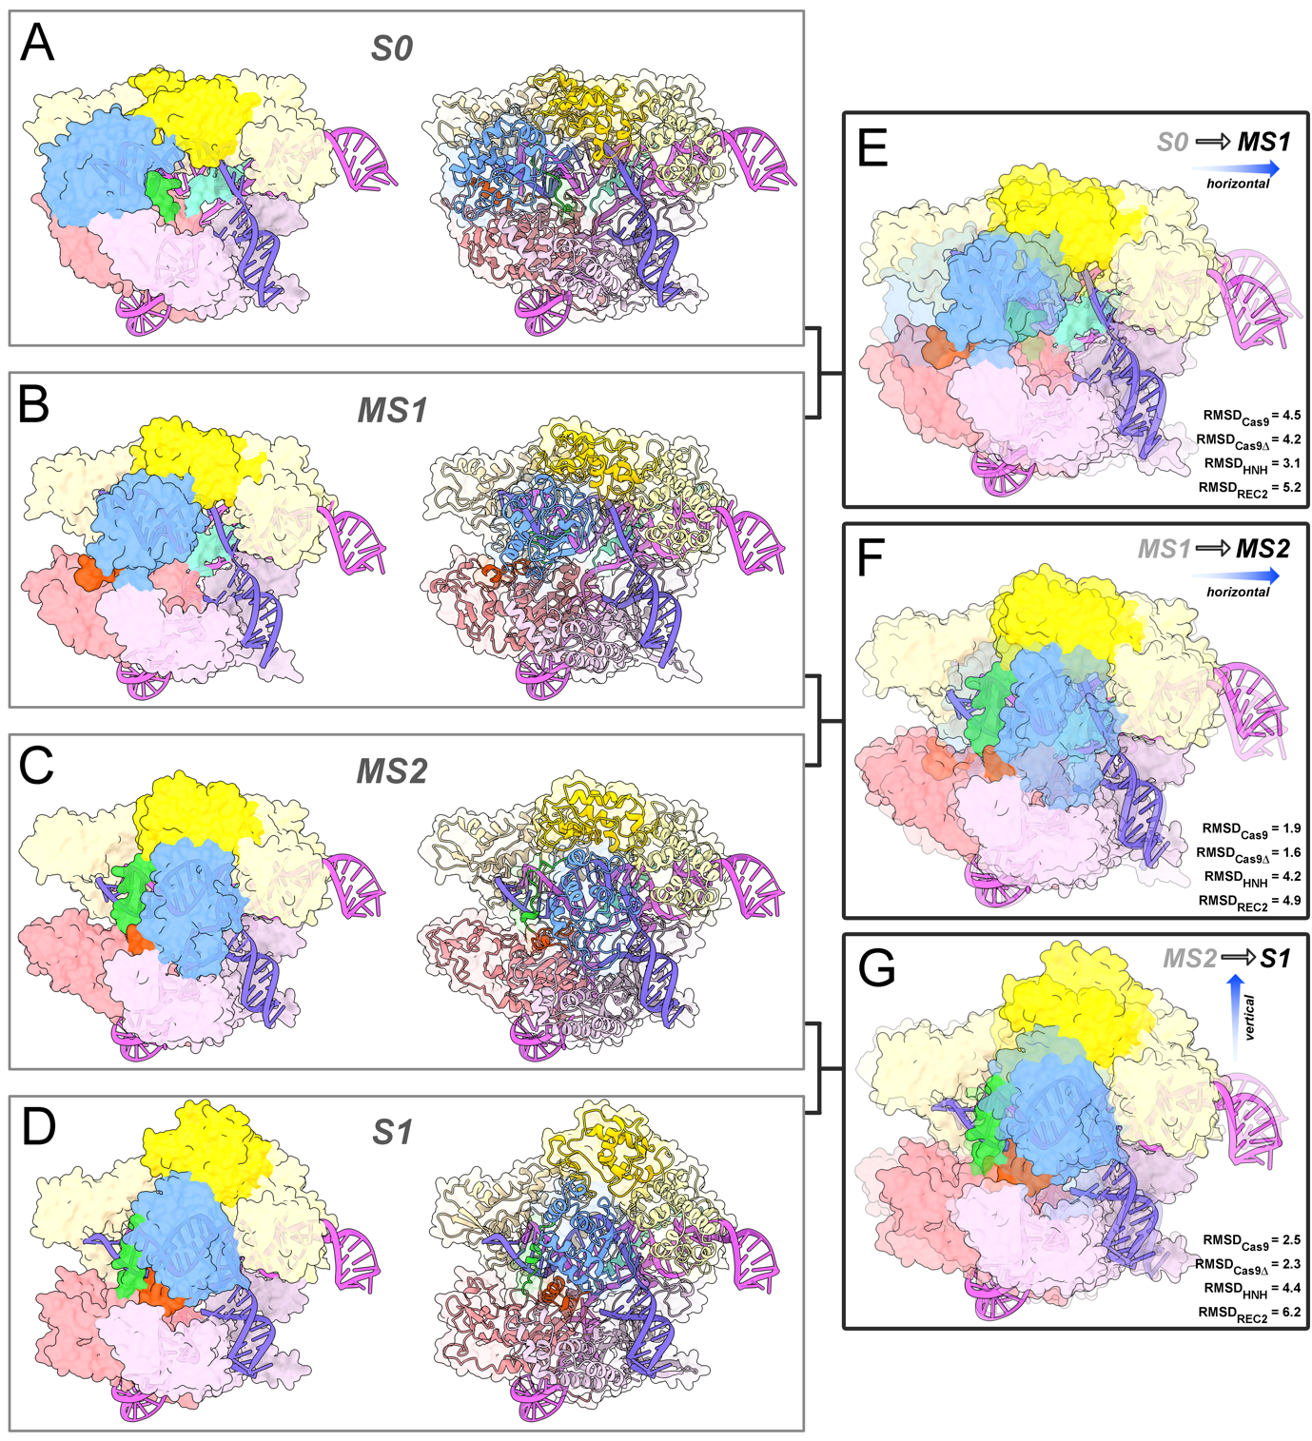
Supplementary Fig. 4 | Surface and cartoon illustration of representative structures extracted from metastable ensemble S0 (A), MS1 (B), MS2 (C) and S1 (D). Domains are color-coded as in Figure 1. Structural superimposition between S0 and MS1 (E), MS1 and MS2 (F), MS2 and S1 (G) representative structures to show the stepwise conformational change, with S0, MS1, and MS2 rendering semi-transparent to indicate the starting structure of SpCas9 RNP during each transition process. Structural similarity of different metastables is estimated through superimposing CA backbone of the corresponding representative structures to calculate the RMSD. Different structural alignments were performed in the current study, RMSD_{Cas9} calculated the whole SpCas9 protein, RMSD_{Cas9∆} calculated the structural difference when deleting REC2, L1, HNH, L2 domains, RMSD_{HNH} compared the structural difference of L1, HNH and L2 domains, and RMSD_{REC2} calculated only REC2 domain. The structural differences suggest that HNH domain first moved horizontally during S0 -> MS1 and MS1 -> MS2 transition, then shifted vertically MS2 -> S1 to approach target.

Supplementary Fig. 5 | Cartoon representation of HNH domain demonstrating its secondary structures. In the current work, 3N refers to the three helices in HNH N-terminus, including αN1 (M781-E790), αN2 (Q794-Q807) and αN3 (E809-Q817). 2C refers to the two helices in HNH C-terminus, including αC1 (Q894-R905) and αC2 (E873-K890). The N- and C-terminal helical regions is connected via a long, disordered loop, in which the catalytic residue H840 is highlighted as dark blue sphere. The remaining domains of SpCas9 are shown as semi-transparent surface color-coded as in Figure 1, with L1 and L2 linkers also shown in cartoon. Only HNH domain from inactive SpCas9 (PDB ID: 6O0Z) is shown here for illustration purpose.

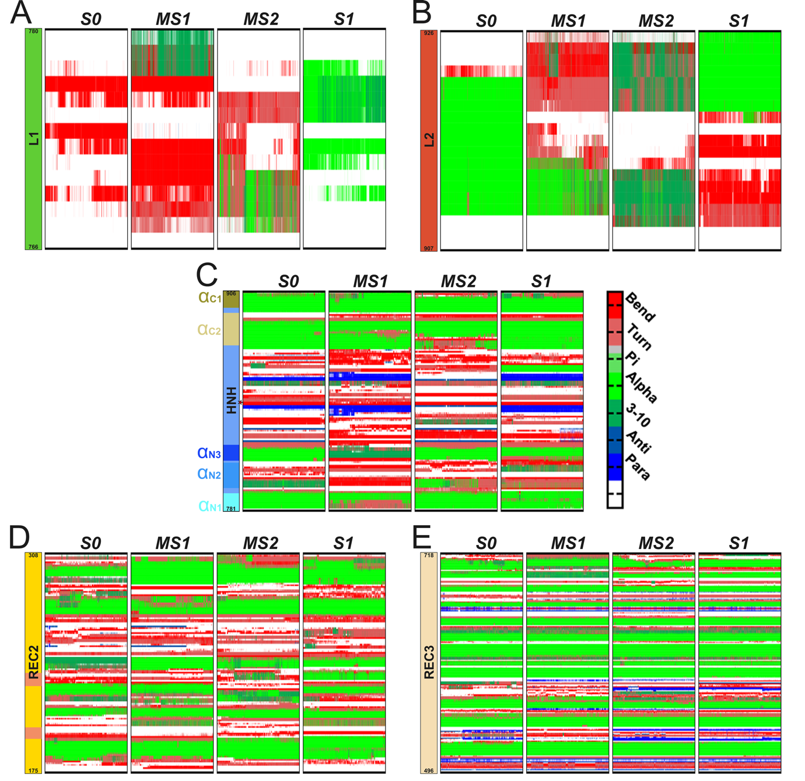
Supplementary Fig. 6 | Secondary structure of L1 linker (A), L2 linker (B), HNH (C), REC2 (D) and REC3 (E) domains in metastable state S0, MS1, MS2 and S1. Secondary structural elements were calculated in representative 500 ns simulation trajectories from each metastable state, and different secondary structures are colored differently according to the colormap in C. Panel C depicts the secondary structure of HNH domain in each metastable states, the catalytic residue H840 is highlighted with a red star, and the helices from HNH helical region 3N and 2C is marked. The two REC2 loop regions (¹⁹⁶FEENPIN²⁰² and ²³⁰PGEKKN²³⁵) were mutated/deleted in later experiments to alter REC2 and HNH motion coordination are highlighted in orange in D.

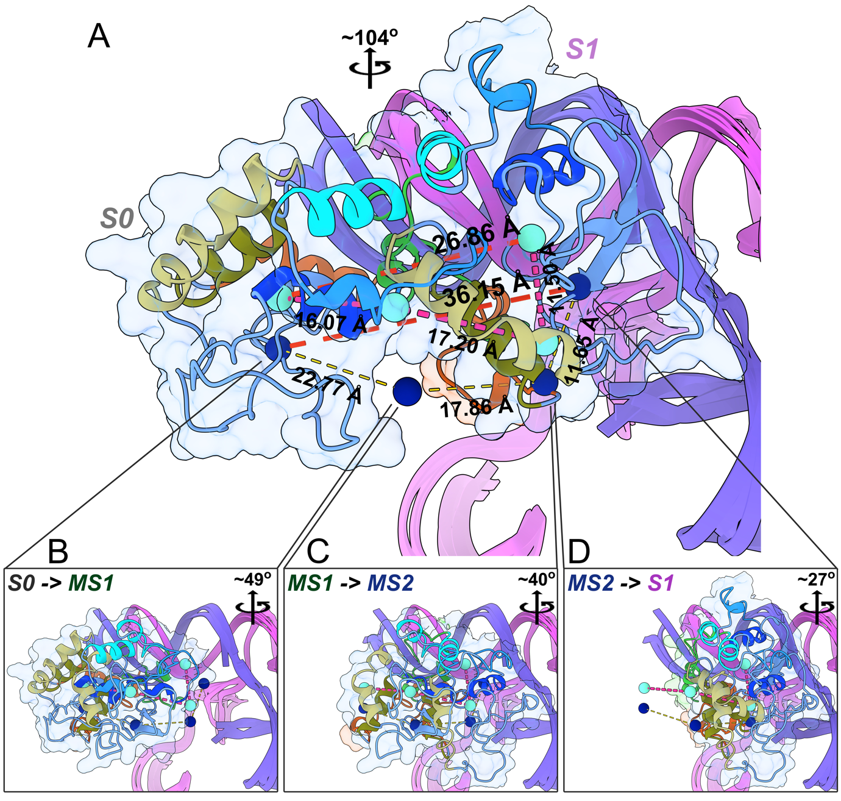
Supplementary Fig. 7 | Structural dynamics of HNH domain during activation. Representative structures from metastable state S0, MS1, MS2 and S1 are superimposed to each other to demonstrate the sequential change of HNH domain position. H840 is highlighted as a dark blue sphere, and the geometric center of HNH domain is demonstrated as a cyan sphere. The distance between H840 or HNH geometric center in different metastable states (after superimposition) is measured to demonstrate the displacement of HNH domain throughout the whole activation process from S0 to S1 (A), and in stepwise transition from S0 to MS1 (B), from MS1 to MS2 (C) and from MS2 to S1 (D). The rotation of HNH domain (around SpCas9 RNP central axis) during conformational transition is also measured for each step and shown in the corresponding panel.

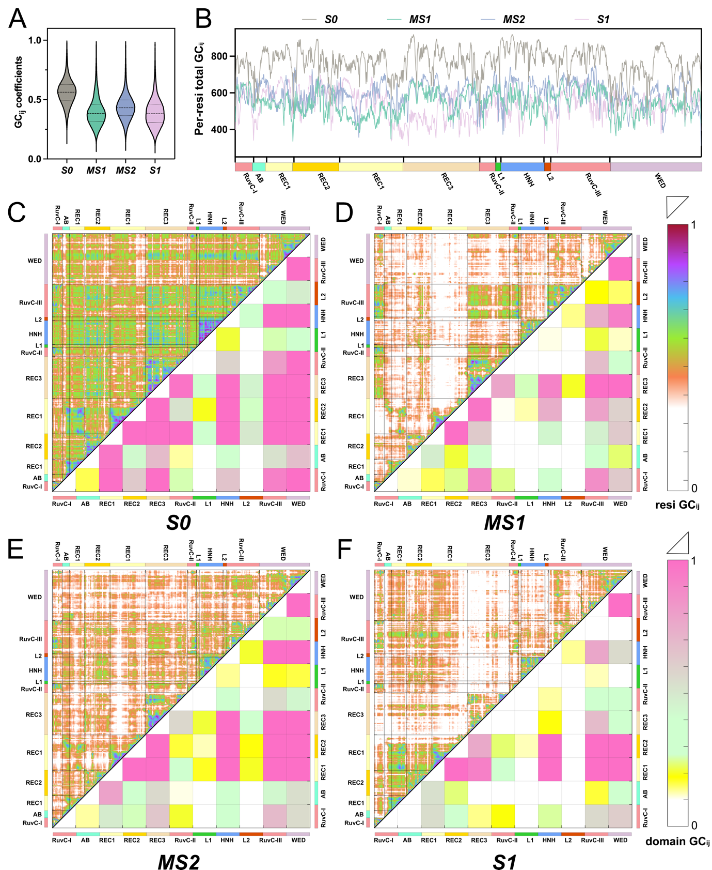
Supplementary Fig. 8 | Correlated motion within SpCas9 during catalytic activation. (A) Violin plot of inter-residual generalized correlation ${GC}_{ij}$. (B) Per-residue ${GC}_{ij}$. Calculated as sum of all ${GC}_{ij}$ coefficient established by certain residue. Inter-residue (upper triangle) and inter-domain (lower triangle) correlation of all SpCas9 residues from metastable state S0 (C), MS1 (D), MS2 (E) and S1 (F). Colormap is shown on the right.

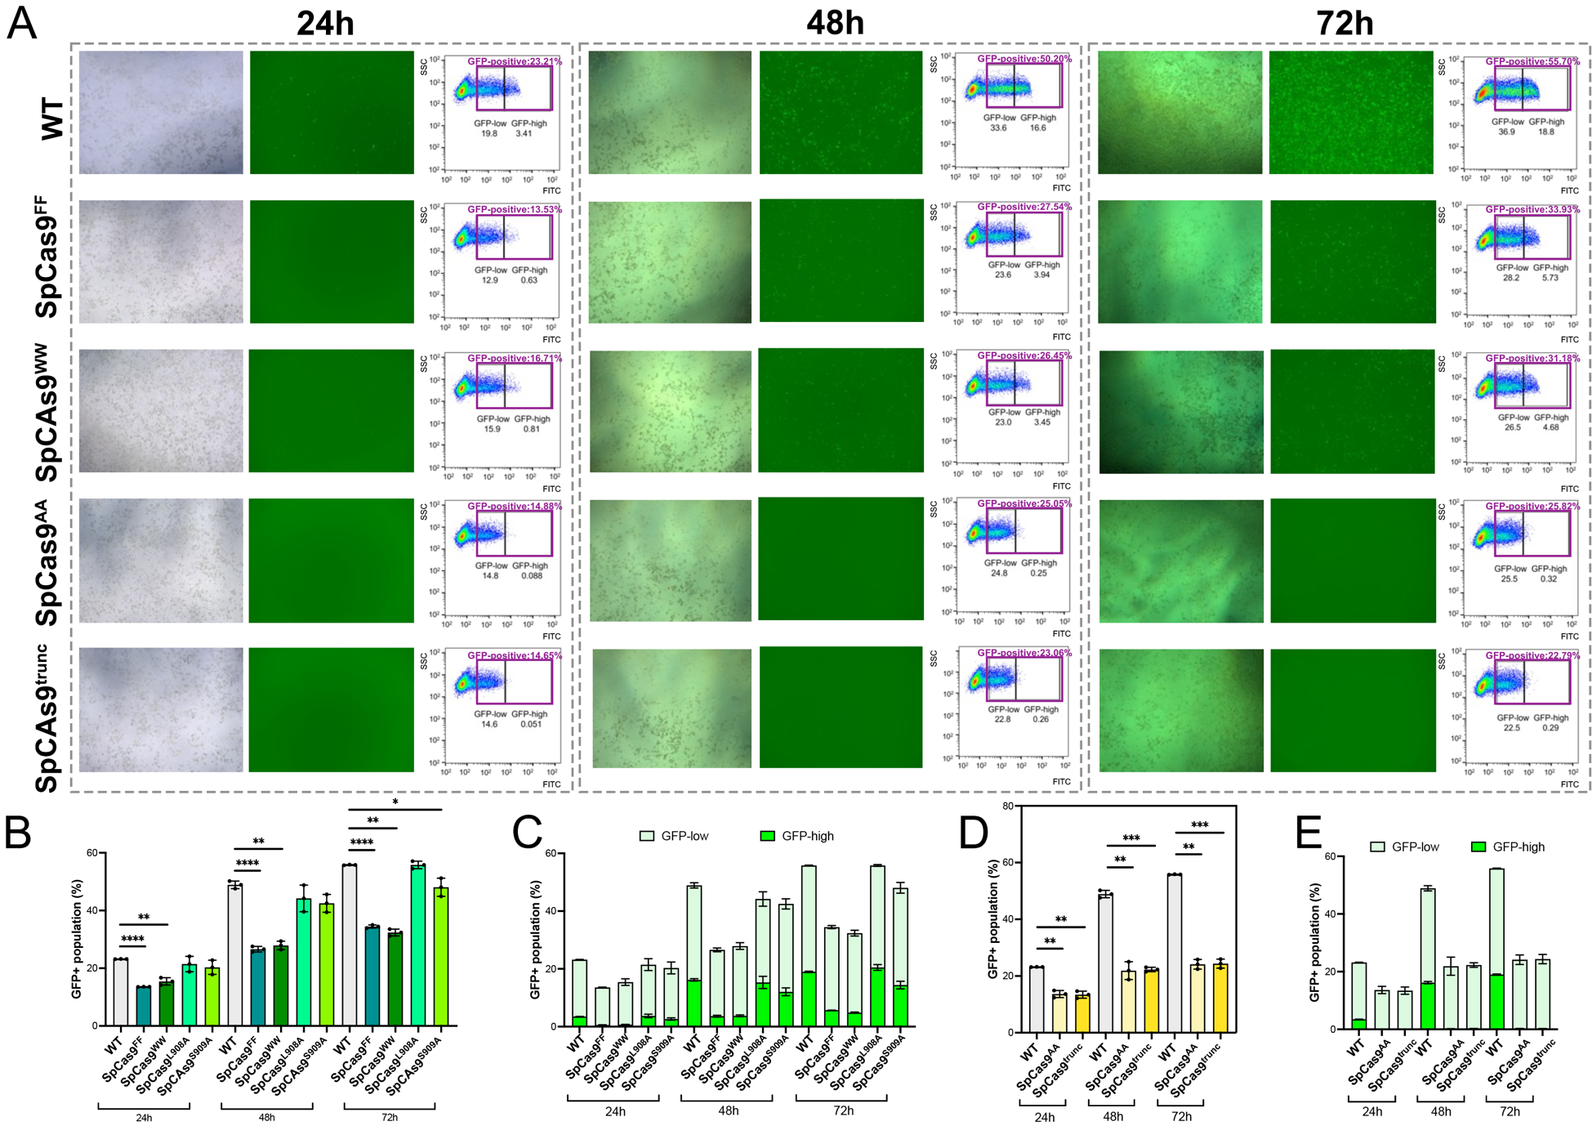
Supplementary Fig. 9 | (A) Widefield microscope and FACS dot blot showing gates for FITC (x-axis) and SSC (y-axis) for HEK293T cells co-transfecting wildtype/mutant SpCas9, sgRNA and GFxFP reporter plasmid after 24 h, 48 h and 72 h. The widefield microscope shows GFP-fluorescent HEK293T cells. In the FACS dot plot, the GFP-positive group is highlighted with a magenta rectangle, and the percentage of this group is indicated above the rectangle. The GFP-positive group is further divided into GFP-low and GFP-high subgroups by black rectangles, and the percentages of the subgroups are indicated below. (B) Quantification of GFP-positive population and (C) GFP-low and GFP-high subgroups within the GFP-positive population in HEK293T cells expressing WT and L2 linker mutant SpCas9 (SpCas9^{FF}, SpCas9^{WW}, SpCas9^{L908A}, SpCas9^{L909A}) after 24 h, 48 h and 72 h. (D) Quantification of GFP-positive population and E GFP-low and GFP-high subgroups within the GFP-positive population in HEK293T cells expressing WT and REC2 mutant SpCas9 (SpCas9^{AA}, SpCas9^{trunc}) after 24 h, 48 h and 72 h. Values are mean (three biologically independent experiments) ± S.E.M. Significance value is calculated with unpaired two-tailed t-test. Difference is not significant if not marked. * p < 0.05, ** p < 0.01, *** p < 0.001, **** p < 0.0001.

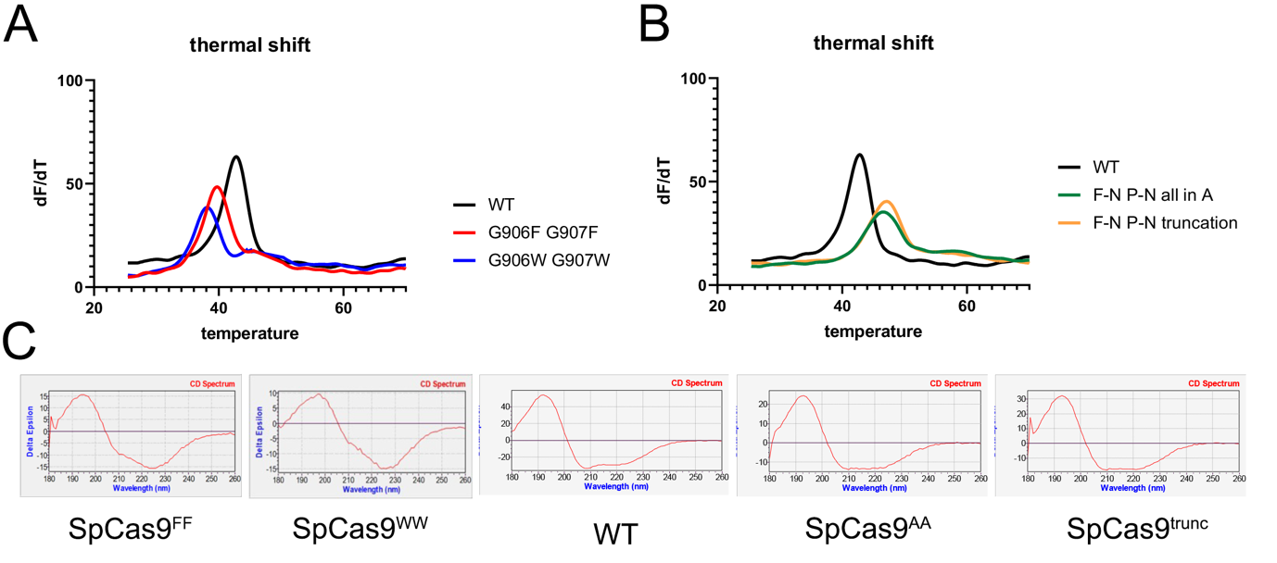
Supplementary Fig. 10 | (A) Protein thermos shift assay of WT SpCas9 and L2 linker mutants. (B) Protein thermos shift assay of WT SpCas9 and REC2 linker mutants. (C) CD spectroscopy of wildtype/mutant SpCas9, showing no significant difference in protein secondary structure after mutation.

