Appendices

Appendix 1 - Types of clinical documents collected and analysed

Document type | Rationale and purpose
Referral letter | Letter from neurologists to neuropsychologist referring for therapy input following confirmation of diagnosis of FND
Clinic letter | Letter summarising consultation in neurology and neuropsychology clinics sent to referring clinicians (e.g., primary care), usually copied to other clinicians involved.
GP letter | Letter sent to primary care physicians from neurology and neuropsychology departments. Usually relates to results of any investigations arranged from the clinic (e.g., EEG, MRI).
Assessment letter | Letter sent from the neuropsychology department following initial attendance at the clinic, addressed to the referring neurologist and primary care.
Discharge letter | Letter summarising a period of inpatient assessment and treatment, usually relates to inpatient video telemetry for diagnosis of FND.

Appendices 2 to 6 – Most salient topics and related keywords identified across document types in the two professional groups (psychologists and neurologists) considered

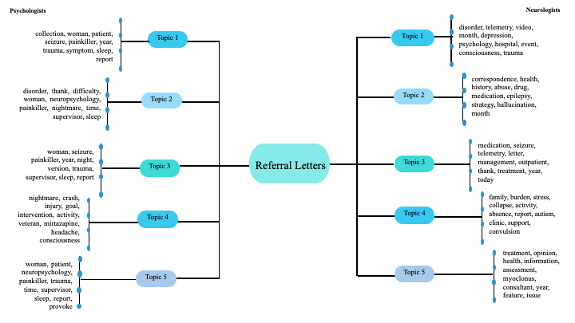Appendix 2 – Referral letters

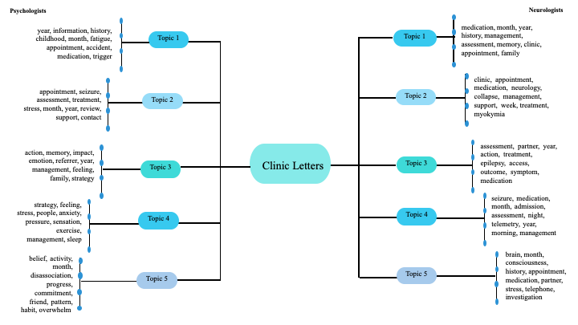
Appendix 3 - Clinic letters

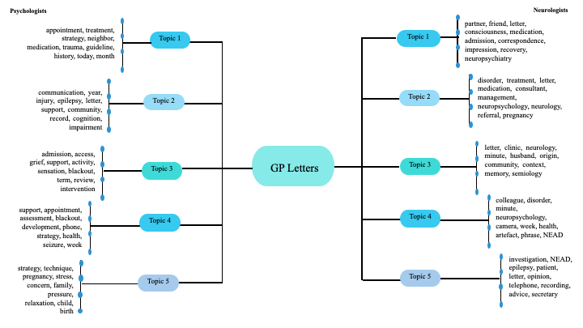
Appendix 4 – GP letters

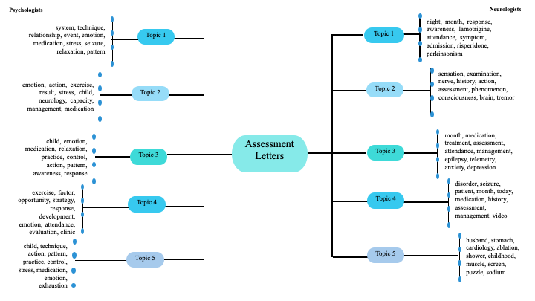
Appendix 5 – Assessment letters

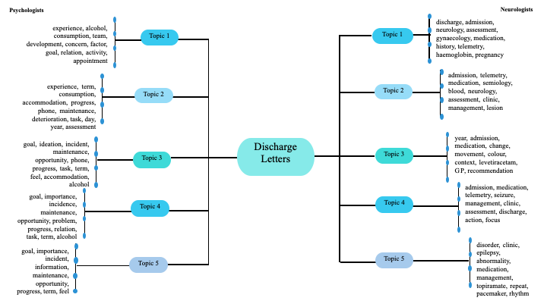

Appendix 6 – Discharge letters

