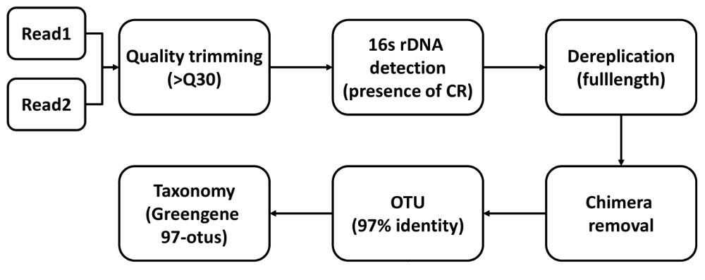

Supplementary Fig. 1 The main steps involved in the bioinformatics analysis pipeline

A

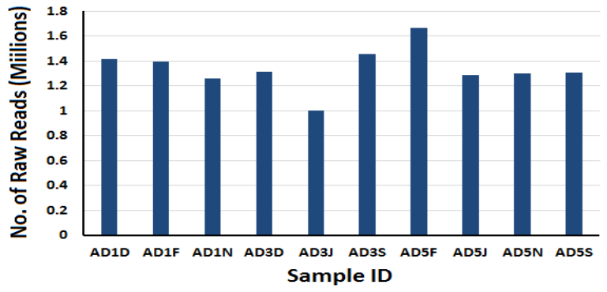
B

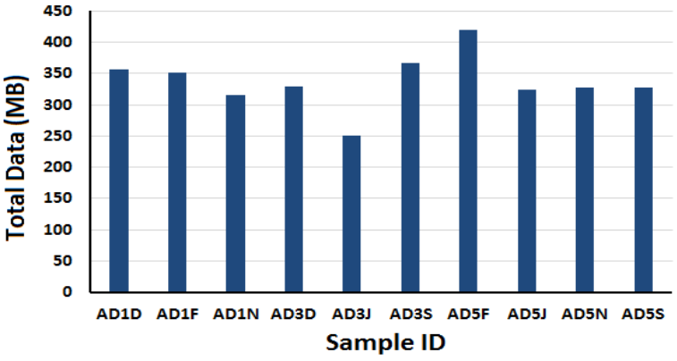
C

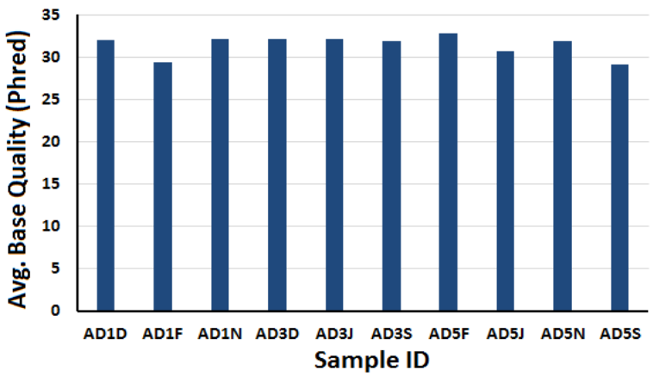
Supplementary Fig. 2 The number of raw reads (A), total data obtained (B) and average base quality (C) for each sample

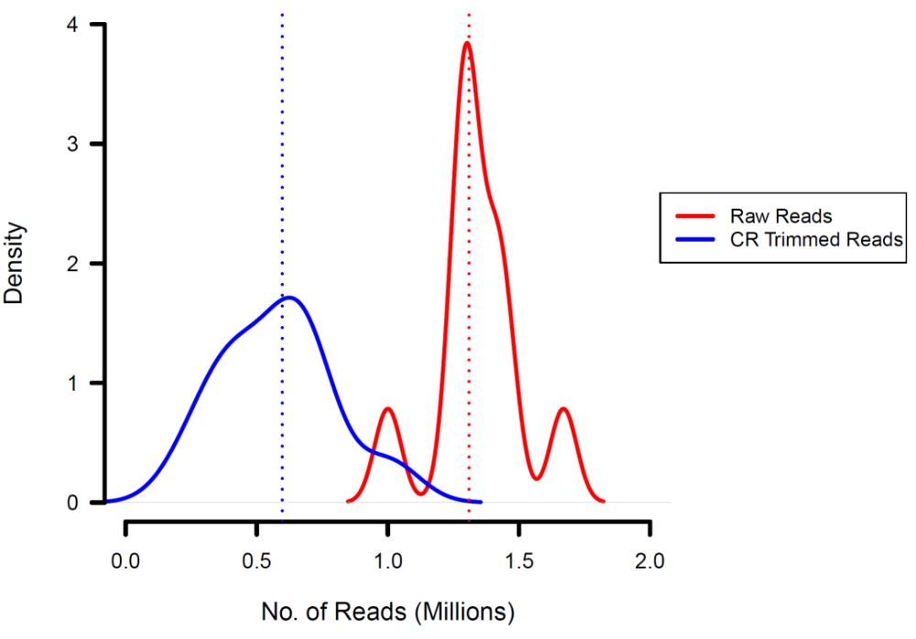
Supplementary Fig. 3 The distribution of number of raw and trimmed reads

