Graphical Abstract
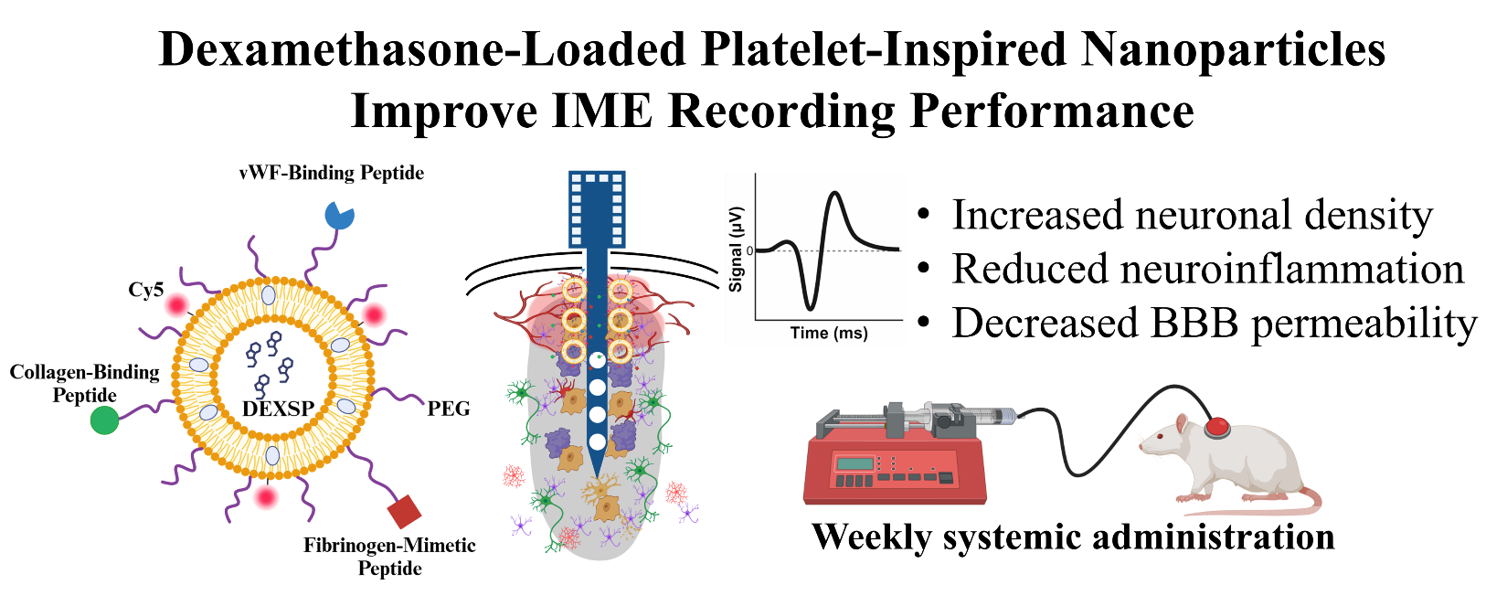
Illustration made in BioRender.

