Supplementary material

MXene-supported Ni-Co bimetallic MOF 2D lamellar membrane for enhanced electrochemical oxygen reactions and Li-O₂ battery
Liming Liu¹, Hongxia Lian¹, Heming Deng², Weixin Zhang^{2,*}
¹ School of Metallurgy, Northeastern University, Shenyang, 110167, China
² School of Material Science and Engineering, Huazhong University of Science and Technology, Wuhan, 430074, China

*Corresponding authors: weixinzhang@hust.edu.cn (W.-X Zhang)

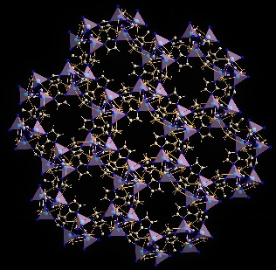
Fig. S1. Molecular structure of Ni/Co-MOF

Fig. S2. Molecular structure of Ti2C3

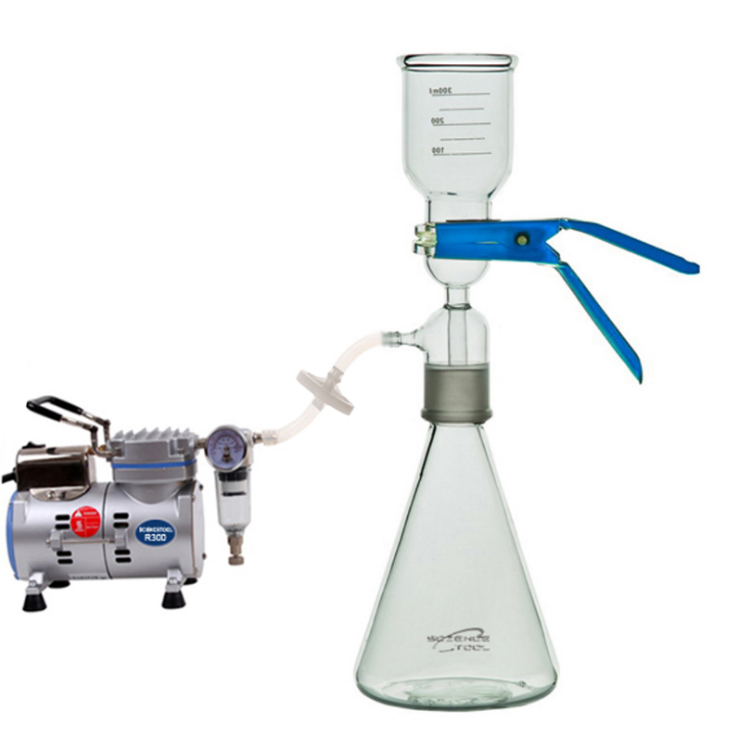
Fig. S3. vacuum filtration equipment

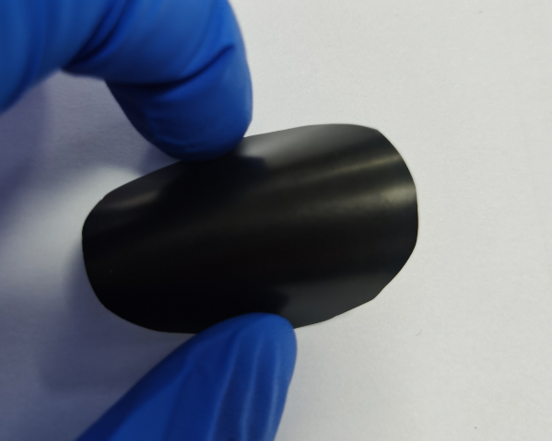
Fig. S4. Picture of free-standing Ni/Co-MOF@Ti3C2 hybrid membrane

Fig. S5. SEM image of Ti3C2 nanosheet

Fig. S6. XRD patterns of Ti₃C₂ and Ni/Co-MOF@Ti₃C₂

Fig. S7. N₂ adsorption-desorption isotherms of at 77 K of Ni/Co-MOF@Ti₃C₂

Fig. S8. O₂ adsorption isotherms at 298 K of Ti₃C₂₂ and Ni/Co-MOF@Ti₃C₂

