Supplementary material

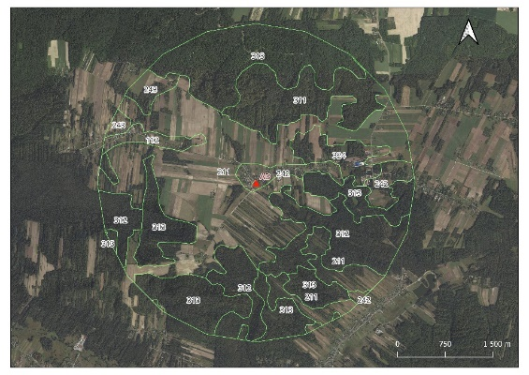 | 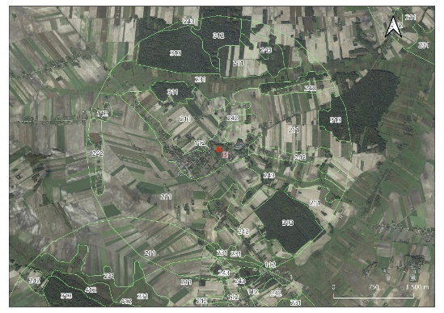
AD (Adamów): 50°35'46.04", E 23°09'53.29" | BI (Białopole): N 50°59'10.22", E 23°44'09.07"
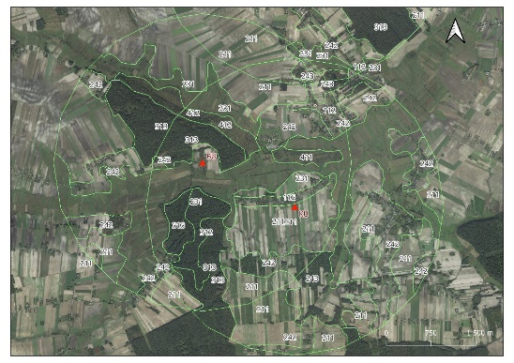 | 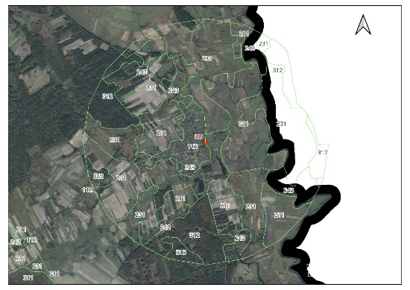
BU (Busieniec): N 50°57'16.3", E 23°42'50.1"and KU (Kurmanów): N 50°56'52.52", E 23°44'01.75") | DU (Dubienka): N 51°03'13.2", E 23°53'31.2"
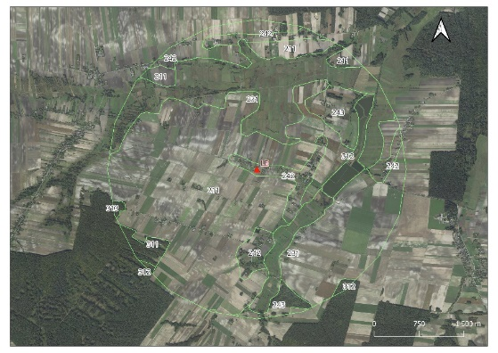 | 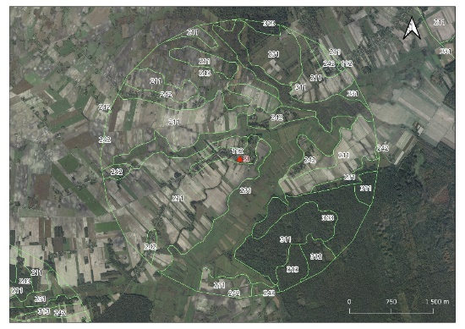
LE (Leszczany): N 51°01'16.25", E 23°36'02.02" | SI (Siedliszcze): N 51°01'09.78", E 23°48'20.76"
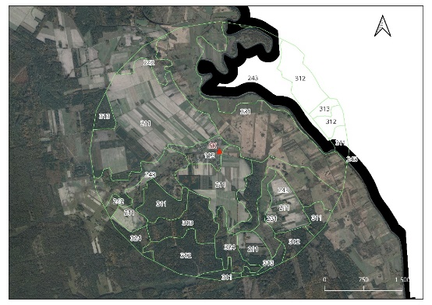 | 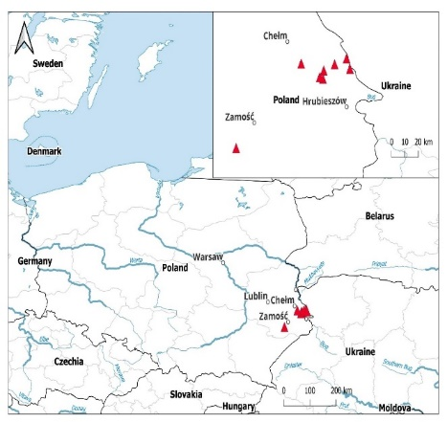
SK (Skryhiczyn): N 50°59'51.73", E 23°55'06.12"
Fig. S1. Major land cover classes identified around the studied nests in SW Poland. Discontinuous urban fabric (code: 112), non-irrigated arable land (code: 211), pastures (code: 231), complex cultivation patterns (code: 242), land principally occupied by agriculture, with significant areas of natural vegetation (code: 243), broad-leaved forest (code: 311), coniferous forest (code: 312), mixed forest (code: 313), transitional woodland-shrub (code: 324), inland marshes (code: 411), peat bogs (code: 412).

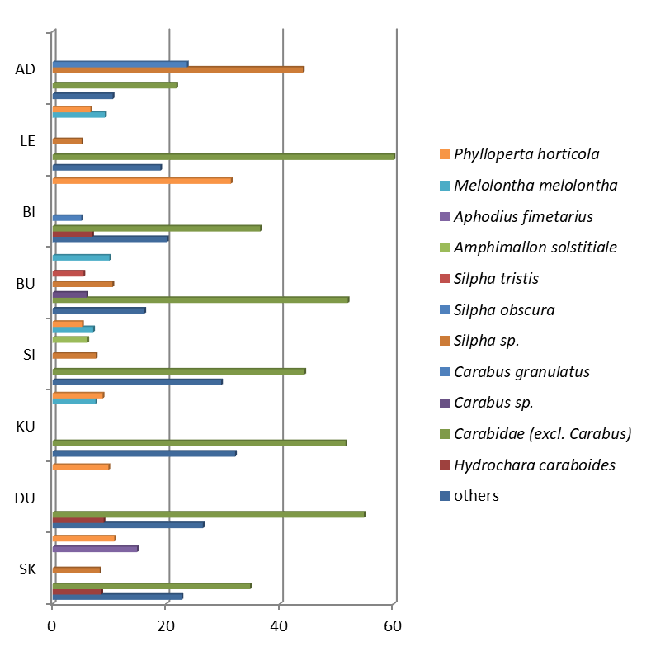

Fig. S2. Dominance structure of the most numerous taxa in the analyzed localities. Only eudominant (D ≤ 10%) and dominant (D >10%) taxa were included..

Our results allow us to characterize the habitat preferences of some species of beetles present in the nestlings’ diet. Notes:
(1) Among the prey of the White Stork, terrestrial beetles dominated (almost 95% of all the identified taxa), while aquatic beetles accounted for slightly more than 5% of all prey (Fig. 2). The most widely represented family, the ground beetles (Carabidae; n. det. excluding the genus Carabus spp.), consisted overwhelmingly (over 95%) of representatives from the tribes Pterostichini, Platynini, Nebrini, Zabrini, Harpalini, and Bembidini (Table 1).
(2) Among the beetle prey items, individuals belonging to aquatic habitat species (these taxa originated primarily from stagnant water bodies) constituted between 0.53% and 11.71% at the various study sites. This fact is closely related to the availability of shallow, warm water bodies in the habitats used by the storks as well as the limited presence or even absence of such water bodies in the vicinity of stork nests in some of the studied locations. Based on the data obtained, it can be concluded that, throughout the season, aquatic habitats of this type do not hold particular significance for the storks, as they tend to capture insects rather incidentally in such habitats.
(3) The highest number of taxa preyed upon by the White Stork was recorded at the site in Skryhiczyn (54), followed by Dubienka (47) and Kurmanów (44), with the lowest number observed in Busieniec (23). The highest biodiversity of prey, measured using the Shannon-Wiener index (Shannon, 1948), was found in nests at the following sites: Skryhiczyn (2.33), Siedliszcze (2.28), and Kurmanów (2.03), while the lowest value was recorded in Adamów (1.53) and Leszczany (1.66) (Fig. 5, Table 2). On the one hand, this may result from easy access to diverse habitats inhabited by birds (including their prey) in the vicinity of the nest (or their abundance and spatial variation); on the other hand, the age of the nest may also have an indirect influence, as it is not known how long the material has been present in the nest. The taxa preyed upon by the white stork primarily comprise widely distributed eurytopic species of beetles, common throughout the country in suitable habitats. Notably, representatives of the family Carabidae (excluding the genus Carabus) were the most abundant prey at most sites (in one case exceeding 60% of the total prey).
(4) At the sites where the proportion of small water bodies and streams ranged from 8.6% to 11.7% of the area, the quantitative share of aquatic insects in the diet varied from 0.53% to 8.97% (Fig. 2). This indicates a deliberate exploration of available microhabitats (including ephemeral ones, such as astatic water bodies in spring, outside of permanent streams) in search of food and the high effectiveness of such foraging efforts (Table 1).

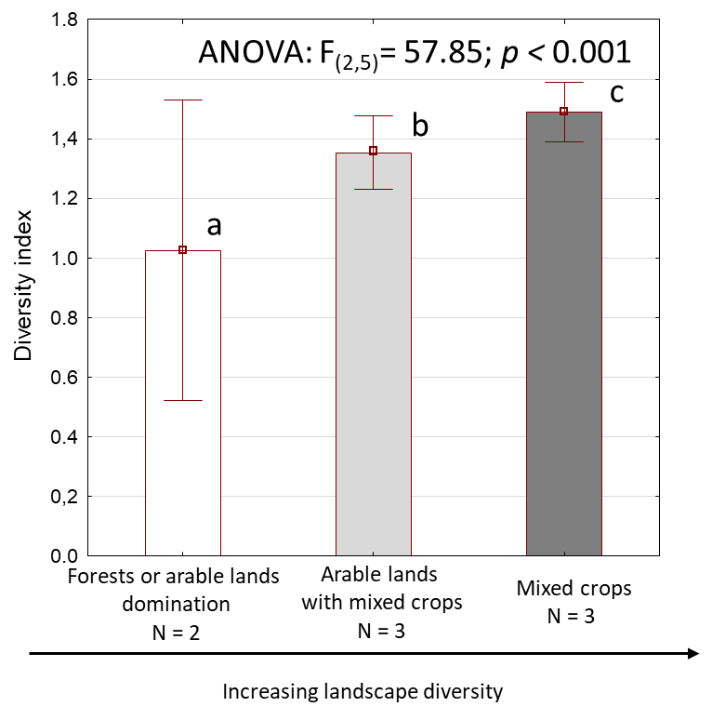
Fig. S3. Results of ANOVA test with post-hoc Tukey test calculated for landscape Shannon-Wiener diversity index values of nest surroundings differing in their dominance structure of land cover types. Different letters indicate significantly different mean values. Inland wetlands, as the less significant variable, were excluded from the analysis.

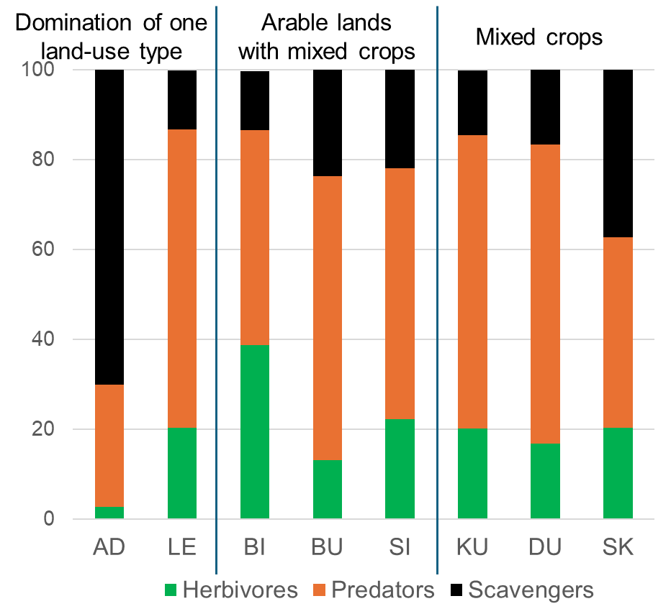

Fig. S4. Percentage composition of the three major trophic functional groups of beetles found in the nest material from eight nests (x-axis) of the White Stork in NE Poland; only beetles identified to the taxa/species were included.

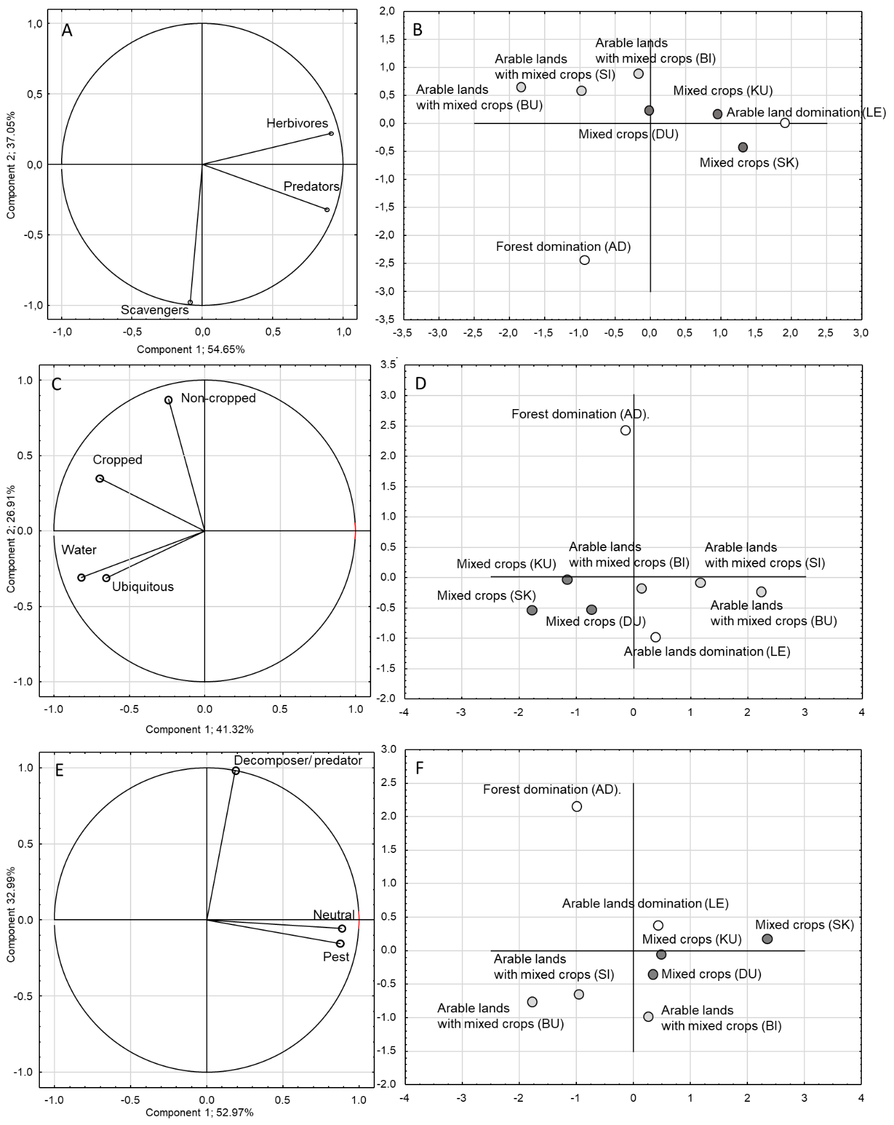

Variables = Functional grups
Cases = habitats in different land cover types different
Fig. S5. PCA analysis diagram based on the number of prey items representing different functional groups of Coleopteran fauna identified in pellets remains from White Stork nests. The detailed results of the PCA analysis are presented in supplementary material (Table S5). A-B: trophic groups (herbivores. predators, and scavengers); C-D: main habitat type (cropped, non-cropped, water, ubiquitous species); E-F: Agricultural importance (pest, neutral, and beneficial: mostly predators and decomposers).
Table S1. Area (in km2) and proportion (%) of different land cover types around the studied nests.

 | Forest domination | Arable lands domination | Arable lands with mixed crops |  |  | Mixed crops
Locality | AD | LE | BI | BU | SI | KU | DU | SK
Forests | 10.0  51% | 0.8  4% | 3.1  16% | 3.2  16% | 3.8  19% | 2.6  14% | 3.3  17% | 4.2  22%
Arable lands | 7.5  38% | 12.6  64% | 10.6  54% | 7.4  38% | 8.0  41% | 6.5  34% | 5.8  30% | 5.8  30%
Mixed crop zones | 1.2  6% | 2.3  11% | 2.8  14% | 2.5  13% | 2.7  14% | 4.7  25% | 3.8  19% | 4.9  25%
Associations of trees and shrubs | 0.7  3% | - | - | - | - | - | - | 0.7  3%
Meadows | - | 4.1  21% | 2.0  10% | 5.1  26% | 4.8  24% | 4.5  24% | 5.8  29% | 3.7  19%
Inland wetlands | - | - | - | 0.9  5% | - | - | - | -
Urbanized areas | 0.3  2% | - | 1.1  6% | 0.6  3% | 0.3  2% | 0.8  4% | 0.9  4% | 0.3  2%

Table S2. Results of PCA analysis based on the share of the main groups of land cover types around the nest. Explanations: Comp – component; variable loading is a measure of a given variable correlation with a PCA component. The most important variables for Component 1 and 2 are bolded.

PCA metric | Comp1 | Comp2
Eigenvalues | 2.73 | 1.79
Variance accounted to each component (%) | 39.05 | 25.62
Eigenvectors for land cover type:
Forests | -0.54 | 0.20
Associations of trees and shrubs | -0.50 | 0.31
Meadows | 0.54 | 0.11
Arable fields | 0.01 | -0.69
Mixed crops | 0.32 | 0.53
Urbanized areas | 0.20 | 0.26
Inland wetlands | 0.15 | -0.09
Variable loadings for land cover type:
Forests | -0.89 | 0.28
Associations of trees and shrubs | -0.82 | 0.41
Meadows | 0.88 | 0.15
Arable fields | 0.02 | -0.93
Mixed crops | 0.53 | 0.72
Urbanized areas | 0.34 | 0.35
Inland wetlands | 0.25 | -0.12

Note: This is supplementary table to Fig. 3.

Table S3. Results of PCA analysis based on the number of prey individuals representing dominating taxa. Explanations: Comp – component; variable loading is a measure of a given variable correlation with a PCA component. The most important variables for Component 1 and 2 are bolded.

PCA metric | Comp1 | Comp2
Eigenvalues | 3.47 | 2.71
Variance accounted to each component (%) | 31.52 | 24.68
Eigenvectors for dominating taxa:
Carabus sp. | -0.51 | -0.11
Silpha sp. | -0.50 | 0.06
S. obscura | -0.49 | 0.04
Amphimallon solstitiale | 0.37 | -0.14
Phyllopertha horticola | 0.22 | -0.28
Silpha tristis | -0.17 | -0.41
Carabus granulatus | -0.15 | -0.39
Melolontha melolontha | 0.09 | -0.40
Aphodius fimetarius | -0.05 | -0.25
Oth Carabidae | -0.02 | -0.52
Hydaticus continentalis | 0.01 | -0.27
Variable loadings for dominating taxa:
Carabus sp. | -0.95 | 0.17
Silpha sp. | -0.94 | 0.10
S. obscura | -0.91 | 0.07
Amphimallon solstitiale | 0.68 | -0.23
Phyllopertha horticola | 0.42 | -0.47
Silpha tristis | -0.31 | -0.68
Carabus granulatus | -0.27 | -0.64
Melolontha melolontha | 0.16 | -0.66
Aphodius fimetarius | -0.08 | -0.41
Carabidae Oth | -0.04 | -0.86
Hydaticus continentalis | 0.01 | -0.44

Note: This is supplementary table to Fig. 4.
Table S4. Percentage composition of the functional guilds of coleopteran fauna found in the White Stork nest material in NE Poland.

Functional group | Average | -95.0% | +95.0% | Range
TROPHIC GROUPS
Herbivores | 19.3 | 10.8 | 27.8 | 2.6-39.0
Scavenger | 26.3 | 10.0 | 42.5 | 13.1-70.0
Predators | 54.4 | 42.5 | 66.3 | 27.3-66.6
HABITAT PREFERENCE
Crops | 0.1 | 0.0 | 0.2 | 0.0-0.3
Non-crops | 25.0 | 8.5 | 41.5 | 8.4-70.1
Water | 5.5 | 1.7 | 9.2 | 0.5-11.7
Ubiquitous species | 69.4 | 54.2 | 84.6 | 28.9-83.4
SPECIES IMPORTANCE
Pest | 18.4 | 9.9 | 26.9 | 2.4-38.6
Decomposer/predator | 75.7 | 64.9 | 86.5 | 52.5-96.5
Neutral | 5.8 | 2.0 | 9.7 | 0.9-12.1

Table S5. Detailed results of PCA analyses based on taxa representing groups of given functional guilds. Explanations: Comp – component; variable loading is a measure of a given variable correlation with a PCA component. The most important variables for Component 1 and 2 are bolded.

PCA Analysis (number of prey items) | Comp1 | Comp2
TROPHIC GROUPS
Eigenvalues | 1.64 | 1.11
Variance accounted to each component (%) | 54.65 | 37.05
Eigenvectors for trophic groups:
Herbivores | 0.71 | 0.21
Predators | 0.69 | -0.30
Scavengers | -0.07 | -0.93
Variable loadings for trophic groups:
Herbivores | 0.92 | 0.22
Predators | 0.88 | -0.32
Scavengers | -0.09 | -0.97
HABITAT TYPES
Eigenvalues | 1.65 | 1.08
Variance accounted to each component (%) | 41.32 | 26.90
Eigenvectors for land use type:
Cropped | -0.54 | 0.34
Non-cropped | -0.19 | 0.84
Water | -0.64 | -0.29
Ubiquitous species | -0.51 | -0.30
Variable loadings for trophic groups:
Cropped | -0,70 | 0,35
Non-cropped | -0,24 | 0,87
Water | -0,82 | -0,31
Ubiquitous species | -0,66 | -0,31
AGRICULTURAL IMPORTANCE
Eigenvalues | 1.59 | 0.99
Variance accounted to each component (%) | 52.96 | 32.99
Eigenvectors for species impact:
Pest | 0,69 | -0,15
Decomposer/predator | 0,15 | 0,99
Neutral | 0,70 | -0,05
Variable loadings for species impact:
Pest | 0,88 | -0,15
Decomposer/predator | 0,19 | 0,98
Neutral | 0,89 | -0,05

Note: This is supplementary table to Fig. S5.

