Structural and Computational Insights into New Nano-sized Cu(II) Metal-Organic Coordination Particles: Synthesis, Crystal Analysis, and Hirshfeld Surface Analysis
Halimeh rajabzadeh ^{* a}
Department of Chemistry, Dezful Branch, Islamic Azad University, Dezful, Iran E-mail: R.rajabzadeh77@gmail.com

Table S1. Local chemical reactivity of the Cu(II) in selected level of theory.
Atoms | F+ | F- | s+ | s- | w+ | w-
1 Cu | 0.0114 | -0.0229 | 0.0232 | -0.0464 | 0.0066 | -0.0133
2 O | -0.0036 | 0.0139 | -0.0073 | 0.0281 | -0.0021 | 0.0080
3 H | -0.0003 | -0.0143 | -0.0006 | -0.0291 | -0.0002 | -0.0083
4 H | 0.0083 | -0.0069 | 0.0169 | -0.0140 | 0.0048 | -0.0040
5 O | 0.0728 | 0.0336 | 0.1479 | 0.0682 | 0.0422 | 0.0195
6 O | 0.0721 | 0.0289 | 0.1464 | 0.0586 | 0.0418 | 0.0167
7 C | 0.0345 | -0.0094 | 0.0701 | -0.0190 | 0.0200 | -0.0054
8 N | -0.0239 | 0.0045 | -0.0486 | 0.0091 | -0.0139 | 0.0026
9 N | -0.0249 | -0.0371 | -0.0506 | -0.0753 | -0.0144 | -0.0215
10 C | -0.0011 | -0.0688 | -0.0023 | -0.1396 | -0.0007 | -0.0399
11 H | -0.0114 | -0.0506 | -0.0231 | -0.1027 | -0.0066 | -0.0293
12 C | 0.0014 | 0.0108 | 0.0028 | 0.0219 | 0.0008 | 0.0063
13 H | 0.0094 | -0.0537 | 0.0190 | -0.1090 | 0.0054 | -0.0312
14 C | 0.0108 | -0.0520 | 0.0218 | -0.1056 | 0.0062 | -0.0302
15 H | 0.0139 | -0.0499 | 0.0282 | -0.1014 | 0.0081 | -0.0290
16 C | -0.0027 | 0.0420 | -0.0054 | 0.0853 | -0.0016 | 0.0244
17 C | 0.0063 | -0.0585 | 0.0127 | -0.1187 | 0.0036 | -0.0339
18 C | 0.0071 | -0.0293 | 0.0145 | -0.0594 | 0.0041 | -0.0170
19 C | -0.0035 | 0.0480 | -0.0072 | 0.0975 | -0.0021 | 0.0279
20 C | 0.0112 | -0.0711 | 0.0227 | -0.1443 | 0.0065 | -0.0412
21 H | 0.0138 | -0.0575 | 0.0279 | -0.1168 | 0.0080 | -0.0334
22 C | 0.0011 | 0.0143 | 0.0022 | 0.0290 | 0.0006 | 0.0083
23 H | 0.0095 | -0.0601 | 0.0193 | -0.1220 | 0.0055 | -0.0349
24 C | -0.0009 | -0.0706 | -0.0017 | -0.1433 | -0.0005 | -0.0410
25 H | -0.0107 | -0.0586 | -0.0218 | -0.1190 | -0.0062 | -0.0340
26 C | 0.0053 | -0.0864 | 0.0108 | -0.1753 | 0.0031 | -0.0501
27 H | 0.0124 | -0.0804 | 0.0252 | -0.1632 | 0.0072 | -0.0466
28 C | 0.0061 | -0.0955 | 0.0124 | -0.1938 | 0.0035 | -0.0554
29 H | 0.0124 | -0.0799 | 0.0253 | -0.1622 | 0.0072 | -0.0464
30 Cu | 0.5603 | -0.0028 | 1.1374 | -0.0056 | 0.3250 | -0.0016
31 O | -0.0237 | 0.0001 | -0.0482 | 0.0003 | -0.0138 | 0.0001
32 H | 0.0309 | 0.0023 | 0.0628 | 0.0047 | 0.0179 | 0.0013
33 H | 0.0286 | -0.0033 | 0.0580 | -0.0067 | 0.0166 | -0.0019
34 O | -0.0489 | -0.0249 | -0.0994 | -0.0506 | -0.0284 | -0.0145
35 O | -0.0505 | -0.0249 | -0.1025 | -0.0505 | -0.0293 | -0.0144
36 C | 0.0321 | -0.0081 | 0.0652 | -0.0164 | 0.0186 | -0.0047
37 N | -0.1827 | 0.0101 | -0.3709 | 0.0205 | -0.1060 | 0.0059
38 N | -0.1848 | 0.0108 | -0.3752 | 0.0219 | -0.1072 | 0.0062
39 C | 0.0483 | 0.0014 | 0.0980 | 0.0028 | 0.0280 | 0.0008
40 H | 0.0226 | 0.0082 | 0.0459 | 0.0166 | 0.0131 | 0.0047
41 C | -0.0010 | 0.0000 | -0.0021 | 0.0000 | -0.0006 | 0.0000
42 H | 0.0366 | -0.0038 | 0.0742 | -0.0077 | 0.0212 | -0.0022
43 C | 0.0410 | -0.0060 | 0.0833 | -0.0121 | 0.0238 | -0.0035
44 H | 0.0379 | -0.0083 | 0.0770 | -0.0168 | 0.0220 | -0.0048
45 C | -0.0118 | 0.0016 | -0.0240 | 0.0033 | -0.0069 | 0.0009
46 C | 0.0772 | -0.0024 | 0.1568 | -0.0048 | 0.0448 | -0.0014
47 C | 0.0826 | -0.0029 | 0.1678 | -0.0059 | 0.0479 | -0.0017
48 C | -0.0144 | 0.0022 | -0.0292 | 0.0044 | -0.0083 | 0.0013
49 C | 0.0433 | -0.0062 | 0.0879 | -0.0125 | 0.0251 | -0.0036
50 H | 0.0379 | -0.0082 | 0.0769 | -0.0167 | 0.0220 | -0.0048
51 C | -0.0029 | 0.0000 | -0.0060 | -0.0001 | -0.0017 | 0.0000
52 H | 0.0364 | -0.0043 | 0.0738 | -0.0086 | 0.0211 | -0.0025
53 C | 0.0488 | 0.0010 | 0.0990 | 0.0021 | 0.0283 | 0.0006
54 H | 0.0227 | 0.0073 | 0.0461 | 0.0149 | 0.0132 | 0.0043
55 C | 0.0162 | -0.0028 | 0.0329 | -0.0057 | 0.0094 | -0.0016
56 H | 0.0312 | -0.0077 | 0.0633 | -0.0156 | 0.0181 | -0.0044
57 C | 0.0181 | -0.0034 | 0.0368 | -0.0070 | 0.0105 | -0.0020
58 H | 0.0313 | -0.0078 | 0.0636 | -0.0157 | 0.0182 | -0.0045

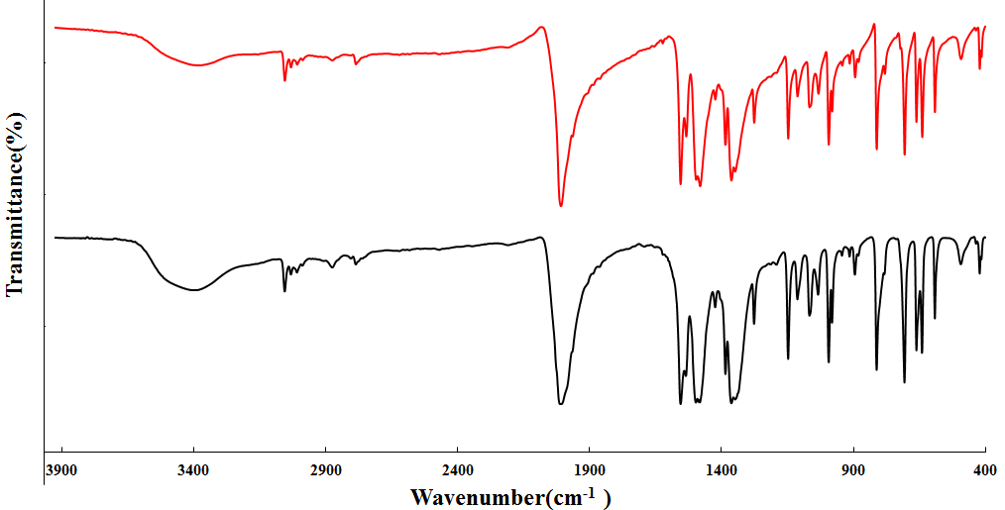
Fig. S1. The IR spectra of, 1-1 obtained by ultra-sonication (red line), 1- 2 simulated from single-crystal X-Ray data of 1 (black line).

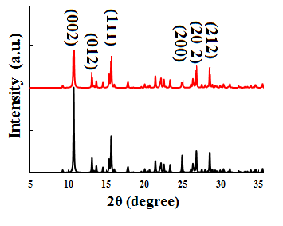
Fig.S2. The PXRD patterns of nano-sized 1-1 obtained by ultra-sonication (black line) and simulated from single-crystal X-Ray data of 1 (red line).

