Reporting checklist
1. Modify the marked manuscript
2. manuscript
3. Response to Reviewers Comments
4. All the pictures in the manuscript
5. Supplementary information:
(1) Data Availability
(2) Acknowledgements
(3) Author Contributions
(4) Competing Interests
(5)A full references list
(6) List of Graph Titles

Supplementary information
Data Availability
All data and models during the study appear in the published paper.

Acknowledgments
The authors are grateful for support from the National Natural Science Foundation of China (Nos:12272190) for their support.

Author contributions
Jiong Gao: Investigation, Data curation, Writing-original draft, Visualization. Yunhong Hao: Writing - review and editing, Methodology, Funding acquisition. Jiaoyu Xuan: Investigation, Writing- review & editing. Rigen Wu: Resources, Investigation.

Competing interests
The authors declare no competing interests.

Reference
1 Tang, Y. J. & Shao, Z. D. The effect of climate on the deterioration of ancient tower bricks. Sci. Conserv. Archaeol. 24(3):33-39 (2012) (in Chinese).
2 Binda, L., Tiraboschi, C. & Baronio, G. On-site investigation on the remains of the Cathedral of Noto. Constr. Build. Mater. 17(8), 543-555 (2003).
3 Sathiparan, N. & Rumeshkumar, U. Effect of moisture condition on mechanical behavior of low strength brick masonry. J Build Eng. 17, 23-31 (2018).
4 Wu, A. L., Liu, K., Hao, Y. H., Wu, R. G. & Xuan, J. Y. Freeze-Thaw Damage of Ancient Architectural Grey Bricks Based on Fractal Theory. J. Build. Mater. 27(8), 701-710 (2024) (in Chinese).
5 Zhang, D. M., Wang, L., Guo, G. l., Wang, Y. & Wang, W. C. Effect of the freeze-thaw on macroscopic properties and microstructural degradation of ancient grey bricks. Sci. Conserv. Archaeol. 33(04), 9-15 (2021) (in Chinese).
6 Shi, J. S., Chun, Q., Feng, S. H., Liu, C., Liu, Z. Y., Wang, D. F. & Zhang, Y. Pore structure and fractal dimension analysis of ancient city wall bricks in China. J Build Eng. 76, 107324 (2023).
7 Bruno, A. W., Gallipoli, D. & Perlot, C. Effect of freezing-thawing cycles on the physical and mechanical properties of fired and unfired earth bricks. J Build Eng. 52, 104501 (2022).
8 Liu, J. X. & Wang, Y. Z. Performance degradation mechanism of adobe materials under freeze-thaw cycles based on moisture transportation characteristics and microstructural analysis. Constr. Build. Mater. 411, 134464 (2024).
9 Perrin, B., Vu, N. A., Multon, S., Voland, T. & Ducroquetz, C. Mechanical behaviour of fired clay materials subjected to freeze–thaw cycles. Constr. Build. Mater. 25(2), 1056-1064 (2011).
10 Wardeh, G. & Perrin, B. Freezing-thawing phenomena in fired clay materials and consequences on their durability. Constr. Build. Mater. 22(5), 820-828 (2008).
11 Huan, W. J., Zhang, Y. S., Liu, G. J. & Zhao, P. "Performance deterioration and microstructure evolution of clay brick submitted to freeze-thaw cycles. J. Southeast Univ. Nat. Sci. Ed. 44(2), 401-405 (2014) (in Chinese).
12 Hao, Y. H., Li, J., Wang, Y. H., He, X. Y. & X, C. G. Investigation on Damage Performance of Coal Gangue-iron Tailings Sintered Porous Brick under Freeze-thaw Cycles. Sci. Technol. Eng. 23(31), 13533-13541 (2023) (in Chinese).
13 Uranjek, M. & Bokan-Bosiljkov, V. Influence of freeze-thaw cycles on mechanical properties of historical brick masonry. Constr. Build. Mater. 84, 416-428 (2015).
14 Yue, J. W. et al. Study on Deterioration of Gray Brick with Different Moisture Contents under Freeze-Thaw Environment. Materials. 15(5) (2022).
15 Netinger Grubesa, I., Vracevic, M., Ranogajec, J. & Vucetic, S. Influence of Pore-Size Distribution on the Resistance of Clay Brick to Freeze-Thaw Cycles. Materials. 13(10) (2020).
16 Zhao, P., Lei, Q., Zhang, X. Z., Huan, W. J. & Ma, H. J. Durability and life prediction of Chinese traditional black bricks under freezing and thawing conditions. Rev Rom Mater. 49(1), 157-166 (2019).
17 Tang, Y. J., Shao, Z. D. & Xu, T. L. Uniaxial compressive tests on ancient brick masonry from heritage buildings under unsaturated freeze-thaw conditions. Constr. Build. Mater. 183, 706-715 (2018).
18 Mandelbrot, B. B. The Fractal Geometry of Nature: Updated and Augmented. New York: W.H. Freeman and Co (1983).
19 Volchuk, V. & Kotov, M. Fractal express methods evaluation of a breaking stress of concrete. Journal of Physics:Conference Series. 1926(1):12-23 (2021).
20 Gao, S., Li, Q. Y. & Luo, J. L. Fractal characteristic of recycled aggregate and its influence on physical property of recycled aggregate concrete. Rev Adv Mater Sci. 60(1), 663-677 (2021).
21 Xie, F. X., Jin, Z. H., Yang, T. F., Han, X., Chen, X. D. & Zhang, Y. Experimental study of dynamic splitting-tensile properties of precast concrete samples under different strain rates. Constr Build Mater. 372. (2023).
22 Zhang, Q., Xia, Y. J., Zhao, J. C., Tang, C. & Zhang, B. Experimental investigation of crack evolution in expansive soil-rubber mixture (ESR) under freeze-thaw cycles. Cold Reg Sci Technol. 217. (2024).
23 Xu, H. Y., Bu, J. W., Chen, X. D., Chen, Q. & Xu, B. Fracture behavior of dredged sand concrete under freeze-thaw cycles. Constr Build Mater, 366 (2023).
24 Cao, R. H. et al. Effects of cyclic freeze-thaw treatments on the fracture characteristics of sandstone under different fracture modes: Laboratory testing. Theor Appl Fract Mec. 109 (2020).
25 Wang, X. J., Zhang, X. D., Jing, P. F. & Li, J. Fractal fracture characteristics of asphalt concrete freeze-thaw cycles. Mech. Eng. 45(01), 100-112 (2023) (in Chinese).
26 Guo, Y. C., Shen, A. Q., He, T. Q. & Zhou, S. B. Micro-crack propagation behavior of pavement concrete subjected to coupling effect of fatigue load and freezing-thawing cycles. J Traffic Transp Eng. 16(5), 1-9. (2016).
27 Liu, C. J., Zhang, Q. J., Zhu, Q. & Deng, H. W. Effect of cyclic freeze-thaw treatments on the dynamic fracture characteristics of granite: Laboratory testing. Eng Fract Mech. 276 (2022).
28 Zhang, K., Ye, J. & Liu, X. Energy evolution and fractured fractal characteristics of loaded sandstone under freeze-thaw cycles. J. Saf. Sci. Technol. 17(8), 111-116 (2021) (in Chinese).
29 Yu, Y., Jiang, Q. C., Liu, Q., Feng, G. L., Zeng, J. J. & Lu, Y. Y. Experimental study on dynamic failure behavior of red sandstone after freeze-thaw cycles. Constr Build Mater. 451: 138582 (2024).
30 He, M. C., Yang, G. X., Jiang, J. L., Jia, X. N. & Jiang, T. T. Classification and research methods of rockburst experimental fragments. Chin. J. Rock Mech. Eng. 28(8), 1521-1529 (2009) (in Chinese).
31 Deng, Y., Chen, M. A., Jin, Y. & Zou, D. W. Theoretical analysis and experimental research on the energy dissipation of rock crushing based on fractal theory. J Nat Gas Sci Eng. 33, 231-239 (2016).
32 Peng, R. D., Ju, Y., Wang, J. G., Xie, H. P., Gao, F. & Mao, L. T. Energy Dissipation and Release During Coal Failure Under Conventional Triaxial Compression. Rock Mech Rock Eng. 48(2), 509-526 (2015).
33 Xie, H. P., Li, L. Y., Peng, R. D. & Ju, Y. Energy analysis and criteria for structural failure of rocks. J Rock Mech Geotech. 1(1), 11-20 (2009).
34 de Behr, V., Hornick, J. L., Cabaraux, J. F., Alvarez, A. & Istasse, L. Growth patterns of Belgian Grey replacement heifers and growing males in commercial farms. Livest. Prod. Sci. 71(2-3), 121-130 (2001).
35 Zhang, S., Wang, H. Y., Li, X. J., Zhang, X. L., An, D. C. & Yu, B. X. Experimental study on development characteristics and size effect of rock fracture process zone. Eng Fract Mech. 241 (2021).
36 Zhang, X., Li, X. S., Liu, Y. H., Liu, W., Li, Q. H. & Li, L. Experimental study on crack propagation and failure mode of fissured shale under uniaxial compression. Theor Appl Fract Mec. 121 (2022).
37 Lai, Y. M. et al. Fractal characteristics of rocks and mesoscopic fractures at different loading rates. Geomech Energy Envir. 33 (2023)
38 Lu, Y., Liu, S. H., Weng, L. P., Wang, L. J., Li, Z. & Xu, L. Fractal analysis of cracking in a clayey soil under freeze-thaw cycles. Eng Geol. 208, 93-99 (2016).
39 Liu, D. Q., Li, D. J., Zhao, F. & Wang, C. C. Fragmentation characteristics analysis of sandstone fragments based on impact rockburst test. J Rock Mech Geotech. 6(3), 251-256 (2014).
40 Li, D. J., Guan, L., Han, L. Q. & Miao, C. Analysis of micro-crack characteristics from rockburst failure of basalt in Baijiao Coal Mine content. Journal of China Coal Society. 39(2), 307-314 (2014)
41 Yin, Y. J., Ren, Q. W., Lei, S., Zhou, J. K., Xu, L. & Wang, T. Mesoscopic crack pattern fractal dimension-based concrete damage identification. Engineering Fracture Mechanics, 296 (2024) (in Chinese).
42 Zamen, S. & Dehghan-Niri, E. Fractal analysis of nonlinear ultrasonic waves in phase-space domain as a quantitative method for damage assessment of concrete structures. Ndt&e Int. 111 (2020).

Fig. 1 Comparison diagram of ancient grey brick and antique grey brick: （a）Ancient brick;（b）Brick specimens.

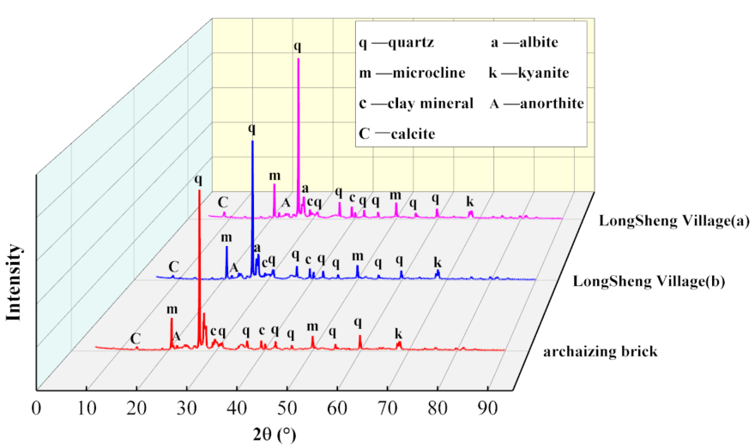
Fig. 2 XRD composition analysis of antique grey brick/ancient brick.

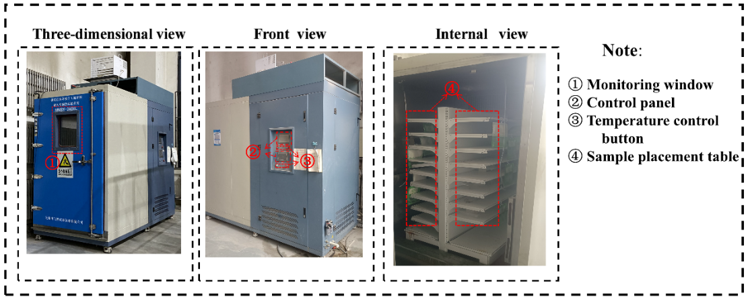
Fig. 3 Freezing and thawing cycles test chamber.

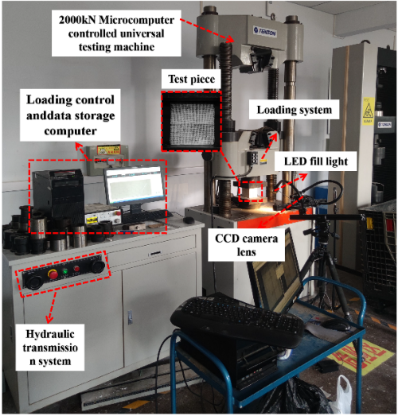
Fig. 4 Uniaxial compression test of grey brick.

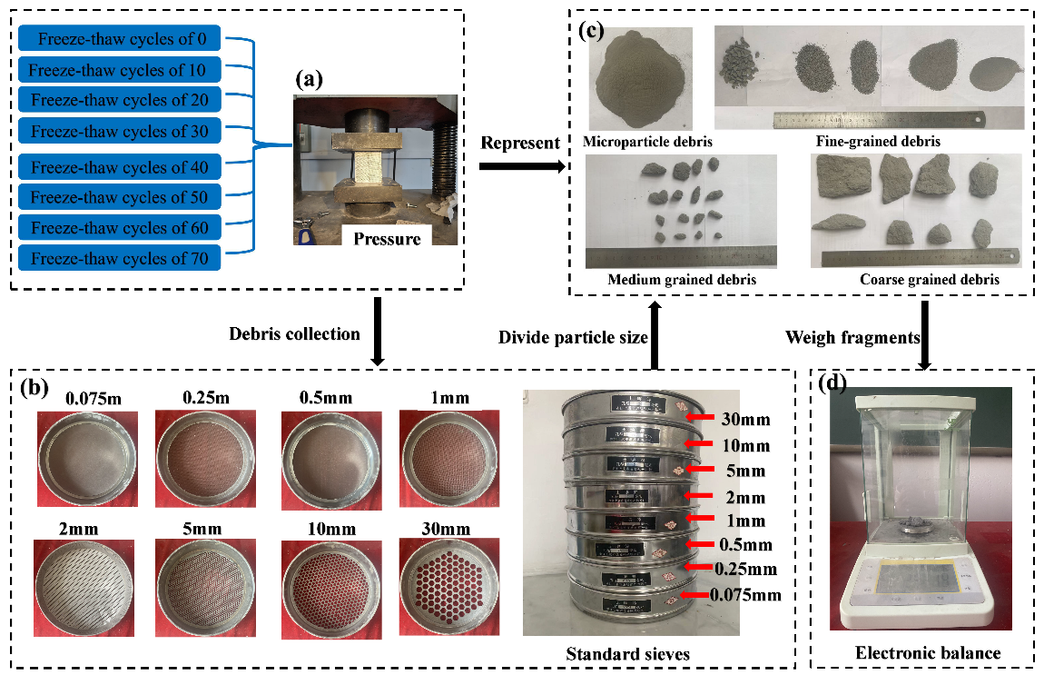
Fig. 5 Experimental process.

Fig.6 Grey brick debris mass distribution diagram.

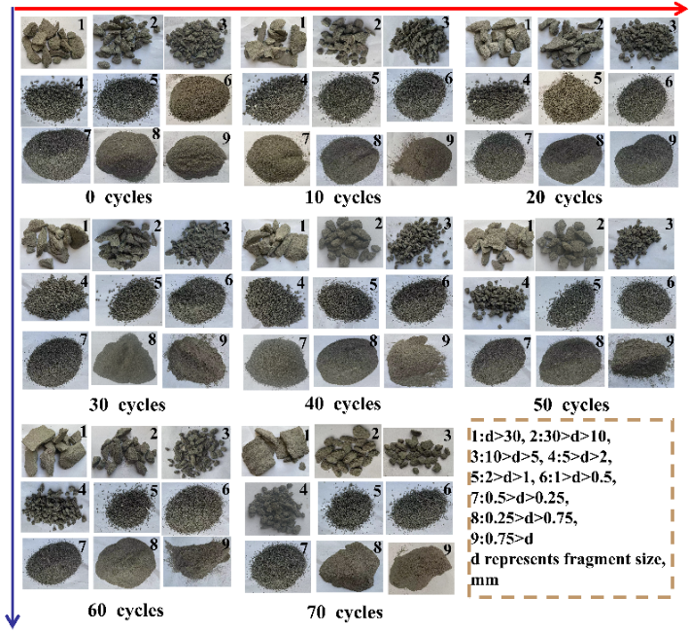
Fig. 7 Grey brick debris distribution diagram.

Fig. 8 Characteristic size ratio distribution diagram of grey brick debris: (a) 0 cycles; (b) 10 cycles; (c) 20 cycles; (d) 30 cycles; (e) 40 cycles; (f) 50 cycles; (g) 60 cycles; (h) 70 cycles.

Fig 9. Fractal dimension determined by particle size-quantity relationship: (a) 0 cycles ; (b) 10 cycles; (c) 20 cycles ; (d) 30 cycles ; (g) 60 cycles ; (h) 70 cycles.

Fig 10. Fractal dimension determined by mass-granularity relationship: (a) 0 cycles ; (b) 10 cycles; (c) 20 cycles ; (d) 30 cycles ; (g) 60 cycles ; (h) 70 cycles.

Fig. 11 The variation of fractal dimension during cycles of freeze-thaw.

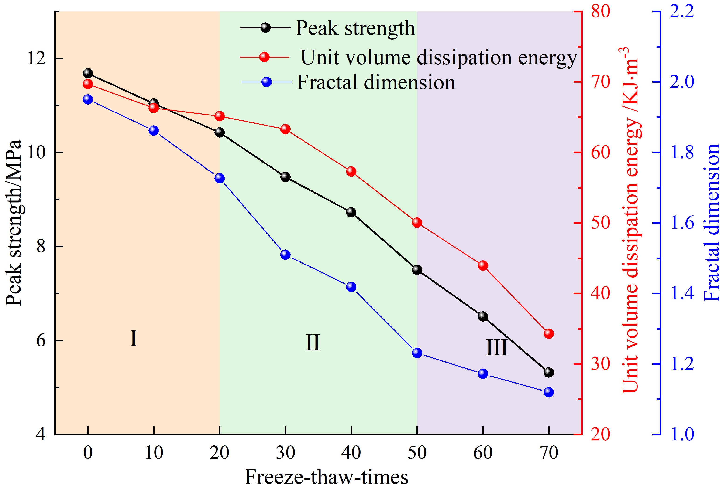
Fig. 12 The variation of compressive strength, energy dissipation per unit volume, and fractal dimension with the amount of cycles of freezing and thawing.

Fig. 13. Diagram of crack evolution characteristics of grey brick during loading: (a) 0 cycles ; (b) 10 cycles; (c) 20 cycles ; (d) 30 cycles ; (g) 60 cycles ; (h) 70 cycles.

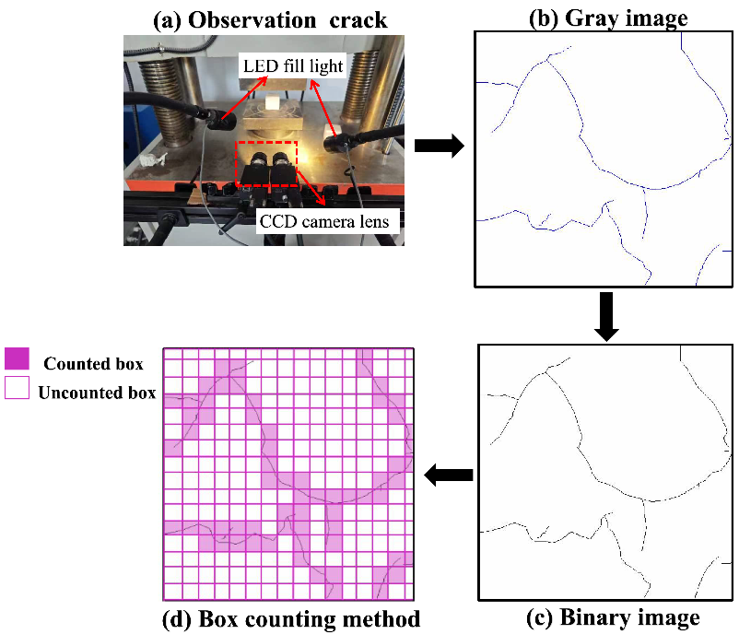
Fig. 14 Diagram of fracture fractal dimension calculation process.

Fig. 15 Crack fractal dimension fitting curve schematic diagram: (a) 0 cycles ; (b) 10 cycles; (c) 20 cycles ; (d) 30 cycles ; (g) 60 cycles ; (h) 70 cycles.

Fig. 16 Change diagram of fracture fractal dimension.

Fig. 17 Change curve of damage factor of grey brick.
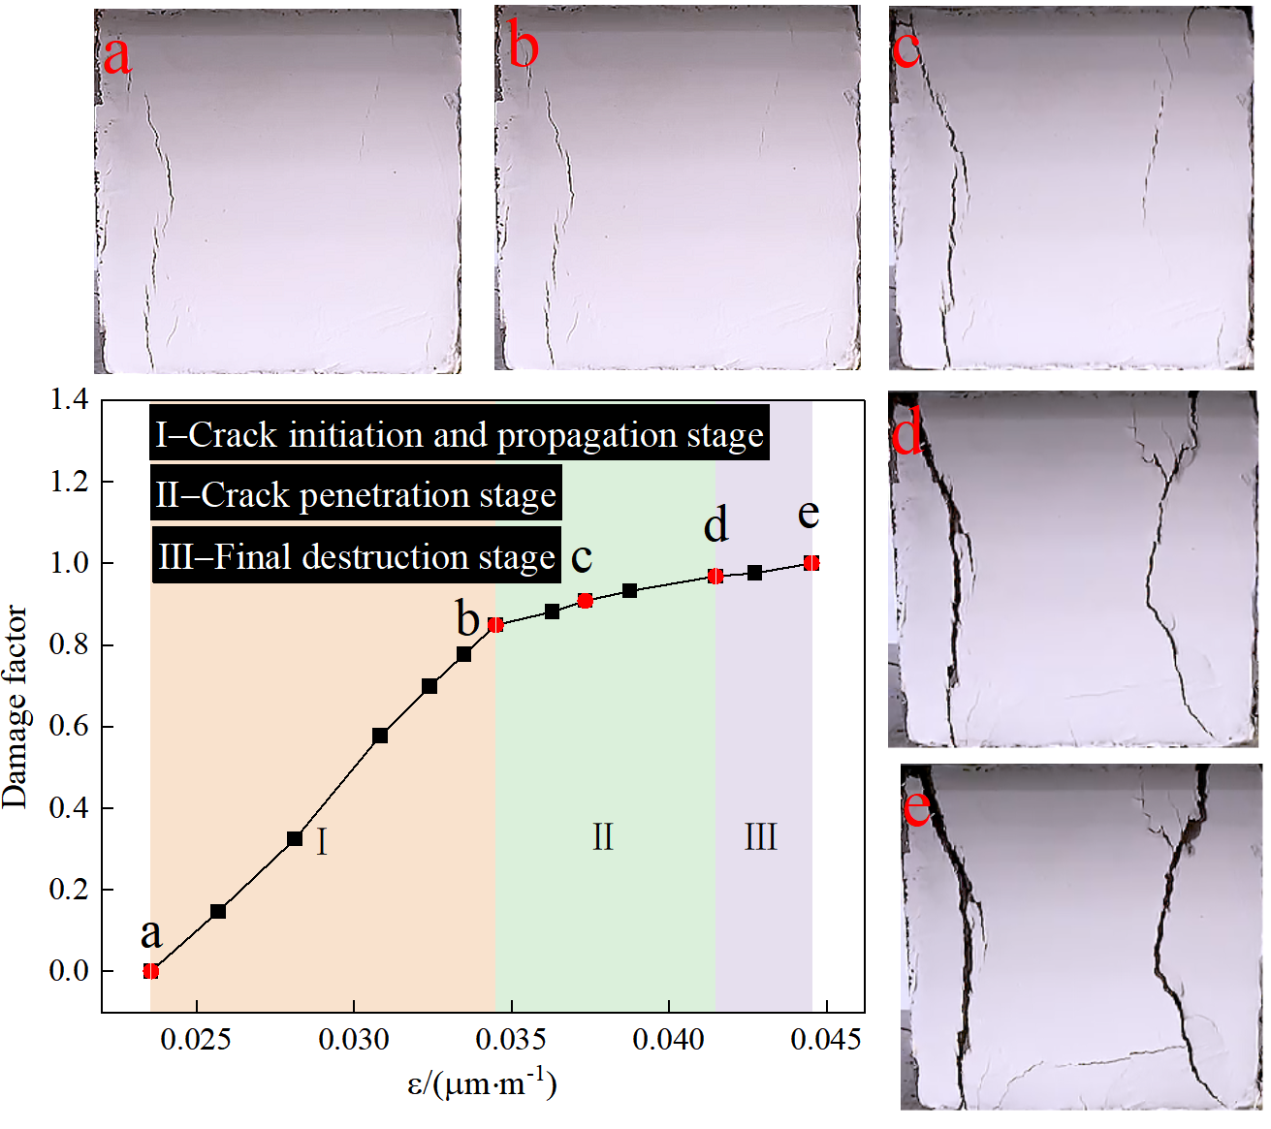
Fig. 18 Crack propagation morphology distribution diagram at key points.

Fig. 19. Grey brick damage factor evolution curve diagram: (a) Quantity of cycles of freeze-thaw; (b) Strain normalization.

Table 1. Performance distribution table of ancient grey brick / antique grey brick.
Specimen/  Physical property |  | Density/ | Water absorption/% | Apparent hardness /MPa | Compressive strength /MPa
Longshengzhuang ancient grey brick | Mean value | 1.9 | 1.68 | 121.12 | 8.81
Antique grey brick | Mean value | 2.1 | 1.72 | 130.76 | 10.26

Fig. 20 The varying curves of different parameters with the amount of cycles of freezing and thawing: (a) First fitting parameter; (b) Strain value.

Table 2. XRF quantitative analysis of antique grey brick/ ancient brick.
Specimen | SiO₂ | CaO | Al₂O₃ | Fe₂O₃ | K₂O | MgO | Na₂O | TiO₂ | Other
Antique grey brick | 47.51 | 16.95 | 13.98 | 9.69 | 4.15 | 3.56 | 2.07 | 1.12 | 0.97
Longshengzhuang ancient grey brick | 45.58 | 19.36 | 13.13 | 9.84 | 3.96 | 3.01 | 2.37 | 1.26 | 1.49

Table 3. Statistics of grey brick debris screening test.
The mass fraction of compressed debris of grey bricks after different freeze-thaw cycles（%）
Freeze-thaw cycles | Particle size range（mm）
Freeze-thaw cycles | Coarse grain group | Medium grain group |  | Fine grain group |  |  |  |  | Microparticle group
Freeze-thaw cycles | >30 | 10∼30 | 5∼10 | 2∼5 | 1∼2 | 0.5∼1 | 0.25∼0.5 | 0.075∼0.25 | 0.075<
0 | 51.94 | 7.84 | 3.59 | 7.86 | 7.08 | 7.44 | 4.82 | 6.39 | 3.04
10 | 60.02 | 6.85 | 3.18 | 5.92 | 3.68 | 5.71 | 4.71 | 6.57 | 3.37
20 | 63.06 | 7.51 | 3.51 | 4.43 | 5.01 | 3.97 | 3.86 | 6.44 | 2.21
30 | 65.11 | 6.01 | 2.63 | 5.17 | 3.02 | 5.44 | 4.04 | 5.79 | 2.83
40 | 65.96 | 8.39 | 3.71 | 4.32 | 2.68 | 3.75 | 3.81 | 4.95 | 2.46
50 | 68.38 | 6.79 | 5.27 | 4.44 | 2.77 | 3.62 | 3.79 | 3.55 | 1.39
60 | 71.57 | 7.49 | 5.32 | 4.47 | 2.68 | 1.59 | 2.36 | 2.38 | 2.13
70 | 73.03 | 5.14 | 6.33 | 3.58 | 3.26 | 3.09 | 2.43 | 2.33 | 1.83

Table 4. The scale ratio and morphological distribution of compression debris of grey brick.
Freeze-thaw cycles | Length to thickness ratio | Width to thickness ratio | Length to width ratio | Blocky debris /% | Plate debris  /% | Flake debris /% | Thin flake debris  /%
0 | 1.06∼6.01/2.99 | 0.95∼3.36/1.89 | 0.49∼3.24/1.59 | 75.32 | 23.39 | 1.29 | 0
10 | 1.01∼6.26/3.19 | 0.95∼2.44/1.69 | 0.91∼3.41/1.88 | 66.24 | 31.89 | 1.87 | 0
20 | 1.03∼6.31/3.29 | 0.18∼3.59/1.94 | 0.19∼3.36/154 | 63.21 | 32.91 | 2.88 | 0
30 | 1.24∼7.47/3.69 | 0.5∼4.43/2.13 | 0.47∼3.68/1.76 | 59.32 | 35.02 | 5.66 | 0
40 | 1.12∼7.55/3.72 | 1.06∼3.9/2.09 | 1.01∼4.03/1.81 | 57.54 | 38.29 | 4.17 | 0
50 | 1.23∼7.76/3.79 | 0.92∼3.69/2.04 | 0.82∼4.28/1.87 | 54.65 | 40.62 | 3.79 | 0.94
60 | 1.12∼8.22/4.08 | 0.91∼5.53/2.57 | 0.86∼3.22/1.59 | 49.95 | 42.67 | 6.09 | 1.29
70 | 1.04∼8.69/4.01 | 0.87∼4.81/2.23 | 0.91∼3.37/1.72 | 45.06 | 45.95 | 7.10 | 1.89

Table 5. Debris fractal dimension obtained by different calculation methods.
Numbering | Relevant parameter | Freeze-thaw cycles | Fractal dimension | Correlation coefficient
① | Equivalent side length -cumulative number | 0 | 1.994 | 0.972
① |  | 10 | 1.926 | 0.971
① |  | 20 | 1.903 | 0.964
① |  | 30 | 1.866 | 0.973
① |  | 40 | 1.746 | 0.978
① |  | 50 | 1.601 | 0.971
① |  | 60 | 1.449 | 0.971
① |  | 70 | 1.266 | 0.968
② | Equivalent side length -cumulative mass | 0 | 2.687 | 0.932
② |  | 10 | 2.668 | 0.943
② |  | 20 | 2.653 | 0.931
② |  | 30 | 2.648 | 0.942
② |  | 40 | 2.626 | 0.919
② |  | 50 | 2.613 | 0.953
② |  | 60 | 2.604 | 0.936
② |  | 70 | 2.581 | 0.942
③ | Maximum length - cumulative number | 0 | 1.757 | 0.947
③ |  | 10 | 1.668 | 0.971
③ |  | 20 | 1.625 | 0.958
③ |  | 30 | 1.584 | 0.935
③ |  | 40 | 1.452 | 0.912
③ |  | 50 | 1.329 | 0.905
③ |  | 60 | 1.266 | 0.939
③ |  | 70 | 1.162 | 0.913
④ | Maximum width - cumulative number | 0 | 1.825 | 0.962
④ |  | 10 | 1.771 | 0.908
④ |  | 20 | 1.735 | 0.907
④ |  | 30 | 1.689 | 0.933
④ |  | 40 | 1.602 | 0.914
④ |  | 50 | 1.513 | 0.939
④ |  | 60 | 1.431 | 0.921
④ |  | 70 | 1.332 | 0.948
⑤ | Maximum thickness -cumulative number | 0 | 2.089 | 0.939
⑤ |  | 10 | 1.951 | 0.929
⑤ |  | 20 | 1.847 | 0.952
⑤ |  | 30 | 1.746 | 0.934
⑤ |  | 40 | 1.704 | 0.924
⑤ |  | 50 | 1.627 | 0.901
⑤ |  | 60 | 1.511 | 0.923
⑤ |  | 70 | 1.305 | 0.941

Table 6. List of parameters of the fitted equation.
Parameter | Cycles of freeze-thaw /N
Parameter | 0 | 10 | 20 | 30 | 40 | 50 | 60 | 70
 | 1.054 | 1.045 | 1.037 | 1.029 | 1.009 | 0.993 | 0.991 | 0.977
 | 0.0445 | 0.0562 | 0.0471 | 0.0603 | 0.0747 | 0.0868 | 0.0911 | 0.111
 | -152.934 | -95.095 | -86.161 | -40.731 | -159.734 | -102.691 | -43.049 | -14.366
 | 0.118 | 0.115 | 0.126 | 0.138 | 0.094 | 0.101 | 0.119 | 0.158
 | 0.998 | 0.989 | 0.995 | 0.992 | 0.994 | 0.981 | 0.989 | 0.955

