Supplementary Data

Diversity and distribution of potential pathogens and antibiotic resistance genes in anthropogenic disturbances aquatic environment and their relationship with microbial indicators

Xiang-Long Zhao¹, Zhao Qi ¹, Hao Huag ¹, Jian Tu ¹, Xiang-Jun Song ¹, Ke-Zong Qi*, Yin Shao*

Text S1 PCR amplification and high-throughput sequencing
The hypervariable region (V3-V4) of bacterial 16Sr RNA gene in water DNA was amplified by PCR using universal primers 341F (5'-CCTACGGGNGGCWGCAG-3') and 805R (5'-GACTACHV GGGTATCTAATCC-3') (Logue et al. 2016). The 5' ends of the primers were tagged with specific barcods per sample and sequencing universal primers. PCR amplification was performed in a total volume of 25 μL reaction mixture containing 25 ng of template DNA, 12.5 μL PCR Premix, 2.5 μL of each primer, and PCR-grade water to adjust the volume. The PCR conditions to amplify the prokaryotic 16S fragments consisted of an initial denaturation at 98 ℃ for 30 seconds; 32 cycles of denaturation at 98 ℃ for 10 seconds, annealing at 54 ℃ for 30 seconds, and extension at 72 ℃ for 45 seconds; and then final extension at 72 ℃ for 10 minutes. The PCR products were confirmed with 2% agarose gel electrophoresis. Throughout the DNA extraction process, ultrapure water, instead of a sample solution, was used to exclude the possibility of false-positive PCR results as a negative control. The PCR products were purifyied by AMPure XT beads (Beckman Coulter Genomics, Danvers, MA, USA) and quantified by Qubit (Invitrogen, USA). The amplicon pools were prepared for sequencing and the size and quantity of the amplicon library were assessed on Agilent 2100 Bioanalyzer (Agilent, USA) and with the Library Quantification Kit for Illumina (Kapa Biosciences, Woburn, MA, USA), respectively. The libraries were sequenced on NovaSeq PE250 platform.
One DNA sample from each sampling site was selected for metagenomic analysis, Sequencing was performed using an Illumina PE150 (IlluminaInc.) at Majorbio, Inc., Shanghai, China.Concentration and purity of extracted DNA was determined with TBS-380 and NanoDrop2000, respectively. DNA extract quality was checked on 1% agarose gel. DNA extract was fragmented to an average size of about 300 bp using Covaris M220 (Gene Company Limited, China) for paired-end library construction. Paired-end library was constructed using NEXTFLEX Rapid DNA-Seq (Bioo Scientific, Austin, TX, USA). Adapters containing the full complement of sequencing primer hybridization sites were ligated to the blunt-end of fragments. Paired-end sequencing was performed on Illumina Hiseq Xten (Illumina Inc., San Diego, CA, USA) at Majorbio Bio-Pharm Technology Co., Ltd. (Shanghai, China) using HiSeq X Reagent Kits according to the manufacturer’s instructions (http://www.illumina.com). Adapter sequence were stripped from the 3' and 5' end of paired end Illumina reads using SeqPrep (https://github.com/jstjohn/SeqPrep). Low-quality reads (length < 50 bp or with a quality value < 20 or having N bases) were removed by Sickle (https://github.com/najoshi/sickle). Metagenomics data were assembled using MEGAHIT (Li et al. 2015) (https://github.com/voutcn/megahit), which makes use of succinct de Bruijn graphs. Contigs with the length being or over 300 bp were selected as the final assembling result, and then the contigs were used for further gene prediction and annotation.
Text S2 Bioinformatic analyses of 16S rRNA amplicon sequencing
Paired-end reads was assigned to samples based on their unique barcode and truncated by cutting off the barcode and primer sequence. Paired-end reads were merged using FLASH. Quality filtering on the raw reads were performed under specific filtering conditions to obtain the high-quality clean tags according to the fqtrim (v0.94). Chimeric sequences were filtered using Vsearch software (v2.3.4) (Rognes et al. 2016). After dereplication using DADA2, we obtained feature table and feature sequence. Alpha diversity and beta diversity were calculated by normalized to the same sequences randomly. Then according to SILVA (release 132) classifier, feature abundance was normalized using relative abundance of each sample. Alpha diversity is applied in analyzing complexity of species diversity for a sample through 5 indices, including Chao1, Observed species, Goods coverage, Shannon, Simpson,and all this indices in our samples were calculated with QIIME2 (Bolyen et al. 2019) (https://qiime2.org/). Beta diversity were calculated by QIIME2. Principal Coordinates Analysis (PCoA) clustered water samples according to bacterial community to investigate the differences of bacterial communities among different water samples. BLAST was used for sequence alignment, and the feature sequences were annotated with SILVA database for each representative sequence. Other diagrams were implemented using the R package (v3.6.1). LEfSe was performed using the OmicStudio tools (https://www.omicstudio.cn/tool/).

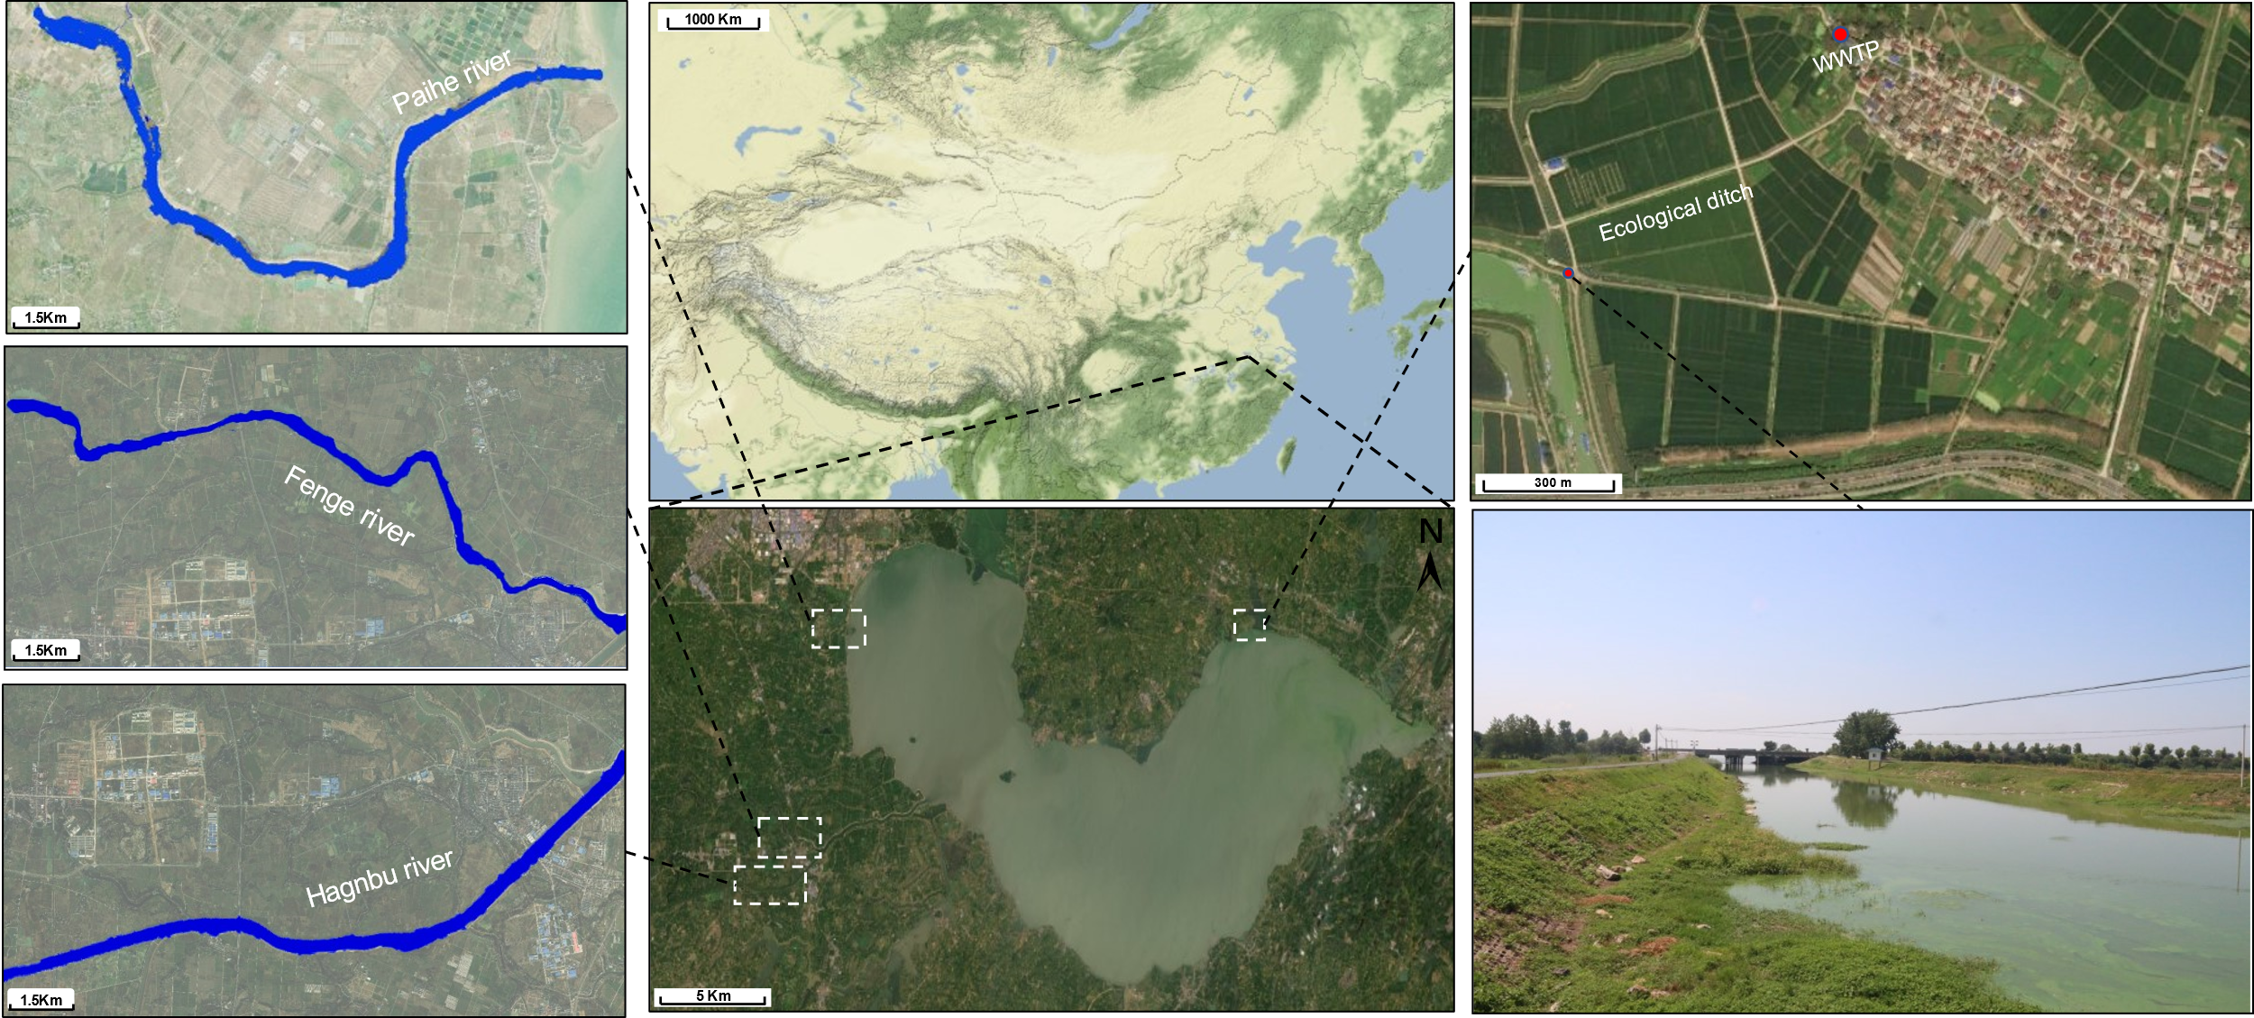
Figure S1. Sampling Map. The data were supported by OpenStreetMap.

Figure S2. Rarefaction curves of 36 sequenced samples.

Figure S3. The Violin Plot shows the difference in a. chao1 b. observed otus, c. shannon, d. simpson and index among water samples (*: p < 0.05, **: p <0.01 and ***: p < 0.001).

Figure S4. LefSe analysis revealed the phylogenetic distribution of bacteria related to sewage (D, E and A) and river water (XR, HR and FR). The phylum, class, order, family and genus levels are listed, differences are represented in the color of the most abundant class (red indicating river water, green indicating wastewater and yellow non-significant). Each circle’s diameter is proportional to the taxon’s abundance.

Figure S5. Correlation network between mobile ARG and indicator bacteria. Connection represents a strong (Spearman’s correlation coefficients ρ > 0.8, P value < 0.01) correlation.
References
Logue JB, Stedmon CA, Kellerman AM, et al (2016) Experimental insights into the importance of aquatic bacterial community composition to the degradation of dissolved organic matter. ISME J 10:533–545. https://doi.org/10.1038/ismej.2015.131
Li D, Liu C-M, Luo R, et al (2015) MEGAHIT: an ultra-fast single-node solution for large and complex metagenomics assembly via succinct de Bruijn graph. Bioinformatics 31:1674–1676. https://doi.org/10.1093/bioinformatics/btv033
Rognes T, Flouri T, Nichols B, et al (2016) VSEARCH: a versatile open source tool for metagenomics. PeerJ 4:e2584. https://doi.org/10.7717/peerj.2584
Bolyen E, Rideout JR, Dillon MR, et al (2019) Reproducible, interactive, scalable and extensible microbiome data science using QIIME 2. Nat Biotechnol 37:852–857. https://doi.org/10.1038/s41587-019-0209-9

