Supplementary Information

Oil-Encapsulated Nanoplastics from Plastic Disposable Food Containers Induce Rapid Cell Death through Cell Membrane Disruption
Ruwen Xie¹, Gulimire Yilihan¹, Qiong Chen¹, Zhen Liu¹, Mengyi Yuan¹, Wanxin Gong¹, Yueer Li¹, Weishang Zhou¹, Peng Gao², Qing Liu^{3,4}, Xin-Hua Feng^{1,5,6}, Mu Xiao^{1,5,6}*, Chao Jiang^{1,5,7}*
¹MOE Key Laboratory of Biosystems Homeostasis & Protection, and Zhejiang Key Laboratory of Molecular Cancer Biology, Life Sciences Institute, Zhejiang University, Hangzhou 310030, China
²Department of Environmental Health, Harvard T.H. Chan School of Public Health, Harvard University, Boston, MA 02115, USA
³Department of Biological Sciences, Clemson University, Clemson, SC 29634, USA
⁴Center for Human Genetics, Clemson University, Greenwood, SC 29646, USA
⁵Center for Life Sciences, Shaoxing Institute, Zhejiang University, Shaoxing, Zhejiang 321000, China
⁶Cancer Center, Zhejiang University, Hangzhou, Zhejiang 310058, China
⁷State Key Laboratory for Diagnosis and Treatment of Infectious Diseases, First Affiliated Hospital, Zhejiang University School of Medicine, Hangzhou, Zhejiang 310009, China
*Corresponding authors: Mu Xiao (mu_xiao@zju.edu.cn) and Chao Jiang (jiang_chao@zju.edu.cn)

Table of contents
Supplementary figures 3
Supplementary tables 13
Reference 20

Supplementary figures

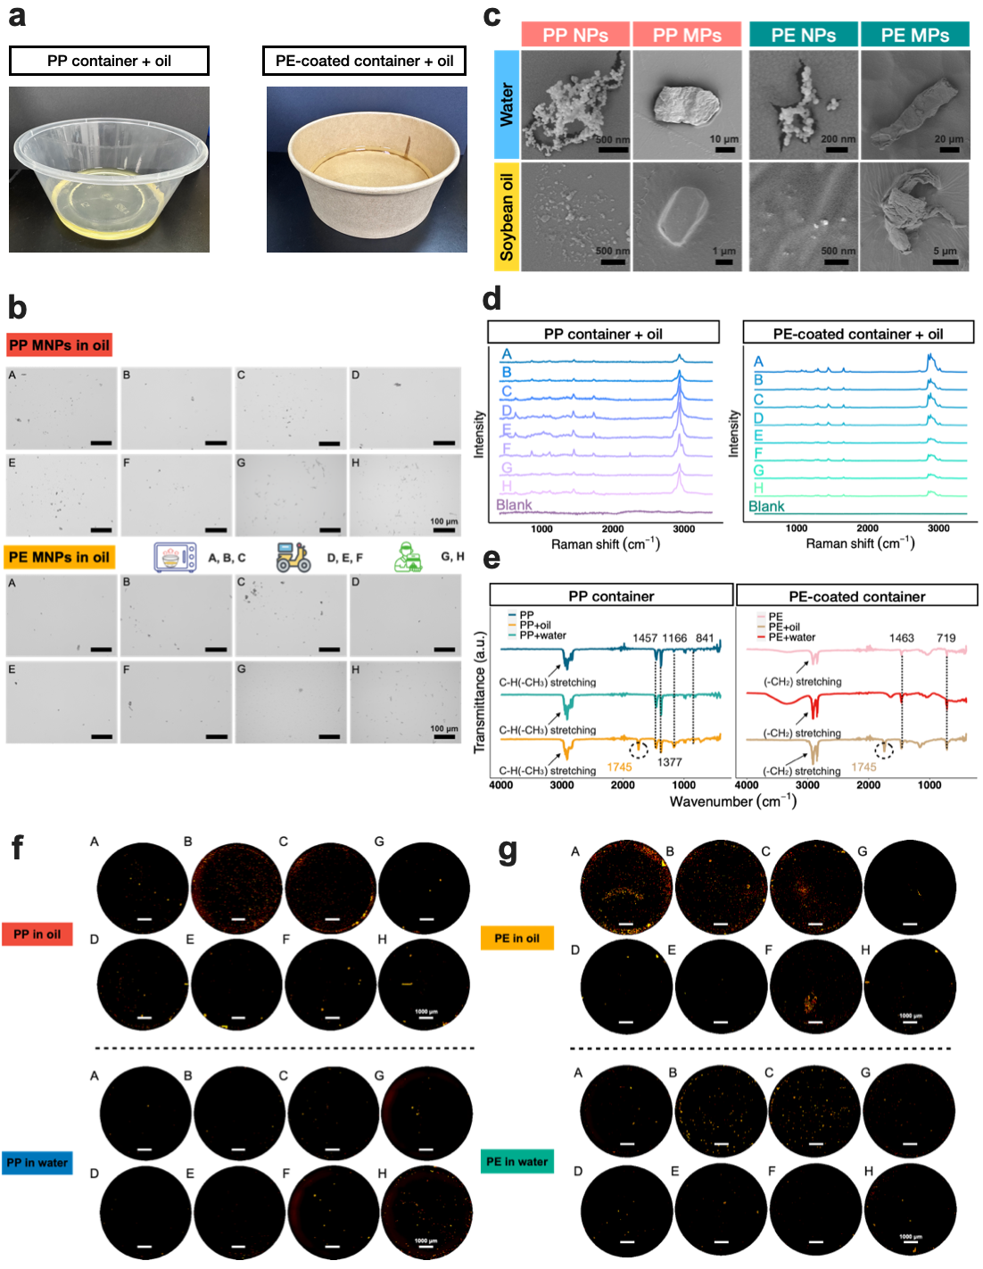
Figure S1. Characterization of microplastics (MPs) and nanoplastics (NPs) released from different containers in various media. (a) PP and PE-coated containers were filled with 100 mL of soybean oil. (b) Optical microscope images (20x magnification) of plastic particles released from PP and PE-coated containers were captured directly in soybean oil under various experimental conditions. (c) SEM images depict PP MPs, PP NPs, PE MPs, and PE NPs released from different containers treated with DI water and soybean oil. (d) Raman spectroscopy profiles show the plastics released from PP and PE-coated containers in contact with soybean oil under various treatments. (e) ATR-FTIR profiles illustrate the plastics released from PP and PE-coated containers exposed to soybean oil and DI water after microwave heating for 3 minutes. (f) Visualization of MPs released from PP containers and (g) PE-coated containers under different usage scenarios in contact with soybean oil and DI water. Representative images were generated from all experimental groups, comprising 28 merged images captured at 4x magnification using the montage function. The experiments in S1a-S1g were repeated independently three times (n=3).

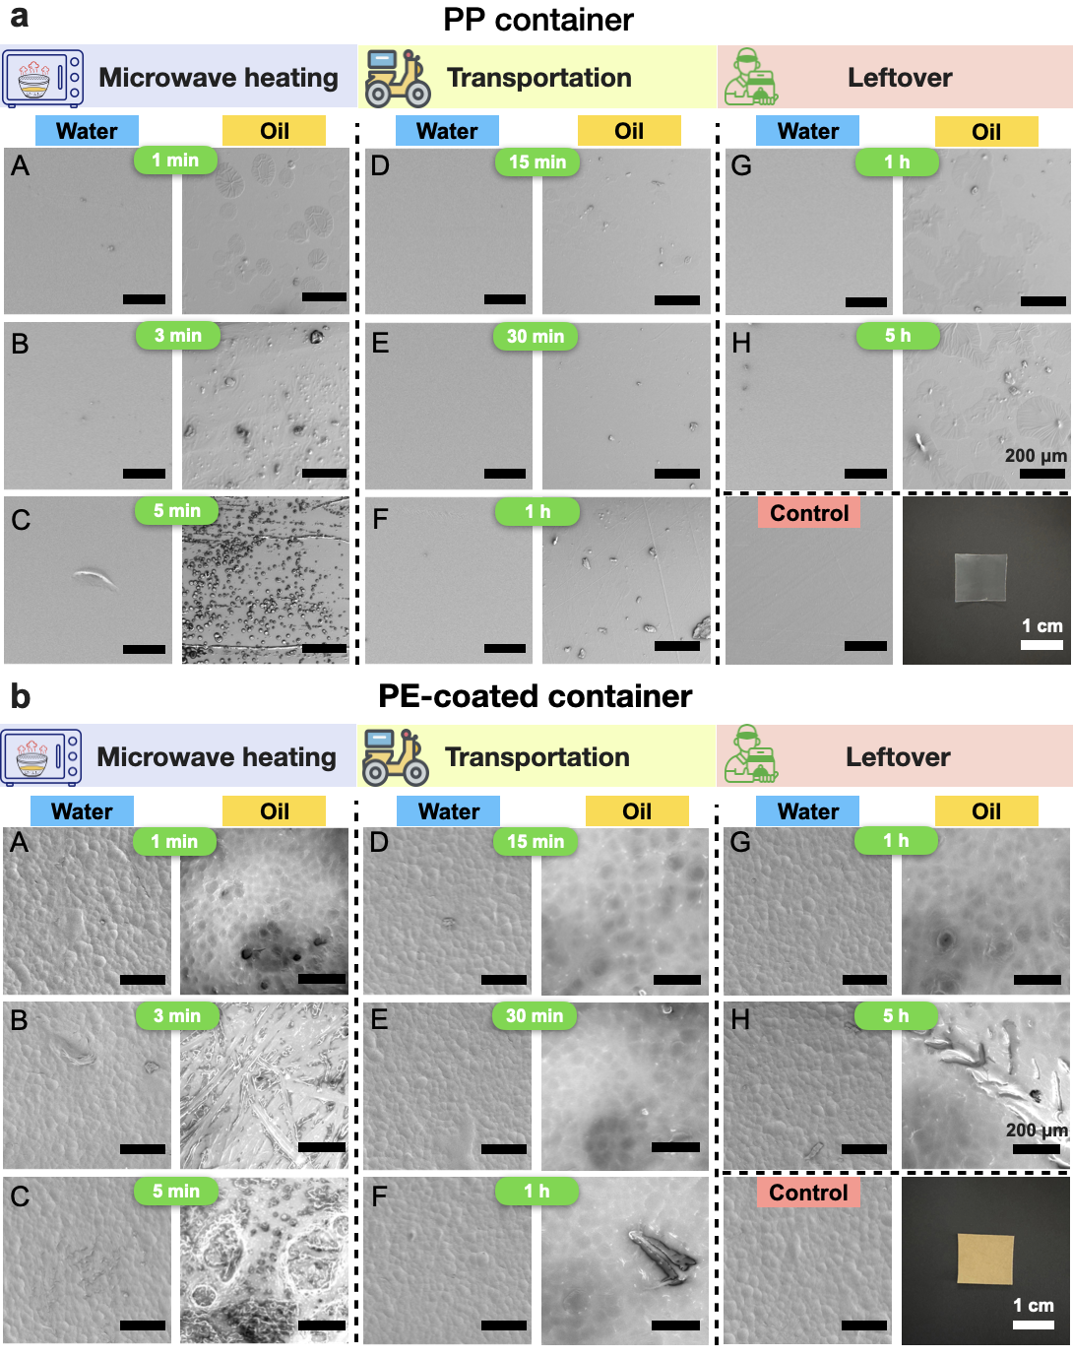
Figure S2. Representative SEM images of PP- and PE-coated plastic containers’ inner walls after different treatments (A-C: microwave heating, D-F: transportation, G-H: leftover). (a) PP-coated containers and (b) PE-coated containers’ inner walls in contact with DI water and soybean oil. Each experiment was repeated three times.

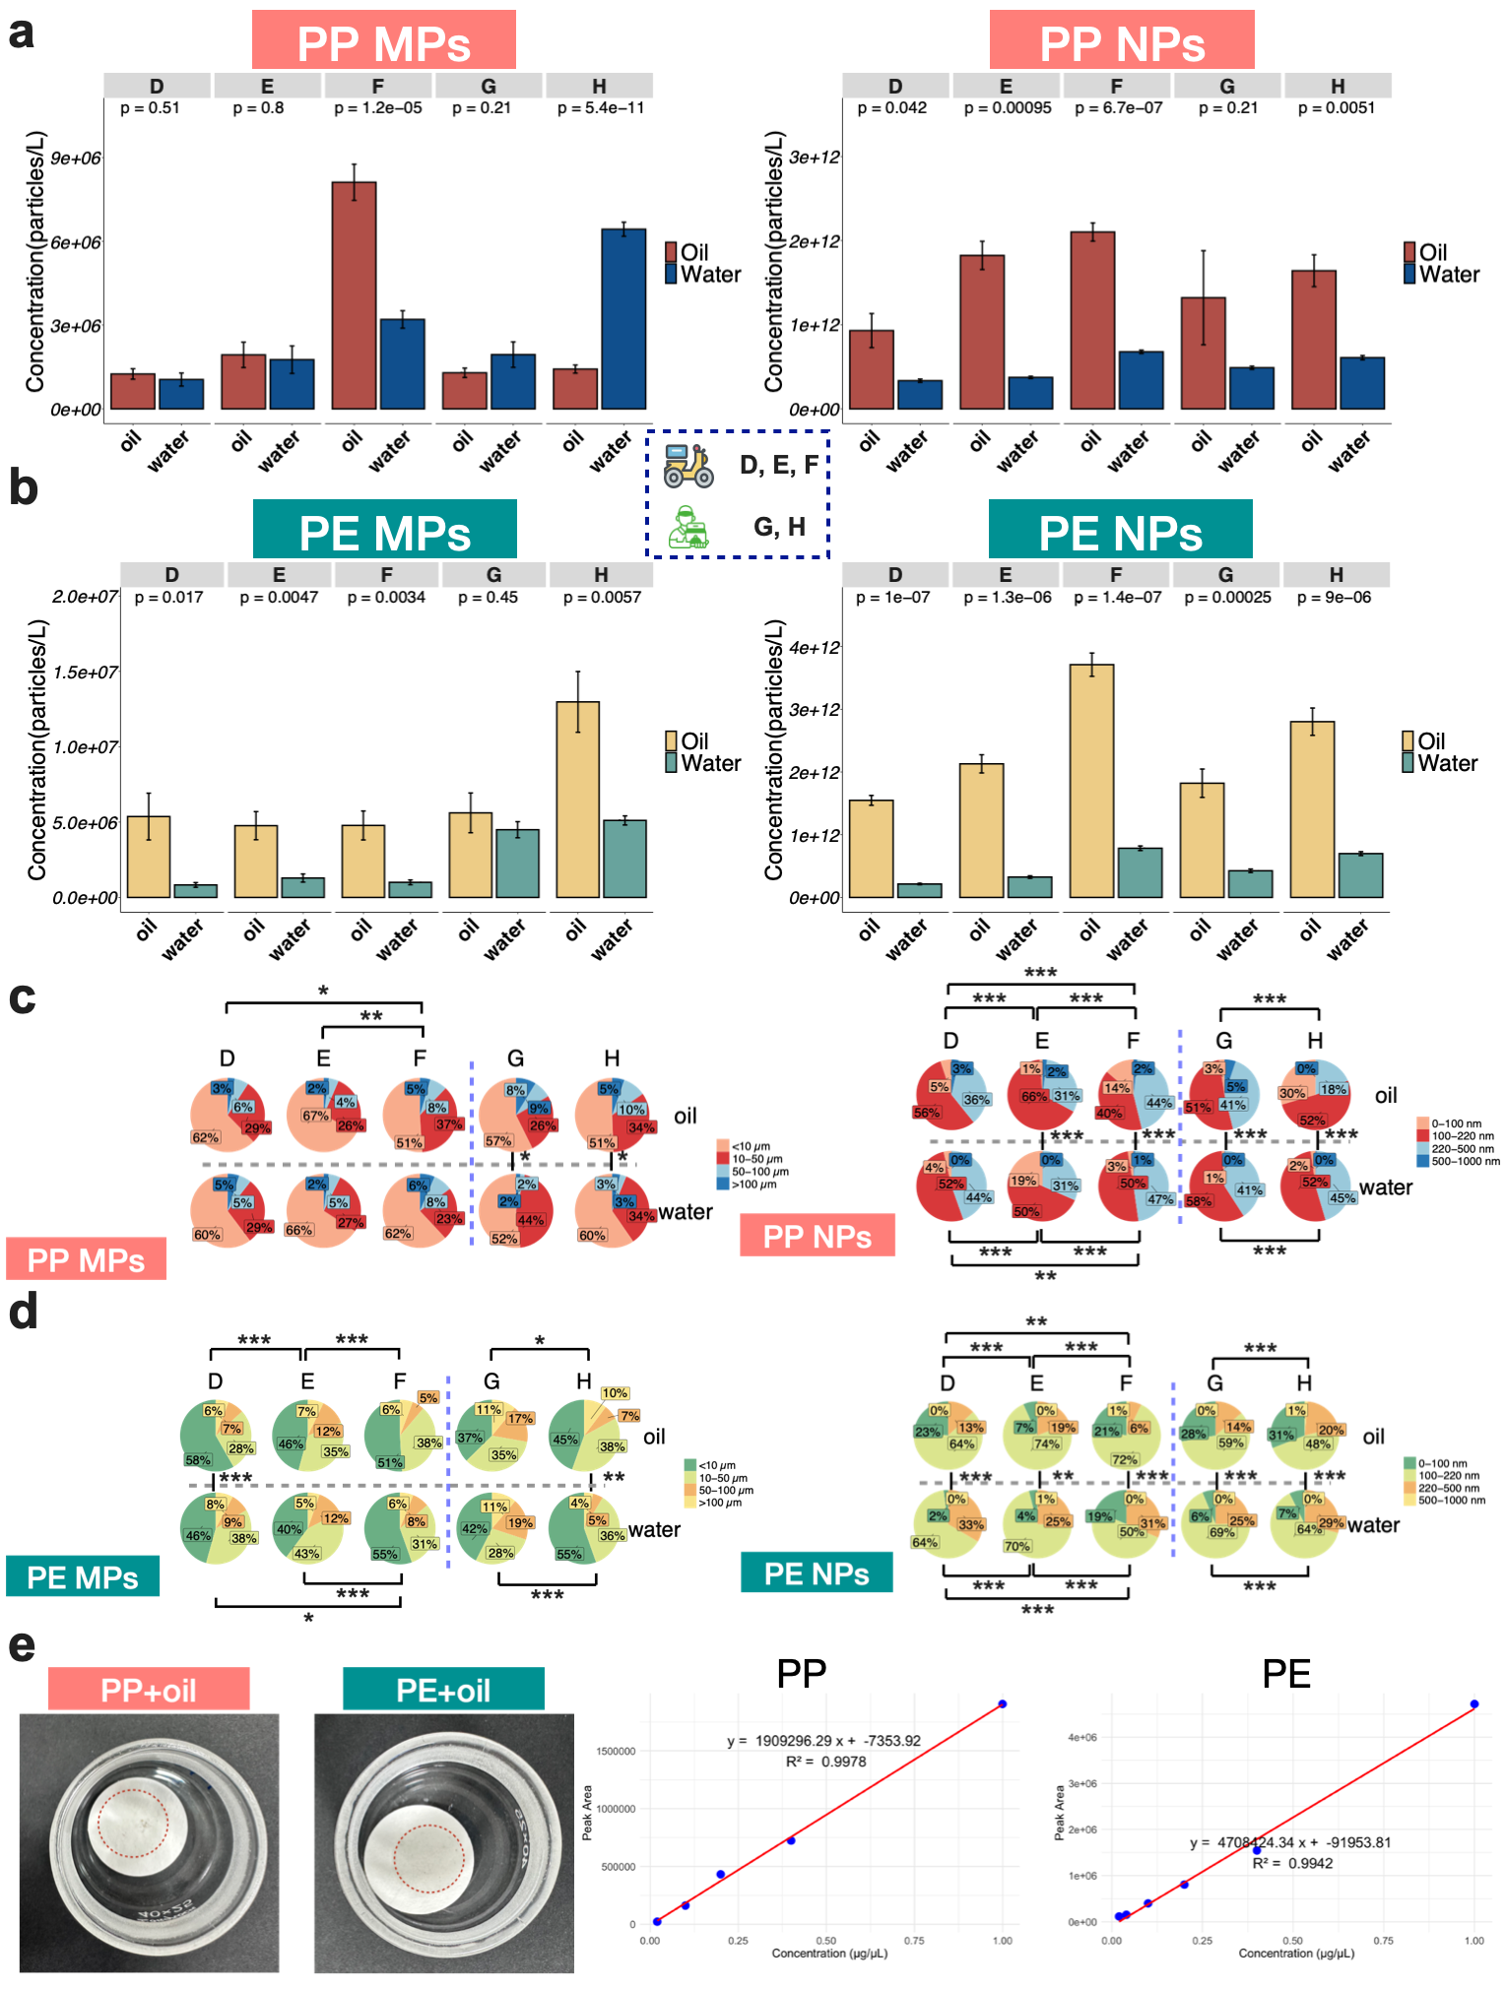
Figure S3. The abundance and size distribution of PP and PE MNPs under different treatment groups. The abundance of (a) PP MPs and PP NPs and (b) PE MPs and PE NPs released from PP and PE-coated containers under experimental conditions in Groups D-H. (c) Size distribution of PP MPs and PP NPs and (d) PE MPs and PE NPs released from PP and PE-coated containers in Groups D-H. (e) PP and PE samples prepared for Py-GC/MS analysis, along with the standard curves of PP and PE used for quantification. The p-values for statistical differences were assessed using the two sample Kolmogorov-Smirnov tests and Student's t-tests where applicable (*p < 0.05; **p < 0.01; ***p < 0.001). Data are expressed as the mean ± standard deviation. The data in S2a-S2b are presented as mean values +/- SD, n=3. The experiments in S2a-S2e were repeated independently three times (n=3).

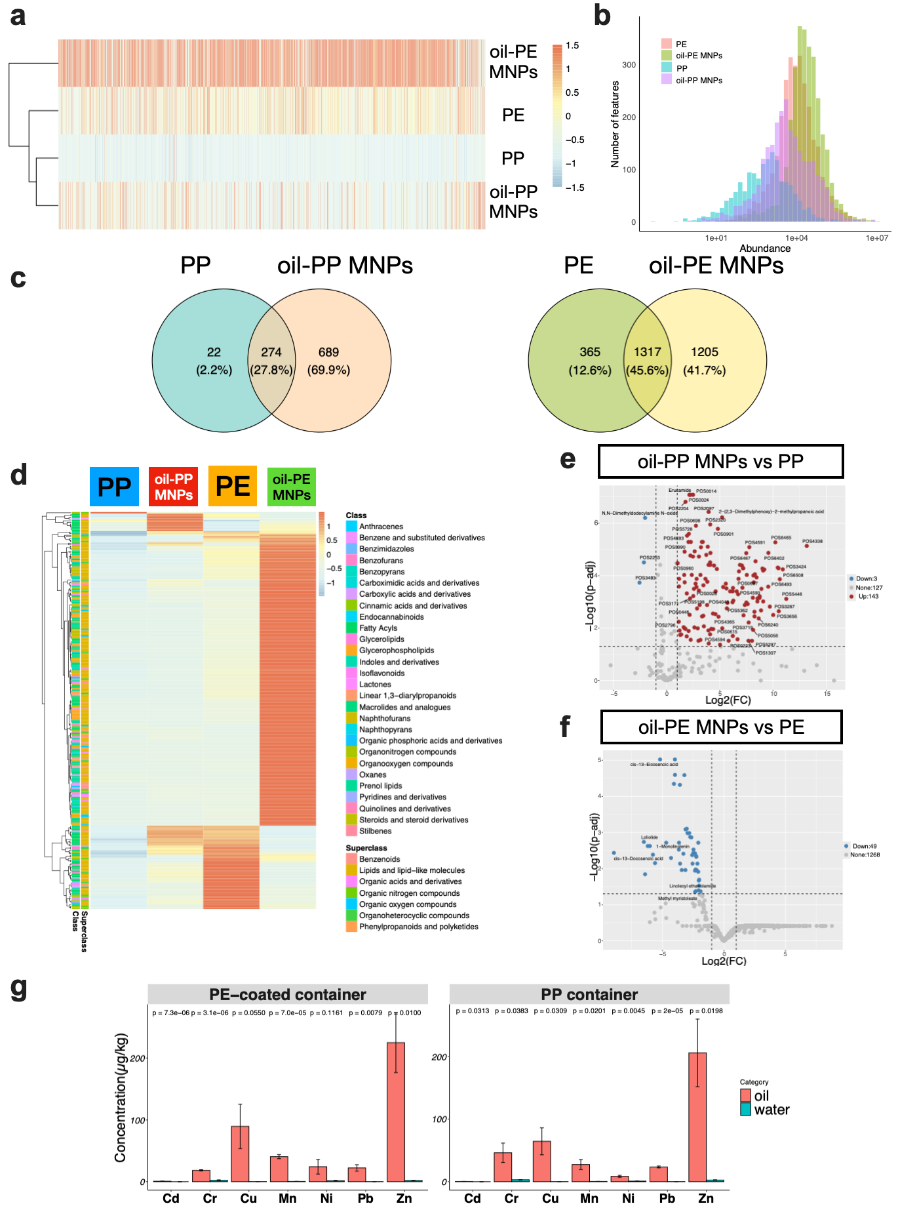
Figure S4. Chemical composition and heavy metal content of different plastic materials. (a) Clustered heatmap of all chemical features for PP, oil-PP MNPs, PE, and oil-PE MNPs samples. (b) abundance of all chemical features per sample. (c) overlap of chemical features between PP and oil-PP MNPs samples, and PE and oil-PE MNPs samples. (d) Heatmap of annotated chemicals categorized by class and superclass. (e-f) Volcano plot reveals significant increases in several annotated chemical features and unannotated chemical features between the (e) oil-PP MNPs and PP samples and (f) oil-PE MNPs and PE samples, particularly those with a |log₂(fold change [FC])| ≥ 1 and a Benjamini-Hochberg (BH)-corrected p-value < 0.05. Compounds exhibiting either an increase or decrease are labeled accordingly. (g) The concentration of heavy metals released from PP and PE-coated containers after 3 minutes of microwave heating. The p-values for statistical differences were assessed using the student’s t-tests. Data are expressed as the mean ± standard deviation (n=3).

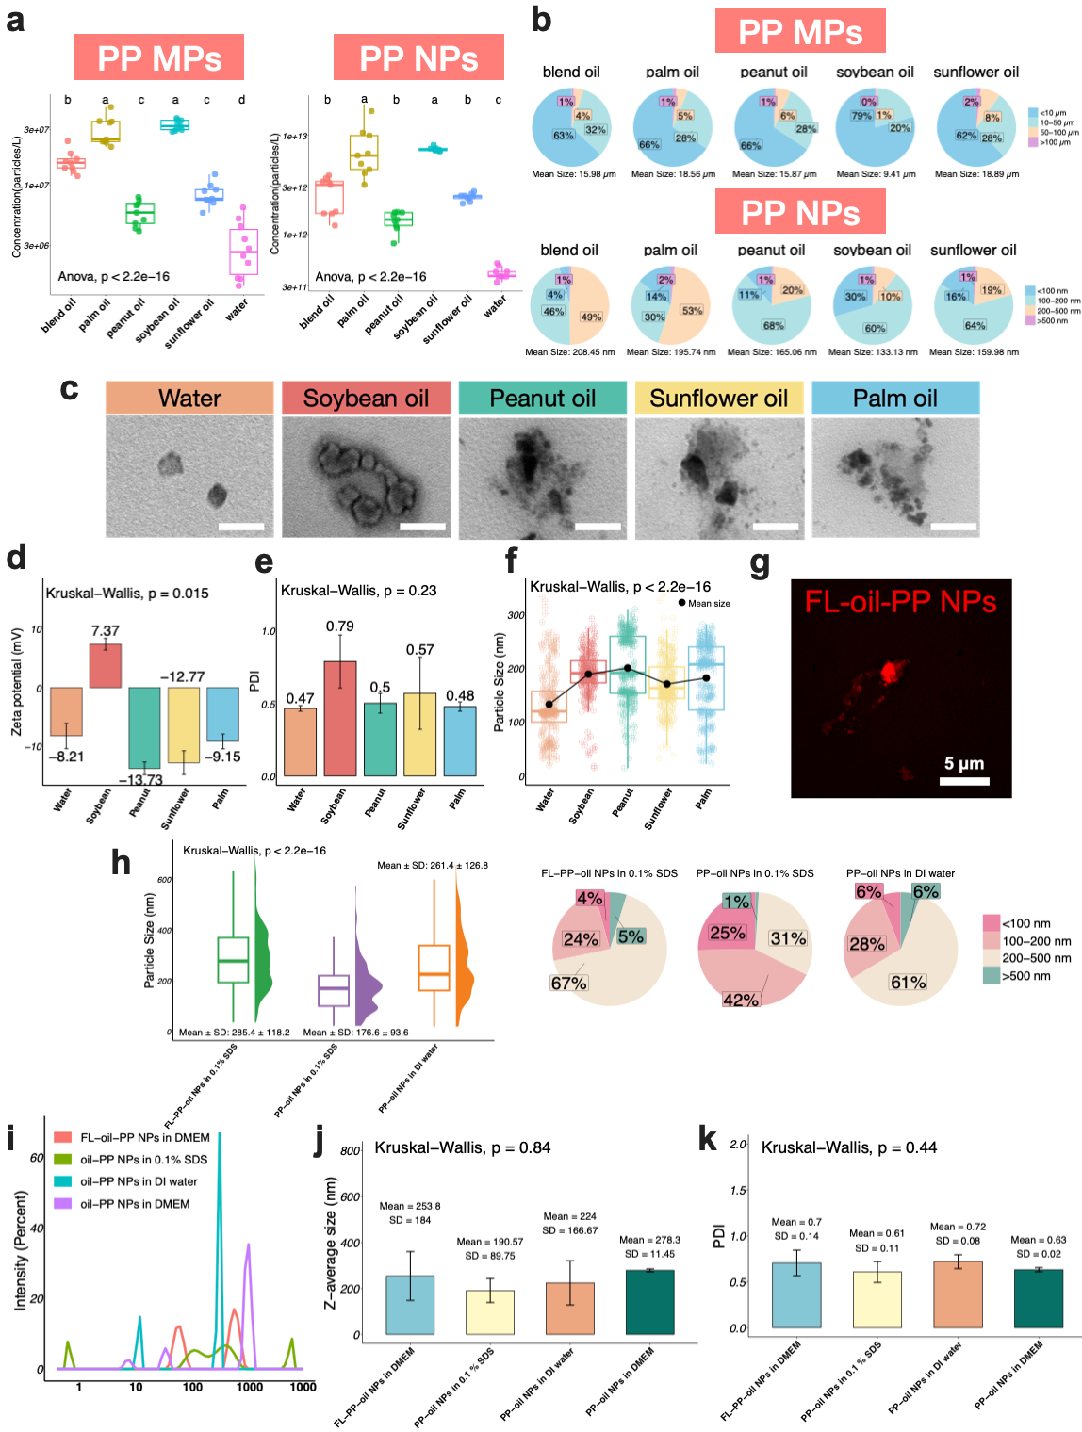
Figure S5. Comprehensive characterization of PP MPs and NPs released into various oils and aqueous media. (a) Abundance and (b) size distribution of MPs and NPs released from PP containers into different oils. (c) TEM images of various types of PP NPs (scale bar: 200 nm). (d) Zeta potential of PP NPs in different media. (e) PDI of different types of PP NPs in DMEM. (f) Size distribution of various PP NPs determined by NTA. (g) SIM image of FL-oil-PP NPs (scale bar: 5 μm). (h) Size distribution of oil-PP NPs in different solvents detected by NTA. (i) Size distribution of various oil-PP NPs measured by DLS. (j) Z-average size and (k) PDI of different types of PP NPs dispersed in various solvents. The p-values for statistical differences were assessed using the one-way ANOVA test with post-hoc Tukey tests and Kruskal-Wallis tests where applicable (*p < 0.05; **p < 0.01; ***p < 0.001). Different letters above each bar indicate p < 0.05. Data are presented as the mean ± standard error (n=3).

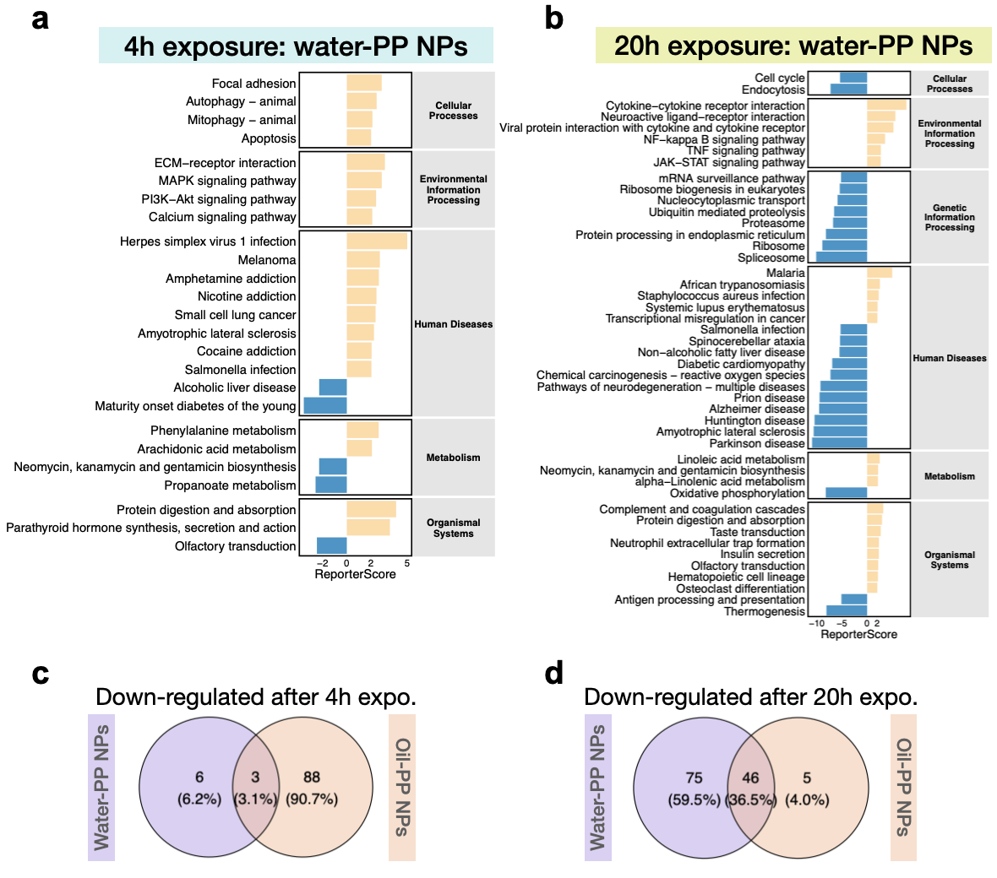
Figure S6. Dose-dependent KEGG pathway enrichment analysis after different exposure times of oil-PP NPs and water-PP NPs. (a) Bar plot displaying pathways with significant (|ReporterScore| > 2, p.adj < 0.05) increases (yellow) or decreases (blue) after 4 hours of exposure to water-PP NPs. (b) Bar plot displaying pathways with significant (|ReporterScore| > 2, p.adj < 0.05) increases (yellow) or decreases (blue) after 20 hours of exposure to water-PP NPs. Venn diagram depicting down-regulated KEGG pathways (ReporterScore < -1.64, p.adj < 0.05) after (c) 4 hours and (d) 20 hours of exposure to oil- and water-PP NPs.

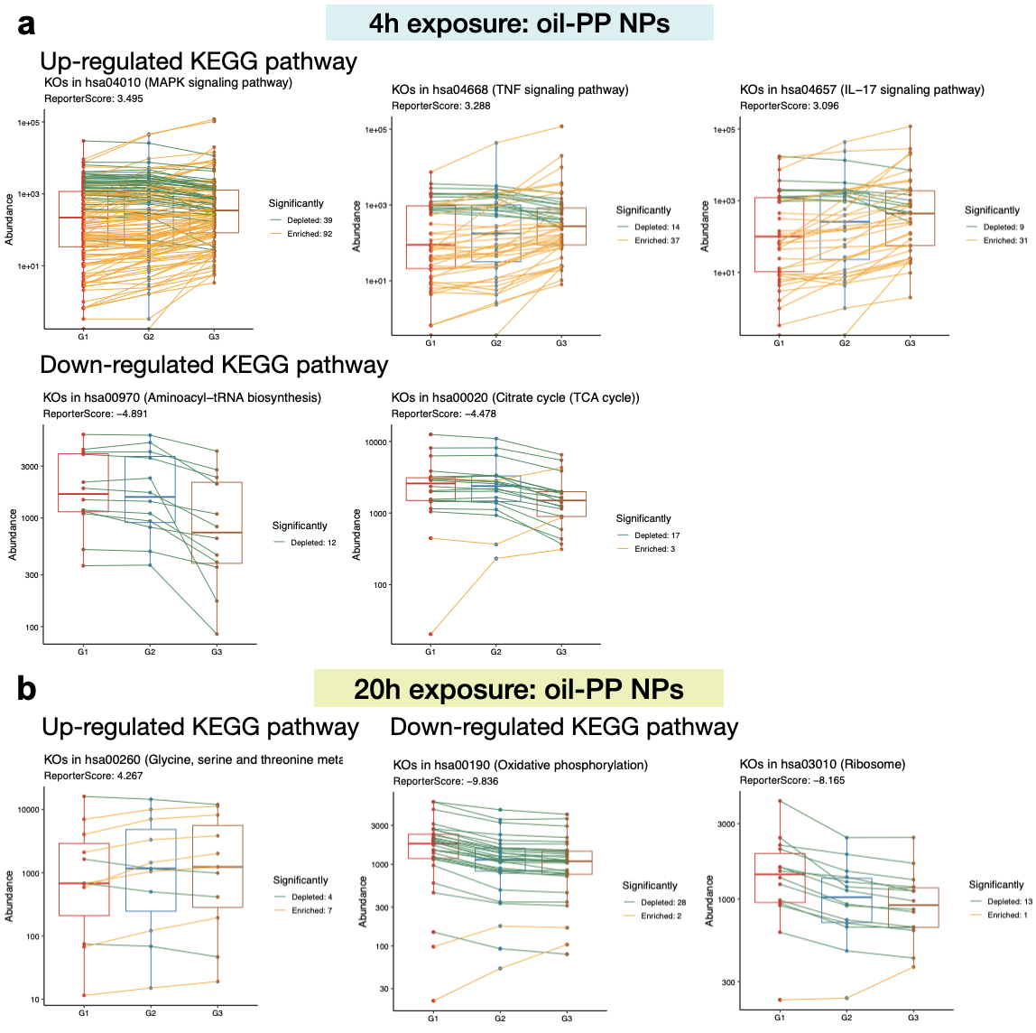
Figure S7. Significantly enriched KEGG pathways in response to oil-PP NPs exposure. (a) Box charts of featured up-regulated and down-regulated KEGG pathways related to 4 hours of exposure to oil-PP NPs. (b) Box charts of featured up-regulated and down-regulated KEGG pathways related to 20 hours of exposure to oil-PP NPs.

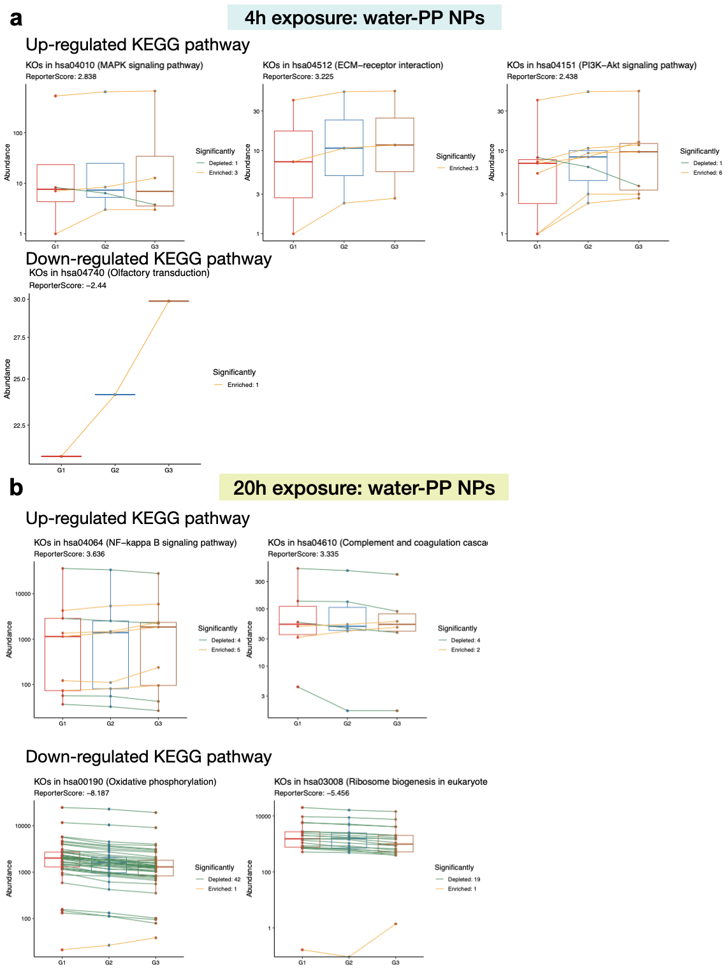
Figure S8. Significantly enriched KEGG pathways in response to water-PP NPs exposure. (a) Box charts of up-regulated and down-regulated KEGG pathways related to 4 hours of exposure to water-PP NPs. (b) Box charts of up-regulated and down-regulated KEGG pathways related to 20 hours of exposure to water-PP NPs.

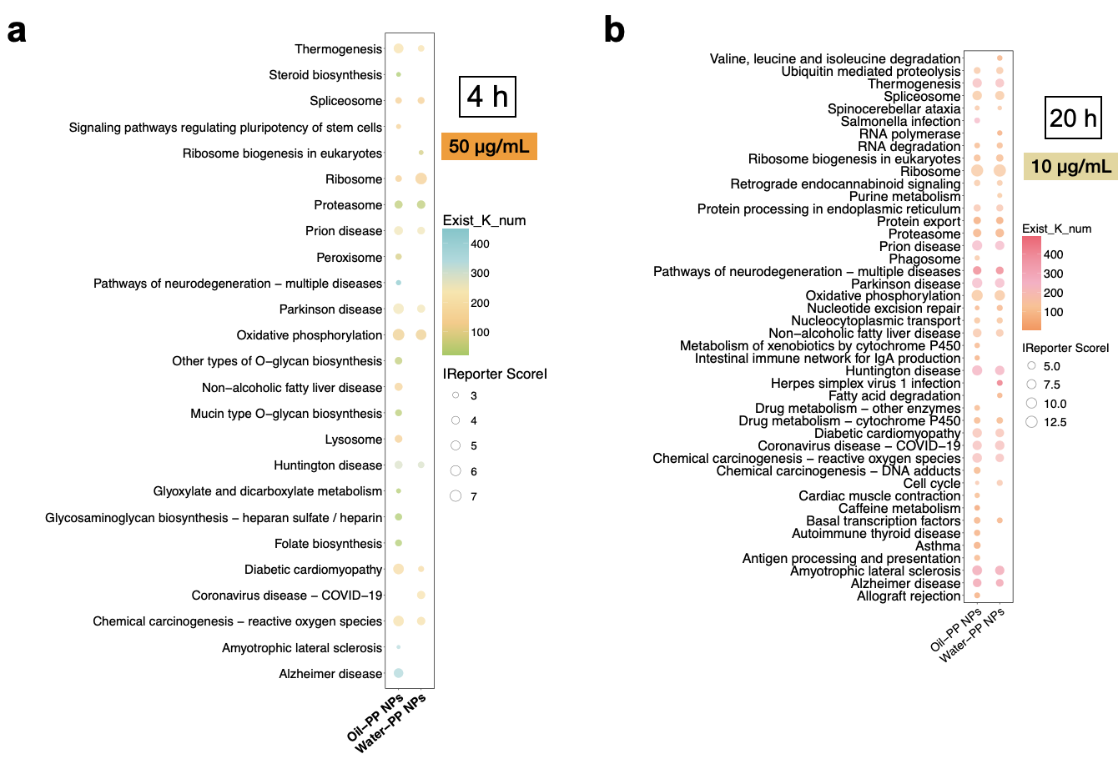
Figure S9. Down-regulated KEGG pathways in oil-PP NPs and water-PP NPs-treated groups. (a) Bubble plot showing down-regulated KEGG pathways for oil-PP NPs vs. control and water-PP NPs vs. control in the 50 μg/mL, 4-hour treatment groups (ReporterScore < -2.5, p < 0.05). (b) Bubble plot showing down-regulated KEGG pathways for oil-PP NPs vs. control and water-PP NPs vs. control in the 10 μg/mL, 20-hour treatment groups (ReporterScore < -2.5, p < 0.05).

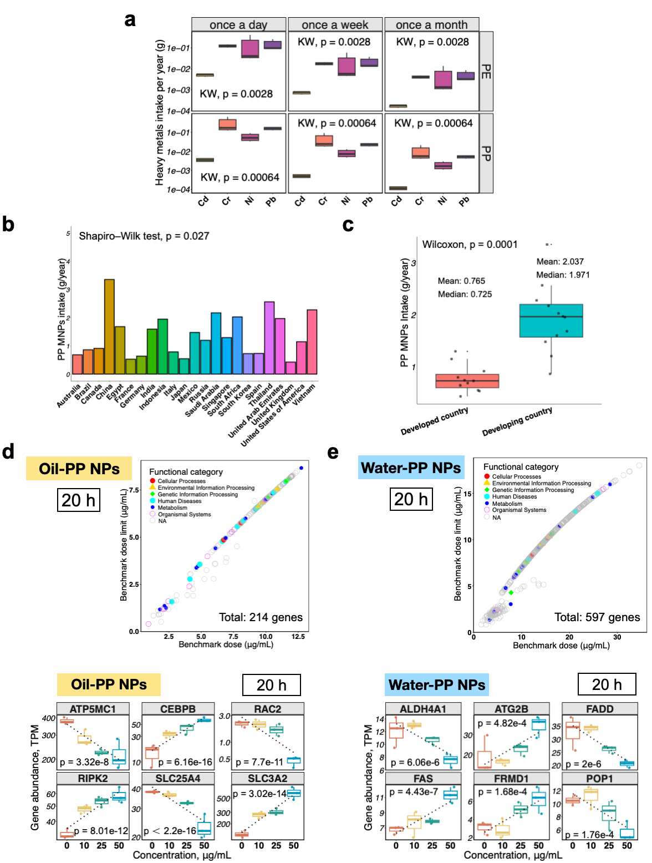
Figure S10. Comparative analysis of heavy metal and MNP Intake across regions and exposure conditions and gene-based BMDL results. (a) Annual heavy metal intake (g/person/year) from PP- and PE-coated containers based on different food ordering frequencies in kids. (c) Comparison of MNP intake between developed and developing countries. All BMD and BMDL values were calculated using transcriptomic data from (d) 20-hour exposure to oil-PP NPs and (e) 20-hour exposure to water-PP NPs, categorized by KEGG pathways, with 6 top biomarkers. The p-values for statistical differences were assessed using the Shapiro-Wilk test, Kruskal-Wallis test, Wilcoxon test, and GLM where applicable (*p < 0.05; **p < 0.01; ***p < 0.001).

Supplementary tables

Table S1. Py-GC/MS method performance and validation

Plastic | PP | PE
Linear range (mg/mL) | 0.02-1 | 0.02-1
Recovery (%) | 95.63 | 123.13
Calibration function | y=1909296.29⋅x−7353.92 | y=4708424.34⋅x−91953.81
Linearity (R²) | 0.997 | 0.994
RSD (%) | 5.43 | 10.38
LOD (S/N=3) (mg/mL) | 0.061 | 0.094
LOQ (S/N=10) (mg/mL) | 0.185 | 0.284

Table S2. Number of features and identified compounds in the samples

Polymer set | Total number of chemical features | Tentatively identified chemical features | Tentatively identified compounds
PP | 296 | 12 | 12
oil-PP MNPs | 963 | 48 | 34
PE | 1682 | 93 | 70
oil-PE MNPs | 2522 | 157 | 131
Total | 3126 | 190 | 159

Table S3. Tentatively identified chemicals among the top ten features per sample.

CAS | Name | High abundance in sample | Plastic related | Use | Toxicity
112-84-5 | Erucamide | PP, oil-PP MNPs, oil-PE MNPs | yes (A, B) | Colorant, filler, lubricant, food contact materials (B) | Irritant (C). Not classified as of potential concern (B)
3886-90-6 | N,N-Dimethylstearamide | PP | yes (A, B) | Cosmetics (C) | Corrosive, irritant, health hazard (C)
112-86-7 | cis-13-Docosenoic acid (Erucic Acid) | PP, oil-PP MNPs | yes (A, B) | Softener and conditioner, fillers, softener and conditioner, lubricating agent (C), plasticizer (B) | Irritant (C). RXR, ERa and ERb agonist, FXR, PPARg and ERR antagonist (D)
11099-07-3 | 2,3-Dihydroxypropyl octadecanoate (Glyceryl Monostearate) | PP | yes (B, C) | Cosmetics, plasticizer (C) | Not classified as of potential concern (B)
- | Anticopalic acid (Copaiferic acid B) | PP | - | - | -
56219-06-8 | Methyl myristoleate | PP | - | - | -
479413-68-8 | 12-[(Cyclohexylcarbamoyl)amino]dodecanoic acid | PP | - | - | -
667440-80-4 | 2-(2,3-Dimethylphenoxy)-2-methylpropanoic acid | PP | - | - | -
23665-96-5 | Neogrifolin | PP | - | - | -
4838-66-8 | 2-[2-(2-Quinolinyl)ethenyl]phenol | PP | - | - | -
70356-09-1 | Avobenzone | oil-PP MNPs, oil-PE MNPs | yes (B) | Light stabilizer (B). Photosensitive chemicals, fragrance (C). UV stabilizer (D) | Irritant, health hazard (C). ERR ERa antagonist, PXR and CAR agonist (D)
163520-33-0 | Isoxadifen-ethyl | oil-PP MNPs, oil-PE MNPs | - | Pesticides (C) | Irritant, environmental hazard (C). PXR agonist (D)
68605-14-1 | Methyl octadecadienoate (Methyl linoleate) | oil-PP MNPs, PE | - | Cosmetics (C) | Not classified (C)
54-28-4 | gamma-Tocopherol | oil-PP MNPs | yes (B) | Antioxidant (B). Food additives, fragrance (D) | Not classified (C). AR, ERa and PPARg agonist, GR and ERa antagonist (D)
- | Oleoyl ethylamide (N-Ethyl-9Z-octadecenamide) | oil-PP MNPs | - | - | -
3443-82-1 | 2-Linoleoylglycerol | oil-PP MNPs | - | - | -
538-23-8 | Glycerol tricaprylate | oil-PP MNPs, oil-PE MNPs | yes (B) | Colorant, lubricant (B). Cosmetics (C) | Not classified (C)
1643-20-5 | N,N-Dimethyldodecylamine N-oxide (Lauramine oxide) | oil-PP MNPs | yes (A, B) | Foamant, emulsifier, surface active agents (C) | Corrosive, irritant, environmental hazard (C)
471-77-2 | Neoabietic acid | PE | - | - | Irritant (C)
3443-82-1 | 2-Linoleoylglycerol | PE | - | - | -
17364-16-8 | 1-Palmitoyl-sn-glycero-3-phosphocholine | PE | - | Food additives and ingredients (C) | -
24570-01-2 | 11beta-Prostaglandin E1 | PE | - | - | -
25496-72-4 | Monoolein (Glyceryl monooleate) | PE | yes (B) | Lubricant additives, emulsifier, lubricating agents, surface active agents (C) | Not classified (C), HSE and PPARd agonist (D)
506-21-8 | Linoelaidic acid | PE | yes (A) | Lubricant (A).Cosmetics (C) | Not classified (C)
1157-39-7 | 4',7-Dimethoxyisoflavone | PE | - | - | -
- | 13-Hydroxy-7-oxoabiet-8(14)-en-18-oic acid | PE | - | - | -
68171-52-8 | Linoleoyl ethanolamide | PE | tentative | Surfactant (C). Softener and conditioner (D) | -
3443-82-1 | 2-Linoleoylglycerol | oil-PE MNPs | - | - | -
471-77-2 | Neoabietic acid | oil-PE MNPs | - | - | Irritant (C)
17364-16-8 | 1-Palmitoyl-sn-glycero-3-phosphocholine | oil-PE MNPs | - | Food additives and ingredients (C) | -
60514-48-9 | 1,2-Dioctanoyl-sn-glycerol | oil-PE MNPs | - | - | -
117-81-7 | DEHP | oil-PE MNPs | yes (B, C) | Binder, plasticizer (C) | Health hazard (C)
22252-07-9 | 1-Linoleoyl-sn-glycero-3-phosphorylcholine | oil-PE MNPs | - | Food additives and ingredients (C) | -

The usage and toxicity data were retrieved from multiple sources, including Sapozhnikova et al. (2021) ¹, which focused on plastic chemicals migrating from food contact materials used in oven and microwave applications (A); Wiesinger et al. (2021)², which detailed intentionally added plastic chemicals (B); as well as PubChem (C) and ToxCast (D).

Table S4. Oil film volume in 200 μL suspension of oil-PP NPs at different concentrations.

Concentration (μg/mL) | 2 | 5 | 10 | 20 | 30 | 50 | 70 | 100 | 200 | 500 | 1000 | 2000
Oil film volume (μL) | 0.005 | 0.013 | 0.027 | 0.054 | 0.081 | 0.135 | 0.190 | 0.271 | 0.542 | 1.353 | 2.708 | 5.415

Table S5. Adults’ and kids’ daily fat intake mass.

Type | Body weight (kg) | Daily calorie intake¹ (kcal) | Daily fat intake² (kcal) | Daily fat intake³ (g) | Fat intake per meal⁴ (g)
Adult (18-59 years old) | 70 | 2500 | 750 | 84.8 | 33.9
Kid (0-3 years old) | 12 | 1200 | 360 | 40.7 | 16.3

(1) Adult (18-59 years old) and kid (0-3 years old) daily calorie intake recommendations were provided by the Food and Agriculture Organization of the United Nations (FAO). (2) The World Health Organization (WHO) recommends reducing total fats to less than 30% of total energy intake. (3) Soybean oil provides 884 kilocalories per 100 grams; daily fat intake was calculated as soybean oil. (4) To calculate the daily fat intake in grams from soybean oil, lunch consumption was considered, accounting for 40% of the total daily food intake, based on the dietary distribution of 30% for breakfast, 40% for lunch, and 30% for dinner.

Table S6. Summary of the annual intake of oil-PP MNPs from microwaving take-out food across different regions.

Country | Average take-out food ordering frequency (per week) | Mass of intake oil-PP MNPs (g/year)
China | 4.459ª | 3.354
South Korea | 0.963ª | 0.725
Thailand | 3.407ª | 2.563
Singapore | 1.720ª | 1.294
Australia | 0.909ª | 0.684
USA | 1.527^{b} | 1.149
UK | 0.568^{b} | 0.427
Egypt | 2.238^{b} | 1.683
Mexico | 1.965^{b} | 1.478
Italy | 1.048^{b} | 0.788
Canada | 1.214^{b} | 0.913
Saudi Arabia | 2.887^{b} | 2.172
South Africa | 2.695^{b} | 2.028
Germany | 0.848^{b} | 0.638
Spain | 0.976^{b} | 0.734
Indonesia | 2.591^{b} | 1.949
UAE | 2.620^{b} | 1.971
Russia | 1.593^{c} | 1.198
Brazil | 1.145^{d} | 0.861
Vietnam | 3.006^{b} | 2.278
India | 2.105^{b} | 1.595
France | 0.696^{b} | 0.528
Japan | 0.719^{b} | 0.545

The average frequency of take-out food ordering in different regions was calculated based on the data collected from (a) Statista, (b) YouGov, (c) Yandex, and (d) Opinion box.

Table S7. Presence of MNPs in human tissues or fluids.

Human biological sample | Physical condition | Main type | Abundance  (range or average) | Reference
Blood | Healthy | PET, PS, and PE | 1.6 μg/mL | ³
Testis | Patients | PE, ABS, N66, PS, PE, and PVC | 15.34 ± 23.31 μg/mL, 328.4 μg/g | ^{4,5}
Bone marrow | Patients | PE, PS, PVC, PA66, and PP | 51.3 μg/g | ⁶
Cumulus granulosa cell | Female patients of infertile couples | PET | 313.1 ± 246.7 µg/g | ⁷
Follicular fluid | Female patients of infertile couples | / | 12.9 ± 15.5 μg/g | ⁷
Placenta | Healthy | PE, PVC, and PA | 126.8 ± 147.5 µg/g | ⁸
Balf | Patients | PP, and PE | 7.1μg/g (PE); PP: 1.1 μg/g (PP) | ⁹
Gallstone | Patients | PP, PE, and PET | 10.69 ±10.56 μg/g | ¹⁰
Feces (adult) | Healthy | PET, PC, PE, and PP | 2.2–16.0 μg/g (PET); 0.037–0.62 μg/g (PC), 3.33−14.0 μg/g, 6.94−16.6 µg/g | ^{11–13}
Feces (infant) | Healthy | PET, and PC | 5.70–82.0 μg/g (PET); 0.049–2.10 μg/g (PC) | ^{11–13}
Carotid artery plaque | Patients | PE (58.4%), PVC (12.1%) | 21.7 ± 24.5 (PE); 5.2 ± 2.4 μg/mg (PVC) | ¹⁴
Atherosclerotic plaque | Patients | PET, PA, PVC, and PE | 118.66 ± 53.87ug/g | ¹⁵
Thrombi | Patients | PE, PA66, and PVC | 14.9–221.8 μg/g | ¹⁶
Cervix | Patients | PE, PP, and PE-co-PP | 1.67 ± 0.94 (Cancer tissue); | ¹⁷
Cervix | Patients | PE, PP, and PE-co-PP | 0.87 ± 0.72 µg/g (Paracancerous tissue) | ¹⁷
Liver | Healthy | PE, PP, PMMA and PC | 141.9 µg/g (2016); 465.3 µg/g (2024) | ¹⁸
Kidney | Healthy | PE, PP and SBR | 538.1 µg/g (2016); 666.3 µg/g (2024) | ¹⁸
Brain | Healthy | PE, PP and PVC | 3420 µg/g (2016); 4763 µg/g (2024) | ¹⁸

PE: polyethylene; PET: polyethylene terephthalate; PVC: polyvinyl chloride; PP: polypropylene; PS: polystyrene; PA: polyamide; PC: polycarbonate; PMMA: polymethyl methacrylate; ABS: Acrylonitrile Butadiene Styrene; N66: Nylon 66; SBR: styrene-butadiene rubber.

Reference
1. Sapozhnikova, Y., Nuñez, A. & Johnston, J. Screening of chemicals migrating from plastic food contact materials for oven and microwave applications by liquid and gas chromatography - Orbitrap mass spectrometry. Journal of Chromatography A 1651, 462261 (2021).
2. Wiesinger, H., Wang, Z. & Hellweg, S. Deep Dive into Plastic Monomers, Additives, and Processing Aids. Environ. Sci. Technol. 55, 9339–9351 (2021).
3. Leslie, H. A. et al. Discovery and quantification of plastic particle pollution in human blood. Environment International 163, 107199 (2022).
4. Zhao, Q. et al. Detection and characterization of microplastics in the human testis and semen. Science of The Total Environment 877, 162713 (2023).
5. Hu, C. J. et al. Microplastic presence in dog and human testis and its potential association with sperm count and weights of testis and epididymis. Toxicological Sciences 200, 235–240 (2024).
6. Guo, X. et al. Discovery and analysis of microplastics in human bone marrow. Journal of Hazardous Materials 477, 135266 (2024).
7. Weina, L. et al. P-762 Discovery and quantification of microplastics in human cumulus granulosa cells. Human Reproduction 39, deae108.1081 (2024).
8. Garcia, M. A. et al. Quantitation and identification of microplastics accumulation in human placental specimens using pyrolysis gas chromatography mass spectrometry. Toxicological Sciences 199, 81–88 (2024).
9. Zhong, C. et al. Nanoplastics in the Human Respiratory System. Am J Respir Crit Care Med 210, 1059–1061 (2024).
10. Zhang, D. et al. Microplastics are detected in human gallstones and have the ability to form large cholesterol-microplastic heteroaggregates. Journal of Hazardous Materials 467, 133631 (2024).
11. Luqman, A. et al. Microplastic Contamination in Human Stools, Foods, and Drinking Water Associated with Indonesian Coastal Population. Environments 8, 138 (2021).
12. Wibowo, A. T. et al. Microplastic Contamination in the Human Gastrointestinal Tract and Daily Consumables Associated with an Indonesian Farming Community. Sustainability 13, 12840 (2021).
13. Zhang, J., Wang, L., Trasande, L. & Kannan, K. Occurrence of Polyethylene Terephthalate and Polycarbonate Microplastics in Infant and Adult Feces. Environ. Sci. Technol. Lett. 8, 989–994 (2021).
14. Marfella, R. et al. Microplastics and Nanoplastics in Atheromas and Cardiovascular Events. N Engl J Med 390, 900–910 (2024).
15. Liu, S. et al. Microplastics in three types of human arteries detected by pyrolysis-gas chromatography/mass spectrometry (Py-GC/MS). Journal of Hazardous Materials 469, 133855 (2024).
16. Wang, T. et al. Multimodal detection and analysis of microplastics in human thrombi from multiple anatomically distinct sites. eBioMedicine 103, 105118 (2024).
17. Xu, H. et al. Detection and analysis of microplastics in tissues and blood of human cervical cancer patients. Environmental Research 259, 119498 (2024).
18. Nihart, A. J. et al. Bioaccumulation of microplastics in decedent human brains. Nat Med 1–6 (2025) doi:10.1038/s41591-024-03453-1.

