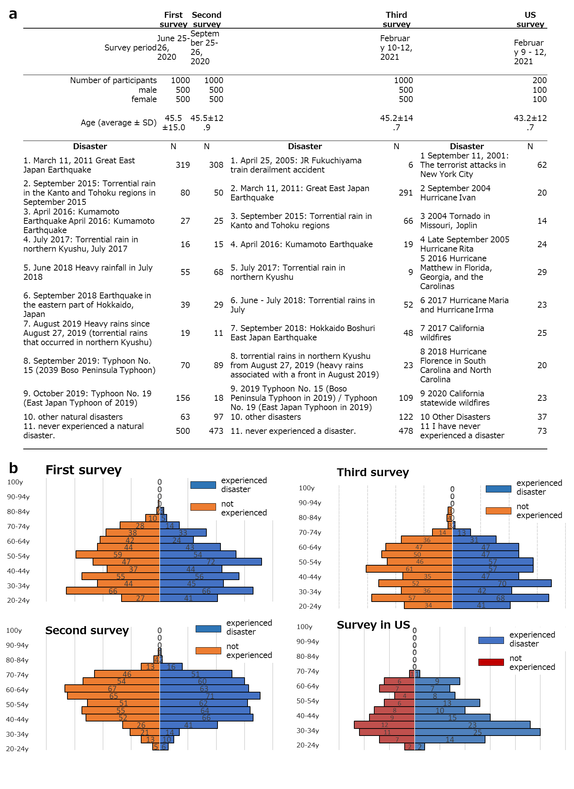
Supplementary Figure 1: Profile of study participants.
Supplemental Figure 1a: Number of participants in the first, second, and third surveys in Japan and the previously experienced disasters questioned in each session. Figure 1b: Number of survey participants and past disasters in the United States.

Supplemental Figure 1b: Experienced and non-experienced disaster participants in the first, second, and third rounds of the Japan and U.S. surveys, shown by age group.

Translated with www.DeepL.com/Translator (free version)
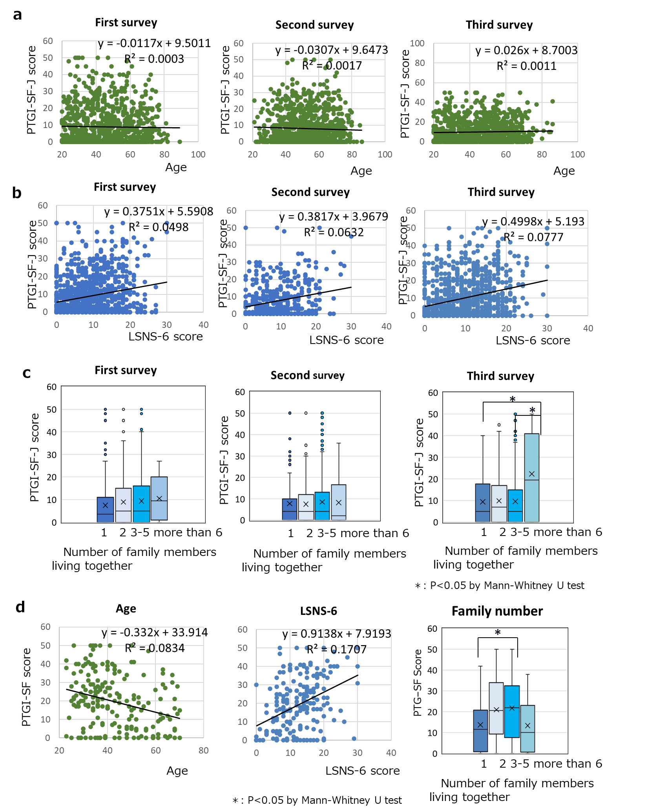

Supplemental Figure 2: Factors associated with resilience.
Supplemental Figure 2a: Relationship between the age of survey participants and resilience scores in the first, second, and third surveys in Japan.
Supplemental Figure 2b: Relationship between the Human Connectedness Scale (LSNS-6 score) and resilience scores in the first, second, and third surveys in Japan.
Supplementary Figure 2c: Relationship between the number of family members living together and resilience scores in the first, second, and third surveys in Japan.
Supplemental Figure 2d: Relationship between age, human connection scale, and number of family members living together and resilience score in the US survey.

Supplemental Figure 1b: Experienced and non-experienced disaster participants in the first, second, and third rounds of the Japan and U.S. surveys, shown by age group.

Translated with www.DeepL.com/Translator (free version)

