Appendix 1

Table 4 Summary of relevant cases
Cases in Japan | TIME | CASE | Content Relevance | Cases in the world | TIME | CASE | Content Relevance
Cases in Japan | 2014-2015 | Osaka Castle  3D Mapping Super Illuminations | Related | Cases in the world | 2015.9-10 | Bolshoi Theatre  1.Swan Lake  2.Parallel Universes | 1. Related
Cases in Japan | 2015 | Kanazawa Castle PJM 2015 | Unrelated | Cases in the world | 2015.10 | Berlin Light Festival  Brandenburg Gate | Unrelated
Cases in Japan | 2015-2016 | Himeji Castle  1.HAKUA  2. KIRAMEKI | Related | Cases in the world | 2015-2018 | Karlsruhe Palace  1.300Fragments 2. BADISCHES LANDESMUSEUM KARLSRUHE  3.Legacy 4. Structure of Life  5.I’M MORTAL | 2. Related
Cases in Japan | 2015.8.30 | Wakayama Castle PJM  Opening ceremony | Unrelated | Cases in the world | 2015.10 | UNESCO Word Tourism  Expo Padova | Related
Cases in Japan | 2015-2019 | Nakagusuku Castle Ruins PJM | Related | Cases in the world | 2016 | THE HISTORY OF JERUSALEM  TERRA SANCTA MUSEUM | Related
Cases in Japan | 2016-2019 | Shimogamo Shrine  Digitized Nature | Unrelated | Cases in the world | 2017. | Songcheng Theme Park, Hangzhou, China  MYSTIC TREE SHOW | Unrelated
Cases in Japan | 2017-2020 | Fukuoka Castle Ruins Digitized City | Less related | Cases in the world | 2017.6-8 | Montreal Basilica  AURA AT THE NOTRE DAME BASILICA | Less related
Cases in Japan | 2018.2 | Tokushima Central Park  Kawa and Mori Light Art Festival | Less related | Cases in the world | 2017 | The 13th Berlin Light Festival  Berliner Dom | Unrelated
Cases in Japan | 2018.6 | Osaka Castle Park  SAKUYA LUMINA | Unrelated | Cases in the world | 2017.7 | Buda Castle  FINA Budapest 2017 World  Championship | Unrelated
Cases in Japan | 2018.9 | Hirado Castle  Fantasy Festival of Light and Sound | Related | Cases in the world | 2018.5 | Aachen Cathedral Germany  40th anniversary of being awarded UNESCO World Heritage Site | Related
Cases in Japan | 2018-2020 | Nijo Castle  1.FLOWERS BY NAKED  2. Cherry Blossom Festival 2020  3.Throughout Time: The Sense of Beauty  4.NAKED SAMURAI | Less related | Cases in the world | 2018.11 | Wuhan Yangtze River Bridge, Labor Day Light Show in Wuhan | Unrelated
Cases in Japan | 2018-2020 | Kochi Castle  Digitized City | Less related | Cases in the world | 2018.11 | Fairview terraces  A night of lights | Unrelated
Cases in Japan | 2018.12 | Nagoya Castle  NIGHT CASTLE OWARI EDOFANTASIA | Related | Cases in the world | 2019.1 | Lantern Festival Light Show Forbidden City of China | Unrelated
Cases in Japan | 2018-2019 | Mifuneyama Land | Unrelated | Cases in the world | 2019.1 | Lantern Festival Light Show Desheng gate of China | Less related
Cases in Japan | 2018-2019 | Tsurumi Castle PJM HARUKA2018-2019 | Less related | Cases in the world | 2019-2020 | REIMS CATHEDRAL  RELIVING THE CROWNING  OF THE FRENCH KINGS | Unrelated
Cases in Japan | 2018.3 | Shirakawa Komine Castle  Sakura Project HARUKA 2018 | Less related | Cases in the world | 2019 | Atturaif Living Museum | Related
Cases in Japan | 2019.3 | Taishakuten PJM | Unrelated | Cases in the world | 2019 | Dresden fortress  Festung Xperience | Related
Cases in Japan | 2019.7 | Hokkaido Akan Mashu National Park  KAMUY LUMINA | Unrelated | Cases in the world | 2020 | Diriyah Gate CT’s 350-metre-wide projection at Saudi ceremony | Related
Cases in Japan | 2019.8 | Okayama Castle  Tenshukaku projection mapping | Related | Cases in the world
Cases in Japan | 2019.9 | PJM world Congress in Odawara Castle | Unrelated | Cases in the world
Cases in Japan | 2019.10 | Kushida Shrine Tsukino Feast | Unrelated | Cases in the world
Cases in Japan | 2019.12 | Kakegawa Castle | Unrelated | Cases in the world
Cases in Japan | 2019.12 | Koriyama Castle Tenshudai PJM | Related | Cases in the world
Cases in Japan | 2020.2 | Japan Culture EXPO in Kashima  Kashima Shrine gate | Less related | Cases in the world
Cases in Japan | 2020.9 | Hirosaki Castle PJM | Unrelated | Cases in the world
Cases in Japan | 2020.10 | Shuri Castle PJM | Related | Cases in the world
Cases in Japan | 2021.2 | Kairakuen Digitized City | Unrelated | Cases in the world

Appendix 2

Data for building surface PJM examples
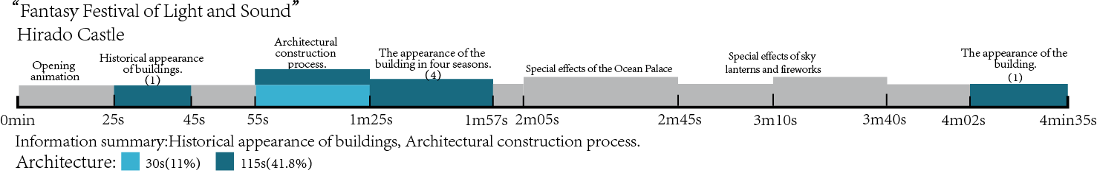
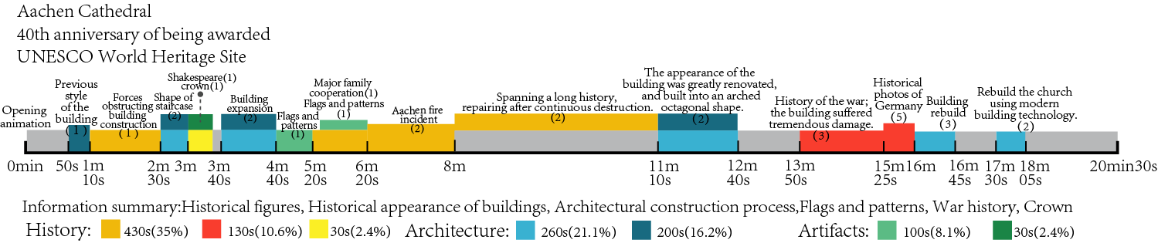

Appendix 3

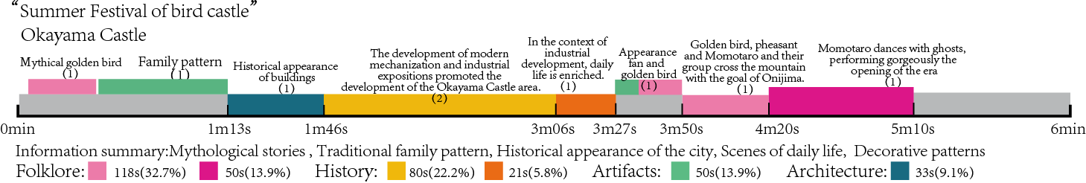
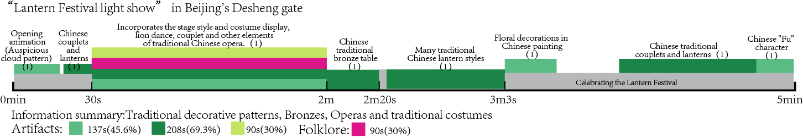
Data for medium-scale PJM examples (long video)

Table 5 Data for medium-scale PJM examples
Information types/  Cases or projects | War history | Historical daily life scene | Historical background and origin | Historical  figures | Structure and  construction  process | BUILDING  Historical  appearance | Mythical  stories | Folklore,  operas | Cultural  relics | Paintings  and patterns | Traditional  costumes
Nagoya Castle |  |  |  |  |  |  |  |  |  | Japanese-style painting of tiger. (1)
Hirado Castle |  |  | Historical stories (1) | Historical figures (1) |  |  |  |  |  |  | Costume characteristics (1)
Kashima  Shrine gate |  |  | The building gradually ages. (3) |  | Structure and  establishment of the gate. (4) |  | Myths about life and death, sun and moon. (3)  Hammer god controls the catfish. (1)  The god of thunder. (2) |  | Style of sword（2） | Deer pattern (3)
TERRA  SANCTA  MUSEUM | War history.  (3) | People gathered around the table to discussion (1)  Scene of laborers being enslaved. (2) | Historical origin and geographical location of relics. (2)  Ruins after the war. (1) | The king's posture. (1) | Structure of the building. (3) | City-state after the war. (1) |  | People follow the priest to the church for worship activities. (1) |  | Expression of western traditional oil paintings, murals and sketches. (3)
Karlsruhe  Palace |  |  | Historical origin and urban development. (3) |  | Structure of the building and the atrium. (2) | Overall look of the city. (3)  Procession of urban planning. (3) |  |  |  | Expression of western traditional oil paintings, murals and sketches. (3)
Tokushima  central park |  |  |  |  |  |  | "Abo Dance" traditional dance. (1) |  |  | Traditional patterns of clothing. (1)

Appendix 4

Graphical abstract
