Chromatograms of Glucose and Lactic acid at different time intervals
Chromatograms showing Glucose peak at 14.14 min and Lactate at 19.72 min. respectively can be noticed. As time progresses glucose peak get diminishes and lactate peak grows continuous showing the sensitivity of the measurement. The document is intended for understanding and not for publication.

Time 1
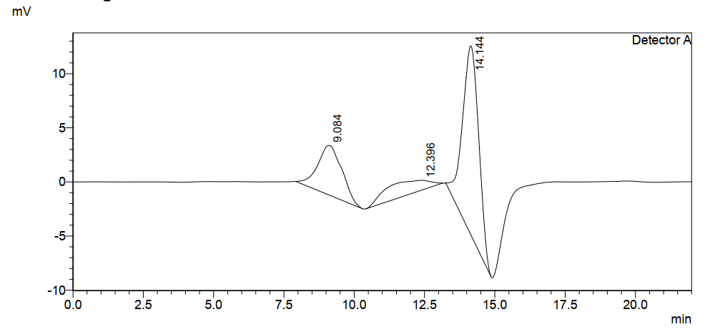

Time 2
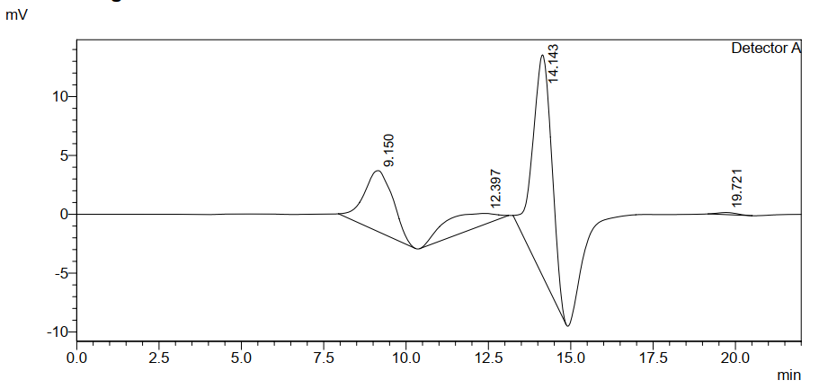

Time 3
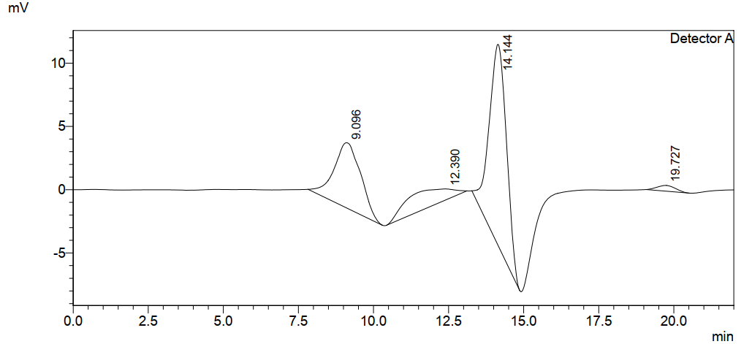

Time 4
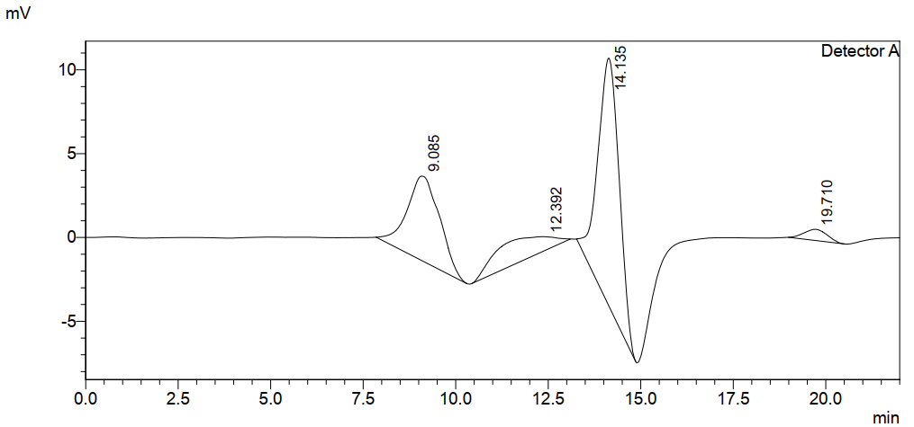

Time 5
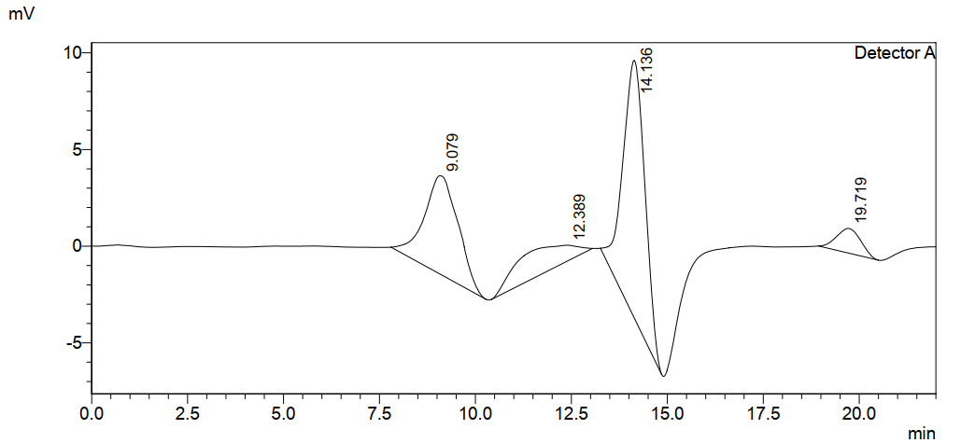
Time 6
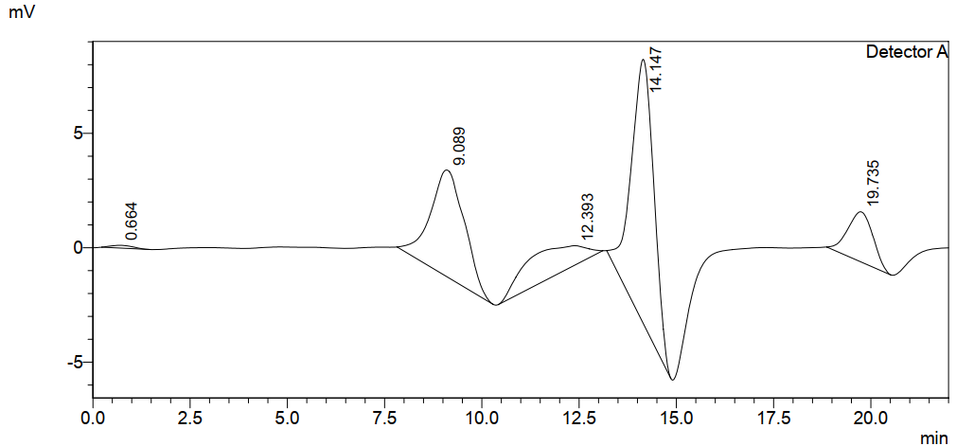

Time 7
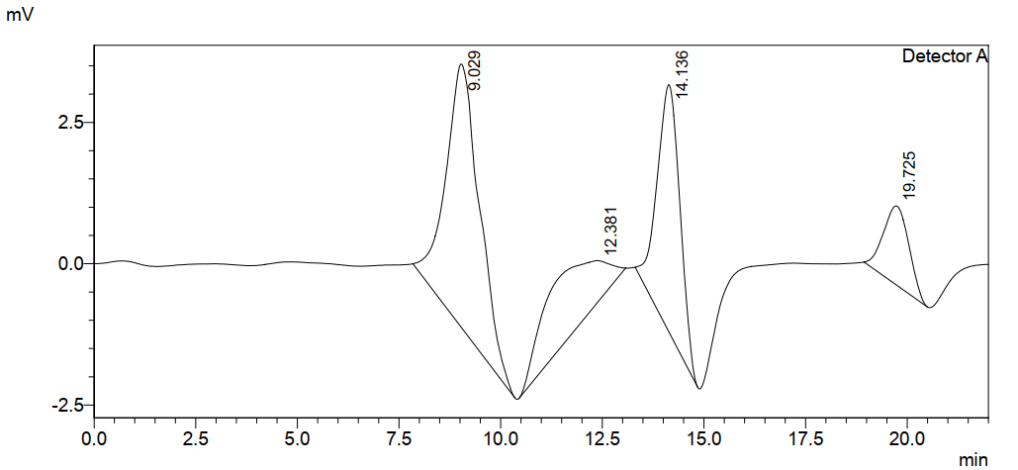
Samples diluted for accuracy of results. From herewith water peaks are much larger at 9.04 min.
Time 8
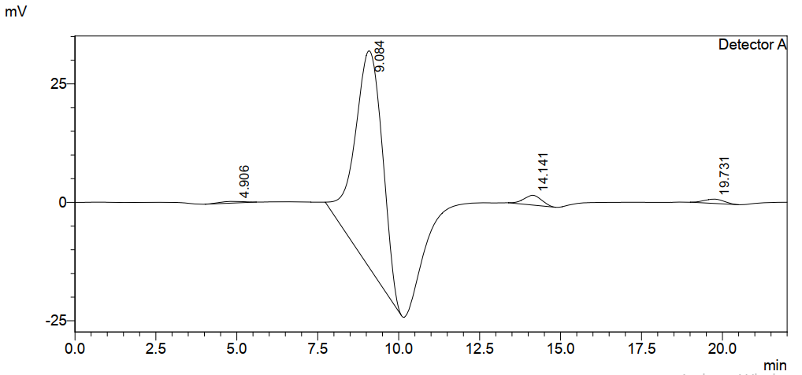
Time 9
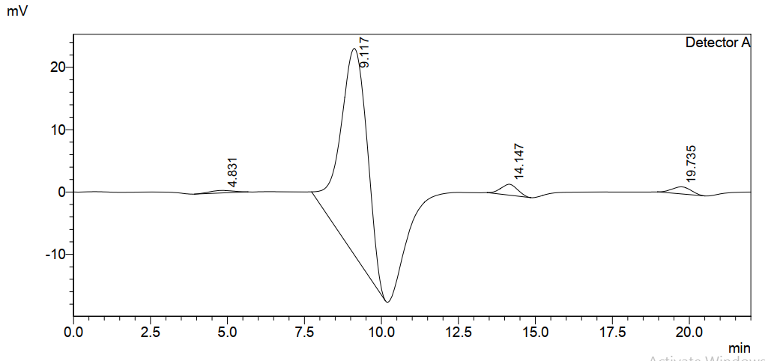
Time 10
