Table S1. Input Parameters to the Dispersion Solver
 | N | V (V||, V_{⊥1,} V_{⊥2}) | T|| | T⊥
Incoming ions | 4.97 | -0.0016, -0.0090, 0.0135 | 0.58 | 0.40
Reflected ions | 1.66 | 0.0050, 0.0278, -0.0404 | 3.13 | 5.38
Incoming electrons | 6.63 | 0, 0, 0 | 3.08 | 3.26
Note. These parameters are obtained from PIC simulation. Densities are in units of upstream density N₀, velocities are in units of c (speed of light), and temperatures are in units of m_{e}c². θ_{kB} is set as 30.4° in the dispersion solver.

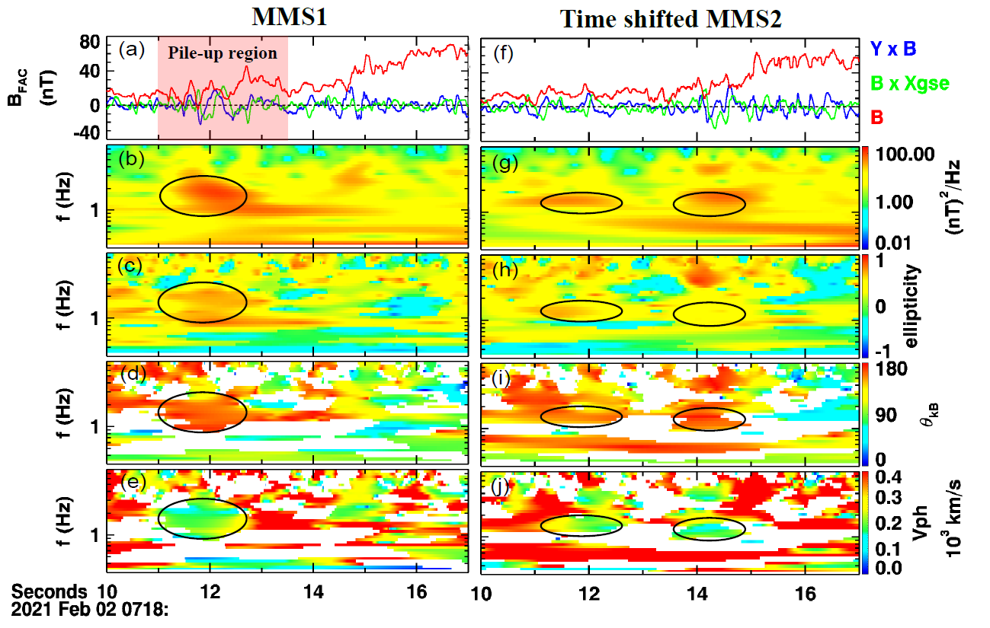
Fig. S1. Wave analysis results in MMS1 and MMS2 based on SVD method, with MMS2 data shifted forward by 2.7 s as Figure 1g. (a, f) The magnetic field components in field-aligned coordinate. (b, g) The power spectral densities of the magnetic field. (c, h) The ellipticities. (d, i) The angle between the wave propagation direction and the magnetic field. (e, j) The phase speed. Data points with planarities smaller than 0.7 are excluded, resulting in gaps in panels (d-e, i-j).

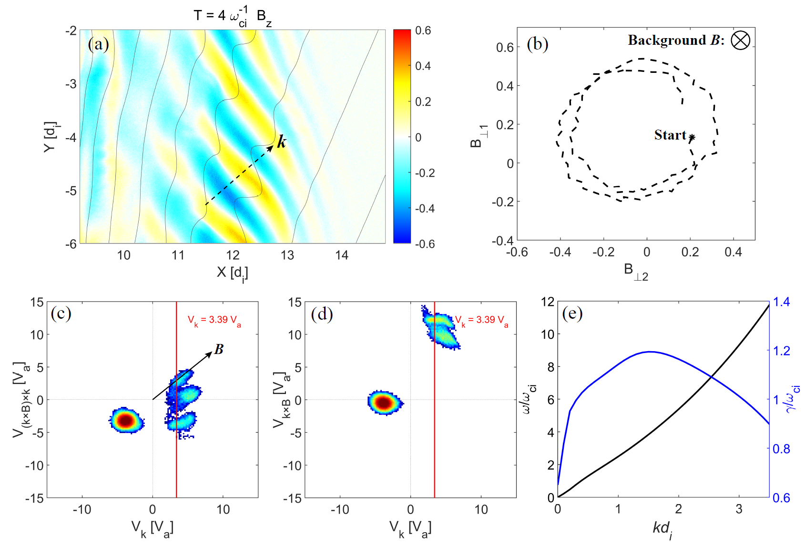
Fig. S2. Wave analysis results in PIC simulation. (a) 2-D picture of B_{z} at 4.0 ω_{ci}⁻¹. Magnetic field lines are overplotted in grey. (b) Hodogram of the wave magnetic field. (c, d) Ion velocity distribution functions at (x, y) = (12, -4.5) d_{i}. The red lines mark the velocity along k that satisfies the Landau resonance condition, which lies in the reflected ion population. (e) The dispersion relation and growth rate of the whistler instability from the linear instability analysis.

