Supplementary Materials for
Oxidation-CO₂ leaching of spent LiFePO₄ for lithium extraction and impurity control

Zhiming Yan^{1,*}, You Wu², Zepeng Lv³, Shiying Qin⁴, Mingrui Yang¹, Anwar Sattar⁵, Zushu Li^{1,**}
1, Advanced Materials Manufacturing Centre, WMG, University of Warwick, Coventry, CV4 7AL, UK
2, Sustainable Materials and Manufacturing Group, WMG, University of Warwick, Coventry, CV4 7AL, UK
3, Zhongyuan Critical Metals Laboratory, Zhengzhou University, 450001 Zhengzhou, Henan, PR China
4, Department of Materials, Design and Manufacturing Engineering, University of Liverpool, Liverpool, L69 3BX, UK
5, Recyclus Group, London, W1S 3PW, UK

Corresponding author:
*Zhiming Yan, Zhiming.yan@warwick.ac.uk
**Zushu Li, z.li.19@warwick.ac.uk

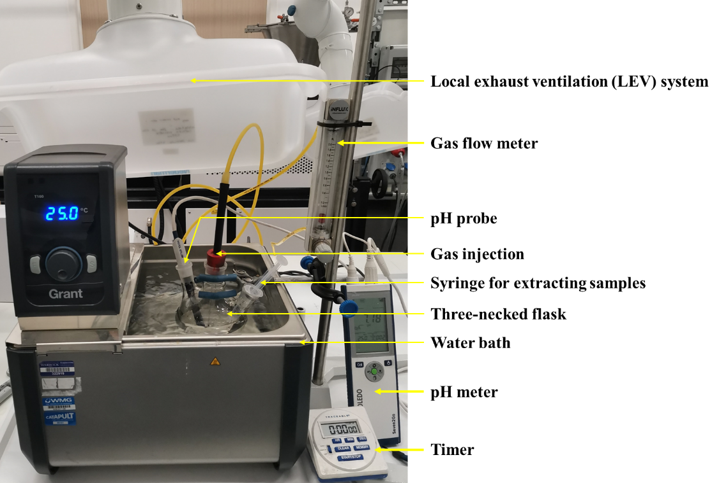
Figure S1. The on-site photos of using H₂O₂-CO₂ leaching strategy to recycle the spent LiFePO₄.

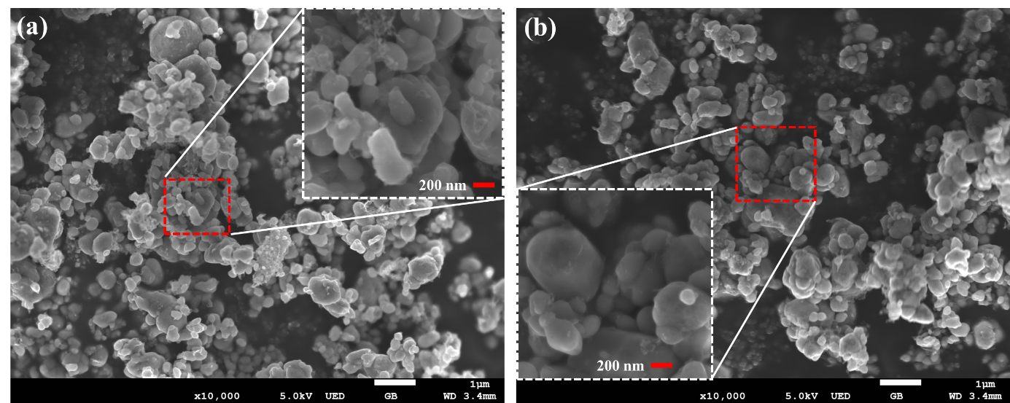
Figure S2. The SEM images of powder: (a) before leaching; (b) after CO₂-H₂O₂ leaching.
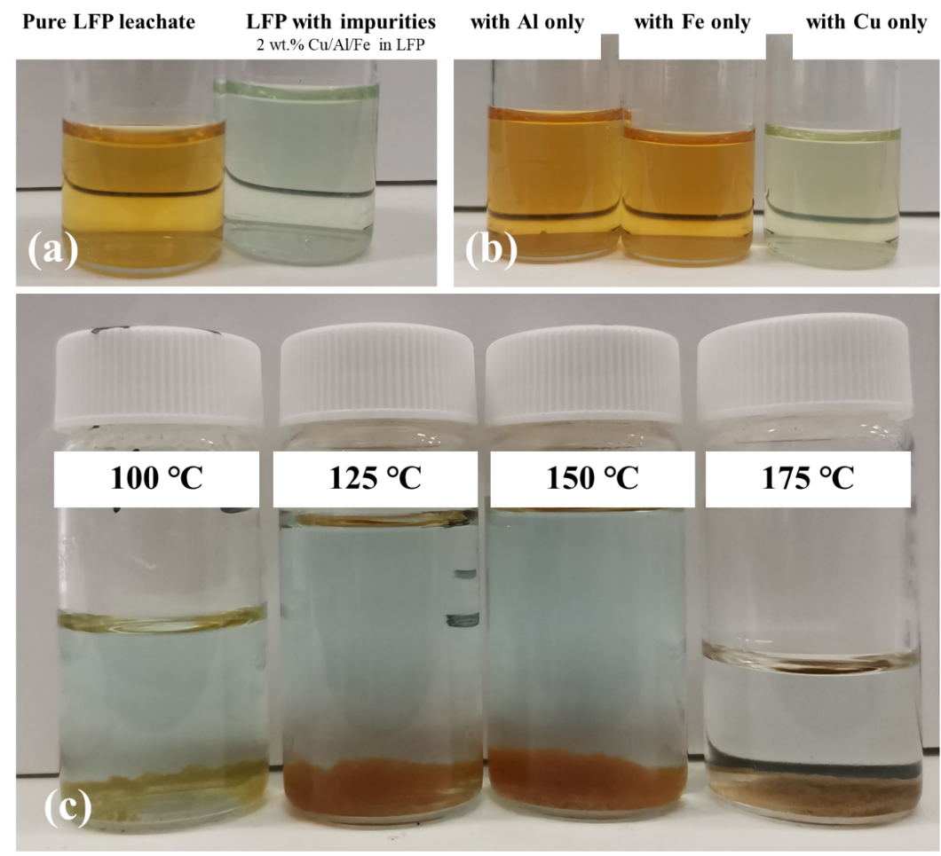
Figure S3. (a) The leachate of LFP without and with impurities. (b) The leachate of LFP with individual impurities. (c) The leachate with impurities after different temperature treatments.
Figure S4. The XRD pattern of the obtained high-purity Li₂CO₃ product.
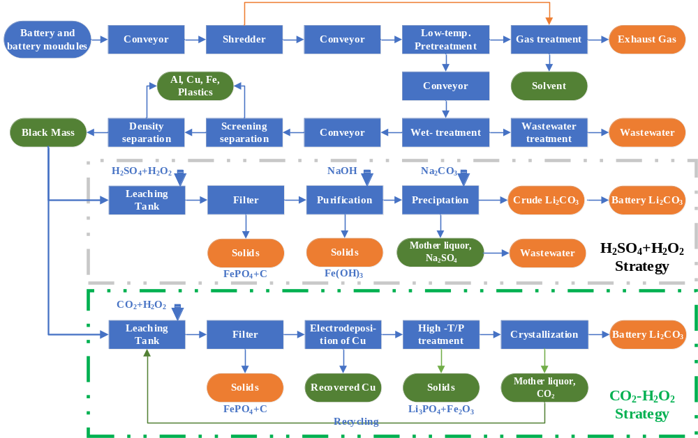
Figure S5. The flowchart of H₂SO₄-H₂O₂ and CO₂-H₂O₂ strategies used in the environmental and economic analysis.
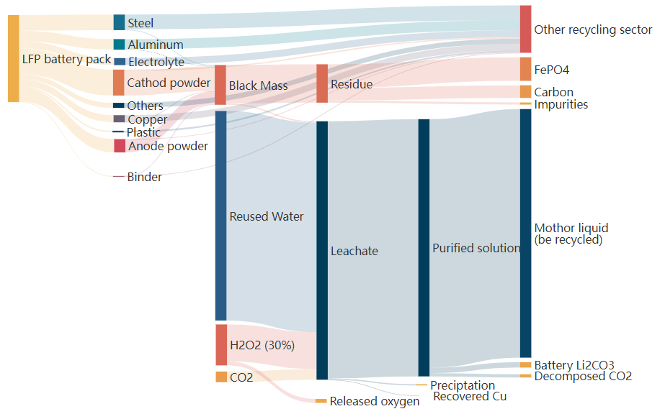
Figure S6. The mass flow of the CO₂-H₂O₂ strategies used in the environmental and economic analysis. 1000kg of spent LFP as input (data shown in Table S4)

Table S1 Reagents and equipment used in the experiments.
Reagents | Purity | Company | Country
LiFePO₄ | 99.9% (battery grade) | PI-KEM | UK
H₂O₂ | 32.00% in H₂O | Merck Life Science Ltd. | UK
CO₂ | 99.9% | BOC gas | UK
Al foil/Cu foil | 99.95% (battery grade) | Thermo Scientific | UK
LiOH | 99.9% | Sigma-Aldrich | USA
CaO | 99.0% | Sigma-Aldrich | USA
Equipment | Model | Company | Country
Water bath | Optima T100 | Grant Instrument | UK
pH meter | Seven2Go | METTLER TOLEDO™ | USA
ICP-OES | 5110 ICP-OES | Agilent Technologies | USA
XRD | Aeris | Malvern Panalytical | UK
SEM | JEOL 7800F | JEOL | Japan
TEM | Talos F200x | FEI | USA
XPS | ESCALAB 250Xi | Thermo Scientific  ( VG Scientific ) | USA
Pressure reactor | Model 4748 Vessels | Parr Instrument | USA
Oil bath | RCT Hotplate Stirrer | IKA | UK
Electrochemical Workstation | QL355TP Power Supply | AIM-TTI Instruments | UK

Table S2. The ICP analysis of the solution, mg/L.
Concentration, mg/L | Al | Cu | Fe | Li | P | Ca | pH
Pure LFP leaching at 25 ℃ | 0 | 0 | 325.65 | 2154.30 | 225.45 | / | 7.32
LFP with impurities leaching at 25 ℃ | 3.03 | 95.19 | 60.12 | 2129.25 | 70.14 | / | 7.48
LFP with impurities leachate treated with 2g/L LiOH | / | 72.72 | 4.04 | 2712.71 | 68.68 | / | 9.89
LFP with impurities leachate treated with 4g/L LiOH | / | 58.58 | 2.02 | 3273.27 | 64.64 |  | 10.85
LFP with impurities leachate treated with 10g/L CaO | / | 35.35 | 3.03 | 2122.12 | 35.35 | 56.56 | 10.18
LFP with impurities leachate treated with 20g/L CaO | / | 24.24 | 2.02 | 2118.6 | 20.20 | 59.59 | 12.50
LFP with impurities leachate treated at 100℃ | / | 57.57 | 7.07 | 2117.97 | 74.74 | / | 8.99
LFP with impurities leachate treated at 125 ℃ | / | 54.54 | 4.04 | 2099.18 | 72.72 | / | 9.19
LFP with impurities leachate treated at 150 ℃ | / | 56.56 | 3.03 | 2022.00 | 46.46 | / | 9.28
LFP with impurities leachate treated at 175 ℃ | / | 29.29 | 1.01 | 1900.10 | 4.04 | / | 9.48

Table S3. The ICP analysis of the Li₂CO₃ products after impurities removal
 | Element | Li | Fe | P | Cu | Al | Ca | Mg
Test 1 | Concentration, mg/L | 2531.89 | 0.17 | 3.32 | 0.39 | nd | 1.069 | nd
Test 1 | Content, wt.% | 18.755% | 0.001% | 0.025% | 0.003% | / | 0.008% | /
Test 2 | Concentration, mg/L | 3567.79 | 0.67 | 4.61 | 0.828 | nd | 1.427 | nd
Test 2 | Content, wt.% | 18.680% | 0.004% | 0.024% | 0.004% | / | 0.007% | /
Test 3 | Concentration, mg/L | 4155.92 | 0.38 | 4.54 | 0.567 | nd | 1.116 | nd
Test 3 | Content, wt.% | 18.720% | 0.002% | 0.020% | 0.003% | / | 0.005% | /
nd: The element(s) measured are not present at the detection limit.

During the measurements, three samples (sample 1: 135mg, sample2: 191mg; sample 3: 222mg) are dissolved in 10 ml of 5M/L HNO₃ then diluted for ICP-OES analysis.
Purity is defined as the ICP measured value of Li divided by the theoretical one.
For Li₂CO₃, theoretically Li content is 6.941/(6.941*2+12+16*3)=18.789%;
The purity of the final Li₂CO₃ product is defined as follows:
$$Purity of Li2CO3=\frac{measured Li content }{theoretical Li content}$$
Then the Li₂CO₃ purity of samples 1-3 is 99.82%, 99.42%, 99.63%, respectively.
By calculating the mean and standard deviation, we can see that the purity of the sample is around 99.62%, and the error is within ±0.16%.

Table S4. The mass balance table of the CO₂-H₂O₂ strategies used in the environmental and economic analysis. 1000kg of spent LFP packs as input.

Materials | Materials | Weight, kg | Materials | Materials | Weight, kg
LFP battery pack | Cathod powder | 298.00 | Black Mass | Residue | 440.73
LFP battery pack | Anode powder | 153.00 | Black Mass | Leachate | 15.37
LFP battery pack | Binder | 9.00 | Water | Leachate | 2406.35
LFP battery pack | Copper | 82.00 | H₂O₂ (30%) | Leachate | 424.50
LFP battery pack | Aluminum | 121.00 | CO₂ | Leachate | 121.78
LFP battery pack | Steel | 179.00 | H₂O₂ (30%) | Released oxygen | 45.60
LFP battery pack | Electrolyte | 81.00 | Residue | Carbon | 145.35
LFP battery pack | Plastic | 19.00 | Residue | FePO₄ | 270.56
LFP battery pack | Others | 58.00 | Residue | Impurities | 24.72
Cathod powder | Black mass | 283.10 | Leachate | Preciptation | 13.88
Anode powder | Black mass | 145.35 | Leachate | Recovered Cu | 0.39
Binder | Black mass | 8.55 | Leachate | Purified solution | 2953.73
Copper | Black mass | 4.10 | Purified solution | Recycled Water | 2854.50
Aluminum | Black mass | 6.05 | Purified solution | Battery Li₂CO₃ | 62.20
Steel | Black mass | 8.95 | Purified solution | Decomposed CO₂ | 37.03
Cathod powder | Other recycling sector | 14.90
Anode powder | Other recycling sector | 7.65
Binder | Other recycling sector | 0.45
Copper | Other recycling sector | 77.90
Aluminum | Other recycling sector | 114.95
Steel | Other recycling sector | 170.05
Electrolyte | Other recycling sector | 81.00
Plastic | Other recycling sector | 19.00
Others | Other recycling sector | 58.00

Table S5 Materials Required for Recycling 1 kg of Spent LFP Battery Packs Using H₂SO₄-H₂O₂ and CO₂-H₂O₂ strategies.
Reagent (kg/kg spent pack) | H₂SO₄-H₂O₂ | CO₂-H₂O₂
Carbon Dioxide | - | 0.122
Hydrogen Peroxide | 0.477 | 0.127
Sodium Hydroxide (NaOH) | 0.015 | -
Sulfuric Acid (H₂SO₄) | 0.122 | -
Soda Ash (Na₂CO₃) | 0.122 | -

Table S6 Energy Input and Water Consumption for Recycling 1 kg of Spent LFP Battery Packs Using H₂SO₄-H₂O₂ and CO₂-H₂O₂ strategies.
Energy and Water | H₂SO₄-H₂O₂ | CO₂-H₂O₂
Diesel (MJ) | 0.60 | 0.60
Natural gas (MJ) | 2.50 | 2.50
Electricity (MJ) | 0.13 | 0.30
Water consumption (L/kg) | 2.20 | 1.39

Table S7 Equipment Selection for H₂SO₄-H₂O₂ and CO₂-H₂O₂ strategies.
Equipment unites | H₂SO₄-H₂O₂ | CO₂-H₂O₂
Conveyor | 5 | 5
Crusher | 1 | 1
Calciner | 1 | 1
Gas treatment | 1 | 1
Wet granulator | 1 | 1
Density separator | 1 | 1
Crystallizer | - | 1
Leaching tank | 1 | 1
Filter press | 4 | 3
Precipitation tank | 2 | 1
Pump | - | 1
Mixing tank | 1 | 1
Dryer | 1 | 1
Wheel loader | 1 | 1
Water treatment | 4 | 1
Screen, vibrating | - | 1
Electrowinning cell | - | 1
Heat treatment furnace | - | 1

Table S8 Life-Cycle Assessment Results for H₂SO₄-H₂O₂ and CO₂-H₂O₂ strategies.
Cost per kg feedstock processed | H₂SO₄-H₂O₂ | CO₂-H₂O₂
Cost per kg feedstock processed | $ 1.23 | $ 1.02
Energy use in MJ per kg feedstock processed
Total Energy | 6.915 | 6.303
Fossil fuels | 6.535 | 5.944
Coal | 3.155 | 2.834
Natural gas | 5.38 | 5.128
Petroleum | 3.2 | 3.183
Water use in gallon | 1.2 | 0.8
Total Emissions in g per kg feedstock processed
VOC | 0.108 | 0.102
CO | 0.439 | 0.425
NOx | 0.911 | 0.908
PM10 | 0.058 | 0.05
PM2.5 | 0.05 | 0.046
SOx | 0.206 | 0.118
BC | 0.02 | 0.021
OC | 0.012 | 0.012
CH₄ | 1.077 | 0.986
N₂O | 0.011 | 0.01
CO₂ | 569 | 523
CO₂ (w/ C in VOC & CO) | 570 | 524
GHGs | 605 | 557
Revenue per kg feedstock processed | $ 1.63 | $ 1.66
Profit | 0.40 | 0.64

Table S9 Annual Cost Details for Different Recycling Plants with a Throughput of 50,000 Tons of LFP Spent Battery Packs
 | H₂SO₄-H₂O₂ | CO₂-H₂O₂
I. Fixed capital investment | $85,121,948 | $84,036,622
A. Inside battery limits (ISBL) plant cost | $45,157,532 | $46,480,432
Purchased Equipment | $14,111,729 | $18,592,173
Equipment erection | $7,055,864 | $11,155,304
Piping | $8,467,037 | $3,718,435
Instumentation and control | $4,233,519 | $3,718,435
Electrical | $2,822,346 | $2,788,826
Civil | $4,233,519 | $3,718,435
Structures and buildings | $2,822,346 | $1,859,217
Lagging and paint | $1,411,173 | $929,609
B. Offsite battery limits (OSBL) cost | $18,063,013 | $18,592,173
C. Design and Engineering Cost | $15,805,136 | $13,014,521
D. Contingency | $6,096,267 | $5,949,495
II. Working Capital | $4,232,040 | $3,819,336
III. Total Capital Investment | $89,353,989 | $87,855,958
IV. Cash cost of production (CCOP), $/year | $25,020,915 | $20,073,712
A. Variable costs of production (VCOP) | $12,971,337 | $8,102,087
Raw Materials | $10,414,836 | $4,793,002
Utilities | $800,562 | $1,990,972
Consumables | $312,445 | $143,790
Effluent disposal | $1,235,197 | $1,078,462
Packaging and shipping | $208,297 | $95,860
B. Fixed costs of production (FCOP), $/year | $12,049,578 | $11,971,625
Labor costs | $3,456,000 | $3,456,000
Operating labour | $1,843,200 | $1,843,200
Supervision and management | $460,800 | $460,800
Direct salary overhead | $1,152,000 | $1,152,000
Maintenance | $2,257,877 | $2,324,022
Property taxes and insurance | $632,205 | $650,726
Rent of land and/or buildings | $1,264,411 | $1,301,452
General plant overhead | $3,164,216 | $3,074,765
R&D costs | $529,075 | $543,591
Selling and marketing costs | $388,741 | $284,774
General and administrative (G&A) costs | $2,246,400 | $2,246,400
Allocated environmental charges | $632,205 | $650,726
Running license fees and royalty payments | $388,741 | $284,774
Capital charges | $253,922 | $229,160
Interest on fixed capital | $- | $-
Interest on working capital | $253,922 | $229,160
V. Annualized Capital Cost (ACC), $/year | $13,853,205 | $8,403,662
VI. Total Cost of Production (TCOP), $/year | $38,874,120 | $28,477,374

Table S10 Mass Proportion, Recycling Yield, and Price of Recycled Materials in Spent LFP Battery Packs
Main component in a pack | Price $/kg [1] | Composition | Recycling yield
LiFePO₄ | 6.10 [2] | 29.80% | 95.0%
Li₂CO₃ | 13.38 [3] | / | /
Graphite | 2.07 [4] | 15.30% | 95.0%
Copper | 6.67 [5] | 8.20% | 95.5%
Aluminum | 1.54 [6] | 12.10% | 95.0%
Plastic | 0.25 [7] | 1.90% | 95.0%

[1] GBP to USD exchange rate: 1.26; RMB to USD exchange rate: 0.14.
[2] https://www.100ppi.com/vane/detail-1312.html, 20/05/2024.
[3] https://carboncredits.com/why-lithium-prices-are-plunging-and-what-to-expect/, 20/05/2024.
[4] https://hq.smm.cn/h5/graphite-price, 20/05/2024.
[5] https://scraplocal.co.uk/scrap-metal-prices, 20/05/2024.
[6] https://scraplocal.co.uk/scrap-metal-prices, 20/05/2024.
[7] https://blog.recycleduklimited.com/current-plastic-recycling-prices, 20/05/2024.

