Table S1. Baseline characteristics of control (CN), mild cognitive impairment (MCI), and Alzheimer's disease (AD)
 | CN | MCI
n | 58 | 396
AGE (years) | 75.11±5.77 | 74.74±7.397
Gender (M/F) | 30/28 | 256/140
APOE4 (n) | 8.62% (6) | 53.2% (211)
CDRSB | 0.026±0.11 | 1.60±0.88
ADAS11 | 6.247±2.794 | 11.52±4.42
MMSE | 28.93±1.153 | 27.03±1.775

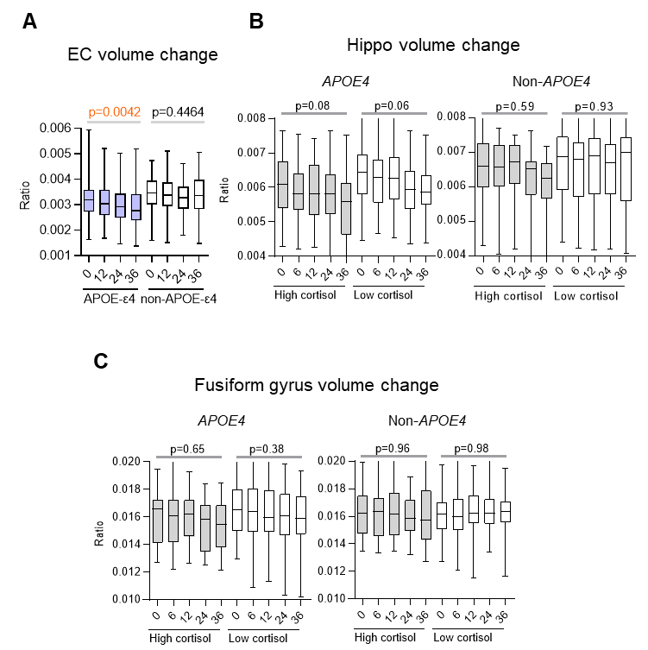
Fig. S1
Hippocampus and fusiform gyrus volume changes and cortisol levels in MCI of APOE4 and non-APOE4 carriers. (A) EC volume changes over time during MCI-to-AD conversion in APOE4 and non-APOE4 carriers. (B), (C) Hippocampus and fusiform gyrus volume changes and cortisol levels during follow-up in MCI of APOE4 and non-APOE4 carriers. Volume measurements were normalized by dividing by whole brain volume. High cortisol levels were defined as plasma cortisol levels exceeding 150 ng/ml, while low cortisol levels were defined as levels below this threshold. Statistical significance was determined using one-way ANOVA, with a significance threshold set at p < 0.05.
Table S2. Mediated effect of entorhinal cortex integrity on cortisol and cognitive function.
ApoE4 |  |  | X->M |  | M->Y |  | X->Y
X | M | Y | B | P value | B | P value | B | P value
Cortisol | EC | CDRSB | -0.0000020 | 0.01 | -320.1 | 0.009 | 0.00169 | 0.232
Cortisol | EC | ADAS11 | -0.0000020 | 0.01 | -1916.3 | <0.001 | 0.00403 | 0.473
Cortisol | EC | ADAS13 | -0.0000020 | 0.01 | -3297.7 | <0.001 | 0.00714 | 0.344
Cortisol | EC | MMSE | -0.0000020 | 0.01 | 656.0 | 0.009 | -0.0045 | 0.121
non-ApoE4 |  |  | X->M |  | M->Y |  | X->Y
X | M | Y | B | P value | B | P value | B | P value
Cortisol | EC | CDRSB | -0.0000002 | 0.872 | -370.4 | <0.001 | 0.00054 | 0.743
Cortisol | EC | ADAS11 | -0.0000002 | 0.872 | -3648.5 | <0.001 | 0.00934 | 0.282
Cortisol | EC | ADAS13 | -0.0000002 | 0.872 | -5369.4 | <0.001 | 0.01215 | 0.306
Cortisol | EC | MMSE | -0.0000002 | 0.872 | 904.8 | <0.001 | -0.00169 | 0.651

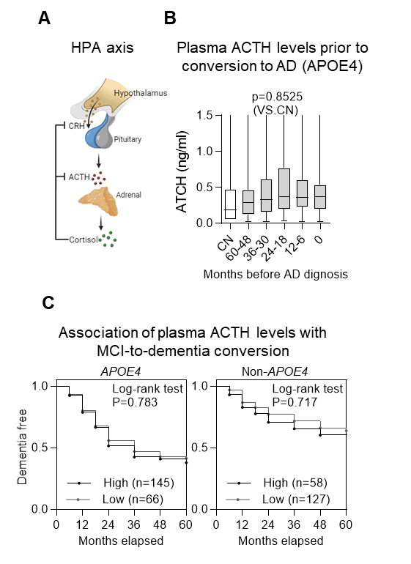
Fig. S2.
No significant association of HPA-ACTH with cortisol activation during the transition from MCI to AD. (A) Schematic diagram of the hypothalamic–pituitary–adrenal (HPA) axis. CRH, corticotropin-releasing hormone. ACTH, adrenocorticotropic hormone. (B) Dynamics of plasma cortisol levels during the timeline of MCI-to-AD progression, stratified by APOE4 and non-APOE4 genotypes. Statistical analyses were performed via one-way ANOVA or two-tailed t tests. The sample sizes were n=134 in the non-APOE4 group and n=246 in the APOE4 group. (C) Association of plasma ACTH levels and MCI-to-dementia conversion, stratified by APOE4 and non-APOE4 genotypes. Statistical analyses were performed via the log-rank test.
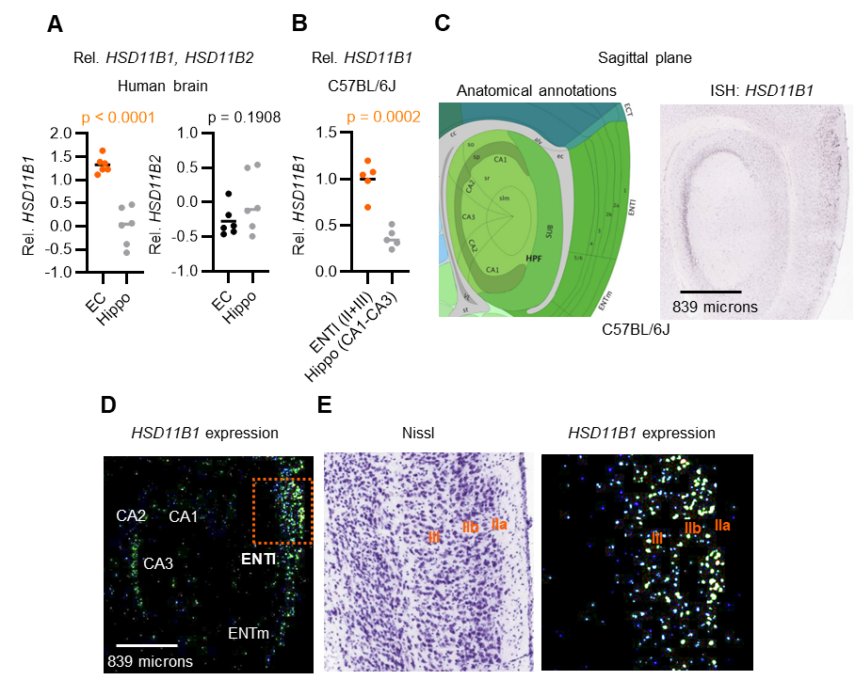
Fig. S3.
The gene expression distribution of HSD11B1 in the EC and hippocampus.
(A) Relative quantification of HSD11B1 expression levels in human hippocampus vs EC. Expression data were obtained and analyzed from the Allen Human Brain Atlas. Probe name: A_23_P63209 (HSD11B1) and A_23_P14986 (HSD11B2). (B) Relative quantification of HSD11B1 expression levels from ISH, which was calculated from images taken at five distinct locations. Data were obtained and analyzed from the Allen Mouse Brain Atlas (Experiment numbers: 79762381 and 73520987). (C) Sagittal plane of HSD11B1 expression. The left panel displays anatomical annotations from the Allen Mouse Brain Atlas, the middle panel shows a Nissl-stained image from a neighboring section of the ISH image in the Allen Reference Atlas, and the right panel presents an ISH image of HSD11B1 expression at the same slice position as panel C. Probe name: RP_071204_04_C01. (D) (E) Quantification of HSD11B1 expression via ISH. These panels show ISH images quantifying HSD11B1 expression in the entorhinal cortex. The red dashed box in panel b is magnified in panel d, offering a higher-resolution view of HSD11B1 expression in the lateral entorhinal cortex (ENTl). ENTm: medial entorhinal cortex. CA1-3: Cornu Ammonis regions 1-3 of the hippocampus.
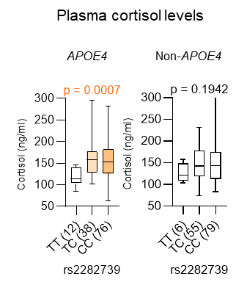
Fig. S4.
Association between an SNP in the HSD11B1 gene and cortisol levels in APOE4 carriers with MCI. Data were retrieved from the ADNI database. The medians are represented by horizontal bars, and the interquartile ranges are represented by vertical bars. Statistical analyses were conducted via Brown-Forsythe ANOVA test with a significance threshold set at p < 0.05.

