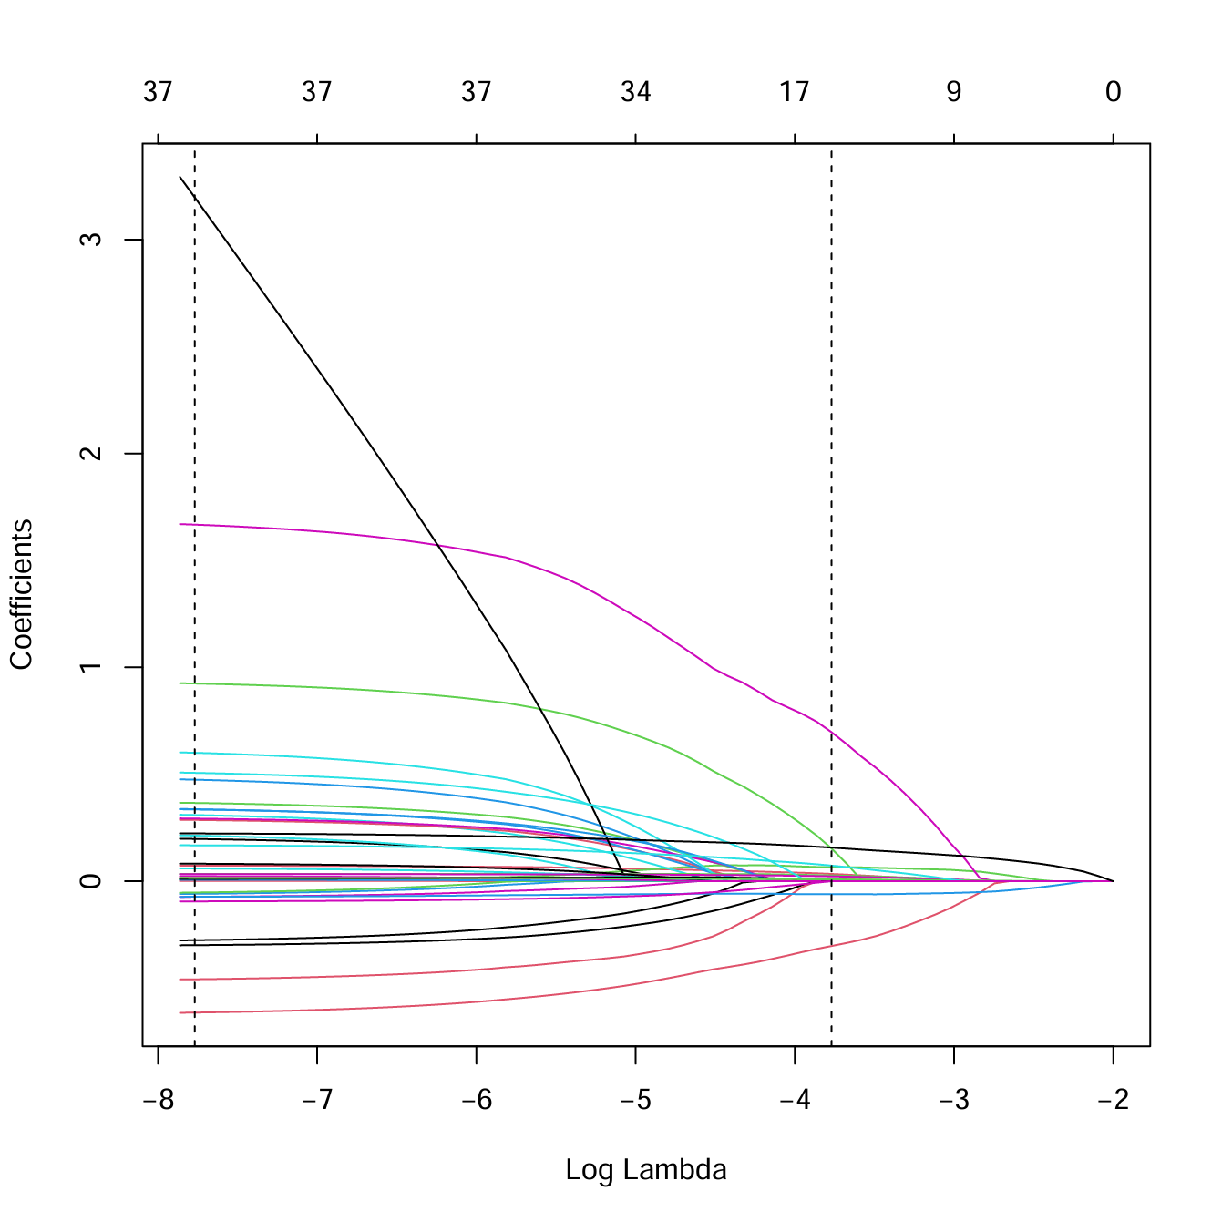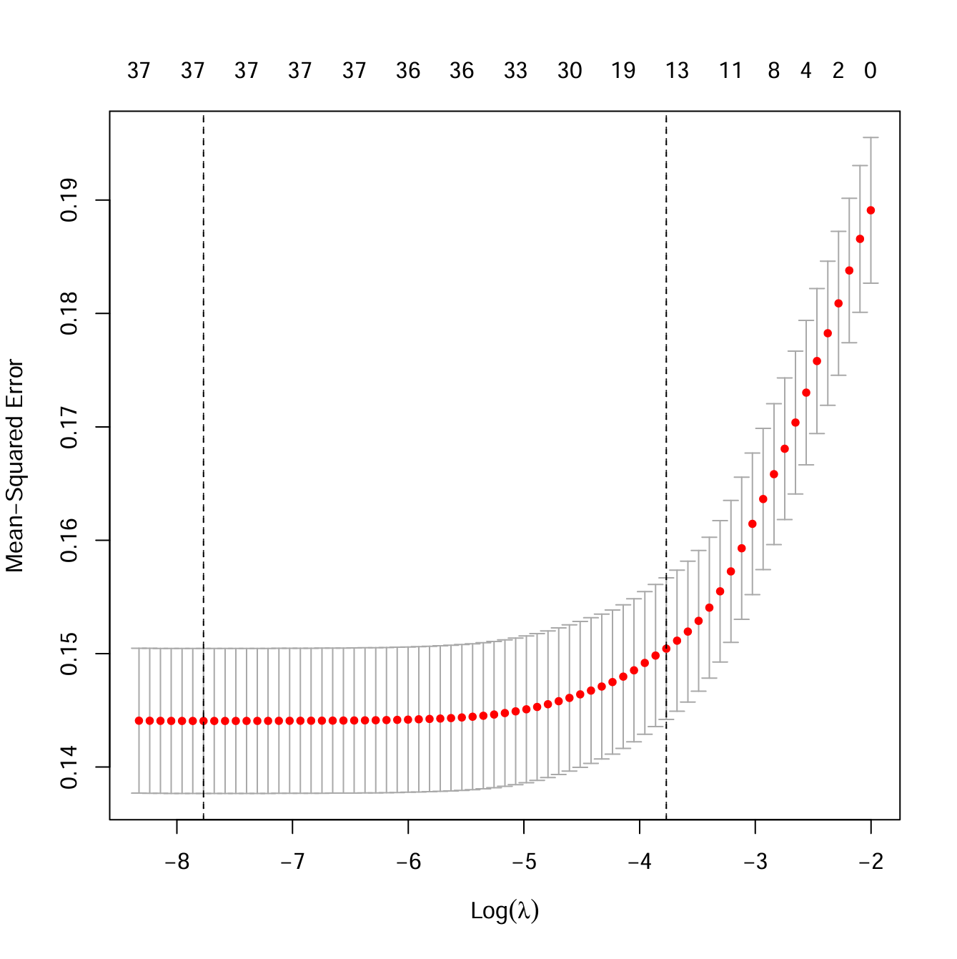
B
A
Appendix FIGURE 1
Lasso regression was used to screen the variables. A. The process of selecting the most appropriate λ in the LASSO model using 10-fold cross-validation shows that as the log lambda value increases, the penalty to the model increases, resulting in fewer characteristic variables being included in the model. B. The dashed line on the left of (B) marks the inclusion of independent variables in the minimal model, while the dashed line on the right marks the inclusion of independent variables in the streamlined model.

