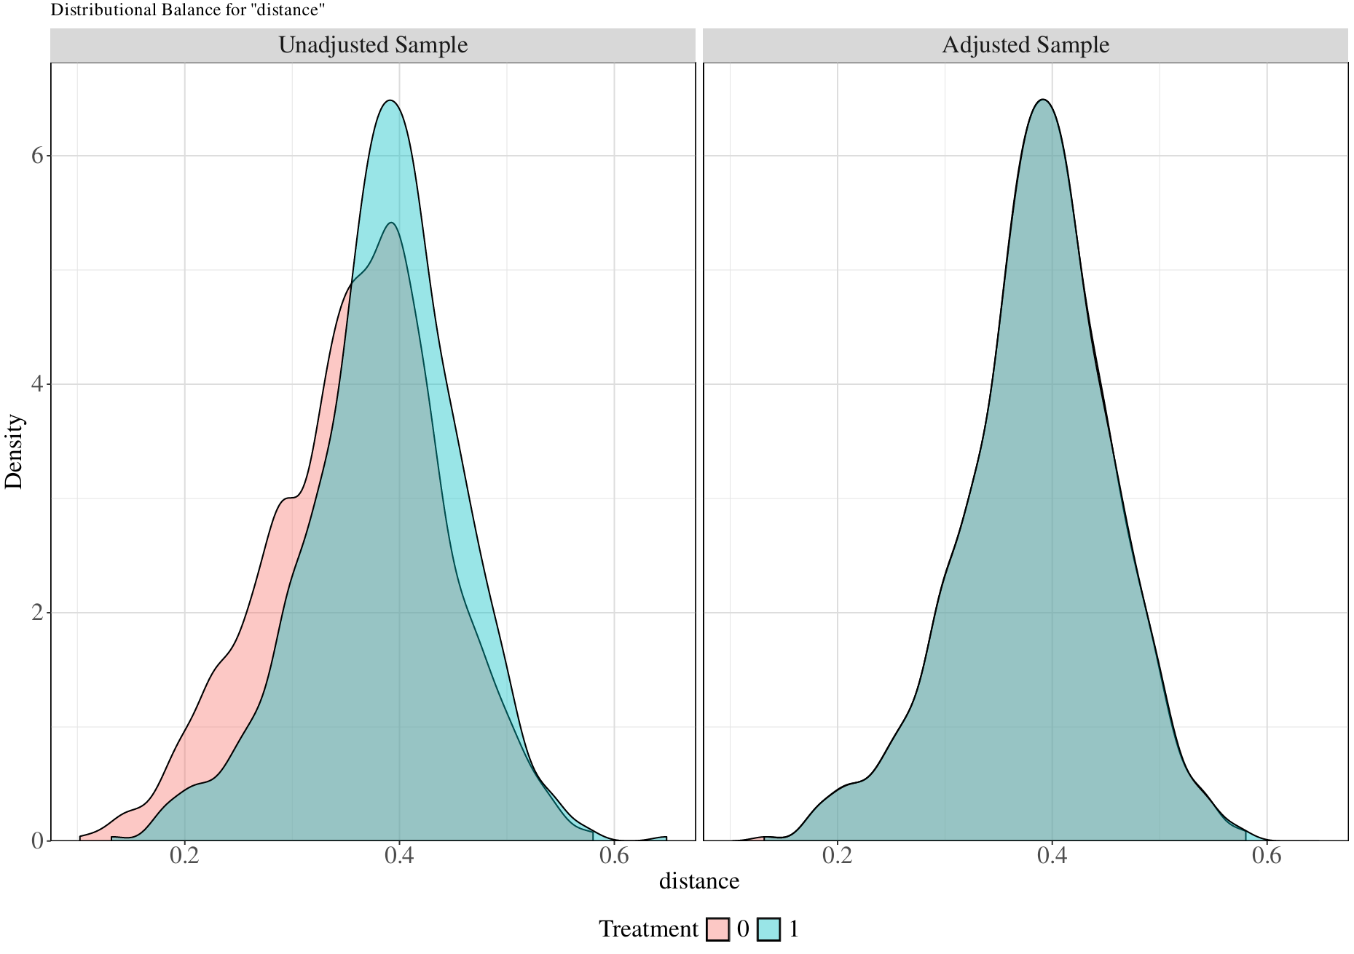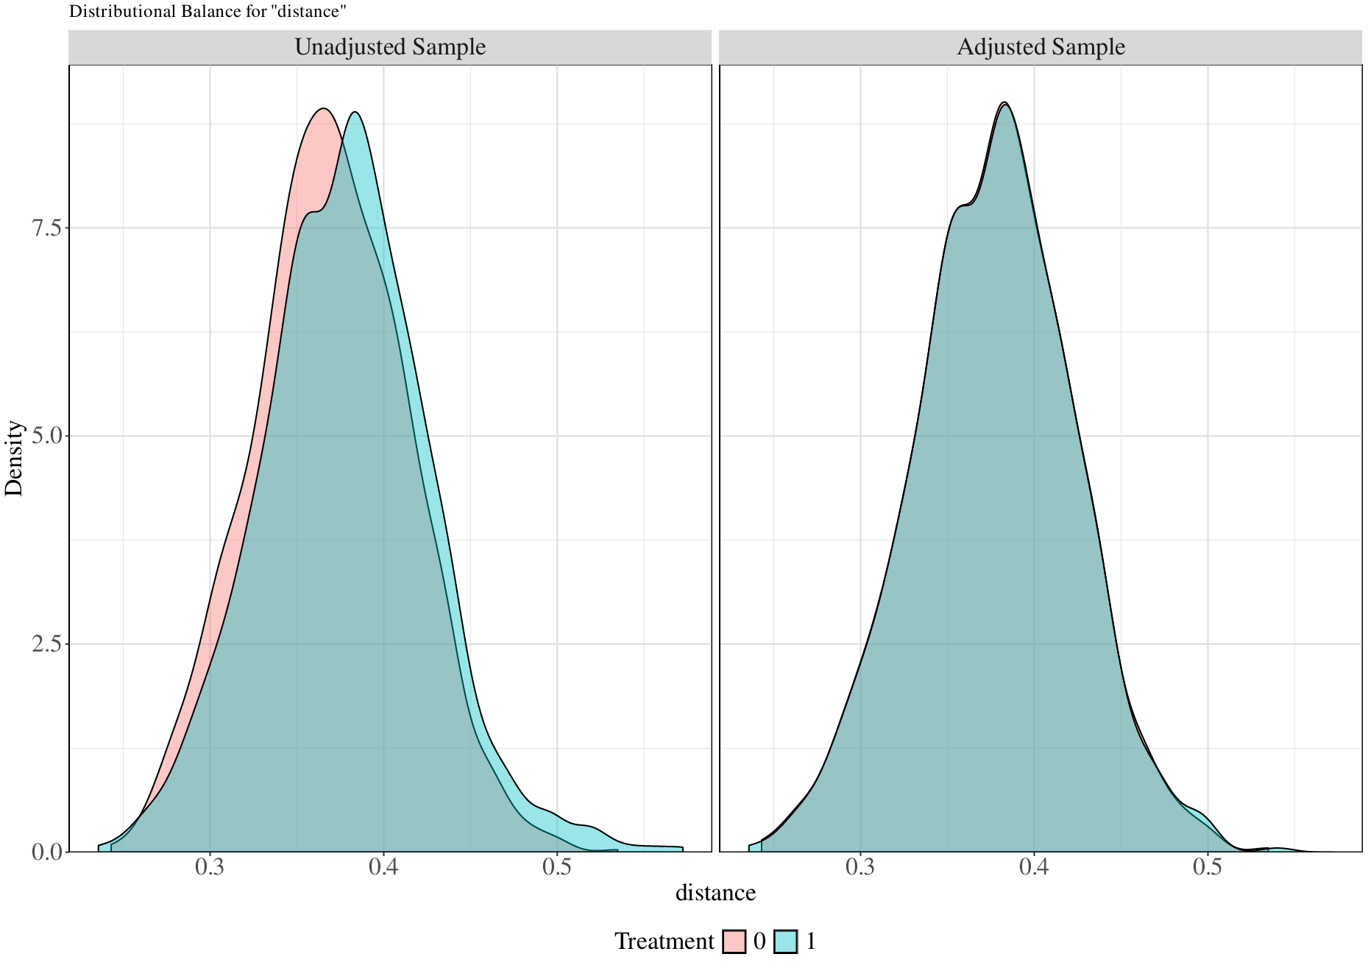
C
B
A
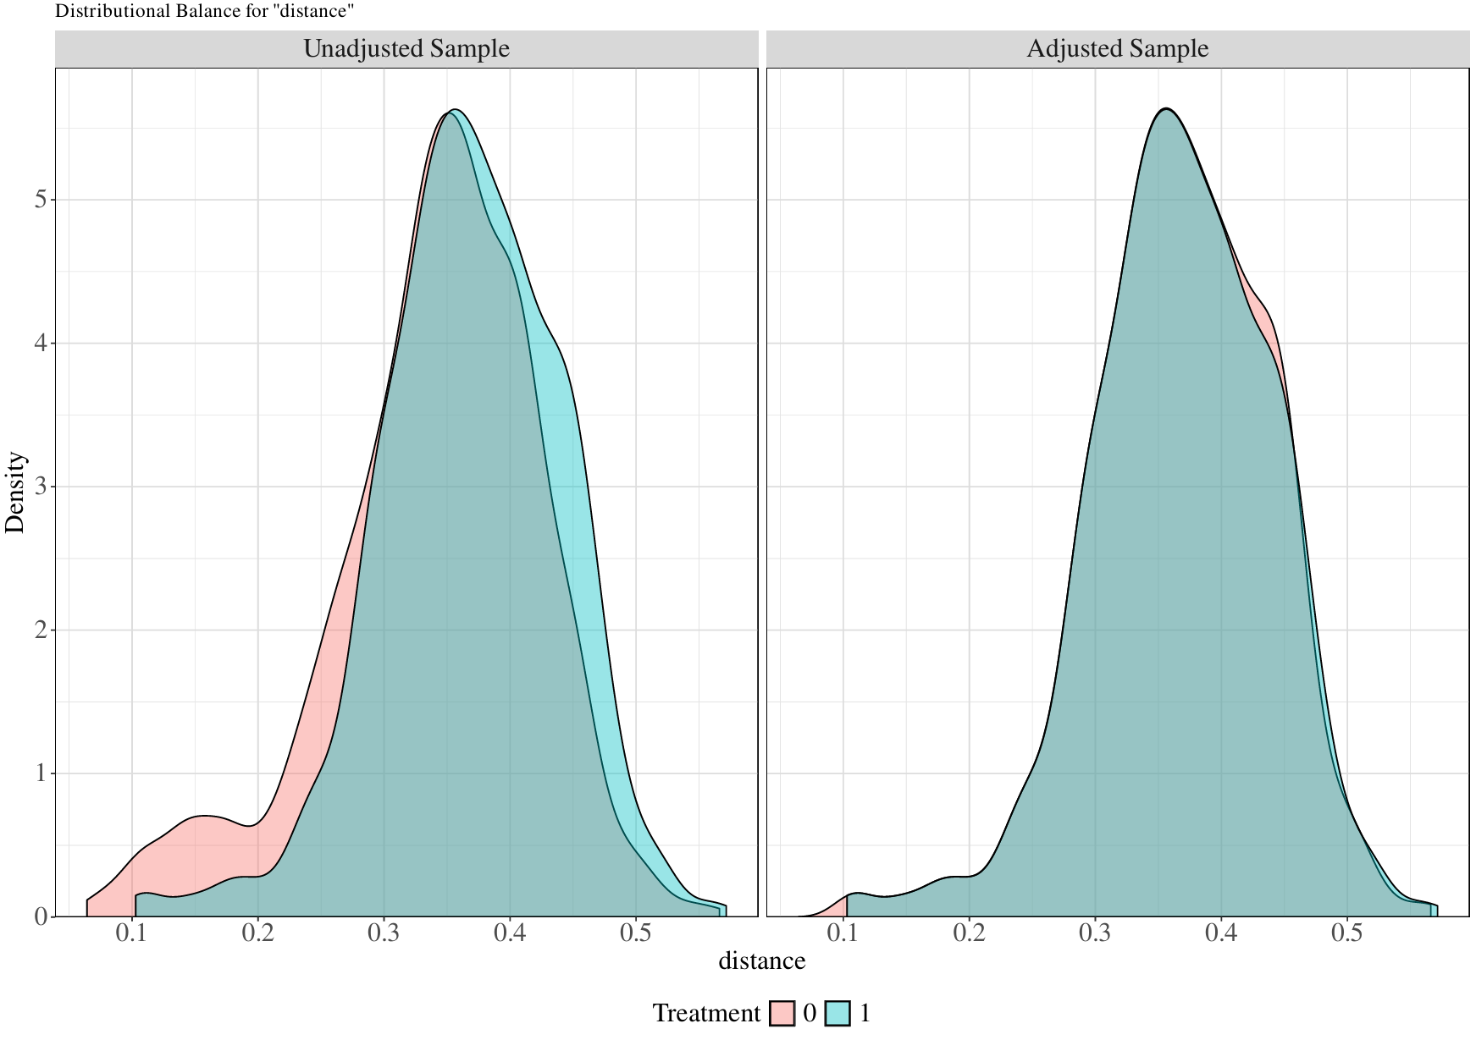
Appendix FIGURE 2
Distributional balance of propensity scores in unmatched and matched samples. 0 = patients outside the optimal blood pressure; 1 = patients within the optimal blood pressure.

