Supplementary information:
Fourier-inspired Automatic Cobb Angles Measurement for Adolescent Idiopathic Scoliosis

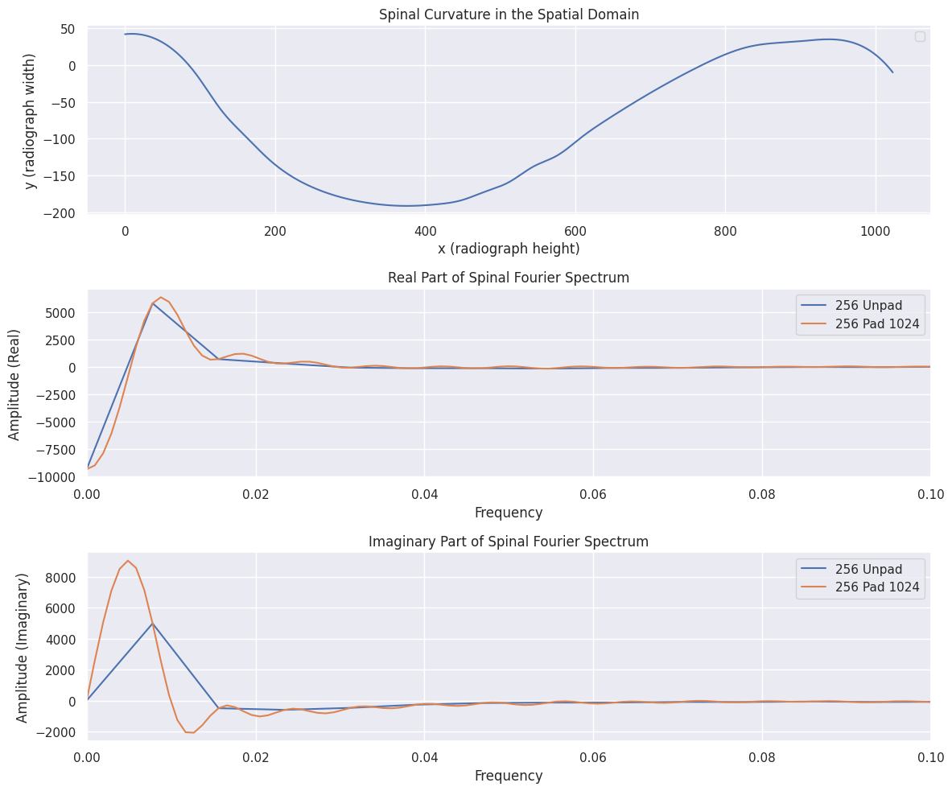
Supplementary Figure S1. Zero padding in the spatial domain before applying Fourier transform helps obtaining a higher resolution of spectrum. As visualized, a 256-dimensional unpad sequence is associated with a rougher spectrum. This behavior explains the better performance with the model with padding applied.
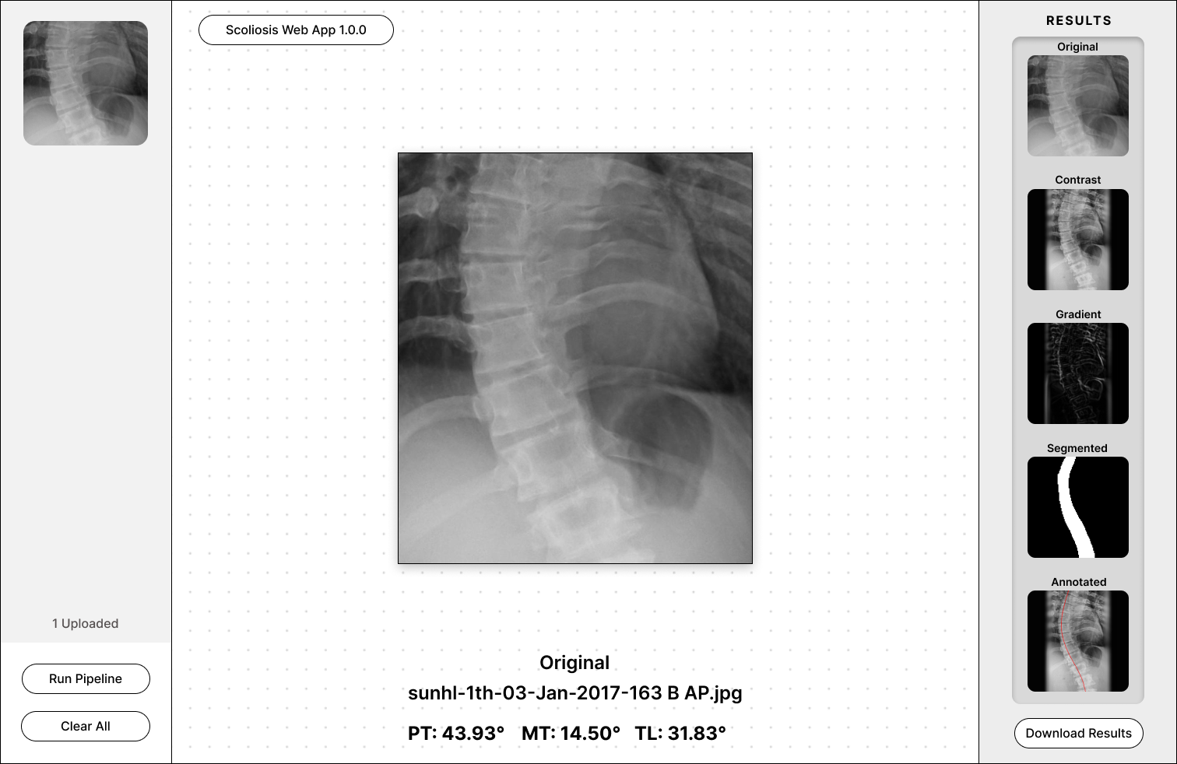
Supplementary Figure S2. The prototype Cobb angles measurement application, when working in conjunction with a hand-held X-ray device, may provide an ideal solution for scoliosis screening in resource-constrained environments.
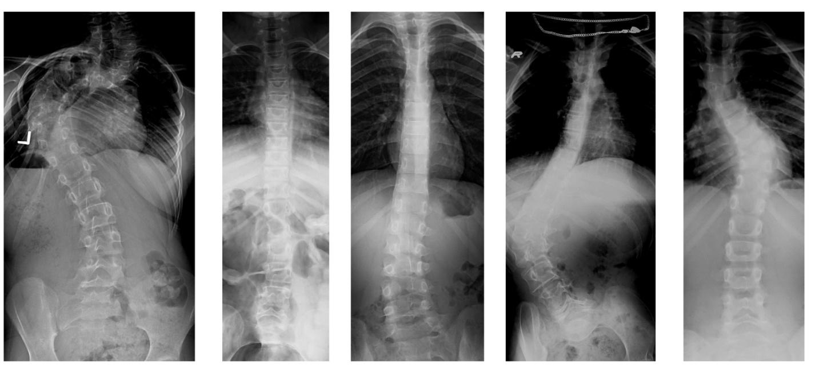
Supplementary Figure S3. Sample radiographs from the MICCAI 2019 scoliosis dataset. The images show varied heights and widths, so data preprocessing is critical.

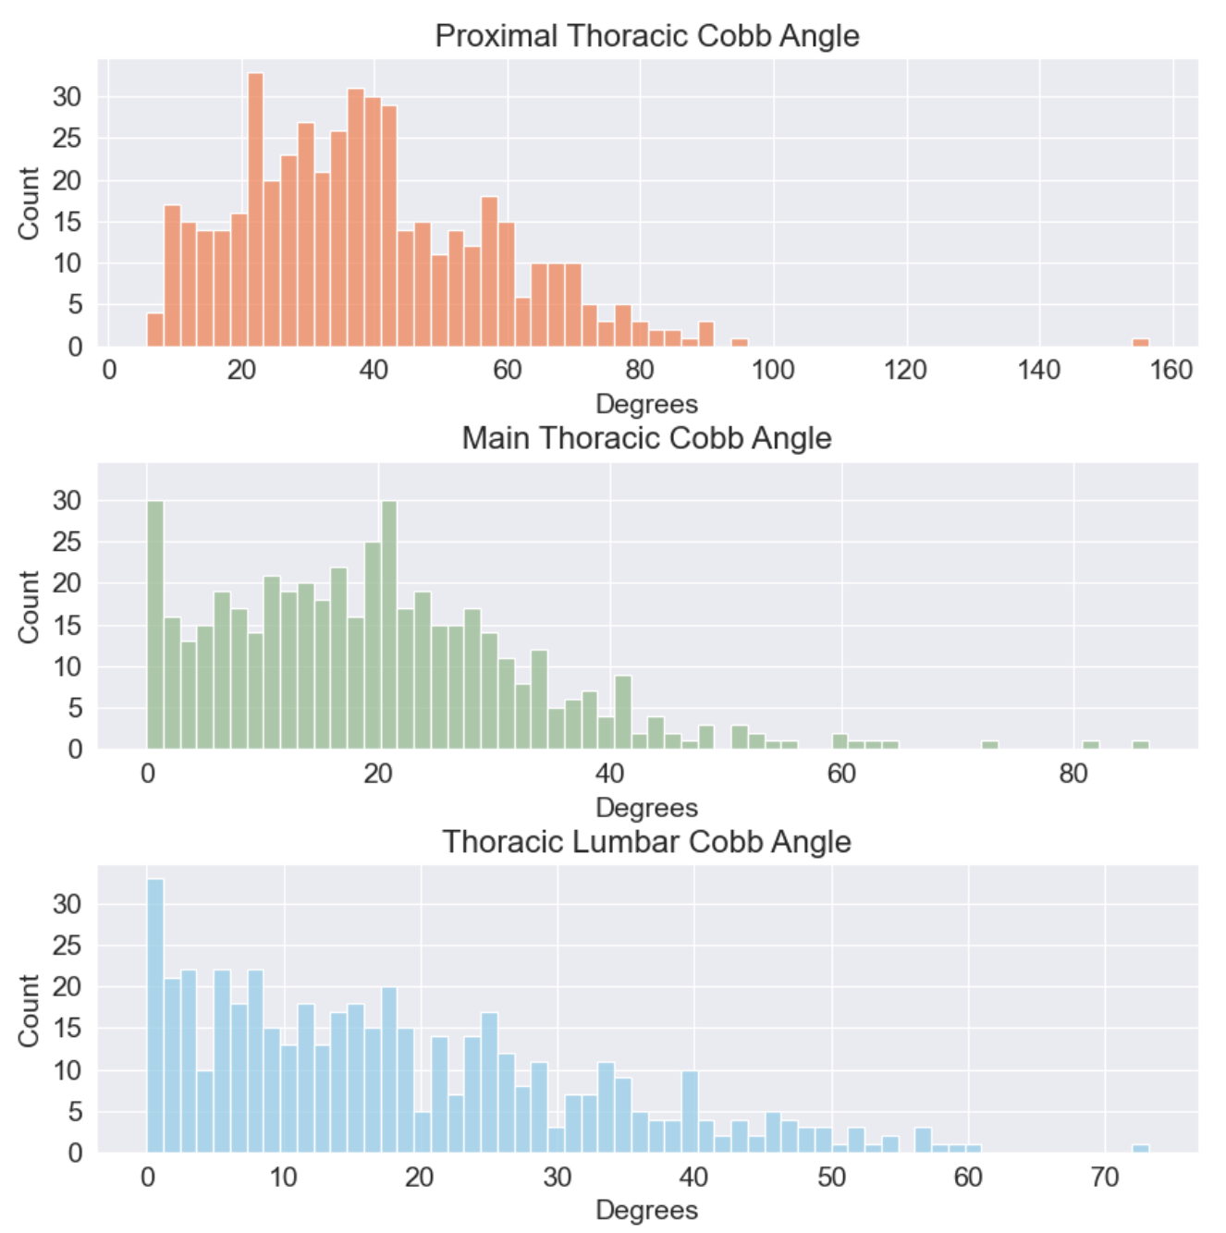
Supplementary Figure S4. The distribution of Cobb angles. Every image is labeled with three Cobb angles. The distribution of the TL angles shows a high standard deviation.

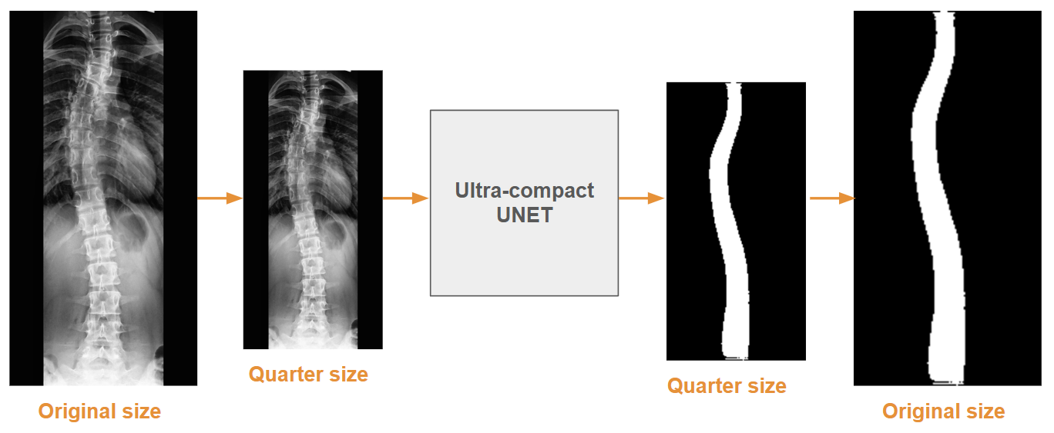

Supplementary Figure S5. The U-NET generated the predicted segmentation mask as one of the three input channels to the spectrum prediction model. To keep the pipeline compact, the input radiograph is resized to a quarter of its width and height. In the output, the segmented image is reverted to the original dimension.

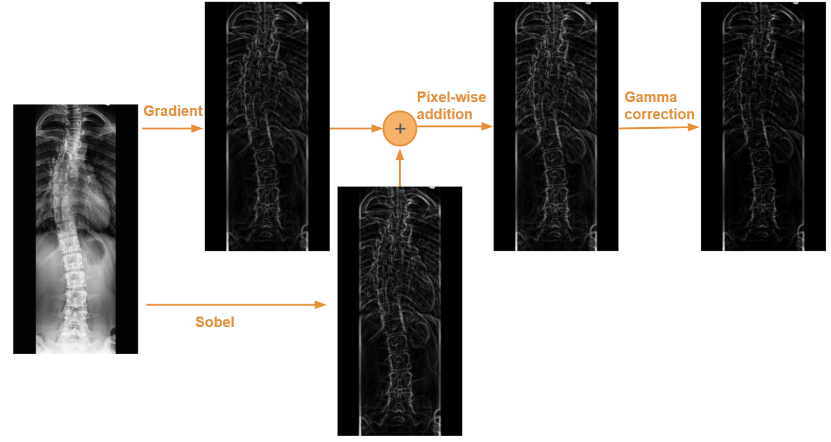
Supplementary Figure S6. The gradient channel emphasizes the bone edges while suppressing the rest. The gradient channel is a scaled pixel-wise addition of the LaPlacian of the radiograph and the Sobel-filtered image.

