Supporting Information
Stable Transmission of Environmentally Induced DNA Methylation Epimutations from Germline to the Liver and Their Association with Fatty Liver Disease in Medaka
Sourav Chakraborty^{1,#}, Santosh Anand^{1,#}, Xuegeng Wang², Ramji Kumar Bhandari^{1,*}
Division of Biological Sciences, University of Missouri, Columbia, MO 65203, United States
College of Life Sciences, South China Normal University, Guangzhou, P.R. China

# Equally contributing authors
*Corresponding Author: Ramji K. Bhandari Email: bhandarir@missouri.edu

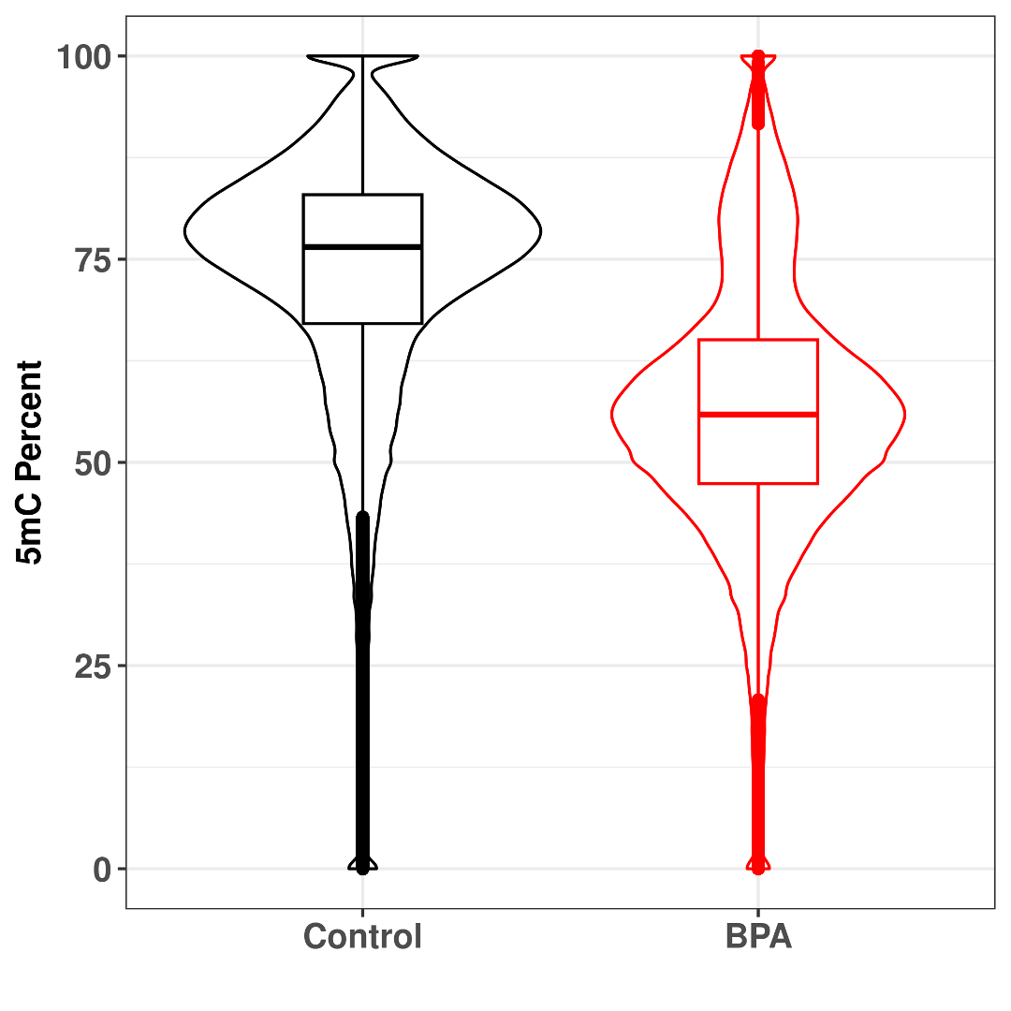
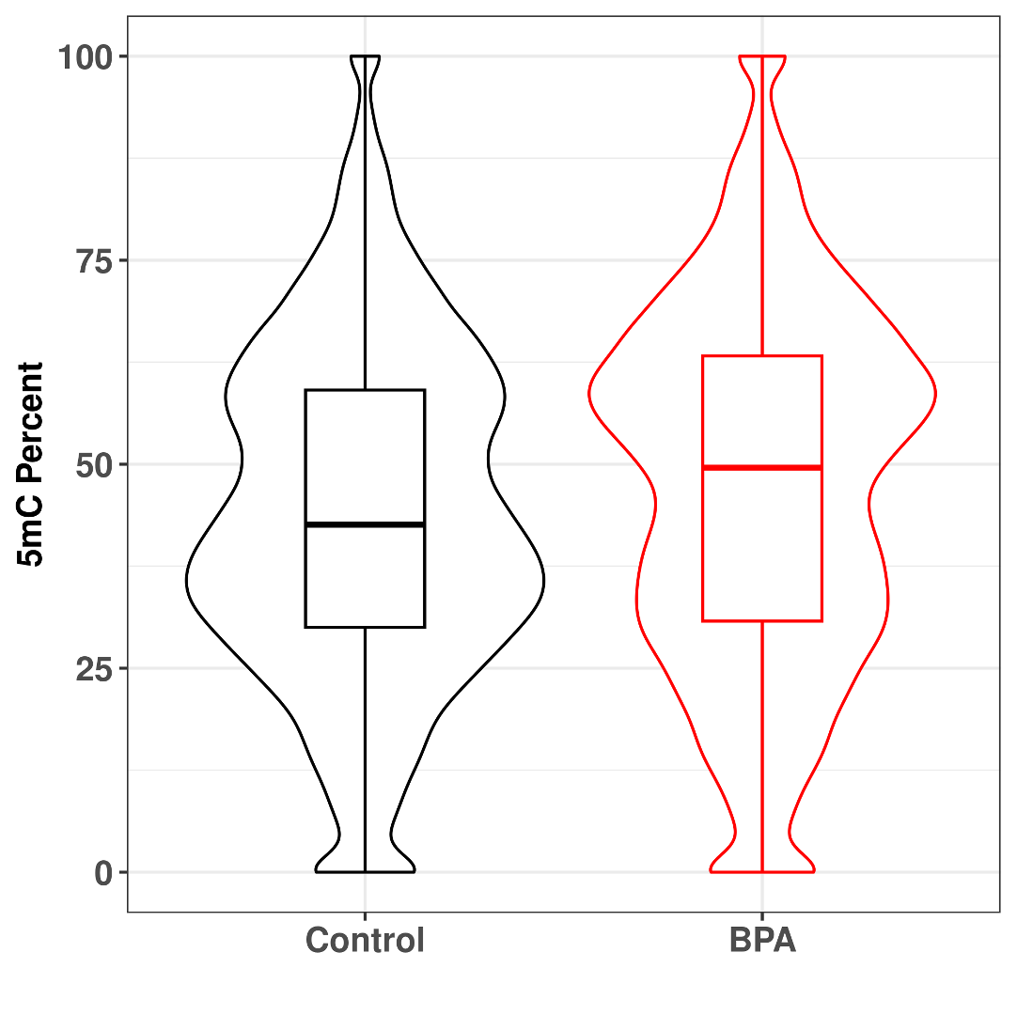
A
F0 Sperm
F1 Sperm

B
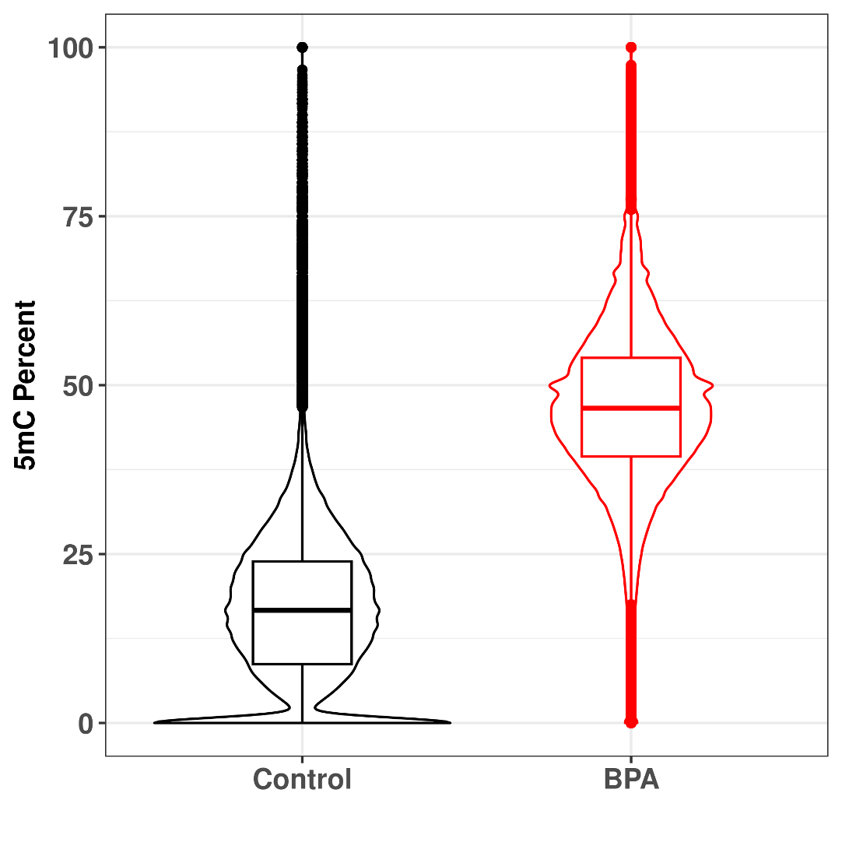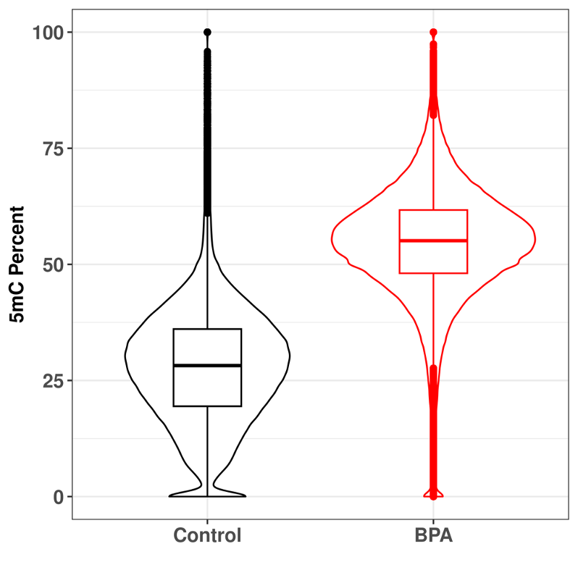
F2 Male Liver
F2 Female Liver
Figure S1. Violin plots illustrating the density distribution of 5mC percentages in Control and BPA lineages. (A) F0 and F1 sperm: Genome-wide methylation percentages were significantly higher in the F1 father’s sperm and lower in the F0 ancestor’s sperm from the BPA lineage compared to respective controls. (B) F2 male and female liver: Genome-wide methylation percentages were significantly higher in F2 BPA males and females than in controls, with a more pronounced difference in F2 female livers than in male livers. (p-value < 2.2e-16, for all comparison)

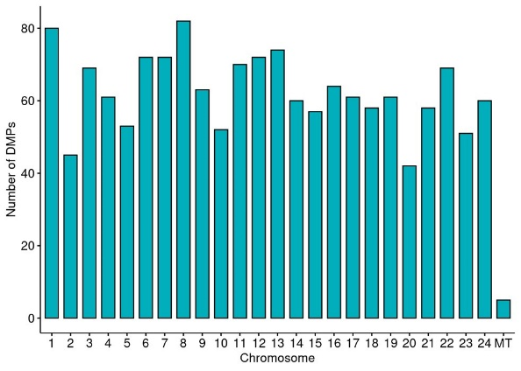
Figure S2. Chromosome-wide distribution of differentially methylated promoter-associated genes (DMPGs) in the liver of F2 females, showing a relatively even distribution across chromosomes.

