Anti-inflammatory activity - Inhibition of albumin denaturation
__________________________________________________________________________
Principle
Protein denaturation is a process in which proteins lose their tertiary structure and secondary structure by application of external stress or compound, such as strong acid or base, a concentrated inorganic salt, an organic solvent, or heat. Most biological proteins lose their biological function when denatured. The denaturation of proteins is a well-documented cause of inflammation. As part of the investigation on the mechanism of the anti-inflammation activity, the ability of plant extract to inhibit protein denaturation was studied. It was effective in inhibiting heat-induced albumin denaturation.
Material Required
Acetyl salicylic acid, BSA was purchased from Sigma Aldrich, USA. 10X PBS was purchased from Himedia, India.
Procedure
Denaturation of proteins is the main cause of inflammation. Inhibition of protein denaturation was evaluated by the method of Mizushima and Kobayashi and Sakatet al. with slight modification. 500 μL of 1% bovine serum albumin was added to NS-2 (500, 250, 100, 50 and 10 μg/mL) of test sample. This mixture was kept at room temperature for 10 minutes, followed by heating at 51°C for 20 minutes. The resulting solution was cooled down to room temperature and absorbance was recorded at 660 nm. Acetyl salicylic acid was taken as a positive control. The experiment was carried out in triplicates and percent inhibition for protein denaturation was calculated using:
% Inhibition=100−((A1-A2)/A0)*100)
Where A1 is the absorbance of the control, A2 is the absorbance of the test sample and A0 is the absorbance of the positive control.
A dose response curve was plotted to determine the IC50 values. IC50 is defined as the concentration sufficient to obtain 50% of a maximum scavenging capacity. All tests and analyses were run in triplicate and averaged.
A. OD Value at 660 nm
Control Mean OD value: 1.963

S. No | Tested sample concentration (μg/ml) | OD Value at 660 nm (in triplicates)
1. | Control | 1.993 | 1.913 | 1.985
2. | 500 μg/ml | 0.997 | 1.020 | 1.036
3. | 250 μg/ml | 1.114 | 1.121 | 1.147
4. | 100 μg/ml | 1.148 | 1.153 | 1.161
5. | 50 μg/ml | 1.677 | 1.693 | 1.686
6. | 10 μg/ml | 2.041 | 2.080 | 2.086
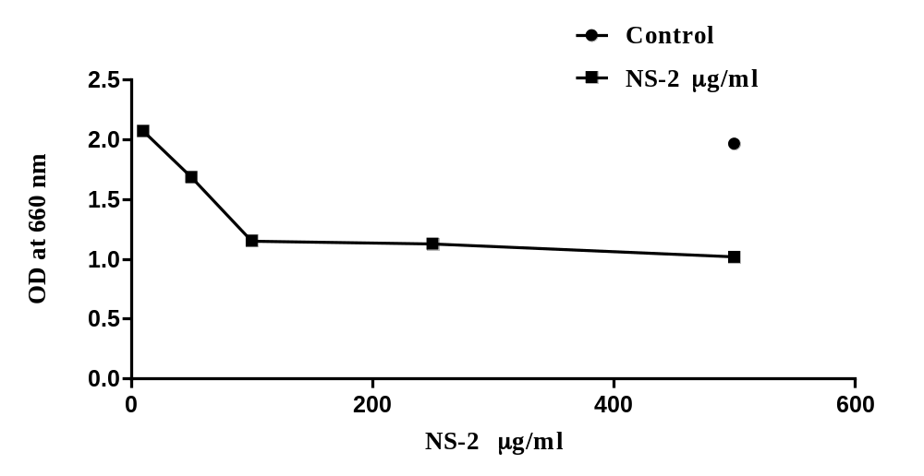

B. Inhibition percentage of albumin denaturation (%)
S. No | Tested sample concentration (μg/ml) | Inhibition percentage albumin denaturation (%)  (in triplicates) |  |  | Mean Value (%)
2. | 500 μg/ml | 49.2104 | 48.0387 | 47.2236 | 48.1576
3. | 250 μg/ml | 43.2501 | 42.8935 | 41.569 | 42.5709
4. | 100 μg/ml | 41.5181 | 41.2634 | 40.8558 | 41.2124
5. | 50 μg/ml | 14.5695 | 13.7545 | 14.1111 | 14.145
6. | 10 μg/ml | 0 | 0 | 0 | 0
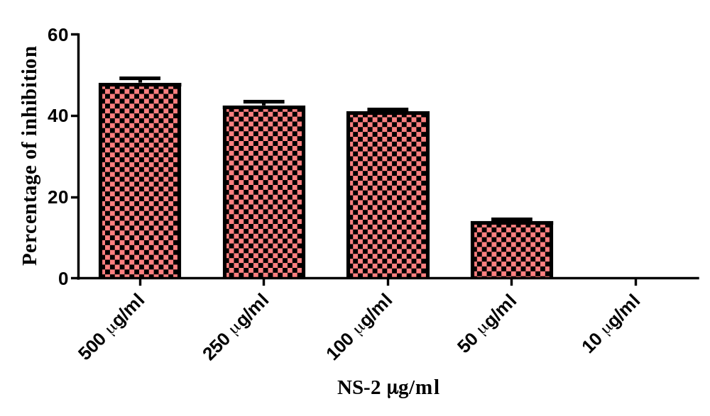

C. IC50 Value of tested sample: 58.68 μg/ml
log(inhibitor) vs. normalized response -- Variable slope
Best-fit values
LogIC50 |  | 1.768
HillSlope |  | -3.351
IC50 |  | 58.68
Std. Error
LogIC50 |  | 0.01391
HillSlope |  | 0.3704
95% Confidence Intervals
LogIC50 |  | 1.738 to 1.799
HillSlope |  | -4.151 to -2.551
IC50 |  | 54.76 to 62.88
Goodness of Fit
Degrees of Freedom |  | 13
R square |  | 0.9858
Absolute Sum of Squares |  | 311.6
Sy.x |  | 4.896
Number of points
Analyzed | 3 | 15

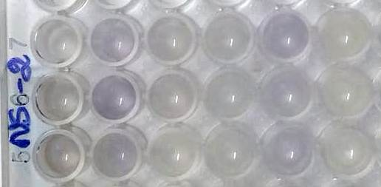
500μg/ml 250μg/ml 100μg/ml 50μg/ml 10μg/ml Control

Reference
1. Mizushima Y, Kobayashi M. Interaction of anti-inflammatory drugs with serum proteins, especially with some biologically active proteins. J Pharm Pharmacol 1968;20(3):169-73.
2. Sakat S, Juvekar AR, Gambhire MN. In vitro antioxidant and anti-inflammatory activity of methanol extract of Oxalis corniculataLinn. Int J Pharm PharmSci 2010;2(1):146-56.

