Extended Data and Supplementary Material for McShea & De Anda et al., Archaeal lineages related to eukaryotes encode functional diterpenoid cyclases.
Supplementary Text
Both sterols and hopanoids are synthesized from the isoprenoid precursors isopentenyl diphosphate (IPP) and its isomer dimethylallyl diphosphate (DMAPP). These precursors are synthesized across the tree of life through either the mevalonate (MVA) or methylerthritol 4-phosphate (MEP) pathway and joined to form isoprenoid chains of various lengths. Sterol- and hopanoid-producing organisms produce 15-carbon (C15) isoprenoids, join these to form a C30 substrate, and then engage a lengthy pathway to produce the final membrane lipid. Here, we explore the sterol or hopanoid biosynthesis capacity of Asgard archaea by searching isoprenoid pathways in 4,578 proteomes comprising 3,585 archaea (668 TACK, 644 DPANN, 1406 Euryarchaeota, and 867 Asgard), and 993 eukaryotes (Supplementary Table 1). We used curated hidden Markov models (HMM) implemented in MEBS v1.2¹ to establish the presence/absence of sterol biosynthesis Pfams as well as Interproscan v5.61- 93.0-64 and BLAST searches of public databases. We first focused on the synthesis of isoprenoid building blocks IPP and DMAPP, via MVA and MEP pathways (Supplementary Table 2). IPP and DMAPP are generated through the MEP pathway in most bacteria, and through the MVA pathway in eukaryotes and archaea^{2,3}. In archaea, isoprenoids from the MVA pathway are ether-linked to glycerol to form bulk membrane lipids known as glycerol dialkyl glycerol tetraethers (GDGTs)⁴. Lombard and Moreira² first suggested that the MVA was inherited from the last universal common ancestor (LUCA) and was later replaced by the MEP pathway in bacteria. Yet, it was recently proposed that MVA genes in eukaryotes were derived from myxobacteria⁵, contrary to the previous inference that the eukaryotic MVA pathway was inherited vertically from LUCA³. Rather than focusing on individual protein phylogenies from the MVA or MEP pathway, we evaluated the phylogenomic distribution of homologous protein families across a comprehensive genomic dataset of archaea and eukaryotes. The MVA pathway is widespread in Archaea and eukaryotes, except Huberarchaeota (DPANN) where none of the isoprenoid/sterol biosynthesis pathways seem to be present (Extended Data Fig. 1). Huberarchaeaota have reduced genomes with genes for biosynthesis of cofactors and amino acids being rare, and obvious gaps in core metabolic pathways⁶. The ubiquity of the MVA pathway in the entire archaeal domain is in agreement with previous studies suggesting the presence of this type of pathway in the archaeal common ancestor. Interestingly, we identified phosphomevalonate kinase (PMVK) – a key enzyme in the classical eukaryotic MVA pathway – in Asgard genomes (Heimdall-, Loki-, Hod- and Sif-). This is consistent with recent analysis using protein structure prediction and sensitive sequence searches to find many new eukaryotic signature proteins, including PMVK, in Asgard archaea⁷. We also confirmed the presence of PMVK in DPANN genomes from Candidatus Woesarchaeota and Microarchaeota (Extended Data Fig. 1) as was previously described by Hoshino and Gaucher³. The presence of PMVK in Microarchaeota was attributed to a horizontal gene transfer event (HGT) to Microarchaeota during the early evolution of eukaryotes. Yet the presence of this enzyme in Asgard genomes could indicate this enzyme could have been present before the eukaryogenesis event.
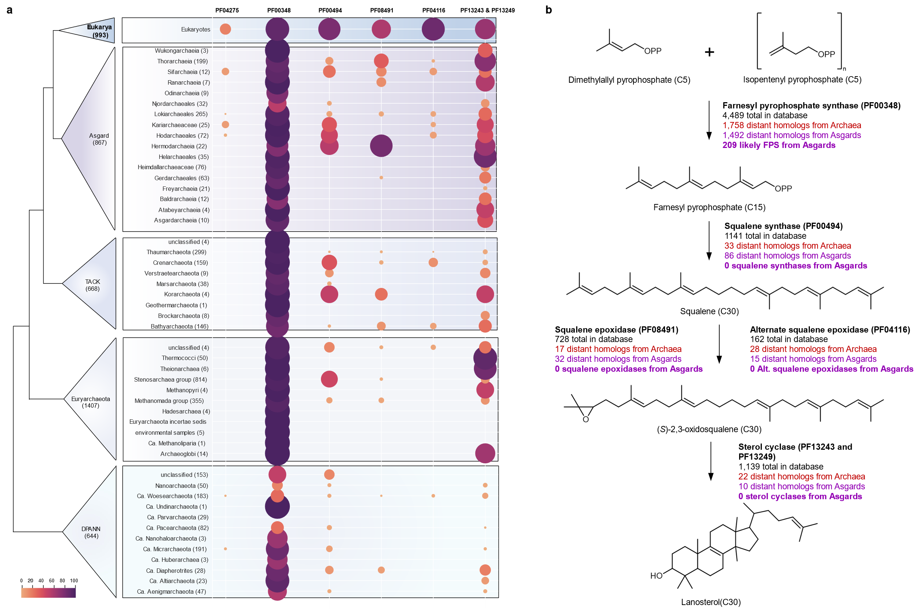
Extended Data Figure 1: Overview of protein families and sterol biosynthesis gene homologs in archaea and eukaryotes. a) Distribution of sterol biosynthesis gene-containing Pfams in the most up-to-date Asgardarchaeota dataset (867 genomes)⁸, compared with ∼4,000 publicly available archaeal genomes (668 TACK, 1,406 Euryarchaeota, 644 DPANN) and 993 eukaryotic genomes⁹. Sterol biosynthesis genes shown include: (1) isoprenoid lipid synthesis by polyprenyl synthase (PPS; PF00348), (2) squalene synthesis by squalene synthase (SQS or HpnCD; PF00494), (3) squalene epoxidation by either squalene epoxidase (SMO or SQE; PF08491) or alternative squalene epoxidase (altSMO; PF04116), and (4) triterpenoid cyclization by oxidosqualene cyclase (OSC; PF13249 and PF13243). Phosphomevalonate kinase (PF04275), which is part of the mevalonate pathway in eukaryotes, is also included due to its restricted distribution in Asgardarchaeota. See Supplementary Text for additional details. (b) Schematic overview of the biosynthesis pathway for simple sterols. Each step is labeled with the Pfam to which the relevant enzyme belongs (in bold). The total number of distant homologs identified by homology in Archaea (red) and in Asgardarchaeota (purple) is shown, while purple bold text indicates the number of sequences likely involved in sterol biosynthesis by phylogenetic analyses (see Extended Data Figs. 2–5).
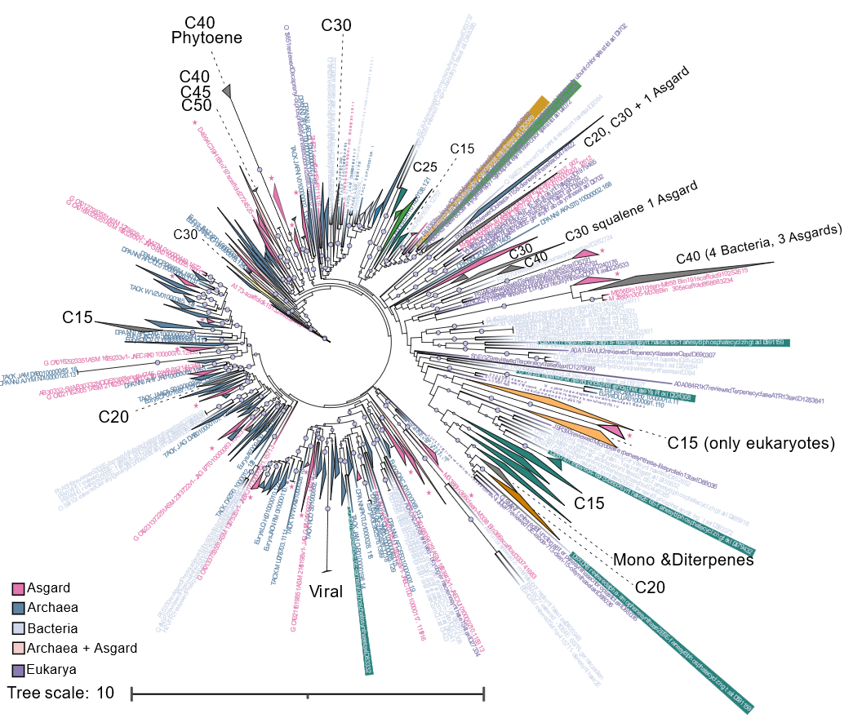
Extended Data Figure 2: Position of Asgard homologs within the polyprenyl synthetase (PPS) protein family. To detect the presence of polyprenyl synthetase we used the hidden Markov model PF00348. We then obtained 955 manually curated and experimentally verified (PPS) IPR008949 from UniProtKB/Swiss-Prot (accessed May 2024). Next, we searched for PPS in the JGI IMG and NCBI databases. Queries were performed using BLAST with an expected threshold of 0.05 and a word size of 5 for NCBI, and an e-value cutoff of 1e-5 for JGI, resulting in 302 bacterial sequences. A filter for only sequences >200 amino acids in length resulted in a total of 4,489 homologs of PPS sequences from: 1,492 Asgard, 821 Eukaryotes, 413 Bacteria, 1,758 Archaea, and 5 viral sequences. These were aligned with MAFFT v7.490 with a gap open penalty of 1.53, offset value of 0.123, and the BLOSUM62 exchangeability matrix. The alignment was masked (> 50% gaps removed) in Geneious prime. The phylogeny was estimated with IQ-TREE v2 with the ultrafast bootstrapping option -bb 1000 and UFBoot tree optimization (-bnni), Model LG+R10 was selected using the Bayesian Information Criterion (BIC). Tree was visualized and annotated in iTOLv6 9.1. CXX labels on figure indicate number of carbons in the isoprenoid chain synthesized by characterized enzymes in that clade: Farnesyl C15, Geranylgeranyl C20, Hexaprenyl C30, Heptaprenyl C35, Octaprenyl C40. Online version of the tree can be accessed here: https://itol.embl.de/tree/12822717208301724079747#
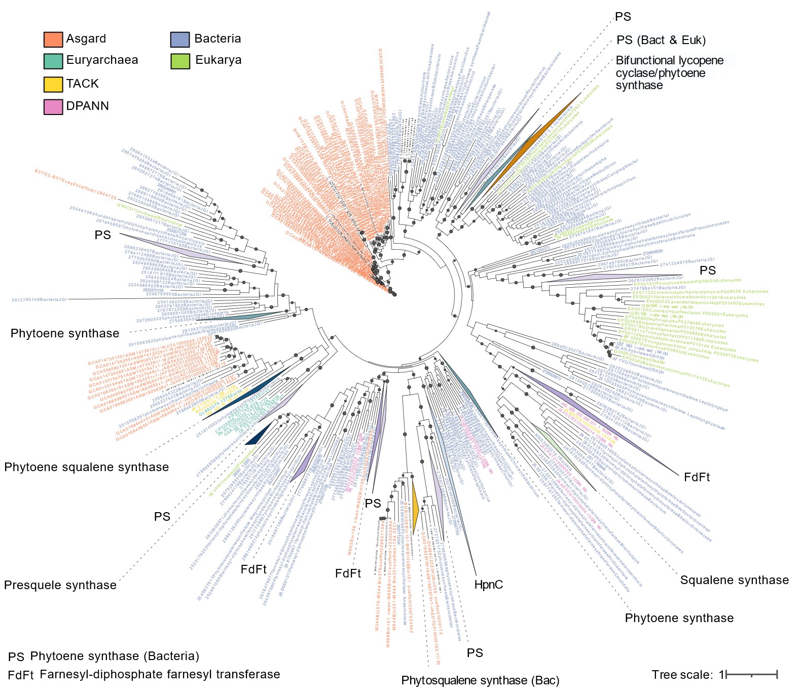
Extended Data Figure 3: Position of Asgard homologs within the squalene/phytoene synthase protein family. The Pfam domain PF00494 was used to detect squalene synthase (SQS, EC 2.5.1.21) and phytoene synthase (PSY, EC 2.5.1.32), as these enzymes shared three well-conserved regions involved in substrate binding and catalysis. First, we obtained 102 manually curated and experimentally tested squalene/phytoene synthase sequences from UniProtKB/Swiss-Prot (reviewed option). Searching the JGI IMG and NCBI databases by BLAST resulted in a total of 1,141 SQS/PSY sequences from 86 Asgard, 865 Bacteria, 9 DPANN, 20 Euryarchaea, 4 TACK, and 157 Eukaryotes. BLAST, alignment, masking, model selection, and IQ-TREE versions and parameters are the same as for Extended Data Fig. 2. Tree was estimated under the evolutionary model LG+F+R10, and can be accessed online here: https://itol.embl.de/tree/12822717178281723831461
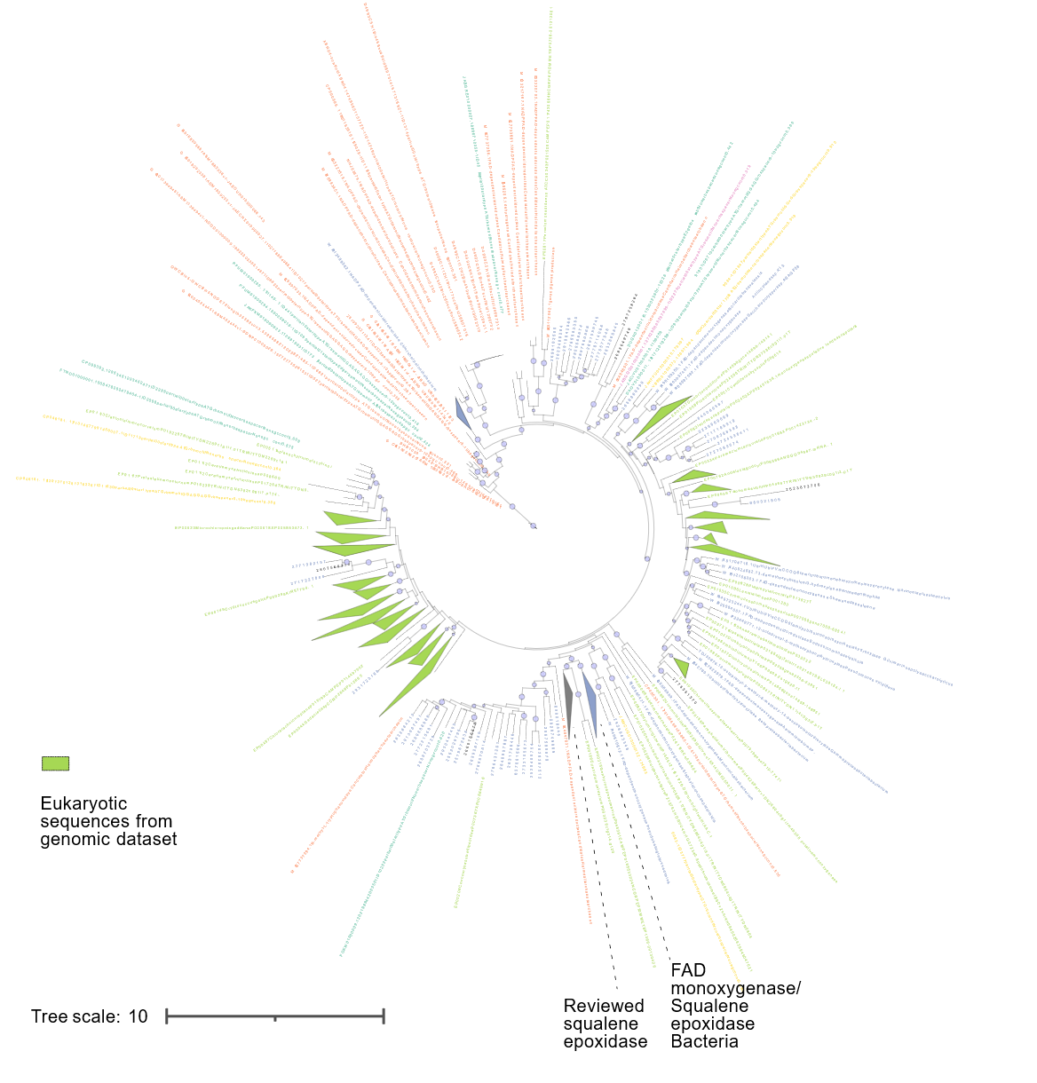
Extended Data Figure 4: Position of Asgard homologs within the squalene epoxidase (SMO) protein family. MEBS v1.2 was used to search for hits to the Pfam HMM PF08491 in our curated eukaryotic and archaeal genomes, and the phylogeny was estimated with these sequences as well as 35 reviewed sequences from UniProtKB/Swiss-Prot, and BLAST results from NCBI and JGI IMG. This resulted in a total of 510 homologs of squalene epoxidase in the eukaryotic genomes, and 77 and 57 homologs from JGI and NCBI respectively. From these, 123 were bacterial sequences (purple clades) and 40 eukaryotic. From the curated archaeal genomes, a total of 32 Asgard, 1 DPANN, 11 Euryarchaea, and 5 TACK are included in the tree. The phylogeny was estimated for a total of 728 squalene epoxidase homologs under the model LG+R10. BLAST, alignment, masking, model selection, and IQ-TREE versions and parameters are the same as for Extended Data Fig. 2. Online version of the tree can be accessed here: https://itol.embl.de/tree/9911493178160411725370573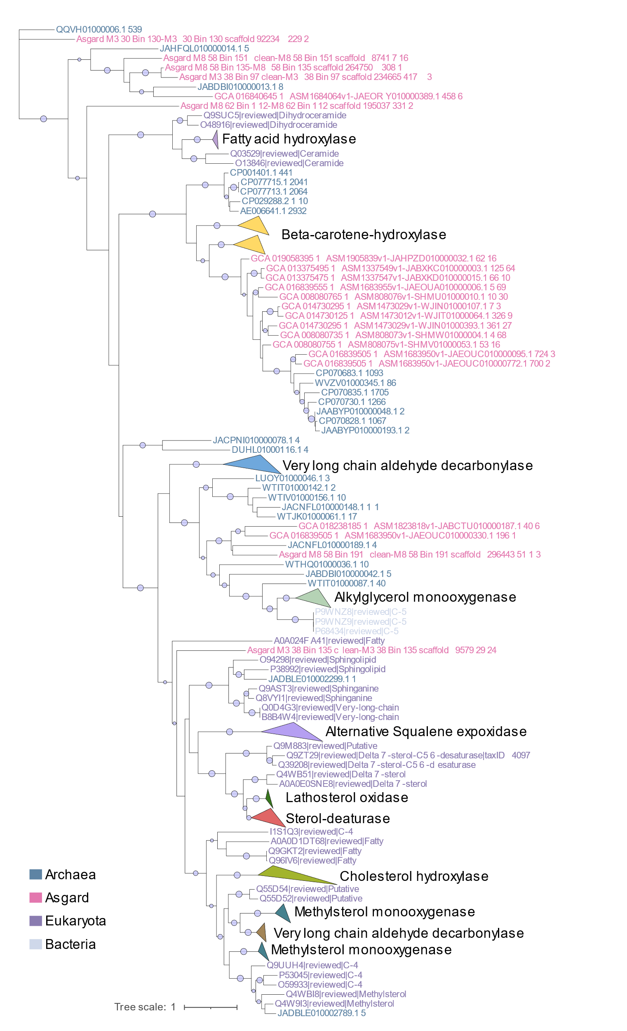
Extended Data Figure 5: Position of Asgard homologs within the alternative squalene epoxidase (AltEpox) protein family. MEBS v1.2 was used to search for hits to the Pfam HMM PF08491 in our curated genomic database (including 43 hits from archaea and 7 from Asgard) . The phylogeny was estimated with these sequences as well as 162 reviewed sequences from UniProtKB/Swiss-Prot, and BLAST results from NCBI and JGI IMG.BLAST. The alignment, masking, and IQ-TREE versions and parameters are the same as for Extended Data Fig. 2. Tree was estimated under the evolutionary model PMB+R7, and can be accessed online here: https://itol.embl.de/tree/9911493178160821727642336
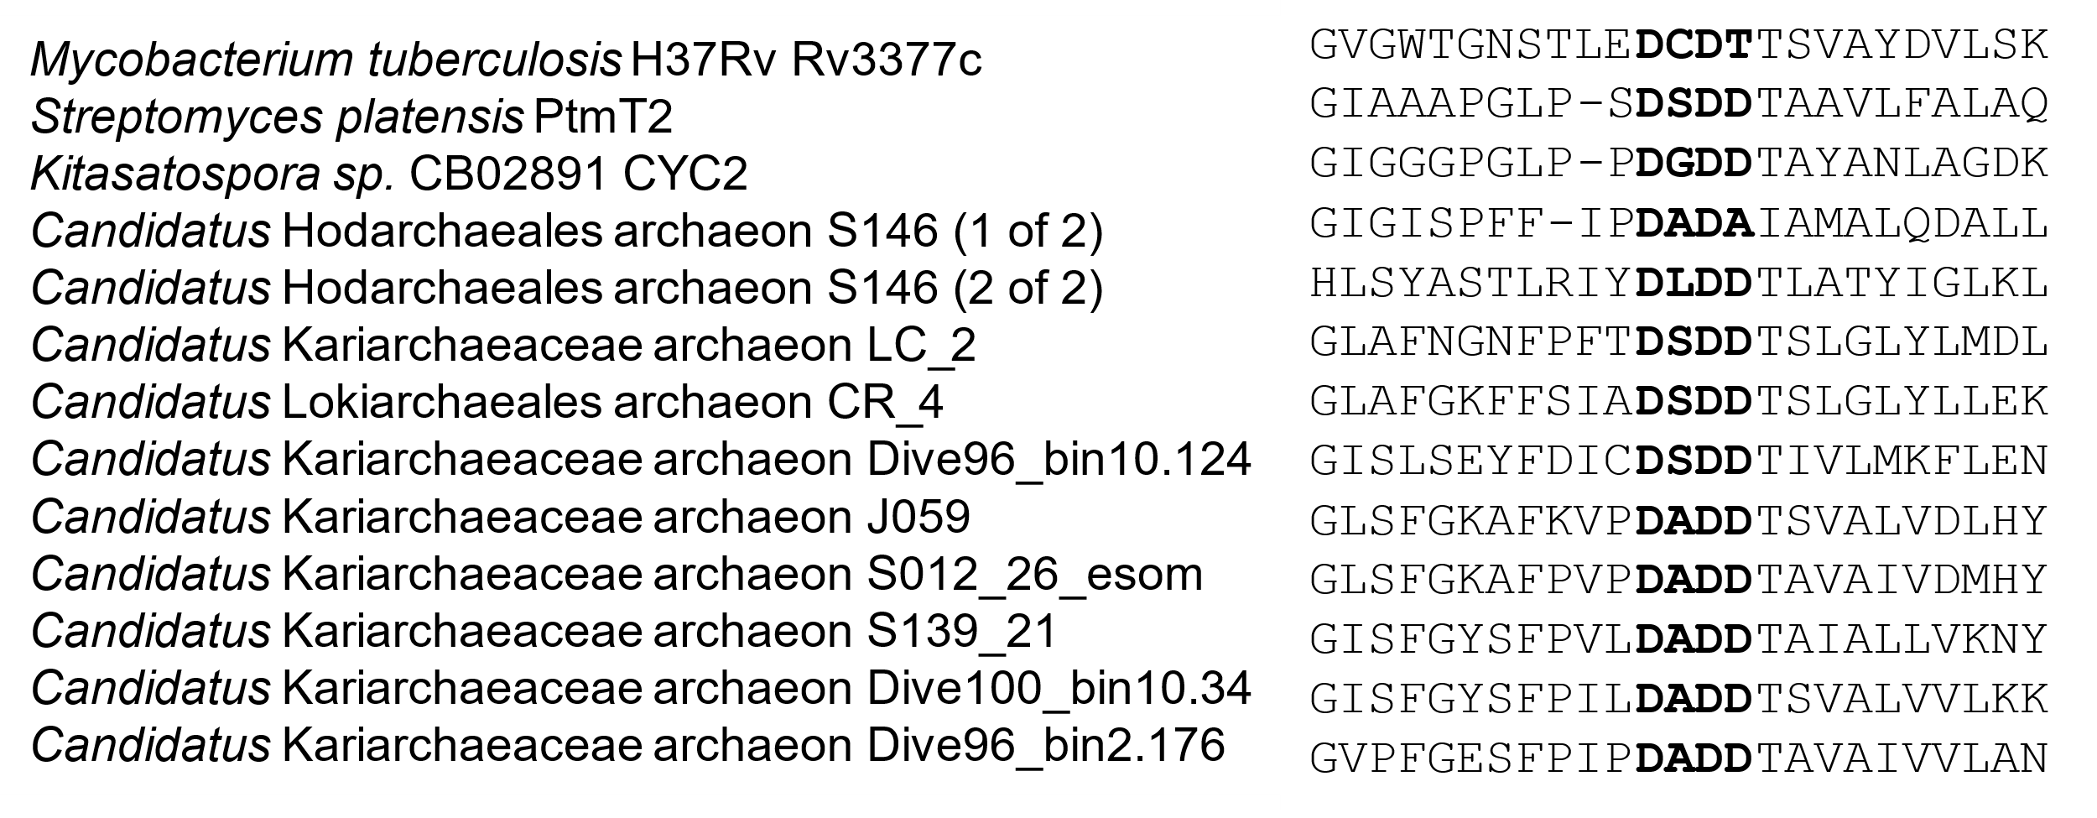 Extended Data Figure 6: Asgard diterpenoid cyclases have the terpenoid cyclase active site motif. Alignment estimated with MAFFT-DASH¹⁰.
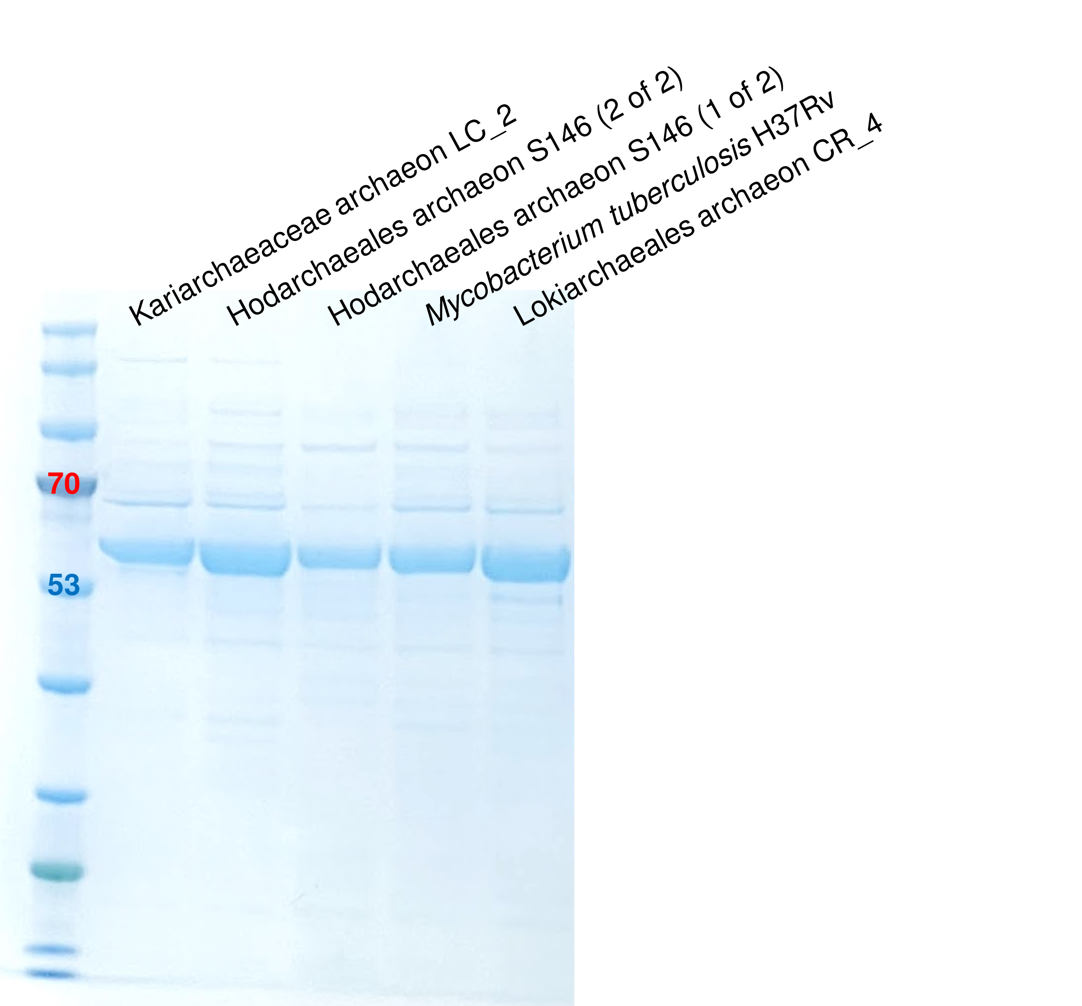
Extended Data Figure 7: Asgard cyclases and positive control from M. tuberculosis were partially purified by affinity chromatography.
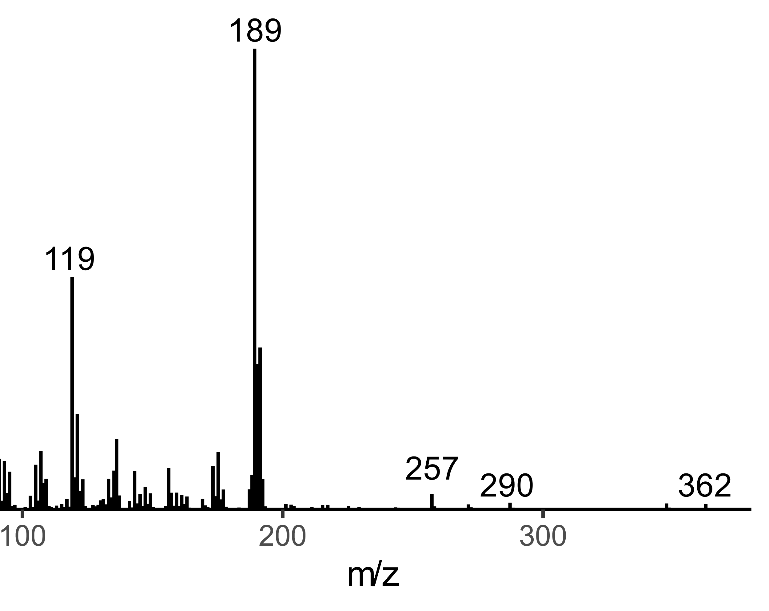
Extended Data Figure 8: Mass spectrum of peak at 21.35 minutes, identified by comparison to published spectra as the trimethylsilyl derivative of 2, halimadienol.

Extended Data Table 1: Asgard cyclases tested for GGPP cyclization in this study.
Short name | Taxon | Assembly | Gene | Product identified
Kariarchaeaceae LC2 | Candidatus Kariarchaeaceae | GCA_001940725_1_ASM194072v1 | Heimdall.LC2_MDVR01000113.1_113_14 | Halimadienyl pyrophosphate (2’)
Hodarchaeales S146 (1 of 2) | Candidatus Hodarchaeales | GCA_015520535_1_ASM1552053v11 | WAPZ01000551.1_551_1 | Halimadienyl pyrophosphate (2’)
Hodarchaeales S146 (2 of 2) | Candidatus Hodarchaeales | GCA_015520535_1_ASM1552053v1 | WAPZ01000470.1_470_2 | None
Lokiarchaeales CR_4 | Candidatus Lokiarchaeales | GCA_001940655_1_ASM194065v1 | MBAA01000202.1_172_3 | None
Extended Data Table 2: Plasmids used in this study.
Plasmid | Description | Source
pET-28a(+) | pET derivative with ColE1/pMB1/pBR322/pUC ori, Kan^{R}, N-terminal 6x His tag. All cyclases were cloned into this plasmid. | Twist Bioscience
pACYC-GroEL/ES-TF  (pPVW7383) | pACYC-Duet1 derivative with p15A ori, Cam^{R}. Addgene #83923. Expresses GroEL/ES and trigger factor. | ¹¹

Extended Data Table 3: Strains constructed in this study.
Expression strain | Plasmids
HM138 | pACYC (pPVW7383), pET-Mycobacterium_tuberculosis_Rv3377c (pHM115)
HM141 | pACYC (pPVW7383), pET-Kariarchaeaceae_LC2 (pHM118)
HM144 | pACYC (pPVW7383), pET-Hodarchaeales_S146_(1 of 2) (pHM134)
HM145 | pACYC (pPVW7383), pET-Hodarchaeales_S146_(2 of 2) (pHM135)
HM147 | pACYC (pPVW7383), pET-Lokiarchaeales_CR_4 (pHM119)

Supplementary References
1. De Anda, V. et al. MEBS, a software platform to evaluate large (meta)genomic collections according to their metabolic machinery: unraveling the sulfur cycle. GigaScience 6, gix096 (2017).
2. Lombard, J. & Moreira, D. Origins and Early Evolution of the Mevalonate Pathway of Isoprenoid Biosynthesis in the Three Domains of Life. Molecular Biology and Evolution 28, 87–99 (2011).
3. Hoshino, Y. & Gaucher, E. A. On the Origin of Isoprenoid Biosynthesis. Molecular Biology and Evolution 35, 2185–2197 (2018).
4. Vinokur, J. M., Korman, T. P., Cao, Z. & Bowie, J. U. Evidence of a Novel Mevalonate Pathway in Archaea. Biochemistry 53, 4161–4168 (2014).
5. Hoshino, Y. & Gaucher, E. A. Evolution of bacterial steroid biosynthesis and its impact on eukaryogenesis. Proceedings of the National Academy of Sciences 118, e2101276118 (2021).
6. Li, L. et al. Comparative Genomics Provides Insights into the Genetic Diversity and Evolution of the DPANN Superphylum. mSystems 6, 10.1128/msystems.00602-21 (2021).
7. Köstlbacher, S. et al. Structure-based inference of eukaryotic complexity in Asgard archaea. 2024.07.03.601958 Preprint at https://doi.org/10.1101/2024.07.03.601958 (2024).
8. Appler, K. E. et al. Oxygen metabolism in descendants of the archaeal-eukaryotic ancestor. 2024.07.04.601786 Preprint at https://doi.org/10.1101/2024.07.04.601786 (2024).
9. Richter, D. J. et al. EukProt: A database of genome-scale predicted proteins across the diversity of eukaryotes. Peer Community Journal 2, (2022).
10. Rozewicki, J., Li, S., Amada, K. M., Standley, D. M. & Katoh, K. MAFFT-DASH: integrated protein sequence and structural alignment. Nucleic Acids Research 47, W5–W10 (2019).
11. Lamppa, J. W., Tanyos, S. A. & Griswold, K. E. Engineering Escherichia coli for soluble expression and single step purification of active human lysozyme. Journal of Biotechnology 164, 1–8 (2013).

