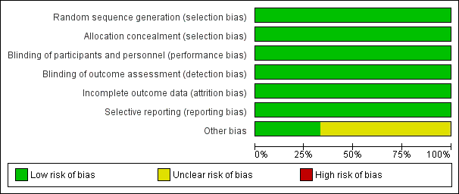
Figure S1: Risk of bias graph.
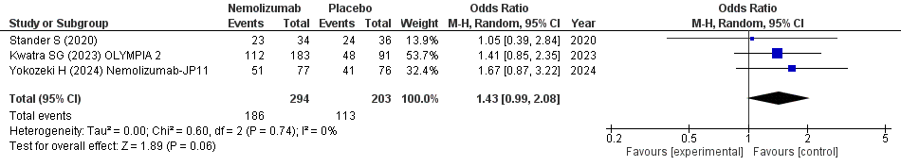
Figure S2: A forest plot of any adverse events incidence in the Nemolizumab group compared with the placebo group.
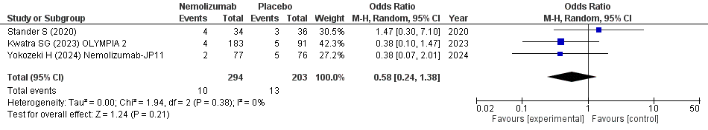
Figure S3: A forest plot of Serious adverse events incidence in the Nemolizumab group compared with the placebo group.
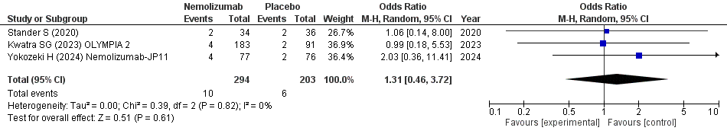
Figure S4: A forest plot of Adverse events leading to treatment discontinuation incidence in the Nemolizumab group compared with the placebo group.
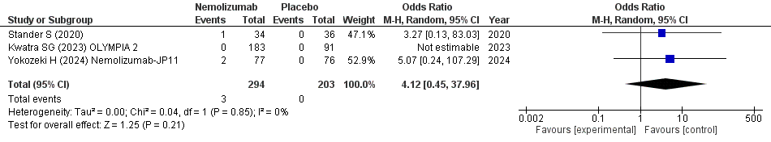
Figure S5: A forest plot of Injection-related reaction incidence in the Nemolizumab group compared with the placebo group.
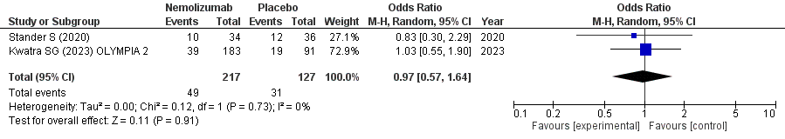
Figure S6: A forest plot of Infection or infestation incidence in the Nemolizumab group compared with the placebo group.
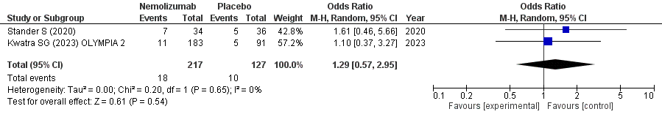
Figure S7: A forest plot of Gastrointestinal event incidence in the Nemolizumab group compared with the placebo group.
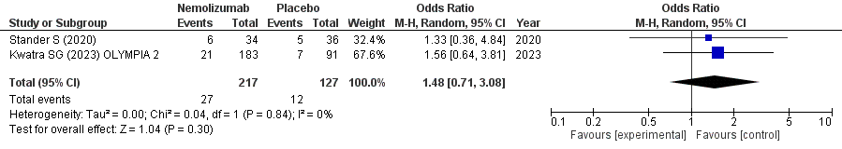
Figure S8: A forest plot of Musculoskeletal or connective-tissue event incidence in the Nemolizumab group compared with the placebo group.
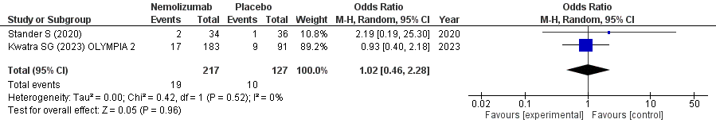
Figure S9: A forest plot of Nervous system disorder incidence in the Nemolizumab group compared with the placebo group.
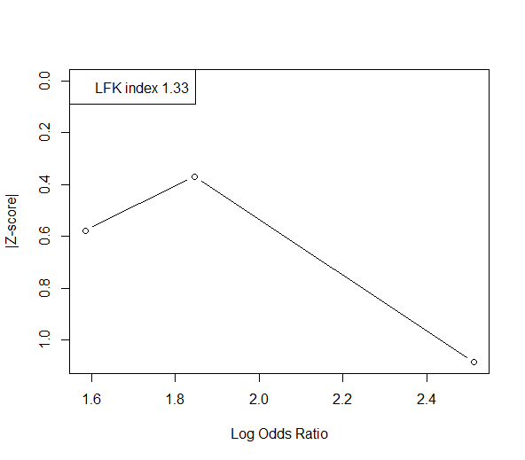
Figure S10: A Doi plot of PP-NRS improvement from baseline of ≥4 points in the Nemolizumab group compared with the placebo group.
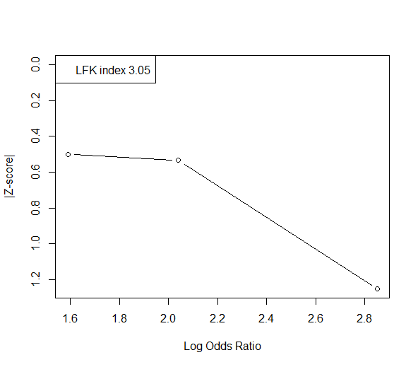
Figure S11: A Doi plot of IGA response in the Nemolizumab group compared with the placebo group.
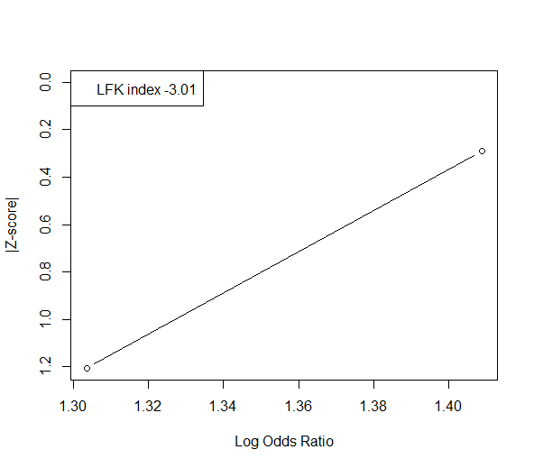
Figure S12: A Doi plot of SD-NRS improvement from baseline of ≥4 points in the Nemolizumab group compared with the placebo group.
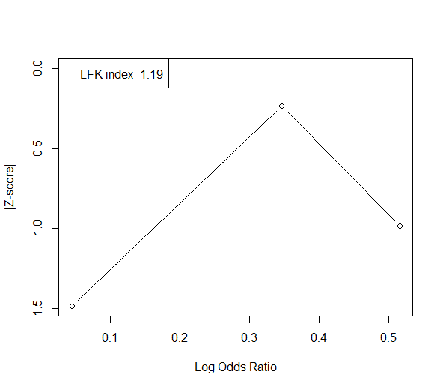
Figure S13: A Doi plot of any adverse event incidence in the Nemolizumab group compared with the placebo group.
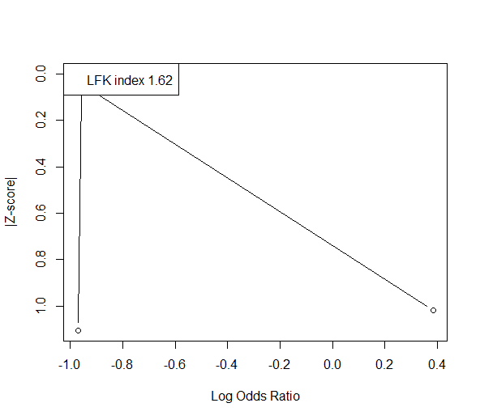
Figure S14: A Doi plot of serious adverse event incidence in the Nemolizumab group compared with the placebo group.
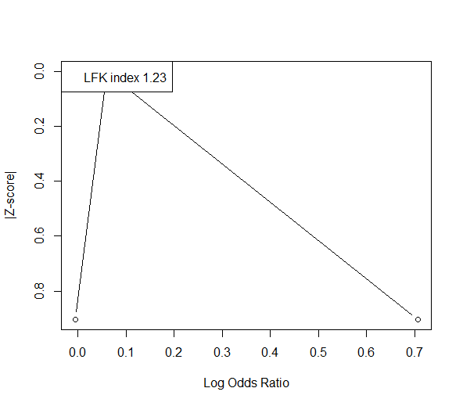
Figure S15: A Doi plot of adverse events leading to treatment discontinuation in the Nemolizumab group compared with the placebo group.
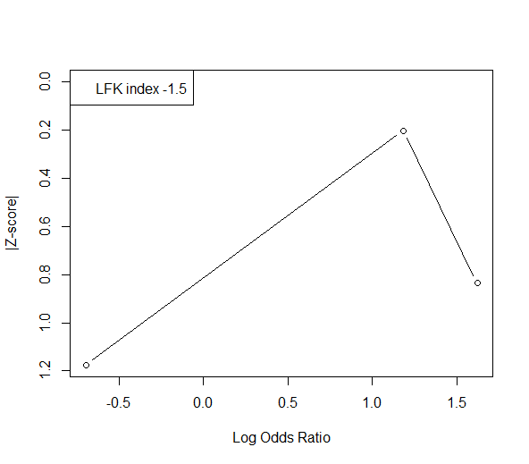
Figure S16: A Doi plot of injection-related reaction incidence in the Nemolizumab group compared with the placebo group.
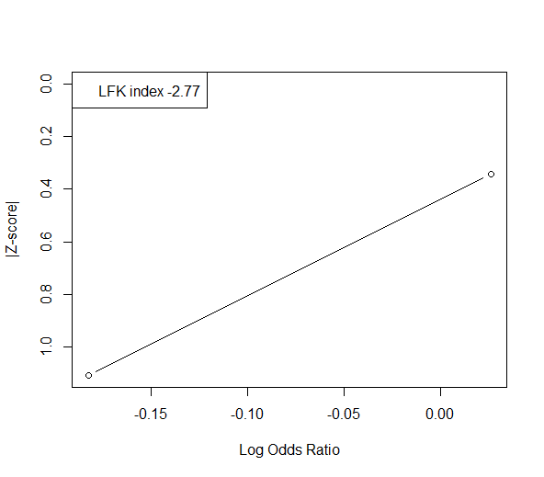
Figure S17: A Doi plot of infection or infestation incidence in the Nemolizumab group compared with the placebo group.
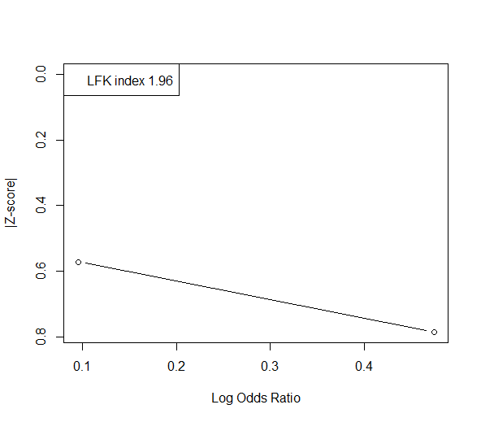
Figure S18: A Doi plot of gastrointestinal event incidence in the Nemolizumab group compared with the placebo group.
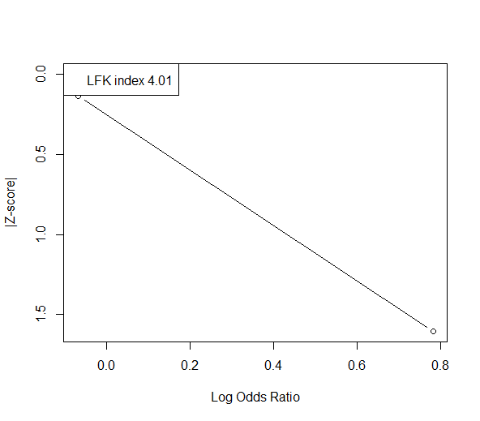
Figure S19: A Doi plot of musculoskeletal or connective-tissue event incidence in the Nemolizumab group compared with the placebo group.
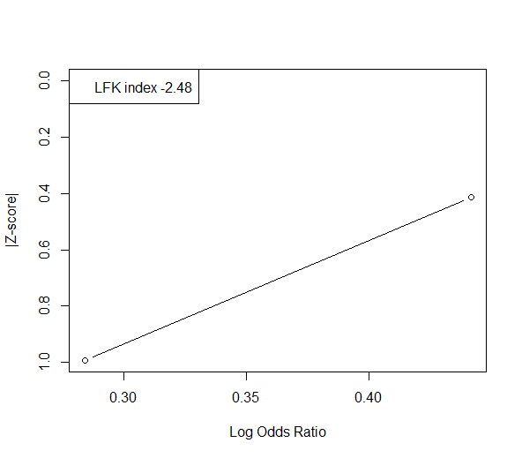
Figure S20: A Doi plot of nervous system disorder incidence in the Nemolizumab group compared with the placebo group.

