Fig S1
Disposable ordinary suction catheter. Produced by Jiangsu HuaXia medical devices limited liability company with a diameter of 8mm.
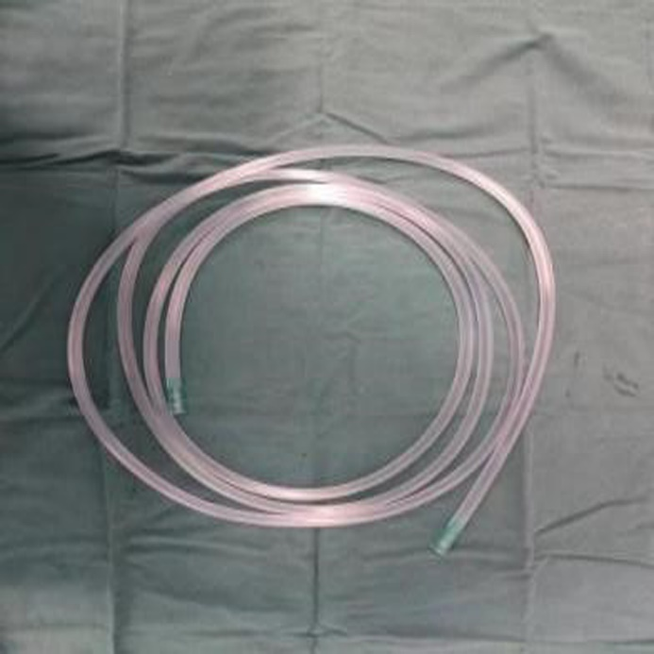

Fig S2
Schematic diagram of instruments used in operation: A: Obturator of plasma resection scope. B: Inner sheath of plasma resection scope. C: Outer sheath of plasma resection scope. D: Self-made irrigation catheter. E: 50ml disposable syringe.
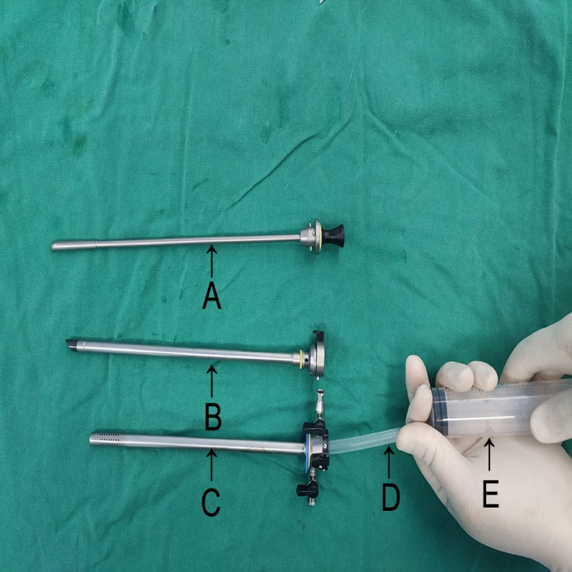

Fig S3
Schematic diagram of bladder blood clot removal surgery using plasma resection scope combined with self-made irrigation catheter.
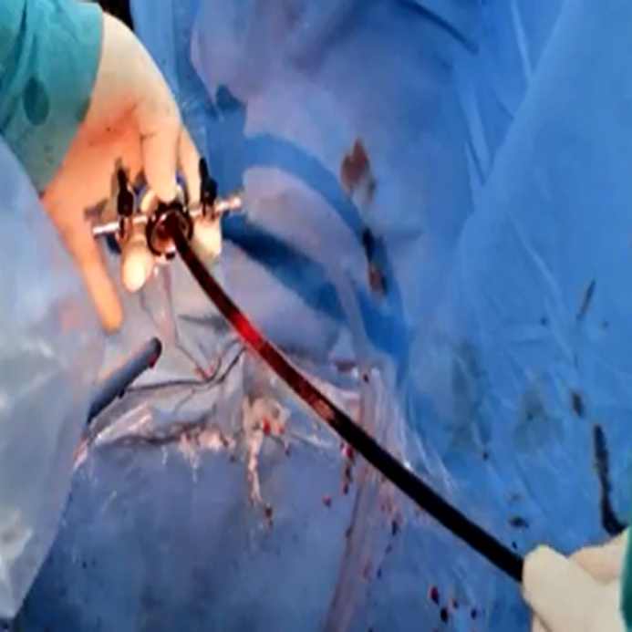

Fig S4
Preoperative computerized tomography (CT) scan showed a large amount of blood clot in the bladder.
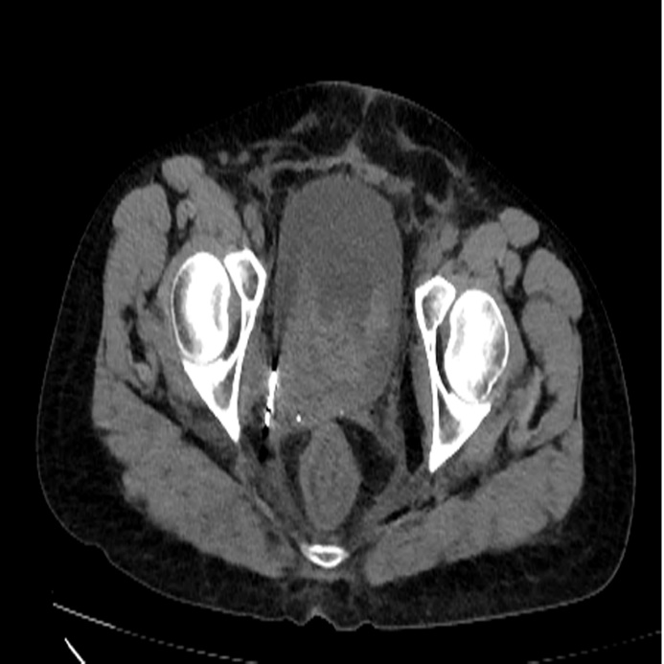

Fig S5
Postoperative computerized tomography (CT) scan showed that the blood clot in the bladder had been cleared completely.
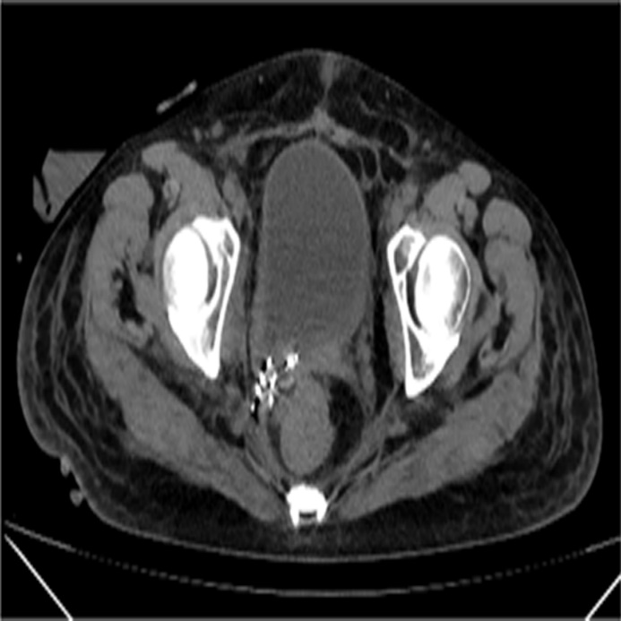

Table S1 The percentage of hemorrhage causes between two groups
Reasons of bleeding | Control group（n=10） |  | Experimental group （n=11）
Reasons of bleeding | Number of patients（n） | Percent（%） | Number of patients（n） | Percent（%）
TURBT | 3 | 30 | 7 | 63
BPH | 2 | 20 | 2 | 18
PCNL | 3 | 30 | 1 | 9.5
URS | 2 | 20 | 1 | 9.5
Total | 10 | 100 | 11 | 100

Table S2 Comparison of blood clot clearance between two groups of patients
Category | Number of patients（n） | Duration of procedure（min） | Redicted size of clots（g） | Postoperative flushing time（d） | Number of rebleeding cases（n）
Control group | 10 | 51.00±12.01 | 178.50±43.85 | 2.05±0.76 | 1
Experimental group | 11 | 36.64±8.19 | 167.27±50.12 | 1.32±0.60 | 1
t |  | 3.230 | 0.544 | 2.453
P |  | 0.004 | 0.593 | 0.024
Note: numbers=n, minutes=min, gram=g, days=d

Table S3 Summary of the methods published works concerning with patients of bladder blood clot tamponade
Number | Authors | Year | Document Type | Number of Patients | Methods | Surgery (Yes/No)
1 | Clarebrough, E et al(9) | 2018 | Retrospective study | 16 | Manual bladder washouts | No
2 | Aydin, Cemil et al(10) | 2019 | Retrospective study | 27 | Thoracic catheter | No
3 | Marc W. Plawker et al(11) | 1997 | Case report | 6 | Rectal tube | No
4 | XU M et al(12) | 2020 | Retrospective study | 31 | Hydrogen peroxide | No
 | WARLICK C A et al(14) | 2006 | NA | 1 | Hydrogen peroxide | No
5 | DELLA CORTE M et al(13) | 2023 | Review | / | Urokinase, streptokinase | No
6 | JIA B et al(15) | 2014 | Retrospective study | 22 | Chymotrypsin, sodium bicarbonate | No
7 | JIANG C Y et al(17) | 2023 | Retrospective study | 49 | Metal urinary catheter | Yes
8 | SU Y T et al(18) | 2019 | Review | 2 | Ellik evacuator | Yes
9 | DOERSCH K M et al(19) | 2017 | Case report | 6 | Prostate morcellation device | Yes
10 | WU R H et al(20) | 2022 | Retrospective study | 9 | Prostate morcellation device with real-time ultrasound guidance | Yes

