Supplemental Tables
Supplemental Table 1. Medications for guideline-directed medical therapy
Beta-blockers
Angiotensin-converting enzyme inhibitors
Angiotensin II receptor blockers
Angiotensin receptor neprilysin inhibitors
Mineralocorticoid receptor antagonists
Aspirin
P2Y12 inhibitors
Direct oral anticoagulants
Warfarin
Loop diuretics
Mineral corticoid receptor antagonists
Tolvaptan
Sodium-glucose cotransporter 2 inhibitors
Statins
Proton pump inhibitors

Supplemental Table 2. Scoring for nursing care needs
 | 0 points | 1 point | 2 points
Turning over in bed | Can do | Can do with support | Cannot do
Transfers | No assistance | Partial assistance | Full assistance
Oral hygiene | No assistance | Needs assistance | –
Feeding | No assistance | Partial assistance | Full assistance
Dressing/undressing | No assistance | Partial assistance | Full assistance
Following instructions for treatment and nursing care | Yes | No | –
Risky behavior | None | – | Present

Supplemental Table 3. Hyperparameter search space for machine learning models
Model | Parameters | Search area
Logistic regression | C | 1e-6, 1e-4, 1e-2, 1, 1e2, 1e4, 1e6
 | max_iter | 10000
 | class_weight | balanced
 | solver | liblinear
Random forests | n_estimators | 50, 100, 200, 500
 | max_depth | 10, 20, 30
 | min_samples_split | 2, 5, 10
 | min_samples_leaf | 1, 2, 4
Extreme gradient boosting | n_estimators | 50, 100, 200, 500
 | max_depth | 3, 5, 7, 10
 | colsample_bytree | 0.3, 0.5, 0.7,1.0
 | subsample | 0.5, 0.7, 0.9, 1.0
 | gamma | 0, 0.1, 0.2
 | min_child_weight | 1, 3, 5
Light gradient boosting machine | n_estimators | 50, 100, 200, 500
 | max_depth | 3, 5, 7, 10
 | num_leaves | 31, 64, 128
 | colsample_bytree | 0.3, 0.5, 0.7,1.0
 | subsample | 0.5, 0.7, 0.9, 1.0
 | min_child_samples | 5, 10, 20

Model | Best Parameters
Logistic regression | {'C': 1}
Random forests | {'n_estimators': 200, 'max_depth': 10, 'min_samples_split': 4, 'min_samples_leaf': 4}
Extreme gradient boosting | {'colsample_bytree': 0.7, 'gamma': 0, 'max_depth': 3, 'min_child_weight': 5, 'n_estimators': 50, 'subsample': 1.0}
Light gradient boosting machine | {'colsample_bytree': 0.3, 'max_depth': 3, 'min_child_samples': 10, 'n_estimators': 50, 'num_leaves': 31, 'subsample': 0.5}
Supplemental Table 4. Optimal hyperparameters for each machine learning model
Supplemental Table 5. Selected features
Feature | Logistic regression | Random forests | Extreme gradient boosting | Light gradient boosting machine
Number of selected features | 28 | 51 | 52 | 36
Demographics
Age (years) | ● | ● | ● | ●
Male sex | ● | ● | ● | ●
Body mass index (kg/m²) |  | ● | ● | ●
Hospitalization days (day) |  | ● | ● | ●
Nursing care needs score at discharge | ● | ● | ● | ●
Prior emergency hospitalizations | ● | ● | ● | ●
Comorbidities
Acute coronary syndrome: ICD10; I200, I21 |  | ●
Atrial fibrillation: ICD10; I48 |  | ●
Dyslipidemia: ICD10; E78 | ● | ● | ●
Diabetes mellitus: ICD10; E10–E14 |  | ● | ●
Hypertension: ICD10; I10–I12, I15 | ● | ● | ● | ●
Ischemic heart disease: ICD10; I201–209, I22–25 |  | ●
Medications at discharge
Beta-blockers | ● | ● | ● | ●
ACE-Is / ARBs and ARNIs | ● | ● | ● | ●
Aspirin |  | ● | ●
P2Y12 inhibitors |  |  | ●
Direct oral anticoagulants |  | ● | ●
Warfarin | ● | ● | ●
Loop diuretics | ● | ● | ●
Mineral corticoid receptor antagonists |  | ● | ●
Tolvaptan | ● | ● | ● | ●
SGLT2 inhibitors |  |  | ●
Statins | ● | ● | ●
Proton pump inhibitors |  | ● | ●
Pimobendan | ●
Gout medications |  | ●
Psychiatric drugs | ● |  | ●
Hypnotics |  | ● | ●
Number of ni-GDMT medications | ● | ● | ● | ●
In-hospital treatments
Catecholamines |  | ● | ●
Opioids |  |  | ●
Intravenous loop diuretics dosage (mg) / hospitalization |  | ● | ● | ●
Ventilator |  |  | ●
Mechanical circulatory supports | ●
Hemodialysis | ●
Laboratory findings at admission
White blood cells (10³/µL) |  | ● | ● | ●
Hemoglobin (g/dL) |  | ● | ● | ●
Aspartate transaminase (IU/L) | ● | ● | ● | ●
Alanine transaminase (IU/L) | ● | ● | ● | ●
Albumin (g/dL) |  | ● | ● | ●
Blood urea nitrogen (mg/dL) |  | ● | ● | ●
Creatine kinase (IU/L) | ● | ● | ● | ●
Uric acid (mg/dL) |  | ● | ● | ●
eGFR (mL/min/1.73 m²) | ● | ● | ● | ●
Sodium (mEq/L) |  | ● | ● | ●
Potassium (mEq/L) |  | ● | ● | ●
NT-proBNP (pg/mL) |  | ● | ● | ●
Laboratory findings at discharge
White blood cells (10³/µL) |  | ● | ● | ●
Hemoglobin (g/dL) | ● | ● | ● | ●
Aspartate transaminase (IU/L) |  | ● | ● | ●
Alanine transaminase (IU/L) |  | ● | ● | ●
Albumin (g/dL) | ● | ● | ● | ●
Blood urea nitrogen (mg/dL) |  | ● | ● | ●
Creatine Kinase (IU/L) |  | ● | ● | ●
Uric acid (mg/dL) | ● | ● | ● | ●
eGFR (mL/min/1.73 m²) | ● | ● | ● | ●
Sodium (mEq/L) | ● | ● | ● | ●
Potassium (mEq/L) | ● | ● | ● | ●
NT-proBNP (pg/mL) | ● | ● | ● | ●
ICD, international statistical classification of diseases and related health problems; ACE-Is, angiotensin-converting enzyme inhibitors; ARBs, angiotensin II receptor blockers; ARNIs, angiotensin receptor neprilysin inhibitors; SGLT2, sodium-glucose cotransporter 2; ni-GDMT, not included in the guideline-directed medical therapy; eGFR, estimated glomerular filtration rate; NT-proBNP, N-terminal pro-brain natriuretic peptide
Supplemental Figure 1.
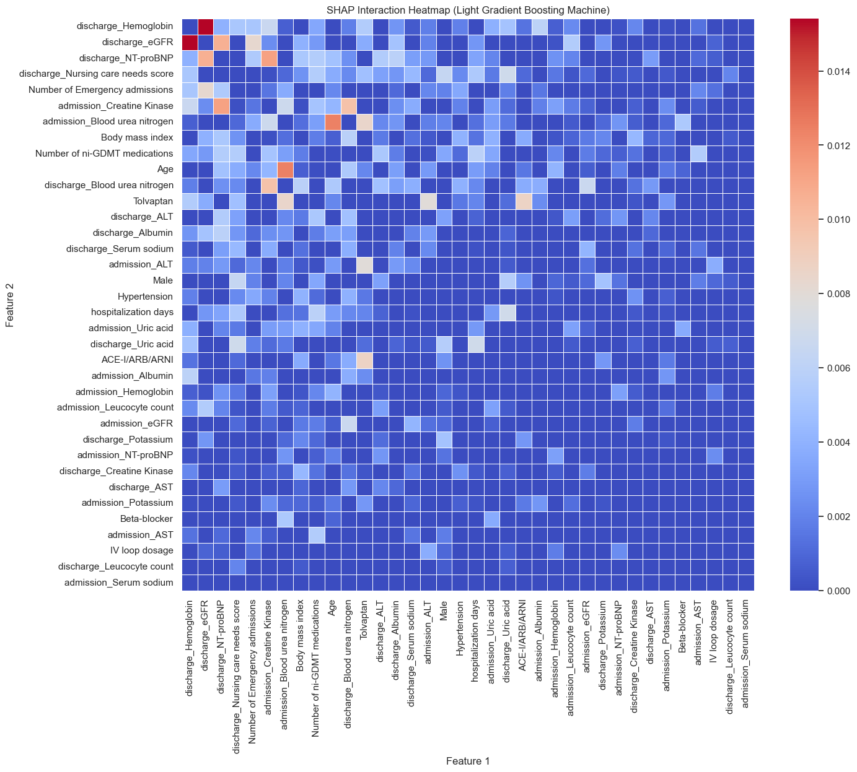
Supplementary Fig 1. SHapley Additive exPlanations (SHAP) interaction heat map
A full matrix heatmap showing the interactions between features in the Light Gradient Boosting Machine is presented. ACE-I, angiotensin-converting enzyme inhibitor; ARB, angiotensin II receptor blocker; ARNI, angiotensin receptor neprilysin inhibitor; ni-GDMT, not included in the guideline-directed medical therapy; ALT, alanine transaminase; AST, aspartate transaminase; NT-proBNP, N-terminal pro-brain natriuretic peptide; eGFR, estimated glomerular filtration rate

