Appendix
- Baseline information
- Strobe checklist for observational studies
 | Item N° | Recommendation
Title and abstract | 1 | (a) Indicate the study’s design with a commonly used term in the title or the abstract | Done
 |  | (b) Provide in the abstract an informative and balanced summary of what was done and what was found | Done
Introduction
Background/rationale | 2 | Explain the scientific background and rationale for the investigation being reported | Done
Objectives | 3 | State specific objectives, including any prespecified hypotheses | Done
Methods
Study design | 4 | Present key elements of study design early in the paper | Done
Setting | 5 | Describe the setting, locations, and relevant dates, including periods of recruitment, exposure, follow-up, and data collection | Done
Participants | 6 | (a) Give the eligibility criteria, and the sources and methods of selection of participants. Describe methods of follow-up | Done
 |  | (b) For matched studies, give matching criteria and number of exposed and unexposed | Done
Variables | 7 | Clearly define all outcomes, exposures, predictors, potential confounders, and effect modifiers. Give diagnostic criteria, if applicable | Done
Data sources/measurement | 8* | For each variable of interest, give sources of data and details of methods of assessment (measurement). Describe comparability of assessment methods if there is more than one group | Done
Bias | 9 | Describe any efforts to address potential sources of bias | Done
Study size | 10 | Explain how the study size was arrived at | Not applicable
Quantitative variables | 11 | Explain how quantitative variables were handled in the analyses. If applicable, describe which groupings were chosen and why | Done
Statistical methods | 12 | (a) Describe all statistical methods, including those used to control for confounding | Done
 |  | (b) Describe any methods used to examine subgroups and interactions | Done
 |  | (c) Explain how missing data were addressed | Done
 |  | (d) If applicable, explain how loss to follow-up was addressed | Not applicable
 |  | (e) Describe any sensitivity analyses | Done
Results
Participants | 13* | (a) Report numbers of individuals at each stage of study—e.g., numbers potentially eligible, examined for eligibility, confirmed eligible, included in the study, completing follow-up, and analyzed | Done
 |  | (b) Give reasons for non-participation at each stage | Done
 |  | (c) Consider use of a flow diagram | Done
Descriptive data | 14* | (a) Give characteristics of study participants (e.g., demographic, clinical, social) and information on exposures and potential confounders | Done
 |  | (b) Indicate number of participants with missing data for each variable of interest | Done
 |  | (c) Summarize follow-up time (e.g., average and total amount) | Done
Outcome data | 15* | Report numbers of outcome events or summary measures over time | Done
Main results | 16 | (a) Give unadjusted estimates and, if applicable, confounder-adjusted estimates and their precision (e.g., 95% confidence interval). Make clear which confounders were adjusted for and why they were included | Done
 |  | Make clear which confounders were adjusted for and why they were included | Done
 |  | (b) Report category boundaries when continuous variables were categorized | Done
 |  | (c) If relevant, consider translating estimates of relative risk into absolute risk for a meaningful time period | Not applicable
Other analyses | 17 | Report other analyses done—e.g. analyses of subgroups and interactions, and sensitivity analyses | Done
Discussion
Key results | 18 | Summarize key results with reference to study objectives | Done
Limitations | 19 | Discuss limitations of the study, taking into account sources of potential bias or imprecision. | Done
 |  | Discuss both direction and magnitude of any potential bias | Done
Interpretation | 20 | Give a cautious overall interpretation of results considering objectives, limitations, multiplicity of analyses, results from similar studies, and other relevant evidence | Done
Generalizability | 21 | Discuss the generalizability (external validity) of the study results | Done
Other information
Funding | 22 | Give the source of funding and the role of the funders for the present study and, if applicable, for the original study on which the present article is based | Done

- List of variables
- Flowchart 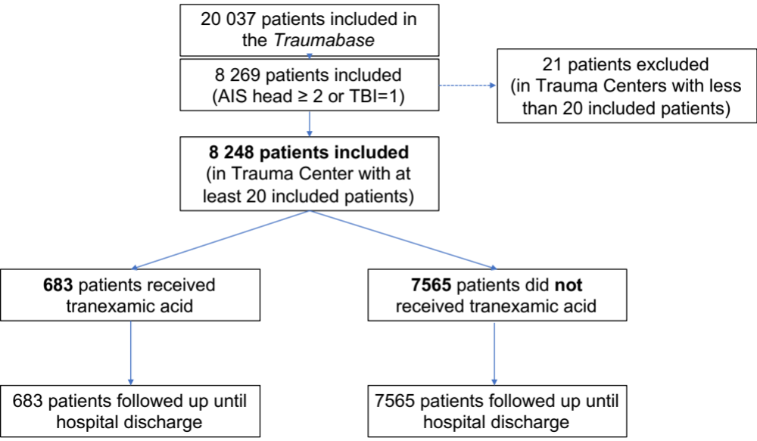
- Theoretical Principles
- Observational data and Principles of causal inference
A fundamental difference between experimental and observational studies consists in the randomization of treatment assignment for the former and absence thereof in the latter. In the absence of an experimental design, estimating a treatment effect with heterogenous observational data the risk of bias and inconsistencies. In critical care, or more generally in health care, if an observational study compares two groups of patients, the group receiving the treatment associates most often with a higher level of severity and thus carry a higher probability to receive the treatment. The control of confounding factors that at the same time attribute administration of the treatment and/or influence the outcome becomes crucial in order to balance these factors between the two groups in the absence of randomization.
Causal inference estimates the connecting relationship between an exposition, such as a treatment, and an effect, such as mortality. The identification of principal confounding factors culminates in the construction of a causal relationship model. These confounding factors are defined by an association to the outcome criterion but are not supposed to contribute to the causal pathway between the exposition variable and the outcome (Lederer). The causal model summarizes the various hypotheses about the eventual causal relationships to define the analysis plan based on the available scientific knowledge.
For a causal analysis to estimate the average treatment effect, this list of features must contain at least the outcome of interest and the treatment assignment.
It is recommended to map these relationships and interactions in a Directed Acyclic Graph (DAG). Within a DAG unidirectional arrows indicate graphic representation of these relationships and interactions. Figure 4 illustrates an example of a DAG.

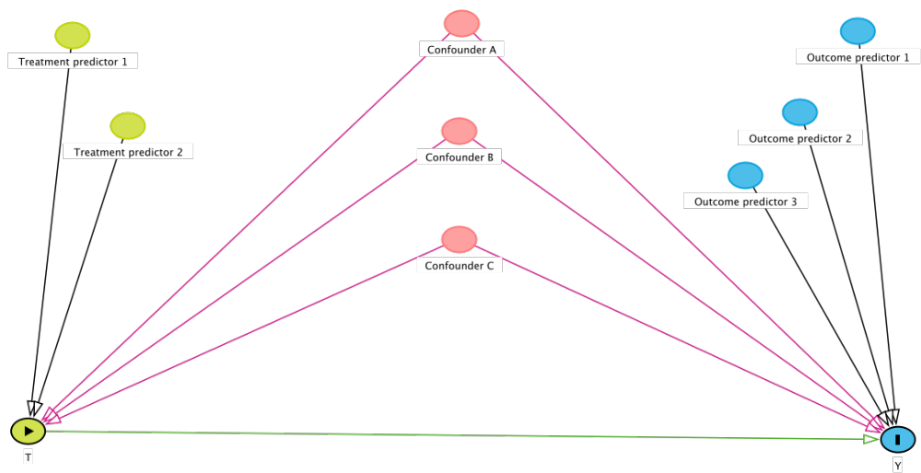

Figure 2: DAG, predictors of exposition (node “T), pictured in green, predictors of the outcome criterion (node “Y”), pictured in blue, confounding factors pictured in red.
- Identifiability and Unconfoundedness
Given the major drawback of observational data with the lack of a randomized treatment assignment, an essential assumption is required to “transform" the data in a way to emulate this property and estimate the average treatment effect. The key aspect of this assumption is known as ignorability or unconfoundedness. In order to estimate the ATE from the present data set, a correction is required to compensate for the lack of randomization of the treatment assignment (in the present example TXA or no TXA). The information contained in the data set allows this compensation in order to emulate an experiment by reversing or retracing the treatment assignment process. This assumption can be translated as “there is sufficient information about the treatment assignment decision process captured in the describing features (e.g., the patient’s pre-treatment state and baseline characteristics), so that conditionally on every possible patient description, we have a random treatment assignment. This ensures independence between potential outcomes and treatment assignment. Defining the correct set of such describing features requires domain-specific knowledge. The information required should allow to emulate an experiment by reversing or retracing the treatment assignment process. For instance, if a treatment is prescribed as soon as at least two out of three conditions $A$, $B$ and $C$ are satisfied, then it is possible to retrospectively retrace this assignment as long as information on conditions $A$, $B$ and $C$ is recorded. The assumption that this correction is possible from the available data is referred to as unconfoundedness or ignorability. This process of correcting for the nonrandomized treatment assignment is also called deconfounding
- Deconfounding or balancing
The key step in estimating treatment effects from observational data is the deconfounding, sometimes also referred to as balancing of the treatment groups. The balancing can be achieved by different means, namely by matching or re-weighting methods. The quality of this balancing can be assessed in different ways using for instance different statistical tests reference, but the most popular approach is to compare standardized mean differences before and after the balancing. If these differences fall beyond some small threshold, usually 10%, for all confounding factors, the balancing step is considered successful. If the balancing step is however failing or insufficient, then the balancing method or the propensity model need to be revisited.
- Model choice
A popular choice for the propensity model, i.e., the model that describes the treatment decision, is logistic regression allowing to relate the confounding factors to the binary treatment assignment. Note that it is possible to handle uninformative missing values in the logistic regression (Jiang et al. 2020). Other possible models are decision trees or their generalization, such as random forests. These can account for interactions between multiple covariates (Wager and Athey 2018).
- Effect of treatment estimation
After completion of these previous steps, it is possible to estimate the average treatment effect from the data set. Balancing renders the treatment groups comparable and enables methods similar to those employed in experimental studies, such as for the estimation of ATE, to analyze the difference of the average outcomes from the balanced groups. Two popular approaches to treatment effect estimation with observational data under the unconfoundedness assumption are propensity score matching and inverse propensity weighting.
A propensity score is based on the propensity model, i.e., a model relating the treatment administration to the list of baseline factors, estimating the probability to receive the treatment depending on a number of confounders. This score ranges from 0 to 1. Although common, matching pairs of patients from both treatment groups reduces the number of available patients in the study and thus reduce power and may also induce a selection bias ^{19,20}. To navigate this difficulty an alternative approach exists, the inverse propensity score weighting (IPW). IPW allows to include all patients of the cohort by applying a weighting factor to each patient. To obtain two comparable groups, the contribution of each patient to the treatment effect is estimated with the following formula:
- 1 / propensity score, for a treated patient;
- 1 / (1- propensity score), for a non-treated patient
Patients with an intermediate propensity score around 0.5 have the same probability to receive the treatment or not to receive the treatment. The propensity of these patients can be considered as equivalent to inclusion in a randomized controlled trial, since their profile does not determine the administration of the intervention. The IPW approach attributes these patients and the corresponding assignment uncertainty more weight, while keeping patients with propensity score close to the boundaries and with small weights. The potentially high variance of the IPW and its pitfalls related to model misspecification call for an alternative, which has been first proposed by Robins et al. (1994), the augmented IPW or doubly robust method.
The doubly robust method disposes of superior statistical characteristics compared to a propensity score or inverse proportional weighting^{17,18}. IPW only takes into account the predictive effect of confounding variables on treatment allocation (an analogous approach exists that only considers the predictive effect on the outcome). The doubly robust method considers the dual aspect of predictors: treatment allocation and outcome. This concept allows for a more efficient alternative to propensity score matching and IPW: it optimally exploits the entire data. Not only is this approach more data-efficient, it is also robust to “bad", i.e., inaccurate, modeling of either the propensity or outcome model. Note that this method requires specification of both the outcome and propensity model. Another advantage of the Doubly Robust Method lies its compatibility with modern machine learning algorithms as applied in the present study.
Additionally, in the case of our specific TXA question, this estimator is most attractive, since it allows us to incorporate information both about the hemorrhage state of the patient – necessary to adjust for the treatment bias – and about the severity of the brain injury.

- Missing data
In almost all data set are contaminated by missing values (Josse, Reiter, and others 2018; Mayer, Josse, et al. 2019). Before proceeding to the actual data analysis, it is essential to assess the data quality, in particular the level of missing data or missingness, i.e., how many observations are available. It is important to understand that it is not necessarily the amount of missing data that can lead to problems in subsequent analyses but rather the source or the mechanism behind missing values. In the statistical literature, a classical taxonomy for the missingness mechanisms basically distinguishes uninformative and informative missing values (Rubin 1976). The former characterizes cases where the missingness mechanism is either completely at random or only depends on observed information, while the latter contains all other cases. For instance, missing values due to a defective measurement device (blood pressure cuff not working) are noninformative. If a value is missing because the measured value exceeds the range of the measurement device, then the missingness is due to the missing value itself. This is an example of informative missingness. In the context of this study, the Glasgow Coma Scale is difficult to assess in an intubated and sedated patient, hence the information is missing but for a specific reason. As any registry, the Traumabase contains missing values, some of which are explicitly encoded as being informative missing values. Figure 4 depicts the percentages of missing values in the Traumbase according to the type and mechanism of missingness; Table 3 give the proportions of missing values in each treatment arm. It is important to distinguish the mechanism behind missing data, since the choice of the statistical analysis tool(s) and imputation approach depends on the detected or assumed missingness mechanism.
Figure 4, Percentage of missing values for each variable of the Traumabase (subset of variables relevant for traumatic brain injury). Different encodings of missing values: NA (not available), not informed, not made, not applicable, impossible.

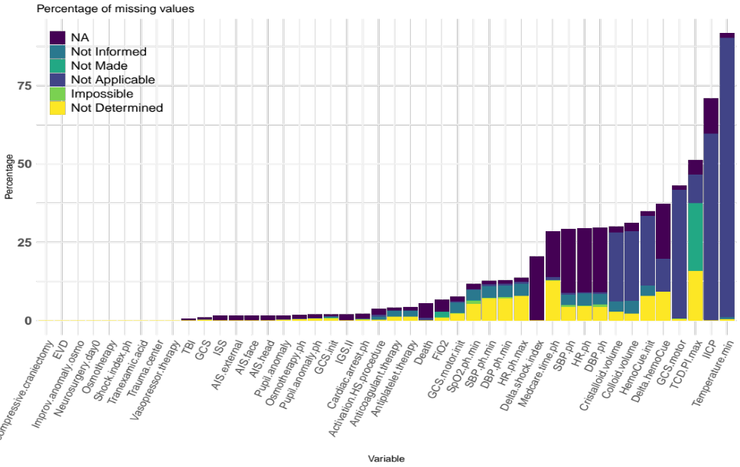
In the context of treatment effect estimation, applying straightforward imputation techniques can lead to heavy bias in the final treatment effect estimates (Leyrat et al. 2019). For a review on different approaches for handling missing values in the context of treatment effect estimation, we refer the reader to and how to combine these with a Doubly Robust Method please refer to Mayer et al. 2020.
The two techniques adopted in this work are Multiple imputation with chained, MICE, and Missing incorporated in attributes, MIA.
- Multiple imputation with chained equations (MICE)

Multiple Imputation with chained equations (MICE) exploits the correlation between various variables and variable patterns replacing missing values with plausible values. In the given example of a TBI cohort, patients with a GCS of 3 is more likely to have a pupil anomaly. MICE is a probabilistic approach taking to a certain extent into account the level of uncertainty associated with estimating missing values. Figure 5 illustrates the approach. For every missing value represented by a “?” five plausible values are suggested by the automatic imputation algorithm based on the correlation patterns of various variables. Five copies of the initial data set are created. In each new set missing values are replaced by plausible values. The ATE (Average treatment effect) is then calculated for every completed data set. The final ATE corresponds to the mean of all ATE for every imputed data set.
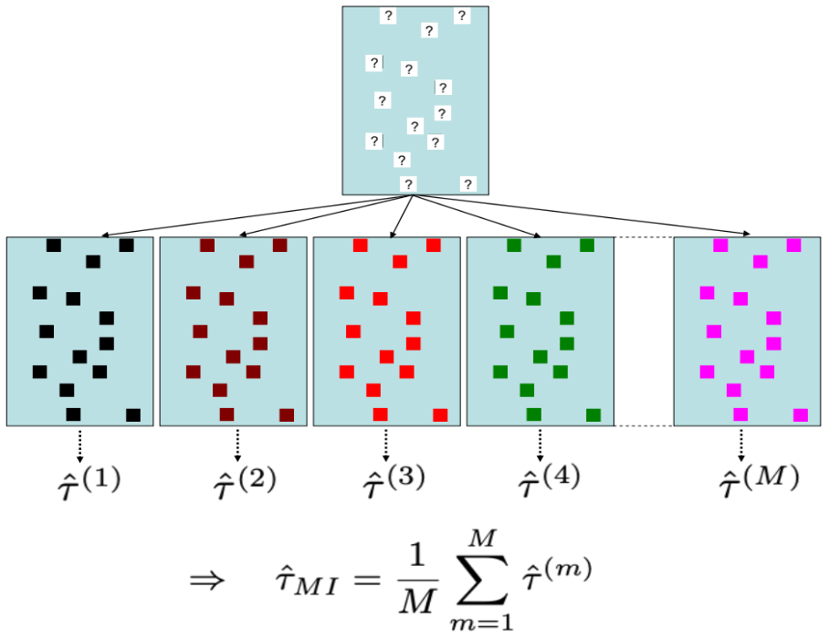
Figure 5: MICE

- Missing incorporated in attributes (MIA)
The method Missing Incorporated in Attributes applies a so-called machine learning component by automatic learning and does not correspond to a classical imputation technique. The method employs random decision forests algorithms learning autonomously and empirically by filtering through the data set. These algorithms train repetitively on multiple examples in the data set and develop mathematical and statistical patterns that are repetitively applied and improved by new and increasing amount of data; hence the concept of learning. This corresponds to a generalisation of the regression line within a cloud of data points to indicate the relationship between patients and the indication for a treatment. For example, the algorithm will identify sub-groups of patients based on their capillary haemoglobin pattern and attribute a level of possible shock or haemorrhage to this value given the data profile of the patient. If the capillary haemoglobin is missing in another patient, the algorithm will complete the missing value with the most frequently one encountered in patients with a corresponding profile. The method is capable of integrating numerous variables and their interaction. To predict whether a patient will receive the treatment, the algorithm will estimate an the most likely answer based on the sample of patients in the cohort and approximate the profile identified in the random forest (see figure 6).
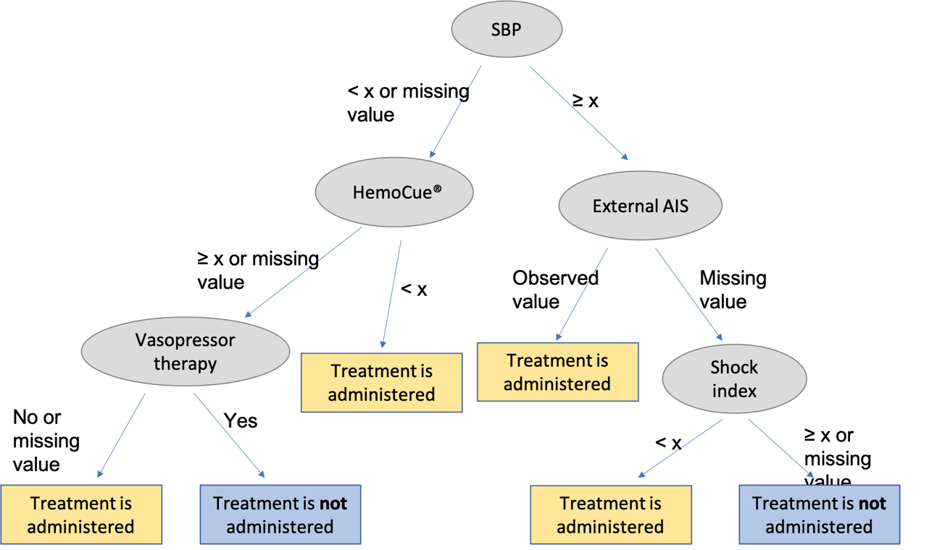
Figure 6: MIA

Variable | TXA group | Control group | p
Gender=male, n (%) | 0 (0) | 64 (1) | < 0.001
Anticoagulant treatment, n (%) | 35 (5) | 316 (4) | 0.235
Antiplatelet treatment, n (%) | 3 (5) | 325 (4) | 0.379
Initial GCS in pre-hospital phase, n (%) | 8 (1) | 157 (2) | 0.116
AIS, n (%)  Head  Face  External | 10 (2)  10 (2)  10 (2) | 128 (2)  128 (2)  128 (2) | 0.757  0.757  0.757
ISS, n (%) | 10 (2) | 122 (2) | 0.874
Pupil anomaly in pre-hospital phase, n (%) | 10 (2) | 151 (2) | 0.388
Osmotherapy in pre-hospital phase, n (%) | 7 (1) | 133 (2) | 0.213
Improvement of pupil anomaly after osmotherapy, n % | 506 (74) | 6454 (85) | < 0.001
Blood pressure un pre-hospital phase, n (%)  Systolic  Diastolic | 208 (31)  209 (31) | 2209 (29)  2230 (30) | 0.510  0.540
Heart rate in pre-hospital phase, n (%) | 187 (27) | 2248 (30) | 0.204
Shock index in pre-hospital phase, n (%) | 219 (32) | 2297 (30) | 0.362
Minmal SpO2 in pre-hospital phase, n (%) | 111 (16) | 855 (11) | < 0.001
Activation of hemorragic shock procedure, n (%) | 28 (4) | 281 (4) | 0.599
Cardiac arrest in pre-hospital phase, n (%) | 3 (0) | 187 (3) | < 0.001
Initial HemoCue®, n (%) | 118 (17) | 2760 (37) | < 0.001
Delta HemoCue®, n (%) | 129 (19) | 2940 (39) | < .001
Cristalloid volume (mL), n (%) | 68 (10) | 2405 (32) | < 0.001
Colloid volume (mL), n (%) | 84 (12) | 2495 (33) | < 0.001
Vasopressor therapy, n (%) | 0 (0) | 0 (0) | 1
GCS at hospital admission, n (%) | 424 (62) | 3050 (40) | < 0.001
Pupil anomaly at hospital admission, n (%) | 9 (1) | 129 (2) | 0.535
Osmotherapy at hospital admission, n (%) | 0 (0) | 0 (0) | 1
IGS II, n (%) | 13 (2) | 156 (2) | 0.888
Maximal PI with transcranial Doppler, n (%) | 362 (53) | 3857 (51) | 0.318
TBI on brain scan, n (%) | 0 (0) | 0 (0) | 1

Table 3: Distribution of missing data by treatment group

