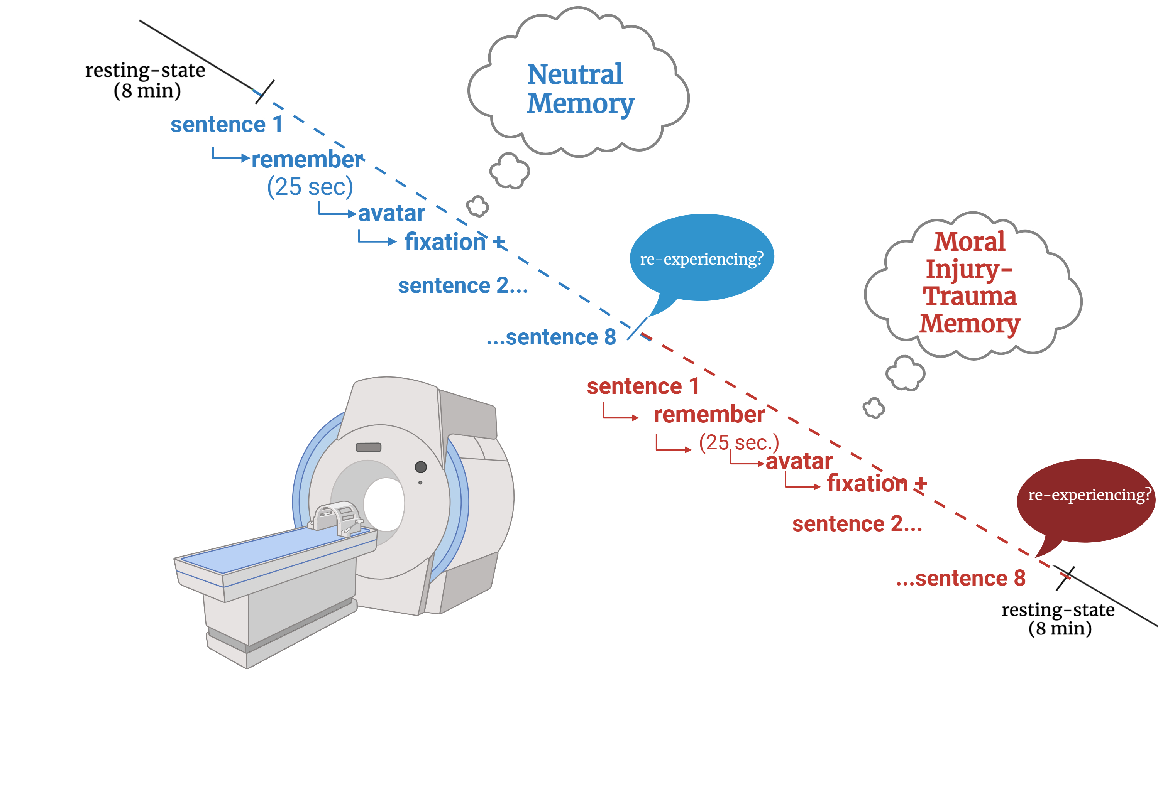

Supplementary Figure 1: fMRI paradigm: Eight-minute resting-state scans were conducted before and after the experimental conditions. For the experimental conditions, participants were instructed to recall their neutral and traumatic memories when presented visually and aurally with their predetermined, personalized script. Scripts were presented one sentence at a time, for a total of eight sentences per memory. After sentence presentation (five seconds), participants spent 25 seconds retrieving that part of their memory in as vivid of detail as possible. Each sentence and its memory retrieval were followed by presentation of a virtual avatar with direct or averted gaze followed by a fixation cross for the purposes of separate analyses. Figure is adapted from previous work²¹ and created using BioRender.com.


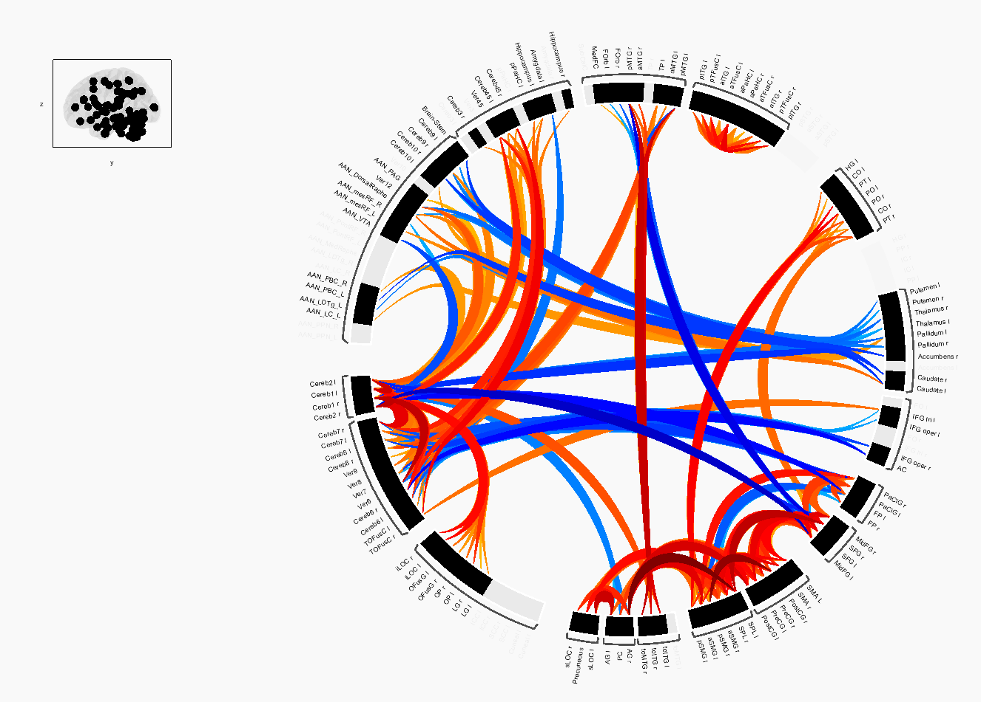
Supplementary Figure 2: PTSD > Control during Traumatic Memory Retrieval. The t-statistic bar is presented in the bottom left corner, with warm colors denoting increased and cool colors denoting decreased functional connectivity strength. The connection threshold was set to p<0.05 uncorrected, and the cluster threshold was set to p<0.05 cluster-level p_{FDR} corrected (MVPA omnibus test).

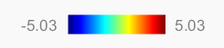
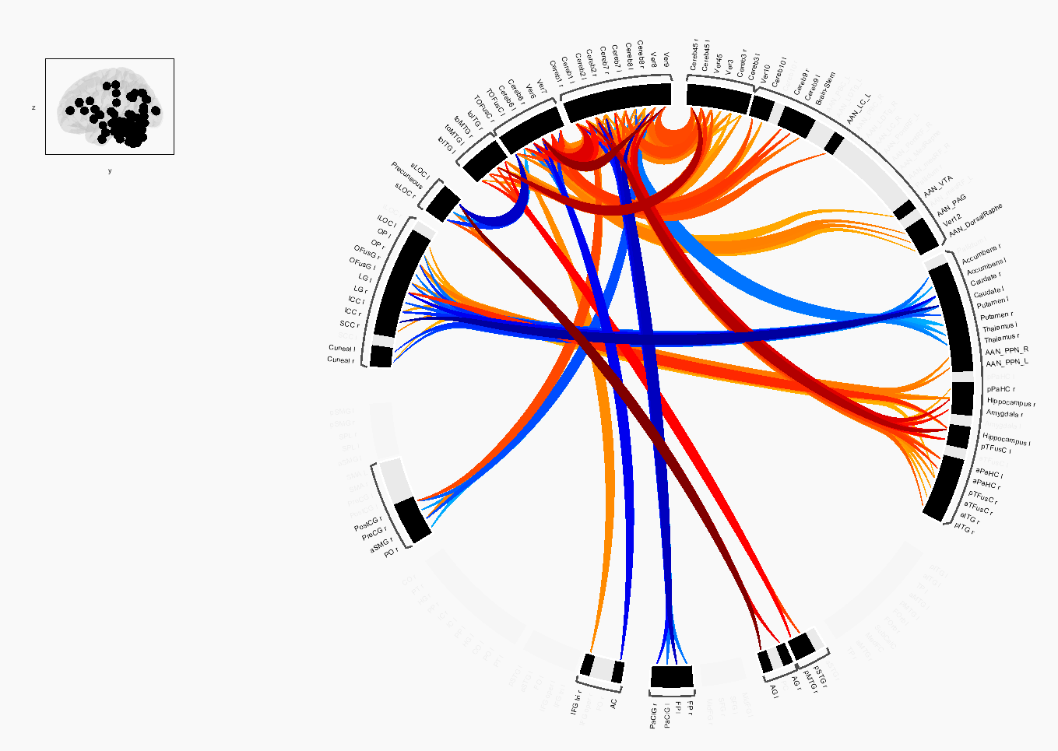
Supplementary Figure 3: PTSD+DS > Control during Traumatic Memory Retrieval. The t-statistic bar is presented in the bottom left corner, with warm colors denoting increased and cool colors denoting decreased functional connectivity strength. The connection threshold was set to p<0.05 uncorrected, and the cluster threshold was set to p<0.05 cluster-level p_{FDR} corrected (MVPA omnibus test).

