Supporting Information
for
Secretory Expression of Cyclohexanone Monooxygenase by Methylotrophic Yeast for Efficient Omeprazole Sulfide Bio-oxidation
Ya-Jing Li, Yu-Cong Zheng, Qiang Geng, Feng Liu, Zhi-Jun Zhang, Jian-He Xu and Hui-Lei Yu*

State Key Laboratory of Bioreactor Engineering, Shanghai Collaborative Innovation Centre for Biomanufacturing, East China University of Science and Technology, Shanghai 200237, China. E-mail: huileiyu@ecust.edu.cn

Table of the contents
Characterization of esomeprazole sodium salt S3
Supplementary reference S3
Supplementary tables S4
Supplementary figures S6
Supplementary HPLC spectrums S12
Supplementary NMR spectrums S14
Supplementary LR-MS spectrums S15

Characterization of esomeprazole sodium salt
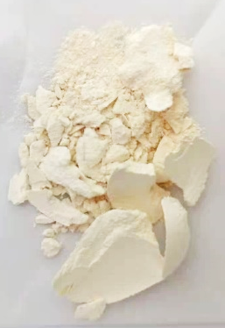
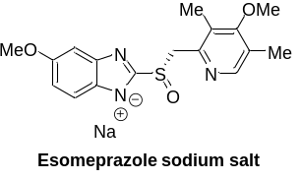Esomeprazole sodium salt^{[S1]}: 2.05 g, 34%. [α]30 D = +24 (c = 1.0 in H₂O). ee>99%, {Lit: [α]20 D = +39 (c = 0.5 in H₂O), ee = 99% of esomeprazole sodium salt [Jiang et al., 2009]} ¹H NMR (600 MHz, DMSO-d₆) δ/ppm: 8.23 (s, 1H), 7.32 (d, J = 8.7 Hz, 1H), 6.98 (d, J = 2.5 Hz, 1H), 6.55 (dd, J = 8.6, 2.5 Hz, 1H), 4.67 (d, J = 12.9 Hz, 1H), 4.38 (d, J = 12.9 Hz, 1H), 3.72 (s, 3H), 3.69 (s, 3H), 2.21 (s, 3H), 2.20 (s, 3H); ¹³C NMR (150 MHz, DMSO-d₆) δ/ppm: 163.3, 161.7, 153.5, 152.0, 149.0, 146.9, 141.6, 126.5, 124.9, 117.4, 108.9, 99.4, 59.8, 59.7, 55.2, 12.9, 11.3. LRMS (EI-TOF): m/z calcd for C₁₇H₁₈N₃SO₃Na [M]: 367.1, found [M+H]⁺: 368.1

Supplementary reference
[S1] Jiang B, Zhao XL, Dong JJ, Wang WJ (2009) Catalytic asymmetric oxidation of heteroaromatic sulfides with tert‐butyl hydroperoxide catalyzed by a titanium complex with a new chiral 1,2‐diphenylethane‐1,2‐diol ligand. Eur J Org Chem 2009: 987−991.

Supplementary tables
Table S1. Primers used in this study.
Name | Sequence
CHMO_{Acineto}-Mut-EcoR I-FP | GGAATTCATGAGCACCAAAATGGACTTCG
CHMO_{Acineto}- Mut-Not I-RP | AAGGAAAAAAGCGGCCGCTTACGCGTTCGCTTGCTGCTT
CHMO_{Acineto}- Mut-Not I-RP (his-tag) | AAGGAAAAAAGCGGCCGCCGCGTTCGCTTGCTGCTT

Table S2. The cost of raw materials for CHMO_{Acineto}-Mut preparation using different expression host.
 | Strain | P. pastoris X33-pPICZαA-CHMO_{Acineto}-Mut |  | E. coli BL21(DE3)-pET-28(a)+-CHMO_{Acineto}-Mut
Final fermentation volume (L) |  | 3 |  | 3.3
 | Price  (CNY/kg) | Consumption  (g) | Cost  (CNY) | Consumption  (g) | Cost  (CNY)
Water | 0.005 | 4000 | 0.02 | 4000 | 0.02
Peptone | 49 | 4 | 0.20 | - | -
Yeast extract | 28 | 4 | 0.11 | 19.5 | 0.55
Tryptone | 30 | - | - | 19.5 | 0.59
Glucose | 1.8 | 4 | 0.01 | - | -
IPTG | 8000 | - | - | 0.14 | 1.12
Methanol | 2.3 | - | - | 1200 | 2.76
Glycerol | 5 | 200 | 1 | 91 | 0.46
Ammonia | 1.4 | 1000 | 1.4 | 250 | 0.35
Na₂SO₄ | 0.7 | - | - | 21 | 0.01
Na₂HPO₄ | 7.5 | - | - | 10.2 | 0.08
MgSO₄ | 3.5 | 29.8 | 0.10 | 0.75 | 0.003
NH₄Cl | 1.5 | - | - | 8.1 | 0.01
Kanamycin | 20,000 | - | - | 0.015 | 0.30
phosphoric acid (85%) | 4.7 | - | - | 53 | 0.25
CaSO₄ | 0.6 | 1.9 | 0.001 | - | 0
K₂SO₄ | 3.8 | 36.4 | 0.14 | - | 0
KOH | 2.5 | 8.3 | 0.02 | - | 0
PTM₁ trace salt | 1.25 | 16 | 0.02 | - | 0
Antifoam | 20 | 1.5 | 0.03 | 1.5 | 0.03
CHMO preparation
K₂CO₃ | 8 | 53 | 0.42 | - | -
KH₂PO₄ | 7.5 | - | - | 61.2 | 0.46
KOH | 2.5 | - | - | 20.4 | 0.05
Water | 0.005 | 250 | 0.001 | 4500 | 0.02
Total |  |  | 3.47 |  | 2.05

Supplementary figures

Figure S1. Shake flask fermentation activity (1% methanol each day, v/v, induced for 72 h) of X33-pPICZαA-CHMO_{Acineto}-Mut strain grown on YPDZ agar plates with different zeocin concentration.

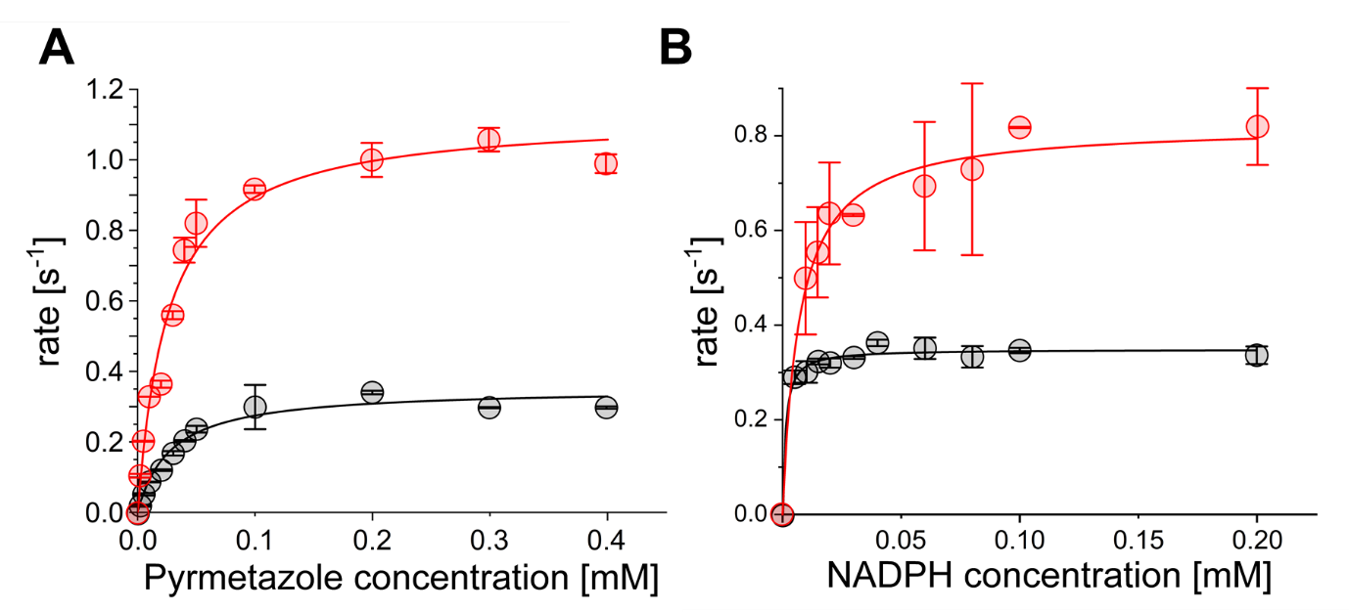
Figure S2. Kinetic curves of CHMO_{Acineto}-Mut-_{P} (○) and CHMO_{Acineto}-Mut-_{E} (○) toward pyrmetazole (A) and NADPH (B).

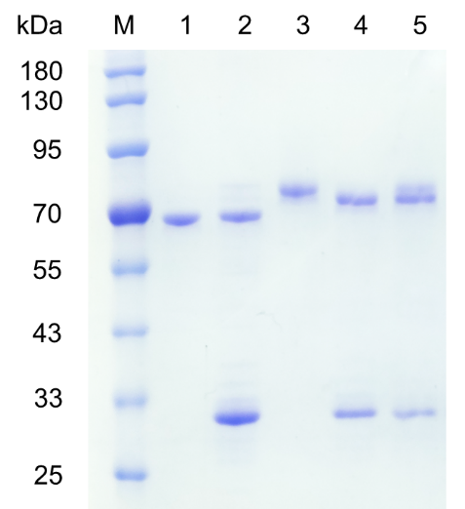
Figure S3. SDS-PAGE of deglycosylated CHMO_{Acineto}-Mut by SpEndo H. M: standard protein marker. Lane 1: purified CHMO_{Acineto}-Mut-_{E}; lane 2: purified CHMO_{Acineto}-Mut-_{E} after incubation with SpEndo H; lane 3: purified CHMO_{Acineto}-Mut-_{P}; purified CHMO_{Acineto}-Mut-_{P} after incubation with SpEndo H; lane 5: deglycosylated CHMO_{Acineto}-Mut-_{P} + native CHMO_{Acineto}-Mut-_{P.}

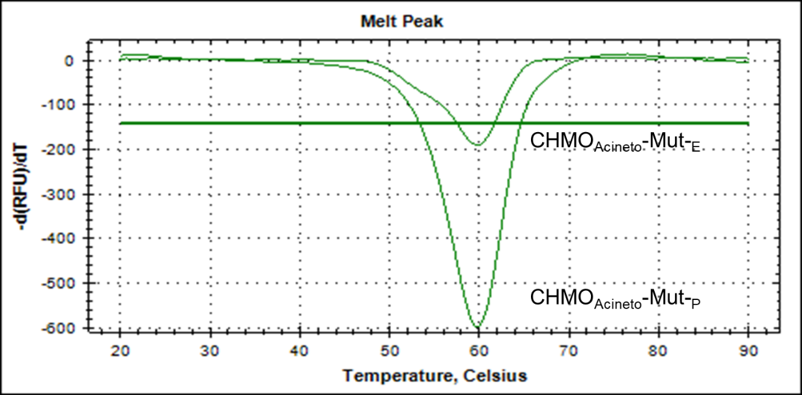
Figure S4. Melting curves of CHMO_{Acineto}-Mut-_{E} and CHMO_{Acineto}-Mut-_{P} determined by ThermoFAD analysis.

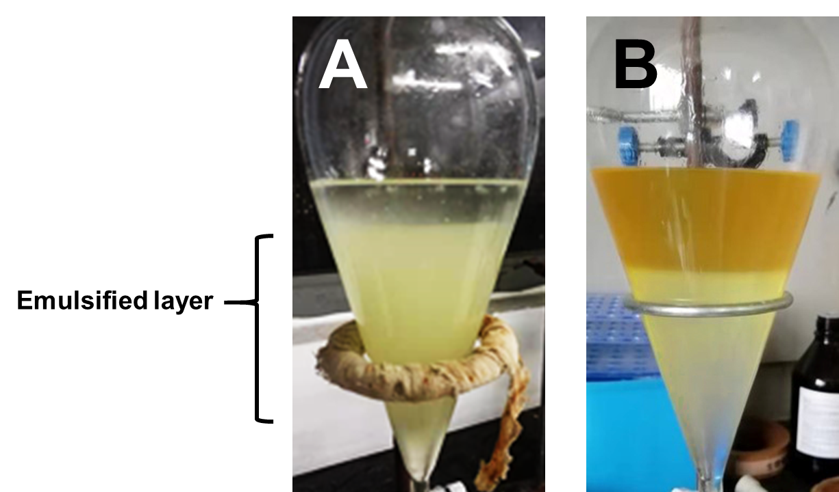
Figure S5. Photograph show of the ethyl acetate extraction of the esomeprazole in the aqueous phase of the reaction mixture (A) CHMO_{Acineto}-Mut-_{E}. (B) CHMO_{Acineto}-Mut-_{P}.

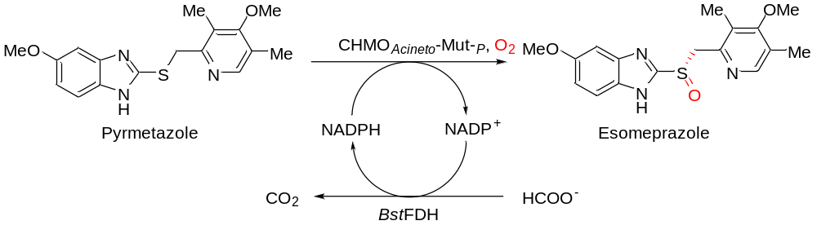
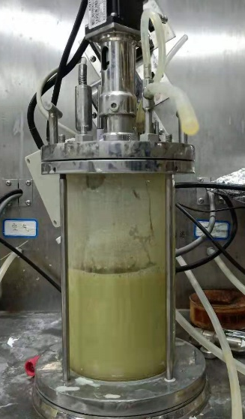
Figure S6. Enzymatic oxidation reaction of pyrmetazole performed in 0.6 L scale and the isolation of esomeprazole sodium.

Supplementary HPLC spectrums
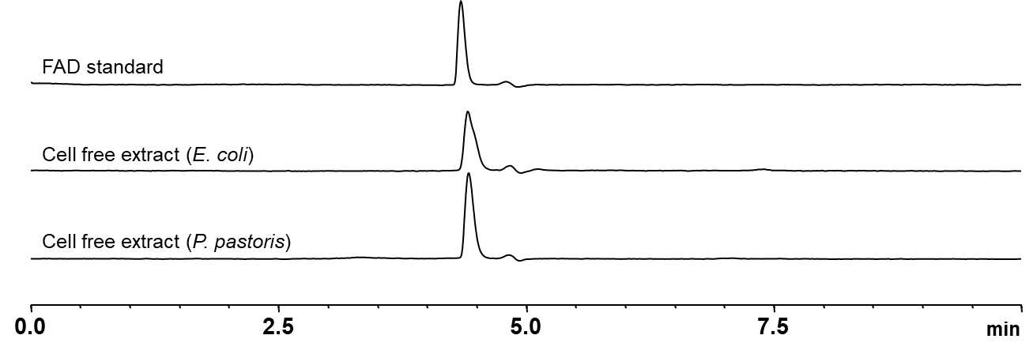
Figure S7. Representative HPLC spectrum of FAD analysis of intracellular constituent.

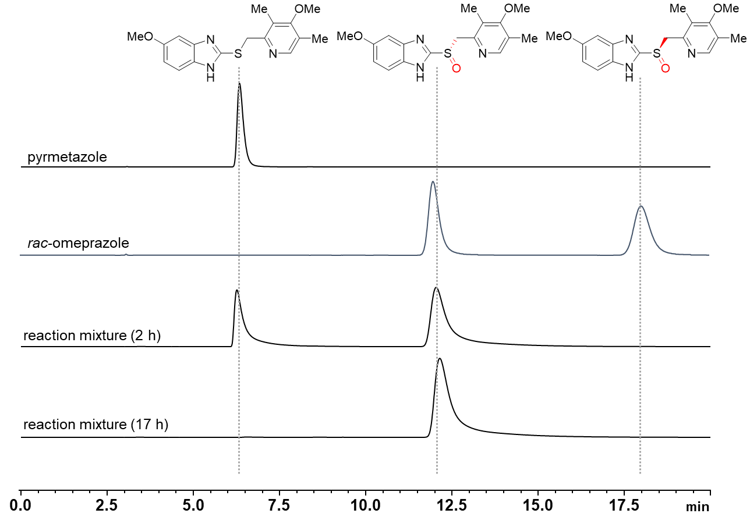
Entry | Ret. Time [min] |  |  | Height [mV] |  |  | Area [mV∙s] |  |  | Area [%]
 | Peak 1 | Peak 2 | Peak 3 | Peak 1 | Peak 2 | Peak 3 | Peak 1 | Peak 2 | Peak 3 | Peak 2 | Peak 3
pyrmetazole | 6.339 | - | - | 131.916 | - | - | 1853.145 | - | - | - | -
rac-omeprazole | - | 11.978 | 18.016 | - | 114.149 | 75.523 | - | 2627.241 | 2599.665 | 50.264 | 49.736
reaction mixture (2 h) | 6.258 | 12.040 | - | 534.482 | 558.278 | - | 12458.368 | 22720.756 | - | 100 | -
reaction mixture (17 h) | - | 12.144 |  | - | 900.307 | - | - | 36703.504 | - | 100 | -
Figure S8. Representative HPLC spectrum of enzymatic esomeprazole synthesis.

Supplementary NMR spectrums
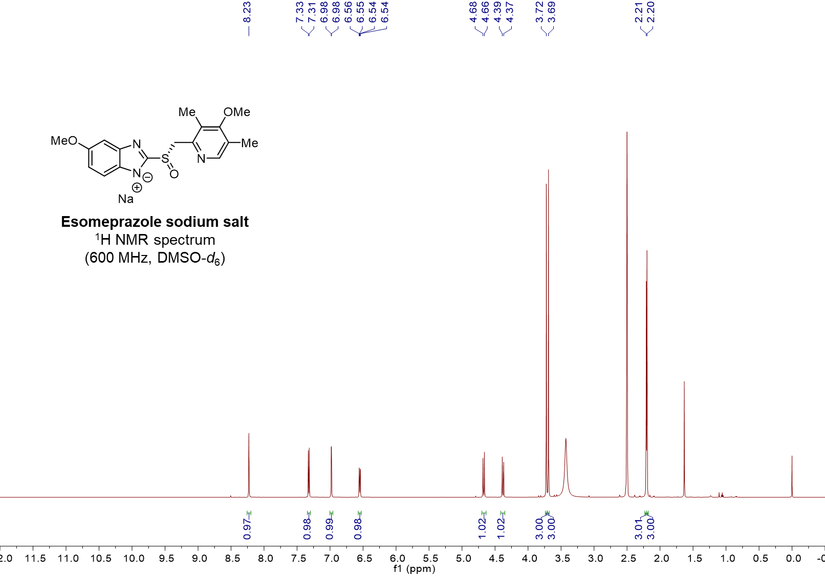
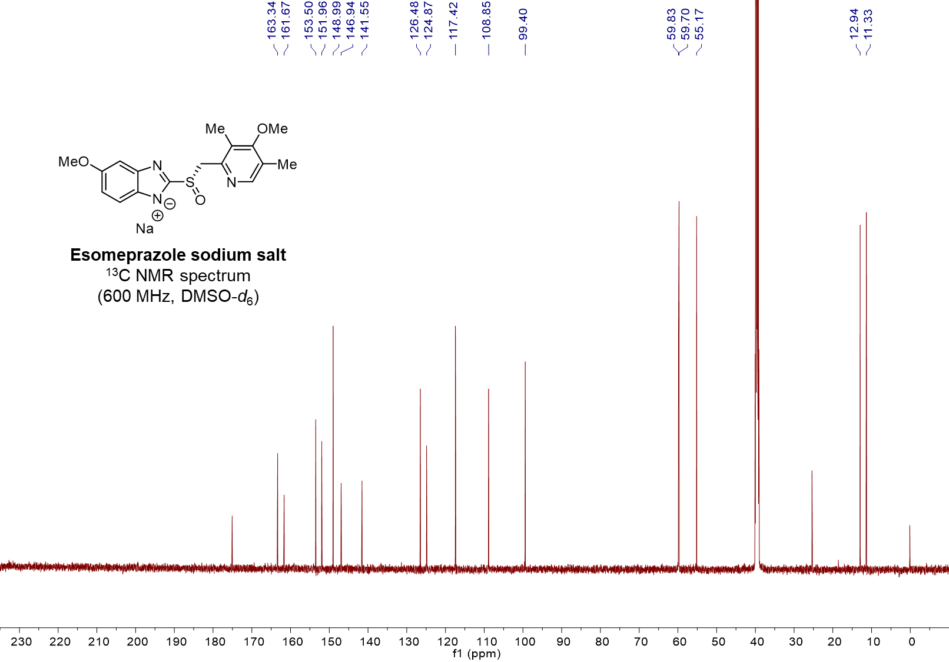
Figure S9. NMR spectrums of esomeprazole sodium salt.

Supplementary LR-MS spectrums
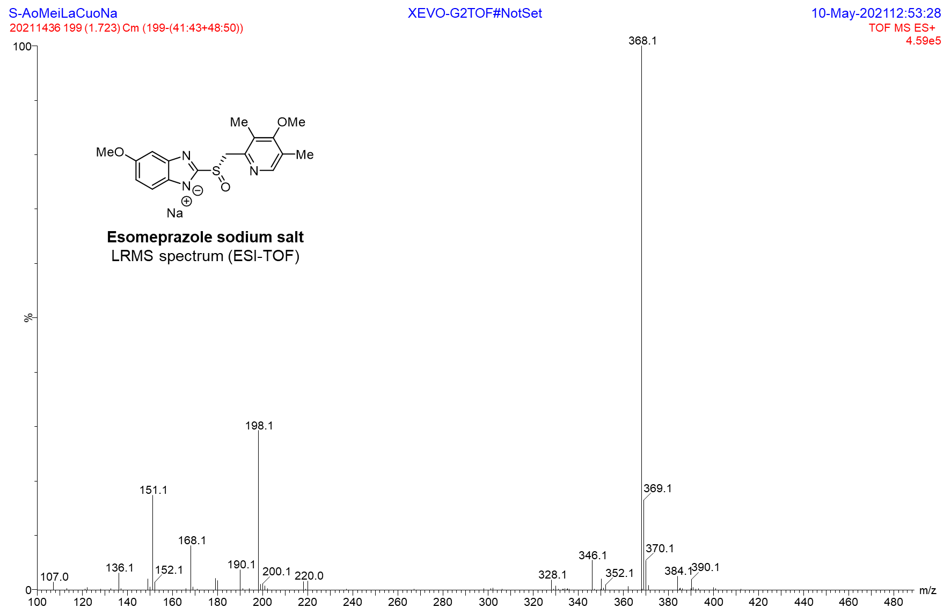
Figure S10. LR-MS spectrums of esomeprazole sodium salt.

