Figure S1. Flow chart of propensity score matching by tumor volume, extent of disease, and lung metastasis

197 patients with HV (Bone alone)
197 patients with HV (Bone alone)
115 patients with LV
(EOD1)

67 patients
(Bone and Lung)

+
・EOD1 and Lung
(n = 19)
・EOD2 and Lung
(n = 12)
・ EOD3 and Lung
(n = 19)
・EOD4 and Lung
(n = 17)
・EOD1
(n = 22)
・EOD2
(n = 58)
・EOD3
(n = 56)
・EOD4
(n = 61)
・EOD1
(n = 22)
・EOD2
(n = 58)
・EOD3
(n = 56)
・EOD4
(n = 61)

Propensity score matching 1:1
Propensity score matching 1:1

(Age, PSA, GS, T-stage N-stage, M1a, initial treatment and radiation therapy)
LV
LV
HV
HV

EOD1
(n = 40)
EOD1
(n = 68)
EOD2 + 11 patients with EOD2 and Lung
(n = 68)
EOD1 + 18 patients with EOD1 and Lung
(n = 40)
EOD1
(n = 22)
EOD1
(n = 57)
EOD1
(n = 53)
EOD1
(n = 56)
EOD1
(n = 22)
EOD2
(n = 57)
EOD3
(n = 53)
EOD4
(n = 56)
Fig. S2. Kaplan–Meier analysis of castration resistant-free survival in the entire cohort by tumor volume and extent of disease
Fig. S3. Kaplan–Meier analysis of overall survival and castration-resistant-free survival in HV-EOD2 by the number of bone metastases ≤10 or ≥11
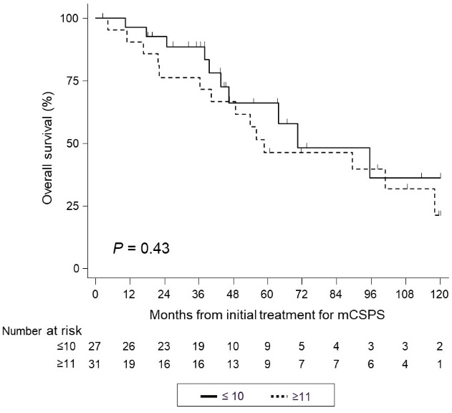
(a)

(b)
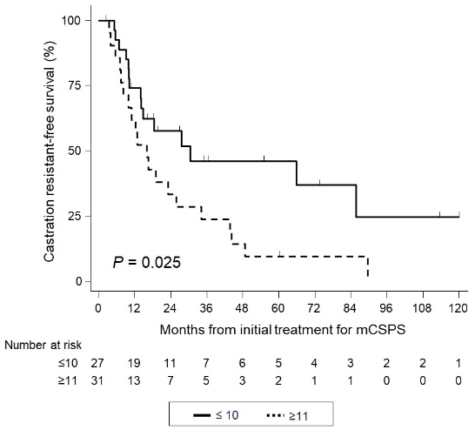

Fig. S4. Kaplan–Meier analysis of castration-resistant-free survival in HV-EOD ≤ 2 and LV-EOD1 after propensity score matching.
(a)

(b)

Fig,S5. Kaplan–Meier analysis of overall survival in HV-EOD ≥ 3 and LV-EOD1 after propensity score matching.
(a)

(b)

Fig. S6. Kaplan–Meier analysis of castration resistant-free survival in HV-EOD ≤ 2, including lung metastasis and LV-EOD1 after propensity score matching
(a)

(b)
