China’s aerosol cleanup has contributed strongly to the recent acceleration in global warming
Bjørn H. Samset*¹, Laura J. Wilcox², Robert J. Allen³, Camilla W. Stjern¹, Marianne T. Lund¹, Sharar Ahmadi², Maxwell T. Elling^{4,5}, Luke Fraser-Leach⁶, Paul Griffiths⁷, James Keeble⁸, Tsuyoshi Koshiro⁹, Paul Kushner⁶, Anna Lewinschal¹⁰, Risto Makkonen¹¹, Joonas Merikanto¹¹, Pierre Nabat¹², Larissa Narazenko^{13,14}, Declan O’Donnell¹¹, Naga Oshima⁹, Steven T. Rumbold¹⁵, Toshihiko Takemura¹⁶, Kostas Tsigaridis^{13,14}, Daniel M. Westervelt^{14,17}
Supplementary Materials
Supplementary Figures

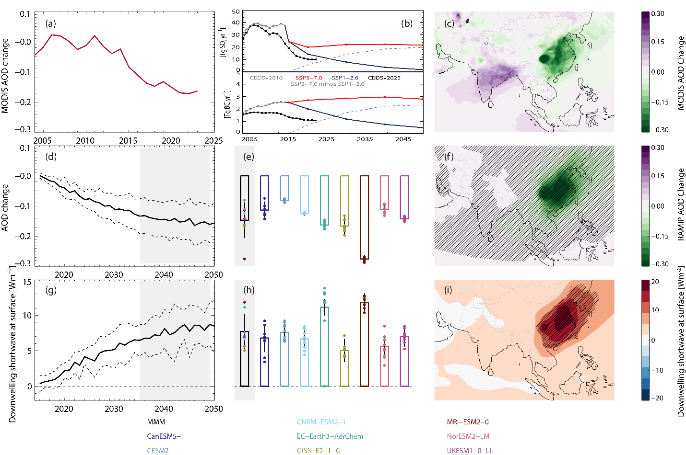

Supplementary Figure 1: Observed changes in aerosol optical depth since 2010, and the corresponding changes in the RAMIP model simulations. (a) Reduction in annual mean Aerosol Optical Depth (AOD) over East Asia, relative to 2005-2010. Mean of MODIS Aqua and Terra. (b) Annual emissions of SO2 (top) and BC aerosols (bottom) from CEDSv2025 (black), and the two scenarios used by RAMIP (red, blue). The older CEDSv2016 used by CMIP6 is also shown. Dashed line shows the emissions perturbation simulated by RAMIP. (c) As (a), spatially resolved, difference between 2014-2023 and 2005-2014. (d) AOD change in the RAMIP simulations, multi-model mean and ±1 standard deviation range. (e) Individual ensemble member (dots), model means (colored boxes) and multi-model mean (black box) AOD difference in RAMIP, for 2035-2049. (f) Spatial distribution of AOD change in RAMIP, multi-model mean. Hatching indicates statistical significance (see Methods). (g-i) As d-f, for downwelling shortwave radiation at the surface.

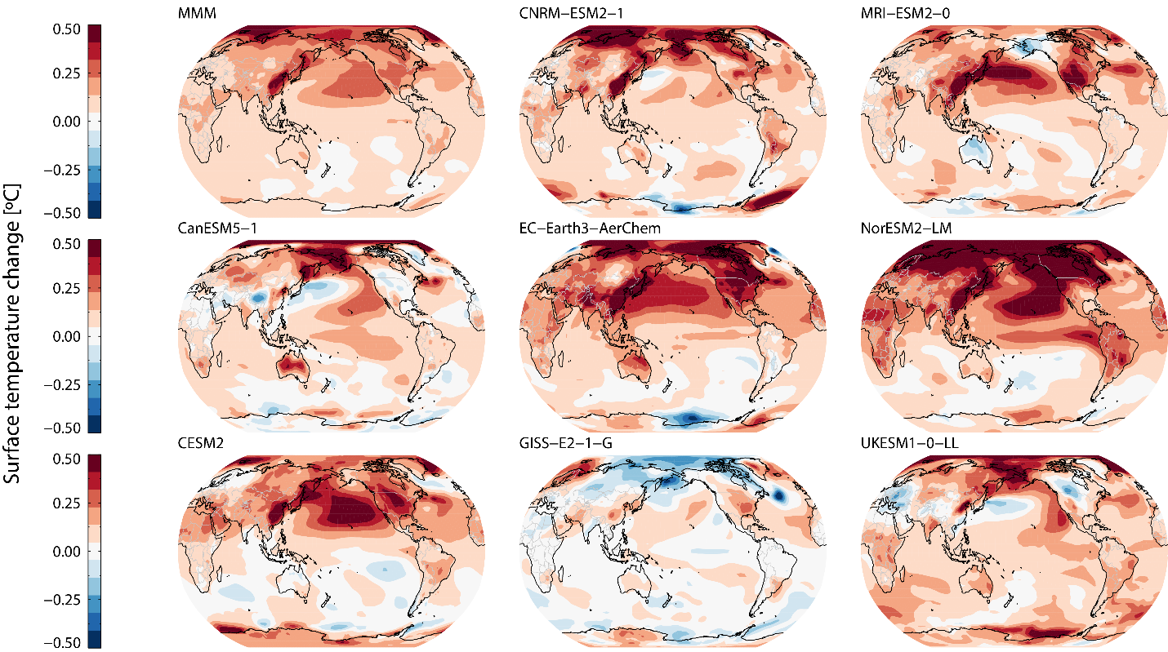

Supplementary Figure 2: RAMIP surface temperature response to East Asian aerosol emissions reductions. Multi-model mean and individual model annual mean temperature change for the 2035-2049 period, difference between the East Asia and baseline simulations. Each model result is the mean of 10 ensemble members.

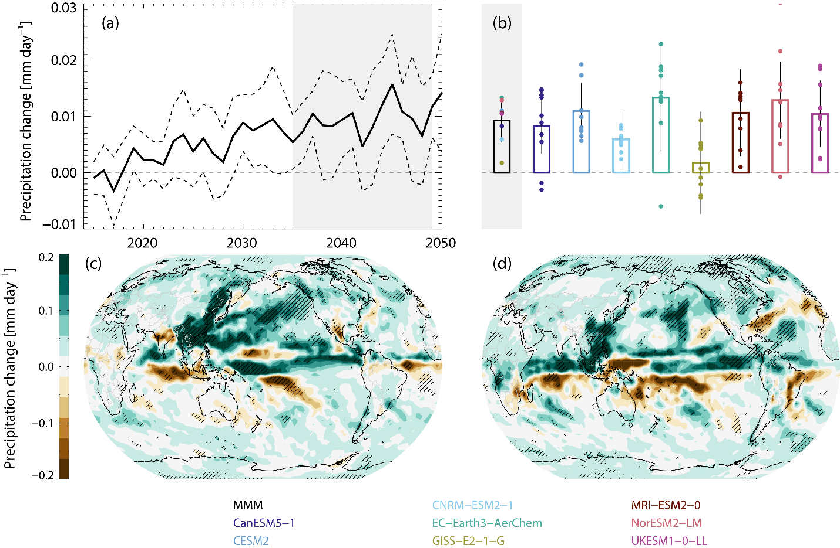

Supplementary Figure 3: Precipitation responses to reductions in East Asian aerosol emissions. (a) Global, annual mean precipitation response to the RAMIP East Asian aerosol emissions perturbations, multi-model mean and ±1 standard deviation range. (b) Ensemble member, model mean and multi-model mean precipitation response for 2035-2049. (c) Multi-model spatial response, for June-July-August. (d) As c, for December-January-February.

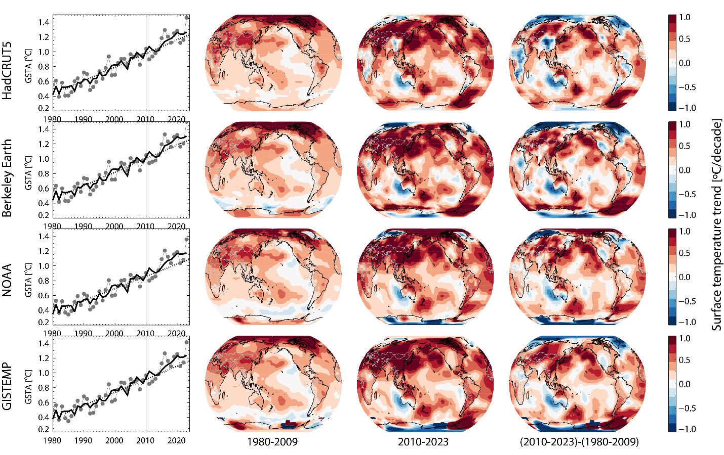

Supplementary Figure 4: Global and regional surface temperature trends from individual reconstructions.
Left: Global, annual mean surface temperature anomalies, relative to 1850-1900 (1880-1900 for GISTEMP) for four reconstructions: HadCRUT5, Berkeley Earth, NOAA and GISTEMP. As in Figure 3, the dashed line shows the 1980-2009 trend, and its continuation through 2023. Subsequent columns show regional trends for 1980-2009 and 2010-2023. The right column shows the difference between the two trend periods.

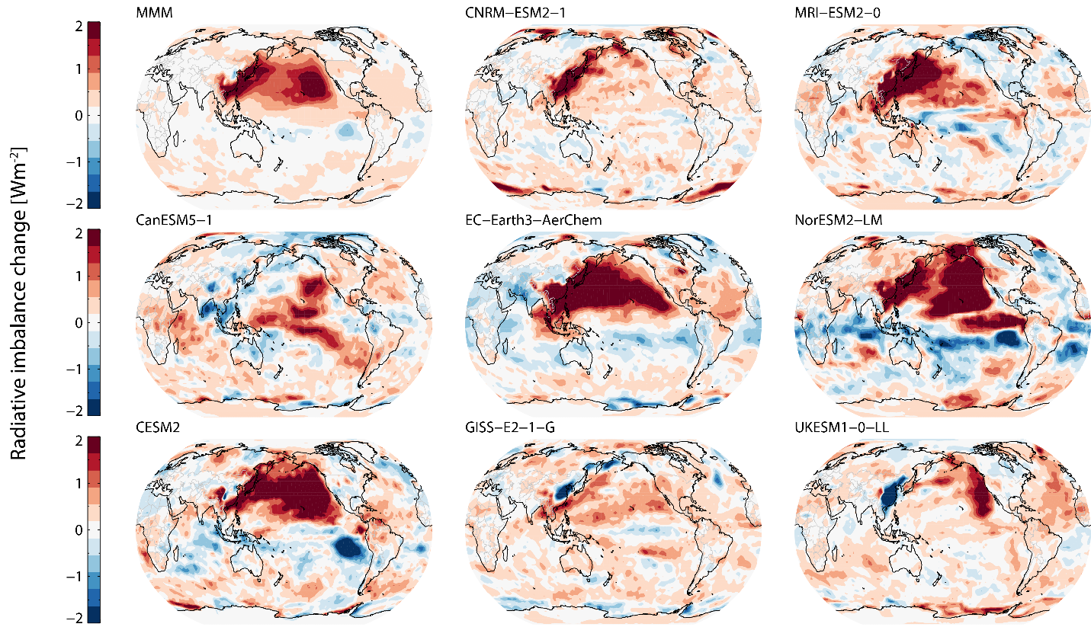

Supplementary Figure 5: RAMIP TOA all sky radiative imbalance response to East Asian aerosol emissions reductions. Multi-model mean and individual model annual mean radiative imbalance (shortwave + longwave) change for the 2035-2049 period, difference between the East Asia and baseline simulations. Each model result is the mean of 10 ensemble members.

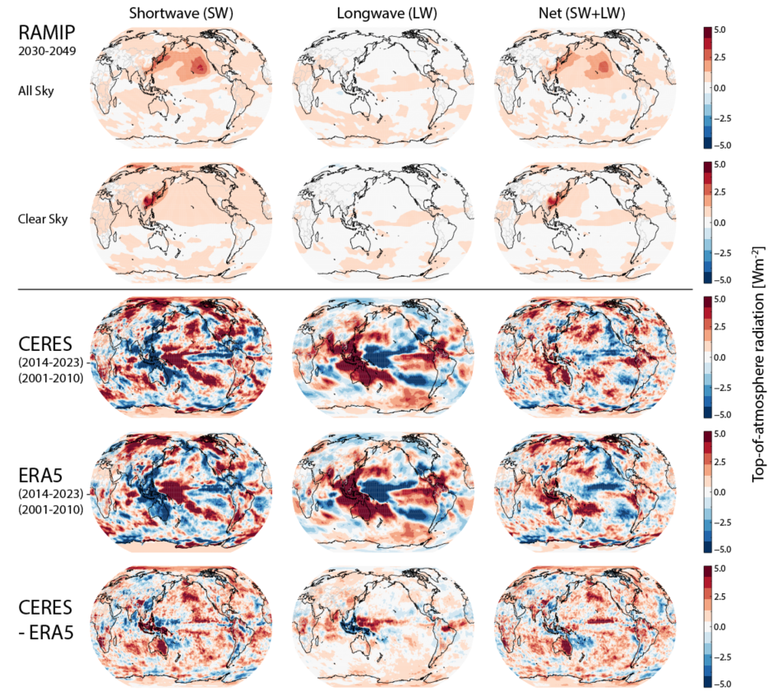

Supplementary Figure 6: Top-of-atmosphere radiative imbalance in RAMIP, observations and reanalysis.
Breakdown of top-of-atmosphere radiative imbalances into shortwave (left), longwave (middle), and net (right) radiation. Two top rows show RAMIP multi-model results for all-sky (i.e. including cloud contributions) and clear sky conditions. Difference between the East Asia and baseline simulations, 2035-2049. Subsequent rows show results from CERES and ERA5, as the difference between two recent decades (see main text). Last column shows the difference between CERES and ERA5.

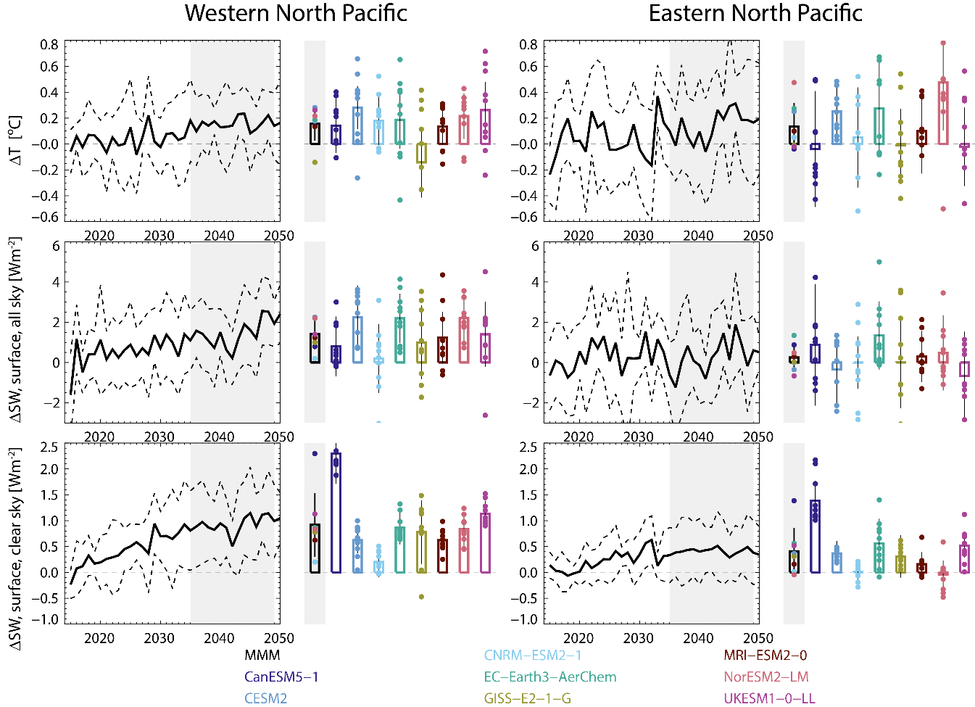

Supplementary Figure 7: RAMIP North Pacific responses
Multi-model and individual model responses in the Western (left) and Eastern (right) North Pacific. Domains used are 120W-180W (West Pacific), 120E-180E (East Pacific), and 25N-52N (both), with an ocean mask applied. Top row: Surface temperature change, as the difference between the East Asia and baseline simulations for 2035-2049. Middle row: Change in downwelling shortwave radiation for all sky conditions. Bottom row: Same, but for clear sky conditions.

Supplementary Tables

Supplementary Table 1: Simulation details
Simulations used in this analysis. For further documentation, see (17). SSP3-7.0 and SSP1-2.6 aerosol emissions are documented in ¹.

Simulation name | RAMIP name | Aerosol emissions |  | Time period | Ensemble members
 |  | East Asia | Elsewhere
Baseline | SSP370 | SSP370 | SSP370 | 2015-2050 | 10
East Asia | SSP370-eas126aer | SSP126 | SSP370 | 2015-2050 | 10

Supplementary Table 2: RAMIP participating models
Technical details and key reference for RAMIP models included in this analysis
Centre | Model | Model construction |  |  | Resolution
 |  | Atmosphere | Aerosol | Chemistry | Lon | Lan | Lev | Model top | Documentation
CCCma | CanESM5-1 | CanAM5 | Interactive | Specified oxidants | 128 | 64 | 49 | 1hPa | ²
NCAR | CESM2 | CAM6 | MAM4 | MAM4 | 288 | 192 | 32 | 2.25hPa | ³
CNRM-CERFACS | CNRM-ESM2-1 | Arpege 6.3 | TACTIC_v2 | REPROBUS-C_v2 | 256 | 128 | 91 | 78.4km | ⁴
EC-Earth-Consortium | EC-Earth3-AerChem | IFS cy36r4 | TM5 | TM5 | 512 | 256 | 91 | 0.01hPa | ⁵
NASA-GISS | GISS-E2-1-G (p3) | GISS-E2.1 | OMA | GPUCCINI | 144 | 90 | 40 | 0.1hPa | ⁶
MRI | MRI-ESM2-0 | MRI-AGCM3.5 | MASINGAR mk2r4 | MRI-CCM2.1 | 320 | 160 | 80 | 0.01hPa | ⁷
NCC | NorESM2-LM | CAM-OSLO | OsloAero | OsloChemSimp | 144 | 96 | 32 | 3mb | ⁸
MOHC | UKESM1-0-LL | MetUM-HadGEM3-GA7.1 | UKCA-GLOMAP-mode | UKCA-StratTrop | 192 | 144 | 85 | 85km | ⁹

Supplementary Table 3: RAMIP model and dataset references
Key reference for CMIP6 and RAMIP datasets included in this analysis

Model | Data reference (historical) | Data reference (RAMIP)
CanESM5-1 | https://doi.org/10.22033/ESGF/CMIP6.3610
CESM2 | https://doi.org/10.22033/ESGF/CMIP6.7627
CNRM-ESM2-1 | https://doi.org/10.22033/ESGF/CMIP6.4068 | https://doi.org/10.22033/ESGF/CMIP6.3924
EC-Earth3-AerChem | https://doi.org/10.22033/ESGF/CMIP6.4701 | https://doi.org/10.22033/ESGF/CMIP6.4530
GISS-E2-1-G (p3) | https://doi.org/10.22033/ESGF/CMIP6.7127 | https://doi.org/10.22033/ESGF/CMIP6.6984
MRI-ESM2-0 | https://doi.org/10.22033/ESGF/CMIP6.6842
NorESM2-LM | https://doi.org/10.22033/ESGF/CMIP6.8036 | https://doi.org/10.22033/ESGF/CMIP6.7848
UKESM1-0-LL | https://doi.org/10.22033/ESGF/CMIP6.6113 | https://doi.org/10.22033/ESGF/CMIP6.5857

1 Rao, S. et al. Future air pollution in the Shared Socio-economic Pathways. Global Environmental Change 42, 346-358, doi:10.1016/j.gloenvcha.2016.05.012 (2017).
2 Swart, N. C. et al. The Canadian Earth System Model version 5 (CanESM5.0.3). Geoscientific Model Development 12, 4823-4873, doi:10.5194/gmd-12-4823-2019 (2019).
3 Danabasoglu, G. et al. The Community Earth System Model Version 2 (CESM2). Journal of Advances in Modeling Earth Systems 12, doi:10.1029/2019ms001916 (2020).
4 Séférian, R. et al. Evaluation of CNRM Earth System Model, CNRM‐ESM2‐1: Role of Earth System Processes in Present‐Day and Future Climate. Journal of Advances in Modeling Earth Systems 11, 4182-4227, doi:10.1029/2019ms001791 (2019).
5 van Noije, T. et al. EC-Earth3-AerChem: a global climate model with interactive aerosols and atmospheric chemistry participating in CMIP6. Geoscientific Model Development 14, 5637--5668, doi:10.5194/gmd-14-5637-2021 (2021).
6 Kelley, M. et al. GISS-E2.1: Configurations and Climatology. Journal of Advances in Modeling Earth Systems 12, e2019MS002025, doi:https://doi.org/10.1029/2019MS002025 (2020).
7 Yukimoto, S. et al. The Meteorological Research Institute Earth System Model Version 2.0, MRI-ESM2.0: Description and Basic Evaluation of the Physical Component. Journal of the Meteorological Society of Japan. Ser. II 97, 931-965, doi:10.2151/jmsj.2019-051 (2019).
8 Seland, Ø. et al. Overview of the Norwegian Earth System Model (NorESM2) and key climate response of CMIP6 DECK, historical, and scenario simulations. Geoscientific Model Development 13, 6165-6200, doi:10.5194/gmd-13-6165-2020 (2020).
9 Sellar, A. A. et al. UKESM1: Description and Evaluation of the U.K. Earth System Model. Journal of Advances in Modeling Earth Systems 11, 4513-4558, doi:10.1029/2019ms001739 (2019).

