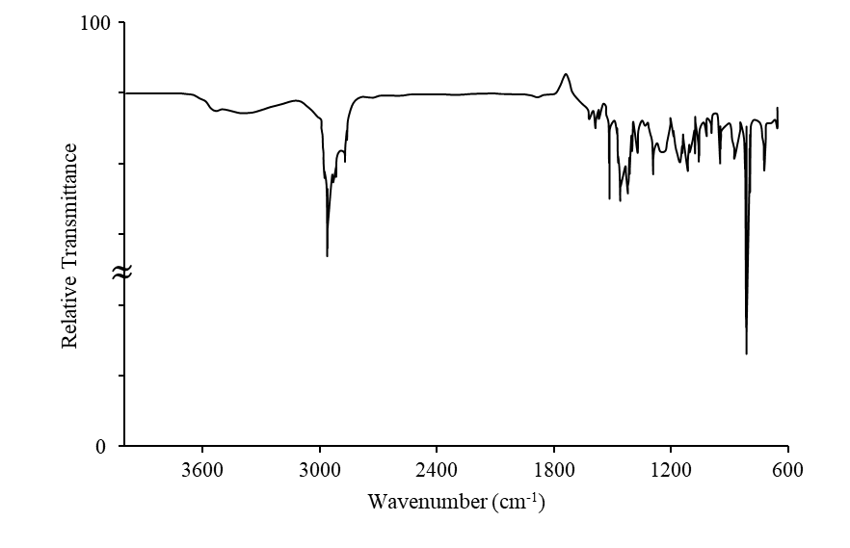
(a)

(b)
≈
0
100

Figure S1. FTIR spectrum of pure EOs (a) Thyme and (b) Sage

Table S1. Equilibrium data for adsorption of Thyme EO on HNS and HPN adsorbent at 25°C
C_{o} (ppm) | HNS |  |  | HPN
C_{o} (ppm) | C_{e} (ppm) | q_{e} (mg/g ads) |  | C_{e} (ppm) | q_{e} (mg/g ads)
24 | 20.28 | 0.61 |  | 22.84 | 0.19
32 | 27.15 | 0.80 |  | 28.06 | 0.65
40 | 34.26 | 0.95 |  | 35.11 | 0.81
60 | 50.50 | 1.58 |  | 50.34 | 1.60
80 | 64.05 | 2.65 |  | 65.34 | 2.44
120 | 94.89 | 4.18 |  | 98.18 | 3.63
160 | 128.06 | 5.32 |  | 128.06 | 5.32

Table S2. Parameters of various isotherms for adsorption of Thyme EO on HNS and HPN at 25 °C

Parameters |  | HNS |  |  |  | HPN
Parameters |  | Langmuir | Freundlich | Temkin |  | Langmuir | Freundlich | Temkin
q_{m} |  | -20.012 | - | - |  | -8.88 | - | -
K_{L} |  | -0.001 | - | - |  | -0.0029 | - | -
K_{F} |  | - | 0.016 | - |  | - | 0.0075 | -
n_{F} |  | - | 0.838 | - |  | - | 0.739 | -
b_{T} |  | - | - | 941.61 |  | - | - | 885.28
A_{T} |  | - | - | 0.048 |  | - | - | 0.0412

Table S3. Error function values for non-linear fitting of equilibrium adsorption data of Thyme EO on Nanocapsules
Error Functions |  | HNS |  |  |  | HPN
Error Functions |  | Langmuir | Freundlich | Temkin |  | Langmuir | Freundlich | Temkin
R² |  | 0.979 | 0.985 | 0.921 |  | 0.981 | 0.989 | 0.948
RMSE |  | 0.286 | 0.243 | 0.563 |  | 0.275 | 0.211 | 0.459

Table S4. Kinetic adsorption data of Thyme and Sage EOs on HNS and HPN adsorbent at 25 °C and initial concentration of 60 ppm (Thyme EO) and 600 ppm (Sage EO)
t (min) |  | Thyme HNS |  |  | Thyme HPN |  |  | Sage HNS |  |  | Sage HPN
t (min) |  | C_{t} (ppm) | q_{t} (mg/g) |  | C_{t} (ppm) | q_{t} (mg/g) |  | C_{t} (ppm) | q_{t} (mg/g) |  | C_{t} (ppm) | q_{t} (mg/g)
5 |  | 56.35 | 0.608 |  | 54.825 | 0.862 |  | 582.000 | 3.000 |  | 574.142 | 4.309
20 |  | 49.35 | 1.770 |  | 47.787 | 2.035 |  | 537.571 | 10.404 |  | 512.857 | 14.523
35 |  | 49.50 | 1.750 |  | 49.075 | 1.820 |  | 515.857 | 14.023 |  | 479.000 | 20.166
50 |  | 48.58 | 1.902 |  | 48.037 | 1.993 |  | 515.000 | 14.166 |  | 480.571 | 19.904
65 |  | 45.63 | 2.390 |  | 47.037 | 2.160 |  | 507.571 | 15.404 |  | 463.142 | 22.809
80 |  | 46.01 | 2.330 |  | 46.762 | 2.206 |  | 505.428 | 15.761 |  | 444.142 | 25.976
95 |  | 44.53 | 2.570 |  | 44.000 | 2.666 |  | 457.142 | 23.809 |  | 438.857 | 26.857
110 |  | 44.31 | 2.610 |  | 45.275 | 2.454 |  | 464.714 | 22.547 |  | 444.857 | 25.857
125 |  | 45.27 | 2.450 |  | 43.825 | 2.695 |  | - | - |  | 392.857 | 34.523

Table S5. Different kinetic models for adsorption of EOs onto adsorbents
Kinetic models | Equation | Parameters
Pseudo-ﬁrst-order (PFO) | $$\ln\left(q_{e}-q_{t}\right)=\ln{q_{e}}-k_{1}t$$ | $$k_{1}$$
Pseudo-ﬁrst-order (PFO) | $$\ln\left(q_{e}-q_{t}\right)=\ln{q_{e}}-k_{1}t$$ | $$q_{e}$$
Pseudo-second-order (PSO) | $$\frac{t}{q_{t}}=\frac{1}{k_{2}q_{e}^{2}}+\frac{t}{q_{t}}$$ | $$k_{2}$$
Pseudo-second-order (PSO) | $$\frac{t}{q_{t}}=\frac{1}{k_{2}q_{e}^{2}}+\frac{t}{q_{t}}$$ | $$q_{e}$$
Elovich | $$q_{t}=\frac{lna_{t}b_{t}}{b_{t}}+\frac{1}{b_{t}}lnt$$ | $$a_{t}$$
Elovich | $$q_{t}=\frac{lna_{t}b_{t}}{b_{t}}+\frac{1}{b_{t}}lnt$$ | $$b_{t}$$
Intraparticle Diffusion | $$q_{t}=k_{p}t^{1/2}+C$$ | $$k_{p}$$
Intraparticle Diffusion | $$q_{t}=k_{p}t^{1/2}+C$$ | C
mixed 1,2-order (MOE) | $$q_{t}=q_{e}\frac{1-exp⁡(-k_{1}t)}{{1-F}_{2}exp⁡(-k_{1}t)}$$ | $$q_{e}$$
mixed 1,2-order (MOE) |  | $$k_{1}$$
mixed 1,2-order (MOE) |  | $$F_{2}$$

Table S6. Parameters of various kinetic models for adsorption of Thyme EO on HNS.
Parameters | PFO | PSO | Elovich | Intra-particle diffusion | MOE
q_{e} | 2.475 | - | - | - | -
k₁ | 0.0451 | - | - | - | -
q_{e} | - | 2.904 | - | - | -
k₂q_{e} | - | 0.0194 | - | - | -
a_{t} | - | - | 0.295 | - | -
b_{t} | - | - | 1.535 | - | -
k_{p} | - | - | - | 0.20 | -
C | - | - | - | 0.528 | -
q_{e} | - | - | - | - | 2.543
k₁ | - | - | - | - | 0.037
F₂ | - | - | - | - | -0.183

Table S7. Parameters of various kinetic models for adsorption of Thyme EO on HPN at 25°C.
Parameters | PFO | PSO | Elovich | Intra-particle diffusion | MOE
q_{e} | 2.356 | - | - | - | -
k₁ | 0.074 | - | - | - | -
q_{e} | - | 2.691 | - | - | -
k₂ | - | 0.034 | - | - | -
a | - | - | 0.582 | - | -
b | - | - | 1.901 | - | -
k_{d} | - | - | - | 0.171 | -
c | - | - | - | 0.801 | -
q_{e} | - | - | - | - | 2.595
k₁ | - | - | - | - | 0.032
F₂ | - | - | - | - | -0.531

Table S8. Parameters of various kinetic models for adsorption of Sage EO on HNS at 25°C
Parameters | PFO | PSO | Intra-particle diffusion | MOE
q_{e} | 22.299 | - | - | -
k₁ | 0.023 | - | - | -
q_{e} | - | 28.775 | - | -
k₂ | - | 0.00078 | - | -
k_{d} | - | - | 2.0043 | -
c | - | - | 0.064 | -
q_{e} | - | - | - | 22.0062
k₁ | - | - | - | 0.022
F₂ | - | - | - | -0.112

Table S9. Parameters of various kinetic models for adsorption of Sage essential oil on polymer nanocapsules at 25 °C
Parameters | PFO | PSO | Intra-particle diffusion | MOE
q_{e} | 30.561 | - | - | -
k₁ | 0.0255 | - | - | -
q_{e} | - | 39.312 | - | -
k₂ | - | 0.00063 | - | -
k_{d} | - | - | 2.8005 | -
c | - | - | 0.462 | -
q_{e} | - | - | - | 32.549
k₁ | - | - | - | 0.0204
F₂ | - | - | - | -0.114

